1.6.2-ALG processImage() Algorithm
Purpose:
Ensures an uploaded image meets program standards by validating the file, resizing or cropping it as needed, compressing it, and preparing it for storage.
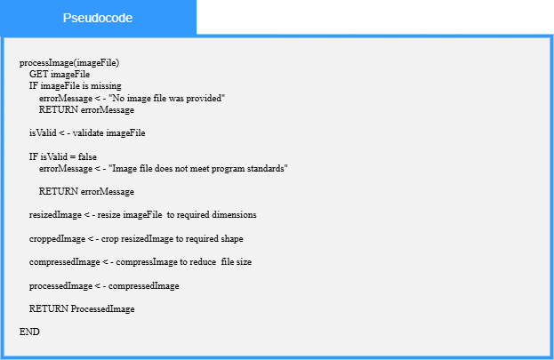

Local Data:
imageFile : File
isValid : Boolean
resizedImage : Image
croppedImage : Image
compressedImage : Image
processedImage : ProcessedImage
errorMessage : String

