2.1 Student Dashboard
Desktop View
[insert desktop view from Angie]

Mobile View
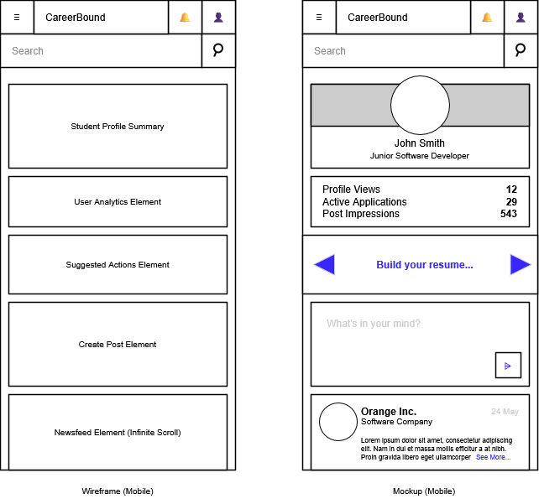

Design Information
Field | Description / Purpose
View Name & Number | 2.1 – Student Dashboard
Purpose / Design Concern | Provides a general overview of the student user’s account
Description | Displays a summarized profile; provides analytics such as profile views, profile completion, matching jobs, post impressions; recommends actions to take such as improve profile, create resume, apply for a job; provides a shortcut to post creation; and displays news feed
Requirements | 3.1 Student User Profile, 3.2 Notifications, 3.4 News Feed, 3.5 Resume
Elements | Student Profile Summary Card
 | Student User Analytics Card
 | Suggested Actions Card
 | Quick Create Post Card
 | News feed List
 | News feed Card
 | Submit Button
 | Navigation
 | Header
 | Search bar
 | Search button
 | Notifications toggle button
 | Profile Page hyperlink button
 | Pagination
Inputs | Student Post
Outputs | New Student Post
Navigation / References | Login/Logout, Student Profile, Resume Builder, Job Search, Notifications, News Feed
Viewpoint | UI Wireframe / Mockup (Desktop & Mobile)

