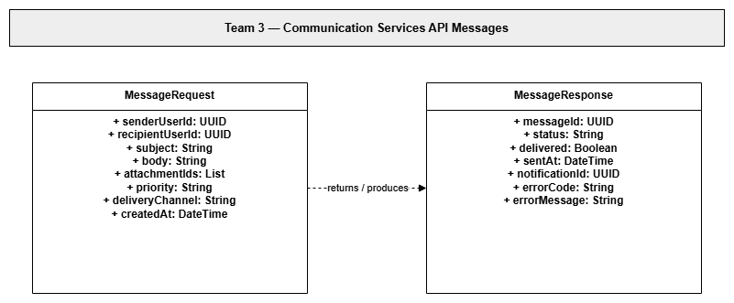

Communication Services API Message Specification
1.10.7-API MessageRequest
Field | Data Type | Required | Description
senderUserId | UUID | Yes | User sending the message.
recipientUserId | UUID | Yes | User receiving the message.
subject | String | No | Short message heading.
body | String | Yes | Message text / notification data content.
attachmentIds | List<UUID> | No | References to attached files or objects.
priority | String | No | Delivery priority such as normal or urgent.
deliveryChannel | String | Yes | In-app, push, email, or other supported channel.
createdAt | DateTime | Yes | Time the request was created.

1.10.8-API MessageResponse
Field | Data Type | Required | Description
messageId | UUID | Yes | Unique ID assigned to the stored/sent message.
status | String | Yes | Processing result such as sent, queued, or failed.
delivered | Boolean | Yes | True when the message was delivered successfully.
sentAt | DateTime | No | Time the message was sent or queued.
notificationId | UUID | No | Related notification generated for the receiver.
errorCode | String | No | Failure code when processing fails.
errorMessage | String | No | Human-readable failure reason.

