SWDD- [obtain number from Conduct of Engineering Document Numbering SharePoint site]

CSE 430 Architectural Design
Career Bound

Software Design Document

Name (s): Jeremy Troy Suchanski, Robert Anderson, Danny Capps, Savannah Harvey, Spencer Beals, Kimberly Uresti, Adam Sheridan, Marco Quintero, Corbin Probasco, Nathan Lipovich, Abraham Moreno-Sanchez, Kaleb Swertfeger, Mike Olson, Kyle Jones, Yat Lam, Ernesto Quispe Cajan, Jacob Mychal Kertesz, Pavel Shvets, Peyton Markus, Carson Roberts, Joe Allen, Sam Evans, Zach Crittenden, Caleb Schmid, Jackson Aden, Scott Shumway, Zachary Humphreys, Braulio Garcia Gonzalez, Ethan Houser, Wessly Green Contreras, William Torman, Ethan Seegmiller, Sergey Tsybenko, Sergio Bravo Bravo Moran, Dallin Stephens, Sunseehray Tirazona, Teph Milford
Section: BYUI
Workstation: Online

Date: 05/13/2026

Revision History
Version | Date | Author | Change Description
1.0 | 5/14/26 | Jeremy Troy Suchanski | Filled in work done for Milestone 1 and started filling in sections relevant to Milestone 2 for Initial SWDD draft
2.0 | 5/22/26 | Nathan Lipovich | Filled in the diagrams for 6.2 and 7 as well as the 6.1 introduction
3.0 | 5/24 | Corbin Probasco | Fill in the missing information for Component Diagram Design Information Tables & other fixes.
4.0 | 5/28/26 | Robert Anderson | Updated Component Diagrams and associated tables with missing information
5.0 | 6/6/26 | Nathan Lipovich | Filled in Entity Identifiication Tables
6.0 | 6/6/26 | Robert Anderson | Filled in Last of EITs. Also added some Structure Charts and DFDs.
7.0 | 6/6/26 | Jeremy Troy Suchanski | Added the Design Rationale and fixed headings.
8.0 | 6/9/26 | Robert Anderson | Added approved Structure charts and DFDs.
9.0 | 6/10/26 | Nathan Lipovich | Added the rest of the Structure Charts, DFDs, and UI Views that had been turned in.
10.0 | 6/11/26 | Jeremy Troy Suchanski | Fixed Headings, Images, and Added Parts I Rounded up From Teams to Complete Milestone 3.
11.0 | 6/15/26 | Jeremy Troy Suchanski | Filled in missing parts of EITs for Web Client and Mobile Client to help determine Pseudocode Algorithms
12.0 | 6/16/26 | Jeremy Troy Suchanski | Filled in Sections 4.1 Data Description & 4.2 Data Dictionary.
13.0 | 6/22/26 | Nathan Lipovich | Filled in most of a new section created by Jeremy for Class Diagrams - Section 4.3 Class Design
14.0 | 6/23/26 | Jeremy Troy Suchanski | Finished filling in and formatting Section 4.3 and created and filled in Sections 4.4 Database Design, 4.5 File Format Specifiations, & 4.6 Network Protocol / API Message Specifications

TABLE OF CONTENTS
1.0 INTRODUCTION 4
1.1 Purpose 4
1.2 Scope 4
1.3 Overview 5
1.4 Reference Material 5
1.5 Definitions and Acronyms 6
2.0 SYSTEM OVERVIEW 6
3.0 SYSTEM ARCHITECTURE 7
3.1 Architectural Design 7
3.2 Decomposition Description 10
3.3 Design Rationale 148
4.0 DATA DESIGN 148
4.1 Data Description 148
4.2 Data Dictionary 148
5.0 COMPONENT DESIGN 148
6.0 HUMAN INTERFACE DESIGN 148
6.1 Overview of User Interface 148
6.2 Screen Images 149
6.3 Screen Objects and Actions 182
7.0 REQUIREMENTS MATRIX 182
8.0 APPENDICES 196

INTRODUCTION

Purpose
This Software Design Document (SWDD) describes the architecture, subsystem breakdown, data design, component structure, and human interface design of the Career Bound system. The document provides the design foundation necessary for implementation and integration of the Career Bound software platform.
The intended audience of this document includes:
- Developers
- Designers
- QA reviewers
- Project managers
- Instructors
- Stakeholders
This document serves as the primary design reference for the Career Bound project and establishes standardized architecture, interface, workflow, and UI design patterns used throughout the system.

Scope
Career Bound is a web and mobile application for career networking and job searching designed to connect students and employers through profiles, resumes, job postings, notifications, and search capabilities.
The system supports:
- Student profile management
- Company profile management
- Resume creation and submission
- Job posting management
- Candidate and job search
- Notifications and news feed updates
- Responsive desktop and mobile interfaces
The goals of the project are to:
- Simplify finding jobs and candidates
- Improve communication between students and employers
- Provide a centralized career development platform
- Support scalable and modular software architecture
- Demonstrate standardized software engineering practices
The project delivers the following key benefits:
- Improved organization of career-related information
  - All student profiles, resumes, job postings, company information, news, and notifications are centralized in one easy-to-access platform instead of being scattered across emails, spreadsheets, and multiple websites.
- Streamlined resume and application workflows
  - Students can create, update, and submit resumes quickly and efficiently, while companies can easily review candidates and manage job postings, which reduces the manual work and speeds up the entire hiring process.
- Improved accessibility on desktop and mobile devices
  - Students and companies can access all features (profiles, search, notifications, resumes, etc.) conveniently from any device. The platform provides consistent, high-quality experiences whether on a desktop computer, laptop, tablet, or mobile phone.
- Modular architecture supporting maintainability and scalability
  - The system is built using well-defined and independent components (as shown in the component diagram). This modularity makes the application easier to maintain, update, and expand in the future without disrupting the entire system.

Overview
This document is organized into the following major sections:
- Introduction and project overview
- System architecture and subsystem decomposition
- Data design and storage structure
- Component design
- Human interface design and screen views
- Requirements traceability
- Supporting appendices and standards
The SWDD combines architectural diagrams, interface views, workflow standards, and UI design patterns to provide a complete description of the Career Bound software system.

Reference Material
The following references were used in the design of Career Bound:
- Software Requirements Specification (SRS)
- IEEE 1016 Software Design Description guidance
- Course textbook Chapter 4.1 – Design Description
- GitHub CareerBound-SDD Repository Standards and Workflow Documentation
- Career Bound Component Diagram Standards
- Career Bound UI and Wireframe Standards

Definitions and Acronyms

Term / Acronym | Definition
API | Application Programming Interface
UI | User Interface
UX | User Experience
QA | Quality Assurance
IC | Individual Contributor
SWDD | Software Design Document
SRS | Software Requirements Specification
REST | Representational State Transfer
Wireframe | Simplified UI layout representation
Component Diagram | Diagram representing major system components and interfaces
Responsive Design | UI design adapting to multiple screen sizes

SYSTEM OVERVIEW

Career Bound is designed as a modular career networking platform that supports interaction between students and employers. The system provides profile management, resume handling, job posting functionality, notifications, and advanced search features.

The system is divided into multiple major services and interface layers in order to improve maintainability, scalability, and separation of responsibilities.

The primary system users include:
- Students
- Employers / Companies
- Administrators

The system supports both desktop and mobile user interfaces through responsive UI design patterns.

Major functional areas include:
- Authentication and user management
- Profile management
- Resume services
- Job posting services
- Search services
- Communication services
- Data storage services

SYSTEM ARCHITECTURE

Architectural Design

The Career Bound system is designed using modular, component-based architecture to clearly separate concerns and thus enable scalability and maintainability. The overall system is decomposed into well-defined, replaceable components that communicate through explicit interfaces and ports.

Figure 1.1 below shows the high-level component diagram for the Career Bound system. This diagram shows how the system responsibilities have been partitioned into major subsystems and how those subsystems collaborate to deliver the complete functionality required by the SRS.

Figure 1.1 — Career Bound System Master Component Diagram (UML 2.0)
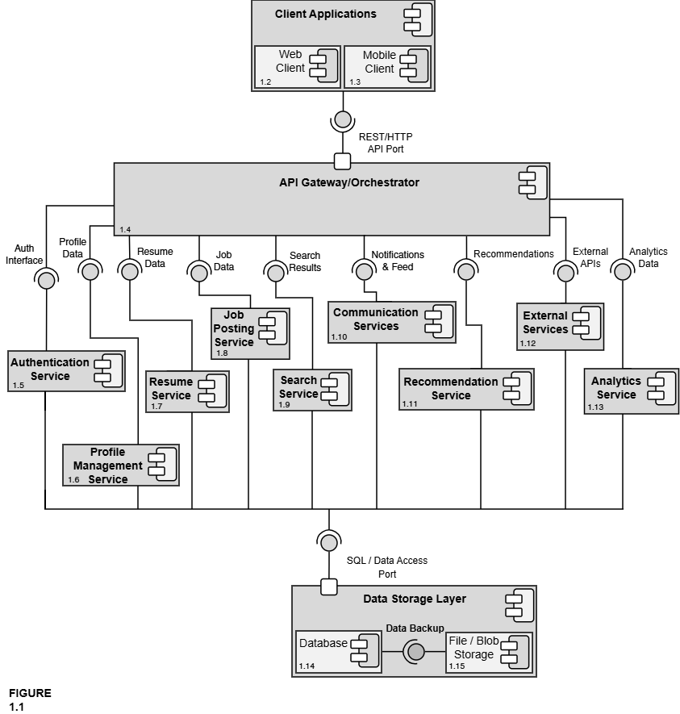

Design Information – Career Bound System Master Component Diagram
Field | Description / Purpose
View Name & Number | 1.1 – Career Bound System Master Component Diagram (UML 2.0)
Purpose | Describe the overall system view.
Description | Basic client, application, database architecture with two types of clients: mobile and web.
Requirements | All SRS sections — 2.1 Company Profile, 2.2 Notifications, 2.3 Search, 2.4 News Feed, 2.5 Job Postings, 3.1 Student Profile, 3.2 Notifications, 3.3 Search, 3.4 News Feed, 3.5 Resume, 4.0 Hardware.
Elements | Client Applications: Web Client and Mobile Client
 | API Gateway/Orchestrator
 | Auth Service
 | Profile Management Service
 | Resume Service
 | Job Posting Service
 | Search Service
 | Communications Service
 | Recommendation Service
 | External Services
 | Analytics Service
Navigation / References | Figures 1.2–1.15 all component detail views
Viewpoint | Component Diagram

The interfaces and ports shown in Figure 1.1 are formally defined in the Interface Glossary below. All components communicate exclusively through these explicit interfaces, ensuring low coupling and high replaceability.

Interface Glossary – Career Bound System Master Component Diagram
Interface Name | Description | Provided By | Required By
REST/HTTP API Port | Formal, well-defined entry point for all client (Web + Mobile) communication | API Gateway / Orchestrator | Client Applications (Web Client + Mobile Client)
Auth Interface | Login, registration, role management, and session handling | Authentication Service | API Gateway
Profile Data | Read/write access to company and student profiles (locations, following, skills, GPA, etc.) | Profile Management Service | API Gateway, Search Service, Recommendation Service
Resume Data | Resume creation, submission, storage, retrieval, and access control | Resume Service | API Gateway, Search Service, Company profiles
Job Data | Job posting creation, editing, deletion, required skills, and job details | Job Posting Service | API Gateway, Search Service, Recommendation Service
Search Results | Candidate and job search results, filters, autocomplete, and wildcards | Search Service | API Gateway
Notifications & Feed | In-app notifications, push notifications, news feed posts, and updates | Communication Services | API Gateway
Recommendations | Job and candidate recommendations based on profiles, resumes, and job data | Recommendation Service | API Gateway
External APIs | Integration with third-party services (USPS address validation, autocomplete APIs, push notification providers, etc.) | External Services | API Gateway
Analytics Data | System usage metrics, reporting, and analytics data | Analytics Service | API Gateway
SQL / Data Access Port | Formal port — the single standardized interface through which all services access persistent data (the only way any service talks to the database or file storage) | Data Storage Layer | All services
The architecture is organized into four primary layers:
- Client Applications (parent) – Encloses the Web Client and Mobile Client. These components provide the unified user interface for both students and companies, supporting all features described in SRS sections 2.x and 3.x.
- API Gateway / Orchestrator – Serves as the single, centralized entry point for all client requests. It routes traffic to the appropriate backend services and enforces cross-cutting concerns such as authentication and request orchestration.
- Core Services Layer – Contains the business logic components:
      - Authentication Service
      - Profile Management Service
      - Resume Service
      - Job Posting Service
      - Search Service
      - Communication Services (Notifications + News Feed)
      - Recommendation Service
      - External Services
      - Analytics Service
Each service is responsible for a cohesive set of related functions and exposes well-defined interfaces to the rest of the system.
- Data Storage Layer (parent) – Acts as the single source of truth for all persistent data. It encloses the Database and File / Blob Storage components and exposes the formal SQL / Data Access Port used by every service in the system.

All communication between the Client Applications and the backend services flows through the REST/HTTP API Port provided by the API Gateway. Every service communicates with the Data Storage Layer exclusively through the SQL / Data Access Port. This design ensures reduced dependencies between components, clear separation of responsibilities, and makes individual components replaceable and maintainable. Detailed views of each major component are provided in Figures 1.2 through 1.15.This modular architecture directly supports the system’s requirements for accessibility, scalability, and maintainability while providing a clear roadmap for implementation and future extension.

Decomposition Description

The master component diagram (Figure 1.1) provides a high-level view of the overall system architecture. This section presents the detailed decomposition of each major component identified in the master diagram. Each sub-diagram shows the internal structure of the component, its sub-components, and the interfaces through which it interacts with the rest of the system. All sub-diagrams maintain the same interface names and ports as defined in the master diagram and the Interface Glossary to ensure consistency.

The following figures provide the detailed decomposition of each major component shown in the master diagram (Figure 1.1).
Additional Decomposition Artifacts
In addition to the component decomposition diagrams and information tables, this section also includes:

- Entity Identification Tables,
- Structure Charts,
- and selected Data Flow Diagrams (DFDs)

for major subcomponents within the system architecture.

These artifacts further decompose the:

- internal functionality,
- entities,
- data movement,
- and functional organization

of the system components identified in the master component diagram.

The Profile, Resume, Job Posting, Search, Communication Services, Recommendation, External Services, and Analytics Orchestrators follow a common orchestration pattern. Each receives a validated request from the API Gateway, coordinates with its assigned downstream service, handles service responses and errors, and returns a normalized response. Because their control responsibilities are similar, their shared entities are documented once within a shared Service Orchestrator Pattern Entity Identification Table, while domain-specific entities are documented separately under each related orchestrator component.
These sub-diagrams illustrate how each major component has been further decomposed into smaller, cohesive sub-components while preserving the explicit interfaces and ports defined at the system level. This decomposition supports modular design principles and enables independent development and maintenance of each subsystem.

Figure 1.2 & 1.3 — Web Client and Mobile Client Shared Architecture
The Web Client and Mobile Client share the same internal architecture and corresponding subcomponents. Therefore, the shared subcomponents are labeled with both their Web Client (1.2.x) and Mobile Client (1.3.x) numbering references.

Differences between the Web Client and Mobile Client are primarily related to layout and presentation. The Web Client uses a desktop layout with sidebar navigation, while the Mobile Client uses a mobile layout with hamburger navigation and responsive screens.
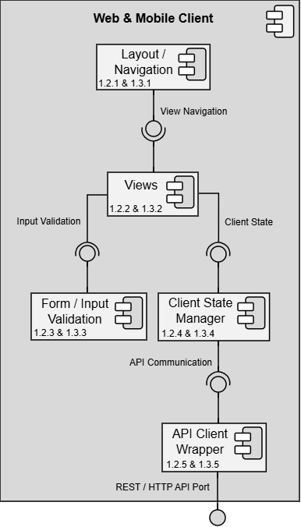

Design Information – Web & Mobile Client
Field | Description / Purpose
View Name & Number | 1.2 – Web Client & 1.3 – Mobile Client
Purpose | Describe the overall system view.
Description | Basic client, application, database architecture with two types of clients: mobile and web.
Requirements | Account
Elements | 1.2.1 & 1.3.1 Layout / Navigation
 | 1.2.2 &1.3.2 Views
 | 1.2.3 & 1.3.3 Form / Input Validation
 | 1.2.4 & 1.3.4 Client State Manager
 | 1.2.5 & 1.3.5 API Client Wrapper
Navigation / References | 1.4 API Gateway / Orchestrator; all screen views (1.1–4.2)
Viewpoint | Component Diagram

Entity Identification Tables – Web and Mobile Client

EI Table 1.2.1 & 1.3.1 – Layout / Navigation
Subcomponent | Entity Name | Entity Type | Description / Purpose | Related Requirement(s) | Collaborators / Related Entities
Layout / Navi-gation | Menu | Class | Represents a menu | 1.2.2 & 1.3.2 | navButton, menuTab, currentView, View, NavigationConfig
Layout / Navi-gation | currentView | Object | Represents the current view shown on the page | 1.2.2 & 1.3.2 | Menu, View, updateView(), viewManager, defaultView
Layout / Navi-gation | updateView() | Method | Navigates to the chosen view when the button is selected | 1.2.2 & 1.3.2 | navButton, currentView, View, viewManager, renderSelected-View()
Layout / Navi-gation | navButton | Object | Represents an interactable button on the screen that navigates to a paired view, calls updateView() | 1.2.2 & 1.3.2 | Menu, updateView(), currentView, View, selectNavigation-Target()
Layout / Navi-gation | Favicon | Data Store | Stores a logo or otherwise small PNG or JPEG image to be used in locations such as the browser tab | 1.2.1 & 1.3.1; 1.2.2 & 1.3.2 | Menu, style, View
Layout / Navi-gation | menuTab | Object | Represents a dropdown tab featuring a collection of buttons | 1.2.1 & 1.3.1; 1.2.2 & 1.3.2 | Menu, navButton, currentView, updateView()
Layout / Navi-gation | style | Data Store | Stores the color code, fonts, and other aesthetic details of the navigation menu | 1.2.1 & 1.3.1; 1.2.2 & 1.3.2 | Menu, Favicon, NavigationConfig, View
Layout / Navi-gation | selectNavigationTarget() | Method | Determines which view should be opened when a navigation option is selected. | 1.2.1 & 1.3.1; 1.2.2 & 1.3.2 | Menu, navButton, currentView, View
Layout / Navi-gation | viewManager | Object/Class | Coordinates navigation between available views. | 1.2.1 & 1.3.1; 1.2.2 & 1.3.2 | Menu, View, currentView
Layout / Navi-gation | NavigationConfig | Data Store | Stores navigation menu structure, available routes, and default view configuration. | 1.2.1 & 1.3.1 | Menu, allowedRoutes, defaultView
Layout / Navi-gation | allowedRoutes | Object/List | Stores the list of views or routes a user is allowed to access. | 1.2.1 & 1.3.1 | NavigationConfig, Menu, user role
Layout / Navi-gation | defaultView | Object / Variable | Identifies the first or default view shown when the client loads. | 1.2.1 & 1.3.1; 1.2.2 & 1.3.2 | NavigationConfig, currentView, View

EI Table 1.2.2 & 1.3.2 – Views
Subcomponent | Entity Name | Entity Type | Description / Purpose | Related Requirement(s) | Collaborators / Related Entities
Views | View | Class | Represents a view | 1.2.2 & 1.3.2 | component, render(), onInit(), refresh(), State
Views | component | Object | Represents a reusable UI element | 1.2.2 & 1.3.2 | View, render(), Style
Views | render() | Method | Displays the view | 1.2.2 & 1.3.2 | View, component, displayData
Views | onInit() | Method | Executes code at the initial loading of the page | 1.2.2 & 1.3.2 | View, ViewData, viewConfig
Views | language | Data Store | Stores the native language of the view, such as English | 1.2.2 & 1.3.2 | View, Localization-Service
Views | LocalizationService | Data Store | Provides manual language translations of elements on the page | 1.2.2 & 1.3.2 | language, View, displayData
Views | refresh() | Method | Reload the screen | 1.2.2 & 1.3.2 | View, ViewData, render()
Views | Style | Data Store | Stores the color code, fonts, and other aesthetic details of the view | 1.2.2 & 1.3.2; 1.2.4 & 1.3.4 | View, component, State, layoutConfig
Views | State | Method | Receives layout information from Client State Manager for resizing the page, desktop vs mobile layout, etc. | 1.2.4 & 1.3.4 | Client State Manager
Views | renderSelectedView() | Method | Renders the selected view after navigation or state changes. | 1.2.2 & 1.3.2 | View, render(), currentView, viewManager
Views | ViewData | Object | Represents data required to populate a view. | 1.2.2 & 1.3.2 | View, displayData, API Client Wrapper
Views | viewId | Variable | Uniquely identifies the view being requested or rendered. | 1.2.2 & 1.3.2 | View, currentView, ViewData
Views | viewConfig | Data Store/Object | Stores configuration information used to render a view. | 1.2.2 & 1.3.2 | View, Style, State, NavigationConfig
Views | displayData | Object | Represents information displayed inside a rendered view. | 1.2.2 & 1.3.2 | ViewData, View, render()

EI Table 1.2.3 & 1.3.3 – Form / Input Validation
Subcomponent | Entity Name | Entity Type | Description / Purpose | Related Requirement(s) | Collaborators / Related Entities
Form / Input Vali-dation | Form | Class | Represents a form | 1.2.2 & 1.3.2 | Fields, Field, input, submit(), populate(), checkForm()
Form / Input Vali-dation | Fields | Object | Represents the collection of fields in a form | 1.2.3 & 1.3.3 | Form, Field, input
Form / Input Vali-dation | Field | Class | Represents a reusable field element | 1.2.2 & 1.3.2 | Form, Fields, input, fieldName, requiredDataType, validateType()
Form / Input Vali-dation | input | Variable | Represents a field’s input | 1.2.3 & 1.3.3 | Field, fieldName, requiredDataType
Form / Input Vali-dation | fieldName | Variable | Represents the name of a field | 1.2.3 & 1.3.3 | Field, input, Fields
Form / Input Vali-dation | requiredDataType | Variable | Determines the data type required by a specific field, such as String or Int | 1.2.3 & 1.3.3 | Field, input, validateType()
Form / Input Vali-dation | submit() | Method | Submits the form and the inputs in each field | 1.2.2 & 1.3.2 | Form, Fields, input, checkForm(), buildPayload(), sendPayload()
Form / Input Vali-dation | populate() | Method | Populates the form with user information saved in the browser | 1.2.2 & 1.3.2 | Form, Fields, Field, input, ViewData
Form / Input Vali-dation | Style | Data Store | Stores the color code, fonts, and other aesthetic details of the form | 1.2.2 & 1.3.2 | Form, Field, View, layoutConfig
Form / Input Vali-dation | checkForm() | Method | Checks the validity of the form when a submission is attempted (ex. are all required fields filled out) | 1.2.3 & 1.3.3 | Form, Fields, Field, checkRequiredFields(), ValidationResult
Form / Input Vali-dation | submitForm() | Method | Coordinates form submission after user input is entered. | 1.2.3 & 1.3.3 | Form,submitInputs(), validateInputs(), buildPayload()
Form / Input Vali-dation | submitInputs() | Method | Collects input values from form fields for submission. | 1.2.3 & 1.3.3 | Form, Fields, Field, input
Form / Input Vali-dation | validateInputs() | Method | Checks submitted form inputs before allowing submission. | 1.2.3 & 1.3.3 | Form, Field, validateType(), check-RequiredFields()
Form / Input Validation | validateType() | Method | Confirms that input values match the required data type. | 1.2.3 & 1.3.3 | Field, input, requiredDataType
Form / Input Validation | checkRequiredFields() | Method | Checks whether all mandatory form fields have been completed. | 1.2.3 & 1.3.3 | Form, Fields, Field, ValidationResult
Form / Input Validation | buildPayload() | Method | Converts validated form data into a request payload. | 1.2.3 & 1.3.3; 1.2.5 & 1.3.5 | Form, input, payload, API Client Wrapper
Form / Input Validation | sendPayload() | Method | Sends the completed form payload through the API Client Wrapper. | 1.2.3 & 1.3.3; 1.2.5 & 1.3.5 | payload, sendAPIRequest(), API Client Wrapper
Form / Input Validation | ValidationResult | Object | Represents the result of form validation. | 1.2.3 & 1.3.3 | validateInputs(), validationErrors, display-Validation-Feedback()
Form / Input Validation | validationErrors | Object / List | Stores validation messages for invalid or missing input fields. | 1.2.3 & 1.3.3 | ValidationResult, Field, display-Validation-Feedback()
Form / Input Validation | Display-ValidationFeedback() | Method | Displays validation errors or confirmation messages to the user. | 1.2.3 & 1.3.3 | validationErrors, ValidationResult, View

EI Table 1.2.4 & 1.3.4 – Client State Manager
Subcomponent | Entity Name | Entity Type | Description / Purpose | Related Requirement(s) | Collaborators / Related Entities
Client State Manager | State | Class | Represents the client state | 1.2.2 & 1.3.2 | width, height, onUpdate(), DynamicUI(), updateAccessibility(), View
Client State Manager | width | Variable | Represents the screen width in pixels | 1.2.2 & 1.3.2 | State, height, checkScreenSize(), DynamicUI()
Client State Manager | height | Variable | Represents the screen height in pixels | 1.2.2 & 1.3.2 | State, width, checkScreenSize(), DynamicUI()
Client State Manager | onUpdate() | Method | Checks for screen updates and acts accordingly (ex. updating width and height) | 1.2.2 & 1.3.2 | State, width, height, checkScreenSize(), checkOrientation(), updateClientState()
Client State Manager | DynamicUI | Method | Provides layout details when certain requirements are met (ex. updates between mobile and desktop based on screen width) | 1.2.2 & 1.3.2 | State, width, height, updateLayout(), layoutConfig, View
Client State Manager | updateAccessibility() | Method | Updates the client based on user accessibility settings | 1.2.2 & 1.3.2 | State, accessibilitySettings, fontSize, contrastMode, screenReaderEnabled, View
Client State Manager | BackgroundHandler | Method | Runs background tasks such as caching, API calls, etc | 1.2.2 & 1.3.2, 1.2.5 & 1.3.5 | Views, API Client Wrapper
Client State Manager | updateClientState() | Method | Updates stored client state when screen, layout, or accessibility settings change. | 1.2.4 & 1.3.4 | State, onUpdate(), DynamicUI()
Client State Manager | checkScreenSize() | Method | Determines current screen width and height for responsive layout handling. | 1.2.4 & 1.3.4 | State, width, height
Client State Manager | checkOrientation() | Method | Determines whether the device is in portrait or landscape orientation. | 1.2.4 & 1.3.4 | State, DynamicUI(), updateLayout()
Client State Manager | updateLayout() | Method | Applies updated layout rules based on screen size, orientation, or device type. | 1.2.4 & 1.3.4 | DynamicUI(), layoutConfig, View
Client State Manager | layoutConfig | Object | Stores layout settings used to switch between web and mobile presentation. | 1.2.4 & 1.3.4 | State, DynamicUI(), updateLayout()
Client State Manager | accessibilitySettings | Object | Stores user accessibility preferences used by the client. | 1.2.4 & 1.3.4 | updateAccessibility(), fontSize, contrastMode, screenReaderEnabled
Client State Manager | contrastMode | Variable | Indicates whether high-contrast display mode is enabled. | 1.2.4 & 1.3.4 | accessibilitySettings, updateAccessibility()
Client State Manager | fontSize | Variable | Stores the user-selected font size setting. | 1.2.4 & 1.3.4 | accessibilitySettings, updateAccessibility()
Client State Manager | screenReaderEnabled | Variable | Indicates whether screen-reader accessibility support is enabled. | 1.2.4 & 1.3.4 | accessibilitySettings, updateAccessibility()

EI Table 1.2.5 & 1.3.5 – API Client Wrapper
Subcomponent | Entity Name | Entity Type | Description / Purpose | Related Requirement(s) | Collaborators / Related Entities
API Client Wrapper | sendRequest() | Method | Sends a request to the API | 1.2.5 & 1.3.5 | Endpoint, HttpClient, ClientRequest, ClientResponse
API Client Wrapper | Endpoint | Class | Represents an API endpoint | 1.2.5 & 1.3.5 | sendRequest(), HttpClient, NetworkConfig
API Client Wrapper | response | Object | Represents a response from the API | 1.2.5 & 1.3.5 | ClientResponse, ResponseParser(), responseBody, statusCode
API Client Wrapper | ResponseParser() | Method | Parses API calls | 1.2.5 & 1.3.5 | response, ClientResponse, responseBody, errorMessage
API Client Wrapper | HttpClient | Class | Represents a raw API engine | 1.2.4 & 1.3.4 | Client State Manager
API Client Wrapper | NetworkConfig | Object | Represents the network configuration details | 1.2.5 & 1.3.5 | Endpoint, HttpClient, headers
API Client Wrapper | JsonSerializer | Object | Represents a JSON encoder and decoder | 1.2.4 & 1.3.4 | Client State Manager
API Client Wrapper | CookieStore | Data Store | Stores cookies in the browser | 1.2.5 & 1.3.5 | headers, ClientRequest, ClientResponse
API Client Wrapper | timeout() | Method | Executes a timeout | 1.2.4 & 1.3.4 | Client State Manager
API Client Wrapper | TimeoutPolicy | Object | Determines the criteria for a timeout | 1.2.5 & 1.3.5 | timeout(), NetworkConfig, ClientErrorReport
API Client Wrapper | sendAPIRequest() | Method | Coordinates sending API requests and receiving API responses. | 1.2.5 & 1.3.5 | sendRequest(), ClientRequest, ClientResponse
API Client Wrapper | ClientRequest | Object | Represents a request sent from the client to the backend API. | 1.2.5 & 1.3.5 | Endpoint, headers, payload, HttpClient
API Client Wrapper | ClientResponse | Object | Represents a response returned from the backend API to the client. | 1.2.5 & 1.3.5 | response, statusCode, responseBody, errorMessage
API Client Wrapper | ClientErrorReport | Object | Represents client-side API error information sent for logging or review. | 1.2.5 & 1.3.5 | errorMessage, statusCode, timeout(), ResponseParser()
API Client Wrapper | headers | Object | Stores HTTP header information sent with requests or received with responses. | 1.2.5 & 1.3.5 | ClientRequest, ClientResponse, HttpClient
API Client Wrapper | payload | Object | Stores the request body sent to the backend API. | 1.2.5 & 1.3.5 | ClientRequest, JsonSerializer, sendRequest()
API Client Wrapper | statusCode | Variable | Stores the HTTP response status code returned by the backend API. | 1.2.5 & 1.3.5 | ClientResponse, ResponseParser(), ClientErrorReport
API Client Wrapper | errorMessage | Variable | Stores an error message when an API request fails. | 1.2.5 & 1.3.5 | ClientResponse, ClientErrorReport, timeout()
API Client Wrapper | responseBody | Object | Stores the parsed body content returned from an API response. | 1.2.5 & 1.3.5 | ClientResponse, ResponseParser(), JsonSerializer

Structure Charts – Web & Mobile Client

SC Figure 1.2.0.1 & 1.3.0.1 – renderSelectedView()
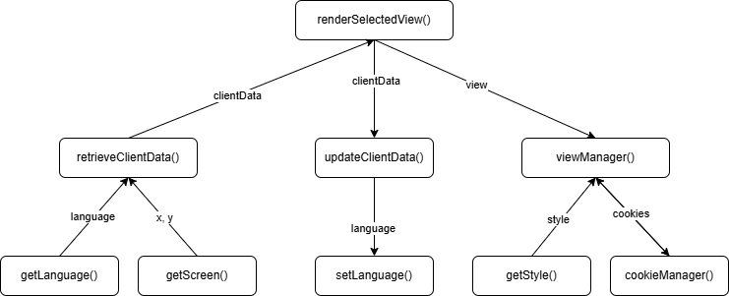

SC Figure 1.2.0.2 & 1.3.0.2 – submitForm()
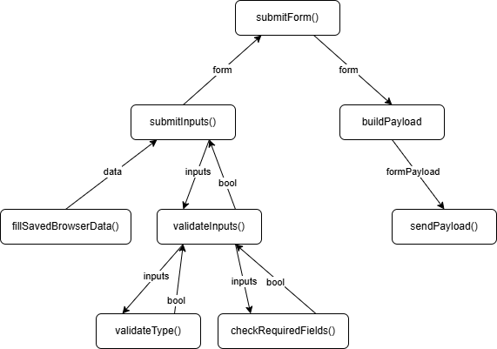

SC Figure 1.2.0.3 & 1.3.0.3 – sendAPIRequest()
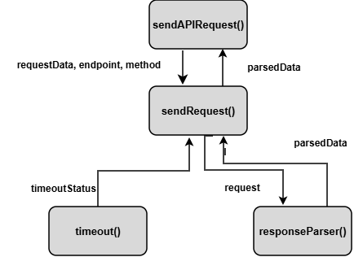

SC Figure 1.2.0.4 & 1.3.0.4 – updateClientState()
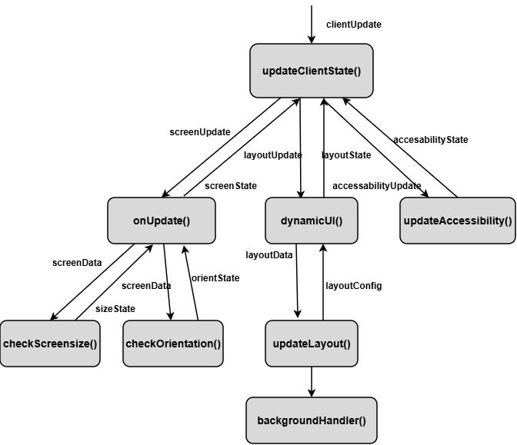

SC Figure 1.2.0.5 & 1.3.0.5 – selectNavigationTarget()

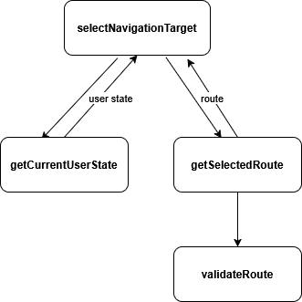

SC Figure 1.2.0.6 & 1.3.0.6 – displayValidationFeedback()

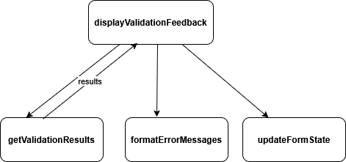

Data Flow Diagrams - Web & Mobile Client

DFD Figure 1.2.0.0.1 & 1.3.0.0.1 – UI View Rendering Data Flow
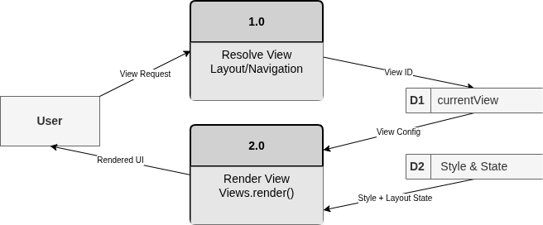

DFD Figure 1.2.0.0.2 & 1.3.0.0.2 – Client State Update Data Flow
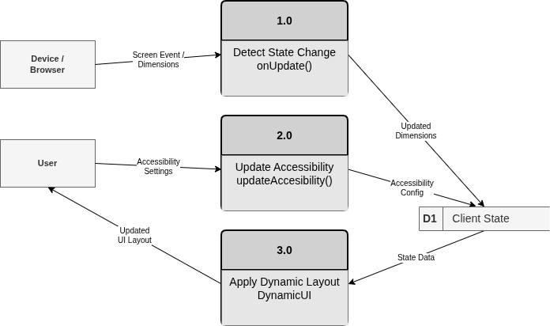

DFD Figure 1.2.0.0.3 & 1.3.0.0.3 – Navigation Selection Data Flow
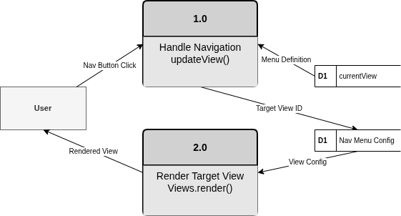

DFD Figure 1.2.0.0.4 & 1.3.0.0.4 – Client API Response Display Data Flow
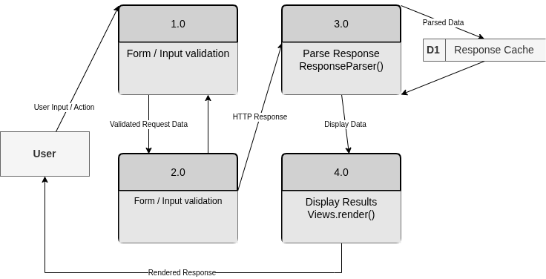

Figure 1.4 — API Gateway / Orchestrator Detail
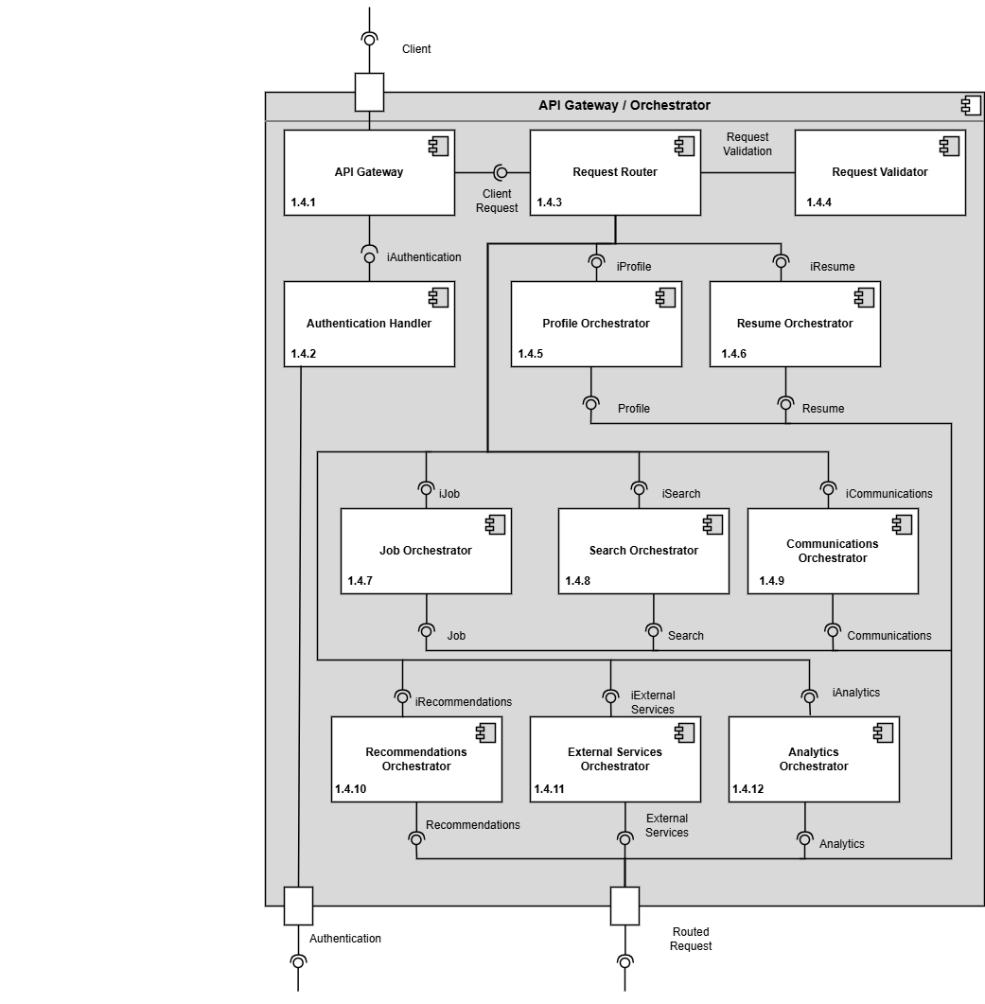

Design Information – API Gateway / Orchestrator
Field | Description / Purpose
View Name & Number | 1.4 – API Gateway / Orchestrator
Purpose | Describe the API/ Orchestrator View
Description | API Gateway with authentication Handling and request routing to various component orchestration. The service-specific orchestrators communicate with their assigned downstream services through the Downstream Service Interfaces port. The individual downstream service relationships are shown in the master component diagram and Interface Glossary.
Requirements | Cross-cutting for all SRS sections — routes all client requests to backend services
Elements | 1.4.1 API Gateway
 | 1.4.2 Authentication Handler
 | 1.4.3 Request Router
 | 1.4.4 Request Validator
 | 1.4.5 Profile Orchestrator
 | 1.4.6 Resume Orchestrator
 | 1.4.7 Job Orchestrator
 | 1.4.8 Search Orchestrator
 | 1.4.9 Communications Orchestrator
 | 1.4.10 Recommendation Orchestrator
 | 1.4.11 External Orchestrator
 | 1.4.12 Analytics Orchestrator
Navigation / References | 1.2 Web Client, 1.3 Mobile Client, 1.5–1.13 all backend service detail views
Viewpoint | Component Diagram

Entity Identification Tables – API Gateway / Orchestrator

EI Table 1.4.1 — API Gateway
Subcomponent | Entity Name | Entity Type | Description / Purpose | Collaborators / Related Entities
API Gateway | GatewayRequest | Class | Represents the request received from the Request Router | RouterRequest, RequestContext
API Gateway | gatewayRequestObj | Object | An instance of GatewayRequest created per incoming request | GatewayRequest
API Gateway | parseIncomingRequest() | Method | Extracts headers, body, and parameters from RouterRequest | RouterRequest, GatewayRequest
API Gateway | GatewayResponse | Class | Represents the response sent back to the client | OrchestratorResponse, ErrorObject
API Gateway | AuthenticationResult | Class | Represents the results of the authentication request that are sent to the client. | AuthenticationHandler, GatewayResponse
API Gateway | RequestContext | Class | Represents and stores the metadata contained within an incoming request. | GatewayRequest, AuthenticationResult
API Gateway | gatewayConfig | Variable | Holds timeout, retry, and routing settings. | GatewayRequest, RoutingDecision
API Gateway | /api/ (Gateway Entry Point) | API Endpoint | Public entry point for all client requests. | Request Router

EI Table 1.4.2 — Authentication Handler
Subcomponent | Entity Name | Entity Type | Description / Purpose | Collaborators / Related Entities
Authentication Handler | AuthenticationRequest | Class | Represents the normalized Login/signup/token refresh request | UserCredential
Authentication Handler | authenticationRequestObj | Object | Instance of AuthenticationRequest created per incoming request | AuthenticationRequest
Authentication Handler | UserCredential | Class | Represents stored user information: hashed password, salt, MFA settings, etc. | AuthenticationRequest
Authentication Handler | AccessToken | Class | Represents a short-lived token for authenticated sessions | AuthenticationResult
Authentication Handler | RefreshToken | Class | Represents a long-lived token for session renewal. | AccessToken
Authentication Handler | AuthenticationResult | Class | Represents Authentication outcome sent to the API Gateway | AccessToken, PermissionSet
Authentication Handler | validateCredentials() | Method | Verifies username and password against stored entries | UserCredentials
Authentication Handler | authDB | Data Store | Stores user credentials, tokens, roles, etc. | UserCredential
Authentication Handler | /auth/login | API Endpoint | Handles login requests | API Gateway

EI Table 1.4.3 — Request Router
Subcomponent | Entity Name | Entity Type | Description / Purpose | Collaborators / Related Entities
Request Router | RouteDefinition | Class | Defines a mapping between a URL path and a target orchestrator | RoutingRule, BackendOrchestrator
Request Router | RoutingDecision | Class | Contains result data obtained from routing requests to target orchestrator. | RoutingRule, BackendOrchestrator
Request Router | RouterRequest | Class | Normalized representation of an incoming request made before routing. | GatewayRequest, RoutingRule
Request Router | routerRequestObj | Object | Instance of RouterRequest created for each incoming request | RouterRequest
Request Router | RoutingRule | Class | Defines rules/conditions used to determine which orchestrator should handle a request. | RouteDefinition, RoutingDecision, RouterRequest
Request Router | requestRoute() | Method | Evaluates RoutingRules and produces a RoutingDecision | RoutingRule, RoutingDecision
Request Router | applyRoutingRules() | Method | Iterates through RoutingRules objects to find rules that match the needs of the request. | RoutingRule, RouterRequest
Request Router | BackendOrchestrator | Class | Contains metadata for orchestrators | RouteDefinition
Request Router | routerConfig | Variable | Stores routing table and orchestrator registry | RouteDefinition
Request Router | routingTable | Data Store | Persistent storage of RouteDefinitions and RoutingRules | RouteDefinition, RoutingRule
Request Router | /route | API Endpoint | Internal endpoint used by the Gateway to forward requests. | API Gateway

EI Table 1.4.4 — Request Validator
Subcomponent | Entity Name | Entity Type | Description / Purpose | Related Requirement(s) | Collaborators / Related Entities
Search Query Manager | searchJobs() | Function | Processes job search requests submitted by the user | 2.3.1–2.3.8 | SearchFilter, JobPosting, SearchResults
Search Query Manager | SearchFilter | Class | Represents the filters selected by the user for job searching | 2.3.2, 2.3.4 | searchJobs(), SearchResults
Request Validator | validateRequest() | Function | Checks requests before sending them to services. | 1.2.1 | Authentication Handler, validateRequiredFields()
Request Validator | validateRequiredFields() | Function | Checks that all needed fields are included. | 3.5.5.1; 3.5.5.2; 3.5.5.3 | ValidationRuleSet, orchestrateResumeRequest()
Request Validator | validateSearchRequest() | Function | Checks search requests before processing. | 2.3.1–2.3.8; 3.3.1–3.3.4 | orchestrateSearchRequest(), Filter Processor
Request Validator | validateNotificationSettings() | Function | Checks notification settings requests. | 3.2.6; 3.2.7 | orchestrateCommunicationRequest(), Notification Controller
Request Validator | validateNewsFeedPost() | Function | Checks news feed posts before submission. | 2.4.1; 2.4.3; 2.4.6; 3.4.2 | orchestrateCommunicationRequest(), News Feed Manager
Request Validator | sanitizeInput() | Function | Removes unsafe input from requests. | 2.1.3.10; 2.4.1; 2.4.3; 2.5.1; 2.5.7; 3.1.2; 3.4.2; 3.5.4.1 | Service Orchestrators, validateRequest()
Request Validator | ValidationRuleSet | Data Entity | Stores validation rules for requests. | 2.1.3.7–2.1.3.9; 3.5.5.2; 3.5.5.3 | validateRequiredFields(), validateRequest()

EI Table 1.4.5–1.4.12— Service Orchestrator Pattern
Subcomponent | Entity Name | Entity Type | Description / Purpose | Related Requirement(s) | Collaborators / Related Entities
Profile Orchestrator | orchestrateProfileRequest() | Function | Handles profile requests. | 2.1.1–2.1.3.10; 3.1.1–3.1.3.4 | validateRequest(), Profile Management Service
Resume Orchestrator | orchestrateResumeRequest() | Function | Handles resume requests. | 3.5.1–3.5.5.3; 2.1.2; 2.2.5; 2.3.3; 2.3.5; | validateRequest(), Resume Service
Job Orchestrator | orchestrateJobRequest() | Function | Handles job posting requests. | 2.5.1–2.5.9; 3.3.1; 3.4.1; 2.2.5 | validateRequest(), Job Posting Service
Search Orchestrator | orchestrateSearchRequest() | Function | Handles search requests. | 2.3.1–2.3.8; 3.3.1–3.3.4 | validateSearchRequest(), Search Service
Communications Orchestrator | orchestrateCommunicationRequest() | Function | Handles notification and news feed requests. | 2.2.1–2.2.5; 2.4.1–2.4.6; 3.2.1–3.2.7; 3.4.1–3.4.2 | validateNotificationSettings(), Communication Services
Recommendation Orchestrator | orchestrateRecommendationRequest() | Function | Handles recommendation requests. | 2.3.1–2.3.8; 2.5.1–2.5.9; 3.1.1–3.1.3.4; 3.5.1–3.5.5.3 | orchestrateSearchRequest(), Recommendation Service
External Orchestrator | orchestrateExternalRequest() | Function | Handles requests to outside services. | 2.1.3.9; 2.3.6; 2.2.2; 3.2.1; 3.2.4 | External Services, validateRequest()
Service Orchestrator Pattern | routeToService() | Function | Sends requests to the correct service. | 1.2.1 | validateRequest(), Service Orchestrators

EI Table 1.4.5 – Profile Orchestrator
Subcomponent | Entity Name | Entity Type | Description / Purpose | Related Requirement(s) | Collaborators / Related  Entities
Profile Orchestrator | ProfileOrchestrator | Class | Coordinates profile-related workflows between the profile page and supporting managers. | 3.1.2, 3.1.3.3, 3.1.3.4, 2.1.2, 2.1.3.6 | Profile Manager, Resume Manager, Privacy Settings Manager, Authentication Service
Profile Orchestrator | ProfileRequest | Object | Represents a request to view, update, or access profile-related information. | 3.1.2, 3.1.3.3, 3.1.3.4 | StudentUser, CompanyRepresentative, Profile Manager
Profile Orchestrator | ProfileResponse | Object | Represents the profile information or access result returned after coordination | 3.1.3.1, 3.1.3.4, 2.1.3.1, 2.1.3.6 | Profile Manager, Resume Manager
Profile Orchestrator | AccessContext | Object | Represents the requesting user, their role, and the action being requested | 3.1.3.3, 3.1.3.4, 2.1.3.6 | Authentication Service, Privacy Settings Manager
Profile Orchestrator | ProfileNavigationReference | Data Store | Represents profile page links or reference to related features managed by other subcomponents | 3.1.3.3, 3.1.3.4, 2.1.3.6 | Resume Manager, Profile Manager
Profile Orchestrator | ProfileWorkflow | Class | Represents a coordinated profile process such as viewing a student profile or accessing a resume link. | 3.1.2, 3.1.3.3, 3.1.3.4, 2.1.2 | Profile Manager, Resume Manager, Job Posting Service

EI Table 1.4.6 – Resume Orchestrator
Subcomponent | Entity Name | Entity Type | Description / Purpose | Related Requirement(s) | Collaborators / Related Entities
API Gateway | resumeServiceRouter() | Module | Routes to requested Resume Service for authenticated users | 3.5.1, 2.5.6 | Resume Services, Authentication Services, Web Client, Database

EI Table 1.4.7 – Job Orchestrator
Subcomponent | Entity Name | Entity Type | Description / Purpose | Related Requirement(s) | Collaborators / Related Entities
Job Orchestrator | Job Orchestrator | Class | Coordinates all job-related requests and responses. | 2.5.1-2.5.4 | RequestRouter, Database
Job Orchestrator | RequestJobs | Method | Sends a request to retrieve job listings | 2.5.1-2.5.4 | Database
Job Orchestrator | GetJobDetails | Method | Requests detailed information for a selected job. | 2.5.1-2.5.4 | Database
Job Orchestrator | FilterJobs | Method | Applies user-selected filters to job search | 2.5.1-2.5.4
Job Orchestrator | JobResults | Object | Stores job listing results returned from services. | 2.5.1-2.5.4 | Database
Job Orchestrator | JobRequest | Object | Contains search criteria and request parameters. | 2.5.1-2.5.4 | RequestRouter
Job Orchestrator | SearchCriteria | Object | Stores keywords, location, and filter values. | 2.5.1-2.5.4 | JobRequest
Job Orchestrator | JobListing | Object | Represents an individual job posting. | 2.5.1-2.5.4 | JobResults
Job Orchestrator | RequestRouter | Class | Routes incoming requests to the Job Orchestrator. | 2.5.1-2.5.4 | JobOrchestrator

EI Table 1.4.8 – Search Orchestrator
Subcomponent | Entity Name | Entity Type | Description / Purpose | Related Requirement(s) | Collaborators / Related Entities
Search Orchestrator | SearchRequest | Class | Contains the search query along with filters used when it enters the orchestrator. | 2.3.1 – 2.3.8, 3.3.1 – 3.3.4 | SearchHandler
Search Orchestrator | SearchHandler | Class | Handles requests and returns responses. | 2.3.1 – 2.3.8, 3.3.1 – 3.3.4 | SearchRequest, SearchResponse, ServiceHandler
Search Orchestrator | SearchResponse | Class | Contains the final, aggregated search result after the services have finished. | 2.3.1 – 2.3.8, 3.3.1 – 3.3.4 | SearchResult
Search Orchestrator | SearchResult | Class | Contains a singular search result within the final result. | 2.3.1 – 2.3.8, 3.3.1 – 3.3.4 | SearchResponse
Search Orchestrator | ServiceTarget | Class | A representation of a downstream service the orchestrator can send tasks to and receive results from. | 2.3.1 – 2.3.8, 3.3.1 – 3.3.4 | ServiceHandler, determineTargets()
Search Orchestrator | ServiceRequest | Class | Represents the transformed request to be sent to a service. | 2.3.1 – 2.3.8, 3.3.1 – 3.3.4 | ServiceTarget, ServiceHandler
Search Orchestrator | ServiceResult | Class | Contains the untransformed result directly from the service. | 2.3.1 – 2.3.8, 3.3.1 – 3.3.4 | ServiceTarget, ServiceHandler
Search Orchestrator | ServiceHandler | Class | Handles service timeouts/retries, calls, and responses. | 2.3.1 – 2.3.8, 3.3.1 – 3.3.4 | ServiceTarget, ServiceRequest, ServiceResult, SearchHandler
Search Orchestrator | routingTable | Data Table | Identifies separate services for job queries and candidate queries. | 2.3.1 – 2.3.8, 3.3.1 – 3.3.4 | determineTargets(), ServiceHandler
Search Orchestrator | correlationId | Variable | Tracks a request across systems. | 2.3.1 – 2.3.8, 3.3.1 – 3.3.4 | SearchRequest, SearchResponse, ServiceRequest, ServiceResponse
Search Orchestrator | handleRequest() | Method | Transforms request, sends request, and returns result. | 2.3.1 – 2.3.8, 3.3.1 – 3.3.4 | SearchHandler, SearchRequest
Search Orchestrator | determineTargets() | Method | Determines which service to send the request. | 2.3.1 – 2.3.8, 3.3.1 – 3.3.4 | ServiceHandler, routingTable
Search Orchestrator | dispatchRequests() | Method | Sends request to a service. | 2.3.1 – 2.3.8, 3.3.1 – 3.3.4 | ServiceHandler, ServiceRequest, ServiceTarget
Search Orchestrator | aggregateResults() | Method | Aggregates multiple results into one result. | 2.3.1 – 2.3.8, 3.3.1 – 3.3.4 | SearchHandler, SearchResult, SearchResponse
Search Orchestrator | /search | API Endpoint | The entry point into the orchestrator. | 2.3.1 – 2.3.8, 3.3.1 – 3.3.4 | SearchHandler, SearchRequest

EI Table 1.4.9 — Communications Orchestrator
Subcomponent | Entity Name | Entity Type | Description / Purpose | Related Requirement(s) | Collaborators / Related Entities
Communications Orchestrator | routeCommunicationRequest() | Function | Sends communication requests to services. | 2.2.1–2.2.5; 2.4.1–2.4.6; 3.2.1–3.2.7; 3.4.1–3.4.2 | validateRequest(), Communication Services
Communications Orchestrator | getNotifications() | Function | Gets notifications for a user. | 2.2.3; 2.2.4; 2.2.5; 3.2.1–3.2.5 | Notification Controller, Notification Repository
Communications Orchestrator | createNotification() | Function | Creates a notification. | 2.2.1–2.2.5; 3.2.1–3.2.5 | Event Listener, Notification Orchestrator
Communications Orchestrator | muteNotifications() | Function | Handles notification mute requests. | 3.2.6 | Notification Controller, Notification Repository
Communications Orchestrator | updateNotificationFilters() | Function | Updates notification filters. | 3.2.7 | Notification Controller, Recipient Resolver
Communications Orchestrator | resolveNotificationRecipients() | Function | Finds users who should receive notifications. | 2.2.2; 2.2.4; 2.2.5; 3.2.2; 3.2.3; 3.2.5 | Recipient Resolver, orchestrateJobRequest(), orchestrateResumeRequest()
Communications Orchestrator | formatNotificationMessage() | Function | Formats notification messages. | 2.2.1 | Notification Formatter, createNotification()
Communications Orchestrator | sendPushNotification() | Function | Sends push notifications. | 2.2.2; 3.2.1; 3.2.2; 3.2.3; 3.2.4 | Push Delivery Component, orchestrateExternalRequest()

EI Table 1.4.10 – Recommendation Orchestrator
Subcomponent | Entity Name | Entity Type | Description / Purpose | Related Requirement(s) | Collaborators / Related Entities
API Gateway | recommendationServiceRouter() | Module | Routes to requested Recommendation Service for authenticated users | 2.2.5, 2.3.5, 3.3.3 | Recommendation Services, Authentication Services, Web Client, Database, Analytics Services, Notifications Services

EI Table 1.4.11 – External Services Orchestrator
Subcomponent | Entity Name | Entity Type | Description / Purpose | Related Requirement(s) | Collaborators / Related Entities
External Services Orchestrator | ExternalServicesOrchestrator | Class | Receives routed requests from the API Gateway and dispatches them to the correct external service adapter. | 2.1.3.9, 2.3.6, 3.2.4 | APIGateway, USPSAddressValidationAdapter, AutocompleteAPIAdapter, PushNotificationGateway
External Services Orchestrator | ExternalServicesRequest | Class | Encapsulates an inbound request destined for an external service, holding the service target and payload. | 2.1.3.9, 2.3.6, 3.2.4 | ExternalServicesOrchestrator, routeRequest(), validateRequest()
External Services Orchestrator | ExternalServiceResponse | Class | Encapsulates the result returned from an external adapter and carries it back upstream to the API Gateway | 2.1.3.9, 2.3.6, 3.2.4 | handleResponse(), APIGateway
External Services Orchestrator | routeRequest() | Method | Inspects and inbound request and dispatches it to the correct external adapter based on the service target. | 2.1.3.9, 2.3.6, 3.2.4 | ExternalServiceRequest, USPSAddressValidationAdapter, AutocompleteAPIAdapter, PushNotificationGateway
External Services Orchestrator | validateRequest() | Method | Validates that an inbound request contains required fields and a recognizer service target before routing proceeds. | 2.1.3.9, 2.3.6, 3.2.4 | ExternalServiceRequest, ExternalServiceResponse
External Services Orchestrator | handleResponse() | Method | Wraps an adapter’s result into an ExternalServiceResponse and returns it upstream to the API Gateway. | 2.1.3.9, 2.3.6, 3.2.4 | ExternalServiceResponse, APIGateway
External Services Orchestrator | serviceTarget | Variable | Identifies which external service the request targets and drives all routing logic within the orchestrator. | 2.1.3.9, 2.3.6, 3.2.4 | ExternalServiceRequest, routeRequest()

Structure Charts – API Gateway / Orchestrator

SC Figure 1.4.0.1 – recieveGatewayRequest()
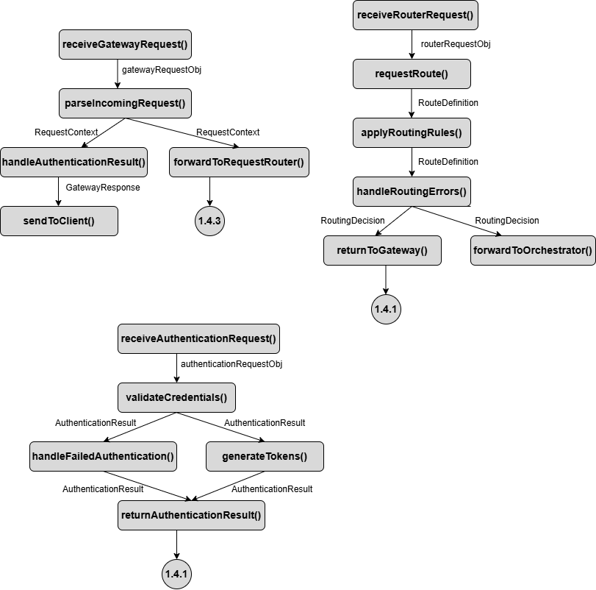

SC Figure 1.4.0.2 – recieveRouterRequest()


SC Figure 1.4.0.3 – receiveAuthenticationRequest()


SC Figure 1.4.0.4 – createNotificationTask()
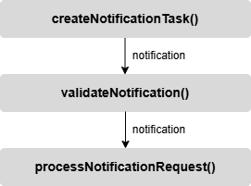

SC Figure 1.4.0.5 – External Services Orchestrator()
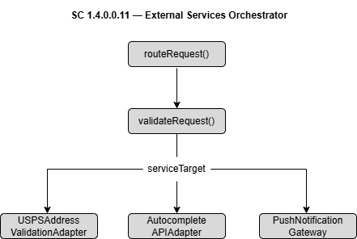

SC Figure 1.4.0.6 – Receive Gateway Request
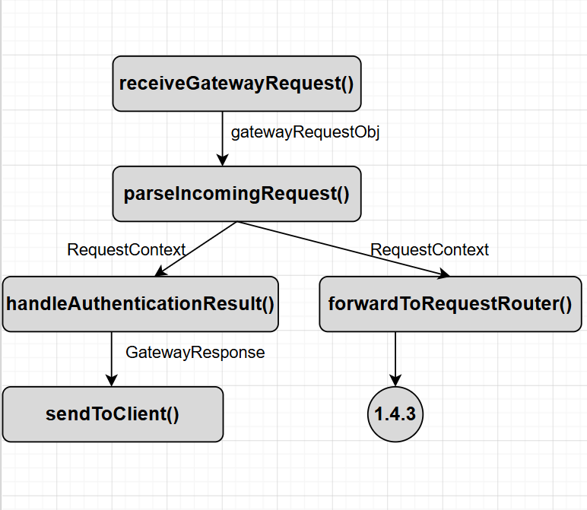

SC Figure 1.4.0.7 – Receive Authentication Request
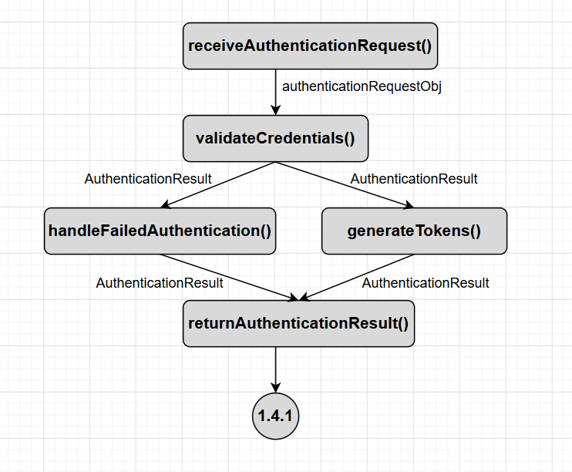

SC Figure 1.4.0.8 – Receive Router Request
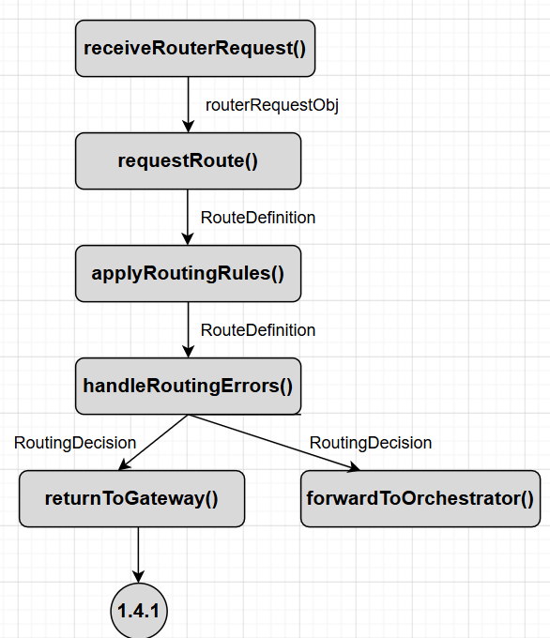

Data Flow Diagrams - API Gateway / Orchestrator

DFD Figure 1.4.0.0.1 –Request Processing
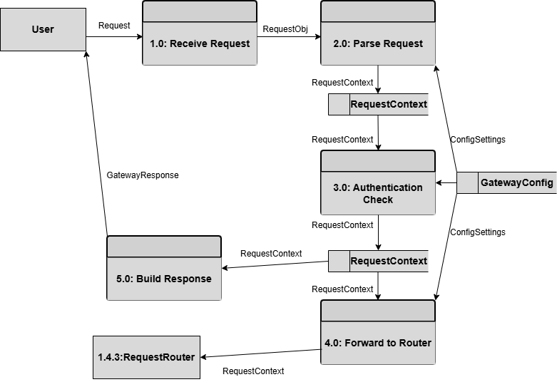

DFD Figure 1.4..0.0.2 – Authentication Validation
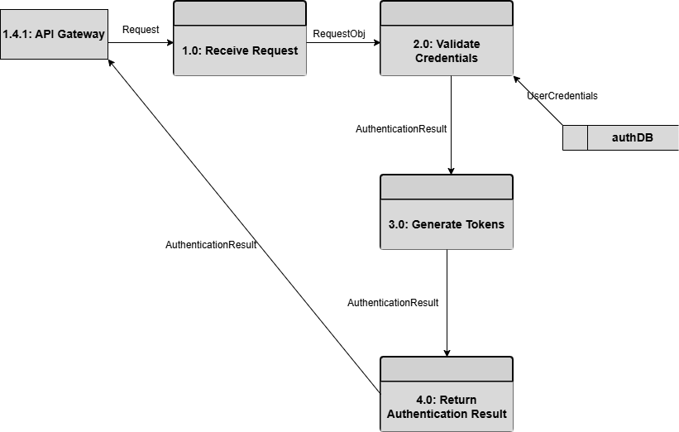

DFD Figure 1.4.0.0.3 – Request Routing
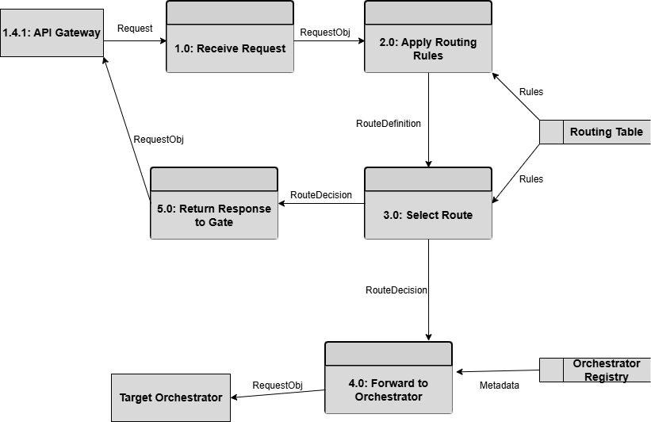

DFD Figure 1.4.0.0.4 – Request Validator
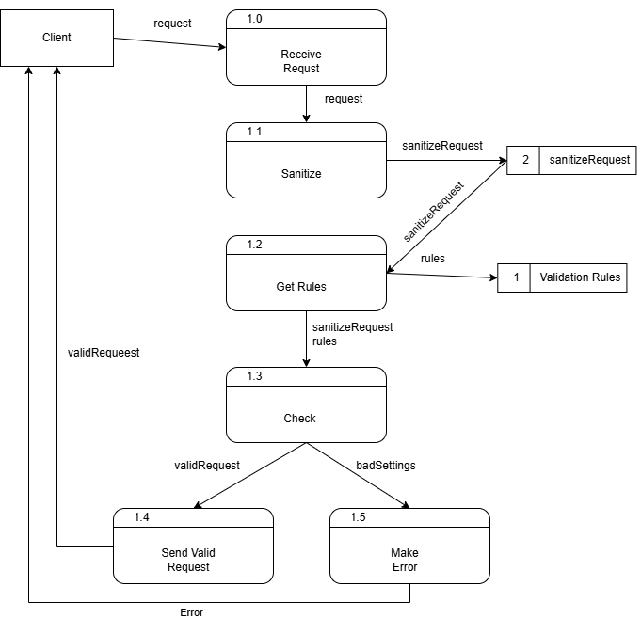

DFD Figure 1.4.0.0.5 – Service Orchestrator Pattern
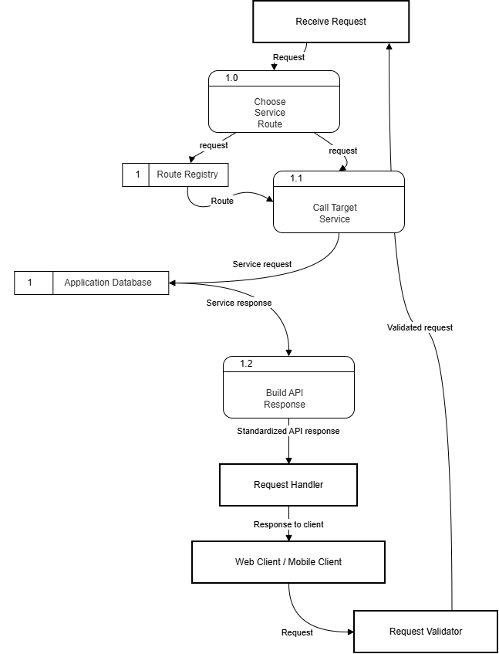

Figure 1.5 — Authentication Service Detail
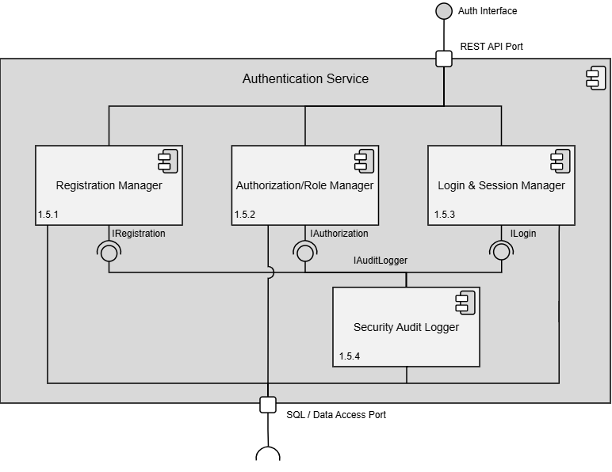

Design Information – Authentication Service
Field | Description / Purpose
View Name & Number | 1.5 Authentication Service
Purpose | Describe the authentication system view.
Description | Basic service demonstrating the authentication service.
Requirements | Foundational requirement for all logged-in features — SRS 2.1.3.10 (Security), 3.1.1 (Student account), 2.1.1 (Company account)
Elements | 1.5.1 Registration Manager
 | 1.5.2 Authorization/ Role Manager
 | 1.5.3 Login and Session Manager
 | 1.5.4 Security Audit Logger
Navigation / References | 1.4 API Gateway / Orchestrator, 1.14 Database; Screen views 1.1 Login / Logout, 1.2 Registration
Viewpoint | Component Diagram

Entity Identification Tables – Authentication Service

EI Table 1.5.1 – Registration Manager
Subcomponent | Entity Name | Entity Type | Description / Purpose | Related Requirement(s) | Collaborators / Related Entities
Registration Manager | UserAccount | Class | Represents a user’s account which contains credentials and role information. | 1.1, 1.2 | UserData  UserForm  registerUser()
Registration Manager | UserForm | Class | A form which contains the user’s information for registration. | 1.1, 1.2 | /api/auth/register/
RegistrationManager | validateEmail() | Function | Checks if the email isn’t already used and ensure it’s in a valid format. | 1.1, 1.2 | UserForm
Registration Manager | validatePassword() | Function | Checks if the password contains any invalid characters and ensures it’s in the valid format. | 1.1, 1.2 | UserForm
Registration Manager | hashPassword() | Function | Hashes the user’s password to be stored securely. | 1.1, 1.2 | UserForm
Registration Manager | registerUser() | Function | Creates the user’s account from the form data. | 1.1, 1.2 | validateEmail(), validatePassword(), hashPassword(), UserAccount
Registration Manager | User Data | Data Table | The database where all user information is held. | 1.1, 1.2 | UserAccount
Registration Manager | /api/auth/register | API Endpoint | Handles incoming API requests for user registration. | 1.1, 1.2 | registerUser()  UserForm

EI Table 1.5.2 – Authorization / Role Manager
Subcomponent | Entity Name | Entity Type | Description / Purpose | Related Requirement(s) | Collaborators / Related Entities
Authorization/Role Manager | Authorization Manager | Class | Manages which users can access protected resources depending on their role. | 1.1,  1.2,  2.1.1,  2.1.3.10, 3.1.2 | checkPermissions()
Authorization/Role Manager | UserAccount | Class | Represents a user’s account which contains credentials and role information. | 1.1,  1.2,  2.1.3.10,  2.5.6, 3.1.2,  3.1.3.4 | User Data,  role
Authorization/Role Manager | role | Variable | The role the user has attached to their account. | 1.1,  1.2 | UserAccount, User Data
Authorization/Role Manager | User Data | Data Table | The database where all user information is held. | 1.1,  1.2 | UserAccount, role
Authorization/Role Manager | checkPermissions() | Function | Validates that a user has access to a protected resource. | 1.1,  1.2,  2.1.1,  2.5.6,  3.1.3.4 | UserAccount, User Data, role
Authorization/Role Manager | /api/auth/authorize | API Endpoint | Handles incoming API requests for user authentication. | 1.1,  1.2 | checkPermissions()

EI Table 1.5.3 – Login & Session Manager
Subcomponent | Entity Name | Entity Type | Description / Purpose | Related Requirement(s) | Collaborators / Related Entities
Login & Session Manager | UserAccount | Class | Represents a user’s account which contains credentials and role information. | 1.1,  1.2 | loginUser(),  Session
Login & Session Manager | UserForm | Class | A form which contains the user’s email and password needed for logging in. | 1.2 | loginUser()o
Login & Session Manager | Session | Class | Represents a user’s active session for their device. | 1.2 | sessionToken
Login & Session Manager | loginUser() | Function | Reads the user’s credentials and creates a new session if there’s a match. | 1.2 | UserAccount,  UserForm,  Session
Login & Session Manager | logoutUser() | Function | Deletes the user’s session for their device on request. | 1.2 | Session, sessionToken
Login & Session Manager | sessionToken | Variable | Represents a user’s session token for their device for later validation. | 1.2 | Session
Login & Session Manager | /api/auth/login | API Endpoint | Handles incoming API requests for user login. | 1.2 | loginUser()
Login & Session Manager | /api/auth/logout | API Endpoint | Handles incoming API requests for user logout. | 1.2 | logoutUser()

EI Table 1.5.4 – Security Audit Logger
Subcomponent | Entity Name | Entity Type | Description / Purpose | Related Requirement(s) | Collaborators / Related Entities
Security Audit Logger | buildAuditLog() | Method | Builds an audit log of different security metrics and displays it to the development team. | 1.2 | logId, loginAttempts, AuditLogException
Security Audit Logger | loginAttempts | Variable | Represents how many times a failed login was attempted for a specific user. | 1.2 | logId, AuditLogException
Security Audit Logger | logId | Variable | Comes from user’s input and gets packaged into the userData structure. | 1.2 | AuditLogException,  buildAuditLog()
Security Audit Logger | AuditLogException | Class | Locks the user’s account in the event that their account was potentially compromised. | 1.2 | buildAuditLog(), throwException()
Security Audit Logger | throwException() | Method | Throws an exception to the system when a security threat arises. | 1.2 | AuditLogException, submit()
Security Audit Logger | submit() | Method | Receives the user’s data where the security risk was brought up to help in the threat assessment. | 1.2 | AuditLogException,  throwException()
Security Audit Logger | /api/auth/log | API Endpoint | Handles incoming Security Audit Logger API requests. | 1.2 | buildAuditLog(),  submit()

Structure Charts – Authentication Service

SC Figure 1.5.0.1 — RegisterUser()
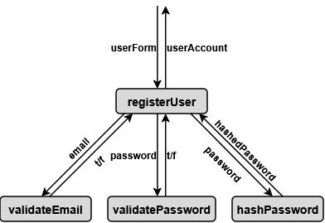

SC Figure 1.5.0.2 — AuthRoleVerification()
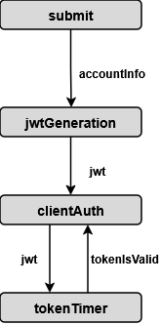

SC Figure 1.5.0.3 — LoginUser()
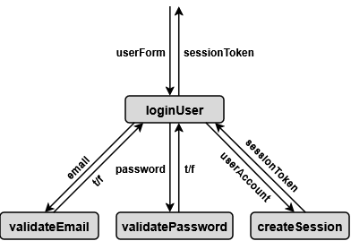

SC Figure 1.5.0.4 — LogoutUser()
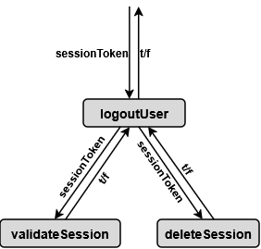

SC Figure 1.5.0.5 — HandleSession()
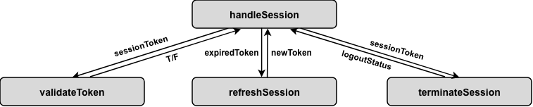

Data Flow Diagrams – Authentication Service

DFD Figure 1.5.0.0.1 — Register User
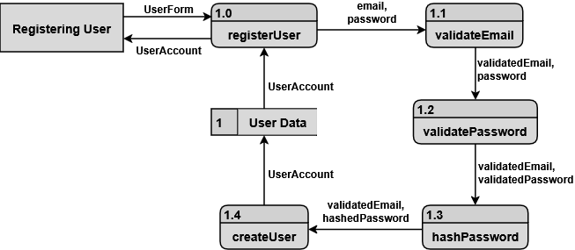

DFD Figure 1.5.0.0.2 — Login Session Validation
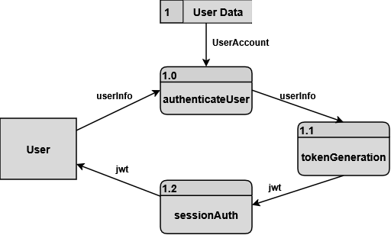

Figure 1.6 — Profile Management Service Detail
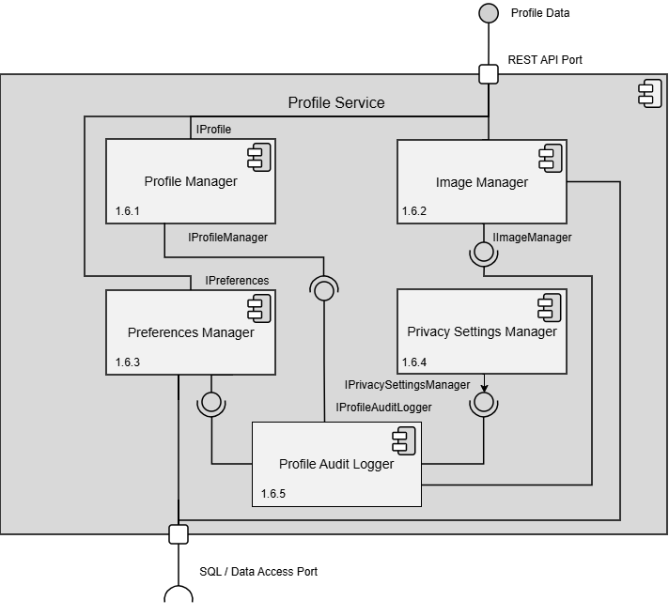

Design Information – Profile Management Service
Field | Description / Purpose
View Name & Number | 1.6 Profile Management Service
Purpose | Describe the profile management service.
Description | Basic service demonstrating the profile management service.
Requirements | SRS 2.1 Company Profile Page (2.1.1–2.1.3.10), 3.1 Student User Profile (3.1.1–3.1.3.3)
Elements | 1.6.1 Profile Manager
 | 1.6.2 Image Manager
 | 1.6.3 Preferences Manager
 | 1.6.4 Privacy Settings Manager
 | 1.6.5 Profile Audit Logger
Navigation / References | 1.4 API Gateway / Orchestrator, 1.14 Database, 1.15 File / Blob Storage
Viewpoint | Component Diagram

Entity Identification Tables – Profile Management Service

EI Table 1.6.1 – Profile Manager
Subcomponent | Entity Name | Entity Type | Description / Purpose | Related Requirement(s) | Collaborators / Related  Entities
Profile  Manager | StudentProfile | Class | Represents and organizes the main profile information for a student. | 3.1.1, 3.1.2, 1.3.2 | Accolades, addAccolade()
Profile Manager | Accolades | Class | Represents achievements, honors, certifications, awards, or recognition that belongs to a student profile. | 3.1.1, 3.1.2,  1.3.2 | StudentProfile
Profile Manager | addAccolade() | Method | Represents a method that adds an accolade. | 3.1.1, 3.1.2,  1.3.2 | StudentProfile
Profile Manager | updateAccolade() | Method | Represents a method that updates an accolade | 3.1.1, 3.1.2, 1.3.2 | StudentProfile
Profile Manager | deleteAccolade() | Method | Represents a method that deletes an accolade | 3.1.1,  3.1.2, 1.3.2 | StudentProfile
Profile Manager | updateProfileImageReference() | Method | Connects the selected image to the student profile. | 3.1.2, 1.3.2 | StudentProfile
Profile Manager | ContactInformation | Data Store | Stores student contact details shown on the profile. | 3.1.2, 1.3.2 | StudentProfile
Profile Manager | EducationInformation | Data Store | Stores student education information shown on the profile | 3.1.2, 1.3.2 | StudentProfile
Profile Manager | Skill(s) | Data Store | Stores a list of one or more skills shown on the profile. | 3.1.2, 1.3.2 | StudentProfile
Profile Manager | AboutMe | Data Store | Stores a summary of content that describes the student, shown on the profile | 3.1.2, 1.3.2 | StudentProfile
Profile Manager | CompanyProfile | Class | Represents and organizes the main profile information for a company. | 2.1.3.1, 2.1.2, 2.1.3.2 | CompanyProfile, CompanyLocation, JobInterestForm
Profile Manager | CompanyLocation | Data Store | Represents a location where the company conducts business and may include a physical address | 2.1.3.3, 2.1.3.4, 2.1.3.5, 2.1.3.6 | CompanyProfile, PhysicalAddress
Profile Manager | PhysicalAddress | Data Store | Stores the address details for a company location. | 2.1.3.5, 2.1.3.7 | CompanyLocation
Profile Manager | JobInterestForm | Data Store | Represents the form a student submits to express interest in a job | 2.1.2 | CompanyProfile, StudentUser, Qualification
Profile Manager | Qualification | Data Store | Represents a student’s listed qualification for a job interest form | 2.1.2 | JobInterestForm, StudentUser
Profile Manager | StudentFollow | Data Store | Represents the relationship between a company representative and a followed student user. | 2.1.2 | CompanyRepresentative, StudentUser
Profile Manager | GPA | Variable | Represents the student’s grade point average shown on the profile. | 3.1.3.1 | StudentProfile
Profile Manager | addProfileInformation | Method | Adds profile-owned data | 3.1.2 | StudentProfile, CompanyProfile
Profile Manager | updateProfileInformation | Method | Updates profile-owned data | 3.1.2 | StudentProfile, CompanyProfile
Profile Manager | deleteProfileInformation | Method | Deletes profile-owned data | 3.1.2 | StudentProfile,  CompanyProfile
Profile Manager | addCompanyLocation | Method | Adds a new company location | 2.1.3.3, 2.1.3.4 | CompanyProfile
Profile Manager | updateCompanyLocation | Method | Updates a company location from the location list. | 2.1.3.3, 2.1.3.5, 2.1.3.7 | CompanyProfile
Profile Manager | deleteCompanyLocation | Method | Deletes a company location from the location list. | 2.1.3.3 | CompanyProfile

EI Table 1.6.2 – Image Manager
Subcomponent | Entity Name | Entity Type | Description / Purpose | Related Requirement(s) | Collaborators / Related Entities
Image Manager | ImageHandler | Class | This oversees handling all image related methods | 2.1, 2.1.3, 3.1, 3.1.3 | UpdateImage(), ValidateImage(), ImageStore
Image Manager | updateImage() | Method | This handles updating images for users | 2.1.3.10  3.1.2 | ImageManager, ImageValidator
Image Manager | processImage() | Method | This crops, resizes, and manipulates an image | 2.1, 2.1.3, 3.1, 3.1.3 | ImageManager, ImageValidator
Image Manager | retrieveImage() | Method | This handles retrieving image data from a database | 2.1, 2.1.3, 3.1, 3.1.3 | ImageManager, ImageStore
Image Manager | ImageValidator | Class | This validates whether an image meets platform standards | 2.1, 2.1.3, 3.1, 3.1.3 | ImageManager
Image Manager | ImageStore | Data Store | This stores all profile images for various users | 2.1, 2.1.3, 3.1, 3.1.3,  3.1.2,  2.1.3.10 | ImageManager
Image Manager | /api/profile | API Endpoint | This is an API endpoint to the overall audit logger | 2.1, 2.1.3, 3.1, 3.1.3 | ImageManager

EI Table 1.6.3 – Preferences Manager
Subcomponent | Entity Name | Entity Type | Description/ Purpose | Related Requirement(s) | Collaborators / Related Entities
Preferences Manager | updateNotificationPreferences() | Method | Updates the user's notification delivery and filtering settings. | 3.3.5, 3.3.6 | NotificationPreferences, ProfileManager
Preferences Manager | NotificationPreferences | Data Table | Stores persistent user settings regarding which notifications to receive and how. | 3.3.5, 3.3.6 | updateNotificationPreferences(), getPreferences()
Preferences Manager | muteNotifications | Variable | Boolean flag representing whether a user has opted to silence all incoming notifications. | 3.3.5 | NotificationPreferences
Preferences Manager | getPreferences() | Method | Retrieves the user's saved preferences for system display and notification routing. | 3.3.6 | NotificationPreferences
Preferences Manager | /api/profile/preferences | API Endpoint | Handles incoming requests to view or modify user preference configurations. | 3.3.5, 3.3.6 | updateNotificationPreferences(), getPreferences()

EI Table 1.6.4 – Privacy Settings Manager
Subcomponent | Entity Name | Entity Type | Description / Purpose | Related Requirement(s) | Collaborators / Related Entities
Privacy Settings Manager | UserPrivacySettings | Object | This contains variables controlling the privacy settings for the user | 3.2 | PrivacySettingsManager
Privacy Settings Manager | updateSettings() | Method | This edits settings for the user | 3.2,  3.2.7 | PrivacySettingsManager, SaveSettings()
Privacy Settings Manager | SettingsValidator | Class | This ensures that all settings for the user all valid | 3.2,  3.2.7 | PrivacySettingsManager
Privacy Settings Manager | initializeSettings() | Method | This sets default settings for an account | 3.2,  3.2.7 | PrivacySettingsManager
Privacy Settings Manager | PrivacySettingsManager | Class | This handles all changes that occur for the privacy settings | 3.2 | UserPrivacySettings, SaveSettings, InitializeSettings(), SettingsValidator, UpdateSettings()
Privacy Settings Manager | saveSettings() | Method | Saves the settings associated with the account | 3.2,  3.2.7 | PrivacySettingsManager
Privacy Settings Manager | /api/profile/manage | API Endpoint | This is an API endpoint to the overall audit logger | 3.2,  3.2.7 | ImageManager

EI Table 1.6.5 – Profile Audit Logger
Subcomponent | Entity Name | Entity Type | Description/ Purpose | Related Requirement(s) | Collaborators / Related Entities
Profile Audit Logger | logActivity() | Method | Records a specific user action or security event into the audit trail. | 3.1.2, UI 4.4 | AuditLog, ProfileManager
Profile Audit Logger | AuditLog | Data Store | Stores immutable records of account changes, logins, and security-related events. | UI 4.4 | logActivity(), getLoginHistory()
Profile Audit Logger | getLoginHistory() | Method | Retrieves past login instances and locations for display on the security screen. | UI 4.4 | AuditLog
Profile Audit Logger | SecurityEvent | Object | An instance of a tracked user action, such as a password change or profile update. | 3.1.2, UI 4.4 | logActivity(), AuditLog
Profile Audit Logger | /api/profile/audit | API Endpoint | Handles requests to fetch the user's recent login and profile activity history. | UI 4.4 | getLoginHistory()

Structure Charts – Profile Management

SC Figure 1.6.0.1 — ProfileCreation()
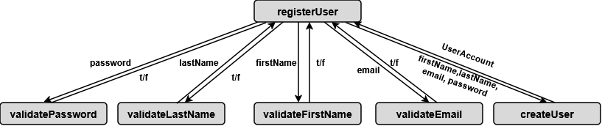

SC Figure 1.6.0.2 — ProfileInformationManager()
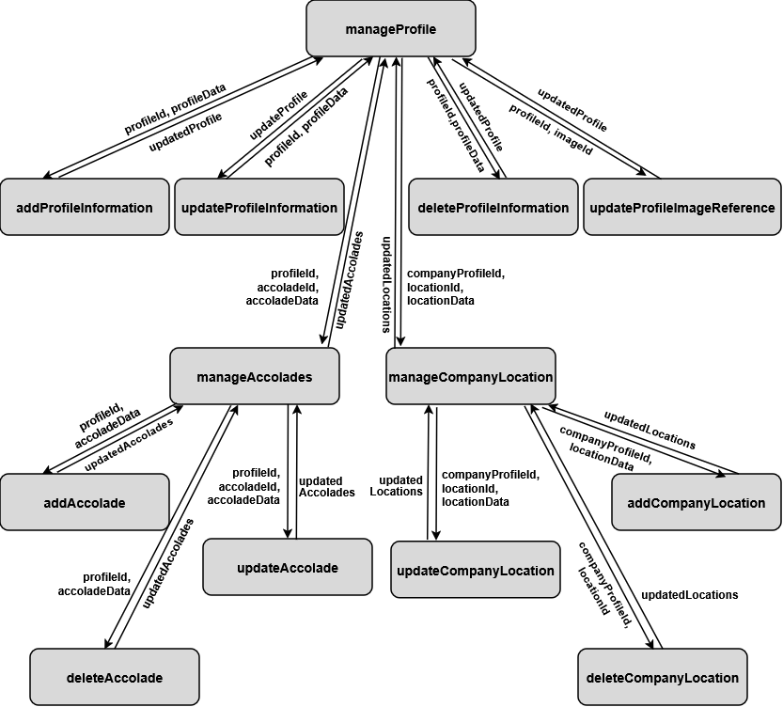

SC Figure 1.6.0.3 — ManageProfileImage()
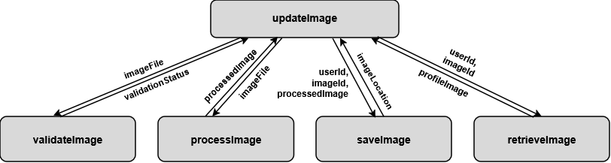

SC Figure 1.6.0.4 — ManagePrivacySettings()
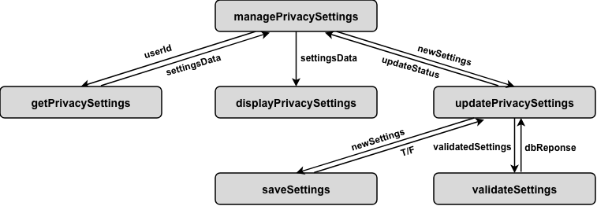

Data Flow Diagram – Profile Management

DFD Figure 1.6.0.0.1 - Profile Creation and Update
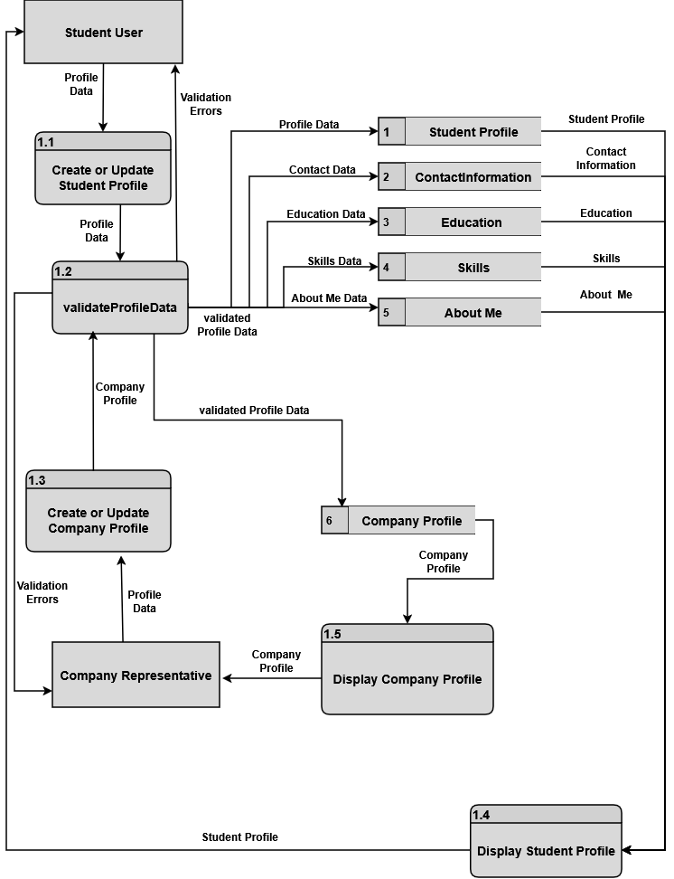

DFD Figure 1.6.0.0.2 — Privacy Settings Update
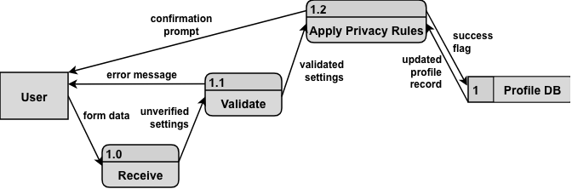

Figure 1.7 — Resume Service Detail
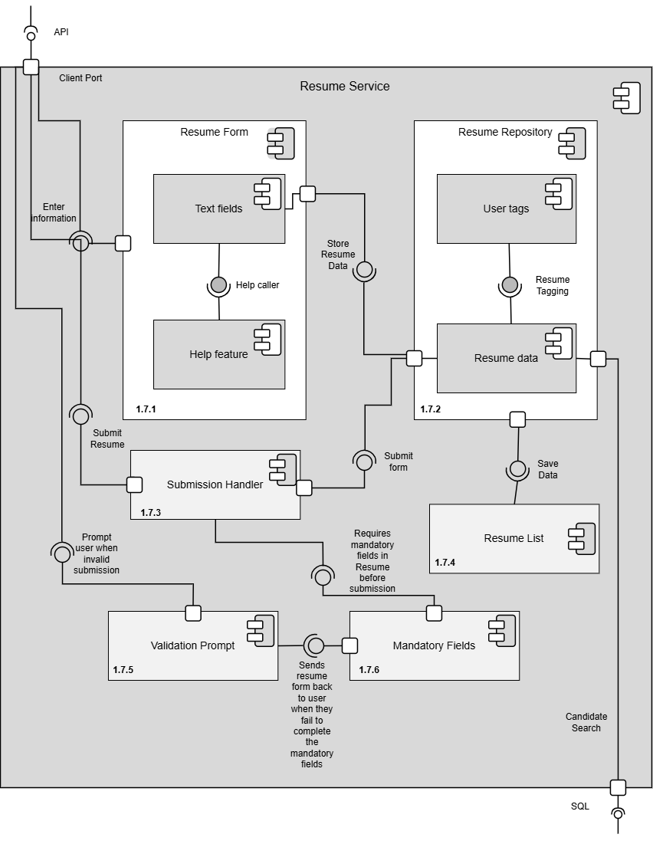

Design Information – Resume Service
Field | Description / Purpose
View Name & Number | 1.7 Resume Service
Purpose | Describe the resume service.
Description | Basic service demonstrating the resume service.
Requirements | SRS 3.5 Resume (3.5.1–3.5.5.2); referenced in 2.1.2, 2.2.5, 2.3.3, 2.3.5, 2.5.6
Elements | 1.7.1 Resume Form
 | 1.7.2 Resume Repository
 | 1.7.3 Submission Handler
 | 1.7.4 Resume List
 | 1.7.5 Validation Prompt
 | 1.7.6 Mandatory Fields
Navigation / References | 1.4 API Gateway / Orchestrator, 1.14 Database, 1.15 File / Blob Storage; Screen view 2.3 Resume Builder
Viewpoint | Component Diagram

Entity Identification Tables – Resume Service

EI Table 1.7.1 – Resume Form
Subcomponent | Entity Name | Entity Type | Description / Purpose | Related Requirement(s) | Collaborators / Related Entities
Resume Service | ResumeInput | Object | Stores the information entered by the student in the resume form | 3.5.1 | ResumeSection,  Submission Handler
Resume Service | ResumeSection | Class | Represents a section of the resume such as education, skills, or experience. | 3.5.1 | ResumeInput, Degree_Info, Experience, Contact_Info, Skill, Student, Resume,  Submission Handler
Resume Service | ResumeFile | Object | Represents the resume file selected by the student for upload | 3.5.2 | Resume Repository, Database, Resume List
Resume Service | FileType | Variable | Stores the type of file being uploaded | 3.5.2 | Resume Repository
Resume Service | FileSize | Variable | Stores the size of the uploaded resume file | 3.5.2 | Resume Repository
Resume Service | ResumeMetadata | Class | Stores information about the resume file such as name, type, size, and upload date | 3.5.2 | ResumeFile, Database
Resume Service | ResumeFiles | Data Store | Stores uploaded resume documents and related files | 3.5.2 | ResumeFile, File / Blob Storage
Resume Service | File / Blob Storage | Data Store | Stores the actual uploaded resume file | 3.5.2 | ResumeFiles, Resume Service
Resume Service | ResumeStatus | Variable | Tracks whether the resume is draft, uploaded, saved, or ready to submit | 3.5.1, 3.5.2, 3.5.4.1 | Resume, Student Dashboard
Resume Service | createResume() | Function | Starts the process of creating a new resume. | 3.5.1 | ResumeBuilder, Resume
Resume Service | collectResumeInput() | Function | Collects resume information entered by the student. | 3.5.1 | ResumeForm, ResumeInput
Resume Service | saveResumeDraft() | Function | Saves the currect resume as a draft. | 3.5.1, 3.5.4.1 | Resume, Database
Resume Service | uploadResume() | Method | Uploads a student resume file | 3.5.2 | ResumeFile, File / Blob Storage
Resume Service | saveResumeMetadata() | Function | Saves resume file information after upload | 3.5.2 | ResumeMetadata, Database
Resume Service | linkResumeToProfile() | Function | Connects the resume to the student profile | 3.5.4.1 | Resume, StudentProfile, Database

EI Table 1.7.2 – Resume Repository
Subcomponent | Entity Name | Entity Type | Description / Purpose | Related Requirement(s) | Collaborators / Related Entities
Resume Service | Resume | Class | Represents a student user resume | 3.5.1 | Contact_Info, Experience, Degree_Info, Skill_List, User_Tag, Resume Form, Database
Resume Service | Contact_Info | Class in a class | Represents the contact information within the Resume class | 3.5.1 | Resume, Full_Name, Email, Phone
Resume Service | Experience | Class in a class | A professional or voluntary experience related to a company within specified dates | 3.5.1 | Resume, Company, Exp_Start_Date, Exp_End_Date, Position, Exp_Desc
Resume Service | Degree_Info | Class in a class | Information pertaining to a user’s specific degree, including what type of degree, GPA, and expected graduation date | 3.5.1 | Resume, Degree_Title, School, GPA, Graduation_Date
Resume Service | Skill | Class | Represents a skill of a student or job requirement | 3.5.1 | Resume, Submission Handler
Resume Service | Exp_Start_Date | Member variable | The start date of an Experience object including month and year | 3.5.1 | Experience
Resume Service | Exp_End_Date | Member variable | The end date of an Experience object including month and year | 3.5.1 | Experience
Resume Service | Position | Member variable | The position title of an Experience object | 3.5.1 | Experience
Resume Service | Degree_Title | Member variable | The degree name obtained from a school for a Degree_Info object | 3.5.1 | Degree_Info
Resume Service | GPA | Member variable | The numerical grade obtained from a degree for the Degree_Info object | 3.5.1 | Degree_Info
Resume Service | Graduation_Date | Member variable | The expected date of graduation for a Degree_Info object including month and year | 3.5.1 | Degree_Info
Resume Service | User_Tag | Member variable | A one-to-three-word long keyword that summarizes the outcome of a resume | 3.5.1 | Resume
Resume Service | Full_Name | Member variable | Represents a student’s Full Name | 3.5.1 | Contact_Info
Resume Service | Email | Member variable | Represents a student’s email address | 3.5.1 | Contact_Info
Resume Service | Phone | Member variable | Represents a student’s contact number | 3.5.1 | Resume

EI Table 1.7.3 – Submission Handler
Subcomponent | Entity Name | Entity Type | Description / Purpose | Related Requirement(s) | Collaborators / Related Entities
Resume Service | saveResume() | Method | Saves a Resume object into the Database if validated | 3.5.5.1 | Resume, Database, Validation Prompt
Resume Service | saveContactInfo() | Function | Saves a Contact_Info to a Resume object | 3.5.5.1 | Resume, Contact_Info, saveResume()
Resume Service | saveExperience() | Function | Saves an Experience to a Resume object | 3.5.5.1 | Resume, saveResume(), Experience
Resume Service | saveDegree_Info() | Function | Saves a Degree_Info to a Resume object | 3.5.5.1 | Resume, saveResume(), Degree_Info
Resume Service | createSkill() | Function | Adds a new skill tagged from the Resume to the student submitter to the Skills Index | 3.5.5.1 | Resume Form, Database, Student
Resume Service | tagSkill() | Function | Tags a skill specified by the student submitter | 3.5.5.1 | Student, Database, Skill

EI Table 1.7.4 – Resume List
Subcomponent | Entity Name | Entity Type | Description / Purpose | Related Requirement(s) | Collaborators / Related Entities
Resume Service | listResumes() | Method | Creates a viewable list of resumes based on filters such as SearchFilter or tagged Student | 3.5.3 | SearchFilter, Student, Resume Repository, viewResume()
Resume Service | viewResume() | Method | Builds a view form of a Resume object | 3.5.3 | Resume, Database
Resume Service | listSkills() | Method | Creates a list of skills tagged to a student and resume | 3.5.3 | viewResume(), Skill, Database, Student, Resume

EI Table 1.7.5 – Validation Prompt
Subcomponent | Entity Name | Entity Type | Description / Purpose | Related Requirement(s) | Collaborators / Related Entities
Resume Service | checkResume() | Method | Validation check for Resume submission | 3.5.5.2, 3.5.5.3 | Submission Handler, Mandatory Fields
Resume Service | ResumeError | Class | Represents an alert for an invalid resume object submission | 3.5.5.3 | checkResume()
Resume Service | Error_ContactInfo | Member variable | Represents an error message for invalid contact information | 3.5.5.3 | ResumeError, Contact_Info, checkContactInfo()
Resume Service | Error_Experience | Member variable | Represents an error message for invalid Experience | 3.5.5.3 | ResumeError, Experience, checkExperience()
Resume Service | Error_Degree_Info | Member variable | Represents an error message for invalid Degree_Info | 3.5.5.3 | ResumeError, Degree_Info, checkDegreeInfo()
Resume Service | checkContactInfo() | Method | Validation checks for Contact_Info in a Resume object | 3.5.5.3 | Contact_Info, Error_ContactInfo, Mandatory Fields
Resume Service | checkExperience() | Method | Validation checks for Experience in a Resume object | 3.5.5.3 | Experience, Error_Experience, Mandatory Fields
Resume Service | checkDegreeInfo() | Method | Validation checks for Degree_Info in a Resume object | 3.5.5.3 | Degree_Info, Error_Degree_Info, Mandatory Fields

EI Table 1.7.6 – Mandatory Fields
Subcomponent | Entity Name | Entity Type | Description / Purpose | Related Requirement(s) | Collaborators / Related Entities
Resume Service | requireStartDate() | Function | Checks that Experience Start_Date is specified | 3.5.5.2, 3.5.5.3 | Experience, checkExperience()
Resume Service | requireGradDate() | Function | Checks that graduation date is specified | 3.5.5.2, 3.5.5.3 | Degree_Info, checkDegreeInfo()
Resume Service | requireEmail() | Function | Checks that email is specified | 3.5.5.2, 3.5.5.3 | Contact_Info, checkContactInfo()
Resume Service | requirePhone() | Function | Checks that phone is specified | 3.5.5.2, 3.5.5.3 | Contact_Info, checkContactInfo()
Resume Service | requireDegName() | Function | Checks that Degree name is specified | 3.5.5.2, 3.5.5.3 | Degree_Info, checkDegreeInfo()
Resume Service | requirePosition() | Function | Checks that position title is specified | 3.5.5.2, 3.5.5.3 | Experience, checkExperience()

Structure Charts – Resume Service

SC Figure 1.7.0.1 — createResume()
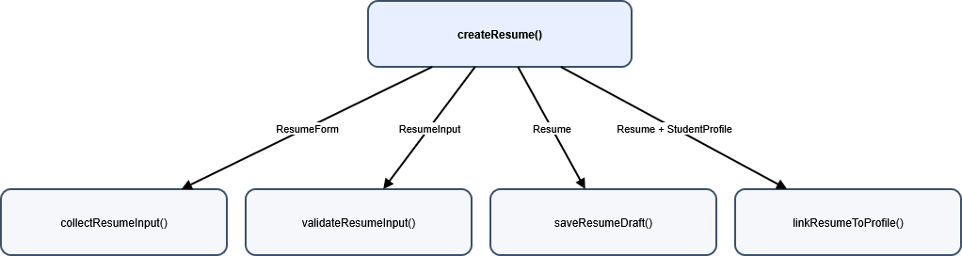

SC Figure 1.7.0.2 — uploadResume()
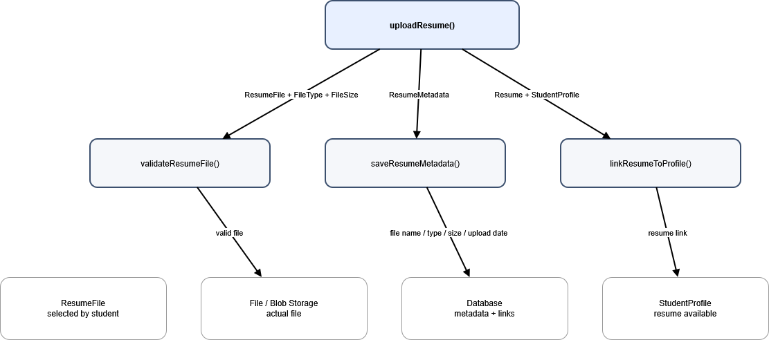

SC Figure 1.7.0.3 — saveResume()
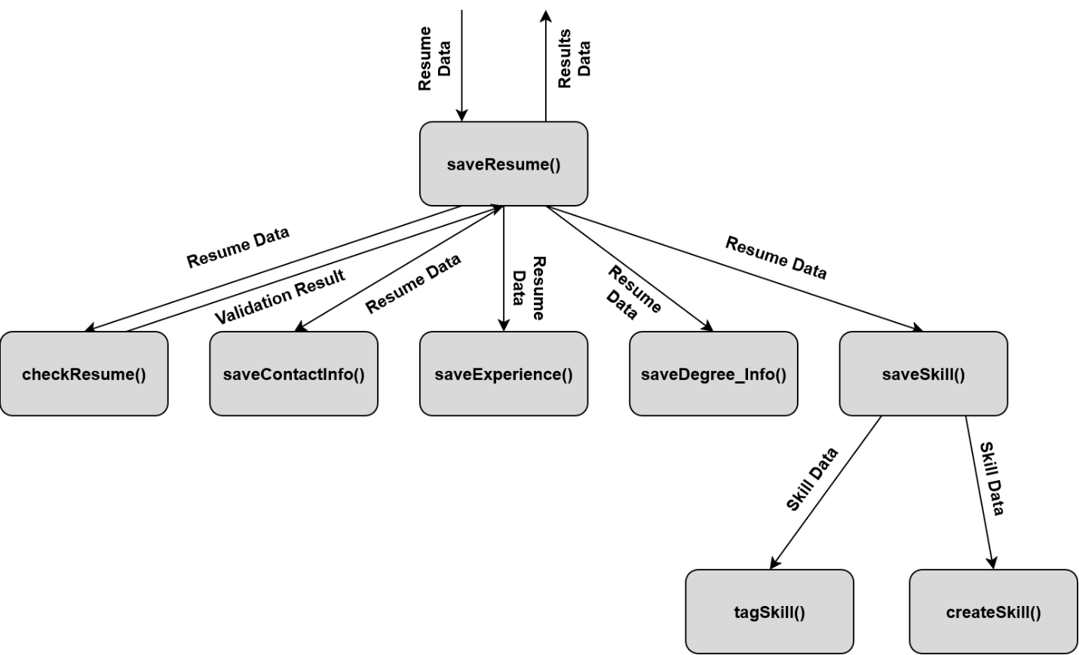

SC Figure 1.7.0.4 — checkResume()
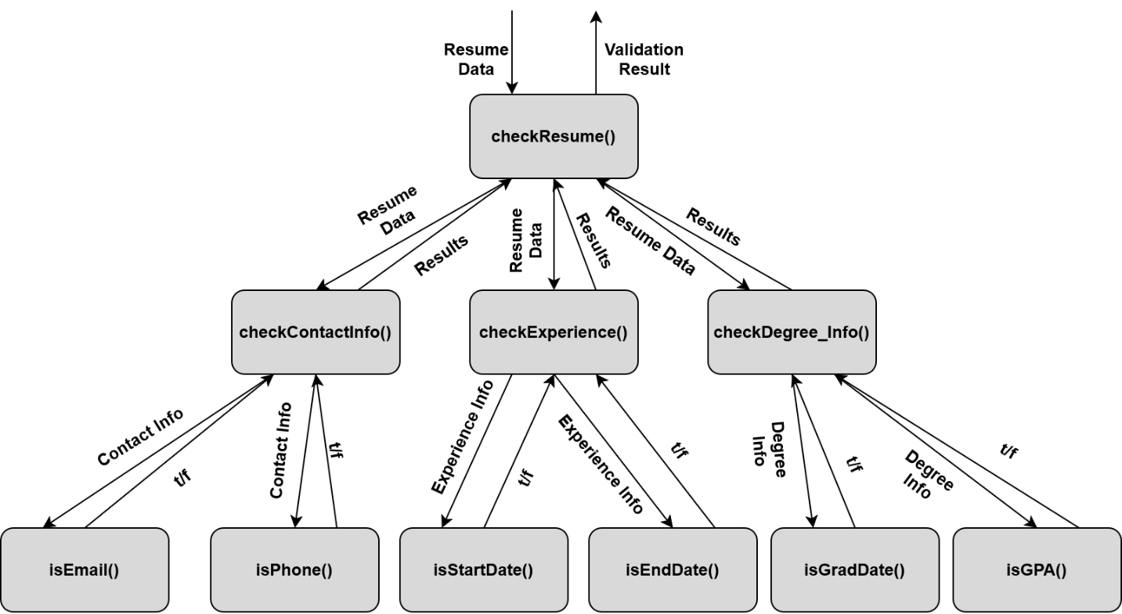

Data Flow Diagrams – Resume Service

DFD Figure 1.7.0.0.1 — Resume Input and Builder
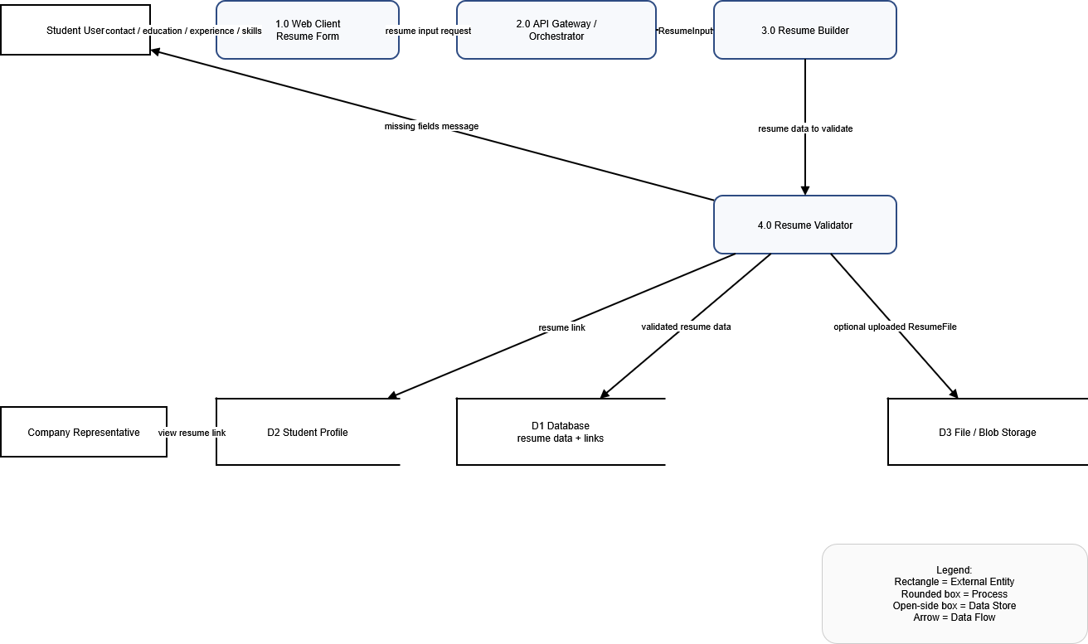

DFD Figure 1.7.0.0.2 — Submission and Storage Workflow
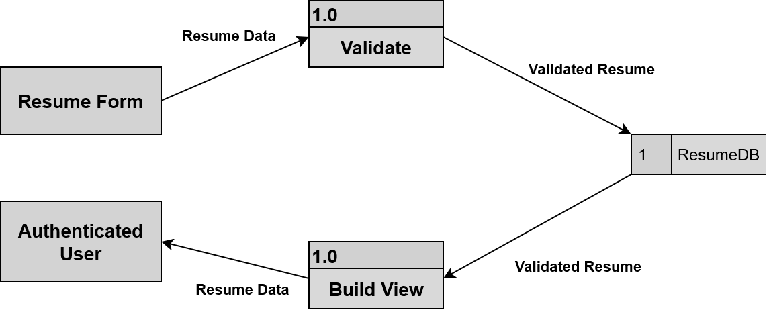

Figure 1.8 — Job Posting Service Detail
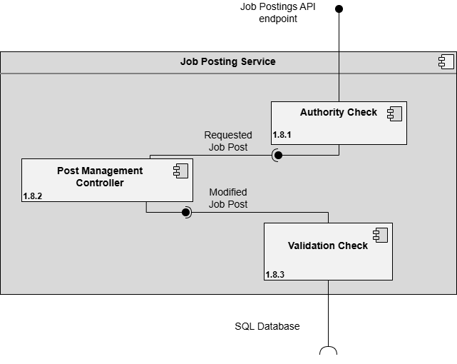

Design Information – Job Posting Service
Field | Description / Purpose
View Name & Number | 1.8 Job Postings Service
Purpose | Describe the jobs posting service.
Description | Basic service demonstrating the jobs posting service.
Requirements | SRS 2.5 Job Postings (2.5.1–2.5.7); referenced in 3.3.1, 3.4.1, 2.2.5
Elements | 1.8.1 Authority Check
 | 1.8.2 Post Management Control
 | 1.8.3 Validation Check
Navigation / References | 1.4 API Gateway / Orchestrator, 1.14 Database; Screen views 3.3 Job Posting Creation, 2.4 Job Search, 2.5 Job Detail
Viewpoint | Component Diagram

Entity Identification Tables – Job Posting Service

EI Table 1.8.1 – Authority Check
Subcomponent | Entity Name | Entity Type | Description / Purpose | Related Requirement(s) | Collaborators / Related Entities
Authority Check | AuthorizationService | Class | Main container for authorization logic | 2.5.1-2.5.4
Authority Check | PermissionManager | Class | Manages permission rules | 2.5.1-2.5.4 | AuthorizationService
Authority Check | RoleManager | Class | Determines user roles | 2.5.1-2.5.4 | AuthorizationService
Authority Check | verifyOwner() | Method | Verifies that a user owns a given job listing | 2.5.1-2.5.4 | AuthorizationService, PermissionManager
Authority Check | canCreateJob() | Method | Checks if a user is allowed to post a job | 2.5.1-2.5.4 | AuthorizationService, PermissionManager
Authority Check | canEditJob() | Method | Checks if a user is allowed to edit a job | 2.5.1-2.5.4 | AuthorizationService, PermissionManager

EI Table 1.8.2 – Post Management Controller
Subcomponent | Entity Name | Entity Type | Description / Purpose | Related Requirement(s) | Collaborators / Related Entities
Post Management Controller | JobPosting | Class | Job data | 2.5.1-2.5.4 | currentPost, JobPostingsTable
Post Management Controller | currentPost | Object | The active job post is being modified by the recruiter | 2.5.1-2.5.4 | JobPosting, updatePostDetails
Post Management Controller | createPost | Method | Initiate a new JobPosting object | 2.5.1-2.5.4 | JobPosting, JobPostingsTable
Post Management Controller | updatePostDetails | Method | Modifies the job data | 2.5.1-2.5.4 | currentPost, JobPostingTable
Post Management Controller | archivePost | Method | Hide the post from student searches | 2.5.1-2.5.4 | currentPost, JobPostingsTable
Post Management Controller | isDraft | Variable | A boolean indicating if the job post is still a hidden draft | 2.5.1-2.5.4 | JobPosting, createPost
Post Management Controller | authorId | Variable | Identifier of the recruiter | 2.5.1-2.5.4 | JobPosting
Post Management Controller | JobPostinsTable | Data Store | The database table that stores all job records | 2.5.1-2.5.4 | JobPosting, createPost, updatePostDetails

EI Table 1.8.3 – Validation Check
Subcomponent | Entity Name | Entity Type | Description / Purpose | Related Requirement(s) | Collaborators / Related Entities
Validation Check | PostValidator | Class | Contains the core logic algortithms used to validate the job post | 2.5.1-2.5.4 | ValidationResult, validateRequiredFields
Validation Check | ValidationResult | Object | Stores the pass/fail breakdown of a completed validation check | 2.5.1-2.5.4 | PostValidator, isValid, errorMessage
Validation Check | validateRequiredFields | Method | Check if any required fields are empty | 2.5.1-2.5.4 | PostValidator, isValid
Validation Check | verifyExpirationDate | Method | Confirms that the job post is still in a valid posting timeline | 2.5.1-2.5.4 | PostValidator, isValid
Validation Check | checkProfanity | Method | Searches text strings for forbidden terms | 2.5.1-2.5.4 | PostValidator, SystemRulesConfig, errorMessage
Validation Check | isValid | Variable | A boolean tracking if the job post is valid to be posted | 2.5.1-2.5.4 | ValidationResult
Validation Check | errorMessage | Variable | Notification to user when the validation check failed | 2.5.1-2.5.4 | ValidationResult
Validation Check | SystemRulesConfig | Data Store | A reference configuration file or directory tracking system constants and forbidden word lists | 2.5.1-2.5.4 | checkProfanity

Structure Charts – Job Posting Service

SC Figure 1.8.0.1 – createPost()
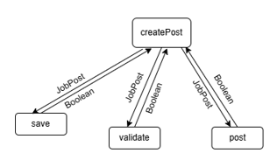

SC Figure 1.8.0.2 – validate()
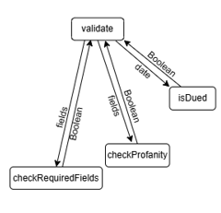

SC Figure 1.8.0.3 – modifyPost()
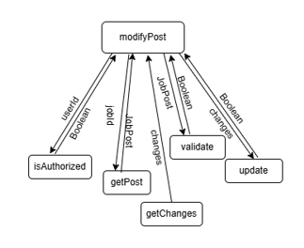

SC Figure 1.8.0.4 – isAuthorized()
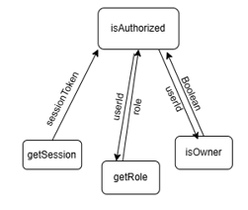

Data Flow Diagrams – Job Posting Service

DFD Figure 1.8.0.0.1 – Job Post Creation & Management
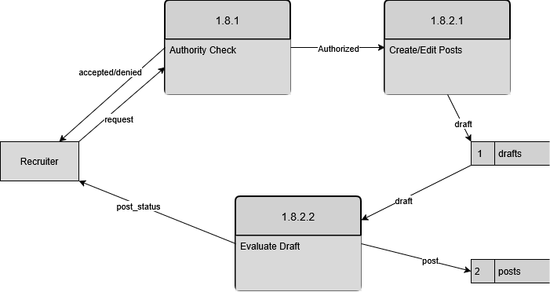

DFD Figure 1.8.0.0.2 – Post Validation & Publishing
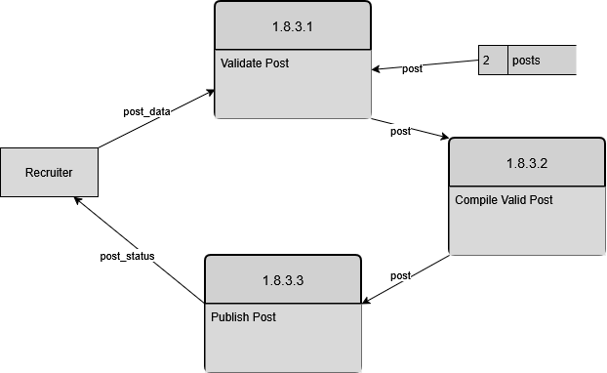

Figure 1.9 — Search Service Detail
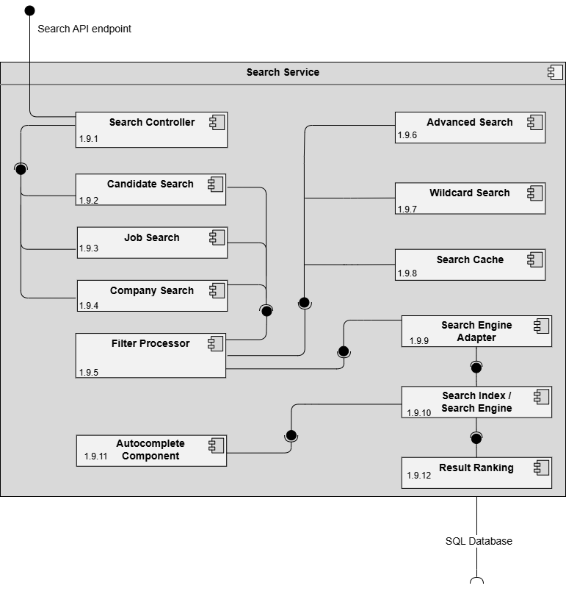

Design Information – Search Service
Field | Description / Purpose
View Name & Number | 1.9 Search Service
Purpose | Describe the search service.
Description | Basic service demonstrating the search service.
Requirements | SRS 2.3 Search Features (2.3.1–2.3.8), 3.3 Student Search Features (3.3.1–3.3.2)
Elements | 1.9.1 Search Controller
 | 1.9.2 Candidate Search
 | 1.9.3 Job Search
 | 1.9.4 Company Search
 | 1.9.5 Filter Processor
 | 1.9.6 Advanced Search
 | 1.9.7 Wildcard Search
 | 1.9.8 Search Cache
 | 1.9.9 Search Engine Adapter
 | 1.9.10 Search Index / Search Engine
 | 1.9.11 Autocomplete Component
 | 1.9.12 Result Ranking
Navigation / References | 1.4 API Gateway / Orchestrator, 1.14 Database; Screen views 2.4 Job Search, 3.2 Candidate Search
Viewpoint | Component Diagram

Entity Identification Tables – Search Service

EI Table 1.9.1 — Search Controller
Subcomponent | Entity Name | Entity Type | Description / Purpose | Related Requirement(s) | Collaborators / Related Entities
Search Controller | SearchController | Class | Coordinates all search requests and routes them to the appropriate search module. | 2.3.6, 2.3.7, 2.3.8, 3.3.1 | CandidateSearch, JobSearch, AutofillAPI
Search Controller | searchQuery | Function | Stores the text entered into the search bar. | 2.3.6, 3.3.1 | SearchController
Search Controller | searchFilters | Function | Stores advanced search filter criteria. | 2.3.8, 3.3.3, 3.3.4 | CandidateSearch, JobSearch
Search Controller | submitSearch() | Method | Processes a search request submitted by a user. | 2.3.5, 3.3.2 | CandidateSearch, JobSearch
Search Controller | autocompleteSearch() | Method | Retrieves autocomplete suggestions from the API. | 2.3.6 | AutofillAPI
Search Controller | wildcardSearch() | Method | Handles wildcard search patterns entered by users. | 2.3.7 | CandidateSearch, JobSearch
Search Controller | advancedSearch() | Method | Executes searches using advanced filtering options. | 2.3.8, 3.3.4 | CandidateSearch, JobSearch

EI Table 1.9.2 – Candidate Search
Subcomponent | Entity Name | Entity Type | Description / Purpose | Related Requirement(s) | Collaborators / Related Entities
Candidate Search | CandidateSearch | Class | Performs searches on student users for company representatives. | 2.3.1–2.3.8 | CompanyRepresentative, StudentUserCollection
Candidate Search | CompanyRepresentative | Object | User performing candidate searches. | 2.3.1, 2.3.4, 2.3.5 | CandidateSearch
Candidate Search | StudentUserCollection | Class | Collection containing all student user profiles. | 2.3.1, 2.3.2 | StudentUser
Candidate Search | candidateFilters | Function | Stores filter criteria entered by the company representative. | 2.3.2, 2.3.4 | CompanyRepresentative
Candidate Search | searchResults | Function | Stores matching student profiles and resumes. | 2.3.5 | StudentUser
Candidate Search | inputFilters() | Method | Prompts the company representative to enter search filters. | 2.3.4 | CompanyRepresentative
Candidate Search | filterCandidates() | Method | Selects student users matching the specified criteria. | 2.3.2, 2.3.3 | StudentUserCollection
Candidate Search | displayResults() | Method | Displays resumes and profiles matching the search criteria. | 2.3.5 | SearchResults

EI Table 1.9.3 – Job Search
Subcomponent | Entity Name | Entity Type | Description / Purpose | Related Requirement(s) | Collaborators / Related Entities
Job Search | JobSearch | Class | Performs searches for job postings and company profiles. | 3.3.1–3.3.4 | StudentUser, JobPosting, CompanyProfile
Job Search | StudentUser | Object | User searching for jobs and companies. | 3.3.1, 3.3.3, 3.3.4 | JobSearch
Job Search | JobPostingCollection | Class | Collection of available job postings. | 3.3.1, 3.3.3 | JobPosting
Job Search | CompanyProfileCollection | Class | Collection of company profile pages. | 3.3.1 | CompanyProfile
Job Search | selectedFilters | Function | Stores search filters chosen by the student user. | 3.3.3, 3.3.4 | StudentUser
Job Search | searchResults | Function | Stores matching jobs and company profiles. | 3.3.2, 3.3.3 | JobPosting, CompanyProfile
Job Search | searchJobs() | Method | Searches job postings using keywords and filters. | 3.3.1, 3.3.3 | JobPostingCollection
Job Search | searchCompanies() | Method | Searches company profile pages. | 3.3.1 | CompanyProfileCollection
Job Search | filterResults() | Method | Narrows search results according to selected filters. | 3.3.3, 3.3.4 | StudentUser
Job Search | displayResults() | Method | Displays matching jobs and company profiles to the student user. | 3.3.2 | SearchResults

EI Table 1.9.4 — Company Search
Subcomponent | Entity Name | Entity Type | Description / Purpose | Related Requirement(s) | Collaborators / Related Entities
Company Search | CompanySearch | Class | Represents the class containing the methods and variables that handle company searches | 3.3.1,  3.3.4 | Search Controller, Wildcard Search
Company Search | searchCompanies() | Function | Processes company search requests submitted by the user | 3.3.1,  3.3.4 | CompanySearch, Filter Processor,  searchQuery
Company Search | searchQuery | Variable | Stores the keyword or phrase entered into the input field | 3.3.4 | searchCompanies()

EI Table 1.9.5 — Filter Processor
Subcomponent | Entity Name | Entity Type | Description / Purpose | Related Requirement(s) | Collaborators / Related Entities
Filter Processor | SearchFilter | Class | Represents the filters selected by the user for company searching | 3.3.1,  3.3.4 | Company Search, Job Search, Candidate Seach, Advanced Search, Wildcard Search
Filter Processor | validateFilters() | Method | Validates user-selected search filters before processing the search | 3.3.4 | SearchFilter

EI Table 1.9.6 — Advanced Search
Subcomponent | Entity Name | Entity Type | Description / Purpose | Related Requirement(s) | Collaborators / Related Entities
Advanced Search | Advanced CompanySearch | Class | Represents the class that inherits from CompanySearch class and contains the overridden methods, additional methods if necessary and additional variables that handle advanced company searches | 3.3.1,  3.3.4 | Search Controller, Wildcard Search
Advanced Search | searchCompanies() | Function | Processes company search requests submitted by the user for advanced search | 3.3.1,  3.3.4 | Advanced  CompanySearch, FilterProcessor,  searchQuery
Advanced Search | Advanced JobSearch | Class | Represents the class that inherits from JobSearch class and contains the overridden methods, additional methods if necessary and additional variables that handle advanced job searches | 3.3.1,  3.3.4 | Search Controller, Wildcard Search
Advanced Search | searchJobs() | Function | Processes job search requests submitted by the user for advanced search | 3.3.1,  3.3.4 | Advanced  JobSearch, FilterProcessor,  searchQuery
Advanced Search | Advanced CandidateSearch | Class | Represents the class that inherits from CandidateSearch class and contains the overridden methods, additional methods if necessary and additional variables that handle advanced candidate searches | 3.3.1,  3.3.4 | Search Controller, Wildcard Search
Advanced Search | searchCandidates() | Function | Processes candidate search requests submitted by the user for advanced search | 3.3.1,  3.3.4 | Advanced  CandidateSearch, FilterProcessor,  searchQuery
Advanced Search | searchQuery | Variable | Stores the keyword or phrase entered into the search bar for advanced search | 3.3.4 | searchCompanies(),  searchJobs(),  searchCandidates()

EI Table 1.9.7 – Wildcard Search
Subcomponent | Entity Name | Entity Type | Description/ Purpose | Related Requirement(s) | Collaborators / Related Entities
Wildcard Search | WildcardSearch | Class | Represents the logic used to process wildcard search queries and match pattern-based input. | 2.3.7, 3.3.1, 3.3.2 | SearchEngineAdapter,  SearchIndex,  searchQuery
Wildcard Search | processWildcardSearch() | Function | Processes a search request using wildcard matching rules and returns matching results. | 2.3.7, 3.3.1, 3.3.2 | WildcardSearch,  SearchIndex
Wildcard Search | wildcardPattern | Variable | Stores the pattern entered by the user for wildcard matching. | 2.3.7 | processWildcardSearch()

EI Table 1.9.8 – Search Cache
Subcomponent | Entity Name | Entity Type | Description / Purpose | Related Requirement(s) | Collaborators / Related Entities
Search Cache | SearchCache | Class | Stores recently used search queries and results to improve repeated search performance. | 2.3.5, 3.3.2 | SearchEngineAdapter,  SearchIndex,  cachedResults
Search Cache | cachedResults | Member Variable | Holds cached search result sets for faster retrieval. | 2.3.5, 3.3.2 | SearchCache,  storeResults(),  retrieveResults()
Search Cache | storeResults() | Method | Saves search results into the cache for later reuse. | 2.3.5 | SearchCache,  cachedResults
Search Cache | retrieveResults() | Method | Retrieves previously cached results for a repeated search request. | 2.3.5, 3.3.2 | SearchCache,  cachedResults

EI Table 1.9.9 – Search Engine Adapter
Subcomponent | Entity Name | Entity Type | Description / Purpose | Related Requirement(s) | Collaborators / Related Entities
Search Engine Adapter | SearchEngineAdapter | Class | Acts as an interface between the search UI and the internal search engine logic. | 2.3.1, 2.3.2, 2.3.7, 3.3.1 | SearchCache,  WildcardSearch,  SearchIndex
Search Engine Adapter | executeSearch() | Method | Sends search requests to the search engine and returns processed results to the caller. | 2.3.1, 2.3.5, 3.3.1, 3.3.2 | SearchEngineAdapter,  SearchIndex,  SearchCache
Search Engine Adapter | searchRequest | Variable | Stores the incoming search query and filter data before execution. | 2.3.1, 2.3.2 | executeSearch(),  SearchCache

EI Table 1.9.10 — Search Index / Search Engine
Subcomponent | Entity Name | Entity Type | Description / Purpose | Related Requirement(s) | Collaborators / Related Entities
Search Index / Search Engine | SearchEngine | Class | Class responsible for managing the Search Index, processing search queries, handling wildcard logic, and executing filtering criteria | 2.3.1, 3.3.1 | searchIndex, searchFilters, executeSearch()
Search Index / Search Engine | searchIndex | Member Variable | Data Structure responsible for storing all search data including profiles, resumes, listings, etc. | 2.3.1, 3.3.1 | SearchEngine, executeSearch()
Search Index / Search Engine | searchFilters | Member Variable | Key Value data related to the searchIndex used to “filter” results from the search queries | 2.3.2, 2.3.3, 2.3.4 | SearchEngine, executeSearch()
Search Index / Search Engine | executeSearch() | Method | Method responsible for executing the search and returning results according to the search query and searchFilters | 3.3.1, 2.3.5, 3.3.2 | SearchEngine, searchIndex, searchFilters

EI Table 1.9.11 — Autocomplete Component
Subcomponent | Entity Name | Entity Type | Description / Purpose | Related Requirement(s) | Collaborators / Related Entities
Autocomplete Component | AutocompleteComponent | Class | Frontend Class managing the Autocomplete API interactions | 2.3.6 | apiEndpoints, suggestions, fetchAutocomplete(), Autocomplete API
Autocomplete Component | apiEndpoints | Member Variable | String storing URL to the Autocomplete API | 2.3.6 | Autocomplete Component, fetchAutocomplete()
Autocomplete Component | suggestions | Member Variable | List of String suggestions returned from the Autocomplete API | 2.3.6 | Autocomplete Component, fetchAutocomplete()
Autocomplete Component | fetchAutocomplete() | Method | Calls API using apiEndpoints URL and returns list of suggestions | 2.3.6 | Autocomplete Component,  apiEndpoints, suggestions
Autocomplete Component | Autocomplete API | Object | External API handling the autocomplete queries | 2.3.6 | Autocomplete Component, fetchAutocomplete()

EI Table 1.9.12 — Result Ranking
Subcomponent | Entity Name | Entity Type | Description / Purpose | Related Requirement(s) | Collaborators / Related Entities
Result Ranking | ResultsRanker | Class | Class responsible for ordering or “ranking” results to be provided to the user | 2.5.8, 3.3.4 | rankingCriteria, rankResults()
Results Ranking | rankingCriteria | Member Variable | Attribute weighted to evaluate result priority (this could be GPA, Skills, Exp Graduation, etc.) | 2.5.8, 3.3.4 | ResultsRanker, rankResults()
Results Ranking | rankResults() | Method | Method responsible for prioritizing search results according to the ranking criteria | 2.5.8, 3.3.4 | ResultsRanker, rankingCriteria

Structure Charts – Search Service

SC Figure 1.9.0.1 – SearchQuery()
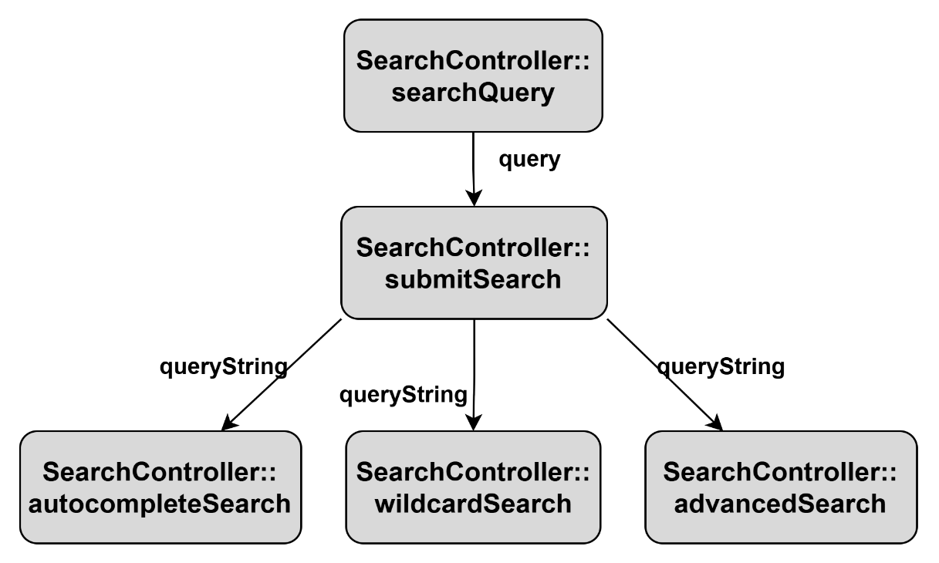

SC Figure 1.9.0.2 – InputFilters()
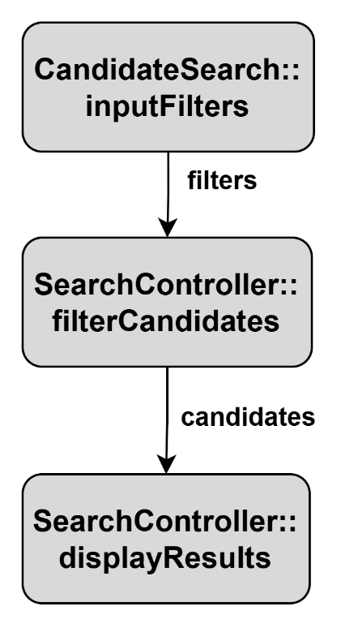

SC Figure 1.9.0.3 – ProcessFilters()
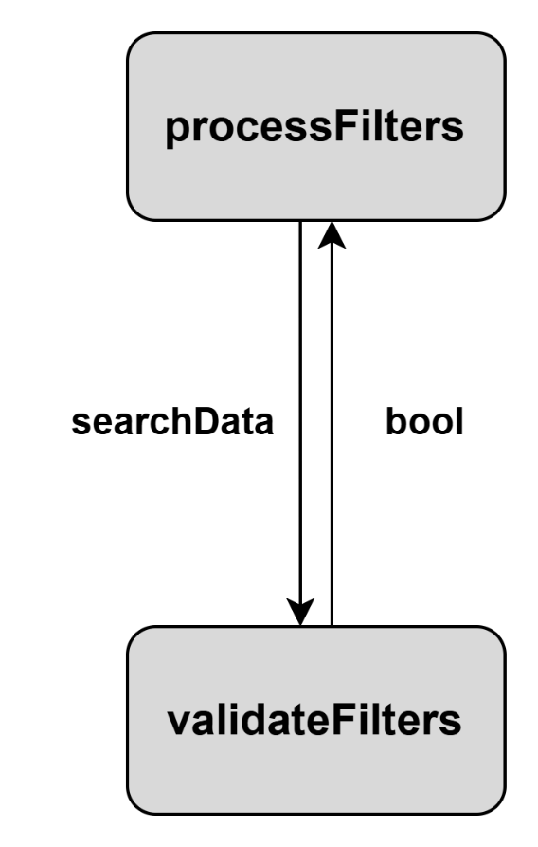

SC Figure 1.9.0.4 – Search()
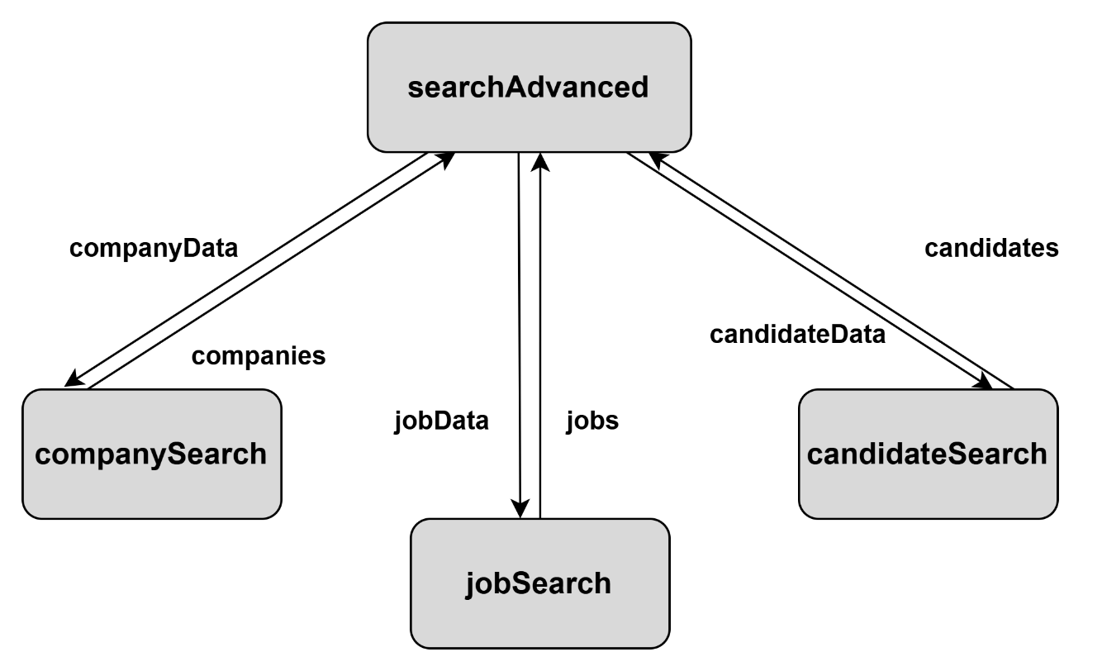

SC Figure 1.9.0.5 – processWildcardSearch()
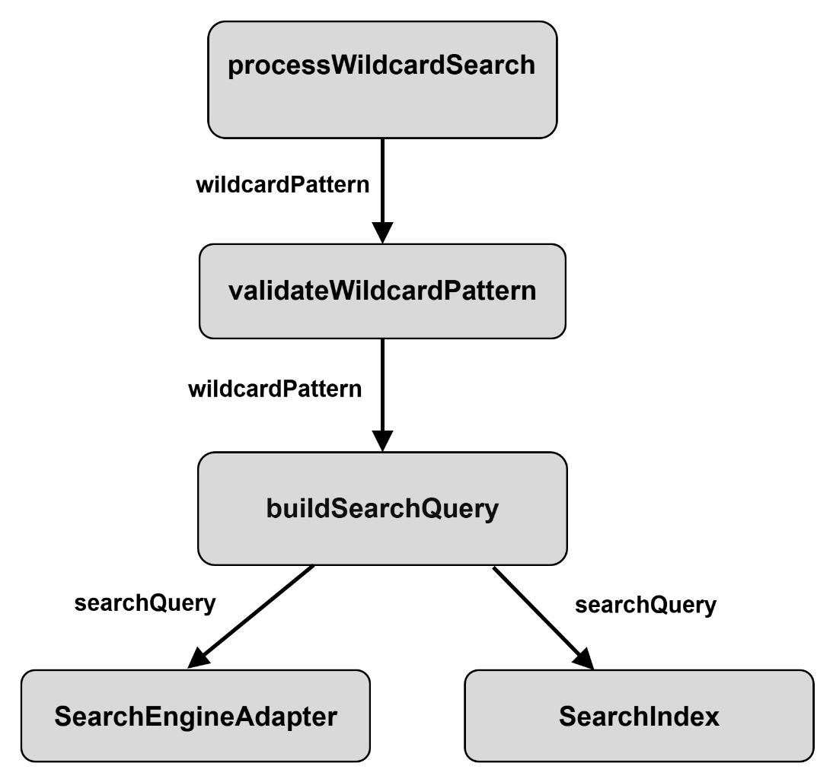

SC Figure 1.9.0.6 – SearchCache()
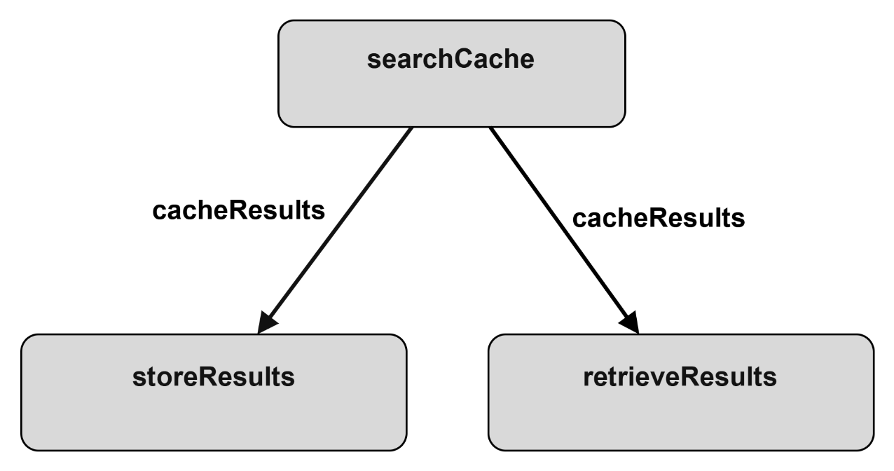

Data Flow Diagrams – Search Service

DFD Figure 1.9.0.0.1 – Job Search
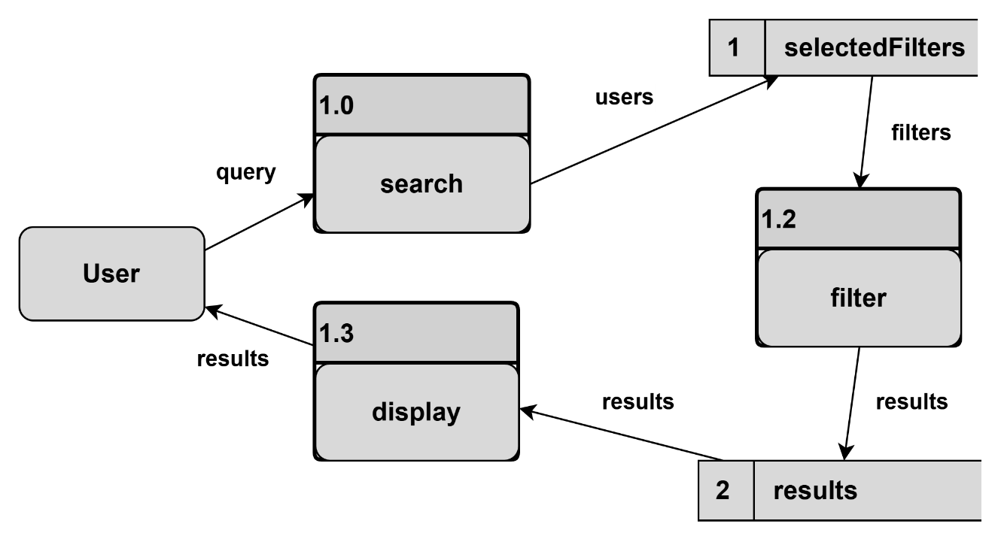

DFD Figure 1.9.0.0.2 – Company Search
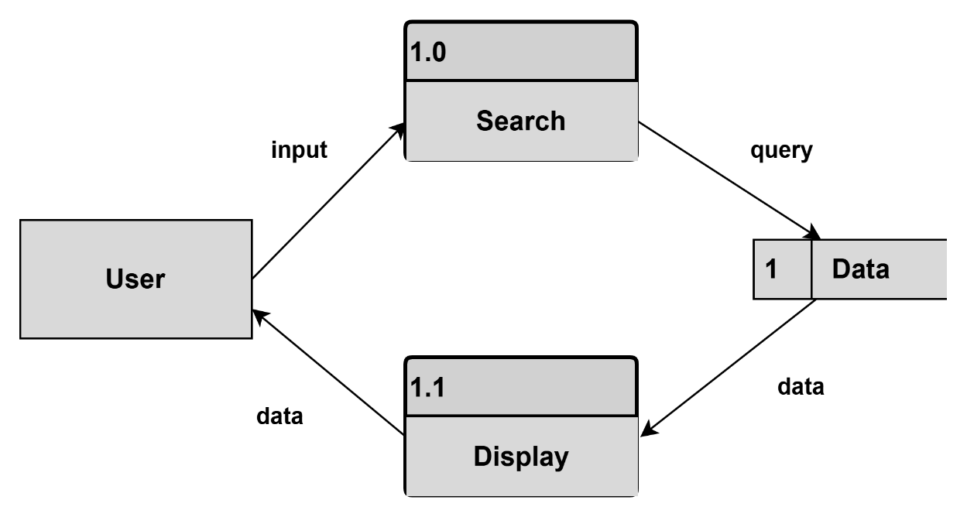

DFD Figure 1.9.0.0.3 – Search Engine Adapter
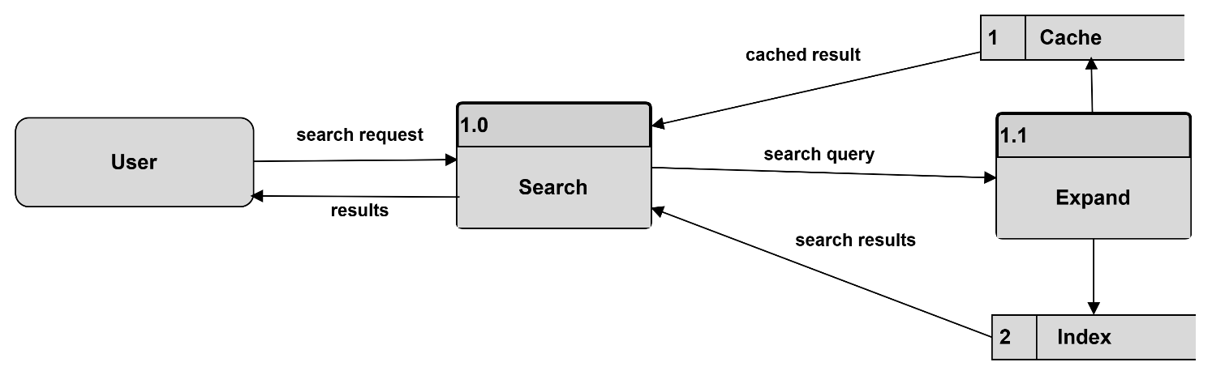

DFD Figure 1.9.0.0.4 – Search Index / Search Engine
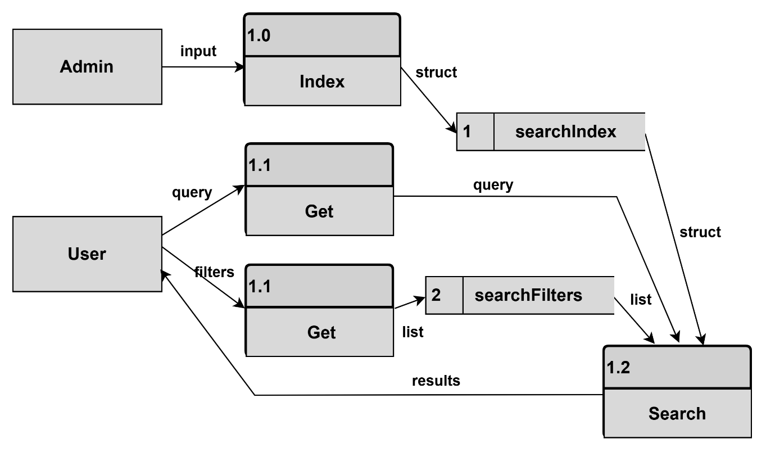

DFD Figure 1.9.0.0.5 – Autocomplete
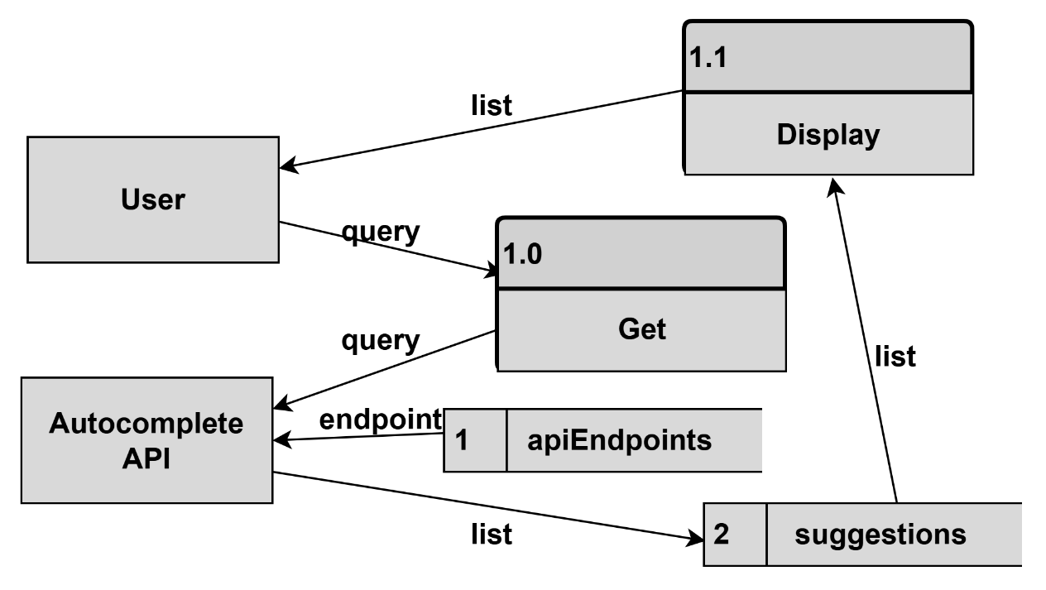

DFD Figure 1.9.0.0.6 – Ranking Results
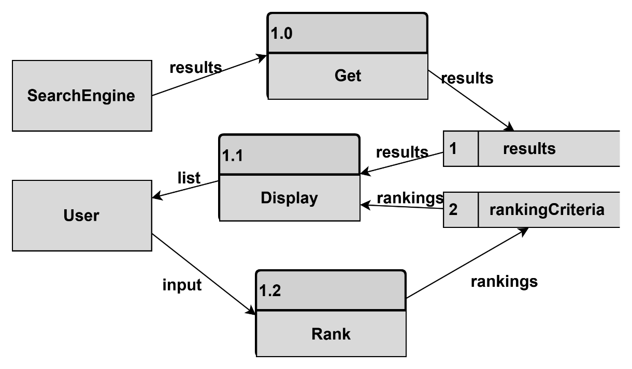

Figure 1.10 — Communication Services (Notifications + News Feed) Detail
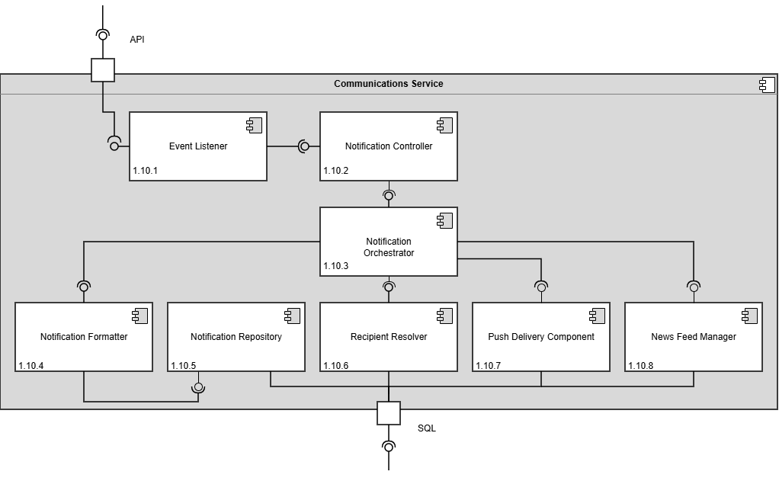

Design Information – Communication Services (Notifications + News Feed)
Field | Description / Purpose
View Name & Number | 1.10 Communication Service
Purpose | Describe the communication service.
Description | Basic service demonstrating the communication service.
Requirements | SRS 2.2 Notifications (2.2.1–2.2.5), 2.4 News Feed (2.4.1–2.4.6), 3.2 Notifications (3.2.1–3.2.2), 3.4 News Feed (3.4.1–3.4.2)
Elements | 1.10.1 Event Listener
 | 1.10.2 Notification Controller
 | 1.10.3 Notification Orchestrator
 | 1.10.4 Notification Formatter
 | 1.10.5 Notification Repository
 | 1.10.6 Recipient Resolver
 | 1.10.7 Push Delivery
 | 1.10.8 News Feed Manager
Navigation / References | 1.4 API Gateway / Orchestrator, 1.14 Database; Screen views 4.1 Notifications, 4.2 News Feed
Viewpoint | Component Diagram

Entity Identification Tables – Communication Service

EI Table 1.10.1 – Event Listener
Subcomponent | Entity Name | Entity Type | Description / Purpose | Related Requirement(s) | Collaborators / Related Entities
Event Listener | listenForEvents() | Function | Continuously monitors incoming system events | 1.4 | EventQueue
Event Listener | validateEvent() | Method | Verifies incoming event data before forwarding | 1.10.2 | Event
Event Listener | ForwardEvent() | Function | Stores the list of matching job postings returned from a search | 1.10.2 | Event
Event Listener | EventQueue | Data Structure | Temporary storage for received events awaiting processing | 1.4 | Event, listenForEvents()
Event Listener | Event | Object | Represents an incoming event requiring notification processing | 1.10.2 | listenForEvents()

EI Table 1.10.2 – Notification Controller
Subcomponent | Entity Name | Entity Type | Description / Purpose | Related Requirement(s) | Collaborators / Related Entities
Notification Controller | processNotificationRequest() | Function | Processes incoming notification requests from Event Listener | 1.10.1 | NotificationRequest
Notification Controller | NotificationRequest | Object | Encapsulates notification processing information | 1.10.2 | createNotificationTask()
Notification Controller | validateNotification() | Method | Ensures notification request data is complete and valid | 1.10.1 | processNotificationRequest()
Notification Controller | NotificationPolicy | Class | Contains rules governing notification generation | 1.10.4 | validateNotification()
Notification Controller | createNotificationTask() | Function | Creates processing tasks for the orchestrator | 1.10.1 | validateNotification()
Notification Controller | NotificationTask | Object | Represents a pending notification workflow | 1.10.1 | createNotificationTask()

EI Table 1.10.3 – Notification Orchestrator
Subcomponent | Entity Name | Entity Type | Description / Purpose | Related Requirement(s) | Collaborators / Related Entities
Notification Orchestrator | orchestrateNotification() | Function | Coordinates the complete notification workflow | 2.2.1–2.2.5, 2.4, 2.4.1–2.4.6, 3.2, 3.2.1–3.2.2, 3.4, 3.4.1–3.4.2 | Formatter, Repository, Resolver, PushDeliveryComponent
Notification Orchestrator | NotificationJob | Object | Represents a notification being processed | 1.10.2 | orchestrateNotification()
Notification Orchestrator | buildNotification() | Method | Constructs notification content from event data | 1.10.4 | NotificationFormatter
Notification Orchestrator | resolveRecipients() | Method | Determines intended notification recipients | 1.10.6 | RecipientResolver
Notification Orchestrator | deliverNotification() | Method | Sends notifications through delivery channels | 1.10.7 | PushDeliveryComponent
Notification Orchestrator | archiveNotification() | Method | Stores notification records for auditing and retrieval | 1.10.5 | NotificationRepository
Notification Orchestrator | updateNewsFeed() | Method | Publishes notification content to the news feed system | 1.10.8 | NewsFeedManager
Search Query Manager | processingStatus | Variable | Tracks workflow progress and state | 1.10.2 – 1.10.8 | NotificationJob

EI Table 1.10.4 – Notification Formatter
Subcomponent | Entity Name | Entity Type | Description / Purpose | Related Requirement(s) | Collaborators / Related Entities
Notification Formatter | NotificationFormatter | Class | Defines formatting behavior for user notifications. | 2.2.1-2.2.5, 3.2.1-3.2.7 | Notification Orchestrator, NotificationContent
Notification Formatter | formatNotification() | Function | Converts event data into a standard notification message. | 2.2.1, 2.2.2, 3.2.1, 3.2.2 | NotificationJob, NotificationTemplate, NotificationContent
Notification Formatter | NotificationTemplate | Class | Represents reusable layouts for notification messages. | 2.2.1-2.2.5, 3.2.1-3.2.7 | formatNotification(), NotificationContent
Notification Formatter | NotificationContent | Object | Stores the formatted title, body, link, and display data. | 2.2.1-2.2.5, 3.2.1-3.2.7 | NotificationTemplate, NotificationRepository
Notification Formatter | formatPushMessage() | Method | Formats content for mobile push delivery. | 2.2.3, 2.2.4, 3.2.3, 3.2.4 | NotificationContent, Push Delivery Component
Notification Formatter | formatInAppMessage() | Method | Formats content for in-app display. | 2.2.1, 2.2.2, 3.2.1, 3.2.2 | NotificationContent, Notification Controller
Notification Formatter | messageBody | Variable | Stores the final notification body text. | 2.2.1, 2.2.2, 3.2.1, 3.2.2 | NotificationContent
Notification Formatter | notificationLink | Variable | Stores the destination link opened from the notification. | 2.2.1-2.2.5, 3.2.1-3.2.7 | NotificationContent, News Feed Manager

EI Table 1.10.5 – Notification Repository
Subcomponent | Entity Name | Entity Type | Description / Purpose | Related Requirement(s) | Collaborators / Related Entities
Notification Repository | NotificationRepository | Class | Manages stored notification records. | 2.2.1-2.2.5, 3.2.1-3.2.7 | Notification Orchestrator, NotificationRecord, NotificationDB
Notification Repository | saveNotification() | Function | Stores a completed notification record. | 2.2.1-2.2.5, 3.2.1-3.2.7 | NotificationContent, NotificationRecord, NotificationDB
Notification Repository | getNotificationHistory() | Function | Retrieves notifications for the notification screen. | 2.2.1, 2.2.2, 3.2.1, 3.2.7 | NotificationRecord, NotificationDB
Notification Repository | NotificationRecord | Object | Represents one stored notification item. | 2.2.1-2.2.5, 3.2.1-3.2.7 | NotificationContent, RecipientList
Notification Repository | markNotificationRead() | Method | Updates a notification when the user views it. | 2.2.1, 3.2.1, 3.2.7 | NotificationRecord, readStatus
Notification Repository | archiveNotification() | Method | Stores notification records for audit and history. | 2.2.1-2.2.5, 3.2.7 | NotificationRecord, NotificationDB
Notification Repository | readStatus | Variable | Tracks whether a notification has been read. | 2.2.1, 3.2.1, 3.2.7 | NotificationRecord, markNotificationRead()
Notification Repository | NotificationDB | Data Store | Stores notification records, delivery status, and history data. | 2.2.1-2.2.5, 3.2.1-3.2.7 | NotificationRepository, Database
Notification Repository | /notifications/history | API Endpoint | Handles requests for notification history. | 2.2.1, 2.2.2, 3.2.1, 3.2.7 | getNotificationHistory(), API Gateway

EI Table 1.10.6 – Recipient Resolver
Subcomponent | Entity Name | Entity Type | Description / Purpose | Related Requirement(s) | Collaborators / Related Entities
Recipient Resolver | RecipientResolver | Class | Determines which users should receive a notification. | 2.2.1-2.2.5, 3.2.1-3.2.7 | Notification Orchestrator, RecipientList
Recipient Resolver | resolveRecipients() | Function | Builds the recipient list for a workflow. | 2.2.1, 2.2.2, 3.2.1, 3.2.2 | NotificationJob, RecipientList
Recipient Resolver | RecipientList | Object | Stores the selected notification recipients. | 2.2.1-2.2.5, 3.2.1-3.2.7 | resolveRecipients(), NotificationRepository
Recipient Resolver | NotificationPreference | Class | Represents user notification settings and filters. | 2.2.5, 3.2.6, 3.2.7 | RecipientList, filterMutedUsers()
Recipient Resolver | followedCompanyList | Variable | Stores followed companies used for recipient matching. | 2.2.2, 3.2.2, 3.2.5 | NotificationPreference, Profile Management Service
Recipient Resolver | filterMutedUsers() | Method | Removes users who muted or filtered the notification type. | 2.2.5, 3.2.6, 3.2.7 | NotificationPreference, RecipientList
Recipient Resolver | applyRecipientRules() | Method | Applies follow, message, profile-view, and preference rules. | 2.2.1-2.2.5, 3.2.1-3.2.7 | recipientRules, RecipientList
Recipient Resolver | recipientRules | Variable | Stores conditions used to match events to recipients. | 2.2.1-2.2.5, 3.2.1-3.2.7 | applyRecipientRules(), NotificationPreference
Recipient Resolver | UserPreferences | Data Table | Stores notification preferences and filter settings. | 2.2.5, 3.2.6, 3.2.7 | NotificationPreference, Database

EI Table 1.10.7 — Push Delivery Component
Subcomponent | Entity Name | Entity Type | Description / Purpose | Related Requirement(s) | Collaborators / Related Entities
Push Delivery Component | PushNotification | Class | Stores and manages push notifications | 2.2.1-2.2.5, 3.2.1-3.2.2 | IsDelivered(), SendNotification(), ToQueue(), NotificationsAvailable(), RetrieveNotification()
Push Delivery Component | Isdelivered() | Function | Changes the attribute of delivered to true | 2.2.1-2.2.5, 3.2.1-3.2.2 | PushNotification, Notification Repository
Push Delivery Component | SendNotification() | Function | Sends notification | 2.2.1-2.2.5, 3.2.1-3.2.2 | NotificationOrchestrator, ToQueue()
Push Delivery Component | ToQueue() | Function | Queues for notifications to be sent | 2.2.1-2.2.5, 3.2.1-3.2.2 | SendNotification(),RetrieveNotification(), NoficationOrchestrator
Push Delivery Component | NotificationsAvailable() | Function | Make sure that notifications are enabled | 2.2.1-2.2.5, 3.2.1-3.2.2 | NotificationOrchestrator
Push Delivery Component | RetrieveNotification() | Function | Retrieves the notification to queue it up | 2.2.1-2.2.5, 3.2.1-3.2.2 | ToQueue(),NotificationRepository

EI Table 1.10.8 — News Feed Manager
Subcomponent | Entity Name | Entity Type | Description / Purpose | Related Requirement(s) | Collaborators / Related Entities
Profile Orchestrator | CheckForNotifications() | Function | Checks for anything to display | 2.2, 2.4, 3.2, 3.4 | Notification Orchestrator, Notification Repository
Resume Orchestrator | FilterBy() | Function | Filters Newsfeed | 2.2, 2.4, 3.2, 3.4 | Notification Repository, Notification Orchestrator
Job Orchestrator | Display() | Function | Displays Notifications/postings | 2.2, 2.4, 3.2, 3.4 | Notification Orchestrator, Notification Repository
Search Orchestrator | HasBeenRead() | Function | Marks if a posting has been seen by the user | 2.2, 2.4, 3.2, 3.4 | Display(), Notification Orchestrator, Notification Repository

Structure Charts - Communication Service

SC Figure 1.10.0.1 – listenForEvents()
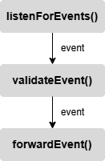

SC Figure 1.10.0.3 – orchestrateNotification()
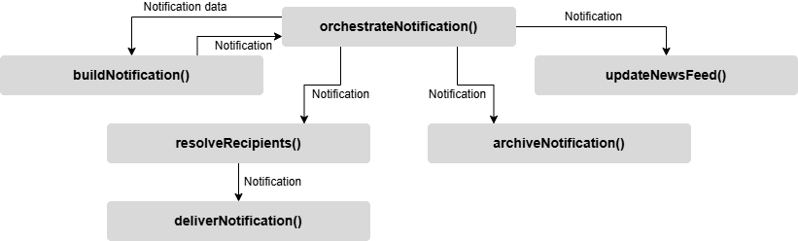

SC Figure 1.10.0.4 – formatNotification()
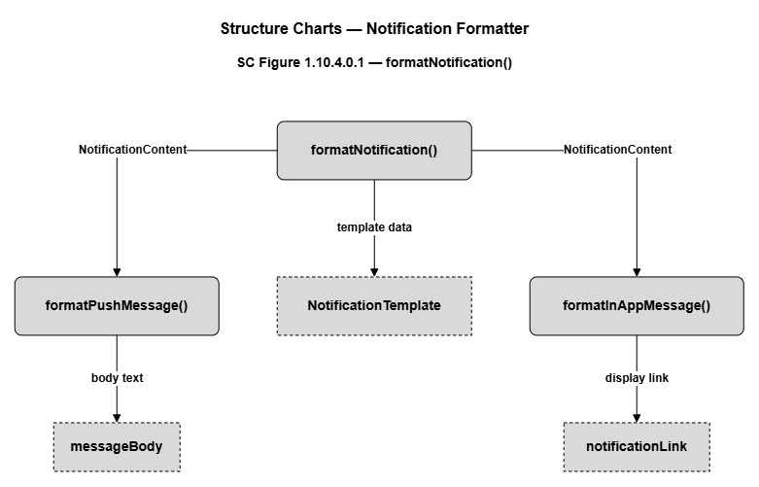

SC Figure 1.10.0.5 – notifiationRepository()
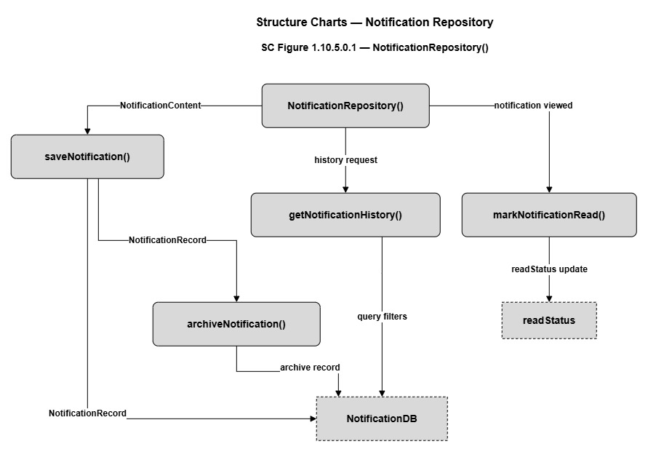

SC Figure 1.10.0.6 – resolveRecipient()
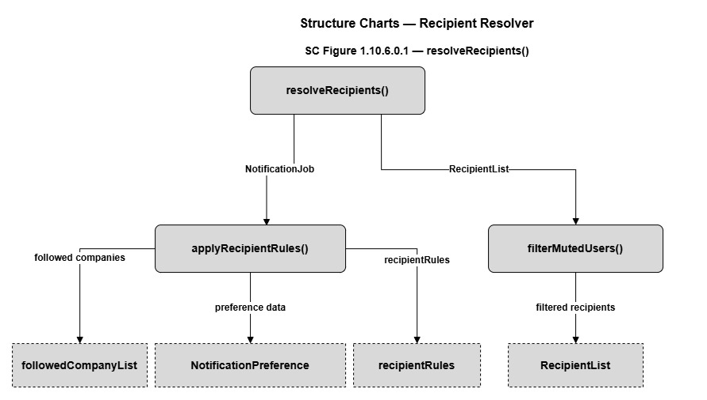

SC Figure 1.10.0.7 — pushDeliveryComponent()
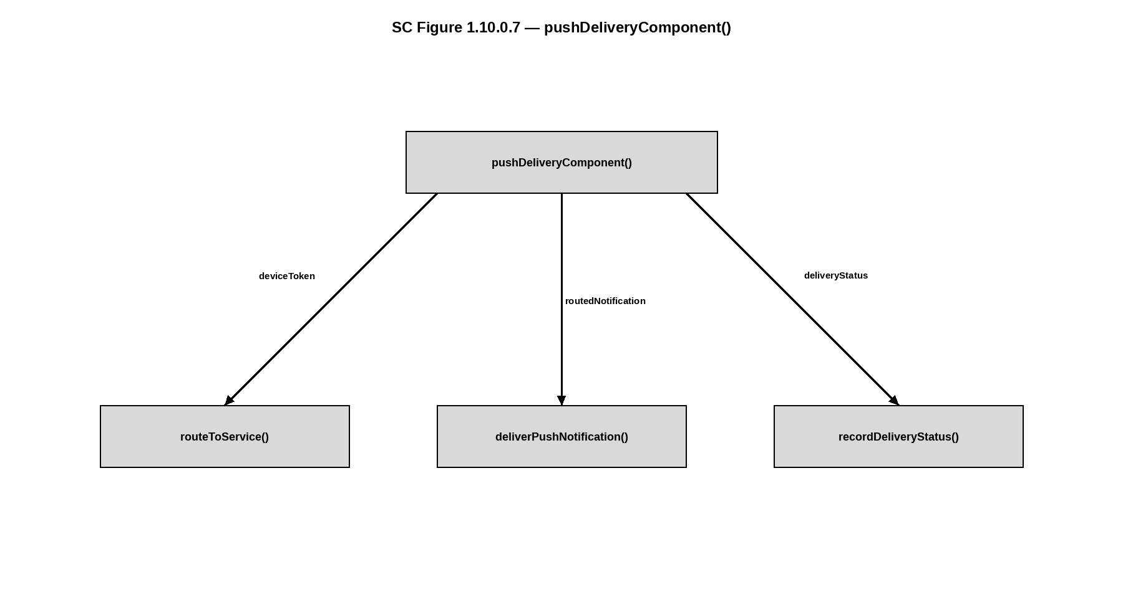

Data Flow Diagrams - Communication Service

DFD Figure 1.10.0.0.1 – Event Listener

DFD Figure 1.10.0.0.2 – Event Source

DFD Figure 1.10.0.0.3 – Notification Controller
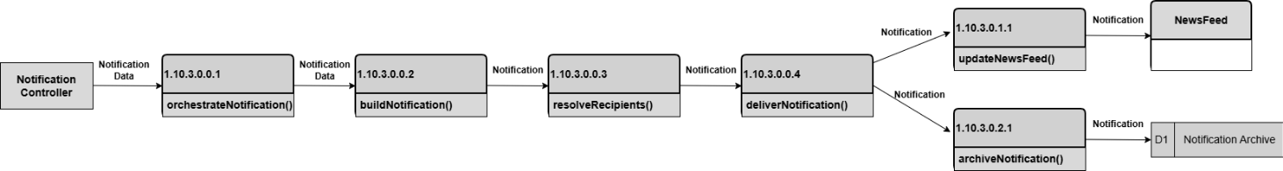

DFD Figure 1.10.0.0.4 – Notification Formatter
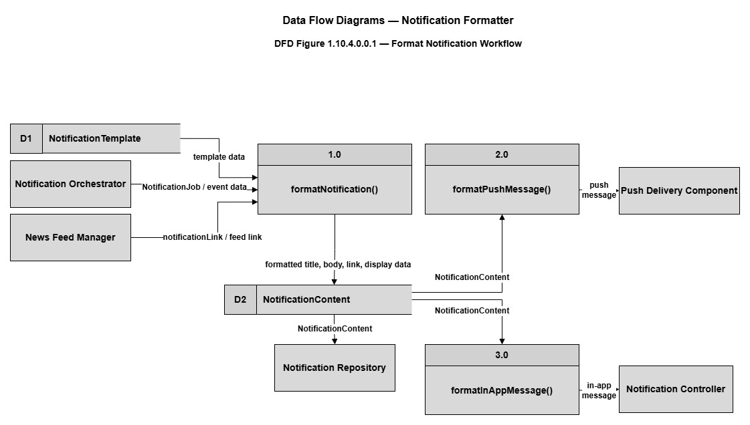

DFD Figure 1.10.0.0.5 – Notification Repository
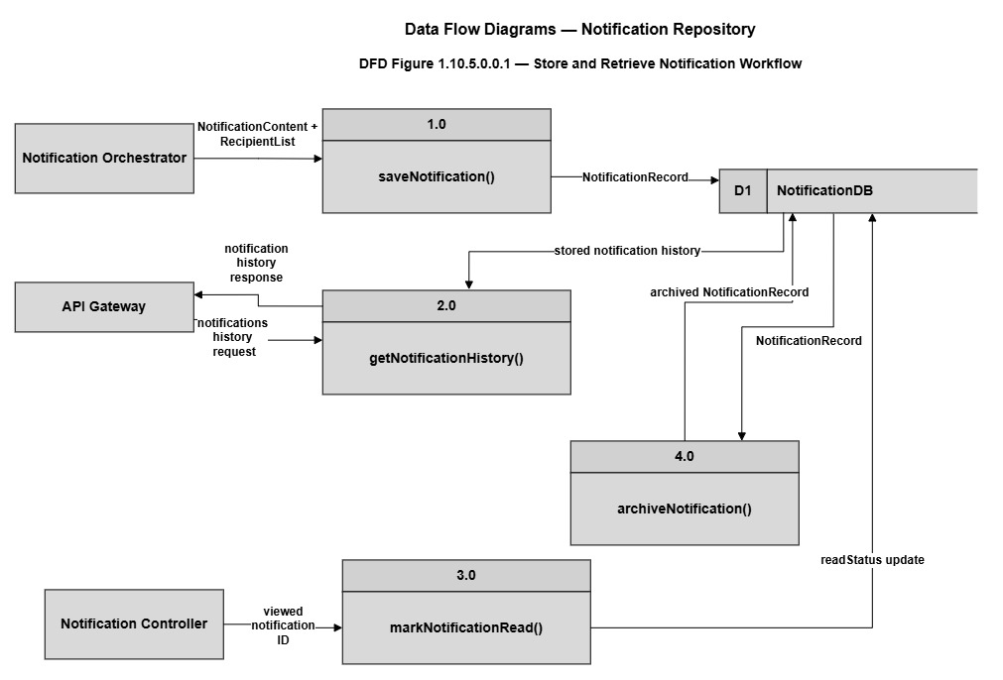

DFD Figure 1.10.0.0.6 – Recipient Resolver
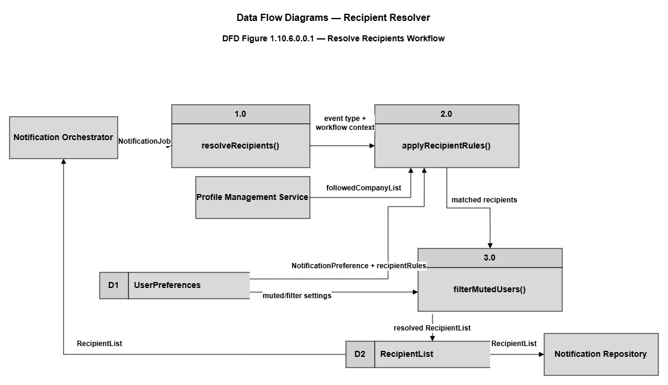

DFD Figure 1.10.0.0.7 — Push Delivery Component
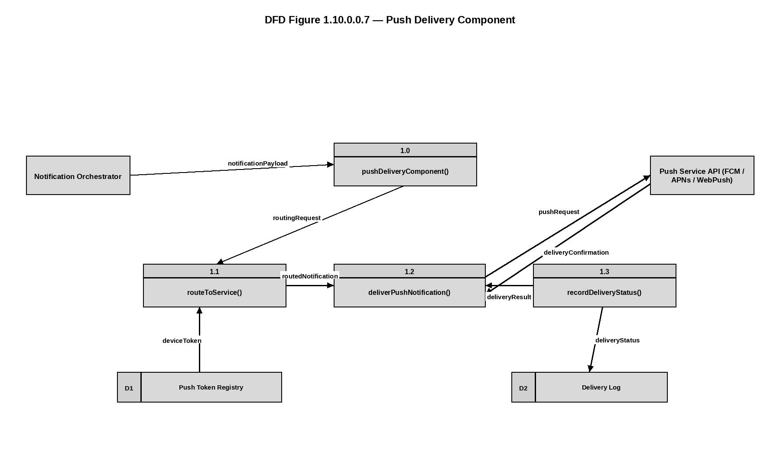

DFD Figure 1.10.0.0.8 — News Feed Manager
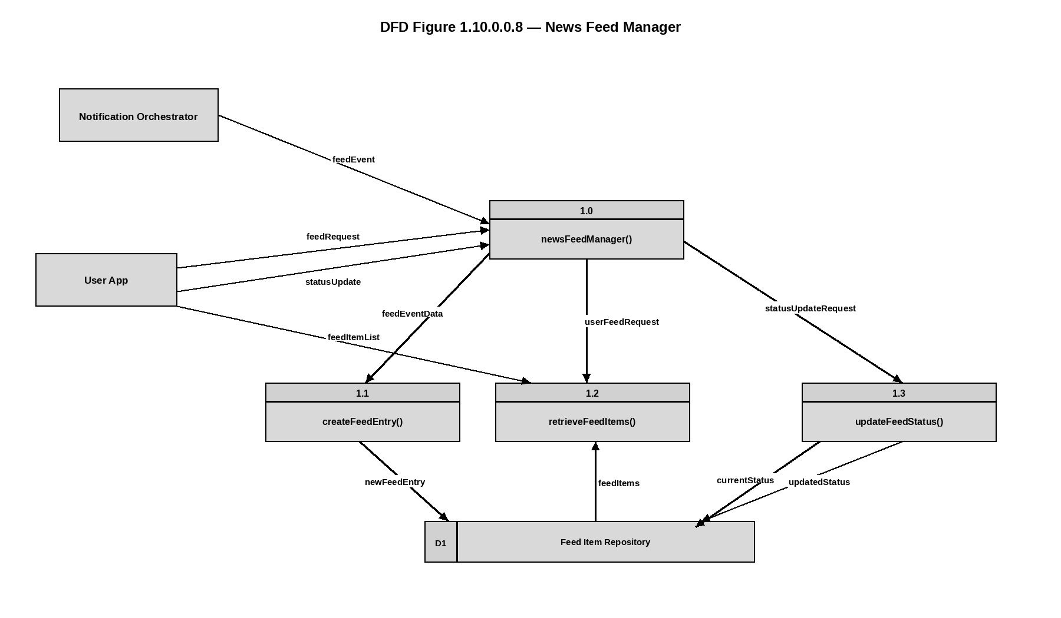

Figure 1.11 — Recommendation Service Detail
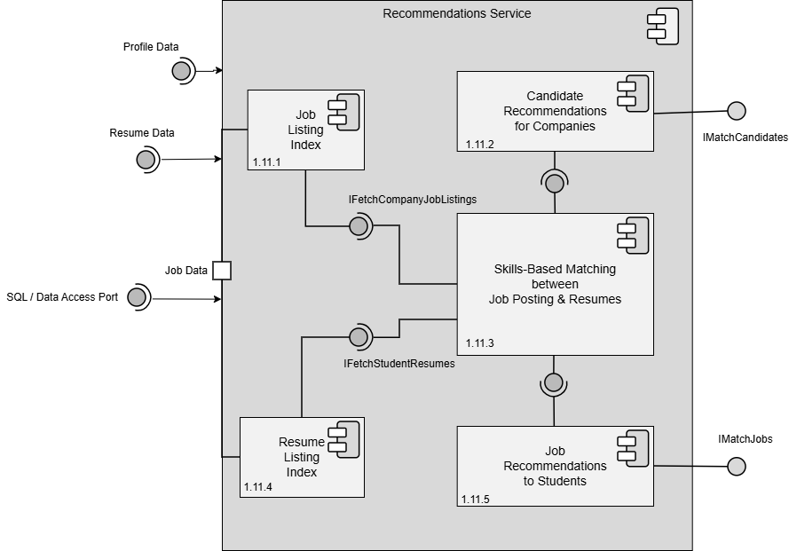

Design Information – Recommendation Service
Field | Description / Purpose
View Name & Number | 1.11 Recommendation Service
Purpose | Describe the recommendation service.
Description | Basic service demonstrating the recommendation service.
Requirements | Implicit in SRS 2.3 Search (2.3.7 Ranking), 2.1.3.8 (Search), 3.3 (Student Search); supports job and candidate recommendations
Elements | 1.11.1 Job Posting Index
 | 1.11.2 Candidate Recommendations
 | 1.11.3 Skills-Based Matching
 | 1.11.4 Resume Listing Index
 | 1.11.5 Job Recommendations to Students
Navigation / References | 1.4 API Gateway / Orchestrator, 1.6 Profile Management Service, 1.7 Resume Service, 1.8 Job Posting Service, 1.14 Database
Viewpoint | Component Diagram

Entity Identification Tables – Recommendation Service

EI Table 1.11.1 – Job Listing Index
Subcomponent | Entity Name | Entity Type | Description / Purpose | Related Requirement(s) | Collaborators / Related Entities
Recommendation Service | JobIndex | Data Store | Stores the indexed list of all active job postings for fast recommendation retrieval | 2.5.9 | IndexJob()
Recommendation Service | IndexJob() | Function | Adds a newly created or updated job posting into the searchable index | 2.5.1, 2.5.9 | JobIndex

EI Table 1.11.2 – Candidate Recommendations for Companies
Subcomponent | Entity Name | Entity Type | Description / Purpose | Related Requirement(s) | Collaborators / Related Entities
Recommendation Service | CandidateRecommender | Module | Generates a ranked list of student profiles for a specific company based on requirement | 2.3.1, 2.3.3 | recommendCandidates()
Recommnedation Service | recommendCandidates() | Function | Processes company search filters to suggest matching student resumes | 2.3.2, 2.3.3 | CandidateRecommender, ResumeIndex

EI Table 1.11.3 – Skills-Based Matching Between Job Posting & Resumes
Subcomponent | Entity Name | Entity Type | Description / Purpose | Related Requirement(s) | Collaborators / Related Entities
Recommendation Service | SkillMatcher | Class | Compares the requires skills of a job to the skills listed on a student’s resume | 2.5.2, 3.1.3.1 | calculateMatchScore()
Recommendation Service | calculateMatchScore() | Method | Computes a compatibility percentage based on shared skills between the job and resume | 2.3.3, 3.3.3 | Skill Matcher

EI Table 1.11.4 – Resume Listing Index
Subcomponent | Entity Name | Entity Type | Description / Purpose | Related Requirement(s) | Collaborators / Related Entities
Recommendation Service | ResumeIndex | Data Store | Maintains a highly optimized database of student resumes for recommendation operations | 3.5.1, 3.5.3 | indexResume()
Recommendation Service | indexResume() | Function | Updates the searchable index whenever a student modifies or uploads their resume. | 3.5.2, 3.5.5.1 | ResumeIndex

EI Table 1.11.5 – Job Recommendations to Students
Subcomponent | Entity Name | Entity Type | Description / Purpose | Related Requirement(s) | Collaborators / Related Entities
Recommendation Service | JobRecommender | Module | Generates a list of suggested job postings tailored to a student’s specific profile criteria | 3.3.3 | recommendJobs()
Recommendation Service | recommendJobs() | Function | Analyzes a student’s skills and degree to recommend relevant job postings to their dashboard | 3.3.3, 3.3.4 | JobRecommender, JobIndex

Structure Charts - Recommendation Service

SC Figure 1.11.0.1 — filterCandidatesByRequirement()
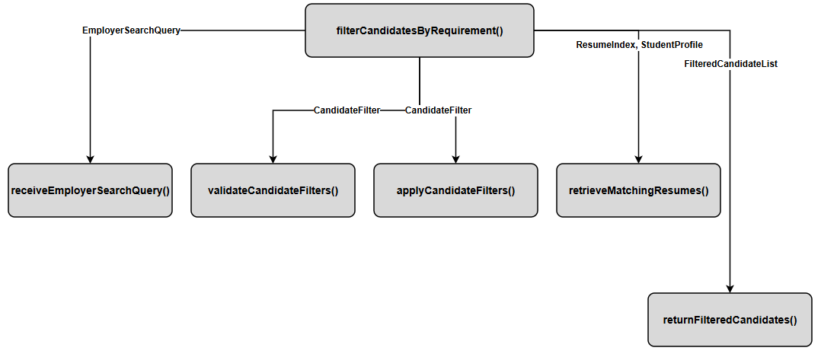

SC Figure 1.11.0.2 — generateRecommendations()
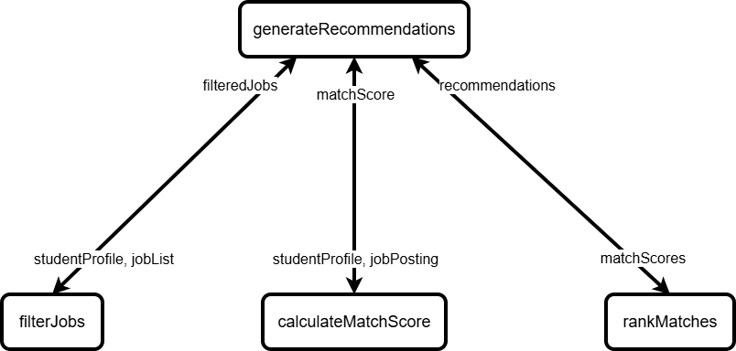

SC Figure 1.11.0.3 — calculateMatchScore()
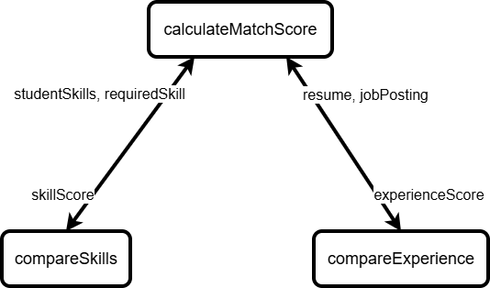

Data Flow Diagrams - Recommendation Service

DFD Figure 1.11.0.0.1 – Employer Candidate Search Filter and Recommendation
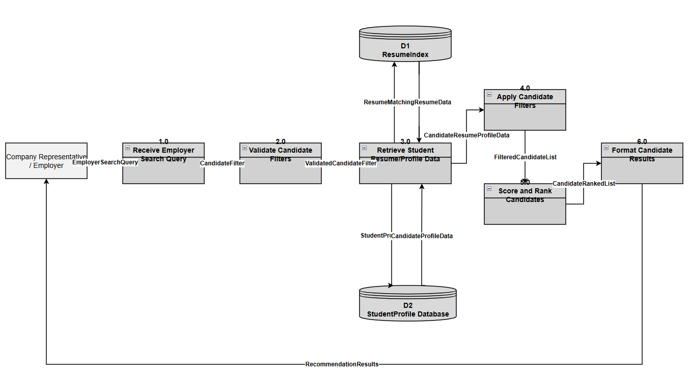

DFD Figure 1.11.0.0.2 – Student-to-Job Matching
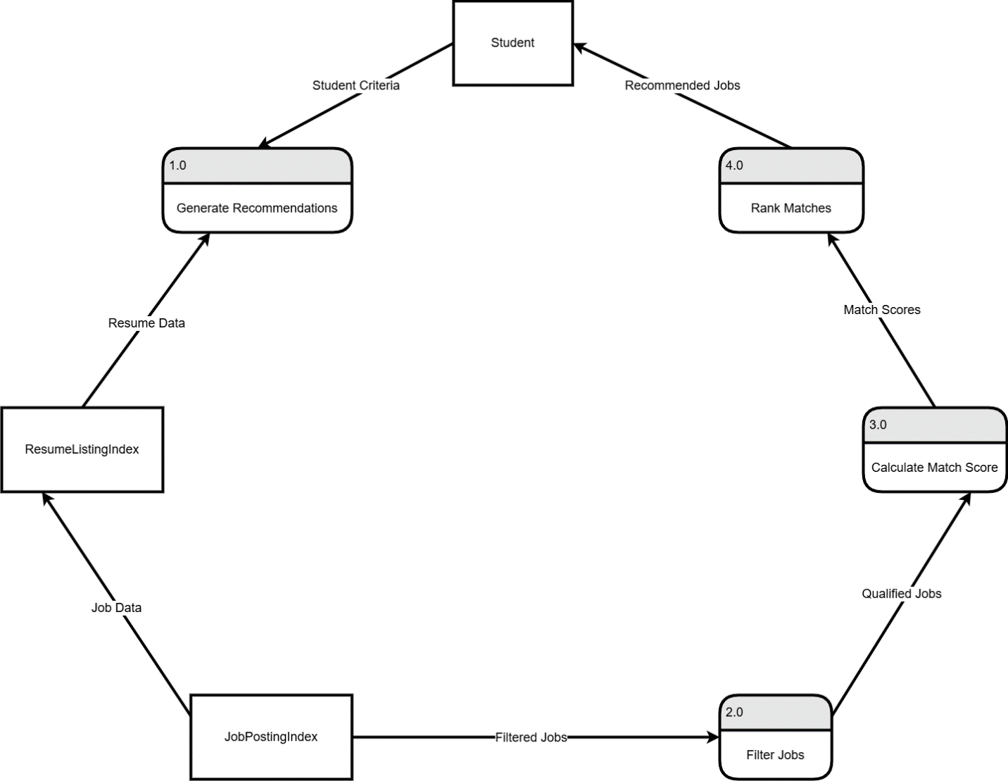

Figure 1.12 — External Services Detail
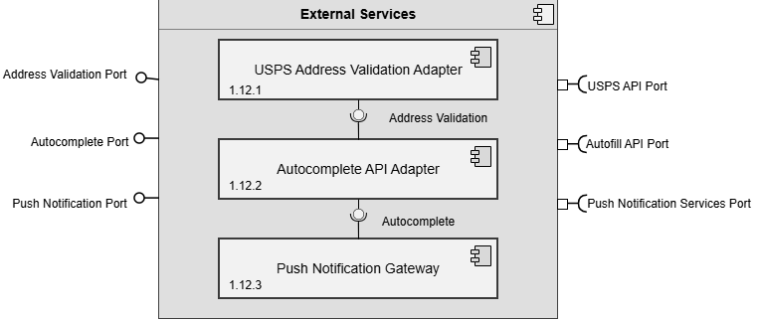

Design Information – External Services
Field | Description / Purpose
View Name & Number | 1.12 External Services
Purpose | Describe the external services.
Description | Basic service demonstrating the external services.
Requirements | SRS 2.1.3.9 (USPS address validation), 2.3.6 (Autocomplete API), 2.2.3–2.2.4 (Push notification delivery)
Elements | 1.12.1 USPS Validation
 | 1.12.2 Autocomplete API Adapter
 | 1.12.3 Push Notifications Gateway
Navigation / References | 1.4 API Gateway / Orchestrator
Viewpoint | Component Diagram

Entity Identification Tables – External Services

EI Table 1.12.1 – USPS Validation Adapter
Subcomponent | Entity Name | Entity Type | Description / Purpose | Related Requirement(s) | Collaborators / Related Entities
USPS Address Validation Adapter | validateAddress() | Function | Validates a company location against USPS address standards before saving. | 2.1.3.7, 2.1.3.9 | USPS API, CompanyLocation
USPS Address Validation Adapter | AddressRequest | Object | Stores address information submitted by a company representative. | 2.1.3.5, 2.1.3.7 | CompanyLocationForm, validateAddress()
USPS Address Validation Adapter | ValidatedAddress | Object | Stores the USPS-standardized address returned from validation. | 2.1.3.9 | USPS API, CompanyLocation
USPS Address Validation Adapter | addressFields | Variable | Stores street, suite/building number, city, state, country, and ZIP code values. | 2.1.3.7 | AddressRequest
USPS Address Validation Adapter | CompanyLocationData | Data Table | Stores validated company location records. | 2.1.3.3, 2.1.3.4, 2.1.3.5 | Database, CompanyLocation
USPS Address Validation Adapter | /api/address/validate | API Endpoint | Receives address validation requests and returns USPS-standardized addresses. | 2.1.3.7, 2.1.3.9 | validateAddress(), ValidatedAddress

EI Table 1.12.3 – Push Notification Gateway
Subcomponent | Entity Name | Entity Type | Description / Purpose | Related Requirement(s) | Collaborators / Related Entities
External Services Orchestrator | pushNotificationGateway() | Function | Manages and securely delivers app notifications by standardizing data, routing messages to each user’s device, and temporarily storing notifications for offline users. | 1.12.1–1.12.3 | USPSAddressValidationAdapter, AutocompleteAPIAdapter
External Services Orchestrator | USPSAddressValidationAdapter | Module | Validates and standardizes user addresses through USPS services. | 1.12.1–1.12.3 | pushNotificationGateway()
External Services Orchestrator | AutocompleteAPIAdapter | Module | Provides address and location autocomplete suggestions through external APIs. | 1.12.1–1.12.3 | pushNotificationGateway()

Structure Charts – External Services

SC Figure 1.12.0.1 – USPS Address Validation Adaptor
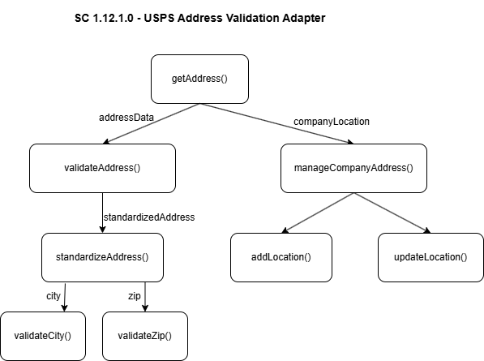

SC Figure 1.12.0.3 — pushNotificationGateway()
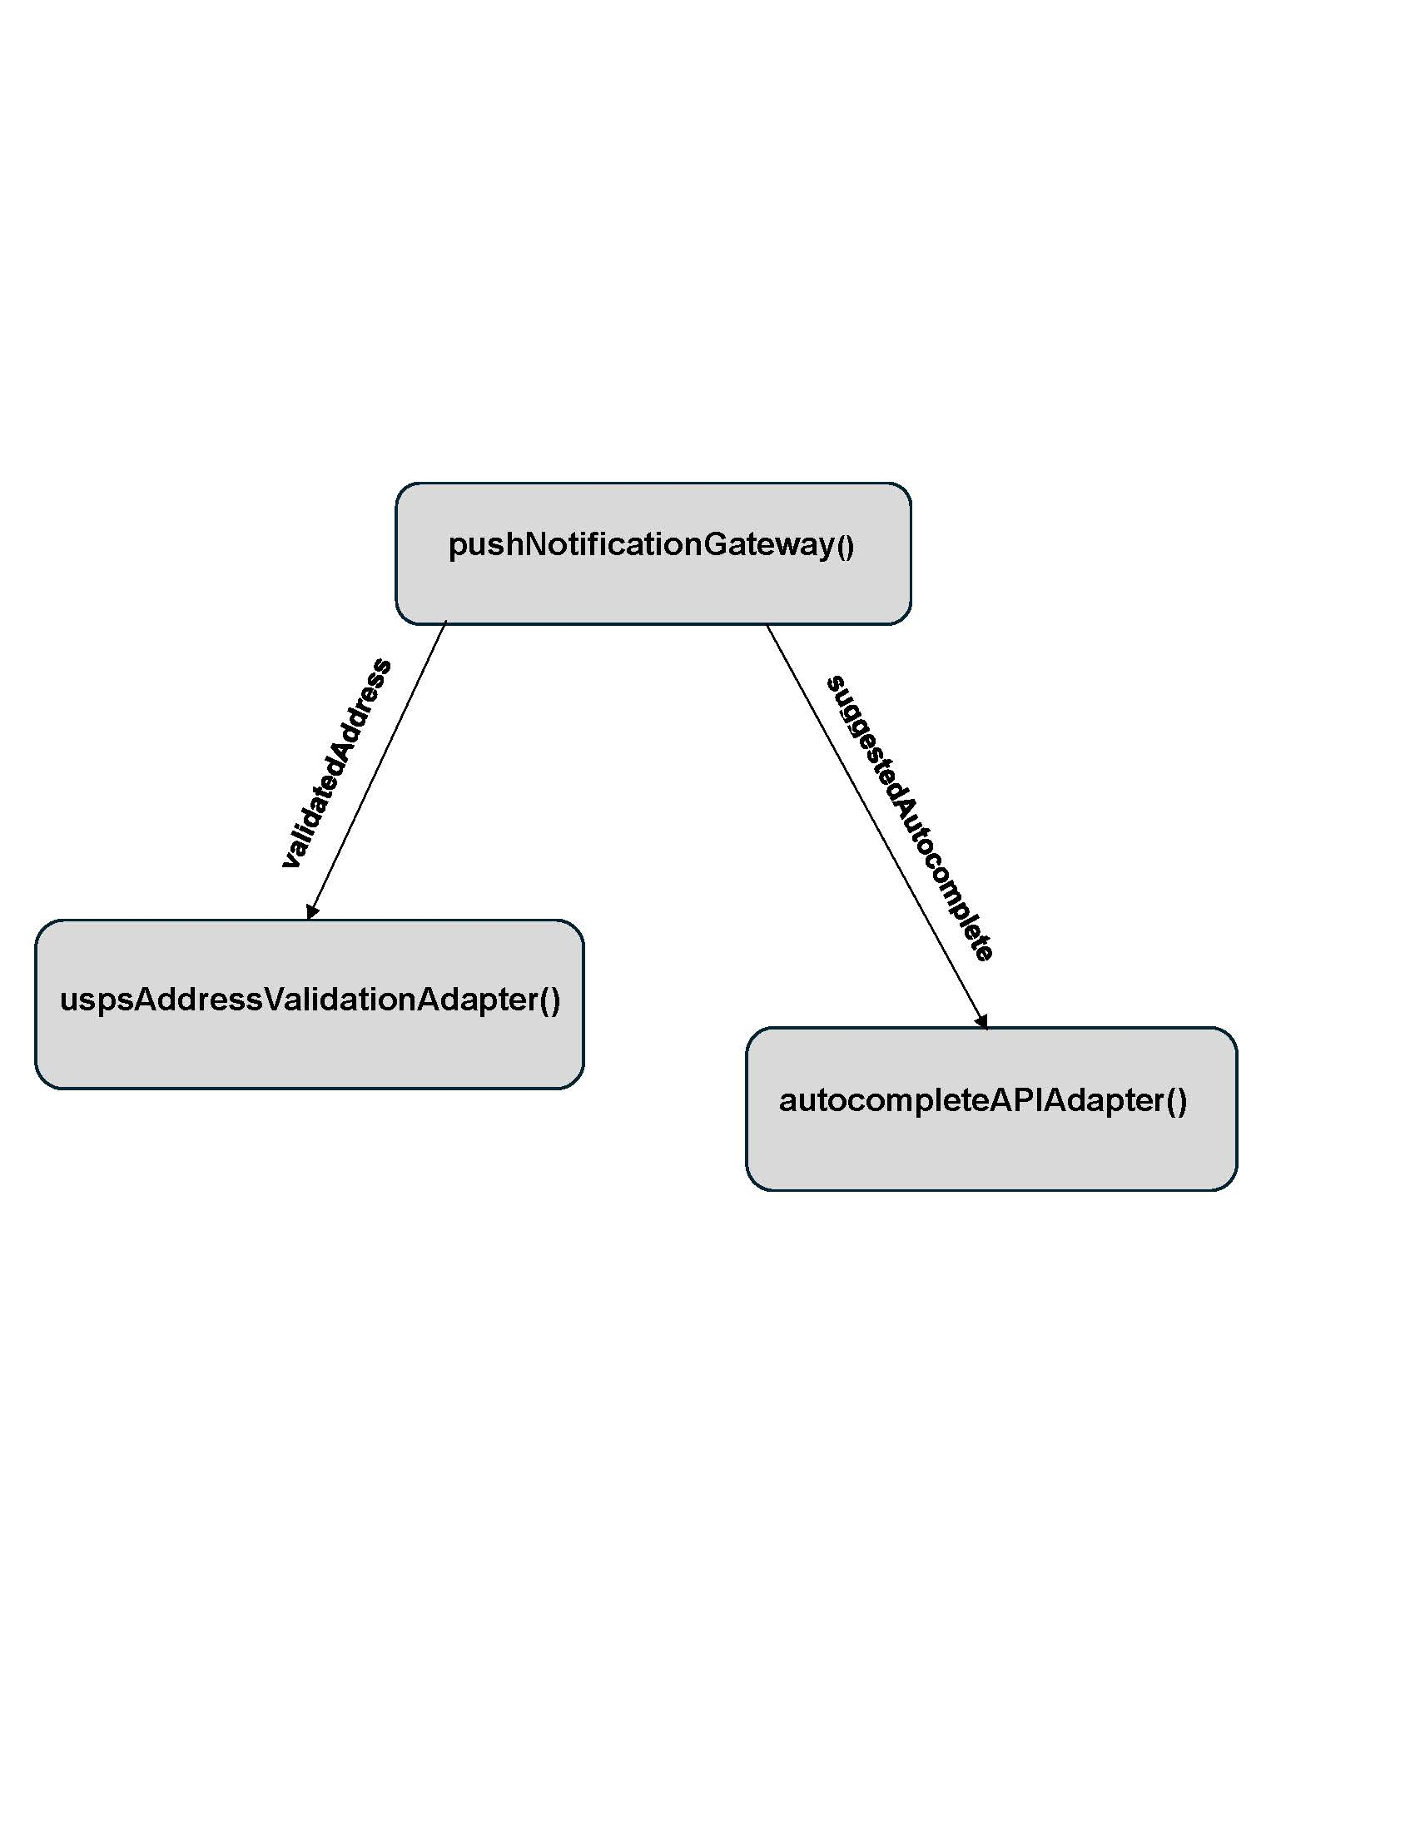

Data Flow Diagram – External Services

DFD Figure 1.12.0.0.1 – Autocomplete API Adapter
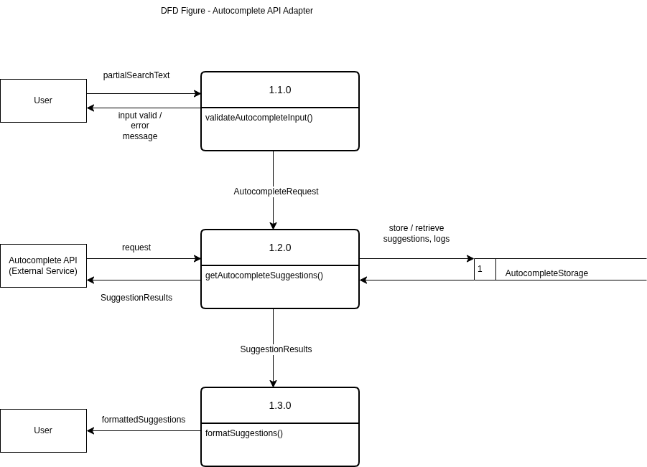

DFD Figure 1.12.0.0.3 — Push Notification Gateway
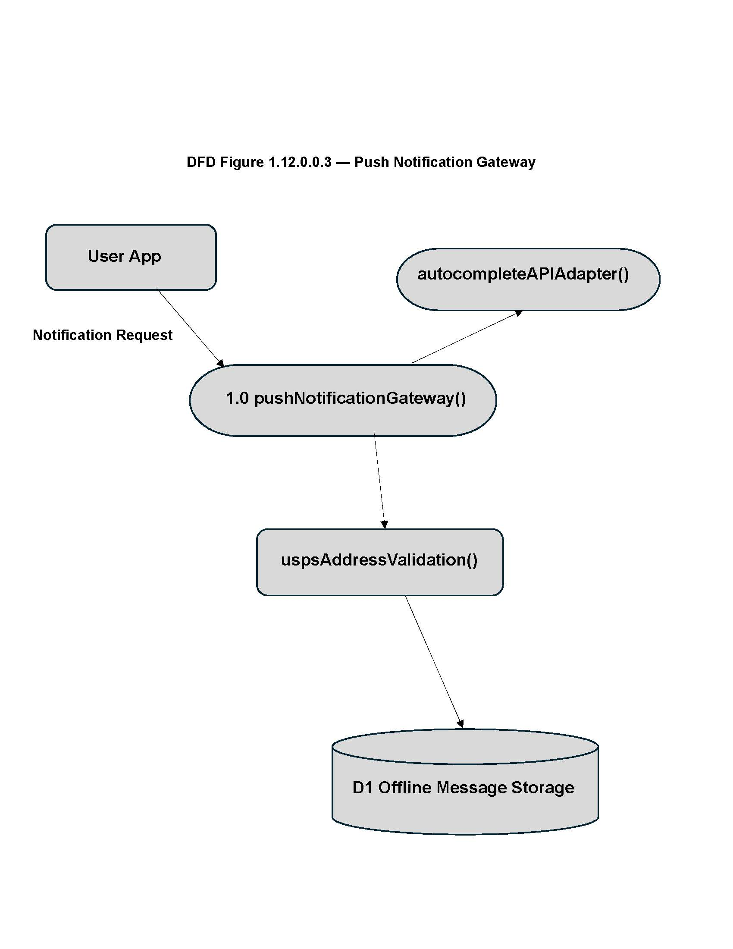

Figure 1.13 — Analytics Service Detail
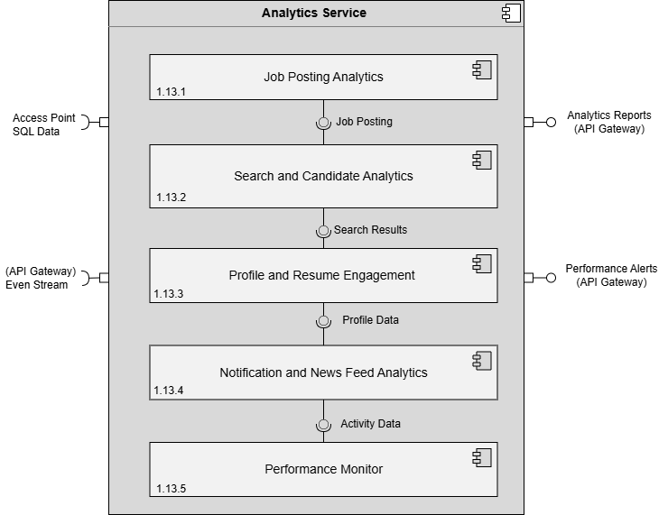

Design Information – Analytics Service
Field | Description / Purpose
View Name & Number | 1.13 Analytics Service
Purpose | Describe the analytics service.
Description | Basic service demonstrating the analytics service.
Requirements | SRS 2.1.3.6 (Company analytics), 2.5.7 (Job posting status/performance tracking)
Elements | 1.13.1 Job Posting Analytics
 | 1.13.2 Search and Candidate Analytics
 | 1.13.3 Profile and Resume Engagement
 | 1.13.4 Notifications and News Feed Analytics
 | 1.13.5 Performance Monitor
Navigation / References | 1.4 API Gateway / Orchestrator, 1.14 Database
Viewpoint | Component Diagram

Entity Identification Tables – Analytics Service Detail

EI Table 1.13.1 – Job Posting Analytics
Subcomponent | Entity Name | Entity Type | Description / Purpose | Related Requirement(s) | Related Collaborators / Entities
Job Posting Manager | manageJobPosting() | Function | Used so a company representative can add, edit, or delete a job posting. | 2.5.1 | addJobPosting(), editJobPosting(), deleteJobPosting(), jobPostingId, JobPosting, /api/job-postings
Job Posting Manager | addJobPosting() | Function | Used so a company representative can add/save a job posting to the database, including adding a list of required skills and free-form job descriptions | 2.5.1, 2.5.7 | manageJobPosting(), jobPostingData, JobPosting, /api/job-postings
Job Posting Manager | editJobPosting() | Function | Used so a company representative can edit/save a job posting to the database, including editing a list of required skills and free-form job descriptions | 2.5.1, 2.5.7 | manageJobPosting(), jobPostingData, jobPostingId, JobPosting, /api/job-postings
Job Posting Manager | deleteJobPosting() | Function | Used so a company representative can delete a job posting from the database, including deleting a list of required skills and free-form job descriptions | 2.5.1, 2.5.7 | manageJobPosting(), jobPostingId, JobPosting, /api/job-postings
Job Posting Manager | jobPostingData | Variable | Stores the job posting data to be stored in the JobPosting data table | 2.5.1, 2.5.7, 2.5.9 | manageJobPosting(), JobPosting, addJobPosting(), editJobPosting()
Job Posting Manager | jobPostingId | Variable | Stores the job posting ID to be used to edit or delete a job posting | 2.5.1 | manageJobPosting(), editJobPosting(), deleteJobPosting(), JobPosting
Job Posting Manager | JobPosting | Data Table | Used so a company representative can store a job posting to the database, including a list of required skills and free-form job descriptions | 2.5.1-2.5.2, 2.5.7, 2.5.9 | addJobPosting(), editJobPosting(), deleteJobPosting(), jobPostingData, jobPostingId, /api/job-postings
Job Posting Manager | job_posting_skill_ids | Variable | Stores a list of skill IDs for a job posting | 2.5.2 | RequiredJobSkillsDictionary, saveRequiredSkills(), addRequiredSkill(), editRequiredSkill(), deleteRequiredSkill(), /api/job-postings/required-skills
Job Posting Manager | RequiredJobSkillsDictionary | Data Table | A normalized data table dictionary used to retrieve the text for required skills for a job posting by skill ID and allows a skill to accommodate any text length | 2.5.2, 2.5.5 | job_posting_skill_ids, saveRequiredSkills(), addRequiredSkill(), editRequiredSkill(), deleteRequiredSkill(), /api/job-postings/required-skills
Job Posting Manager | saveRequiredSkills() | Function | Used so a company representative may save required job skills to a job posting by checking checkboxes | 2.5.3 | job_posting_skill_ids, RequiredJobSkillsDictionary, /api/job-postings/required-skills
Job Posting Manager | addRequiredSkill() | Function | Used so a company representative can add/save a new required skill to a job posting | 2.5.4 | job_posting_skill_ids, RequiredJobSkillsDictionary, /api/job-postings/required-skills
Job Posting Manager | editRequiredSkill() | Function | Used so a company representative can edit an existing required skill on a job posting | 2.5.4 | job_posting_skill_ids, RequiredJobSkillsDictionary, /api/job-postings/required-skills
Job Posting Manager | deleteRequiredSkill() | Function | Used so a company representative can delete a required skill from a job posting | 2.5.4 | job_posting_skill_ids, RequiredJobSkillsDictionary, /api/job-postings/required-skills
Job Posting Manager | ResumeSubmissions | Data Table | Stores all resume form submissions for a job posting | 2.5.6 | getResumeSubmissions(), DisplayResumeSubmissions
Job Posting Manager | getResumeSubmissions() | Function | Fetches all resume form submissions for a job posting and accepts parameters to sort and filter candidates | 2.5.6, 2.5.8 | ResumeSubmissions, DisplayResumeSubmissions, SortCandidates
Job Posting Manager | DisplayResumeSubmissions | Class | Displays all resume form submissions for a job posting | 2.5.6 | ResumeSubmissions, getResumeSubmissions()
Job Posting Manager | SortCandidates | Class | Used so a company representative may sort candidates using filters | 2.5.8 | getResumeSubmissions()
Job Posting Manager | /api/job-postings/required-skills | API Endpoint | Handles incoming API HTTP requests POST, PUT, DELETE for required skills | 2.5.2-2.5.5 | job_posting_skill_ids, RequiredJobSkillsDictionary, saveRequiredSkills(), addRequiredSkill(), editRequiredSkill(), deleteRequiredSkill()
Job Posting Manager | /api/job-postings | API Endpoint | Handles incoming API HTTP requests: POST, PUT, DELETE for job postings | 2.5.1, 2.5.7, 2.5.9 | JobPosting, addJobPosting(), editJobPosting(), deleteJobPosting()

EI Table 1.13.2 – Search and Candidate Analytics
Subcomponent | Entity Name | Entity Type | Description / Purpose | Related Requirement(s) | Related Collaborators / Entities
Candidate Search Manager | searchCandidates() | Function | Pulls a list of all the candidates matching a user’s selected criteria | 2.3.1-2.3.8 | activeSearchFilters, candidateSearchResults, searchQuery, parsedQuery, /api/search/candidates
Candidate Search Manager | CandidateSearchFilter | Class | Filters candidates by the filter the user selects (skills, location, work preference, willingness to relocate, position type, start date availability, years of experience, degree level, graduation date, application source, GPA) | 2.3.2-2.3.4, 2.3.8 | activeSearchFilters
Candidate Search Manager | activeSearchFilters | Variable | Stores all of the active filters the user selects | 2.3.2-2.3.4, 2.3.8 | searchCandidates(), CandidateSearchFilter, /api/search/candidates
Candidate Search Manager | candidateSearchResults | Variable | Stores all the candidate profiles that matches with the selected filters the user selects | 2.3.2, 2.3.3, 2.3.5 | searchCandidates(), displayFilteredCandidates()
Candidate Search Manager | displayFilteredCandidates() | Function | Displays filtered candidate profiles and their resumes within 3 seconds of search request submission | 2.3.5 | candidateSearchResults
Candidate Search Manager | autoFillSearchBar() | Function | Main function that auto fills search bar by fetching suggestions from what the user inputs | 2.3.6 | fetchAutoFillSuggestions(), searchInput, autoFillSuggestions, AutoFillAPI
Candidate Search Manager | fetchAutoFillSuggestions() | Function | Calls the Auto Fill API to retrieve suggestions from what the user inputted | 2.3.6 | autoFillSearchBar(), searchInput, autoFillSuggestions, AutoFillAPI
Candidate Search Manager | searchInput | Variable | Stores the input the user enters in the search bar | 2.3.6 | autoFillSearchBar(), fetchAutoFillSuggestions(), autoFillSuggestions
Candidate Search Manager | autoFillSuggestions | Variable | Stores the suggestions retrieved from the AutoFillAPI so it can be displayed to the user | 2.3.6 | autoFillSearchBar(), fetchAutoFillSuggestions(),searchInput, autoFillAPI
Candidate Search Manager | AutoFillAPI | Module | Fetches words from a normalized dictionary as a user types to suggest autocomplete words | 2.3.6 | autoFillSearchBar(), fetchAutoFillSuggestions(), autoFillSuggestions
Candidate Search Manager | searchQuery | Variable | Stores the search criteria the user entered | 2.3.7 | searchCandidates(), parseWildcardSearches()
Candidate Search Manager | parsedQuery | Variable | Stores the search criteria with wildcard symbols converted to RegEx | 2.3.7 | searchCandidates(), parseWildcardSearches()
Candidate Search Manager | parseWildcardSearches() | Function | Converts wildcard symbols such as * or ? into queries using Regex to accommodate flexible searching | 2.3.7 | /api/search/candidates, searchQuery, parsedQuery
Candidate Search Manager | /api/search/candidates | API Endpoint | Handles incoming HTTP requests for candidate search based on matches, wildcards, and filters | 2.3.1–2.3.8 | searchCandidates(), activeSearchFilters , parseWildcardSearches()

EI Table 1.13.3 – Profile and Resume Engagement
Subcomponent | Entity Name | Entity Type | Description / Purpose | Related Requirement(s) | Collaborators / Related Entities
Profile and Resume Engagement | viewStudentProfile() | Function | Allows a company representative to view a student's profile information. | 3.1.3.1, 3.1.3.4 | StudentProfile, Resume
Profile and Resume Engagement | StudentProfile | Object | Stores student profile information including contact information, GPA, portfolio, resume, and skills. | 3.1.3.1 | Resume, ProfileView
Profile and Resume Engagement | Resume | Object | Stores resume information submitted by a student user. | 3.5.1, 3.5.2 | StudentProfile
Profile and Resume Engagement | followStudent() | Function | Allows a company representative to follow a student user. | 2.1.1 | StudentProfile
Profile and Resume Engagement | ProfileView | Object | Records when a company representative views a student profile. | 3.2.5 | StudentProfile, ProfileViewNotification
Profile and Resume Engagement | ResumeMatch | Object | Represents a resume that satisfies company skill requirements | 2.2.5, 2.5.2 | validateAddress(), ValidatedAddress
Profile and Resume Engagement | ProfileViewNotification | Object | Stores notification data when a profile view triggers a student notification | 3.2.5 | ProfileView
Profile and Resume Engagement | ResumeRepository | Data Table | Stores submitted resumes and associated user tags. | 3.1.5 | Resume
Profile and Resume Engagement | StudentProfileRepository | Data Table | Stores student profile information available to company representatives. | 3.1.3.1 | StudentProfile
Profile and Resume Engagement | /api/profile/view | API Endpoint | Endpoint  Handles requests to retrieve student profile information. | 3.1.3.4 | viewStudentProfile(), StudentProfile

EI Table 1.13.4 – Notification and News Feedback Analytics
Subcomponent | Entity Name | Entity Type | Description / Purpose | Related Requirement(s) | Collaborators / Related Entities
Analytics Services Orchestrator | notificationAndNewsFeedbackAnalytics() | Function | Monitors, collects, and analyzes user interactions and reactions to app notifications and news feeds. | 1.13.1–1.13.4 | JobPostingAnalytics, SearchAndCandidateAnalytics, ProfileAndResumeEngagement
Analytics Services Orchestrator | JobPostingAnalytics | Module | Collects and analyzes job posting engagement metrics. | 1.13.1–1.13.4 | notificationAndNewsFeedbackAnalytics()
Analytics Services Orchestrator | SearchAndCandidateAnalytics | Module | Analyzes search activity and candidate interaction metrics. | 1.13.1–1.13.4 | notificationAndNewsFeedbackAnalytics()
Analytics Services Orchestrator | ProfileAndResumeEngagement | Module | Tracks profile views, resume interactions, and engagement trends. | 1.13.1–1.13.4 | notificationAndNewsFeedbackAnalytics()

EI Table 1.13.5 – Performance Monitor
Subcomponent | Entity Name | Entity Type | Description / Purpose | Related Requirement(s) | Related Collaborators / Entities
Performance Monitor | PerformanceMonitor | Class | Consumes activity data and event streams to track system performance and produce alerts and reports for the API gateway. | 4.1, 2.5.7 | APIGateway, Database, JobPostingAnalytics, SearchAndCandidateAnalytics, ProfileAndResumeEngagement, NotificationAndNewsFeedAnalytics
Performance Monitor | ActivityData | Object | Inbound data objects passed from upstream analytics component containing system activity events to be monitored. | 2.5.7 | PerformanceMonitor, NotificationAndNewsFeedAnalytics
Performance Monitor | PerformanceAlert | Object | Outbound object produced when a monitored metric exceeds an acceptable threshold, sent to the API Gateway. | 4.1 | PerformanceMonitor, APIGateway
Performance Monitor | AnalyticReport | Object | Outbound object containing aggregated performance data delivered to the API Gateway for display or storage. | 2.5.7 | PerformanceMonitor, APIGateway
Performance Monitor | monitorPerformance() | Method | Continuously evaluates incoming activity data and event stream metrics against performance thresholds. | 4.1, 2.5.7 | ActivityData, APIGatewayEventStream
Performance Monitor | generateAlert() | Method | Produces and dispatches a PerformanceAlert to the API Gateway when a metric breach is detected. | 4.1 | PerformanceAlert, APIGateway
Performance Monitor | generateReport() | Method | Aggregates monitored metrics into an AnalyticsReport and sends it to the API Gateway. | 2.5.7 | AnalyticsReport, APIGateway
Performance Monitor | APIGatewayEventStream | Data Store | Inbound stream of system events from the API Gateway consumed by the Performance Monitor as a data source. | 4.1, 2.5.7 | PerformanceMonitor, APIGateway
Performance Monitor | AccessPointSQLData | Data Store | SQL database access point supplying persistent system data consumed by the Performance Monitor. | 4.1, 2.5.7 | PerformanceMonitor, Database

Structure Charts - Analytics Service

SC Figure 1.13.0.1 – Analytics Orchaestrator
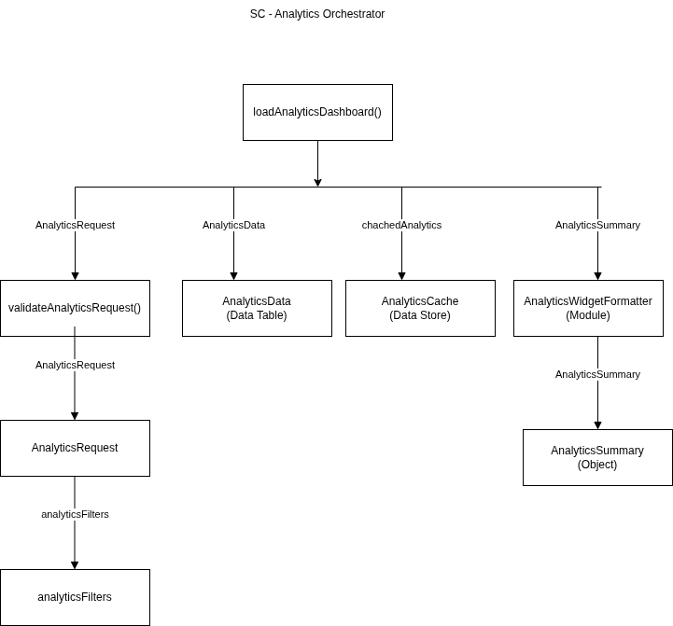

SC Figure 1.13.0.2 – AutoCumplete API Adaptor
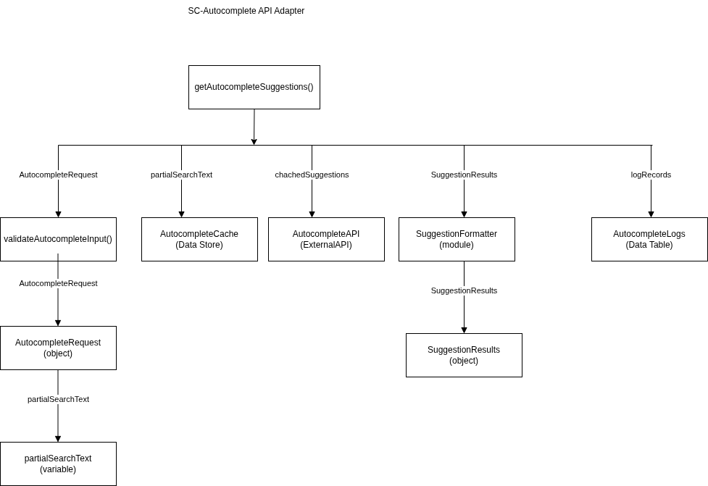

SC Figure 1.13.0.3 – Profile and Resume Engagement
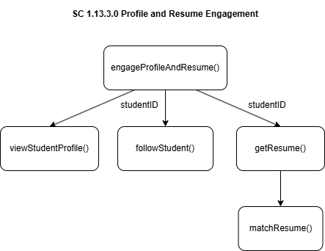

SC Figure 1.13.0.4 – Performance Monitor
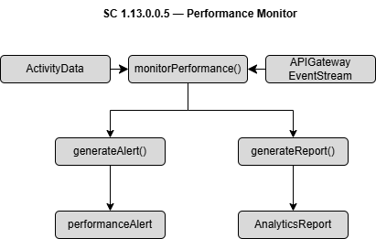

SC Figure 1.13.0.5 – notificationAndNewsFeedbackAnalytics()
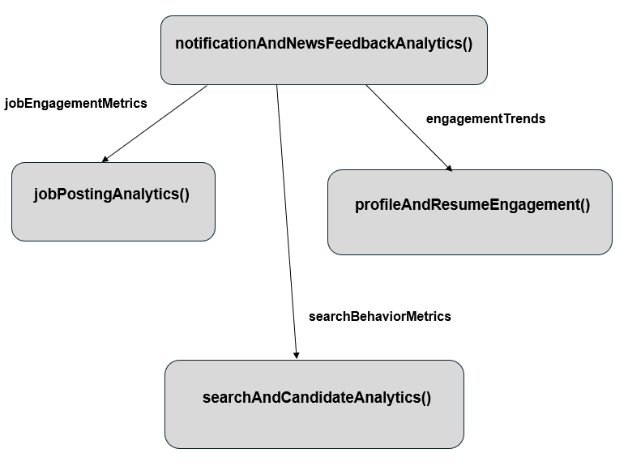

SC Figure 1.13.0.6 — searchCandidates()
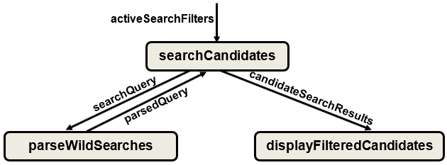

SC Figure 1.13.0.7 — manageJobPosting()
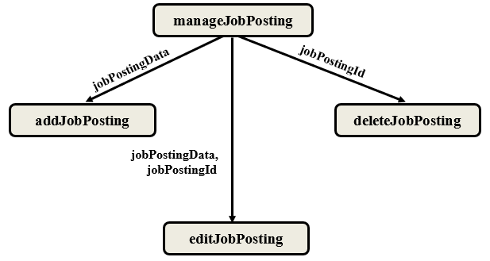

SC Figure 1.13.0.8 — autoFillSearchBar()
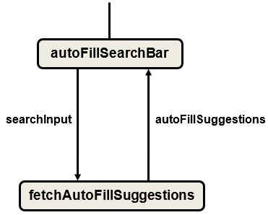

Data Flow Diagrams - Analytics Service

DFD Figure 1.13.0.0.3 – Profile and Resume Service
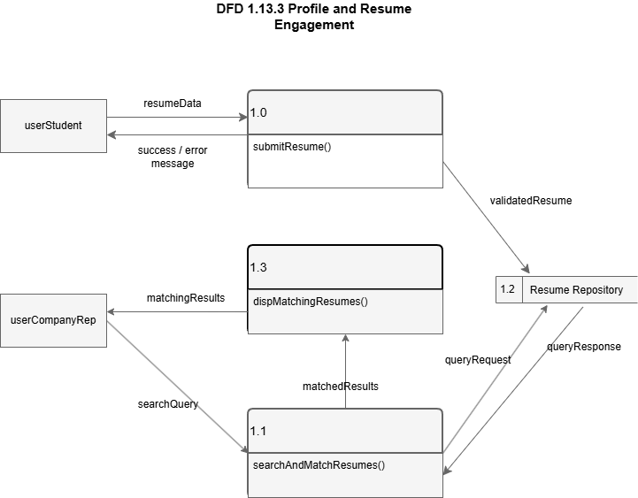

DFD Figure 1.13.0.0.5 – Performance Monitor
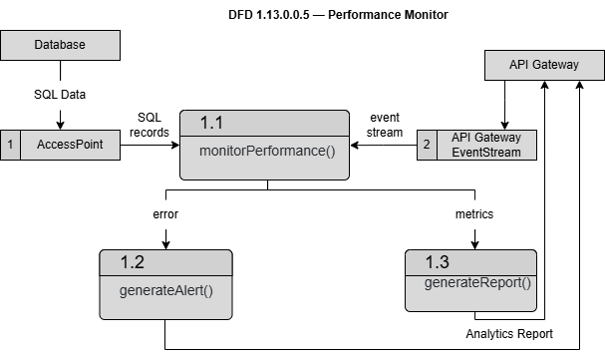

DFD Figure 1.13.0.0.6 — Candidate Search Workflow
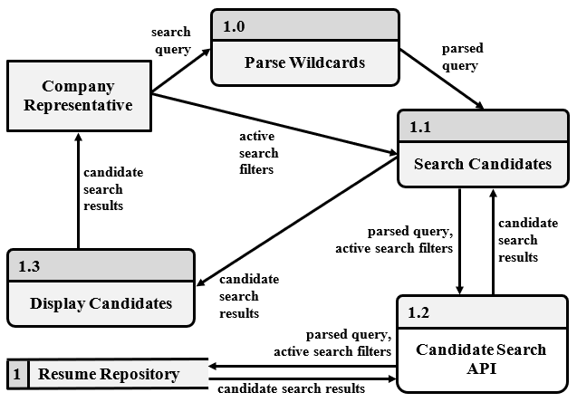

Figure 1.14 — Database Detail
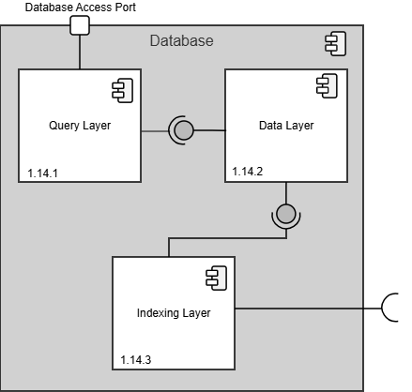

Design Information – Design Information
Field | Description / Purpose
View Name & Number | 1.14 Database
Purpose | Describe the database.
Description | Basic service demonstrating the database.
Requirements | All SRS sections — provides persistent storage for all services. supports 2.1, 2.2, 2.3, 2.4, 2.5, 3.1, 3.2, 3.3, 3.4, 3.5
Elements | 1.14.1 Query Layer
 | 1.14.2 Data Layer
 | 1.14.3 Indexing Layer
Navigation / References | 1.5–1.13 (all service detail views)/ part of Data Storage Layer  (Figure 1.1)
Viewpoint | Component Diagram

Entity Identification Tables – Database

EI Table 1.14.1 – Query Layer
Subcomponent | Entity Name | Entity Type | Description / Purpose | Related Requirement(s) | Collaborators / Related Entities
Query Layer | QueryProcessor | Class | Coordinates execution of database queries | 3.1.3, 2.5.9
Query Layer | SQLParser | Class | Converts SQLStatements into executable search queries | 3.1.3, 2.5.9 | QueryProcessor, ExecutionPlan
Query Layer | QueryOptimizer | Class | Determines the most efficient query execution strategy | 3.1.3, 2.5.9 | SQLParser, ExecutionPlan
Query Layer | ExecutionPlan | Object | Stores the generated plan used to execute a query | 3.1.3, 2.5.9 | QueryOptimizer, QueryExecutor
Query Layer | ResultSet | Object | Contains records returned from a completed query | 3.1.3, 2.5.9 | QueryExecutor
Query Layer | ExecuteQuery() | Method | Processes and executes an incoming query request | 3.1.3, 2.5.9 | QueryProcessor
Query Layer | FetchResults() | Method | Retrieves the query results for the service | 3.1.3, 2.5.9 | ResultSet
Query Layer | ParseSQL() | Method | Parse SQL syntax into internal structures | 3.1.3, 2.5.9 | SQLParser
Query Layer | OptimizeQuery() | Method | Generates an optimized execution plan | 3.1.3, 2.5.9 | QueryOptimizer

EI Table 1.14.2 – Data Layer
Subcomponent | Entity Name | Entity Type | Description / Purpose | Related Requirement(s) | Collaborators / Related Entities
Data Layer | UserProfile | Data Table | Stores persistent student and company user profile data accessible by the system | 3.1.3.1, 2.1.3 | ResumeRecord, JobPosting, FollowRelation
Data Layer | ResumeRecord | Data Table | Stores structured resume form submissions linked to a student user tag | 3.5.1, 3.5.2, 3.1.3.2 | UserProfile, SkillTag, JobPosting
Data Layer | JobPosting | Data Table | Stores persistent job posting data created by company representatives | 2.5.1, 2.5.9, 3.4.1 | UserProfile, RequiredSkillsList, ApplicationRecord
Data Layer | RequiredSkillsList | Data Store | Stores the list of required skills associated with a specific job posting | 2.5.2, 2.5.3, 2.5.4, 2.5.5 | JobPosting, SkillTag
Data Layer | SkillTag | Object | Represents a single keyword skill tag attached to a resume or job posting | 2.2.5, 2.3.3 | ResumeRecord, RequiredSkillsList
Data Layer | FollowRelation | Data Table | Stores follower-followee relationships between student and company users | 2.1.1, 2.2.4, 3.2.2 | UserProfile, NotificationRecord
Data Layer | NotificationRecord | Data Table | Stores notification data pending delivery to a target user | 2.2.1, 3.2.1, 3.2.4 | FollowRelation, UserProfile
Data Layer | ApplicationRecord | Data Table | Stores student resume form submissions sent to a specific job posting | 2.1.2, 2.5.6, 3.1.3.2 | ResumeRecord, JobPosting, UserProfile
Data Layer | fetchRecord() | Function | Retrieves a single record from the appropriate data table by primary key | 2.3.5, 3.3.2 | UserProfile, ResumeRecord, JobPosting

EI Table 1.14.3 – Indexing Layer
Subcomponent | Entity Name | Entity Type | Description / Purpose | Related Requirement(s) | Collaborators / Related Entities
Indexing Layer | SearchIndex | Data Store | Stores pre-built indexed entries that map keywords to database record IDs | 2.3.1, 3.3.1 | IndexBuilder, QueryResolver
Indexing Layer | IndexBuilder | Module | Builds and updates the search index whenever relevant records are added or modified | 2.3.5, 3.3.2 | SearchIndex, JobPosting, ResumeRecord
Indexing Layer | QueryResolver | Function | Maps an incoming search query to matching index entries and returns record IDs | 2.3.1, 2.3.8, 3.3.1 | SearchIndex, FilterProcessor
Indexing Layer | FilterProcessor | Class | Applies user-selected filters to a set of index-resolved candidate records | 2.3.2, 2.3.4, 3.3.4 | QueryResolver, SearchFilter
Indexing Layer | SearchFilter | Object | Represents the collection of filter criteria selected for a given search request | 2.3.2, 2.3.7, 3.3.3 | FilterProcessor, QueryResolver
Indexing Layer | indexQuery | Variable | Stores the normalized search query string used to look up entries in the index | 2.3.1, 3.3.1 | QueryResolver
Indexing Layer | WildcardMatcher | Module | Expands wildcard patterns in a query to match partial keyword entries in the index | 2.3.7 | QueryResolver, SearchIndex
Indexing Layer | AutocompleteIndex | Data Store | Stores prefix-keyed term suggestions used by the search bar autocomplete function | 2.3.6 | IndexBuilder, SearchIndex
Indexing Layer | indexResults | Variable | Stores the list of record IDs returned by the index lookup before data retrieval | 2.3.5, 3.3.2 | QueryResolver, FilterProcessor

Data Flow Diagrams – Database

DFD Figure 1.14.0.0.1 – Query Processing and Data Retrieval

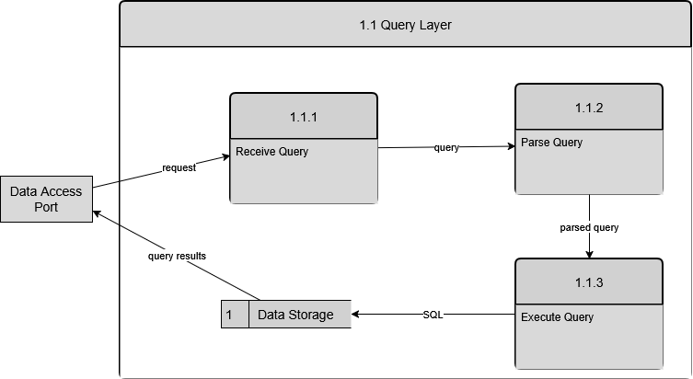

DFD Figure 1.14.0.0.2 – Indexed Data Lookup
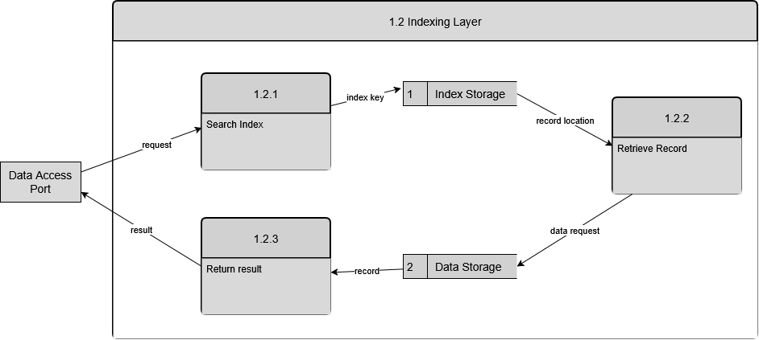

Figure 1.15 — File / Blob Storage Detail
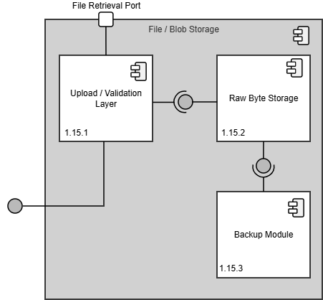

Design Information – File / Blob Storage
Field | Description / Purpose
View Name & Number | 1.15 File / Blob Storage
Purpose | Describe the file and blob storage.
Description | Basic service demonstrating file and blob storage.
Requirements | SRS 3.5 Resume (resume file storage), 2.1.3.1 (profile image uploads), 2.1.2 (company resume access)
Elements | 1.15.1 Upload / Validation Layer
 | 1.15.2 Raw Byte Storage
 | 1.15.3 Backup Module
Navigation / References | 1.14 Database; 1.6 Profile Management Service, 1.7 Resume Service; part of Data Storage Layer (Figure 1.1)
Viewpoint | Component Diagram

Entity Identification Tables – File / Blob Storage

EI Table 1.15.1 – Upload / Validation Layer
Subcomponent | Entity Name | Entity Type | Description / Purpose | Related Requirement(s) | Collaborators / Related Entities
Upload/ Validation Layer | UploadManager | Class | Manages file uploads | 3.1.3, 2.5.9 | UploadManager
Upload/ Validation Layer | validateFileType() | Method | Checks that file is of an accepted type | 3.1.3, 2.5.9 | UploadManager, FileValidator
Upload/ Validation Layer | FileValidator | Class | Handles all file validation | 3.1.3, 2.5.9 | validateFileType()
Upload/ Validation Layer | FileMetadata | Data Store | Stores data related to a given file | 3.1.3, 2.5.9 | UploadManager

EI Table 1.15.2 – Raw Byte Storage
Subcomponent | Entity Name | Entity Type | Description / Purpose | Related Requirement(s) | Collaborators / Related Entities
Raw Byte Storage | RawByteStorageModule | Module | Subsystem responsible for persistent file storage | 3.1.3, 2.5.9 | RawByteStorageModule
Raw Byte Storage | BlobStore | Class | Stores Binary Large Objects | 3.1.3, 2.5.9 | RawByteStorageModule
Raw Byte Storage | StorageManager | Class | Main interface to storage | 3.1.3, 2.5.9 | RawByteStorageModule
Raw Byte Storage | FileChunkManager | Class | Splits large files into chunks | 3.1.3, 2.5.9 | RawByteStorageModule
Raw Byte Storage | storeFile() | Method | Initializes file storage process | 3.1.3, 2.5.9 | StorageManager
Raw Byte Storage | retrieveFile() | Method | Initializes file retrieval process | 3.1.3, 2.5.9 | StorageManager
Raw Byte Storage | BlobStorage | Data Store | Main storage repository | 3.1.3, 2.5.9 | RawByteStorageModule
Raw Byte Storage | ChunkStorage | Data Store | Stores file chunks | 3.1.3, 2.5.9 | RawByteStorageModule

EI Table 1.15.3 – Backup Module
Subcomponent | Entity Name | Entity Type | Description / Purpose | Related Requirement(s) | Collaborators / Related Entities
Backup Module | BackupManager | Class | Container for all backup logic | 3.1.3, 2.5.9
Backup Module | BackupScheduler | Class | Responsible for automated system backups | 3.1.3, 2.5.9 | BackupManager
Backup Module | BackupStorage | Data Store | Stores backup files | 3.1.3, 2.5.9 | BackupManager
Backup Module | RestoreManager | Class | Manages file restoration requests | 3.1.3, 2.5.9 | BackupManager
Backup Module | SnapshotManager | Class | Creates system snapshots | 3.1.3, 2.5.9 | BackupManager

Data Flow Diagram – File / Blob Storage

DFD Figure 1.15.0.0.1 – File Upload and Storage
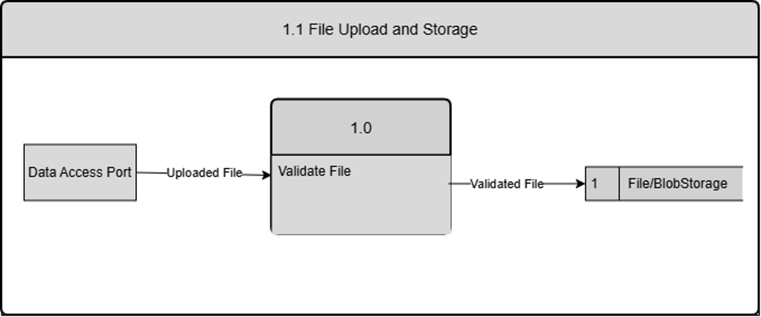

DFD Figure 1.15.0.0.2 – Backup Creation and File Recovery
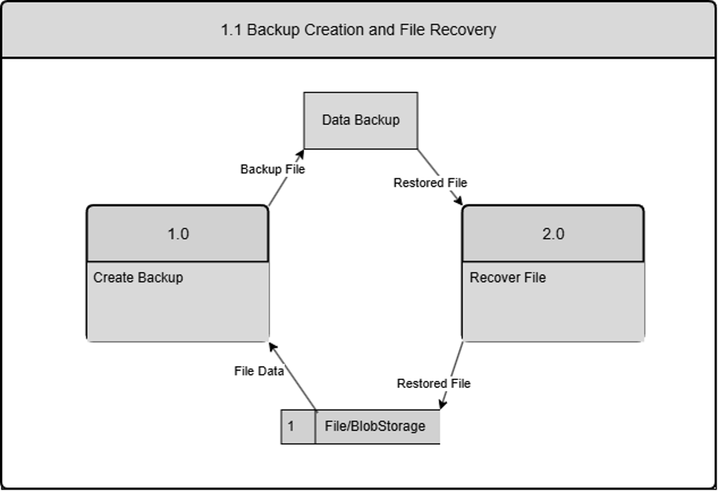

Design Rationale
The Career Bound architecture was designed using a service-oriented approach that separates major business capabilities into distinct components. Core system functions such as authentication, profile management, resume management, job posting management, search, communications, recommendations, analytics, and external integrations are implemented as separate services. This decomposition improves maintainability, allows individual services to evolve independently, and provides clear ownership boundaries for development teams.
An API Gateway / Orchestrator architecture was selected to centralize authentication, request validation, routing, and service coordination. This approach reduces coupling between client applications and backend services by providing a single-entry point for system interactions. The orchestrator pattern also simplifies the implementation of workflows that require coordination among multiple backend services. The trade-off is the introduction of an additional architectural layer that may increase implementation complexity and create a potential bottleneck if not properly managed.
Separate Web Client and Mobile Client components were selected to support multiple user platforms while maintaining a consistent user experience. Both clients share a common architectural structure and communicate with backend services through standardized REST/HTTP interfaces. This approach promotes reuse of design concepts while allowing platform-specific presentation and navigation differences.
A centralized database was selected to provide consistent storage of user accounts, profiles, resumes, job postings, applications, notifications, and analytics data. File / Blob Storage was introduced as a separate component to manage large binary assets such as resumes, profile images, and attachments. Separating structured data from binary file storage improves scalability and simplifies storage management.
The selected architecture represents a balance between modularity, maintainability, scalability, and implementation complexity. The service-oriented design provides clear separation of concerns while remaining manageable for the expected size and scope of the system.

DATA DESIGN

Data Description
The information domain of Career Bound consists of students, companies, resumes, job postings, applications, notifications, search activities, and analytics events. These concepts are transformed into software data structures represented by classes, database records, API messages, and stored files. Each major business entity is assigned a corresponding data structure to support storage, processing, and communication throughout the system.
User account information is managed by the Authentication Service and stored in the primary database. Student and company profile information is managed by the Profile Management Service and stored in the primary database. Resume metadata is stored in the primary database while uploaded resume files are stored in File / Blob Storage. Job postings, applications, notifications, search activity data, and analytics events are similarly managed by their corresponding services and persisted within the system's data stores.
Persistent business data is maintained within the primary database, while binary assets and uploaded documents are maintained within File / Blob Storage. Data exchanged between client applications and backend services is transmitted through REST API messages over the system's communication interfaces.
Data Storage Items:
- Primary Database
- User Accounts
- Student Profiles
- Company Profiles
- Job Postings
- Applications
- Notifications
- Search Activity Data
- Analytics Data

- File / Blob Storage
- Resume Documents
- Profile Images
- Attachments
Career Bound stores data related to user authentication, student profiles, company profiles, resumes, job postings, search activities, notifications, and analytics events.
Persistent data is stored in the system database. Temporary data is exchanged through REST API messages between the client applications and backend services.

Data Dictionary
The detailed identification of system entities, functions, data stores, classes, modules, and related data structures is documented within the Entity Identification Tables (EITs) provided throughout Section 3.2 Decomposition Description. The EITs serve as the primary source for entity definitions and provide the foundation for the Class Designs, Database Design, File Format Specifications, and Network Protocol/API Message Specifications described in Sections 4.3 through 4.6.
For convenience, the major business and system data entities within Career Bound are summarized below. The following summary-level data dictionary connects these entities to the component decomposition presented in Section 3.2. Each entity listed below is managed, processed, stored, or exchanged by one or more components identified in Figures 1.2 through 1.15. The Related Component / Figure column provides traceability between the data entities and the architectural components responsible for their creation, management, storage, or use. Infrastructure, routing, presentation, and protocol-related entities are documented within the corresponding EITs and supporting design artifacts but may not be individually represented in this summary table.
Entity | Type | Description | Related Component / Figure
Analytics Event | System Entity | Recorded user activity and system metrics | - Analytics Service — Figure 1.13  - Database — Figure 1.14
Application | Business Entity | Student application submitted for a job posting | - Job Posting Service — Figure 1.8  - Database — Figure 1.14
Company Profile | Business Entity | Company account and profile information | - Profile Management Service — Figure 1.6  - Database — Figure 1.14
Job Posting | Business Entity | Published employment opportunity | - Job Posting Service — Figure 1.8  - Search Service — Figure 1.9; Database — Figure 1.14
Notification | Business Entity | System-generated user notification | - Communication Services — Figure 1.10  - Database — Figure 1.14
Recommendation | System Entity | Job or candidate recommendations generated by the system | - Recommendation Service — Figure 1.11
Resume | Business Entity | Student resume data and associated uploaded files | - Resume Service — Figure 1.7  - File / Blob Storage — Figure 1.15
Student Profile | Business Entity | Student account and profile information | - Profile Management Service — Figure 1.6  - Database — Figure 1.14
User Account | Business Entity | Authenticated user account information | - Authentication Service — Figure 1.5  - Database — Figure 1.14

  - Class Design

Class Diagrams – 1.2 & 1.3 Web & Mobile Client

1.2.1 & 1.3.1–CD Menu Class Diagram
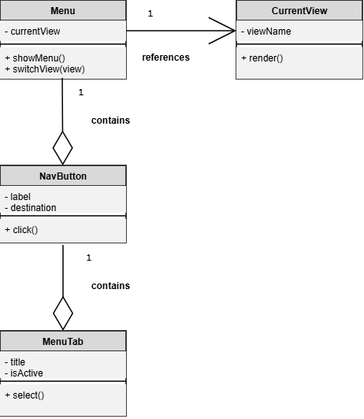

1.2.2 & 1.3.2–CD Navigation Management Class Diagram
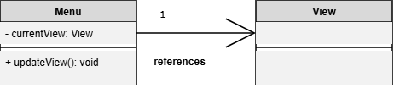

1.2.3 & 1.3.3–CD View Class Diagram
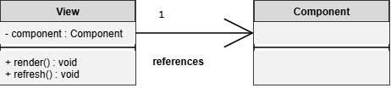

1.2.3 & 1.3.3-CD Form Class Diagram
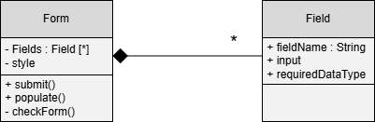

1.2.3 & 1.3.3-CD Form Validation Class Diagram
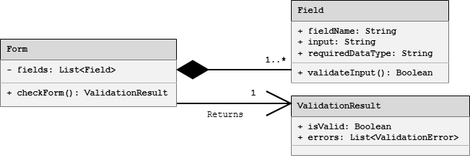

1.2.4 & 1.3.4–CD Localization Class Diagram
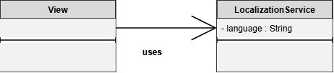

1.2.4 & 1.3.4–CD State Class Diagram
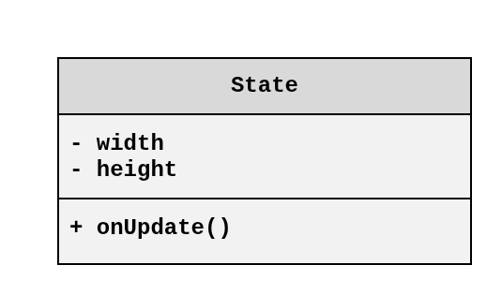

1.2.4 & 1.3.4–CD Dynamic UI Class Diagram
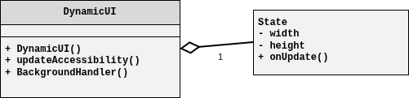

1.2.5 & 1.3.5–CD NetworkConfig Class Diagram
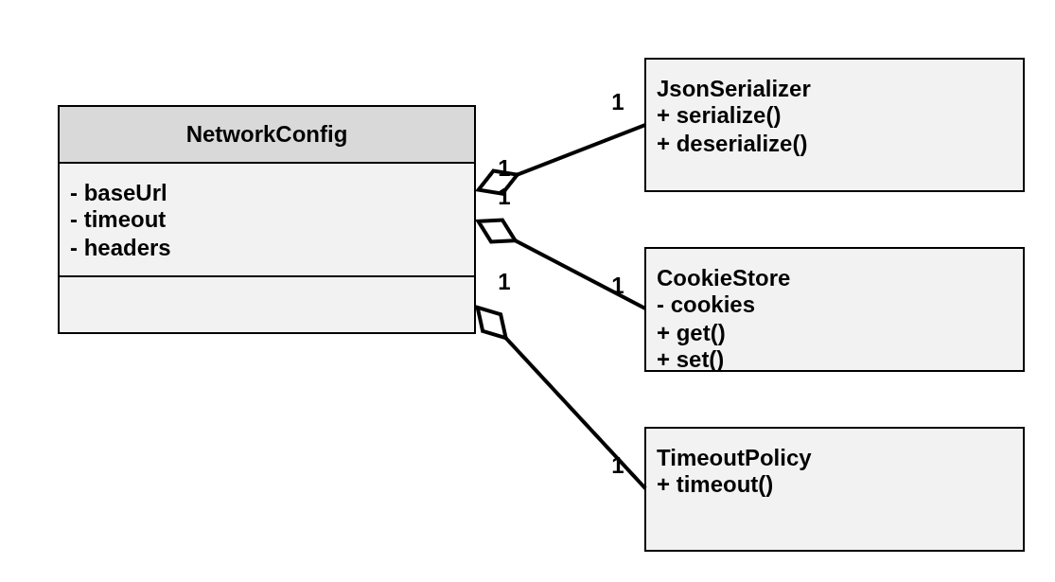

1.2.5 & 1.3.5-CD API Request Processing Class Diagram
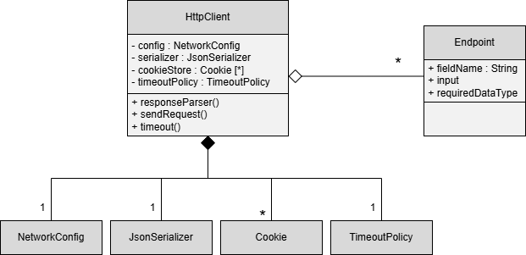

Class Diagrams – 1.4 API Gateway / Orchestrator

1.4.1 – CD API Gateway Class Diagram
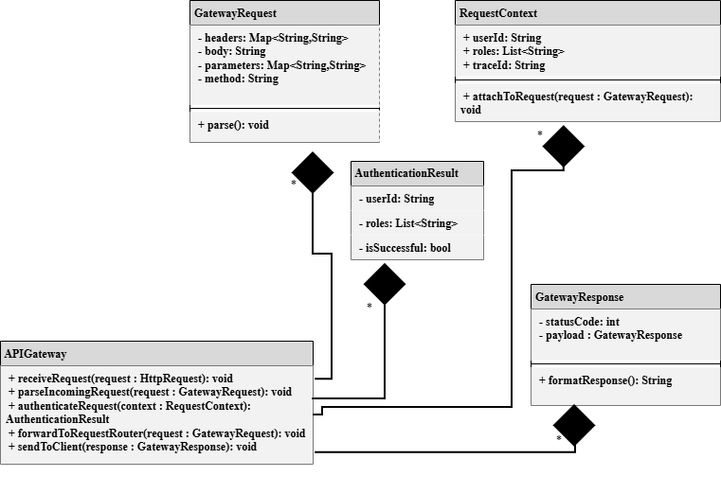

1.4.2 - CD Authentication Handler Class Diagram View
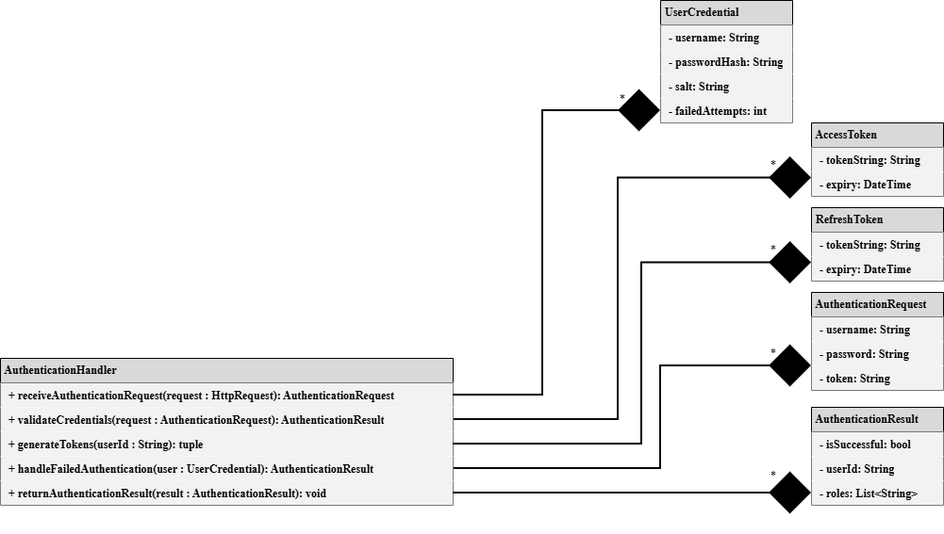

1.4.3-CD Request Router Class Diagram View
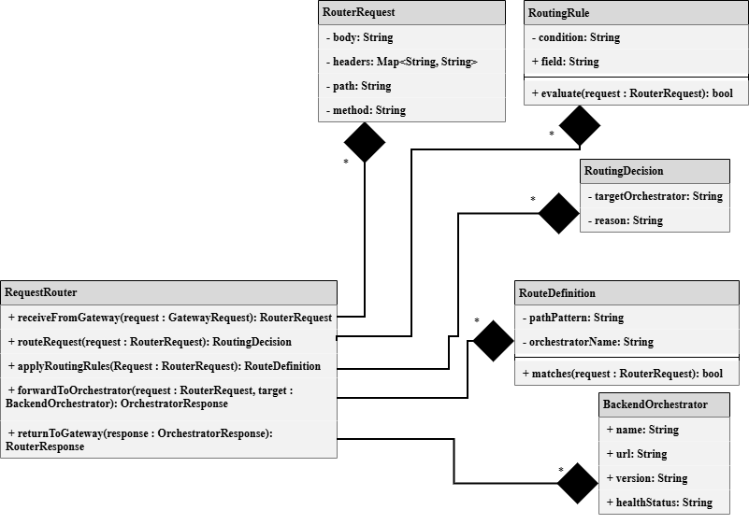

1.4.11–CD ExternalServicesOrchestrator Class Diagram
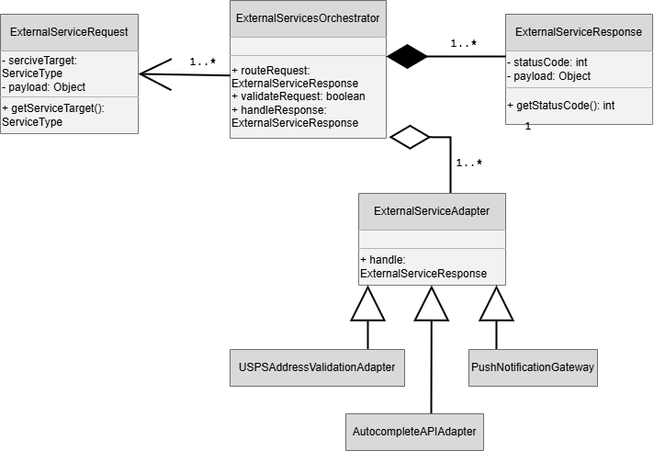

Class Diagrams – 1.5 Authentication Service

1.5.1–CD Registration Manager Class Diagram
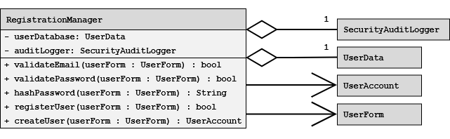

1.5.2-CD UserAccount Class Diagram
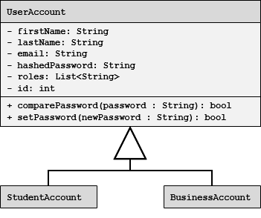

1.5.2–CD Authorization/Role Manager Class Diagram
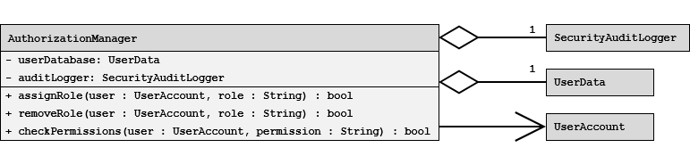

1.5.3-CD Login & Session Manager Class Diagram
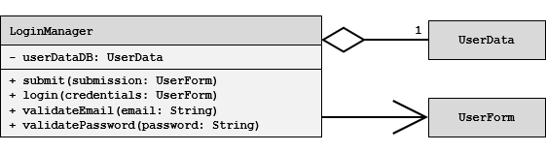

Class Diagrams – 1.6 Profile Management Service

1.6.1-CD User Account Types Class Diagram


1.6.1-CD Accolade Class Diagram
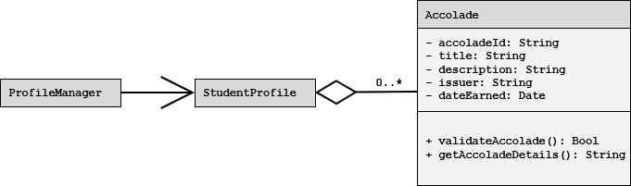

1.6.2-CD Image Manager Class Diagram
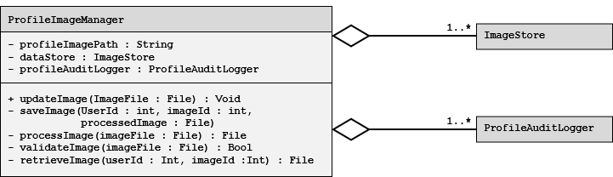

1.6.3-CD Preferences Manager Class Diagram
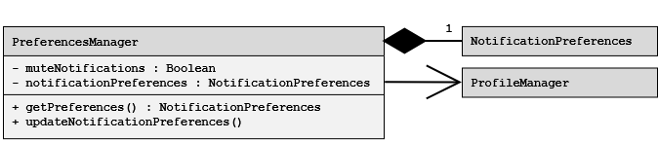

1.6.4-CD Privacy Settings Manager Class Diagram
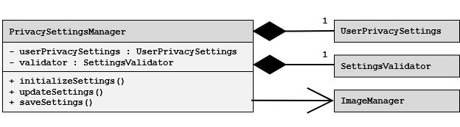

1.6.5-CD Profile Audit Logger Class Diagram
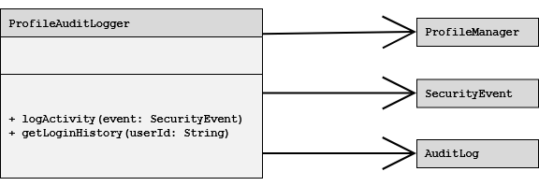

Class Diagrams – 1.7 Resume Service

1.7.1-CD Resume Class Diagram
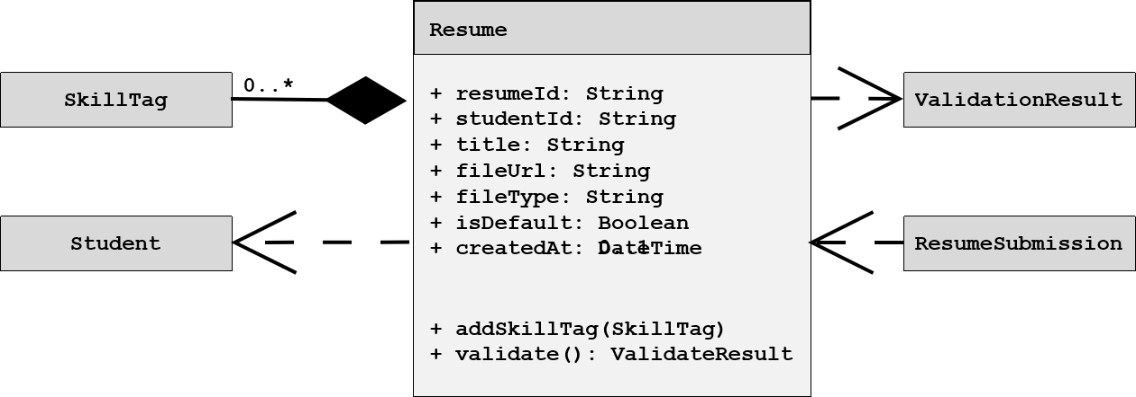

1.7.3-CD ResumeSubmission Class Diagram
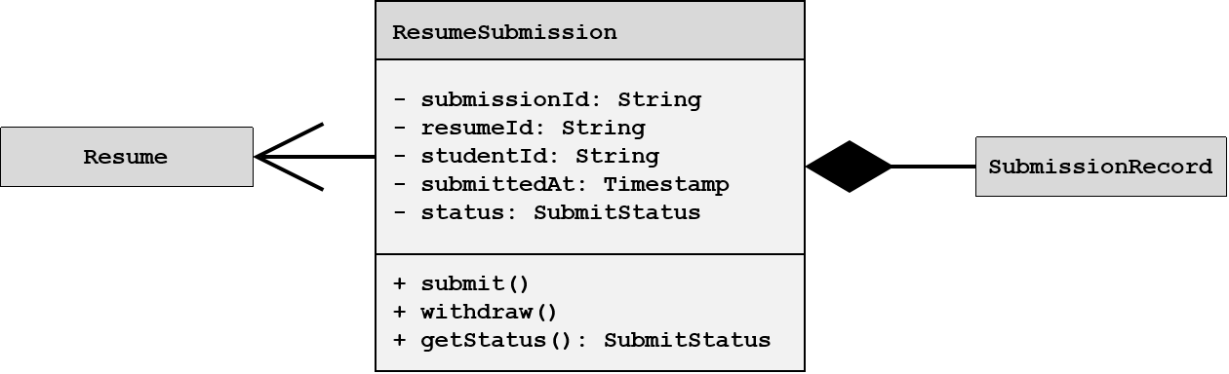

1.7.3-CD Update Resume Request Class Diagram
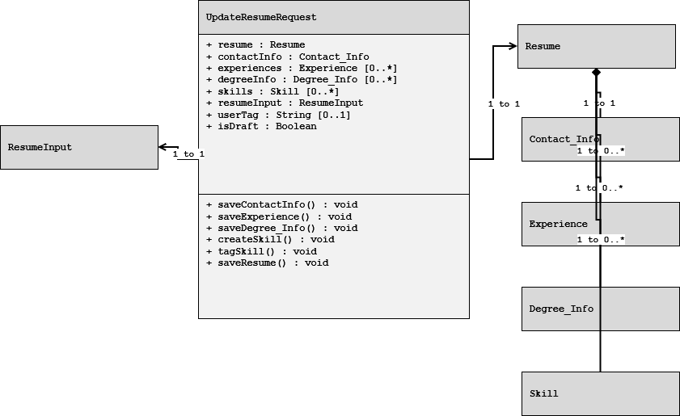

1.7.3-CD Skill Class Diagram
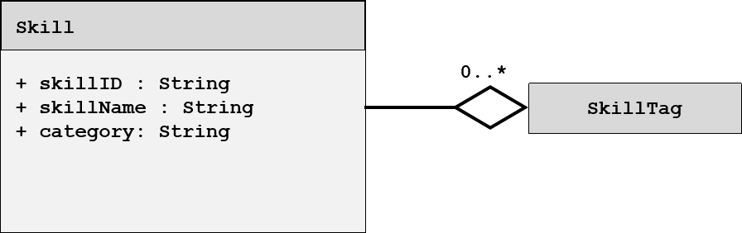

1.7.3-CD SkillTag Class Diagram
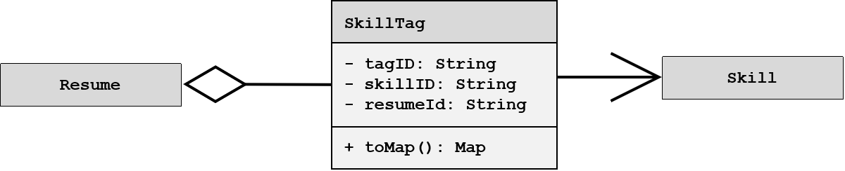

1.7.3-CD Update Resume Response Class Diagram
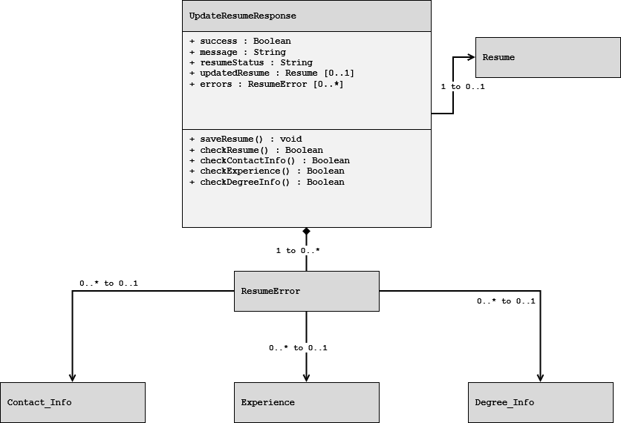

1.7.5-CD ValidationResult Class Diagram
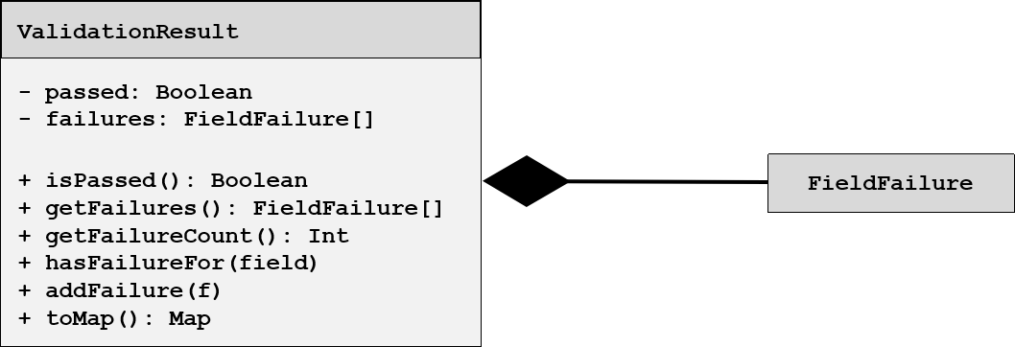

Class Diagrams – 1.9 Search Service

1.9.1-CD SearchController Class Diagram
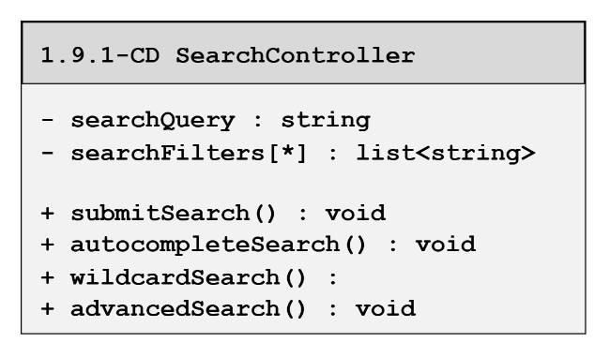

1.9.2-CD CandaditeSearch Class Diagram
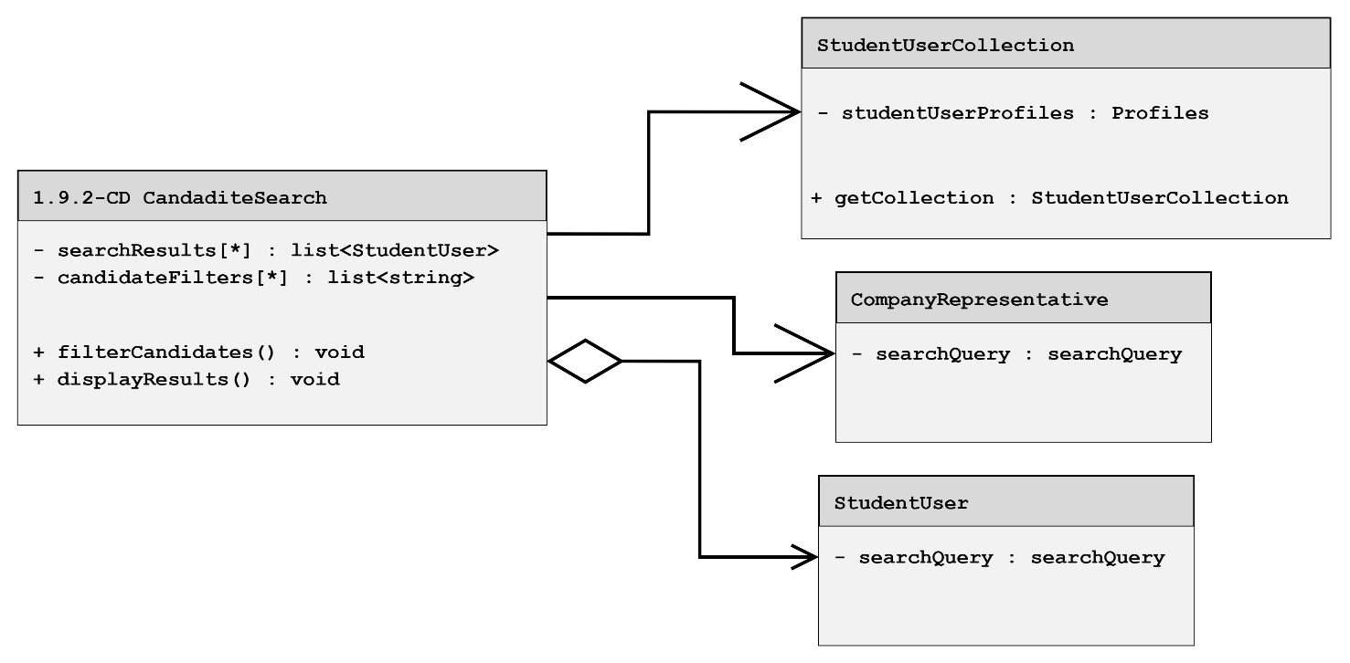

1.9.3-CD JobSearch Class Diagram
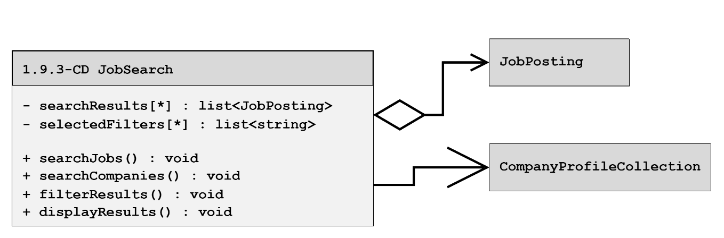

1.9.4-CD CompanySearch Class Diagram
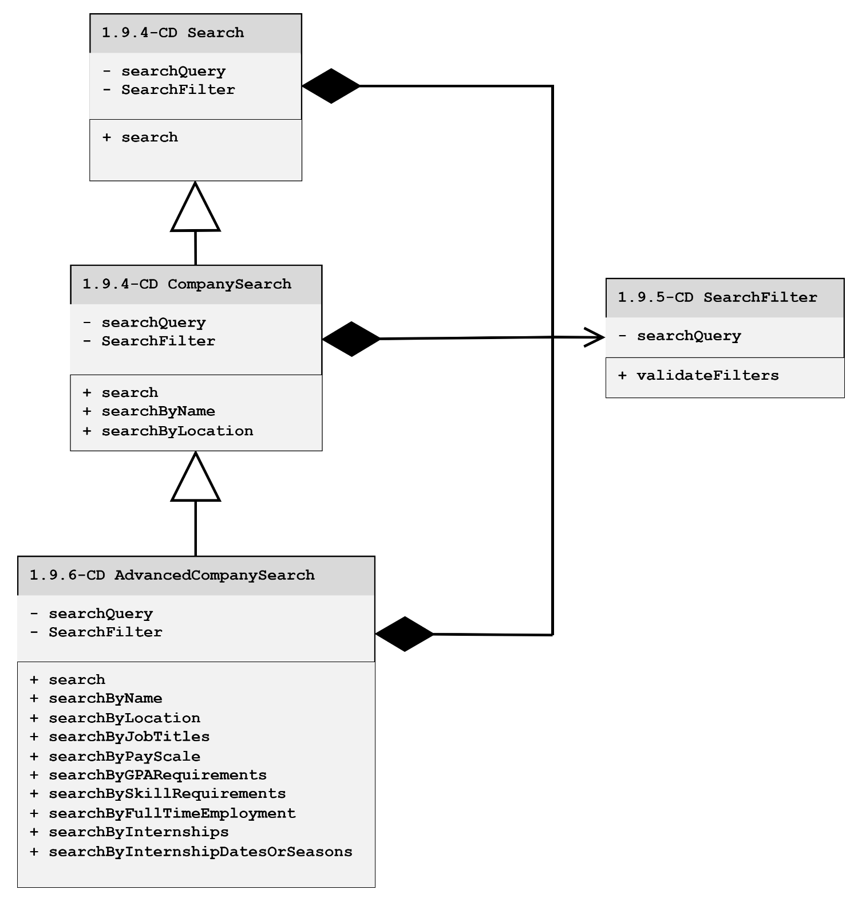

1.9.6 – CD AdvancedCompanySearch Class Diagram
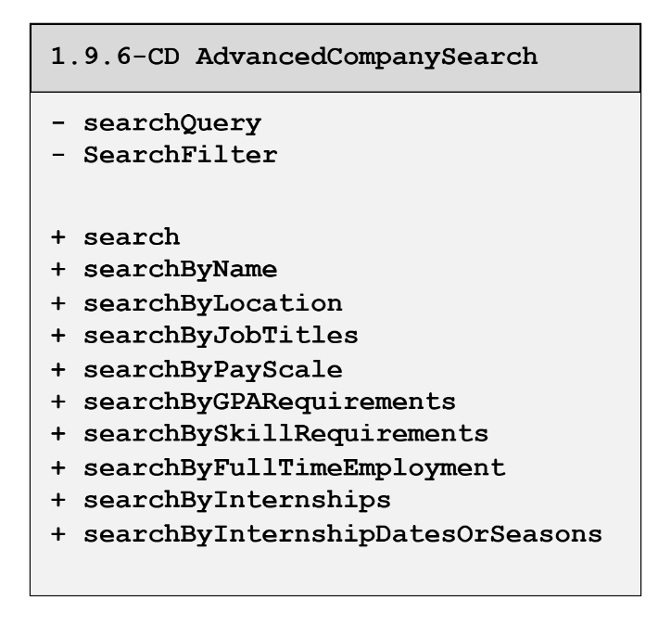

1.9.7-CD WildcardSearch Class Diagram
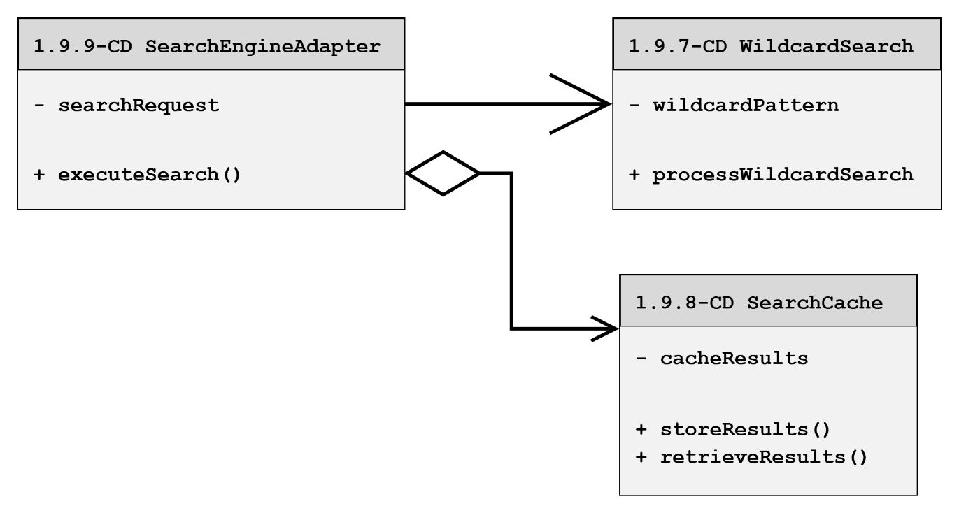

1.9.9-CD SearchEngineAdapter Class Diagram
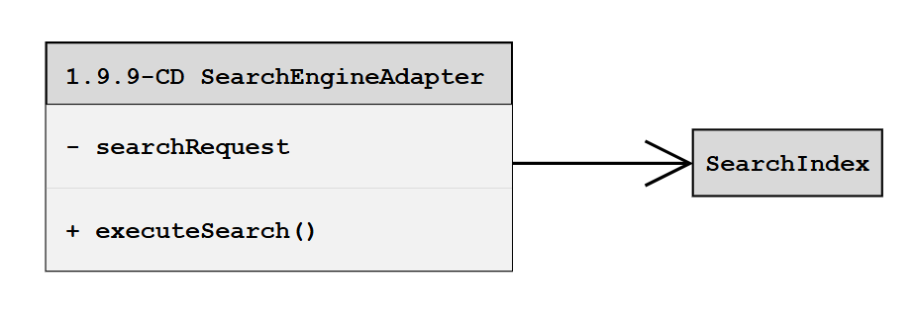

1.9.10-CD SearchEngine Class Diagram
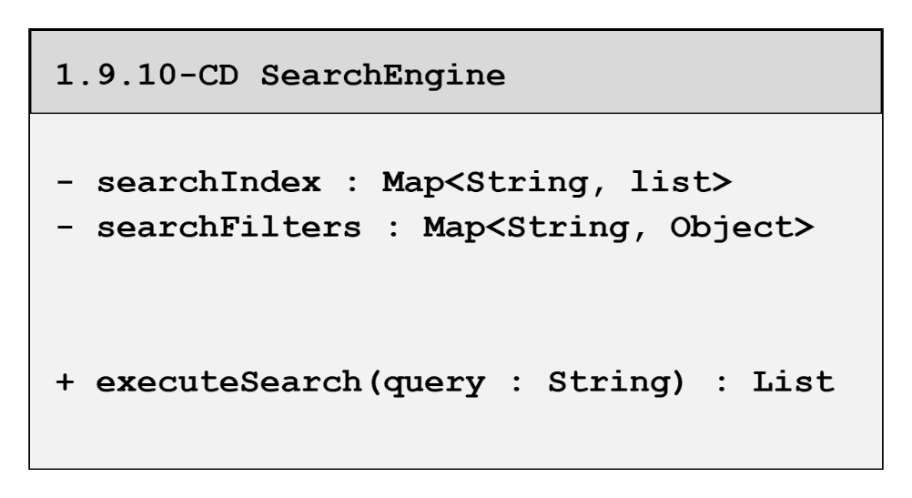

1.9.11-CD Autocomplete Class Diagram
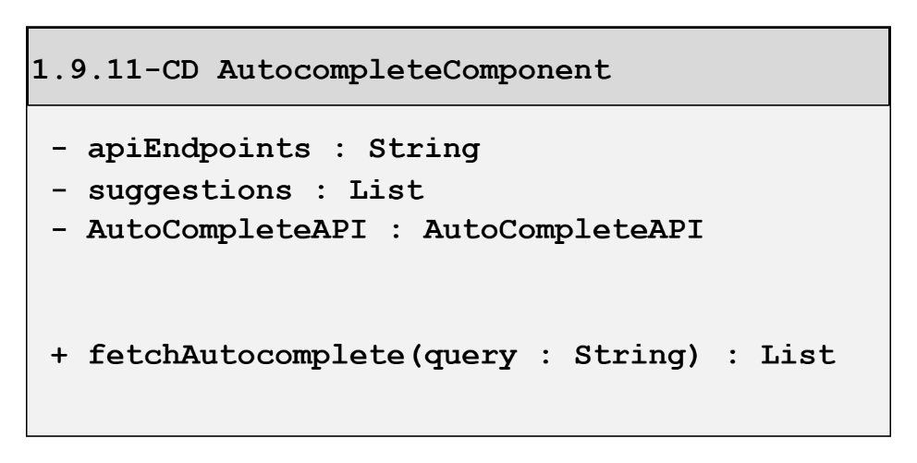

1.9.12-CD ResultsRanker Class Diagram
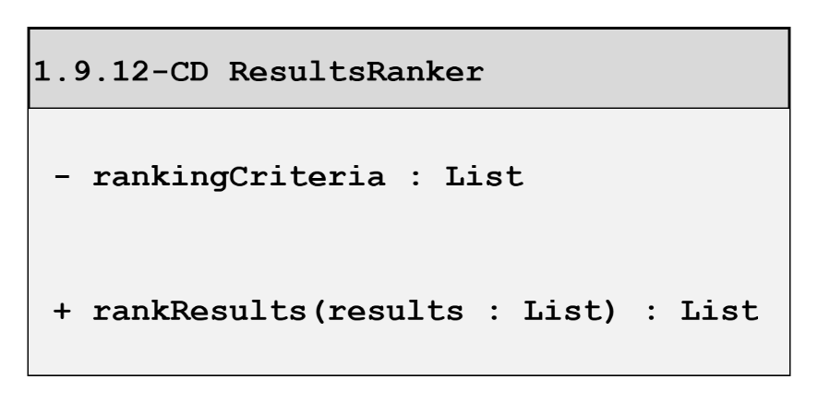

Class Diagrams – 1.10 Communication Services

1.10.1 Event Listener Class Diagram
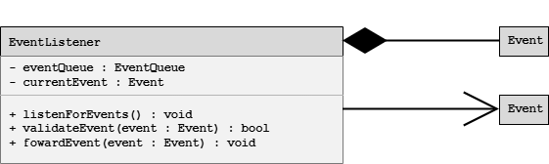

1.10.2 Notification Controller Class Diagram
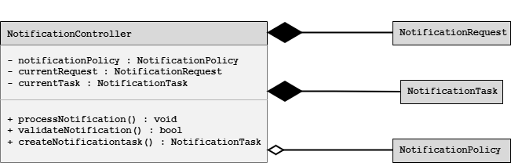

1.10.3 Notification Orchestrator Class Diagram
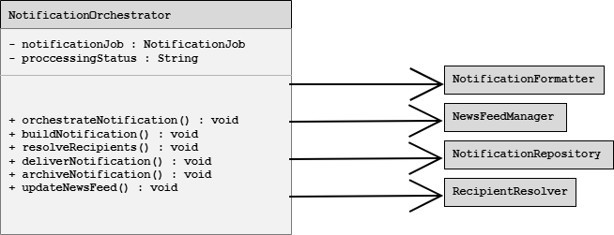

1.10.4-CD Notification Formatter Class Diagram
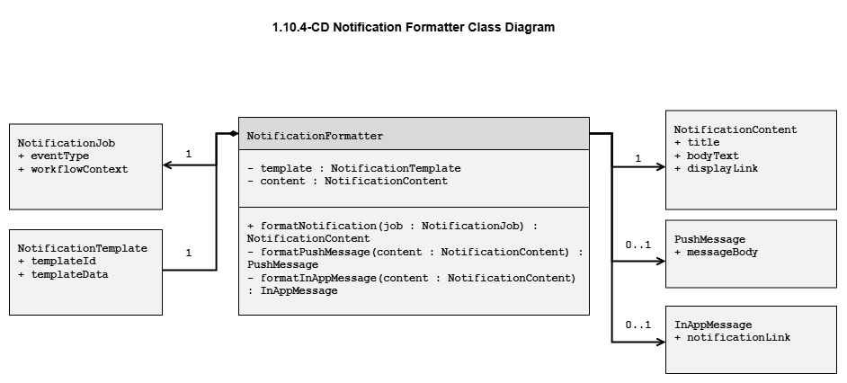

1.10.5-CD Notification Repository Class Diagram
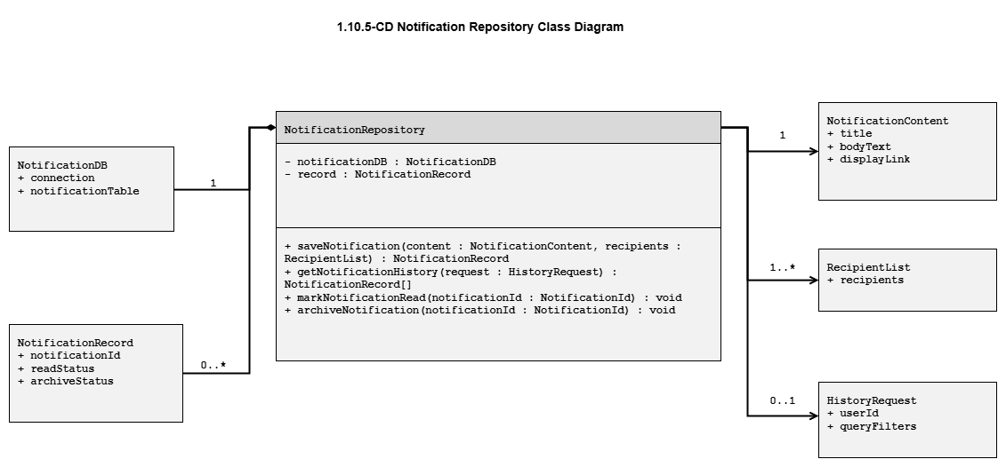

1.10.6-CD Recipient Resolver Class Diagram
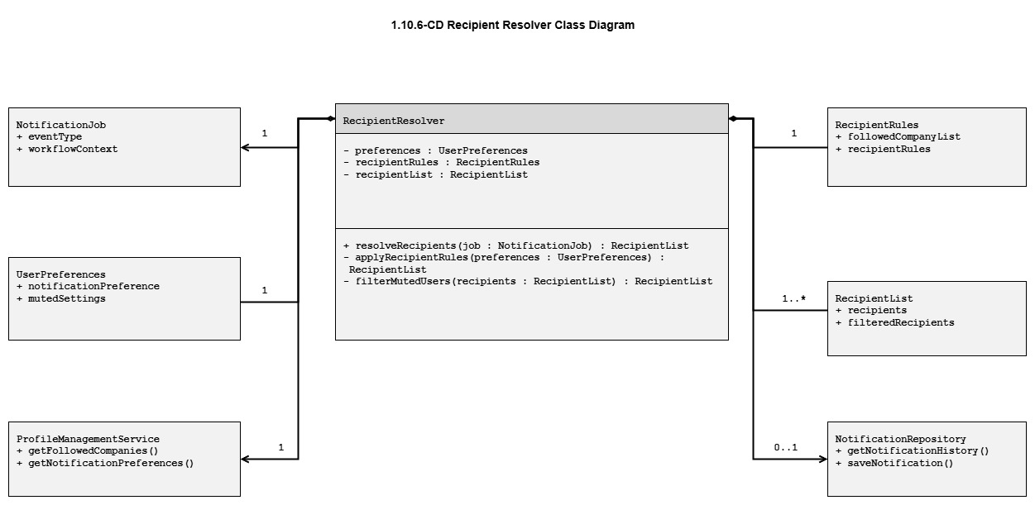

Class Diagrams – 1.11 Recommendation Service

1.11.2-CD CandidateRecommender Class Diagram
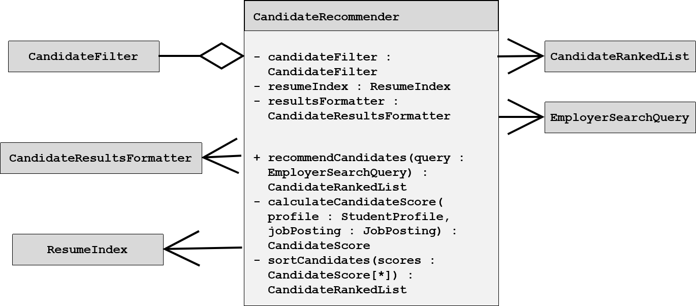

1.11.1-CD JobPosting Class Diagram
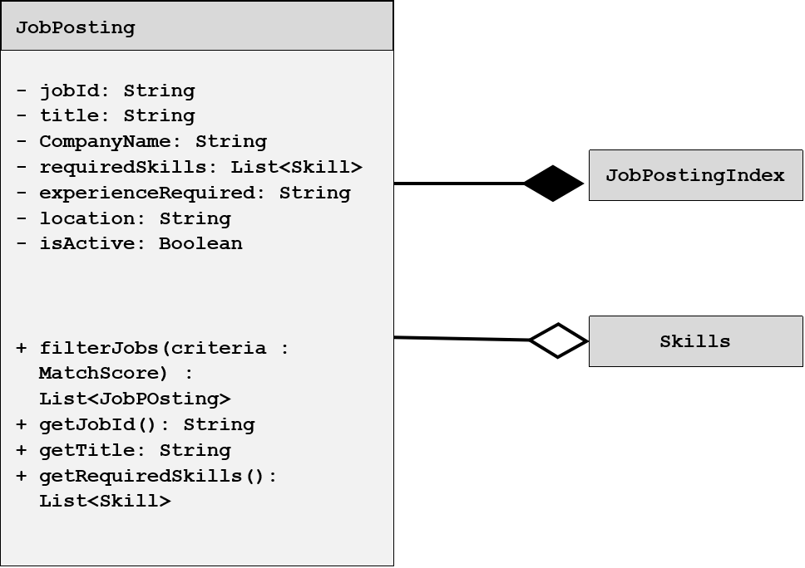

1.11.2-CD CandidateFilter Class Diagram
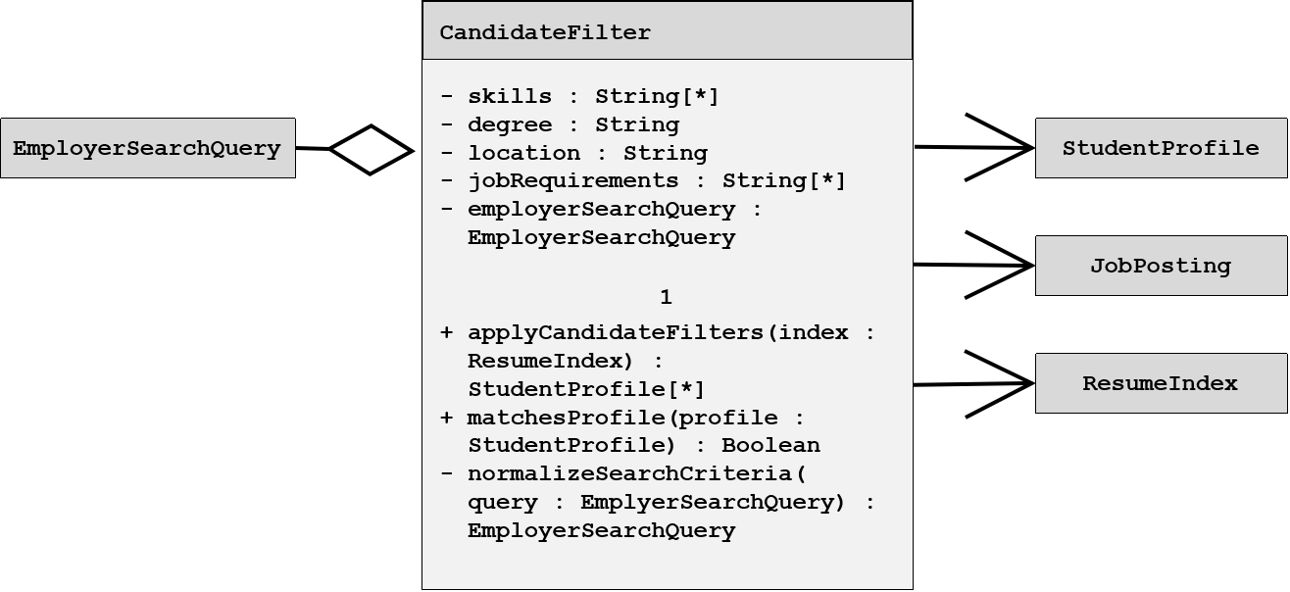

1.11.5-CD Recommendation Class Diagram
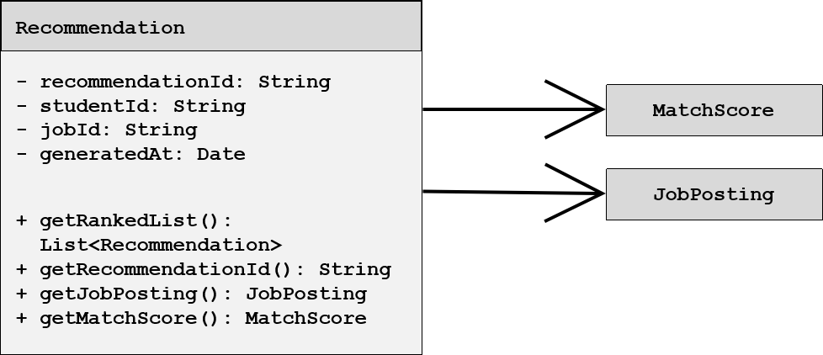

1.11.5-CD StudentProfile Class Diagram
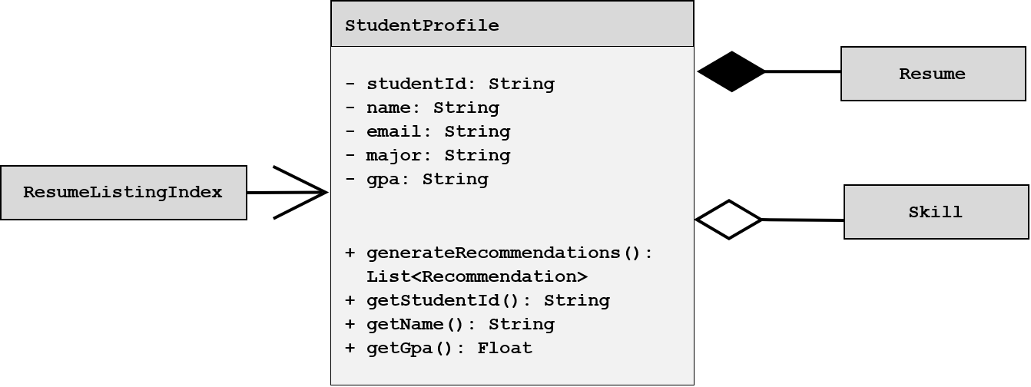

Class Diagrams – 1.12 External Services

1.12-CD External Services Orchestrator Class Diagram


1.12.1-CD USPS Address Validation Adapter Class Diagram
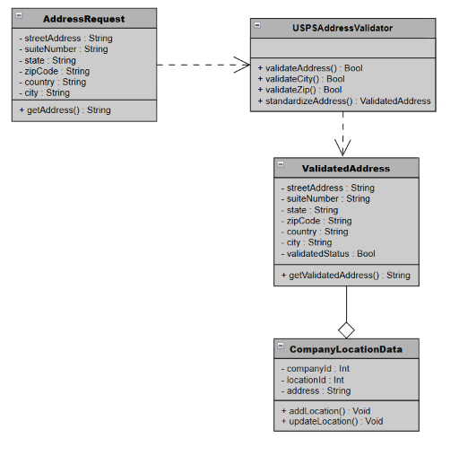

1.12.1-CD Profile and Resume Engagement
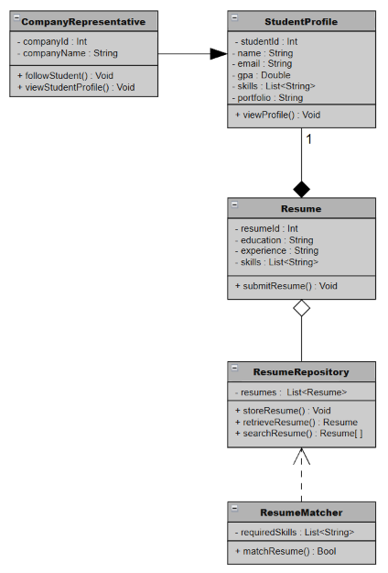

1.12.2-CD Autocomplete API Adapter Class Diagram
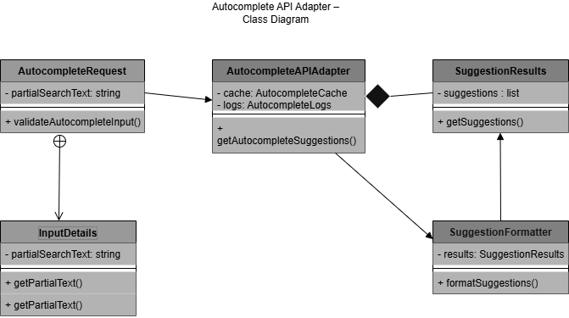

1.12.3-CD Push Notification Gateway
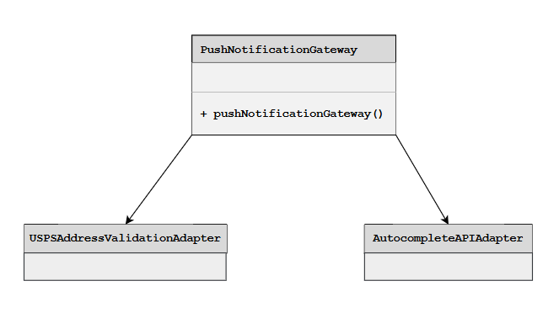

Class Diagrams – 1.13 Analytics Service

1.13-CD Analytics Orchestrator Class Diagram
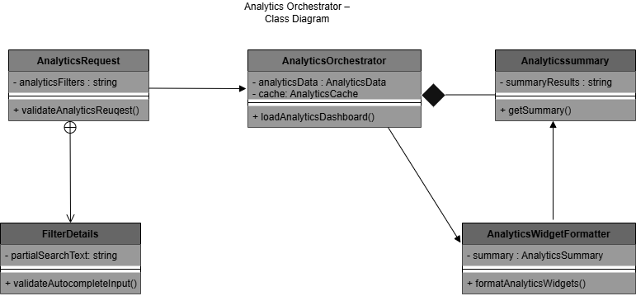

1.13.1-CD JobPostingManager Class Diagram
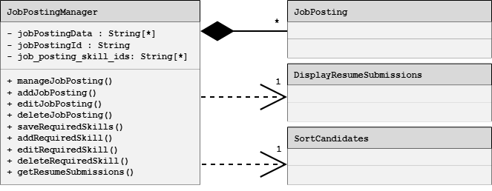

1.13.2-CD CandidateSearchManager Class Diagram
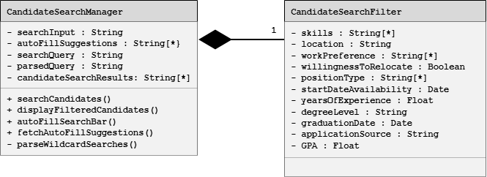

1.13.4-CD Notification and News Feedback Analytics
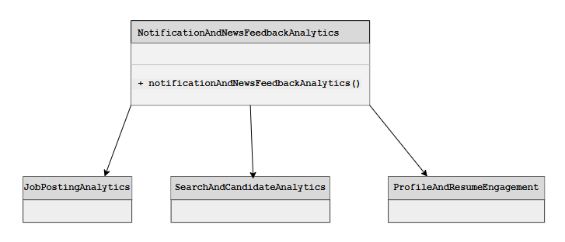

1.13.5-CD Performance Monitor Class Diagram
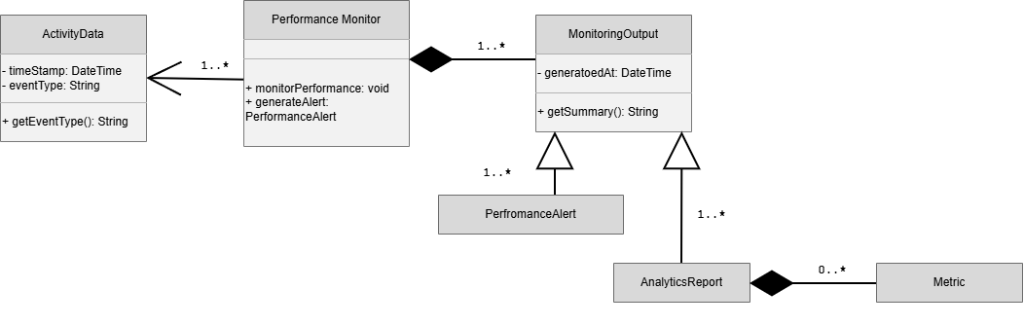

  - Database Design

StudentProfiles Database Table
Column | Data Type | Required | Key | Description
StudentProfileID | UUID | Yes | PK | Primary key for the table.
UserID | UUID | Yes | FK | Key linking this table to the Users table.
StudentSkillsID | UUID | No | FK | Key linking this table to the StudentSkills table.
AboutMeText | TEXT | No |  | User-inputed text for About Me field
ProfilePictureFileID | UUID | No | FK | Key linking to Files table with info about the profile picture.
Degree | VARCHAR(255) | No |  | User-inputted text for the Degree field.
LinkedInProfileLink | VARCHAR(255) | No |  | User-inputted text for LinkedIn URL field

Components StudentProfiles Database Supports
- Figure 1.6 — Profile Management Service Detail — Primary storage for student profile information, including About Me text, degree information, LinkedIn profile link, and profile-picture reference.
- Figure 1.7 — Resume Service Detail — Provides student identity and profile context associated with resumes.
- Figure 1.11 — Recommendation Service Detail — Provides profile information, degree information, and student skills context used for recommendations.
- Figure 1.13 — Analytics Service Detail — Provides profile-related data that may be summarized for profile and resume engagement analytics.

Companies Database Table
Column | Data Type | Required | Key | Description
CompanyID | UUID | Yes | PK | Primary key for the table.
CompanyName | VARCHAR(255) | Yes |  | Company Name
CompanyDescription | TEXT | No |  | Company Description
CompanyProfilePictureID | UUID | No | FK | Foreign Key linking to Files table.

Components Companies Database Supports
- Figure 1.6 — Profile Management Service Detail — Stores company profile information, including company name, description, and profile-picture reference.
- Figure 1.8 — Job Posting Service Detail — Provides company information associated with job postings.
- Figure 1.9 — Search Service Detail — Supports displaying and filtering job search results by company information.

CompanyUsers Database Table
Column | Data Type | Required | Key | Description
CompanyUsersID | UUID | Yes | PK | Primary key for table.
CompanyID | UUID | Yes | FK | Foreign Key linking to Companies Table
UserID | UUID | Yes | FK | Foreign Key linking to Users table

Components CompanyUsers Database Supports
- Figure 1.6 — Profile Management Service Detail — Connects user accounts to company profiles.
- Figure 1.5 — Authentication Service Detail — Supports identifying which authenticated users are associated with a company.
- Figure 1.8 — Job Posting Service Detail — Supports authorization and ownership checks for company users who create or manage job postings.

Users Database Table
Column | Data Type | Required | Key | Description
UserId | UUID | Yes | PK | Unique identifier for the user account
Username | VARCHAR(50) | Yes |  | Unique login name for the account
Email | VARCHAR(255) | Yes |  | User's email address (unique)
PasswordHash | VARCHAR(255) | Yes |  | Hashed password used for authentication (never stored as plaintext)
FirstName | VARCHAR(50) | Yes |  | User's first name
LastName | VARCHAR(50) | Yes |  | User's last name
PhoneNum | VARCHAR(20) | No |  | User's phone number

Components Users Database Supports
- Figure 1.5 — Authentication Service Detail — Stores user account credentials and identity information used for registration, login, and account access.
- Figure 1.6 — Profile Management Service Detail — Links user accounts to student and company profiles.
- Figure 1.7 — Resume Service Detail — Associates resumes and uploaded files with the applicable user.
- Figure 1.10 — Communication Services (Notifications + News Feed) Detail — Identifies notification and message senders and recipients.
- Figure 1.8 — Job Posting Service Detail — Supports company-user authorization for job-posting management.

Roles Database Table
Column | Data Type | Required | Key | Description
RoleId | INT | Yes | PK | Unique identifier for the role
RoleName | VARCHAR(50) | Yes |  | Name of the role (e.g., Student, Company Representative)
Description | VARCHAR(255) | No |  | Explanation of what the role represents and the access it grants

Components Roles Database Supports
- Figure 1.5 — Authentication Service Detail — Defines available system roles, such as Student and Company Representative.
- Figure 1.4 — API Gateway / Orchestrator Detail — Supports role-based authorization decisions before requests are routed to downstream services.

UsersRoles Database Table
Column | Data Type | Required | Key | Description
RoleId | INT | Yes | FK | References Roles.RoleId
UserId | UUID | Yes | FK | References Users.UserId
UsersRoleId | UUID | Yes | PK | Unique identifier for the users-role assignment

Components UsersRoles Database Supports
- Figure 1.5 — Authentication Service Detail — Associates each user account with one or more authorized roles.
- Figure 1.4 — API Gateway / Orchestrator Detail — Supports role-based access-control checks during request routing.

Job Posting Database Table
Column | Data Type | Required | Key | Description
JobPostingID | UUID | Yes | PK | Primary key
JobTitle | VARCHAR(255) | Yes |  | Title of job posting
CompanyID | UUID | Yes | FK | Foreign key to company
JobDescription | TEXT | No |  | The job description
JobSkillID | UUID | No | FK | Foreign key to job skills

Components Job Posting Database Supports
- Figure 1.8 — Job Posting Service Detail — Primary storage for job-posting information.
- Figure 1.9 — Search Service Detail — Provides job-posting data that can be searched, filtered, and returned to users.
- Figure 1.11 — Recommendation Service Detail — Provides active job postings and job requirements used to generate student job recommendations.
- Figure 1.13 — Analytics Service Detail — Provides job-posting data for job-posting analytics.

Job Posting Category Database Table
Column | Data Type | Required | Key | Description
JobPostingCategoryID | UUID | Yes | PK | The primary key for this linking table
JobPostingID | UUID | Yes | FK | Foreign key to a job posting
JobCategoryID | UUID | Yes | FK | Foreign key to a job category

Components Job Posting Category Database Supports
- Figure 1.8 — Job Posting Service Detail — Associates job postings with categories.
- Figure 1.9 — Search Service Detail — Supports filtering job postings by category.

Job Category Database Table
Column | Data Type | Required | Key | Description
JobCategoryID | UUID | Yes | PK | The primary key
JobCategoryName | VARCHAR(255) | Yes |  | Name of the category

Components Job Category Database Supports
- Figure 1.8 — Job Posting Service Detail — Stores the available job categories used when creating or updating job postings.
- Figure 1.9 — Search Service Detail — Supports category-based job searching and filtering.

Skills Database Table
Column | Data Type | Required | Key | Description
SkillID | INT | Yes | PK | Unique skill ID
SkillName | VARCHAR | Yes | Neither | Name of the skill
AddedDate | DATETIME | Yes | Neither | Date the Skill was added

Components Skills Database Supports
- Figure 1.7 — Resume Service Detail — Stores skills that may be associated with student resumes.
- Figure 1.8 — Job Posting Service Detail — Stores skills that may be identified as job requirements.
- Figure 1.11 — Recommendation Service Detail — Supports skills-based matching between student resumes and job postings.
- Figure 1.6 — Profile Management Service Detail — Supports student-profile skill information.

Notifications Database Table
Column | Data Type | Required | Key | Description
NotificationID | INT | Yes | PK | Unique Notification ID
UserID | INT | Yes | FK | User receiving the notification
NotificationType | VARCHAR | Yes | Neither | Type of Notification
Title | VARCHAR | Yes | Neither | Notification Title
Message | TEXT | Yes | Neither | Content of the Notification
CreatedDate | DATETIME | Yes | Neither | Date Notification was generated
IsRead | BOOLEAN | Yes | Neither | Indicates whether notification has been viewed
ReadDate | DATETIME | No | Neither | Date Notification was read

Components Notifications Database Supports
- Figure 1.10 — Communication Services (Notifications + News Feed) Detail — Primary storage for user notifications, including notification type, content, creation date, and read status.
- Figure 1.13 — Analytics Service Detail — Provides notification activity data for analytics.

Messages Database Table
Column | Data Type | Required | Key | Description
MessageID | INT | Yes | PK | Unique Message ID
SenderID | INT | Yes | FK | User sending Message
RecipientID | INT | Yes | FK | User Receiving Message
Subject | VARCHAR | No | Neither | Message Subject
MessageContent | TEXT | Yes | Neither | Message Body
SentDate | DATETIME | Yes | Neither | Date Message was sent
IsRead | BOOLEAN | Yes | Neither | Indicates whether Message was read
ReadDate | DATETIME | No | Neither | Date Message was read

Components Messages Database Supports
- Figure 1.10 — Communication Services (Notifications + News Feed) Detail — Primary storage for messages between users, including sender, recipient, content, sent date, and read status.
- Figure 1.6 — Profile Management Service Detail — Uses user/profile information to identify message senders and recipients.

Applications Database Table
Column | Data Type | Required | Key | Description
ApplicationId | UUID | Yes | PK | Unique job application identifier
UserId | UUID | Yes | FK | Associated user account
ResumeId | UUID | Yes | FK | Associated resume
StatusId | UUID | Yes | FK | Associated application status
JobTitle | VARCHAR(255) | Yes |  | Name of the position applied for
CompanyName | VARCHAR(255) | Yes |  | Name of the company offering the job
Notes | TEXT | No |  | Optional field for the user to write reminders or interview feedback
CreateAt | TIMESTAMP | Yes |  | When the application entry was created
UpdatedAt | TIMESTAMP | Yes |  | Automatically updates whenever the status or notes change

Components Applications Database Supports
- Figure 1.8 — Job Posting Service Detail — Stores job-application records associated with job titles and companies.
- Figure 1.7 — Resume Service Detail — Links each application to the resume used for that application.
- Figure 1.13 — Analytics Service Detail — Provides application activity and status information for analytics.

ApplicationStatuses Database Table
Column | Data Type | Required | Key | Description
StatusId | UUID | Yes | PK | Unique application status identifier
Status | ENUM(‘applied’, ‘reviewing’, ‘interview’, ‘scheduled’, ‘offered’, ‘rejected’) | Yes |  | The status

Components ApplicationStatuses Database Supports
- Figure 1.8 — Job Posting Service Detail — Defines the available status values for job applications.
- Figure 1.13 — Analytics Service Detail — Supports application-status reporting and analytics.

Files Database Table
Column | Data Type | Required | Key | Description
ResumeId | UUID | Yes | PK | Unique resume identifier
UserId | UUID | Yes | FK | Associated user account
FileName | VARCHAR(255) | Yes |  | The original name of the file
FileURL | TEXT | Yes |  | The absolute public URL
UploadedAt | TIMESTAMP | Yes |  | Exact date and time the file was added
FileLocation | VARCHAR(255) | Yes |  | Location of file within File Blob Storage

Components Files Database Supports
- Figure 1.7 — Resume Service Detail — Stores resume-file metadata, including file name, URL, upload date, and blob-storage location.
- Figure 1.6 — Profile Management Service Detail — Supports references to profile-picture files.
- Figure 1.12 — External Services Detail — May support external file-storage integration if File / Blob Storage is treated as an external infrastructure service.

Database Table / Component Support Matrix
Database Table | 1.5  Authentication | 1.6  Profile  Management | 1.7  Resume | 1.8  Job Posting | 1.9  Search | 1.10  Communication | 1.11  Recommendation | 1.13  Analytics
StudentProfiles |  | X | X |  | X |  | X | X
Companies |  | X |  | X | X |  |  | X
CompanyUsers | X | X |  | X
Users | X | X | X | X |  | X
Roles | X
UsersRoles | X
Job Posting |  |  |  | X | X |  | X | X
Job Posting Category |  |  |  | X | X
Job Category |  |  |  | X | X
Skills |  | X | X | X | X |  | X | X
Notifications |  |  |  |  |  | X |  | X
Messages |  | X |  |  |  | X
Applications |  |  | X | X |  |  |  | X
ApplicationStatuses |  |  |  | X |  |  |  | X
Files |  | X | X

  - File Format Specifications

1.15.1-FF System Log File Format
Field | Description
File Name | System Log
Purpose | Stores a record of system events and errors generated by the system
Supported Formats | LOG, TXT
Storage Location | File / Blob Storage
Associated Entity | System
Maximum File Size | 100 MB per file (a new file is started when the limit is reached)
Required Metadata | FileId, FileName, CreatedDate
Validation Rules | Must be a LOG or TXT file within the maximum size limit; entries are append-only and cannot be edited after they are written
Accessed By | System (internal use only)
Security Notes | Internal system file; not exposed to students or employers, and protected from modification

Components System Log File Format Supports
- Figure 1.5 — Authentication Service Detail — Records authentication, authorization, login/session, and security-audit events.
- Figure 1.6 — Profile Management Service Detail — Records profile, preference, image, privacy-setting, and profile-audit events.
- Figure 1.7 — Resume Service Detail — Records resume creation, upload, validation, and submission events.
- Figure 1.8 — Job Posting Service Detail — Records job-posting management, authority-check, and validation events.
- Figure 1.9 — Search Service Detail — Records search-processing, cache, indexing, and search-engine adapter events.
- Figure 1.10 — Communication Services Detail — Records notification, messaging, and news-feed events.
- Figure 1.11 — Recommendation Service Detail — Records recommendation and matching-processing events.
- Figure 1.12 — External Services Detail — Records adapter, external-request, and external-response events.
- Figure 1.13 — Analytics Service Detail — Records analytics-processing and dashboard-loading events.

1.15.1-FF Resume Document File Format
Field | Description
File Name | Resume Document
Purpose | Stores a student resume document
Supported Formats | PDF, DOCX
Storage Location | File / Blob Storage
Associated Entity | Resume
Maximum File Size | 10 MB
Required Metadata | FileID, StudentId, ResumeId, FileName, UploadDate
Validation Rules | Must be PDF or DOCX and within maximum size limit
Accessed By | Resume Service, Profile Management Service
Security Notes | Access restricted to authorized users

Components Resume Document File Format Supports
- Figure 1.7 — Resume Service Detail — Uploads, validates, stores, lists, and retrieves student resume documents.
- Figure 1.6 — Profile Management Service Detail — Makes a student’s resume document available through the student profile.
- Figure 1.11 — Recommendation Service Detail — Uses resume information to support resume indexing and recommendation matching.

1.15.1-FF Profile Image File Format
Field | Description
File Name | ProfileImage
Purpose | Personalize account
Supported Formats | .png and .jpeg
Storage Location | File blob storage
Associated Entity | Student profile
Maximum File Size | 10mb
Required Metadata | File name, date uploaded and file size
Validation Rules | Validate image size and file size
Accessed By | Users with the student role
Security Notes | Access restricted to authorized users

Components Profile Image File Format Supports
- Figure 1.6 — Profile Management Service Detail — Uploads, validates, stores, and retrieves student profile images through the Image Manager.
- Figure 1.2 & 1.3 — Web Client and Mobile Client Shared Architecture — Displays profile images to authorized users.

1.15.1-FF Exported Report File Format
Field | Description
File Name | Resume Analysis Report
Purpose | Presents AI-generated feedback comparing a resume against a job description
Supported Formats | PDF (.pdf), Microsoft Word (.docx)
Storage Location | File / Blob Storage
Associated Entity | Resume Service, Analytics Service
Maximum File Size | 5 mb
Required Metadata | Report ID, User ID, Resume ID, Analysis Date, Job Description ID
Validation Rules | Report must contain completed analysis results; Required metadata fields must be populated; File size must not exceed limit
Accessed By | User, Resume Service, Analytics Service
Security Notes | Contains potentially sensitive resume and employment information; authentication required before download

Components Exported Report File Format Supports
- Figure 1.13 — Analytics Service Detail — Generates resume-analysis report content and provides analytics results used in the report.
- Figure 1.7 — Resume Service Detail — Supplies the resume data used for report generation and provides access to the completed report.
- Figure 1.2 & 1.3 — Web Client and Mobile Client Shared Architecture — Allows an authorized user to download or view the completed report.

1.15.1-FF Message Attachment File Format
Field | Description
File Name | Message Attachment
Purpose | To allow users to upload and share multimedia assets, documents, and references directly within direct messages or team chat threads
Supported Formats | PDF, DOCX, PNG, JPG,
Storage Location | Cloud Blob Storage
Associated Entity | Messages
Maximum File Size | 25 MB
Required Metadata | FILEId, MessageId, SenderId, OriginalFileName, StorageURL
Validation Rules | Must be between 0 and 25 MB.  Sanitized before transferring to cloud storage
Accessed By | Messageing Service API, Notification Engine, Frontend Client-Side Rendering layer
Security Notes | Access to sender and receiver

Components Message Attachment File Format Supports
- Figure 1.10 — Communication Services Detail — Uploads, stores, retrieves, and shares message attachments through messaging functions.
- Figure 1.2 & 1.3 — Web Client and Mobile Client Shared Architecture — Allows authorized users to upload, download, and view message attachments.
- Figure 1.12 — External Services Detail — May support secure cloud blob-storage integration when attachments are transferred to external storage.

  - Network Protocol / API Message Specifications
Career Bound uses a RESTful API architecture over HTTPS.

All client-to-server and service-to-service communication is performed using HTTP request and response messages. API payloads are encoded using JSON.

Supported HTTP methods include:
- GET
- POST
- PUT
- DELETE

Authentication tokens are transmitted using HTTPS-secured headers. API responses are encoded using JSON message formats defined in the API Message Specifications that follow.

API Message Specifications – 1.2 & 1.3 Web & Mobile Client

1.2.1 & 1.3.1-API NavigationConfigRequest
Field | Data Type | Required | Description
userId | String | Yes | Unique identifier of the logged-in user
role | String | Yes | User’s role (e.g., student, admin, employee)
deviceType | String | Yes | Type of device (web, mobile, tablet)
currentView | String | Yes | The current screen/view the user is on

1.2.1 & 1.3.1-API NavigationConfigResponse
Field | Data Type | Required | Description
menuItems | Array<Object> | Yes | List of navigation menu items
defaultView | String | Yes | The default screen to load
allowedRoutes | Array<String> | Yes | Routes the user is allowed to access
navigationStyle | String | No | UI style (sidebar, top menu, etc.)
status | String | Yes | Success or failure status
errorMessage | String | No | Error message if request fails

1.2.2 & 1.3.2-API ViewDataRequest
Field | Data Type | Required | Description
viewId | String | Yes | Identifier for the requested view
userId | String | Yes | Unique identifier of the user
role | String | Yes | User role for permission control
languageCode | String | No | Language preference (e.g., en-US)

1.2.2 & 1.3.2-API ViewDataResponse
Field | Data Type | Required | Description
viewId | String | Yes | Identifier of the returned view
viewTitle | String | Yes | Title of the view/page
components | Array<Object> | Yes | UI components to render (forms, tables, etc.)
displayData | Object | Yes | Actual data to populate the components
status | String | Yes | Success or failure status
errorMessage | String | No | Error message if something went wrong

1.2.2 & 1.3.2-API LocalizationRequest
Field | Data Type | Required | Description
languageCode | String | Yes | BCP 47 language tag identifying the user's preferred language (e.g., "en-US", "es-MX")
viewId | String | Yes | Identifier of the view requesting localized content
region | String | No | ISO 3166-1 alpha-2 region code for region-specific formatting preferences

1.2.2 & 1.3.2-API LocalizationResponse
Field | Data Type | Required | Description
languageCode | String | Yes | Language code resolved and applied to this response
labels | Object | Yes | Key-value map of UI label identifiers to their localized display strings
messages | Object | No | Key-value map of system message identifiers to their localized text
dateFormat | String | Yes | Locale-specific date format pattern (e.g., "MM/DD/YYYY")

1.2.3 & 1.3.3-API FormSubmitRequest
Field | Data Type | Required | Description
formId | String | Yes | Identifier of the form being submitted (e.g., "resumeForm", "applicationForm")
userId | UUID | Yes | Unique identifier of the authenticated user submitting the form
formData | Object | Yes | Key-value map of form field names to their submitted input values
submittedAt | DateTime | Yes | ISO 8601 timestamp of when the form was submitted by the client

1.2.3 & 1.3.3-API FormSubmitResponse
Field | Data Type | Required | Description
success | Boolean | Yes | Indicates whether the form submission was accepted by the server
recordId | UUID | No | Unique identifier of the created or updated record; null if submission failed
validationErrors | Array | No | List of field-level validation error objects; empty if success is true
message | String | No | Human-readable status or error message returned by the server

1.2.4 & 1.3.4-API AccessibilitySettingsRequest
Field | Data Type | Required | Description
userID | String | Yes | Unique identifier of the user
fontSize | Integer | Yes | Default font size to be used
contrastMode | Boolean | Yes | Determines if high-contrast is enabled or not
screenReaderEnabled | Boolean | Yes | Determines if screen reader is enabled or not
colorBlindPreset | String | No | Determines the color blindness palette if needed
language | String | No | Determines preferred language. If not provided, defaults to EN-US

1.2.4 & 1.3.4-API AccessibilitySettingsResponse
Field | Data Type | Required | Description
success | Boolean | Yes | True if the request was completed successfully
timestamp | DateTime | Yes | Logged timestamp of the operation
errorCode | String | No | Returned if an error occurred and specifies the error
settings | AccessibilitySettings | Yes | Object containing the user settings

1.2.5 & 1.3.5-API ClientRequest
Field | Data Type | Required | Description
Endpoint | String | Yes | Endpoint being accessed
payloadData | Object | No | Data being sent if part of the request
requestID | String | No | Logged identifier if required
timeoutWait | Int | Yes | Maximum allotted time to wait for a response before timing out

1.2.5 & 1.3.5-API ClientResponse
Field | Data Type | Required | Description
statusCode | Int | Yes | HTTP status code (ex. 404)
responseData | Object | No | Data being sent if part of the response
success | Boolean | Yes | True if the request was completed successfully
timestamp | DateTime | Yes | Logged timestamp of the operation
responseTime | Int | Yes | Time required to complete the request

API Message Specifications – 1.4 API Gateway / Orchestrator

1.4.1-API GatewayRequest
Field | Data Type | Required | Description
headers | Map<String, String> | Yes | HTTP headers provided by the client
body | String | No | Body of the Request text
parameters | Map<String, String> | No | URL query parameters extracted from the request
method | String | Yes | HTTP method
Path | String | Yes | Full request file path
requestId | String | Yes | Unique ID attached to each request for logging purposes
Timestamp | DateTime | Yes | Time the Gateway received the request
clientIp | String | No | Client IP address
authenticationToken | String | No | Token extracted from headers if present
RequestContext | Object (RequestContext) | No | UserId, roles, request ID, etc.

1.4.1-API GatewayResponse
Field | Data Type | Required | Description
statusCode | integer | Yes | HTTP status code
payload | Object | No | Response body returned to the client
Message | String | No | Human-readable message
Errors | List<Errors> | No | List of errors if request failed
requestId | String | Yes | Request ID traced from the Gateway Request. Used for logging purposes
Timestamp | DateTime | Yes | Time the Response was generated
metadata | Map<String,Any> | No | Additional response metadata

API Message Specifications – 1.5 Authentication Service

1.5.1-API RegisterUserRequest
Field | Data Type | Required | Description
firstName | String | Yes | User’s first name.
lastName | String | Yes | User’s last name.
email | String | Yes | Email address used to create and identify the account.
password | String | Yes | Password chosen by user for account authentication.
confirmPassword | String | Yes | Re-entered password to confirm it was entered correctly.
role | String | Yes | Identifies type of user being created, student or company representative.

1.5.1-API RegisterUserResponse
Field | Data Type | Required | Description
success | Boolean | Yes | Indicates whether the user account was created successfully.
message | String | Yes | Result of the user registration request or error message.
userId | UUID | No | Unique user identifier.
role | String | No | Type of account created, student or company representative.
createdAt | DateTime | No | Date and time the user account was created.

1.5.1-API CreateStudentProfileRequest
Field | Data Type | Required | Description
userId | UUID | Yes | Unique user identifier
firstName | String | Yes | User’s first name
lastName | String | Yes | User’s last name
email | String | Yes | User’s Email
phoneNumber | String | No | User’s phone number

1.5.1-API CreateStudentProfileResponse
Field | Data Type | Required | Description
profileId | UUID | Yes | Unique profile identifier

1.5.1-API CreateCompanyProfileRequest
Field | Data Type | Required | Description
userId | UUID | Yes | Unique user identifier
companyName | String | Yes | User’s first name
email | String | Yes | User’s Email
phoneNumber | String | No | User’s phone number

1.5.1-API CreateCompanyProfileResponse
Field | Data Type | Required | Description
profileId | UUID | Yes |  | Unique profile identifier

1.5.2-API ValidateSessionRequest
Field | Data Type | Required | Description
sessionToken | String | Yes | The active session token to be validated by the system.
resourcePath | String | No | The specific protected API route or resource the user is attempting to access.

1.5.2-API ValidateSessionResponse
Field | Data Type | Required | Description
isValid | Boolean | Yes | Indicates whether the provided session token is valid, active, and not expired.
role | String | Yes | The specific role attached to the user's account to verify permissions.
userId | UUID | Yes | The unique identifier of the user associated with the session.

1.5.3-API LoginRequest
Field | Data Type | Required | Description
userId | UUID | Yes | Unique user identifier
password | String | Yes | Authentication String for User

1.5.3-API LoginResponse
Field | Data Type | Required | Description
authorized | Boolean | Yes | Is the user authenticated?
token | String | No | JWT session permission (only on authorized = True)
role | UUID | Yes | User role

1.5.3-API LogoutRequest
Field | Data Type | Required | Description
sessionToken | String | Yes | The active session token that needs to be deleted from the device.

1.5.3-API LogoutResponse
Field | Data Type | Required | Description
success | Boolean | Yes | Confirms that the logoutUser() method successfully removed the session.

API Message Specifications – 1.6 Profile Management Service

1.6.1-API GetProfileRequest
Field | Data Type | Required | Description
profileId | UUID | Yes | Unique profile identifier.
userId | UUID | Yes | Unique user identifier.
authToken | String | Yes | Authentication token to verify user logged in.

1.6.1-API GetProfileResponse
Field | Data Type | Required | Description
success | Boolean | Yes | Indicates whether the profile was successfully retrieved.
message | String | No | Status or error message.
profileId | UUID | Yes | Unique profile identifier.
userId | UUID | Yes | Unique user identifier.
name | String | Yes | Name profile displays.
contactInformation | Object | No | Contact details shown based on privacy settings.
skills | List<String> | No | Skills listed on the profile.
accolades | List<Accolade> | No | Honors, certificates, or awards listed on the profile.
resumeLink | String | No | Link to the user’s resume, if available.
profileImageUrl | String | No | Link to the profile image, if available.

1.6.1-API UpdateProfileRequest
Field | Data Type | Required | Description
profileId | UUID | Yes | Unique profile to update identifier.
userId | UUID | Yes | Unique user identifier.
authToken | String | Yes | Authentication token to verify user logged in.
name | String | Yes | Updated display name for the profile.
contactInformation | Object | No | Contact details shown based on privacy settings.
location | String | No | Updated location for company profile
skills | List<String> | No | Updated list of skills shown on the profile.
accolades | List<Accolade> | No | Updated list of honors, certificates, or awards listed on the profile.
resumeLink | String | No | Updated link to the user’s resume.
profileImageUrl | String | No | Updated link to the user’s profile image.

1.6.1-API UpdateProfileResponse
Field | Data Type | Required | Description
success | Boolean | Yes | Indicates whether profile update was successful.
message | String | Yes | Result of the update request or error message.
profileId | String or Integer | Yes | Unique profile identifier
updatedFields | List<String> | No | Names profile fields that were updated.
lastUpdated | DateTime | No | Timestamp showing when profile was last updated.

1.6.3-API UpdatePreferencesRequest
Field | Data Type | Required | Description
userId | UUID | Yes | The unique identifier of the user modifying their settings.
muteNotifications | Boolean | Yes | A boolean flag representing whether the user has opted to silence incoming notifications.

1.6.3-API UpdatePreferencesRequest
Field | Data Type | Required | Description
success | Boolean | Yes | Confirms that the updateNotificationPreferences() method successfully saved the data.

API Message Specifications – 1.7 Resume Service

1.7.3-API CreateResumeRequest
Field | Data Type | Required | Description
studentId | String (UUID) | Yes | Unique identifier of the student submitting the resume.
title | String | Yes | Label for this resume (e.g. 'Software Engineer Resume').
fileData | Base64 String | Yes | Base64-encoded content of the resume file.
fileType | String (Enum) | Yes | MIME type of the uploaded file (e.g. application/pdf, application/vnd.openxmlformats-officedocument.wordprocessingml.document).
fileName | String | Yes | Original filename of the uploaded resume (e.g. resume_v2.pdf).
skills | Array<String> | No | Optional list of skill tags to associate with this resume (e.g. ["Java", "Spring Boot"]).
isDefault | Boolean | No | If true, sets this resume as the student's default submission. Defaults to false.
submittedAt | String (ISO 8601) | No | Timestamp of submission. If omitted, server uses current UTC time.

1.7.3-API CreateResumeResponse
Field | Data Type | Required | Description
resumeId | String (UUID) | Yes | Unique identifier assigned to the newly created resume.
studentId | String (UUID) | Yes | Identifier of the student who owns this resume.
title | String | Yes | Label of the created resume as stored.
fileUrl | String (URL) | Yes | Publicly accessible (or signed) URL to download the stored resume file.
fileType | String (Enum) | Yes | MIME type of the stored file as recorded by the server.
fileName | String | Yes | Stored filename of the resume.
skills | Array<String> | Yes | List of skill tags associated with this resume (empty array if none provided).
isDefault | Boolean | Yes | Indicates whether this resume is set as the student's default.
status | String (Enum) | Yes | Processing status of the submission: PENDING, VALIDATED, or REJECTED.
createdAt | String (ISO 8601) | Yes | Timestamp when the resume record was created on the server.
message | String | No | Optional human-readable message (e.g. success confirmation or validation warning).

1.7.3-API UpdateResumeRequest
Field | Data Type | Required | Description
studentId | String | Yes | Unique identifier for the student updating the resume.
resumeId | String | Yes | Unique identifier for the resume being updated.
contactInfo | Contact_Info | Yes | Contact information entered by the student, including full name, email, and phone.
experiences | Array<Experience> | No | List of professional or volunteer experience entries to save with the resume.
degreeInfo | Array<Degree_Info> | No | List of education entries, including degree title, school, GPA, and graduation date.
skills | Array<Skill> | No | List of skills entered or tagged from the resume.
userTag | String | No | One-to-three-word keyword that summarizes the resume outcome.
isDraft | Boolean | Yes | Indicates whether the resume should be saved as a draft or prepared for submission.

1.7.3-API UpdateResumeResponse
Field | Data Type | Required | Description
success | Boolean | Yes | Indicates whether the resume update was completed successfully.
resumeId | String | Yes | Unique identifier for the resume that was updated or attempted to be updated.
resumeStatus | String | Yes | Current status of the resume, such as draft, saved, uploaded, or ready to submit.
message | String | Yes | Human-readable summary of the update result.
updatedResume | Resume | No | Updated Resume object returned when the update is successful.
errors | Array<ResumeError> | No | List of validation or processing errors returned when the update fails.
savedAt | DateTime | No | Timestamp showing when the resume update was saved.
validationPassed | Boolean | Yes | Indicates whether the resume passed required field validation.

API Message Specifications – 1.8 Job Posting Service

1.8.2-API CreateJobPostingRequest
Field | Data Type | Required | Description
title | String | Yes | Title of the job posting
companyId | String | Yes | Unique identifier of the company creating the posting
location | String | Yes | Location where the job is based
employmentType | String | Yes | Type of employment (e.g., Full-Time, Part-Time, Internship)
salaryMin | Number | No | Minimum salary or hourly wage offered
salaryMax | Number | No | Maximum salary or hourly wage offered
description | String | Yes | Detailed description of the job responsibilities
requirements | Array of Strings | No | List of qualifications and requirements for applicants
applicationDeadline | Date | No | Final date applications will be accepted
saveAsDraft | Boolean | No | Indicates whether the posting should be saved as a draft instead of published

1.8.2-API CreateJobPostingResponse
Field | Data Type | Required | Description
success | Boolean | Yes | Indicates whether the job posting was created successfully
message | String | Yes | Human-readable status message
jobId | String | Yes | Unique identifier assigned to the new job posting
title | String | Yes | Title of the created job posting
companyId | String | Yes | Identifier of the company associated with the posting
status | String | Yes | Current status of the posting (e.g., Active, Draft)
createdAt | DateTime | Yes | Timestamp indicating when the posting was created

1.8.2-API UpdateJobPostingRequest
Field | Data Type | Required | Description
jobPostingId | Integer | Yes | Identification number in database
companyName | String | No | Official name of the company
jobTitle | String | No | Position title
requiredSkills | String array | No | Skills required for the job
jobDescription | String | No | Information about what the job implies
hours | String | No | Time that has to be devoted to work
positionType | String | No | Type of contract
compensation | String | No | Salary amount
location | String | No | Physical address of the place of work
contactInformation | String | No | Phone numbers and emails to enquire about the job
linksToApply | String | No | Links to apply online

1.8.2-API UpdateJobPostingResponse
Field | Data Type | Required | Description
HTTP Header | String | Yes | Information about the content type, the status code of the update
Response Body | JSON | Yes | It depends on status code and it might include id of the updated record with updated fields. It might also include information modified or generated by the server.

API Message Specifications – 1.9 Search Service

1.9.3-API JobSearchRequest
Field | Data Type | Required | Description
keywords | String | No | Words or phrases entered by the user to search job postings.
location | String | No | City, region, or remote preference used to filter jobs.
category | String | No | Job category or industry filter.
employmentType | String | No | Type of employment such as full-time, part-time, or internship.
salaryMin | Decimal | No | Minimum salary value requested by the user.
salaryMax | Decimal | No | Maximum salary value requested by the user.
pageNumber | Integer | Yes | Page number for paginated search results.
pageSize | Integer | Yes | Number of job results requested per page.
sortBy | String | No | Sort option such as relevance, datePosted, or salary.

1.9.3-API JobSearchResponse
Field | Data Type | Required | Description
searchId | UUID | Yes | Unique identifier for the search transaction.
totalResults | Integer | Yes | Total number of matching job postings found.
pageNumber | Integer | Yes | Current page number returned in the response.
pageSize | Integer | Yes | Number of job postings included in the response page.
jobs | Array<JobSummary> | Yes | List of job postings matching the search criteria.
status | String | Yes | Result status such as success or noResults.
message | String | No | Additional information about the search result.

1.9.2-API CandidateSearchRequest
Field | Data Type | Required | Description
companyId | UUID | Yes | Unique identifier of the company representative initiating the search request.
searchQuery | String | No | Text search term targeting student profiles and resumes.
filters | Object | No | Collection of filters selected by the representative.
filters.skills | Array<String> | No | Technical or soft skills listed on profile.
filters.major | String | No | Major or field of study listed on profile.
filters.gpa | Float | No | Minimum GPA filter listed on profile.
pageNumber | Integer | Yes | Page number for paginated search results.
pageSize | Integer | Yes | Number of student profile results requested per page.

1.9.2-API CandidateSearchResponse
Field | Data Type | Required | Description
searchId | UUID | Yes | Unique identifier for the search transaction.
totalResults | Integer | Yes | Total number of matching student profiles found.
pageNumber | Integer | Yes | Current page number returned in the response.
pageSize | Integer | Yes | Number of student profiles included in the response page.
students | Array<StudentSummary> | Yes | List of student records matching criteria
status | String | Yes | Result status such as success or noResults.
message | String | No | Additional information about the search result.

API Message Specifications – 1.10 Communication Services

1.10.2-API NotificationRequest
Field | Data Type | Required | Description
recipientId | String | Yes | User who will receive the notification.
channel | String | Yes | Delivery method, such as Push, Email, SMS, or In-App.
message | String | Yes | Main notification text.
notificationType | String | Yes | Type of notification being sent.
priority | String | No | Importance level, such as Low, Normal, or High.
metadata | JSON/Object | No | Extra data needed for processing.

1.10.2-API NotificationResponse
Field | Data Type | Required | Description
notificationId | String | Yes | Unique ID for the notification.
status | String | Yes | Result of the request, such as Accepted, Failed, or Queued.
message | String | No | Short response message.
sentAt | DateTime | No | Time the notification was sent or queued.
errorCode | String | No | Error code if the request failed.
notificationId | String | Yes | Unique ID for the notification.
1.10.7-API MessageRequest
Field | Data Type | Required | Description
senderUserId | UUID | Yes | User sending the message.
recipientUserId | UUID | Yes | User receiving the message.
subject | String | No | Short message heading.
body | String | Yes | Message text / notification data content.
attachmentIds | List<UUID> | No | References to attached files or objects.
priority | String | No | Delivery priority such as normal or urgent.
deliveryChannel | String | Yes | In-app, push, email, or other supported channel.
createdAt | DateTime | Yes | Time the request was created.

1.10.8-API MessageResponse
Field | Data Type | Required | Description
messageId | UUID | Yes | Unique ID assigned to the stored/sent message.
status | String | Yes | Processing result such as sent, queued, or failed.
delivered | Boolean | Yes | True when the message was delivered successfully.
sentAt | DateTime | No | Time the message was sent or queued.
notificationId | UUID | No | Related notification generated for the receiver.
errorCode | String | No | Failure code when processing fails.
errorMessage | String | No | Human-readable failure reason.

1.10.8-API NewsFeedPostRequest
Field | Data Type | Required | Description
authorId | UUID | Yes | Unique identifier of the user creating the post
title | String | Yes | Title displayed for the news feed post
content | String | Yes | Main body text of the news feed post
category | String | no | Optional category or tag for organizing posts
visibility | String | Yes | Defines whether the post is Public, Private, or ConnectionsOnly
attachments | Array<String> | No | List of attachments identifiers or URLs
createdTimestamp | DateTime | Yes | Date and time the post was created
priority | Integer | No | Optional priority level for featured posts

1.10.8-API NewsFeedPostResponse
Field | Data Type | Required | Description
success | Boolean | Yes | Indicates whether the request completed succesfully
postId | UUID | Yes | Unique identifier assigned to the created news feed post
status | String | Yes | Current processing status (published, pending, failed)
message | String | No | Human-readable status or error message
publishedTimeStamp | DateTime | Yes | Date and time the post became available
notificationSent | Boolean | no | Indicates whether associated notifications were successfully generated

API Message Specifications – 1.11 Recommendation Service

1.11.2-API CandidateRecommendationRequest
Field | Data Type | Required | Description
employerId | String | Yes | Unique identifier of the employer requesting recommendations.
companyId | String | Yes | Company profile identifier used for candidate matching.
jobPostingId | String | No | Optional job posting used as the source of requirements.
requiredSkills | List<String> | Yes | Skill requirements used by CandidateRecommender.
candidateFilters | CandidateFilter | Yes | Filters such as degree, location, GPA, experience, and availability.
limit | Integer | No | Maximum ranked candidates to return; defaults to 10.
minScore | Float | No | Minimum match score required for inclusion.

1.11.2-API CandidateRecommendationResponse
Field | Data Type | Required | Description
recommendationId | String | Yes | Unique identifier for the generated recommendation result.
employerId | String | Yes | Echoes the requesting employer ID.
companyId | String | Yes | Echoes the company profile used for matching.
jobPostingId | String | No | Echoes the source job posting, if provided.
recommendations | List<Recommendation> | Yes | Ranked candidate Recommendation objects.
matchScore | List<MatchScore> | Yes | Compatibility scores calculated by calculateMatchScore().
candidateProfiles | List<StudentProfile> | Yes | Student profile and resume records returned to the employer.
generatedAt | DateTime | Yes | Timestamp when the recommendations were generated.
status | String | Yes | Operation status, such as SUCCESS, NO_MATCH, or ERROR.
totalMatches | Integer | No | Total matching candidates before the limit was applied.

1.11.5-API JobRecommendationRequest
Field | Data Type | Required | Description
studentId | String | Yes | Unique identifier of the student requesting job recommendations
skills | List<String> | Yes | List of skill names pulled from the student's profile via Skill class
experience | String | Yes | Student's work experience summary sourced from the Resume object
gpa | Float | No | Student's GPA used as a secondary filter during CalculateMatchScore()
location | String | No | Student's preferred job location used by filterJobs() to narrow results
limit | Integer | No | Maximum number of ranked recommendations to return; defaults to 10
minScore | Float | No | Minimum compatibility score threshold applied by filterJobs()

1.11.5-API JobRecommendationResponse
Field | Data Type | Required | Description
recommendationId | String | Yes | Unique identifier for this generated Recommendation object
studentId | String | Yes | Echoes the requesting student's ID for client-side verification
recommendations | List<Recommendation> | Yes | Ranked list of Recommendation objects ordered by matchScore via rankMatches()
matchScore | List<MatchScore> | Yes | Compatibility scores for each returned job calculated by CalculateMatchScore()
jobPostings | List<JobPosting> | Yes | Job posting details for each recommended position from JobPostingIndex
generatedAt | Date | Yes | Timestamp of when the recommendations were generated
status | String | Yes | Result status of the operation (e.g., SUCCESS, NO_MATCH, ERROR)
totalMatches | Integer | No | Total number of jobs matched before limit was applied

API Message Specifications – 1.12 External Services

1.12.2 – API AutocompleteRequest
Field | Data Type | Required | Description
partialSearchText | String | Yes | Partial text entered by the user in the search field.
requestTimestamp | DateTime | No | Timestamp when the autocomplete request was submitted.
userId | UUID | No | Identifier of the user submitting the request.
maxSuggestions | Integer | No | Maximum number of autocomplete suggestions to return.

1.12.2 – API AutocompleteResponse
Field | Data Type | Required | Description
suggestions | String | Yes | List of autocomplete suggestions returned by the API.
cacheHit | Boolean | No | Indicates whether suggestions were retrieved from cache.
responseTimestamp | DateTime | No | Timestamp when the autocomplete response was generated.
requestId | UUID | Yes | Unique identifier associated with the autocomplete request.

API Message Specifications – 1.13 Analytics Service

1.13.1 – API JobPostingAnalyticsRequest
Field | Data Type | Required | Description
companyId | UUID | Yes | Unique company identifier in creating the job posting
jobTitle | String | Yes | Job title for the job posting
jobDescription | String | Yes | Job description which includes things such as job duties and qualifications
selectedjobSkillUUIDs | UUID | Yes | Unique skill identifiers selected when the company rep selects the skills from the skills dictionary for the job posting
newJobSkillNames | String[] | No | Optional job skill names entered by a company rep for skills not in the skills dictionary yet

1.13.1 – API JobPostingAnalyticsResponse
Field | Data Type | Required | Description
jobPostingId | UUID | Yes | Unique job posting identifier
newJobSkillUUIDs | UUID[] | No | Unique job skill identifiers for the new job skills entered by a company rep
job_posting_skill_ids | UUID[] | Yes | Stores a list of skill IDs for a job posting

1.13.2 – API CandidateSearchAnalyticsRequest
Field | Data Type | Required | Description
searchQuery | String | Yes | Stores the final search criteria the user entered in the search bar
activeSearchFilters | String[] | No | Stores the active filters the user selects from checkboxes
searchInput | String | No | Stores the input the user enters into the search bar in real-time, character by character, so that suggestions are provided

1.13.2 – API CandidateSearchAnalyticsResponse
Field | Data Type | Required | Description
candidateSearchResults | Object[] | Yes | Stores all of the candidate profiles that matche with the search criteria and selected filters the user selected so it can be displayed to the user
autoFillSuggestions | String[] | No | Stores the suggestions retrieved from the AutoFillAPI module so it can be displayed to the user

1.13.5-API PerformanceMetricRequest
Field | Data Type | Required | Description
metricName | String | Yes | Name of the performance metric
metricValue | String | Yes | Numeric value of the measured metric
unit | String | Yes | Unit of measurement for the metric value
timeStamp | DateTime | Yes | Timestamp indicating when the metric was captured
componentId | String | Yes | Identifier of the system component or service being monitored
environment | String | Yes | Type of deployment environment from which the metric originates
tags | Map<String, String> | No | Optional key-value pairs that provide more context to the metric
thresholdMax | Double | No | Optional error handling for when a metric exceeds a specific threshold
thresholdMin | Double | No | Optional error handling for when a metric falls below a specific threshold
requestId | ID | No | Optional ID linking a metric to an API request.

1.13.5-API PerformanceMetricResponse
Field | Data Type | Required | Description
success | Boolean | Yes | Indicates whether the metric was accpeted and stored successfully
metricId | ID | Yes | Unique identifier assigned to the metric
metricName | String | Yes | Name of the metric processed from the request
componentId | String | Yes | ID for the component from the request
timestamp | DateTime | Yes | Timestamp for when the metric is saved to the database
alertTriggered | Boolean | Yes | Indicates if the recorded value crossed a threshold and triggered an alert
alertSeverity | String | No | Level of severity when an alert is triggered
Message | String | No | Message that a person can read to be made aware of an alert or failure
Errors | String[] | No | List of error messages returned if failed

COMPONENT DESIGN

In this section, we take a closer look at what each component does in a more systematic way. If you gave a functional description in section 3.2, provide a summary of your algorithm for each function listed in 3.2 in procedural description language (PDL) or pseudocode. If you gave an OO description, summarize each object member function for all the objects listed in 3.2 in PDL or pseudocode. Describe any local data when necessary.

HUMAN INTERFACE DESIGN

Overview of User Interface

The following diagrams provide an approximation of the central UI elements that will allow the users to utilize the various services provided, including descriptions of their functionality and purposes as well as site navigation details.
The Career Bound interface uses role-aware navigation to simplify the user experience while maintaining role-specific functionality. Shared navigation labels such as Dashboard dynamically direct users to the appropriate interface based on their authenticated role. For example, student users are directed to the Student Dashboard, while company representatives are directed to the Company Dashboard. This approach reduces interface clutter and maintains consistent navigation across the system.

Screen Images

UI View 1.1 — Login / Logout

Desktop View – Login / Logout
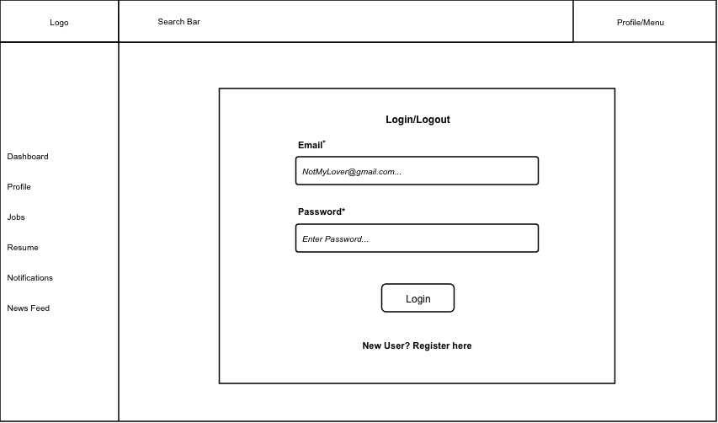

Mobile View – Login / Logout
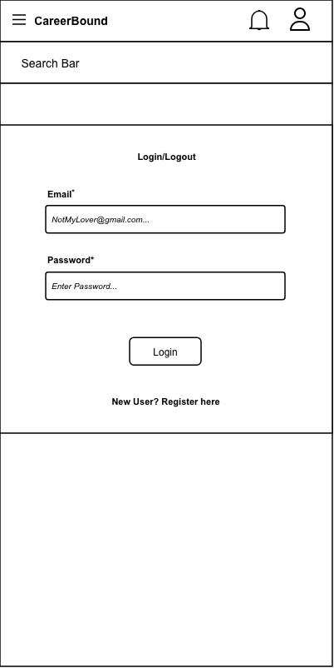

Design Information – Login / Logout
Field | Description / Purpose
View Name & Number |  | 1.1 Login / Logout
Purpose / Design Concern |  | Provides a way for students and companies to log into their profiles.
Description |  | A website page which displays a log in field for the user to input their email and password to authenticate themselves.
Requirements |  | Authentication requirements supporting all protected system functionality under Sections 2.x and 3.x
Elements |  | Email Field
 |  | Password Field
 |  | Login Button
 |  | Invalid Login Information Field
 |  | Registration Redirect Button
Inputs |  | Email and Password fields, Login button click, Register link click, Forgot Password link click.
Outputs |  | Redirect to Dashboard (2.1 for students, 3.1 for companies) if user log in was successful. Displays an error message if invalid credentials were provided.
Navigation / References |  | Student Dashboard 2.1, Company Dashboard 3.1, Registration 1.2
Viewpoint |  | UI Wireframe / Mockup (Desktop & Mobile).

UI View 1.2 — Registration

Desktop View – Registration
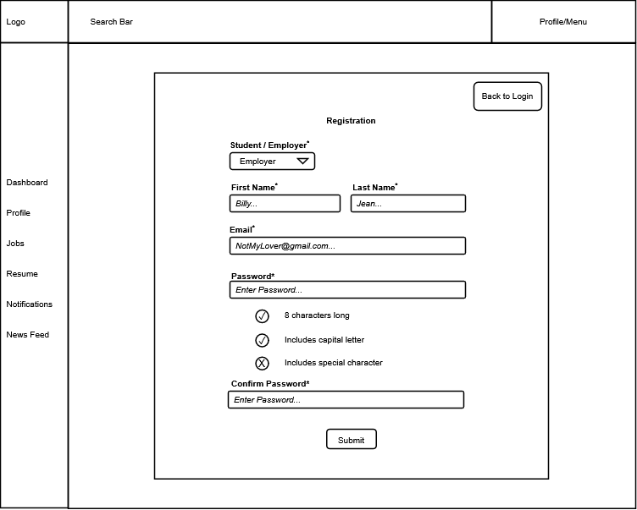

Mobile View – Registration
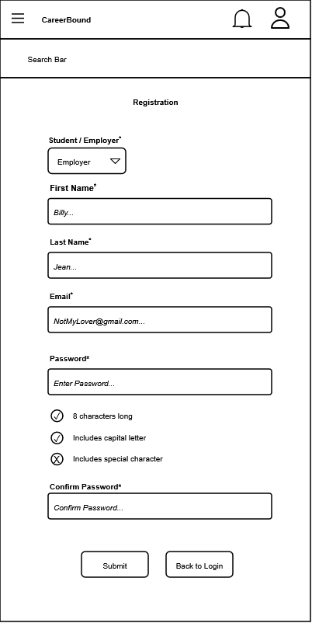

Design Information – Registration
Field | Description / Purpose
View Name & Number | 1.2 Registration
Purpose / Design Concern | Facilitates user account creation and role selection for new users.
Description | Displays a registration form allowing a user to select their role and establish account credentials.
Requirements | SRS 2.1 Company Profile Page, 3.1 Student User Profile
Elements | Back to Login button
 | Student / Employer role selection dropdown
 | Text fields
 | Password validation checklist
 | Submit button
Inputs | Role selection, First Name string, Last Name string, Email string, Password string, Confirm Password string, Submit action.
Outputs | Visual feedback on password requirement validation (status icons for "8 characters long", "Includes capital letter", and "Includes special character").
Navigation / References | 1.1 Login / Logout (accessed via "Back to Login" button).  2.1 Student Dashboard or 3.1 Company Dashboard upon successful submission.
Viewpoint | UI Wireframe / Mockup (Desktop & Mobile).

UI View 2.1 — Student Dashboard

Desktop View – Student Dashboard
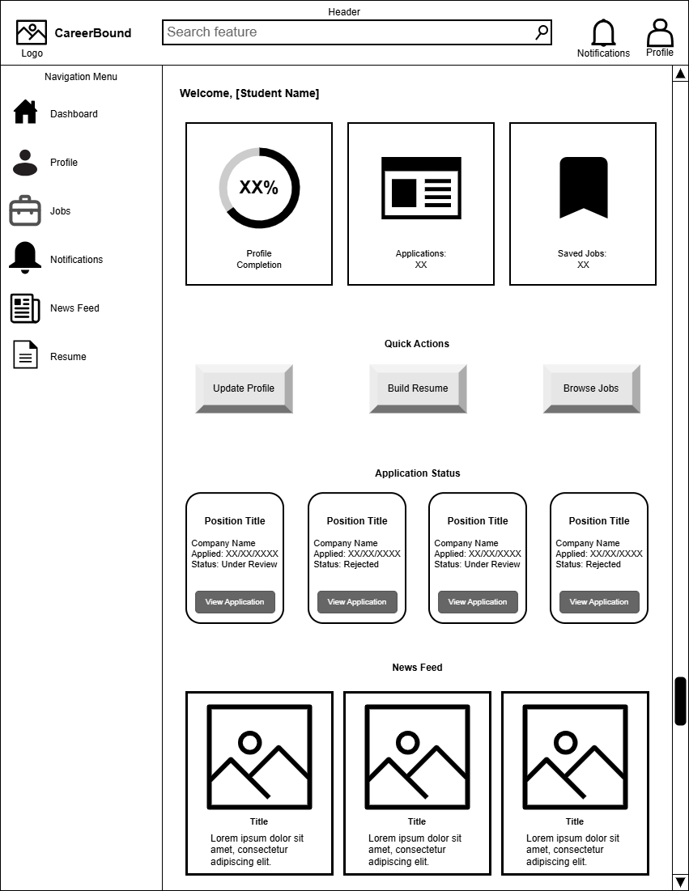

Mobile View – Student Dashboard
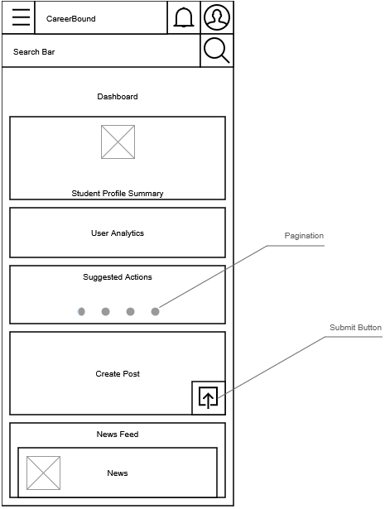

Design Information – Student Dashboard
Field | Description / Purpose
View Name & Number | 2.1 – Student Dashboard
Purpose / Design Concern | Provides students with a centralized dashboard for managing career development activities, tracking applications, accessing important tools, and viewing personalized updates within the Career Bound system.
Description | Displays a summarized student profile; profile progress (desktop) provides analytics such as profile views, profile completion, matching jobs, post impressions, application summaries; application tracking cards (desktop); recommends actions (mobile) to take such as improve profile, create resume, apply for a job; provides a shortcut to post creation; and displays social media-style news feed containing career-related updates and announcements.
Requirements | 3.1 Student User Profile, 3.2 Notifications, 3.3 Search Features, 3.4 News Feed, 3.5 Resume
Elements | Student Profile Summary Card (mobile)
 | Student User Analytics Card (mobile)
 | Suggested Actions Card (mobile)
 | Quick Create Post Card (mobile)
 | News feed List
 | News feed Cards
 | Submit Button
 | Navigation menu (Sidebar for desktop, toggle for mobile)
 | Header
 | Search Feature
 | Applications Summary Card (desktop)
 | Saved Jobs Summary Card (desktop)
 | Applications Status Cards (desktop)
 | Notifications toggle button
 | Profile Page hyperlink button
 | Pagination
Inputs | Student Post, Click, Scroll, Search queries, navigation selections, notification interactions, profile selections, quick action button selections, application card selections, news feed interactions
Outputs | Profile completion percentage, application status information, saved job totals, recommended actions, job application details, career updates, company announcements, News feed content, New Student Post, Navigation redirects, Navigate to next action card
Navigation / References | Authentication, Student Profile, Resume Builder, Job Search, Job Details, Notifications, News Feed, Saved Jobs, Job Applications
Viewpoint | UI Wireframe / Mockup (Desktop & Mobile)

UI View 2.2 — Student Profile

Desktop View – Student Profile
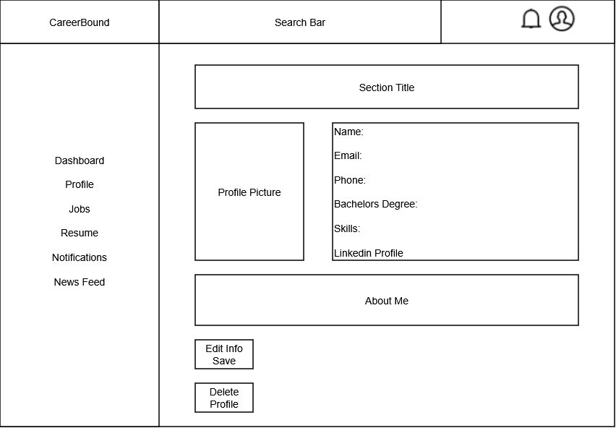

Mobile View – Student Profile
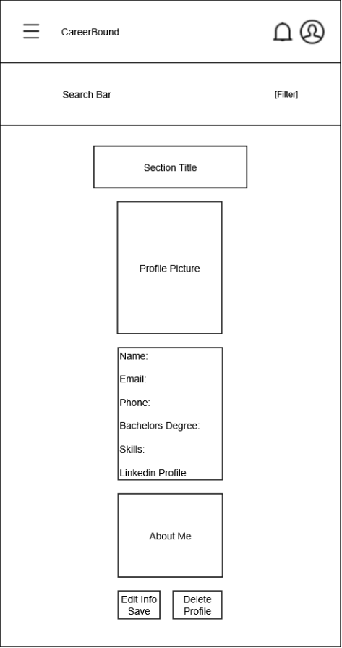

Design Information – Student Profile
Field | Description / Purpose
View Name & Number | 2.2 – Student Profile
Purpose / Design Concern | Allows students to view and manage their profile information.
Description | Displays student information such as name, contact information, program, skills, and resume-related details.
Requirements | 3.1 Student User Profile (3.1.1–3.1.3.3)
Elements | Logo
 | Search bar
 | Menu/Profile
 | Left Navigation
 | Section Title
 | Profile Picture
 | User Information
 | About Me
 | Save/Delete buttons
Inputs | Updated student profile information, Upload CV
Outputs | Displayed student profile information
Navigation / References | Dashboard, Profile, Jobs, Resume, Notifications, News Feed
Viewpoint | UI Wireframe / Mockup (Desktop & Mobile)

UI View 2.3 — Resume Builder

Desktop View – Resume Builder
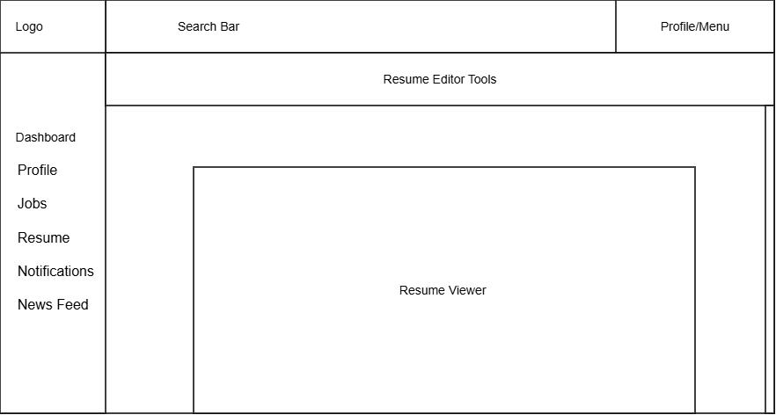

Mobile view – Resume Builder
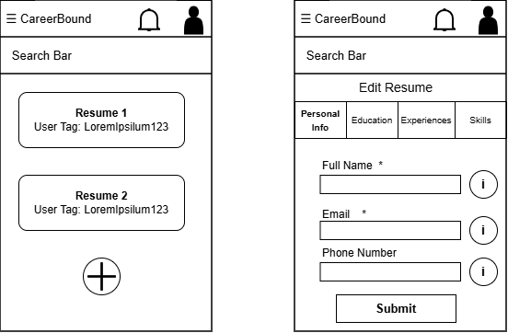

Design Information – Resume Builder
Field | Description / Purpose
View Name & Number | 2.3 Resume Builder
Purpose / Design Concern | Provides a space that allows students to view and edit their resume that is to be used.
Description | Displays student’s resume and gives tools to make and save changes to the resume.
Requirements | SRS 3.5 Resume (3.5.1–3.5.5.2), 3.5.4 User Input, 3.5.5 Input Submission
Elements | Logo
 | Search Bar
 | Profile/Menu
 | Dashboard
 | Profile
 | Jobs
 | Resume
 | Notifications
 | News Feed
 | Resume Editor Tools: Edit Resume Section Tabs/ Add New Resume Button/ Helpful info buttons/ Submit Resume Button/ Asterisks denoting Required Data Entry
 | Resume Viewer: Resume List
Inputs | Resume Edits, Search terms, Resume data entries, Wildcard search
Outputs | Resume reflecting saved changes and recent changes made, Matching resume data terms, resume list search results, new resume data entries
Navigation / References | Profile/Menu, Dashboard, Profile, Jobs, Resume, Notifications, News Feed, Resume List, Edit Resume Screen
Viewpoint | UI Wireframe / Mockup (Desktop & Mobile)

UI View 2.4 — Job Search

Desktop View – Job Search
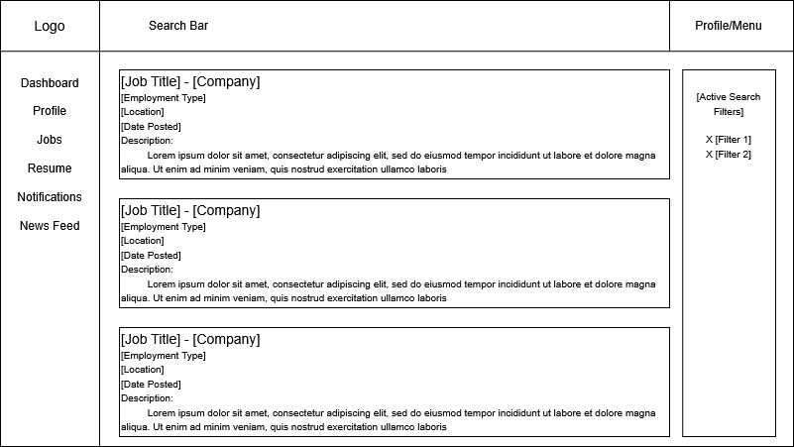

Mobile View – Job Search
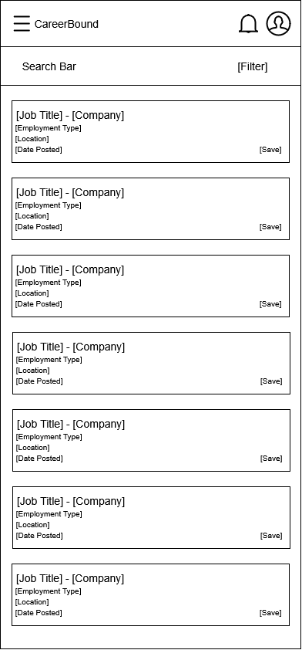

Design Information – Job Search
Field | Description / Purpose
View Name & Number | 2.4 – Job Search
Purpose / Design Concern | Allows students to search for jobs and companies.
Description | Displays searchable job listings with filters and detailed results.
Requirements | SRS 2.3 Search Features, 3.3 Student Search Features
Elements | Search bar
 | Filters
 | Results list
 | Save/apply buttons
Inputs | Search terms, filter selections, wildcard search
Outputs | Matching job postings and company search results
Navigation / References | Job Details Screen, Company Profile, Student Dashboard
Viewpoint | UI Wireframe / Mockup (Desktop & Mobile)

UI View 2.5 — Job Details

Desktop View – Job Details
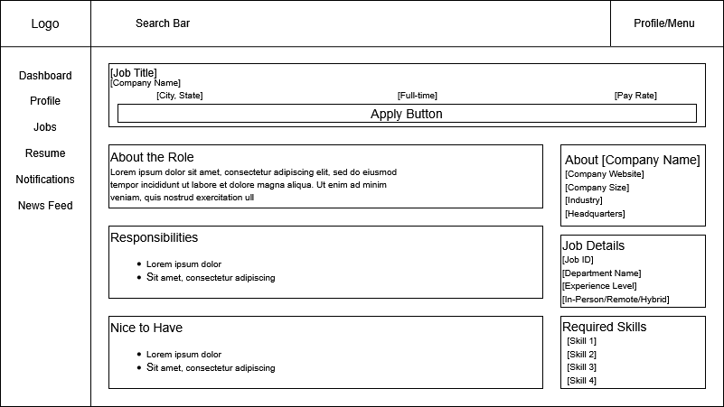

Mobile View – Job Details
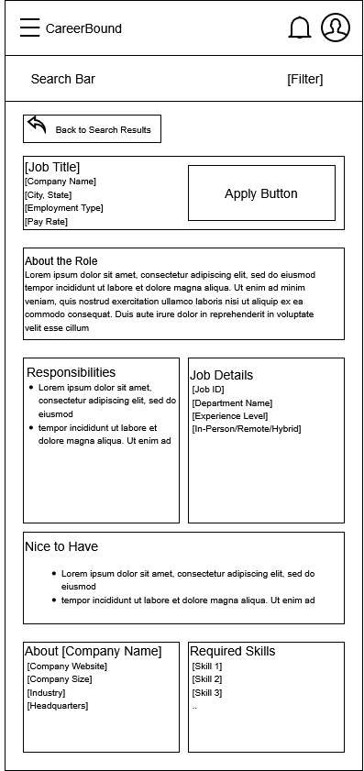

Design Information – Job Details
Field | Description / Purpose
View Name & Number | 2.5 – Job Details
Purpose / Design Concern | Allows students to get more information for Job Postings.
Description | Displays all information relevant to a given Job Postings.
Requirements | SRS 2.5.2, SRS 2.5.7, SRS 2.5.9
Elements | Back Button
 | Job Data
Inputs | Tap/Click on Apply Button
Outputs | Application Submission Confirmation, Updated Application Status
Navigation / References | Job Search Screen, Company Profile, Student Dashboard
Viewpoint | UI Wireframe / Mockup (Desktop & Mobile)

UI View 2.6 — Application Status Tracking

Desktop View – Application Status Tracking
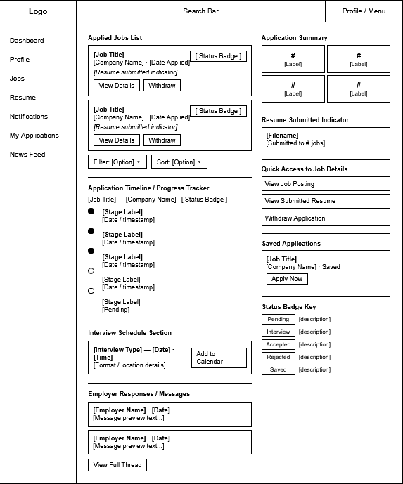

Mobile View – Application Status Tracking
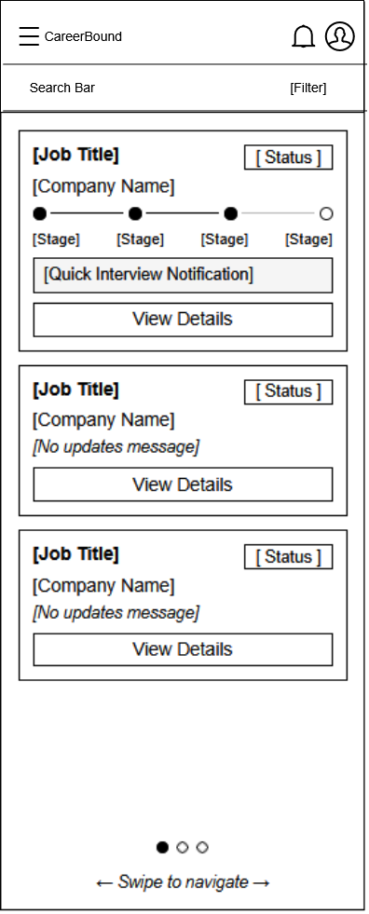

Design Information – Application Status Tracking

Field | Description / Purpose
View Name & Number | 2.6 – Application Status Tracking Screen
Purpose / Design Concern | Allows students to view the status of their job applications.
Description | Displays applications students have submitted and their current status.
Requirements | 1.2.1, 2.5.6, 3.1.3.2, 3.3.1
Elements | Applied Jobs List
 | Application Summary
 | Application Timeline
Inputs | Filter selections, Button input
Outputs | Filtered Application list, Page redirect
Navigation / References | Job Details, Apply, Recent Applications Widget
Viewpoint | UI Wireframe / Mockup (Desktop & Mobile)

UI View 3.1 — Company Dashboard

Desktop View – Company Dashboard
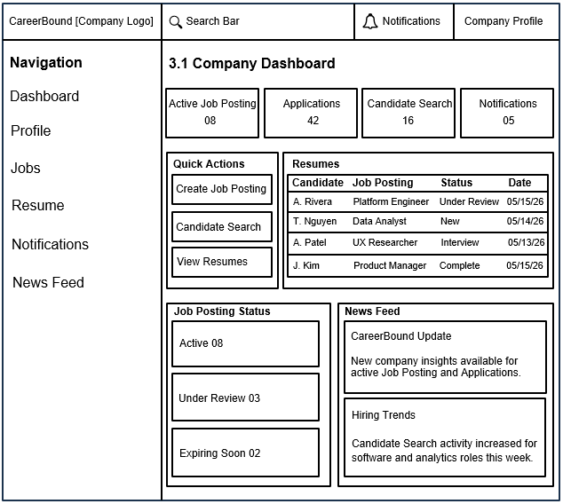

Mobile View – Company Dashboard
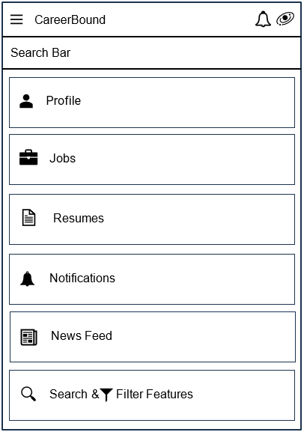

Design Information – Company Dashboard
Field | Description / Purpose
View Name & Number | 3.1 – Company Dashboard
Purpose / Design Concern | Company dashboard to help a company manage recruiting activity from desktop and mobile views.
Description | Provides a desktop and mobile view where company users can review job posting activity, applications, candidate search access, notifications, and company-related updates.
Requirements | Software Requirements Specification (SRS) for Career Bound:  2.1 Company Profile Page, 2.2 Notifications, 2.3 Search Features,  2.4 News Feed, 2.5 Job Postings  Reference: https://content.byui.edu/file/968cdd33-09eb-4430-99a4-131d25e138d4/1/Teach/SRS/430.SRS.CareerBound.pdf
Elements | Navigation menu: provides a company with a list of options to select from.
 | Search bar: provides a company the ability to search.
 | Company Profile area: provides a company with access to all company profile data.
 | Notifications area: provides a company with access to company notifications.
 | Candidate Search feature: provides a company the ability to search or filter job candidates.
 | Job Posting area: provides a company access to job postings.
 | Resume section: provides a company access to a list of candidates who have submitted job applications.
 | News Feed section: provides a company access to news feed options
 | Login / Logout: clicking the company logo provides a company with the ability to login or logout.
Inputs | Search query text, clicks on navigation items, clicks on quick action buttons, and selections related to applications or job postings.
Outputs | Company dashboard metrics, application status information, job posting status information, notifications, and news feed updates.
Navigation / References | 1.1 Login / Logout, 3.2 Candidate Search, 3.3 Job Posting Creation, 4.1 Notifications, 4.2 News Feed
Viewpoint | UI Wireframe / Mockup (Desktop & Mobile)

UI View 3.2 — Candidate Search

Desktop View – Candidate Search
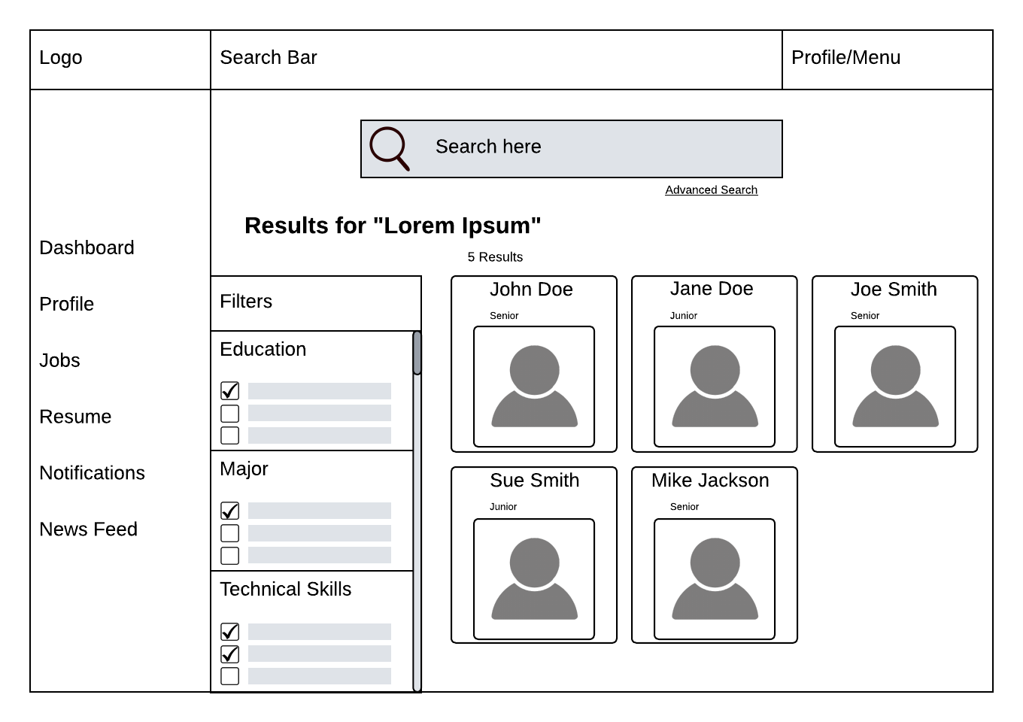

Mobile View – Candidate Search
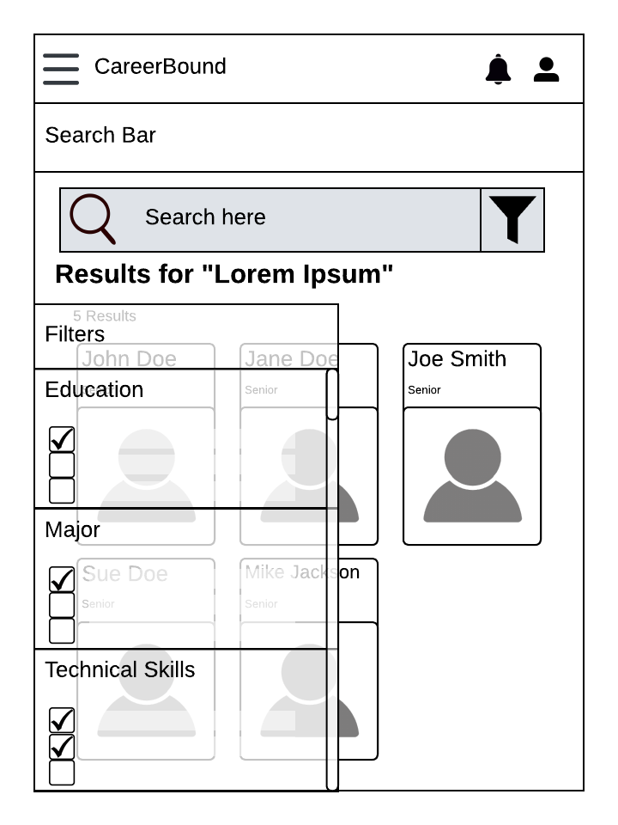

Design Information – Candidate Search
Field | Description / Purpose
View Name & Number | 3.2 Candidate Search
Purpose / Design Concern | Allows company recruiters a way to find potential job seekers.
Description | A specialized search engine for the user to find candidates based on desired filters. Designed for both desktop users and mobile users.
Requirements | 2.3.1, 2.3.2, 2.3.4, 2.3.8
Elements | Search Bar
 | Site Navigation
 | Search Results Grid
 | Filter Categories
 | Filter Checkboxes
 | Search Result Cards
 | Advanced Search Toggle
 | Candidate Name
 | Candidate Profile Picture
 | Candidate Year
 | Filter Scroll Bar
Inputs | User will click on the search bar and enter a search item; user can choose a filter to toggle; the user can choose a candidate to open a new page.
Outputs | Candidate profile cards display candidate information; candidate profiles can be filtered.
Navigation / References | 3.1 Company Dashboard, 3.3 Job Posting Creation
Viewpoint | UI Wireframe / Mockup (Desktop & Mobile)

UI View 3.3 — Job Posting Creation

Desktop View – Job Posting Creation
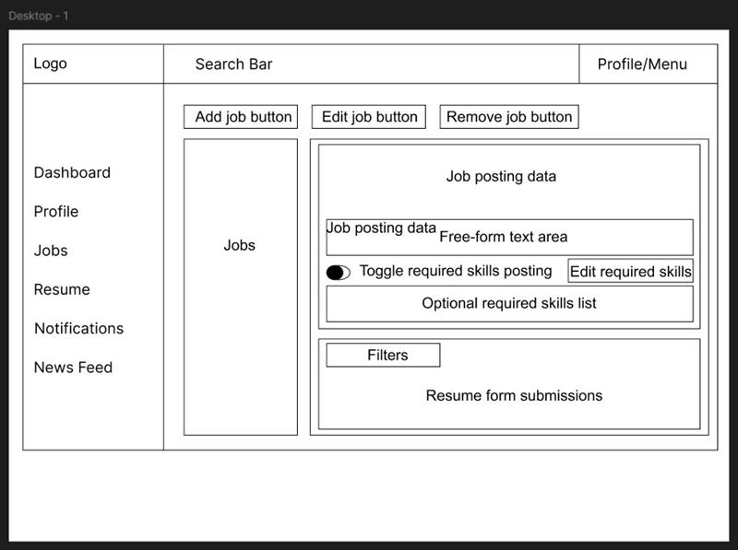

Mobile View – Job Posting Creation
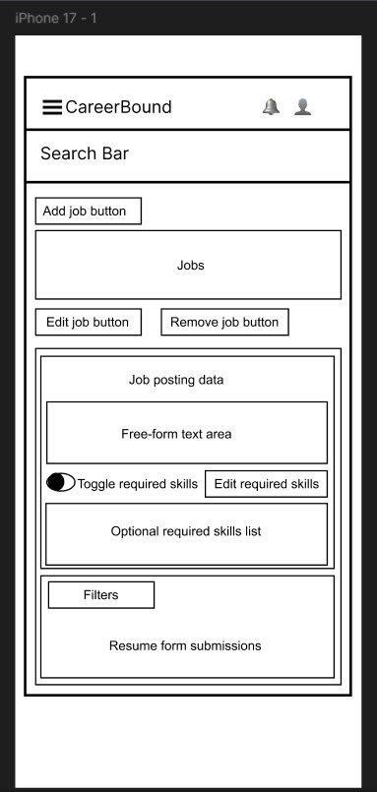

Design Information – Job Posting Creation
Field | Description / Purpose
View Name & Number | 3.3 Job Posting Creation
Purpose / Design Concern | Allows company users to create, edit, and remove job postings, manage required skills, and review resume submissions in a centralized Jobs view.
Description | Displays a company-facing Jobs screen with job posting controls, a job posting data panel, a free-form text area, a required skills toggle, an editable required-skills list, a filters section, and a resume form submissions area in both desktop and mobile wireframe layouts.
Requirements | SRS 2.5 Job Postings (2.5.1--2.5.7)
Elements | Header with logo, search bar, and profile/menu
 | Navigation menu with Dashboard, Profile, Jobs, Resume, Notifications, and News Feed
 | Add Job Button
 | Edit Job Button
 | Remove Job Button
 | Jobs Panel
 | Job Posting data section
 | Free-form text area
 | Required skills toggle
 | Edit Required Skills button
 | Optional required skills list
 | Filters section
 | Resume form submission panel
Inputs | Company user selects Add Job, Edit Job, or Remove Job; enters or edits job posting text; toggles required skills on or off; edits the required skills list; applies filters; reviews submitted resumes.
Outputs | Displayed job posting information, updated required skills settings, filtered submission results, and visible resume form submissions for review.
Navigation / References | Related views include Company Dashboard (3.1), Candidate Search (3.2)
Viewpoint | UI Wireframe / Mockup (Desktop & Mobile)

UI View 4.1 — Notifications

Desktop View – Notifications
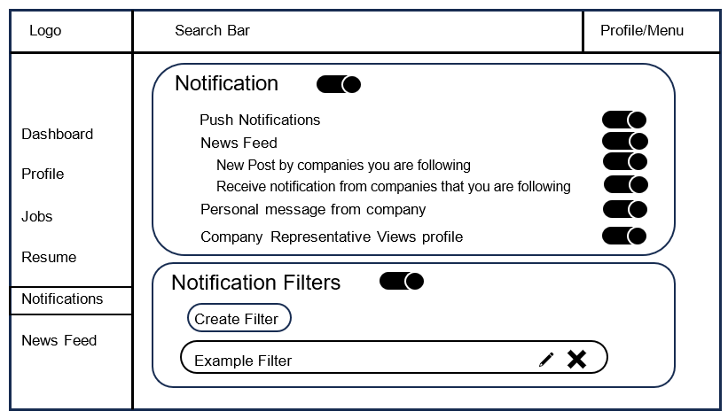

Mobile View – Notifications
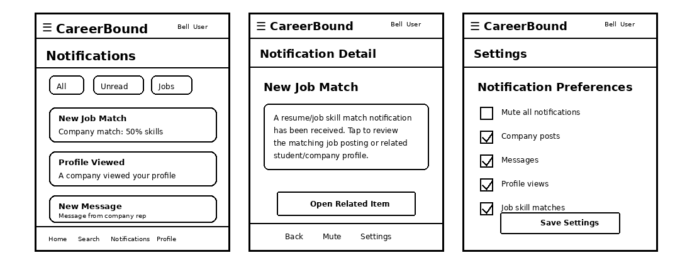

Design Information – Notifications
Field | Description / Purpose
View Name & Number | 4.1 Notifications Screen
Purpose / Design Concern | The Notification Screen exist to allow the user to customize what notifications they receive from Career Bound. This is for the End User and satisfies section 2.2 / 3.2 in the SRS.CareerBound.docx
Description | The Notification Screen will allow the user to customize notifications about their News Feed, Company Viewing their profile, Push Notifications, New posts by company they follow, notifications from company they follow, personal messages, and allow the user to mute all notifications. Uses the filter component to create a list of companies to receive notifications from.  Shows mobile notification screens for student users and company representatives, including the notification list, notification detail screen, push notification handling, and notification preferences.
Requirements | 1.2.1 Application Scope;  2.2 Notifications;  3.2.1. There shall be a notification push sent to the student user instantly after a notification trigger.  3.2.2. The student user shall receive a notification when a company they are following makes a post or sends out a notification to its followers.  3.2.3. The student user shall receive a notification when a company sends them a personal message.  3.2.4. Notifications may be pushed to a student user’s phone outside of the system  3.2.5.Student users may receive a notification when a company representative views his/her  profile.  3.2.6.All users may choose to mute notifications  3.2.7.There shall be settings allowing the student user to add, alter and remove filters for notifications.
Elements | Search Bar
 | App navigation
 | Toggle Switch
 | Create Filter Button
 | Edit Pen Icon
 | Delete X Icon
 | Notification Card: Notification Screen; Notification List; Notification Detail View; Push Notification Handler; Notification Preferences; Mute Notification Control;
 | Notification Filter Card: Filter Settings;
 | Profile/Menu
 | API Client Adapter / REST/HTTP API Port
Inputs | Toggle Switch, Click Button, Click Text, Filter Companies, Search, Selected notification, filter settings, mute setting changes, push notification trigger, and mobile navigation actions
Outputs | Notifications Settings, Filtered Company List, Notification list, notification detail information, filtered notification results, push notification display, and updated notification settings
Navigation / References | Filter Create Screen, Dashboard Screen, Profile Screen, Jobs Screen, Resume Screen, News Feed Screen, Mobile Client, Notification Screen, Notification Detail View, Notification Preferences, API Gateway / Orchestrator
Viewpoint | UI Wireframe / Mockup (Desktop & Mobile)

UI View 4.2 — News Feed

Desktop View – News Feed
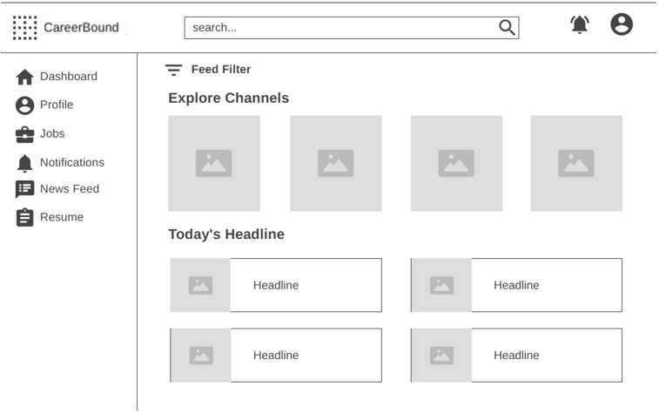

Mobile View – News Feed
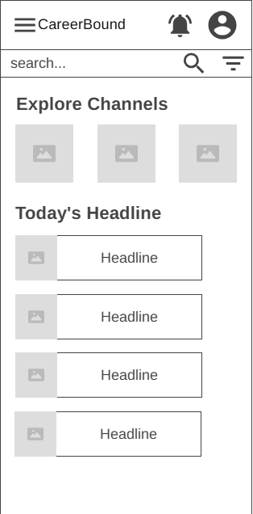

Design Information – News Feed
Field | Description/Purpose
View Name & Number | 4.2 – News Feed
Purpose / Design Concern | Allows students to filter and view their news feed.
Description | Displays relevant news for students, which can be filtered by different tags to view specific news reports.
Requirements | 2.4 News Feed (2.4.1–2.4.6), 3.4 News Feed (3.4.1–3.4.2)
Elements | Logo
 | Notifications
 | Search Bar
 | Menu/Profile
 | Feed Filter
 | Explore Channels
 | Headlines
Inputs | Current news, current location
Outputs | Updated news feed, current location displayed
Navigation / References | Dashboard, Profile, Jobs, Resume, Notifications, News Feed
Viewpoint | UI Wireframe / Mockup (Desktop & Mobile)

UI View 4.3 — Analytics Dashboard

Desktop View – Analytics Dashboard
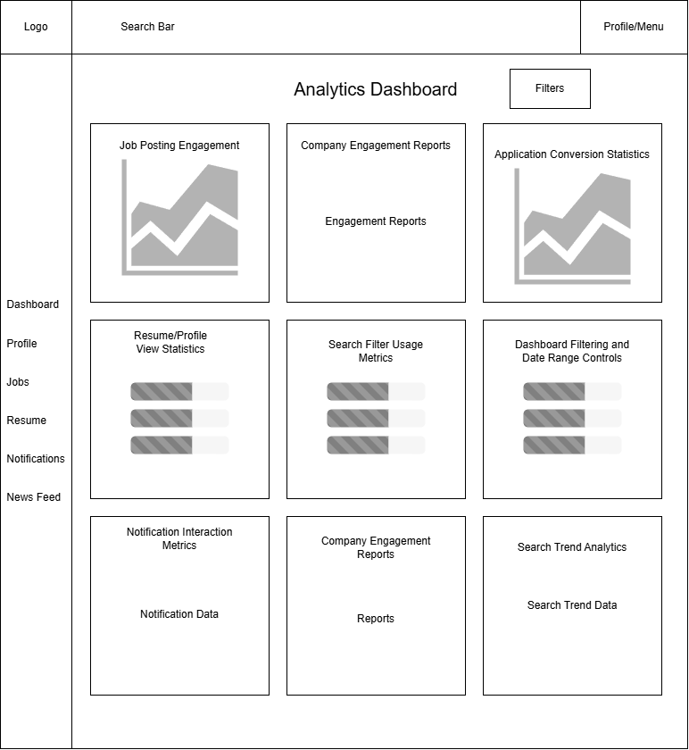

Mobile View – Analytics Dashboard
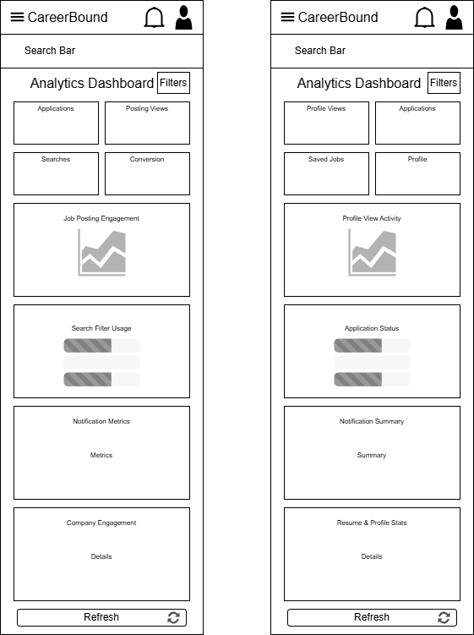

Design Information – Analytics Dashboard
Field | Description / Purpose
View Name & Number | 4.3 – Analytics Dashboard Screen
Purpose / Design Concern | Provides user roles for companies and students to view the activity and engagement within CareerBound.
Description | Display available to both desktop and mobile users that allows access to role specific metrics, charts, and summaries. The user accesses information via a card-click from their role specific dashboard.
Requirements | SRS 2.2.5, SRS 2.3.5, SRS 2.4.5, SRS 3.2.5, SRS 3.3.2, SRS 4.1, SRS 4.2, SRS 4.3, SRS 4.4
Elements | Job Posting Engagement Graphs
 | Resume / Profile View Statistics
 | Notification Interaction Metrics
 | Search Trend Analytics
 | Company Engagement Reports
 | Search Filter Usage Metrics
 | Application Conversion Statistics
 | Dashboard Filtering & Data Range Controls
 | Simplified Analytics Cards
 | Real-Time Metric Updates
Inputs | Filter button, role authentication token, platform activity data, search queries submitted by companies
Outputs | Metric Cards, Job Posting Engagement Chart, Application Conversion Rate, Resume and Profile View Statistics, Search Trend Statistics, and Real-Time Metric Refresh.
Navigation / References | Student Dashboard → Analytics Summary Cards (Profile Completion / Applications / Saved Jobs) → View Analytics → 4.3 Analytics Dashboard Screen  Company Dashboard → Applications / Hiring Trends / Candidate Search Metrics cards → 4.3 Analytics Dashboard Screen
Viewpoint | There are two viewpoints. They are rendered separately as two variants of the same screen. One for students and one for companies.

UI View 4.4 – Privacy Security Settings

Desktop View – Privacy Security Settings
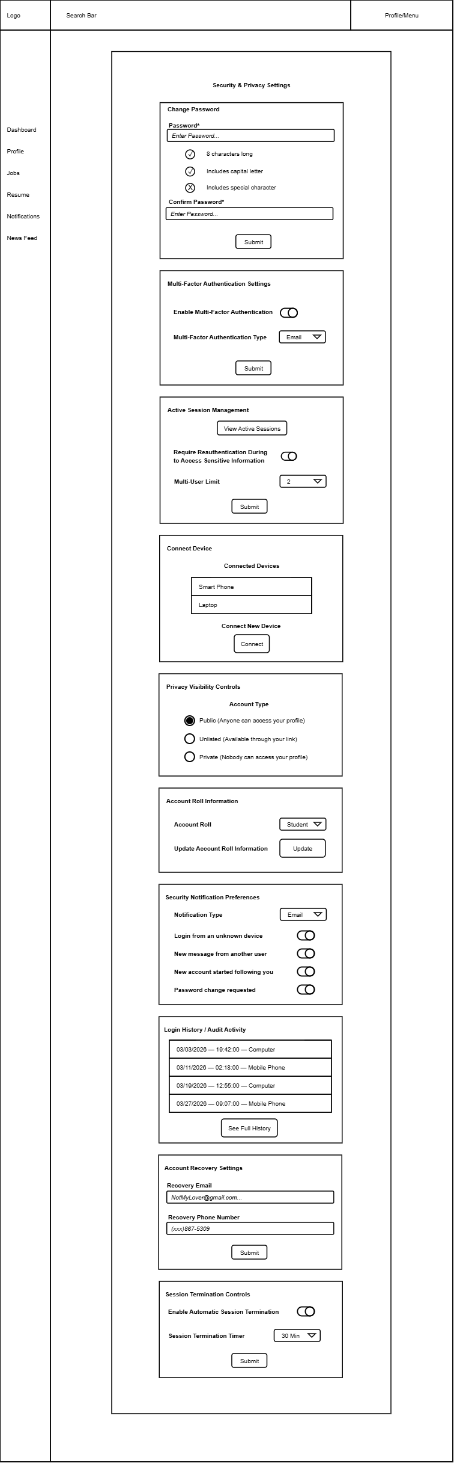



Mobile View – Privacy Security Settings
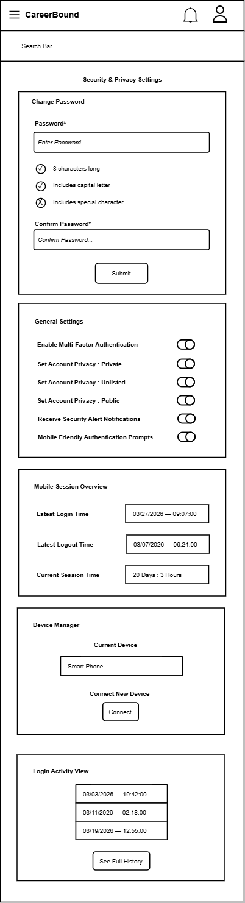


Design Information – Privacy Security Settings
Field | Description / Purpose
View Name & Number | 4.1 Security & Privacy Settings Screen
Purpose / Design Concern | Facilitates changing various privacy settings associated with an account.
Description | Displays all the settings associated with managing an account.
Requirements | SRS 3.2 Notifications
Elements | Change Password Form
 | Multi-Factor Authentication Settings
 | Active Session Management
 | Connect Device List
 | Privacy Visibility Controls
 | Account Roll Information
 | Security Notification Preferences
 | Login History / Audit Activity
 | Account Recovery Settings
 | Session Termination Controls
Inputs | Password string, Confirm Password string, Submit action, Multi-Factor Authentication Toggle, Multi-Factor Authentication Type, View Active Session Click, Require Reauthentication Toggle, Multi-User Limit, New Device for Connection, Account Visibility Radio, Account Roll Type Input, Notification Type, Notification Toggles, See History Click, Recovery Email String, Recovery Phone String, Automatic Session Termination Toggle, Session Termination Time Amount.
Outputs | Visual feedback on password requirement validation (status icons for "8 characters long", "Includes capital letter", and "Includes special character"), Toggles Enabled/Disabled, Dropdown Menu Types Displayed, Connected Devices List, Active Radio Toggles, Login History List.
Navigation / References | 2.1 Student Dashboard or 3.1 Company Dashboard by clicking on Settings -> Account Settings -> Privacy/Security
Viewpoint | UI Wireframe / Mockup (Desktop & Mobile).

Screen Objects and Actions

A discussion of screen objects and actions associated with those objects.

REQUIREMENTS MATRIX
The following table provides a cross-reference that traces each major component in the system architecture to the specific SRS requirements it fulfills. Below this SRS Requirements Mapping Table you will find Requirements Traceability Matrices for quick visual SRS Requirements tracing.

SRS Requirements Mapping Table

Component | SRS Sections / Requirements It Directly Supports
Client Applications  (Parent) | • 1.2 Application Scope (web and mobile interfaces that share the same features)  • Overall client-side architecture, shared UI patterns, role-based views, and coordination between web and mobile clients
Web Client | • Primary web-based user interface (browser UI)  • Implements all web UI elements for Company and Student features (sections 2.x and 3.x)  • Profile pages, search bar, forms, news feed display, notifications display, resume form, job browsing, etc. (1.2.1)
Mobile Client | • Mobile application user interface  • Implements the same features and characteristics as the Web Client (per SRS 1.2.1)  • Mobile-optimized UI for all features in sections 2.x and 3.x (profiles, search, news feed, notifications, resume form, job browsing, etc.)
API Gateway / Orchestrator | • Cross-cutting orchestration for all client–service communication (implicit in 1.2 and all functional requirements in 2.x / 3.x)
Authentication Service | • Foundational requirement for all logged-in features (profiles, following, notifications, job postings, resume access, etc.)  • Required for every section under 2.x and 3.x
Profile Management Service | • 2.1 Company Profile Page (2.1.1–2.1.3.10)  • 3.1 Student User Profile (3.1.1–3.1.3.3)
Resume Service | • 3.5 Resume (3.5.1–3.5.5.2)  • Referenced in 2.1.2, 2.2.5, 2.3.3, 2.3.5, 2.5.6, 3.1.3.1–3.1.3.3
Job Posting Service | • 2.5 Job Postings (2.5.1–2.5.7)  • Referenced in 3.3.1, 3.4.1, 2.2.5
Search Service | • 2.3 Search Features (2.3.1–2.3.8)  • 3.3 Search Features (3.3.1–3.3.2)
Communication Services (Notifications + News Feed) | • 2.2 Notifications (2.2.1–2.2.5)  • 2.4 News Feed (2.4.1–2.4.6)  • 3.2 Notifications (3.2.1–3.2.7)  • 3.4 News Feed (3.4.1–3.4.2)
Recommendation Service | • Job and candidate recommendations based on profiles, resumes, and job postings  • Supports 2.3 Search Features, 2.5 Job Postings, 3.3 Search Features, and 3.1/3.5 profile/resume data
External Services | • External integrations (USPS address validation in 2.1.3.9, autocomplete API in 2.3.6, push notification services in 2.2, etc.)  • Any third-party APIs referenced throughout the SRS
Analytics Service | • Provides reporting and analytics on job posting performance (views, applications, 2.5), candidate search effectiveness (filters, results, 2.3), profile and resume engagement (2.1, 3.1, 3.5), and notification / news feed activity (2.2, 2.4, 3.2, 3.4)  • Monitors key performance metrics (e.g., search results returned within 3 seconds per 2.3.5)  • Supports data-driven platform improvements, usage insights, and overall system monitoring
Data Storage Layer  (Parent) | • Provides the single unified SQL / Data Access Port used by every service in the system  • Acts as the central enclosing component that coordinates Database and File/Blob Storage  • Manages system-wide data concerns (transactions, consistency, backups, scalability, reliability)  • 4. Hardware requirements (implicit backend storage, servers, infrastructure)
Database | • All persistent data storage for profiles, resumes, job postings, notifications, news feed, authentication, etc.  • Referenced in every “Data X.X.X” entry throughout the SRS
File / Blob Storage | • Storage of uploaded resumes, profile images, attachments, and other binary files  • Supports 3.5 Resume submission and any file-related requirements
The following Requirements Traceability Matrices map the requirements defined within the Software Requirements Specification (SRS) to the CareerBound system architecture components responsible for supporting, implementing, or interacting with those requirements.
These matrices are intended to:
- verify that all documented requirements are addressed within the system design,
- demonstrate traceability between requirements and architectural components,
- support validation and quality assurance activities, and
- ensure consistency between the SRS and the Software Design Description (SDD).
An “X” within a matrix cell indicates that the corresponding component directly supports, implements, manages, or participates in fulfilling the specified requirement.
The matrices are organized by major SRS requirement sections for improved readability and maintainability.

  - Company Profile Requirements Matrix (SRS 2.1)

Component | 2.1.1 Profile | 2.1.2 Resume | 2.1.3.1 Contact | 2.1.3.2 Location | 2.1.3.3 Skills | 2.1.3.4 Following | 2.1.3.5 Posting | 2.1.3.6 Analytics | 2.1.3.7 Messaging | 2.1.3.8 Search | 2.1.3.9 Validation | 2.1.3.10 Security
Web Client | X | X | X | X | X | X | X | X | X | X | X | X
Mobile Client | X | X | X | X | X | X | X | X | X | X | X | X
API Gateway / Orchestrator | X | X | X | X | X | X | X | X | X | X | X | X
Authentication Service | X | X | X | X | X | X | X | X | X | X | X | X
Profile Management Service | X | X | X | X | X | X | X | X | X | X | X | X
Resume Service |  | X |  |  | X |  |  | X
Job Posting Service |  |  |  | X |  | X
Search Service |  | X |  |  |  | X |  |  |  | X | X
Communication Services |  |  | X |  |  | X |  |  | X
Recommendation Service |  | X |  |  |  | X |  |  |  | X
External Services |  |  |  |  |  |  |  |  |  |  | X
Analytics Service |  | X |  | X | X | X |  |  | X
Database | X | X | X | X | X | X | X | X | X | X | X | X
File / Blob Storage |  | X |  |  |  | X

  - Notification Requirements Matrix (SRS 2.2)

Component | 2.2.1 Alerts | 2.2.2 Updates | 2.2.3 Push | 2.2.4 Delivery | 2.2.5 Preferences
Web Client | X | X | X | X | X
Mobile Client | X | X | X | X | X
API Gateway / Orchestrator | X | X | X | X | X
Authentication Service | X | X | X | X | X
Profile Management Service
Resume Service
Job Posting Service
Search Service
Communication Services | X | X | X | X | X
Recommendation Service
External Services |  |  | X | X
Analytics Service | X | X | X | X | X
Database | X | X | X | X | X
File / Blob Storage

  - Search Requirements Matrix (SRS 2.3)

Component | 2.3.1 Candidate | 2.3.2 Company | 2.3.3 Filters | 2.3.4 Wildcards | 2.3.5 Performance | 2.3.6 Autocomplete | 2.3.7 Ranking | 2.3.8 Resume
Web Client | X | X | X | X | X | X | X | X
Mobile Client | X | X | X | X | X | X | X | X
API Gateway / Orchestrator | X | X | X | X | X | X | X | X
Authentication Service | X | X | X | X | X | X | X | X
Profile Management Service |  | X | X
Resume Service |  |  | X
Job Posting Service | X | X | X | X | X
Search Service | X | X | X | X | X | X | X | X
Communication Services
Recommendation Service |  | X | X | X |  |  | X | X
External Services |  |  |  |  |  | X | X
Analytics Service | X | X | X | X | X | X | X | X
Database | X | X | X | X | X | X | X | X
File / Blob Storage

  - News Feed Requirements Matrix (SRS 2.4)

Component | 2.4.1 Posts | 2.4.2 Updates | 2.4.3 Media | 2.4.4 Comments | 2.4.5 Reactions | 2.4.6 Feed
Web Client | X | X | X | X | X | X
Mobile Client | X | X | X | X | X | X
API Gateway / Orchestrator | X | X | X | X | X | X
Authentication Service | X | X | X | X | X | X
Profile Management Service
Resume Service
Job Posting Service
Search Service
Communication Services | X | X | X | X | X | X
Recommendation Service
External Services
Analytics Service | X | X | X | X | X | X
Database | X | X | X | X | X | X
File / Blob Storage |  |  | X

  - Job Posting Requirements Matrix (SRS 2.5)

Component | 2.5.1 Create | 2.5.2 Edit | 2.5.3 Delete | 2.5.4 Skills | 2.5.5 Details | 2.5.6 Apply | 2.5.7 Status | 2.5.8 Filters | 2.5.9 Data
Web Client | X | X | X | X | X | X | X | X | X
Mobile Client | X | X | X | X | X | X | X | X | X
API Gateway / Orchestrator | X | X | X | X | X | X | X | X | X
Authentication Service | X | X | X | X | X | X | X | X | X
Profile Management Service
Resume Service |  |  |  |  |  | X | X | X
Job Posting Service | X | X | X | X | X | X | X | X | X
Search Service | X | X | X | X |  |  | X | X | X
Communication Services
Recommendation Service | X | X | X | X | X | X | X | X | X
External Services
Analytics Service | X | X | X | X | X | X | X | X | X
Database | X | X | X | X | X | X | X | X | X
File / Blob Storage |  |  | X

  - Student Profile Requirements Matrix (SRS 3.1)

Component | 3.1.1 Student | 3.1.2 Accolades | 3.1.3.1 GPA | 3.1.3.2 Skills | 3.1.3.3 Experience | 3.1.3.4 Resume
Web Client | X | X | X | X | X | X
Mobile Client | X | X | X | X | X | X
API Gateway / Orchestrator | X | X | X | X | X | X
Authentication Service | X | X | X | X | X | X
Profile Management Service | X | X | X | X | X | X
Resume Service |  |  | X | X | X | X
Job Posting Service
Search Service
Communication Services
Recommendation Service |  | X | X | X | X | X
External Services
Analytics Service | X | X | X | X | X | X
Database | X | X | X | X | X | X
File / Blob Storage |  |  | X | X |  | X

  - Shared Notification Requirements Matrix (SRS 3.2)

Component | 3.2.1 Alerts | 3.2.2 Messages | 3.2.3 Push | 3.2.4 Delivery | 3.2.5 Tracking | 3.2.6 Preferences | 3.2.7 History
Web Client | X | X | X | X | X | X | X
Mobile Client | X | X | X | X | X | X | X
API Gateway / Orchestrator | X | X | X | X | X | X | X
Authentication Service
Profile Management Service
Resume Service
Job Posting Service
Search Service
Communication Services | X | X | X | X | X | X | X
Recommendation Service
External Services |  |  | X | X |  | X
Analytics Service | X | X | X | X | X | X | X
Database | X | X | X | X | X | X | X
File / Blob Storage

  - Student Search Requirements Matrix (SRS 3.3)

Component | 3.3.1 Jobs | 3.3.2 Companies | 3.3.3 Matches | 3.3.4 Filters
Web Client | X | X | X | X
Mobile Client | X | X | X | X
API Gateway / Orchestrator | X | X | X | X
Authentication Service
Profile Management Service |  | X |  | X
Resume Service
Job Posting Service | X |  | X
Search Service | X | X | X | X
Communication Services
Recommendation Service | X | X | X | X
External Services
Analytics Service | X | X | X | X
Database | X | X | X | X
File / Blob Storage

  - Shared News Feed Requirements Matrix (SRS 3.4)

Component | 3.4.1 Feed | 3.4.2 Updates
Web Client | X | X
Mobile Client | X | X
API Gateway / Orchestrator | X | X
Authentication Service
Profile Management Service
Resume Service
Job Posting Service
Search Service
Communication Services | X | X
Recommendation Service
External Services
Analytics Service | X | X
Database | X | X
File / Blob Storage

  - Resume Requirements Matrix (SRS 3.5)

Component | 3.5.1 Builder | 3.5.2 Upload | 3.5.3 Storage | 3.5.4.1 Fields | 3.5.4.2 Help | 3.5.5.1 Submit | 3.5.5.2 Review | 3.5.5.3 Required
Web Client | X | X | X | X | X | X | X | X
Mobile Client | X | X | X | X | X | X | X | X
API Gateway / Orchestrator | X | X | X | X | X | X | X | X
Authentication Service | X | X | X | X | X | X | X | X
Profile Management Service |  |  | X |  |  |  | X
Resume Service | X | X | X | X | X | X | X | X
Job Posting Service
Search Service
Communication Services
Recommendation Service |  | X | X |  |  |  | X
External Services
Analytics Service | X | X | X | X | X | X | X | X
Database | X | X | X | X | X | X | X | X
File / Blob Storage | X | X | X |  |  | X | X

  - Hardware Requirements Matrix (SRS 4.0)

Component | 4.1 Performance | 4.2 Browsers | 4.3 Devices | 4.4 Supported
Web Client | X | X | X | X
Mobile Client | X | X | X | X
API Gateway / Orchestrator | X
Authentication Service | X
Profile Management Service | X
Resume Service | X
Job Posting Service | X
Search Service | X
Communication Services | X
Recommendation Service | X
External Services |  |  | X | X
Analytics Service | X
Database | X
File / Blob Storage | X

APPENDICES

This section is optional.

Appendices may be included, either directly or by reference, to provide supporting details that could aid in the understanding of the Software Design Document.

