- DATA DESIGN

  - Data Description
The information domain of Career Bound consists of students, companies, resumes, job postings, applications, notifications, search activities, and analytics events. These concepts are transformed into software data structures represented by classes, database records, API messages, and stored files. Each major business entity is assigned a corresponding data structure to support storage, processing, and communication throughout the system.
User account information is managed by the Authentication Service and stored in the primary database. Student and company profile information is managed by the Profile Management Service and stored in the primary database. Resume metadata is stored in the primary database while uploaded resume files are stored in File / Blob Storage. Job postings, applications, notifications, search activity data, and analytics events are similarly managed by their corresponding services and persisted within the system's data stores.
Persistent business data is maintained within the primary database, while binary assets and uploaded documents are maintained within File / Blob Storage. Data exchanged between client applications and backend services is transmitted through REST API messages over the system's communication interfaces.
Data Storage Items:
- Primary Database
- User Accounts
- Student Profiles
- Company Profiles
- Job Postings
- Applications
- Notifications
- Search Activity Data
- Analytics Data

- File / Blob Storage
- Resume Documents
- Profile Images
- Attachments
Career Bound stores data related to user authentication, student profiles, company profiles, resumes, job postings, search activities, notifications, and analytics events.
Persistent data is stored in the system database. Temporary data is exchanged through REST API messages between the client applications and backend services.
  - Data Dictionary
The detailed identification of system entities, functions, data stores, classes, modules, and related data structures is documented within the Entity Identification Tables (EITs) provided throughout Section 3.2 Decomposition Description. The EITs serve as the primary source for entity definitions and provide the foundation for the Class Designs, Database Design, File Format Specifications, and Network Protocol/API Message Specifications described in Sections 4.3 through 4.6.
For convenience, the major business and system data entities within Career Bound are summarized below. The following summary-level data dictionary connects these entities to the component decomposition presented in Section 3.2. Each entity listed below is managed, processed, stored, or exchanged by one or more components identified in Figures 1.2 through 1.15. The Related Component / Figure column provides traceability between the data entities and the architectural components responsible for their creation, management, storage, or use. Infrastructure, routing, presentation, and protocol-related entities are documented within the corresponding EITs and supporting design artifacts but may not be individually represented in this summary table.
Entity | Type | Description | Related Component / Figure
Analytics Event | System Entity | Recorded user activity and system metrics | - Analytics Service — Figure 1.13  - Database — Figure 1.14
Application | Business Entity | Student application submitted for a job posting | - Job Posting Service — Figure 1.8  - Database — Figure 1.14
Company Profile | Business Entity | Company account and profile information | - Profile Management Service — Figure 1.6  - Database — Figure 1.14
Job Posting | Business Entity | Published employment opportunity | - Job Posting Service — Figure 1.8  - Search Service — Figure 1.9; Database — Figure 1.14
Notification | Business Entity | System-generated user notification | - Communication Services — Figure 1.10  - Database — Figure 1.14
Recommendation | System Entity | Job or candidate recommendations generated by the system | - Recommendation Service — Figure 1.11
Resume | Business Entity | Student resume data and associated uploaded files | - Resume Service — Figure 1.7  - File / Blob Storage — Figure 1.15
Student Profile | Business Entity | Student account and profile information | - Profile Management Service — Figure 1.6  - Database — Figure 1.14
User Account | Business Entity | Authenticated user account information | - Authentication Service — Figure 1.5  - Database — Figure 1.14

  - Class Design

Class Diagrams – 1.2 & 1.3 Web & Mobile Client

1.2.1 & 1.3.1–CD Menu Class Diagram
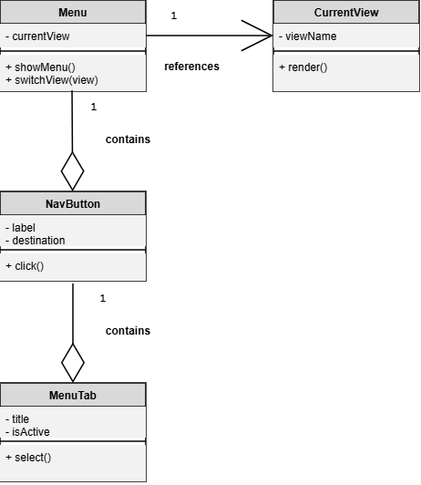

1.2.2 & 1.3.2–CD Navigation Management Class Diagram
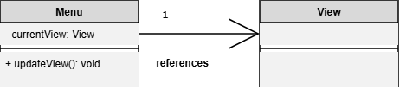

1.2.3 & 1.3.3–CD View Class Diagram
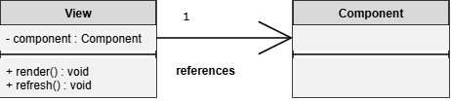

1.2.3 & 1.3.3-CD Form Class Diagram
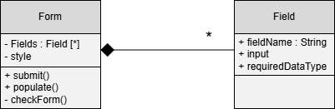

1.2.3 & 1.3.3-CD Form Validation Class Diagram
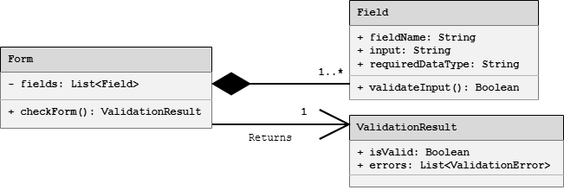

1.2.4 & 1.3.4–CD Localization Class Diagram
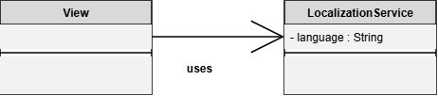

1.2.4 & 1.3.4–CD State Class Diagram
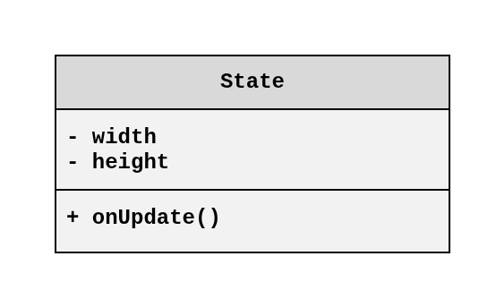

1.2.4 & 1.3.4–CD Dynamic UI Class Diagram
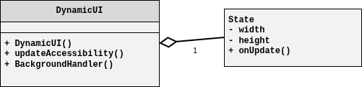

1.2.5 & 1.3.5–CD NetworkConfig Class Diagram
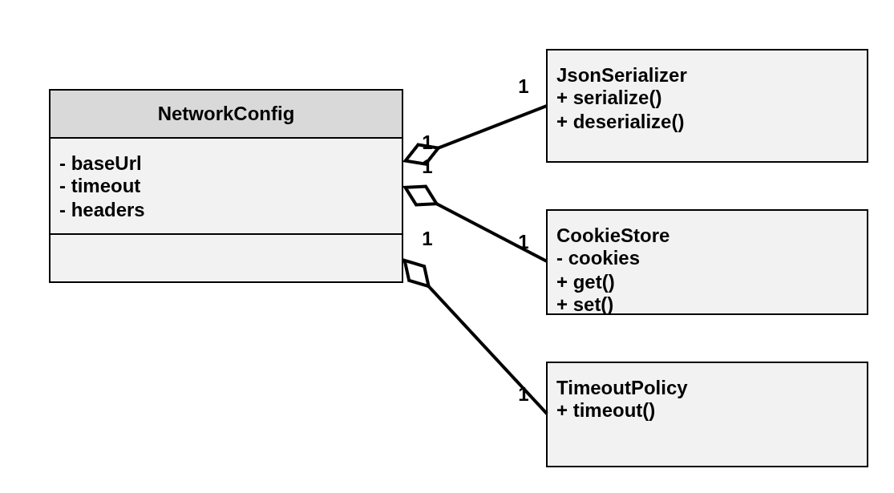

1.2.5 & 1.3.5-CD API Request Processing Class Diagram
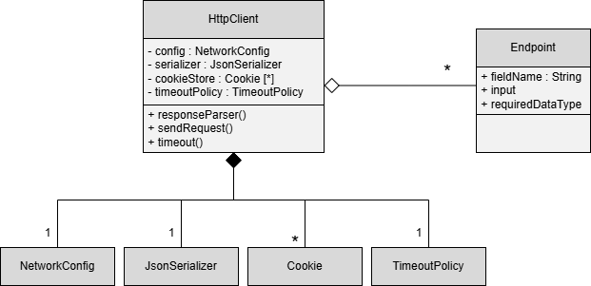

Class Diagrams – 1.4 API Gateway / Orchestrator

1.4.1 – CD API Gateway Class Diagram
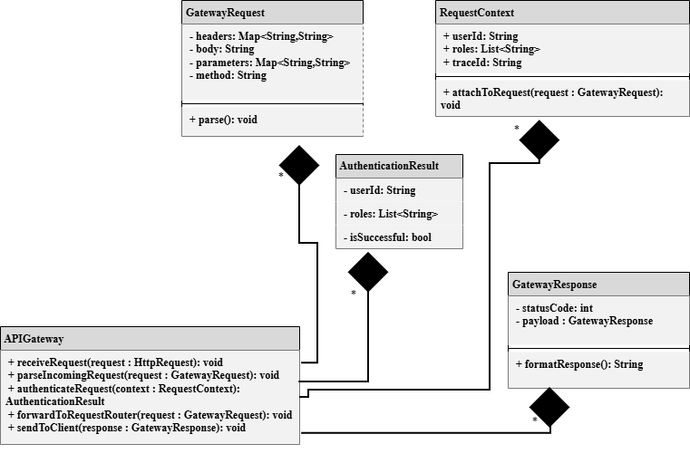

1.4.2 - CD Authentication Handler Class Diagram View
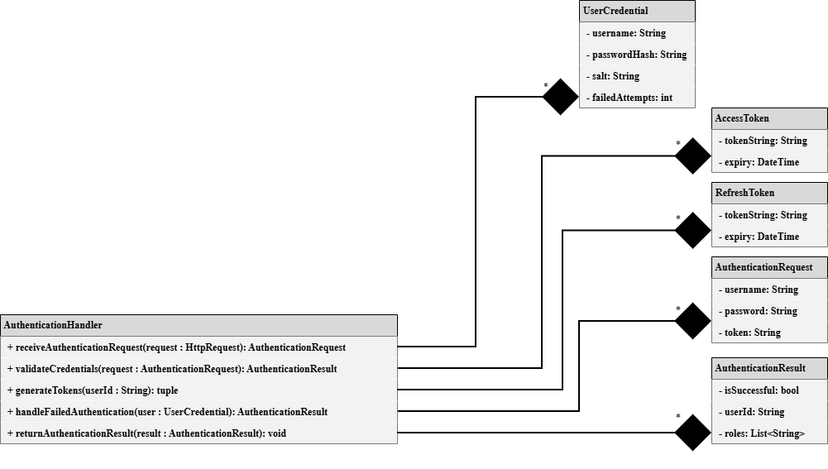

1.4.3-CD Request Router Class Diagram View
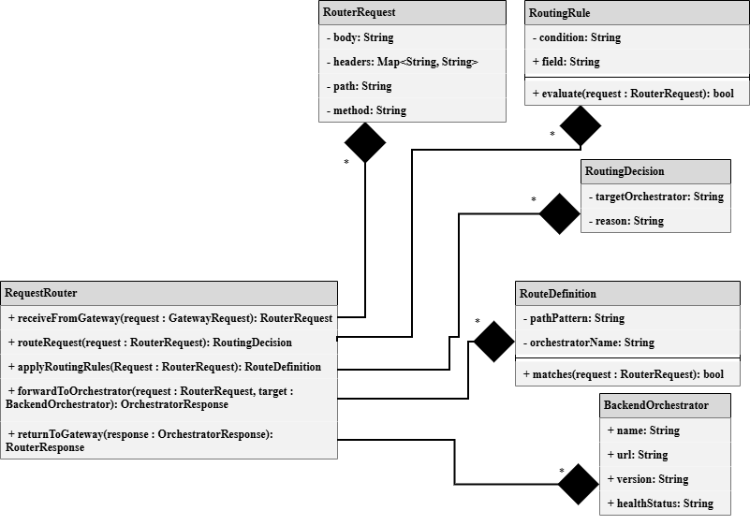

1.4.11–CD ExternalServicesOrchestrator Class Diagram
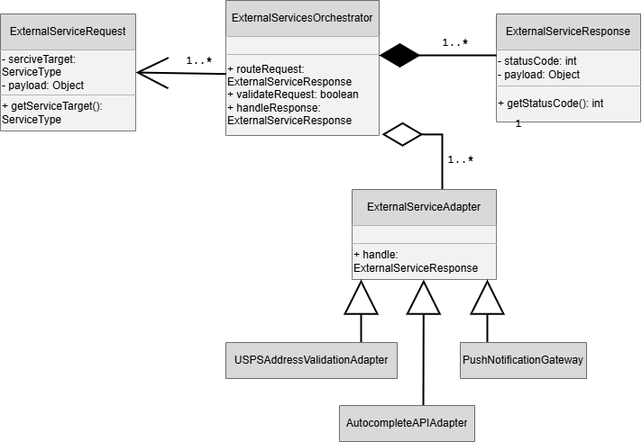

Class Diagrams – 1.5 Authentication Service

1.5.1–CD Registration Manager Class Diagram
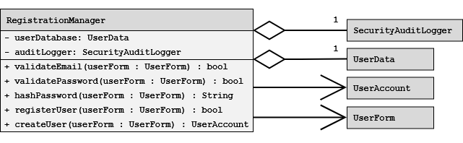

1.5.2-CD UserAccount Class Diagram
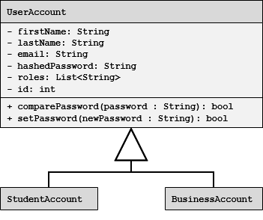

1.5.2–CD Authorization/Role Manager Class Diagram
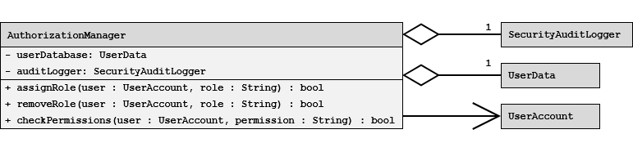

1.5.3-CD Login & Session Manager Class Diagram
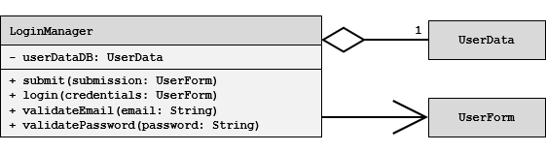

Class Diagrams – 1.6 Profile Management Service

1.6.1-CD User Account Types Class Diagram


1.6.1-CD Accolade Class Diagram
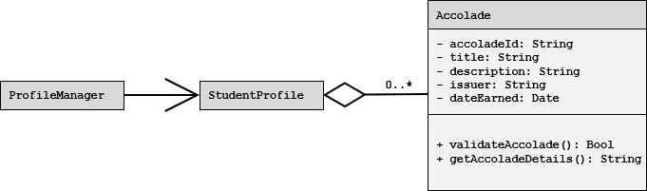

1.6.2-CD Image Manager Class Diagram
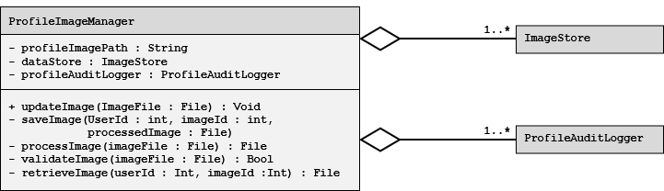

1.6.3-CD Preferences Manager Class Diagram
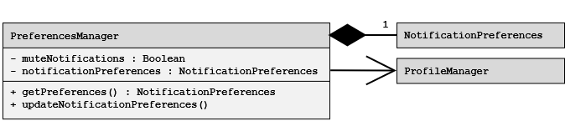

1.6.4-CD Privacy Settings Manager Class Diagram
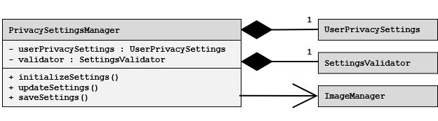

1.6.5-CD Profile Audit Logger Class Diagram
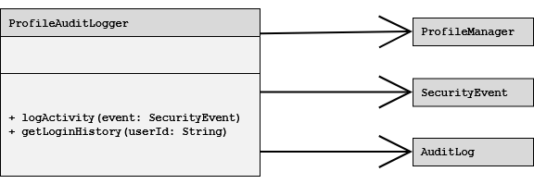

Class Diagrams – 1.7 Resume Service

1.7.1-CD Resume Class Diagram
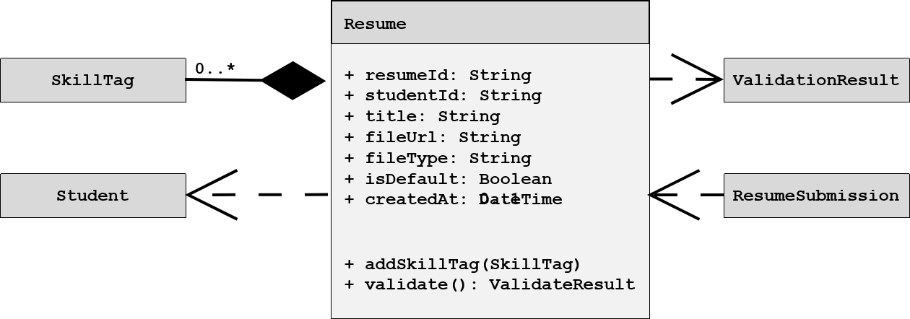

1.7.3-CD ResumeSubmission Class Diagram
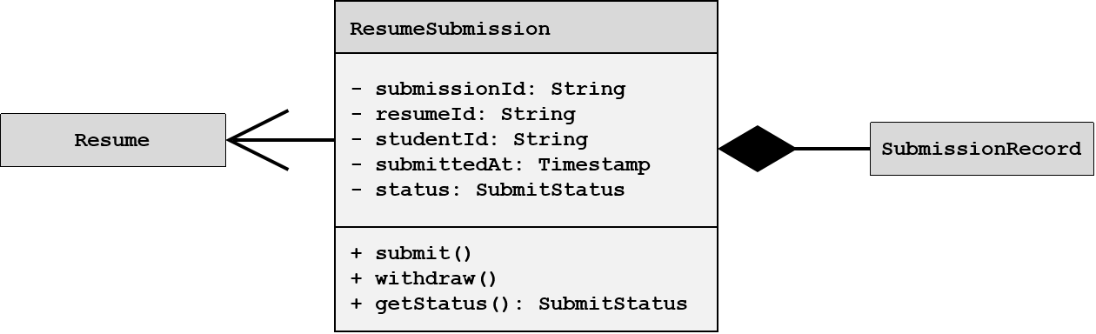

1.7.3-CD Update Resume Request Class Diagram
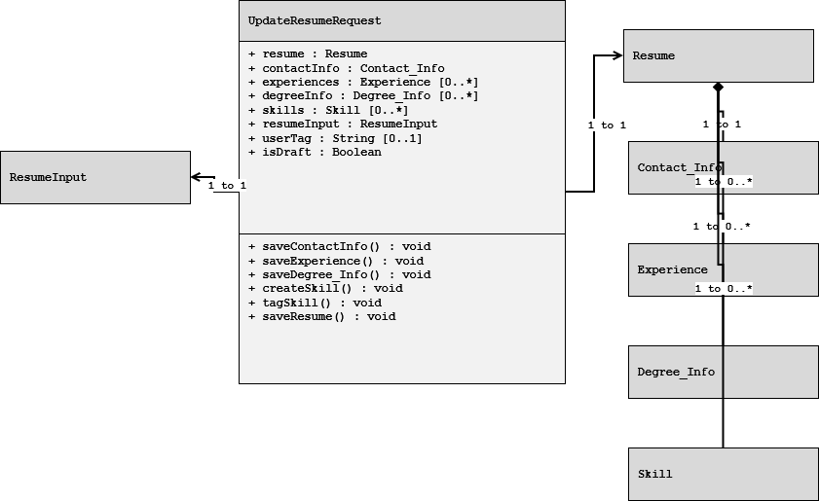

1.7.3-CD Skill Class Diagram
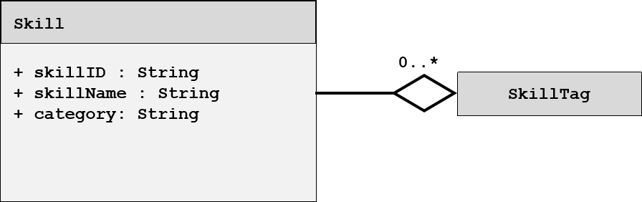

1.7.3-CD SkillTag Class Diagram
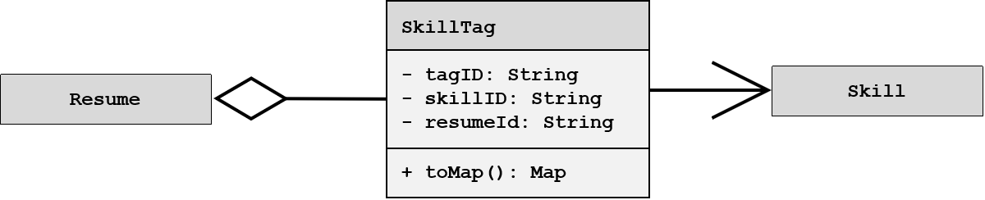

1.7.3-CD Update Resume Response Class Diagram
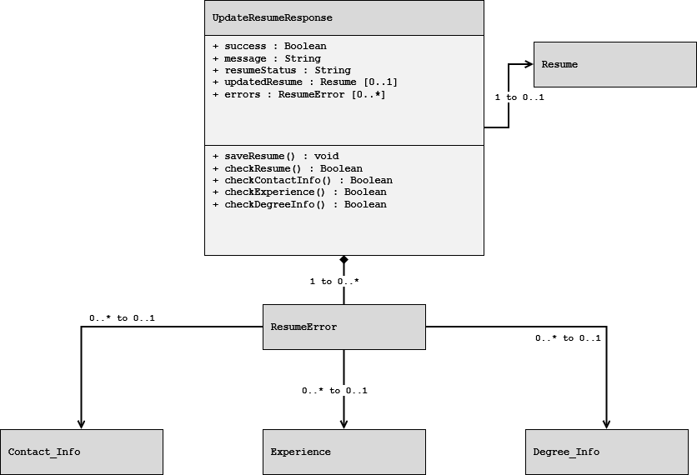

1.7.5-CD ValidationResult Class Diagram
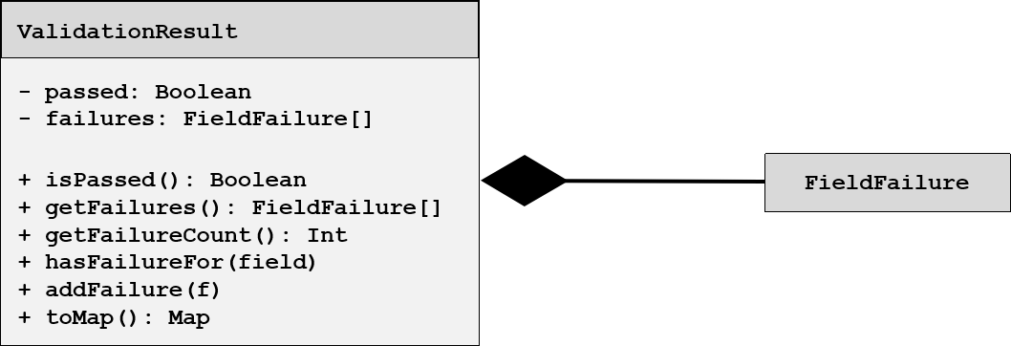

Class Diagrams – 1.9 Search Service

1.9.1-CD SearchController Class Diagram
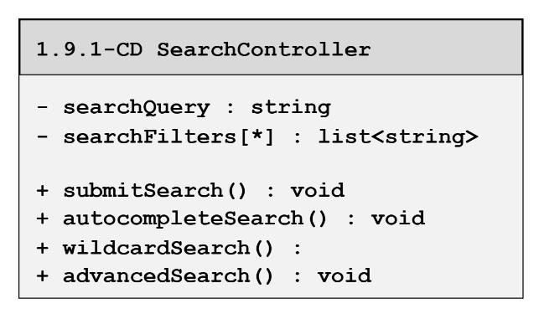

1.9.2-CD CandaditeSearch Class Diagram
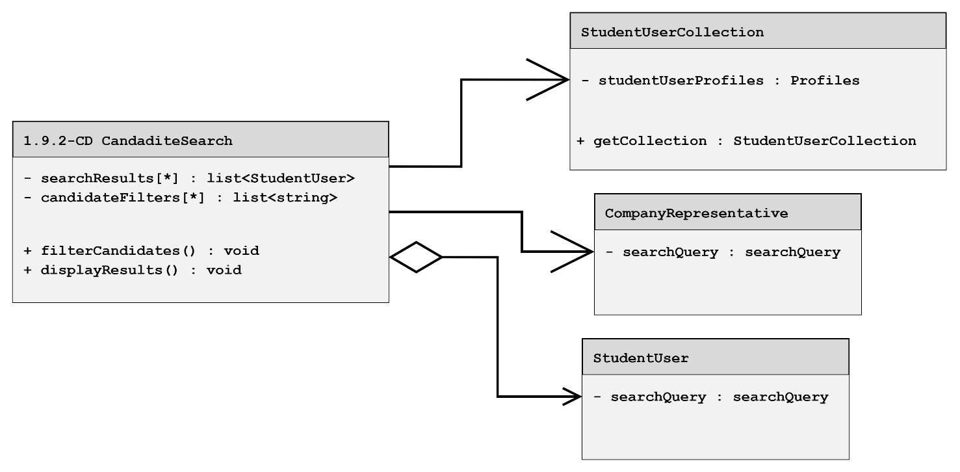

1.9.3-CD JobSearch Class Diagram
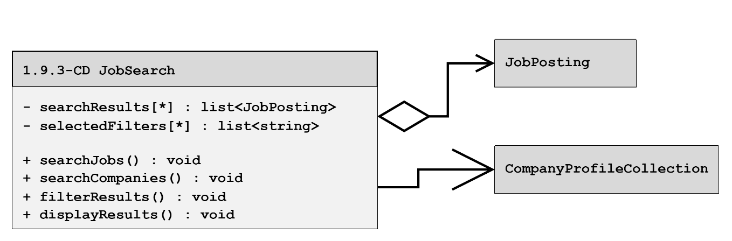

1.9.4-CD CompanySearch Class Diagram
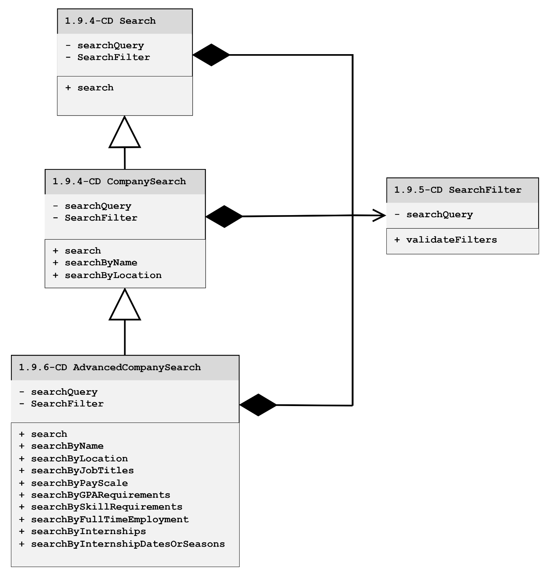

1.9.6 – CD AdvancedCompanySearch Class Diagram
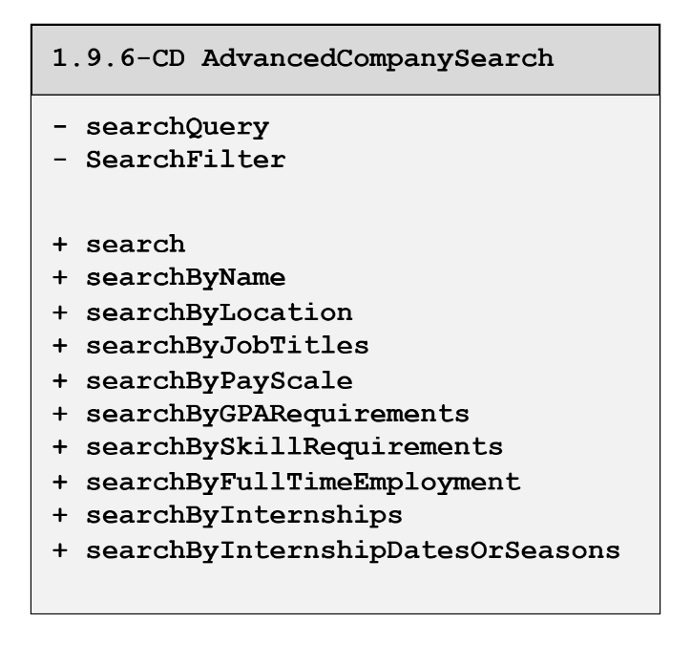

1.9.7-CD WildcardSearch Class Diagram
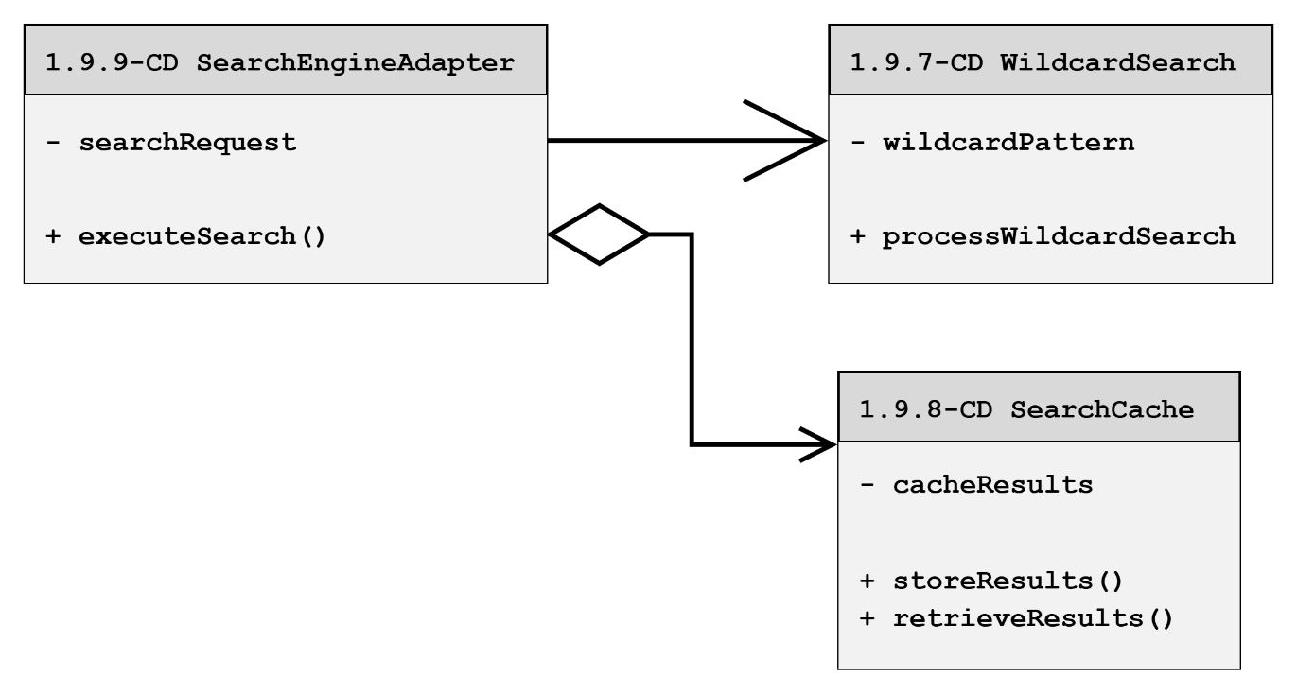

1.9.9-CD SearchEngineAdapter Class Diagram
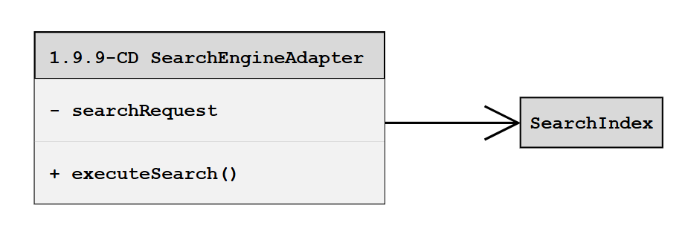

1.9.10-CD SearchEngine Class Diagram
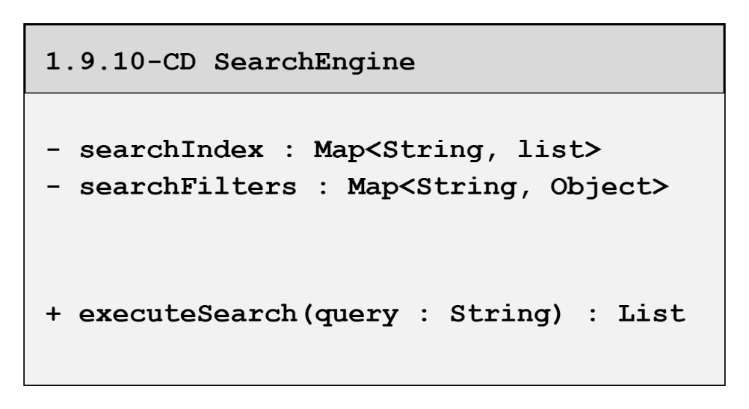

1.9.11-CD Autocomplete Class Diagram
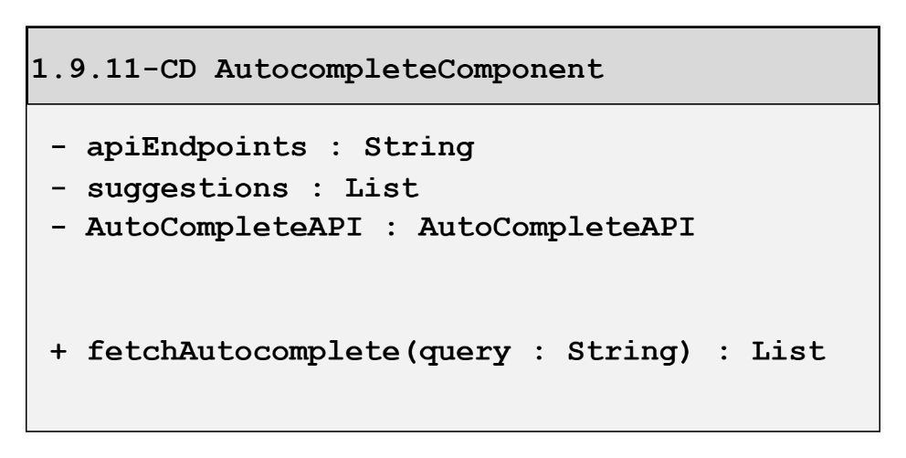

1.9.12-CD ResultsRanker Class Diagram
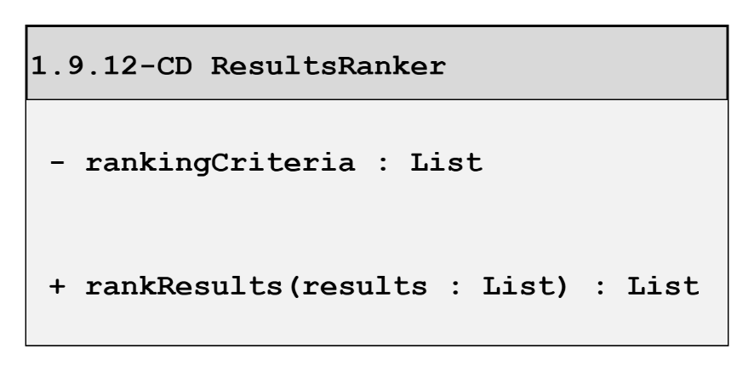

Class Diagrams – 1.10 Communication Services

1.10.1 Event Listener Class Diagram
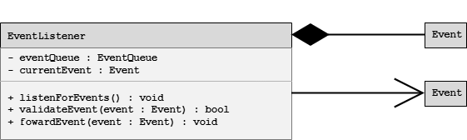

1.10.2 Notification Controller Class Diagram
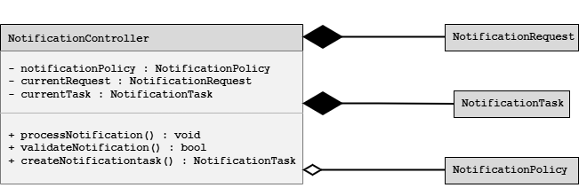

1.10.3 Notification Orchestrator Class Diagram
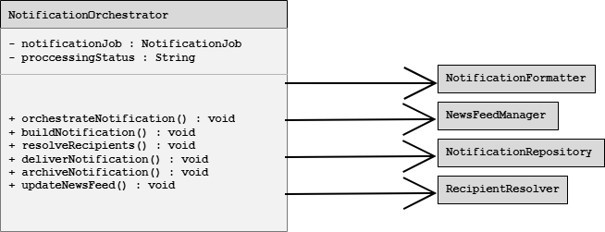

1.10.4-CD Notification Formatter Class Diagram
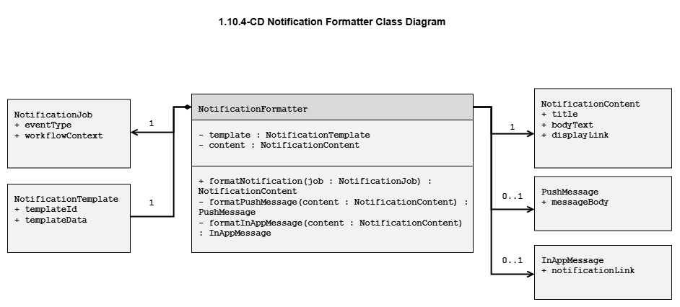

1.10.5-CD Notification Repository Class Diagram
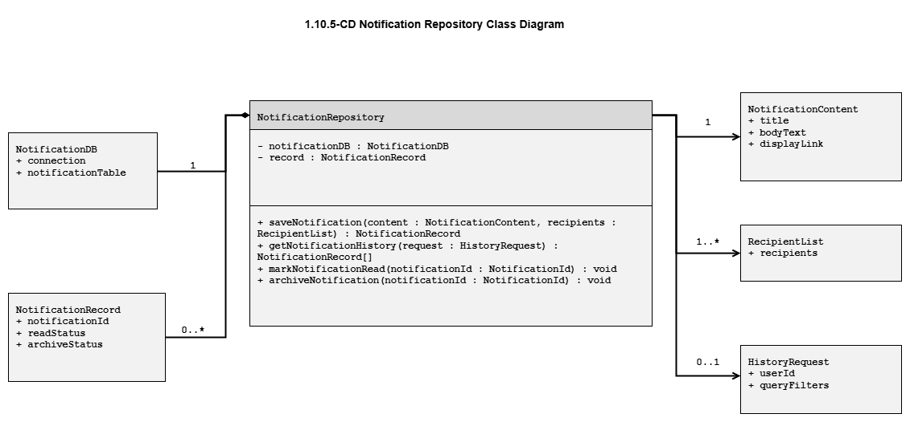

1.10.6-CD Recipient Resolver Class Diagram
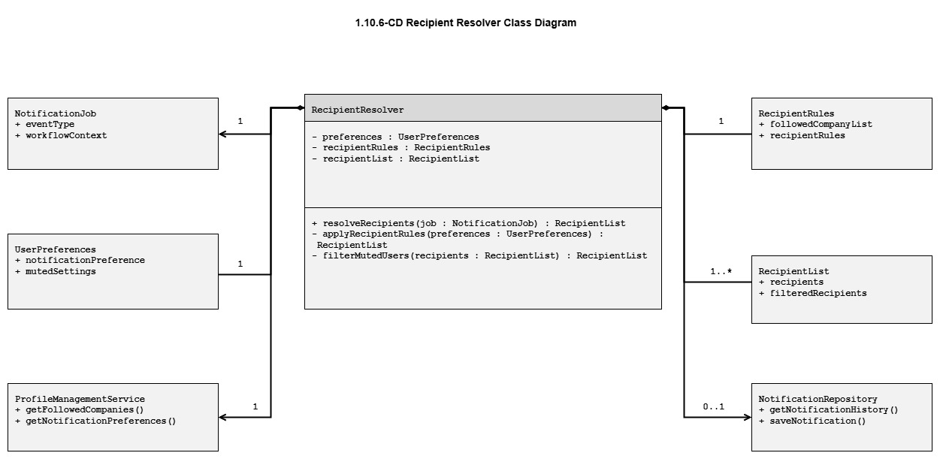

Class Diagrams – 1.11 Recommendation Service

1.11.2-CD CandidateRecommender Class Diagram
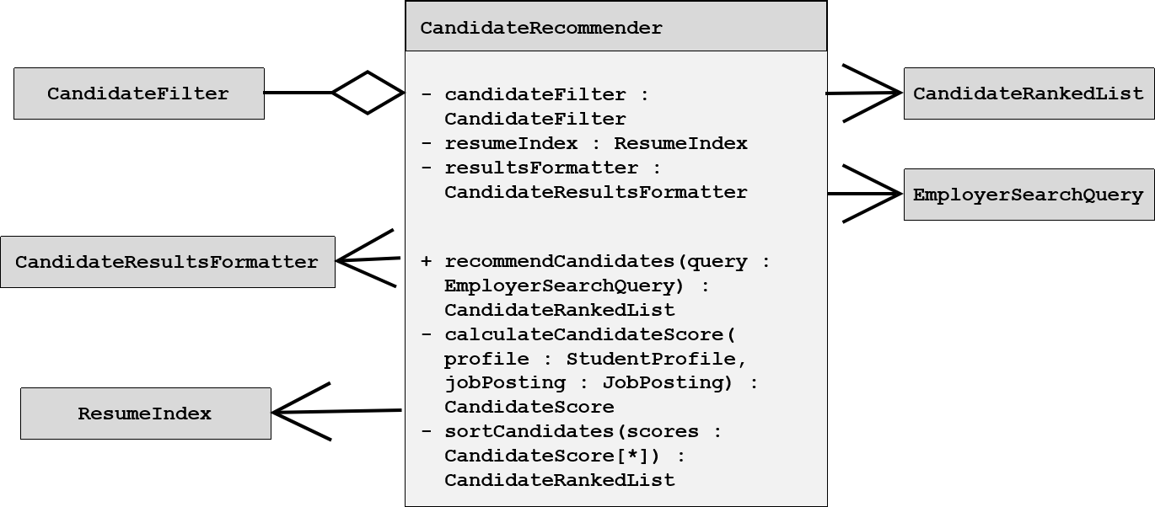

1.11.1-CD JobPosting Class Diagram
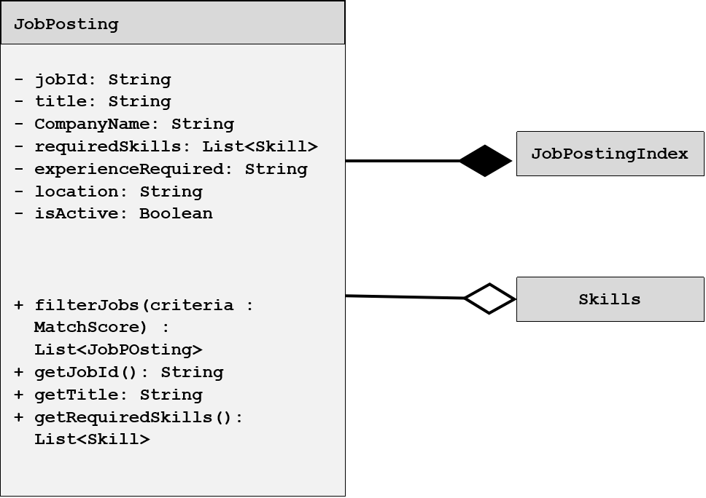

1.11.2-CD CandidateFilter Class Diagram
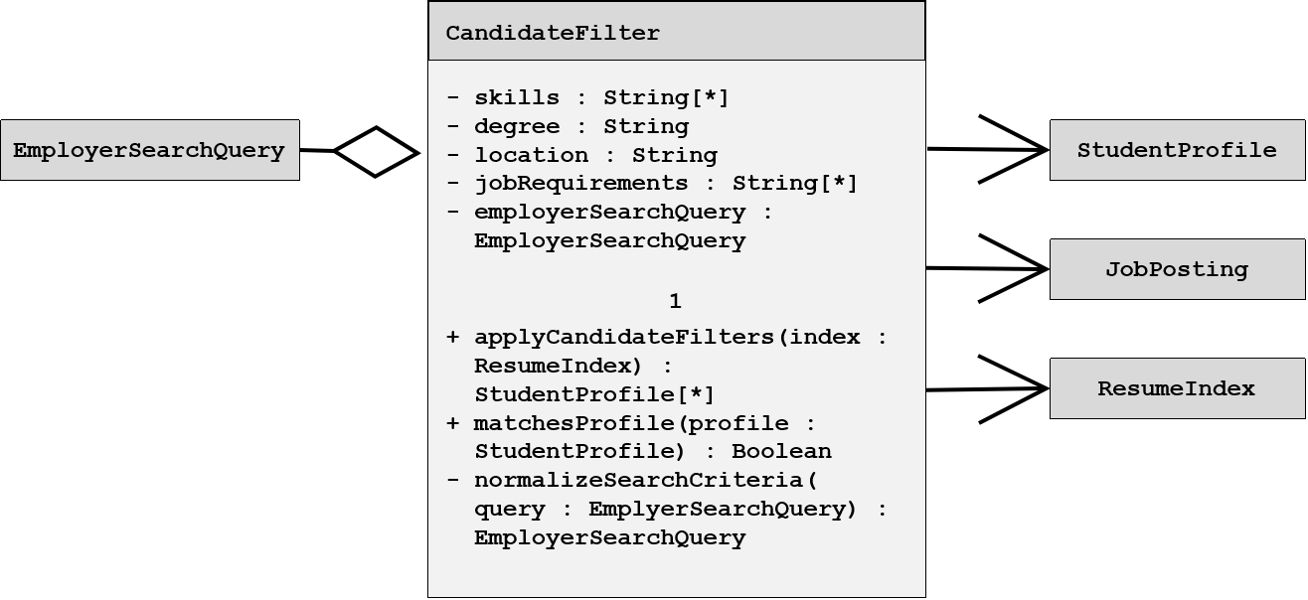

1.11.5-CD Recommendation Class Diagram
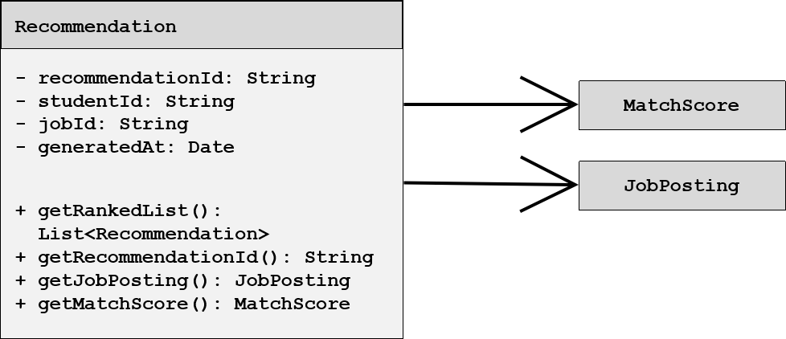

1.11.5-CD StudentProfile Class Diagram
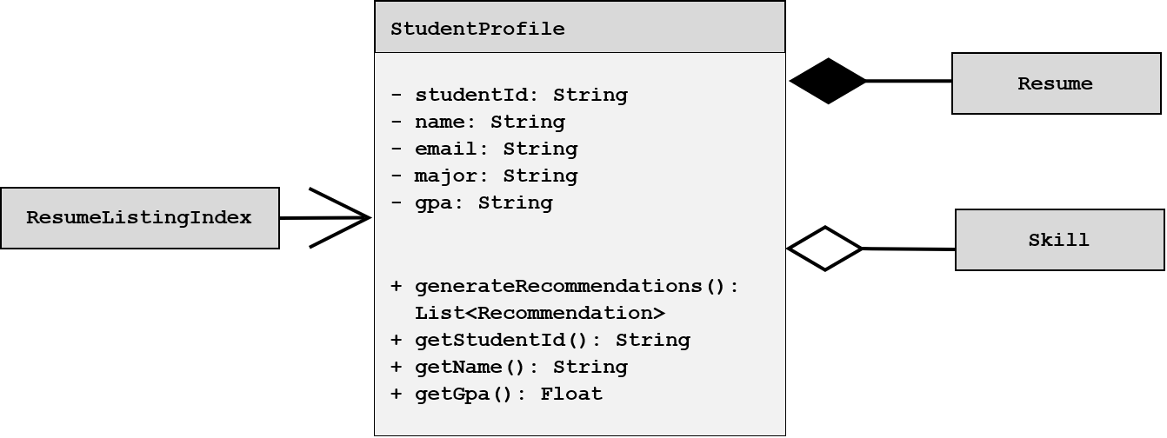

Class Diagrams – 1.12 External Services

1.12-CD External Services Orchestrator Class Diagram


1.12.1-CD USPS Address Validation Adapter Class Diagram
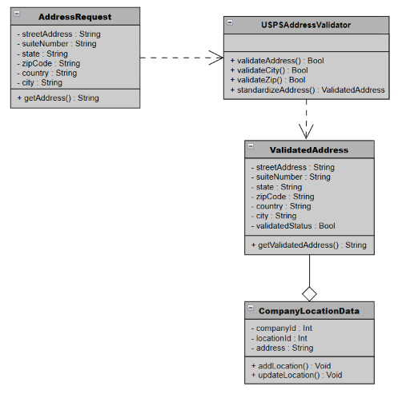

1.12.1-CD Profile and Resume Engagement
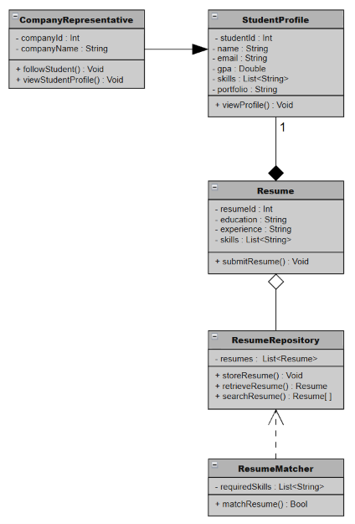

1.12.2-CD Autocomplete API Adapter Class Diagram
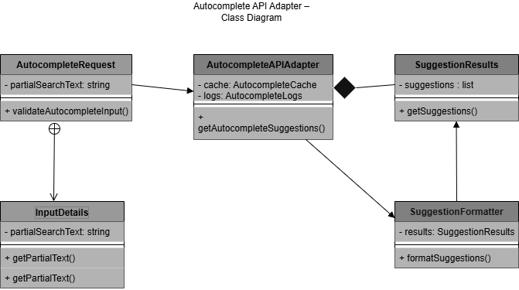

1.12.3-CD Push Notification Gateway
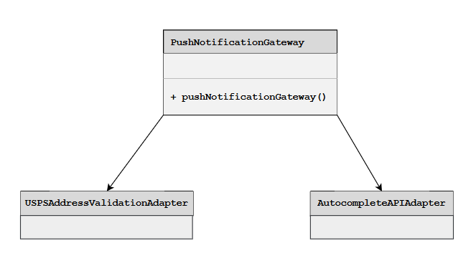

Class Diagrams – 1.13 Analytics Service

1.13-CD Analytics Orchestrator Class Diagram
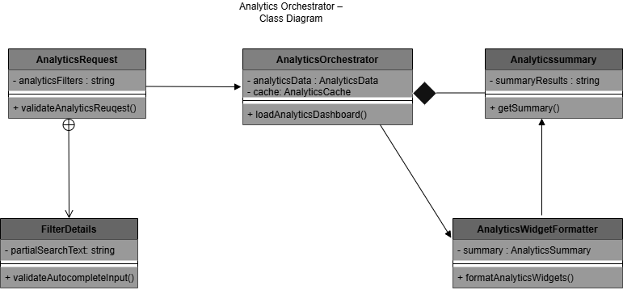

1.13.1-CD JobPostingManager Class Diagram
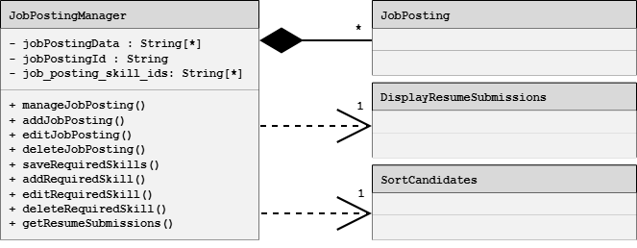

1.13.2-CD CandidateSearchManager Class Diagram
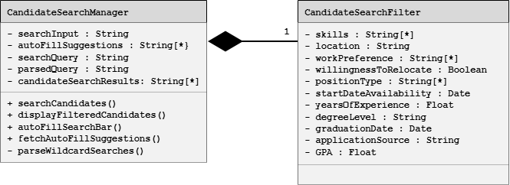

1.13.4-CD Notification and News Feedback Analytics
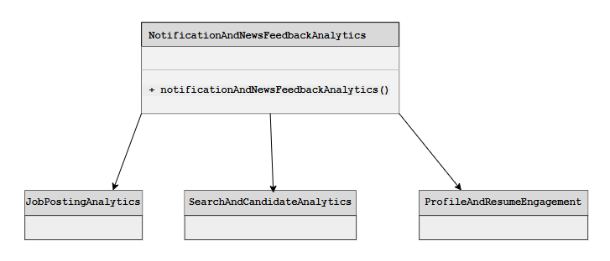

1.13.5-CD Performance Monitor Class Diagram
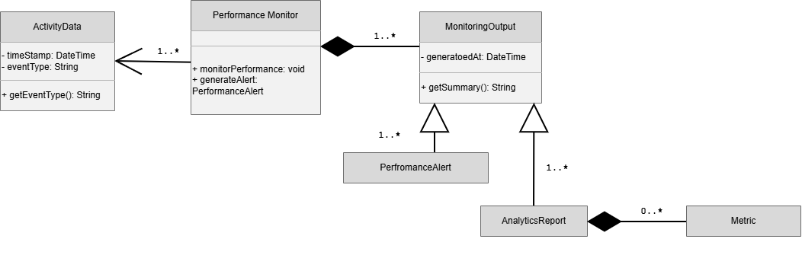

  - Database Design

StudentProfiles Database Table
Column | Data Type | Required | Key | Description
StudentProfileID | UUID | Yes | PK | Primary key for the table.
UserID | UUID | Yes | FK | Key linking this table to the Users table.
StudentSkillsID | UUID | No | FK | Key linking this table to the StudentSkills table.
AboutMeText | TEXT | No |  | User-inputed text for About Me field
ProfilePictureFileID | UUID | No | FK | Key linking to Files table with info about the profile picture.
Degree | VARCHAR(255) | No |  | User-inputted text for the Degree field.
LinkedInProfileLink | VARCHAR(255) | No |  | User-inputted text for LinkedIn URL field

Components StudentProfiles Database Supports
- Figure 1.6 — Profile Management Service Detail — Primary storage for student profile information, including About Me text, degree information, LinkedIn profile link, and profile-picture reference.
- Figure 1.7 — Resume Service Detail — Provides student identity and profile context associated with resumes.
- Figure 1.11 — Recommendation Service Detail — Provides profile information, degree information, and student skills context used for recommendations.
- Figure 1.13 — Analytics Service Detail — Provides profile-related data that may be summarized for profile and resume engagement analytics.

Companies Database Table
Column | Data Type | Required | Key | Description
CompanyID | UUID | Yes | PK | Primary key for the table.
CompanyName | VARCHAR(255) | Yes |  | Company Name
CompanyDescription | TEXT | No |  | Company Description
CompanyProfilePictureID | UUID | No | FK | Foreign Key linking to Files table.

Components Companies Database Supports
- Figure 1.6 — Profile Management Service Detail — Stores company profile information, including company name, description, and profile-picture reference.
- Figure 1.8 — Job Posting Service Detail — Provides company information associated with job postings.
- Figure 1.9 — Search Service Detail — Supports displaying and filtering job search results by company information.

CompanyUsers Database Table
Column | Data Type | Required | Key | Description
CompanyUsersID | UUID | Yes | PK | Primary key for table.
CompanyID | UUID | Yes | FK | Foreign Key linking to Companies Table
UserID | UUID | Yes | FK | Foreign Key linking to Users table

Components CompanyUsers Database Supports
- Figure 1.6 — Profile Management Service Detail — Connects user accounts to company profiles.
- Figure 1.5 — Authentication Service Detail — Supports identifying which authenticated users are associated with a company.
- Figure 1.8 — Job Posting Service Detail — Supports authorization and ownership checks for company users who create or manage job postings.

Users Database Table
Column | Data Type | Required | Key | Description
UserId | UUID | Yes | PK | Unique identifier for the user account
Username | VARCHAR(50) | Yes |  | Unique login name for the account
Email | VARCHAR(255) | Yes |  | User's email address (unique)
PasswordHash | VARCHAR(255) | Yes |  | Hashed password used for authentication (never stored as plaintext)
FirstName | VARCHAR(50) | Yes |  | User's first name
LastName | VARCHAR(50) | Yes |  | User's last name
PhoneNum | VARCHAR(20) | No |  | User's phone number

Components Users Database Supports
- Figure 1.5 — Authentication Service Detail — Stores user account credentials and identity information used for registration, login, and account access.
- Figure 1.6 — Profile Management Service Detail — Links user accounts to student and company profiles.
- Figure 1.7 — Resume Service Detail — Associates resumes and uploaded files with the applicable user.
- Figure 1.10 — Communication Services (Notifications + News Feed) Detail — Identifies notification and message senders and recipients.
- Figure 1.8 — Job Posting Service Detail — Supports company-user authorization for job-posting management.

Roles Database Table
Column | Data Type | Required | Key | Description
RoleId | INT | Yes | PK | Unique identifier for the role
RoleName | VARCHAR(50) | Yes |  | Name of the role (e.g., Student, Company Representative)
Description | VARCHAR(255) | No |  | Explanation of what the role represents and the access it grants

Components Roles Database Supports
- Figure 1.5 — Authentication Service Detail — Defines available system roles, such as Student and Company Representative.
- Figure 1.4 — API Gateway / Orchestrator Detail — Supports role-based authorization decisions before requests are routed to downstream services.

UsersRoles Database Table
Column | Data Type | Required | Key | Description
RoleId | INT | Yes | FK | References Roles.RoleId
UserId | UUID | Yes | FK | References Users.UserId
UsersRoleId | UUID | Yes | PK | Unique identifier for the users-role assignment

Components UsersRoles Database Supports
- Figure 1.5 — Authentication Service Detail — Associates each user account with one or more authorized roles.
- Figure 1.4 — API Gateway / Orchestrator Detail — Supports role-based access-control checks during request routing.

Job Posting Database Table
Column | Data Type | Required | Key | Description
JobPostingID | UUID | Yes | PK | Primary key
JobTitle | VARCHAR(255) | Yes |  | Title of job posting
CompanyID | UUID | Yes | FK | Foreign key to company
JobDescription | TEXT | No |  | The job description
JobSkillID | UUID | No | FK | Foreign key to job skills

Components Job Posting Database Supports
- Figure 1.8 — Job Posting Service Detail — Primary storage for job-posting information.
- Figure 1.9 — Search Service Detail — Provides job-posting data that can be searched, filtered, and returned to users.
- Figure 1.11 — Recommendation Service Detail — Provides active job postings and job requirements used to generate student job recommendations.
- Figure 1.13 — Analytics Service Detail — Provides job-posting data for job-posting analytics.

Job Posting Category Database Table
Column | Data Type | Required | Key | Description
JobPostingCategoryID | UUID | Yes | PK | The primary key for this linking table
JobPostingID | UUID | Yes | FK | Foreign key to a job posting
JobCategoryID | UUID | Yes | FK | Foreign key to a job category

Components Job Posting Category Database Supports
- Figure 1.8 — Job Posting Service Detail — Associates job postings with categories.
- Figure 1.9 — Search Service Detail — Supports filtering job postings by category.

Job Category Database Table
Column | Data Type | Required | Key | Description
JobCategoryID | UUID | Yes | PK | The primary key
JobCategoryName | VARCHAR(255) | Yes |  | Name of the category

Components Job Category Database Supports
- Figure 1.8 — Job Posting Service Detail — Stores the available job categories used when creating or updating job postings.
- Figure 1.9 — Search Service Detail — Supports category-based job searching and filtering.

Skills Database Table
Column | Data Type | Required | Key | Description
SkillID | INT | Yes | PK | Unique skill ID
SkillName | VARCHAR | Yes | Neither | Name of the skill
AddedDate | DATETIME | Yes | Neither | Date the Skill was added

Components Skills Database Supports
- Figure 1.7 — Resume Service Detail — Stores skills that may be associated with student resumes.
- Figure 1.8 — Job Posting Service Detail — Stores skills that may be identified as job requirements.
- Figure 1.11 — Recommendation Service Detail — Supports skills-based matching between student resumes and job postings.
- Figure 1.6 — Profile Management Service Detail — Supports student-profile skill information.

Notifications Database Table
Column | Data Type | Required | Key | Description
NotificationID | INT | Yes | PK | Unique Notification ID
UserID | INT | Yes | FK | User receiving the notification
NotificationType | VARCHAR | Yes | Neither | Type of Notification
Title | VARCHAR | Yes | Neither | Notification Title
Message | TEXT | Yes | Neither | Content of the Notification
CreatedDate | DATETIME | Yes | Neither | Date Notification was generated
IsRead | BOOLEAN | Yes | Neither | Indicates whether notification has been viewed
ReadDate | DATETIME | No | Neither | Date Notification was read

Components Notifications Database Supports
- Figure 1.10 — Communication Services (Notifications + News Feed) Detail — Primary storage for user notifications, including notification type, content, creation date, and read status.
- Figure 1.13 — Analytics Service Detail — Provides notification activity data for analytics.

Messages Database Table
Column | Data Type | Required | Key | Description
MessageID | INT | Yes | PK | Unique Message ID
SenderID | INT | Yes | FK | User sending Message
RecipientID | INT | Yes | FK | User Receiving Message
Subject | VARCHAR | No | Neither | Message Subject
MessageContent | TEXT | Yes | Neither | Message Body
SentDate | DATETIME | Yes | Neither | Date Message was sent
IsRead | BOOLEAN | Yes | Neither | Indicates whether Message was read
ReadDate | DATETIME | No | Neither | Date Message was read

Components Messages Database Supports
- Figure 1.10 — Communication Services (Notifications + News Feed) Detail — Primary storage for messages between users, including sender, recipient, content, sent date, and read status.
- Figure 1.6 — Profile Management Service Detail — Uses user/profile information to identify message senders and recipients.

Applications Database Table
Column | Data Type | Required | Key | Description
ApplicationId | UUID | Yes | PK | Unique job application identifier
UserId | UUID | Yes | FK | Associated user account
ResumeId | UUID | Yes | FK | Associated resume
StatusId | UUID | Yes | FK | Associated application status
JobTitle | VARCHAR(255) | Yes |  | Name of the position applied for
CompanyName | VARCHAR(255) | Yes |  | Name of the company offering the job
Notes | TEXT | No |  | Optional field for the user to write reminders or interview feedback
CreateAt | TIMESTAMP | Yes |  | When the application entry was created
UpdatedAt | TIMESTAMP | Yes |  | Automatically updates whenever the status or notes change

Components Applications Database Supports
- Figure 1.8 — Job Posting Service Detail — Stores job-application records associated with job titles and companies.
- Figure 1.7 — Resume Service Detail — Links each application to the resume used for that application.
- Figure 1.13 — Analytics Service Detail — Provides application activity and status information for analytics.

ApplicationStatuses Database Table
Column | Data Type | Required | Key | Description
StatusId | UUID | Yes | PK | Unique application status identifier
Status | ENUM(‘applied’, ‘reviewing’, ‘interview’, ‘scheduled’, ‘offered’, ‘rejected’) | Yes |  | The status

Components ApplicationStatuses Database Supports
- Figure 1.8 — Job Posting Service Detail — Defines the available status values for job applications.
- Figure 1.13 — Analytics Service Detail — Supports application-status reporting and analytics.

Files Database Table
Column | Data Type | Required | Key | Description
ResumeId | UUID | Yes | PK | Unique resume identifier
UserId | UUID | Yes | FK | Associated user account
FileName | VARCHAR(255) | Yes |  | The original name of the file
FileURL | TEXT | Yes |  | The absolute public URL
UploadedAt | TIMESTAMP | Yes |  | Exact date and time the file was added
FileLocation | VARCHAR(255) | Yes |  | Location of file within File Blob Storage

Components Files Database Supports
- Figure 1.7 — Resume Service Detail — Stores resume-file metadata, including file name, URL, upload date, and blob-storage location.
- Figure 1.6 — Profile Management Service Detail — Supports references to profile-picture files.
- Figure 1.12 — External Services Detail — May support external file-storage integration if File / Blob Storage is treated as an external infrastructure service.

Database Table / Component Support Matrix
Database Table | 1.5  Authentication | 1.6  Profile  Management | 1.7  Resume | 1.8  Job Posting | 1.9  Search | 1.10  Communication | 1.11  Recommendation | 1.13  Analytics
StudentProfiles |  | X | X |  | X |  | X | X
Companies |  | X |  | X | X |  |  | X
CompanyUsers | X | X |  | X
Users | X | X | X | X |  | X
Roles | X
UsersRoles | X
Job Posting |  |  |  | X | X |  | X | X
Job Posting Category |  |  |  | X | X
Job Category |  |  |  | X | X
Skills |  | X | X | X | X |  | X | X
Notifications |  |  |  |  |  | X |  | X
Messages |  | X |  |  |  | X
Applications |  |  | X | X |  |  |  | X
ApplicationStatuses |  |  |  | X |  |  |  | X
Files |  | X | X

  - File Format Specifications

1.15.1-FF System Log File Format
Field | Description
File Name | System Log
Purpose | Stores a record of system events and errors generated by the system
Supported Formats | LOG, TXT
Storage Location | File / Blob Storage
Associated Entity | System
Maximum File Size | 100 MB per file (a new file is started when the limit is reached)
Required Metadata | FileId, FileName, CreatedDate
Validation Rules | Must be a LOG or TXT file within the maximum size limit; entries are append-only and cannot be edited after they are written
Accessed By | System (internal use only)
Security Notes | Internal system file; not exposed to students or employers, and protected from modification

Components System Log File Format Supports
- Figure 1.5 — Authentication Service Detail — Records authentication, authorization, login/session, and security-audit events.
- Figure 1.6 — Profile Management Service Detail — Records profile, preference, image, privacy-setting, and profile-audit events.
- Figure 1.7 — Resume Service Detail — Records resume creation, upload, validation, and submission events.
- Figure 1.8 — Job Posting Service Detail — Records job-posting management, authority-check, and validation events.
- Figure 1.9 — Search Service Detail — Records search-processing, cache, indexing, and search-engine adapter events.
- Figure 1.10 — Communication Services Detail — Records notification, messaging, and news-feed events.
- Figure 1.11 — Recommendation Service Detail — Records recommendation and matching-processing events.
- Figure 1.12 — External Services Detail — Records adapter, external-request, and external-response events.
- Figure 1.13 — Analytics Service Detail — Records analytics-processing and dashboard-loading events.

1.15.1-FF Resume Document File Format
Field | Description
File Name | Resume Document
Purpose | Stores a student resume document
Supported Formats | PDF, DOCX
Storage Location | File / Blob Storage
Associated Entity | Resume
Maximum File Size | 10 MB
Required Metadata | FileID, StudentId, ResumeId, FileName, UploadDate
Validation Rules | Must be PDF or DOCX and within maximum size limit
Accessed By | Resume Service, Profile Management Service
Security Notes | Access restricted to authorized users

Components Resume Document File Format Supports
- Figure 1.7 — Resume Service Detail — Uploads, validates, stores, lists, and retrieves student resume documents.
- Figure 1.6 — Profile Management Service Detail — Makes a student’s resume document available through the student profile.
- Figure 1.11 — Recommendation Service Detail — Uses resume information to support resume indexing and recommendation matching.

1.15.1-FF Profile Image File Format
Field | Description
File Name | ProfileImage
Purpose | Personalize account
Supported Formats | .png and .jpeg
Storage Location | File blob storage
Associated Entity | Student profile
Maximum File Size | 10mb
Required Metadata | File name, date uploaded and file size
Validation Rules | Validate image size and file size
Accessed By | Users with the student role
Security Notes | Access restricted to authorized users

Components Profile Image File Format Supports
- Figure 1.6 — Profile Management Service Detail — Uploads, validates, stores, and retrieves student profile images through the Image Manager.
- Figure 1.2 & 1.3 — Web Client and Mobile Client Shared Architecture — Displays profile images to authorized users.

1.15.1-FF Exported Report File Format
Field | Description
File Name | Resume Analysis Report
Purpose | Presents AI-generated feedback comparing a resume against a job description
Supported Formats | PDF (.pdf), Microsoft Word (.docx)
Storage Location | File / Blob Storage
Associated Entity | Resume Service, Analytics Service
Maximum File Size | 5 mb
Required Metadata | Report ID, User ID, Resume ID, Analysis Date, Job Description ID
Validation Rules | Report must contain completed analysis results; Required metadata fields must be populated; File size must not exceed limit
Accessed By | User, Resume Service, Analytics Service
Security Notes | Contains potentially sensitive resume and employment information; authentication required before download

Components Exported Report File Format Supports
- Figure 1.13 — Analytics Service Detail — Generates resume-analysis report content and provides analytics results used in the report.
- Figure 1.7 — Resume Service Detail — Supplies the resume data used for report generation and provides access to the completed report.
- Figure 1.2 & 1.3 — Web Client and Mobile Client Shared Architecture — Allows an authorized user to download or view the completed report.

1.15.1-FF Message Attachment File Format
Field | Description
File Name | Message Attachment
Purpose | To allow users to upload and share multimedia assets, documents, and references directly within direct messages or team chat threads
Supported Formats | PDF, DOCX, PNG, JPG,
Storage Location | Cloud Blob Storage
Associated Entity | Messages
Maximum File Size | 25 MB
Required Metadata | FILEId, MessageId, SenderId, OriginalFileName, StorageURL
Validation Rules | Must be between 0 and 25 MB.  Sanitized before transferring to cloud storage
Accessed By | Messageing Service API, Notification Engine, Frontend Client-Side Rendering layer
Security Notes | Access to sender and receiver

Components Message Attachment File Format Supports
- Figure 1.10 — Communication Services Detail — Uploads, stores, retrieves, and shares message attachments through messaging functions.
- Figure 1.2 & 1.3 — Web Client and Mobile Client Shared Architecture — Allows authorized users to upload, download, and view message attachments.
- Figure 1.12 — External Services Detail — May support secure cloud blob-storage integration when attachments are transferred to external storage.

  - Network Protocol / API Message Specifications
Career Bound uses a RESTful API architecture over HTTPS.

All client-to-server and service-to-service communication is performed using HTTP request and response messages. API payloads are encoded using JSON.

Supported HTTP methods include:
- GET
- POST
- PUT
- DELETE

Authentication tokens are transmitted using HTTPS-secured headers. API responses are encoded using JSON message formats defined in the API Message Specifications that follow.

API Message Specifications – 1.2 & 1.3 Web & Mobile Client

1.2.1 & 1.3.1-API NavigationConfigRequest
Field | Data Type | Required | Description
userId | String | Yes | Unique identifier of the logged-in user
role | String | Yes | User’s role (e.g., student, admin, employee)
deviceType | String | Yes | Type of device (web, mobile, tablet)
currentView | String | Yes | The current screen/view the user is on

1.2.1 & 1.3.1-API NavigationConfigResponse
Field | Data Type | Required | Description
menuItems | Array<Object> | Yes | List of navigation menu items
defaultView | String | Yes | The default screen to load
allowedRoutes | Array<String> | Yes | Routes the user is allowed to access
navigationStyle | String | No | UI style (sidebar, top menu, etc.)
status | String | Yes | Success or failure status
errorMessage | String | No | Error message if request fails

1.2.2 & 1.3.2-API ViewDataRequest
Field | Data Type | Required | Description
viewId | String | Yes | Identifier for the requested view
userId | String | Yes | Unique identifier of the user
role | String | Yes | User role for permission control
languageCode | String | No | Language preference (e.g., en-US)

1.2.2 & 1.3.2-API ViewDataResponse
Field | Data Type | Required | Description
viewId | String | Yes | Identifier of the returned view
viewTitle | String | Yes | Title of the view/page
components | Array<Object> | Yes | UI components to render (forms, tables, etc.)
displayData | Object | Yes | Actual data to populate the components
status | String | Yes | Success or failure status
errorMessage | String | No | Error message if something went wrong

1.2.2 & 1.3.2-API LocalizationRequest
Field | Data Type | Required | Description
languageCode | String | Yes | BCP 47 language tag identifying the user's preferred language (e.g., "en-US", "es-MX")
viewId | String | Yes | Identifier of the view requesting localized content
region | String | No | ISO 3166-1 alpha-2 region code for region-specific formatting preferences

1.2.2 & 1.3.2-API LocalizationResponse
Field | Data Type | Required | Description
languageCode | String | Yes | Language code resolved and applied to this response
labels | Object | Yes | Key-value map of UI label identifiers to their localized display strings
messages | Object | No | Key-value map of system message identifiers to their localized text
dateFormat | String | Yes | Locale-specific date format pattern (e.g., "MM/DD/YYYY")

1.2.3 & 1.3.3-API FormSubmitRequest
Field | Data Type | Required | Description
formId | String | Yes | Identifier of the form being submitted (e.g., "resumeForm", "applicationForm")
userId | UUID | Yes | Unique identifier of the authenticated user submitting the form
formData | Object | Yes | Key-value map of form field names to their submitted input values
submittedAt | DateTime | Yes | ISO 8601 timestamp of when the form was submitted by the client

1.2.3 & 1.3.3-API FormSubmitResponse
Field | Data Type | Required | Description
success | Boolean | Yes | Indicates whether the form submission was accepted by the server
recordId | UUID | No | Unique identifier of the created or updated record; null if submission failed
validationErrors | Array | No | List of field-level validation error objects; empty if success is true
message | String | No | Human-readable status or error message returned by the server

1.2.4 & 1.3.4-API AccessibilitySettingsRequest
Field | Data Type | Required | Description
userID | String | Yes | Unique identifier of the user
fontSize | Integer | Yes | Default font size to be used
contrastMode | Boolean | Yes | Determines if high-contrast is enabled or not
screenReaderEnabled | Boolean | Yes | Determines if screen reader is enabled or not
colorBlindPreset | String | No | Determines the color blindness palette if needed
language | String | No | Determines preferred language. If not provided, defaults to EN-US

1.2.4 & 1.3.4-API AccessibilitySettingsResponse
Field | Data Type | Required | Description
success | Boolean | Yes | True if the request was completed successfully
timestamp | DateTime | Yes | Logged timestamp of the operation
errorCode | String | No | Returned if an error occurred and specifies the error
settings | AccessibilitySettings | Yes | Object containing the user settings

1.2.5 & 1.3.5-API ClientRequest
Field | Data Type | Required | Description
Endpoint | String | Yes | Endpoint being accessed
payloadData | Object | No | Data being sent if part of the request
requestID | String | No | Logged identifier if required
timeoutWait | Int | Yes | Maximum allotted time to wait for a response before timing out

1.2.5 & 1.3.5-API ClientResponse
Field | Data Type | Required | Description
statusCode | Int | Yes | HTTP status code (ex. 404)
responseData | Object | No | Data being sent if part of the response
success | Boolean | Yes | True if the request was completed successfully
timestamp | DateTime | Yes | Logged timestamp of the operation
responseTime | Int | Yes | Time required to complete the request

API Message Specifications – 1.4 API Gateway / Orchestrator

1.4.1-API GatewayRequest
Field | Data Type | Required | Description
headers | Map<String, String> | Yes | HTTP headers provided by the client
body | String | No | Body of the Request text
parameters | Map<String, String> | No | URL query parameters extracted from the request
method | String | Yes | HTTP method
Path | String | Yes | Full request file path
requestId | String | Yes | Unique ID attached to each request for logging purposes
Timestamp | DateTime | Yes | Time the Gateway received the request
clientIp | String | No | Client IP address
authenticationToken | String | No | Token extracted from headers if present
RequestContext | Object (RequestContext) | No | UserId, roles, request ID, etc.

1.4.1-API GatewayResponse
Field | Data Type | Required | Description
statusCode | integer | Yes | HTTP status code
payload | Object | No | Response body returned to the client
Message | String | No | Human-readable message
Errors | List<Errors> | No | List of errors if request failed
requestId | String | Yes | Request ID traced from the Gateway Request. Used for logging purposes
Timestamp | DateTime | Yes | Time the Response was generated
metadata | Map<String,Any> | No | Additional response metadata

API Message Specifications – 1.5 Authentication Service

1.5.1-API RegisterUserRequest
Field | Data Type | Required | Description
firstName | String | Yes | User’s first name.
lastName | String | Yes | User’s last name.
email | String | Yes | Email address used to create and identify the account.
password | String | Yes | Password chosen by user for account authentication.
confirmPassword | String | Yes | Re-entered password to confirm it was entered correctly.
role | String | Yes | Identifies type of user being created, student or company representative.

1.5.1-API RegisterUserResponse
Field | Data Type | Required | Description
success | Boolean | Yes | Indicates whether the user account was created successfully.
message | String | Yes | Result of the user registration request or error message.
userId | UUID | No | Unique user identifier.
role | String | No | Type of account created, student or company representative.
createdAt | DateTime | No | Date and time the user account was created.

1.5.1-API CreateStudentProfileRequest
Field | Data Type | Required | Description
userId | UUID | Yes | Unique user identifier
firstName | String | Yes | User’s first name
lastName | String | Yes | User’s last name
email | String | Yes | User’s Email
phoneNumber | String | No | User’s phone number

1.5.1-API CreateStudentProfileResponse
Field | Data Type | Required | Description
profileId | UUID | Yes | Unique profile identifier

1.5.1-API CreateCompanyProfileRequest
Field | Data Type | Required | Description
userId | UUID | Yes | Unique user identifier
companyName | String | Yes | User’s first name
email | String | Yes | User’s Email
phoneNumber | String | No | User’s phone number

1.5.1-API CreateCompanyProfileResponse
Field | Data Type | Required | Description
profileId | UUID | Yes |  | Unique profile identifier

1.5.2-API ValidateSessionRequest
Field | Data Type | Required | Description
sessionToken | String | Yes | The active session token to be validated by the system.
resourcePath | String | No | The specific protected API route or resource the user is attempting to access.

1.5.2-API ValidateSessionResponse
Field | Data Type | Required | Description
isValid | Boolean | Yes | Indicates whether the provided session token is valid, active, and not expired.
role | String | Yes | The specific role attached to the user's account to verify permissions.
userId | UUID | Yes | The unique identifier of the user associated with the session.

1.5.3-API LoginRequest
Field | Data Type | Required | Description
userId | UUID | Yes | Unique user identifier
password | String | Yes | Authentication String for User

1.5.3-API LoginResponse
Field | Data Type | Required | Description
authorized | Boolean | Yes | Is the user authenticated?
token | String | No | JWT session permission (only on authorized = True)
role | UUID | Yes | User role

1.5.3-API LogoutRequest
Field | Data Type | Required | Description
sessionToken | String | Yes | The active session token that needs to be deleted from the device.

1.5.3-API LogoutResponse
Field | Data Type | Required | Description
success | Boolean | Yes | Confirms that the logoutUser() method successfully removed the session.

API Message Specifications – 1.6 Profile Management Service

1.6.1-API GetProfileRequest
Field | Data Type | Required | Description
profileId | UUID | Yes | Unique profile identifier.
userId | UUID | Yes | Unique user identifier.
authToken | String | Yes | Authentication token to verify user logged in.

1.6.1-API GetProfileResponse
Field | Data Type | Required | Description
success | Boolean | Yes | Indicates whether the profile was successfully retrieved.
message | String | No | Status or error message.
profileId | UUID | Yes | Unique profile identifier.
userId | UUID | Yes | Unique user identifier.
name | String | Yes | Name profile displays.
contactInformation | Object | No | Contact details shown based on privacy settings.
skills | List<String> | No | Skills listed on the profile.
accolades | List<Accolade> | No | Honors, certificates, or awards listed on the profile.
resumeLink | String | No | Link to the user’s resume, if available.
profileImageUrl | String | No | Link to the profile image, if available.

1.6.1-API UpdateProfileRequest
Field | Data Type | Required | Description
profileId | UUID | Yes | Unique profile to update identifier.
userId | UUID | Yes | Unique user identifier.
authToken | String | Yes | Authentication token to verify user logged in.
name | String | Yes | Updated display name for the profile.
contactInformation | Object | No | Contact details shown based on privacy settings.
location | String | No | Updated location for company profile
skills | List<String> | No | Updated list of skills shown on the profile.
accolades | List<Accolade> | No | Updated list of honors, certificates, or awards listed on the profile.
resumeLink | String | No | Updated link to the user’s resume.
profileImageUrl | String | No | Updated link to the user’s profile image.

1.6.1-API UpdateProfileResponse
Field | Data Type | Required | Description
success | Boolean | Yes | Indicates whether profile update was successful.
message | String | Yes | Result of the update request or error message.
profileId | String or Integer | Yes | Unique profile identifier
updatedFields | List<String> | No | Names profile fields that were updated.
lastUpdated | DateTime | No | Timestamp showing when profile was last updated.

1.6.3-API UpdatePreferencesRequest
Field | Data Type | Required | Description
userId | UUID | Yes | The unique identifier of the user modifying their settings.
muteNotifications | Boolean | Yes | A boolean flag representing whether the user has opted to silence incoming notifications.

1.6.3-API UpdatePreferencesRequest
Field | Data Type | Required | Description
success | Boolean | Yes | Confirms that the updateNotificationPreferences() method successfully saved the data.

API Message Specifications – 1.7 Resume Service

1.7.3-API CreateResumeRequest
Field | Data Type | Required | Description
studentId | String (UUID) | Yes | Unique identifier of the student submitting the resume.
title | String | Yes | Label for this resume (e.g. 'Software Engineer Resume').
fileData | Base64 String | Yes | Base64-encoded content of the resume file.
fileType | String (Enum) | Yes | MIME type of the uploaded file (e.g. application/pdf, application/vnd.openxmlformats-officedocument.wordprocessingml.document).
fileName | String | Yes | Original filename of the uploaded resume (e.g. resume_v2.pdf).
skills | Array<String> | No | Optional list of skill tags to associate with this resume (e.g. ["Java", "Spring Boot"]).
isDefault | Boolean | No | If true, sets this resume as the student's default submission. Defaults to false.
submittedAt | String (ISO 8601) | No | Timestamp of submission. If omitted, server uses current UTC time.

1.7.3-API CreateResumeResponse
Field | Data Type | Required | Description
resumeId | String (UUID) | Yes | Unique identifier assigned to the newly created resume.
studentId | String (UUID) | Yes | Identifier of the student who owns this resume.
title | String | Yes | Label of the created resume as stored.
fileUrl | String (URL) | Yes | Publicly accessible (or signed) URL to download the stored resume file.
fileType | String (Enum) | Yes | MIME type of the stored file as recorded by the server.
fileName | String | Yes | Stored filename of the resume.
skills | Array<String> | Yes | List of skill tags associated with this resume (empty array if none provided).
isDefault | Boolean | Yes | Indicates whether this resume is set as the student's default.
status | String (Enum) | Yes | Processing status of the submission: PENDING, VALIDATED, or REJECTED.
createdAt | String (ISO 8601) | Yes | Timestamp when the resume record was created on the server.
message | String | No | Optional human-readable message (e.g. success confirmation or validation warning).

1.7.3-API UpdateResumeRequest
Field | Data Type | Required | Description
studentId | String | Yes | Unique identifier for the student updating the resume.
resumeId | String | Yes | Unique identifier for the resume being updated.
contactInfo | Contact_Info | Yes | Contact information entered by the student, including full name, email, and phone.
experiences | Array<Experience> | No | List of professional or volunteer experience entries to save with the resume.
degreeInfo | Array<Degree_Info> | No | List of education entries, including degree title, school, GPA, and graduation date.
skills | Array<Skill> | No | List of skills entered or tagged from the resume.
userTag | String | No | One-to-three-word keyword that summarizes the resume outcome.
isDraft | Boolean | Yes | Indicates whether the resume should be saved as a draft or prepared for submission.

1.7.3-API UpdateResumeResponse
Field | Data Type | Required | Description
success | Boolean | Yes | Indicates whether the resume update was completed successfully.
resumeId | String | Yes | Unique identifier for the resume that was updated or attempted to be updated.
resumeStatus | String | Yes | Current status of the resume, such as draft, saved, uploaded, or ready to submit.
message | String | Yes | Human-readable summary of the update result.
updatedResume | Resume | No | Updated Resume object returned when the update is successful.
errors | Array<ResumeError> | No | List of validation or processing errors returned when the update fails.
savedAt | DateTime | No | Timestamp showing when the resume update was saved.
validationPassed | Boolean | Yes | Indicates whether the resume passed required field validation.

API Message Specifications – 1.8 Job Posting Service

1.8.2-API CreateJobPostingRequest
Field | Data Type | Required | Description
title | String | Yes | Title of the job posting
companyId | String | Yes | Unique identifier of the company creating the posting
location | String | Yes | Location where the job is based
employmentType | String | Yes | Type of employment (e.g., Full-Time, Part-Time, Internship)
salaryMin | Number | No | Minimum salary or hourly wage offered
salaryMax | Number | No | Maximum salary or hourly wage offered
description | String | Yes | Detailed description of the job responsibilities
requirements | Array of Strings | No | List of qualifications and requirements for applicants
applicationDeadline | Date | No | Final date applications will be accepted
saveAsDraft | Boolean | No | Indicates whether the posting should be saved as a draft instead of published

1.8.2-API CreateJobPostingResponse
Field | Data Type | Required | Description
success | Boolean | Yes | Indicates whether the job posting was created successfully
message | String | Yes | Human-readable status message
jobId | String | Yes | Unique identifier assigned to the new job posting
title | String | Yes | Title of the created job posting
companyId | String | Yes | Identifier of the company associated with the posting
status | String | Yes | Current status of the posting (e.g., Active, Draft)
createdAt | DateTime | Yes | Timestamp indicating when the posting was created

1.8.2-API UpdateJobPostingRequest
Field | Data Type | Required | Description
jobPostingId | Integer | Yes | Identification number in database
companyName | String | No | Official name of the company
jobTitle | String | No | Position title
requiredSkills | String array | No | Skills required for the job
jobDescription | String | No | Information about what the job implies
hours | String | No | Time that has to be devoted to work
positionType | String | No | Type of contract
compensation | String | No | Salary amount
location | String | No | Physical address of the place of work
contactInformation | String | No | Phone numbers and emails to enquire about the job
linksToApply | String | No | Links to apply online

1.8.2-API UpdateJobPostingResponse
Field | Data Type | Required | Description
HTTP Header | String | Yes | Information about the content type, the status code of the update
Response Body | JSON | Yes | It depends on status code and it might include id of the updated record with updated fields. It might also include information modified or generated by the server.

API Message Specifications – 1.9 Search Service

1.9.3-API JobSearchRequest
Field | Data Type | Required | Description
keywords | String | No | Words or phrases entered by the user to search job postings.
location | String | No | City, region, or remote preference used to filter jobs.
category | String | No | Job category or industry filter.
employmentType | String | No | Type of employment such as full-time, part-time, or internship.
salaryMin | Decimal | No | Minimum salary value requested by the user.
salaryMax | Decimal | No | Maximum salary value requested by the user.
pageNumber | Integer | Yes | Page number for paginated search results.
pageSize | Integer | Yes | Number of job results requested per page.
sortBy | String | No | Sort option such as relevance, datePosted, or salary.

1.9.3-API JobSearchResponse
Field | Data Type | Required | Description
searchId | UUID | Yes | Unique identifier for the search transaction.
totalResults | Integer | Yes | Total number of matching job postings found.
pageNumber | Integer | Yes | Current page number returned in the response.
pageSize | Integer | Yes | Number of job postings included in the response page.
jobs | Array<JobSummary> | Yes | List of job postings matching the search criteria.
status | String | Yes | Result status such as success or noResults.
message | String | No | Additional information about the search result.

1.9.2-API CandidateSearchRequest
Field | Data Type | Required | Description
companyId | UUID | Yes | Unique identifier of the company representative initiating the search request.
searchQuery | String | No | Text search term targeting student profiles and resumes.
filters | Object | No | Collection of filters selected by the representative.
filters.skills | Array<String> | No | Technical or soft skills listed on profile.
filters.major | String | No | Major or field of study listed on profile.
filters.gpa | Float | No | Minimum GPA filter listed on profile.
pageNumber | Integer | Yes | Page number for paginated search results.
pageSize | Integer | Yes | Number of student profile results requested per page.

1.9.2-API CandidateSearchResponse
Field | Data Type | Required | Description
searchId | UUID | Yes | Unique identifier for the search transaction.
totalResults | Integer | Yes | Total number of matching student profiles found.
pageNumber | Integer | Yes | Current page number returned in the response.
pageSize | Integer | Yes | Number of student profiles included in the response page.
students | Array<StudentSummary> | Yes | List of student records matching criteria
status | String | Yes | Result status such as success or noResults.
message | String | No | Additional information about the search result.

API Message Specifications – 1.10 Communication Services

1.10.2-API NotificationRequest
Field | Data Type | Required | Description
recipientId | String | Yes | User who will receive the notification.
channel | String | Yes | Delivery method, such as Push, Email, SMS, or In-App.
message | String | Yes | Main notification text.
notificationType | String | Yes | Type of notification being sent.
priority | String | No | Importance level, such as Low, Normal, or High.
metadata | JSON/Object | No | Extra data needed for processing.

1.10.2-API NotificationResponse
Field | Data Type | Required | Description
notificationId | String | Yes | Unique ID for the notification.
status | String | Yes | Result of the request, such as Accepted, Failed, or Queued.
message | String | No | Short response message.
sentAt | DateTime | No | Time the notification was sent or queued.
errorCode | String | No | Error code if the request failed.
notificationId | String | Yes | Unique ID for the notification.
1.10.7-API MessageRequest
Field | Data Type | Required | Description
senderUserId | UUID | Yes | User sending the message.
recipientUserId | UUID | Yes | User receiving the message.
subject | String | No | Short message heading.
body | String | Yes | Message text / notification data content.
attachmentIds | List<UUID> | No | References to attached files or objects.
priority | String | No | Delivery priority such as normal or urgent.
deliveryChannel | String | Yes | In-app, push, email, or other supported channel.
createdAt | DateTime | Yes | Time the request was created.

1.10.8-API MessageResponse
Field | Data Type | Required | Description
messageId | UUID | Yes | Unique ID assigned to the stored/sent message.
status | String | Yes | Processing result such as sent, queued, or failed.
delivered | Boolean | Yes | True when the message was delivered successfully.
sentAt | DateTime | No | Time the message was sent or queued.
notificationId | UUID | No | Related notification generated for the receiver.
errorCode | String | No | Failure code when processing fails.
errorMessage | String | No | Human-readable failure reason.

1.10.8-API NewsFeedPostRequest
Field | Data Type | Required | Description
authorId | UUID | Yes | Unique identifier of the user creating the post
title | String | Yes | Title displayed for the news feed post
content | String | Yes | Main body text of the news feed post
category | String | no | Optional category or tag for organizing posts
visibility | String | Yes | Defines whether the post is Public, Private, or ConnectionsOnly
attachments | Array<String> | No | List of attachments identifiers or URLs
createdTimestamp | DateTime | Yes | Date and time the post was created
priority | Integer | No | Optional priority level for featured posts

1.10.8-API NewsFeedPostResponse
Field | Data Type | Required | Description
success | Boolean | Yes | Indicates whether the request completed succesfully
postId | UUID | Yes | Unique identifier assigned to the created news feed post
status | String | Yes | Current processing status (published, pending, failed)
message | String | No | Human-readable status or error message
publishedTimeStamp | DateTime | Yes | Date and time the post became available
notificationSent | Boolean | no | Indicates whether associated notifications were successfully generated

API Message Specifications – 1.11 Recommendation Service

1.11.2-API CandidateRecommendationRequest
Field | Data Type | Required | Description
employerId | String | Yes | Unique identifier of the employer requesting recommendations.
companyId | String | Yes | Company profile identifier used for candidate matching.
jobPostingId | String | No | Optional job posting used as the source of requirements.
requiredSkills | List<String> | Yes | Skill requirements used by CandidateRecommender.
candidateFilters | CandidateFilter | Yes | Filters such as degree, location, GPA, experience, and availability.
limit | Integer | No | Maximum ranked candidates to return; defaults to 10.
minScore | Float | No | Minimum match score required for inclusion.

1.11.2-API CandidateRecommendationResponse
Field | Data Type | Required | Description
recommendationId | String | Yes | Unique identifier for the generated recommendation result.
employerId | String | Yes | Echoes the requesting employer ID.
companyId | String | Yes | Echoes the company profile used for matching.
jobPostingId | String | No | Echoes the source job posting, if provided.
recommendations | List<Recommendation> | Yes | Ranked candidate Recommendation objects.
matchScore | List<MatchScore> | Yes | Compatibility scores calculated by calculateMatchScore().
candidateProfiles | List<StudentProfile> | Yes | Student profile and resume records returned to the employer.
generatedAt | DateTime | Yes | Timestamp when the recommendations were generated.
status | String | Yes | Operation status, such as SUCCESS, NO_MATCH, or ERROR.
totalMatches | Integer | No | Total matching candidates before the limit was applied.

1.11.5-API JobRecommendationRequest
Field | Data Type | Required | Description
studentId | String | Yes | Unique identifier of the student requesting job recommendations
skills | List<String> | Yes | List of skill names pulled from the student's profile via Skill class
experience | String | Yes | Student's work experience summary sourced from the Resume object
gpa | Float | No | Student's GPA used as a secondary filter during CalculateMatchScore()
location | String | No | Student's preferred job location used by filterJobs() to narrow results
limit | Integer | No | Maximum number of ranked recommendations to return; defaults to 10
minScore | Float | No | Minimum compatibility score threshold applied by filterJobs()

1.11.5-API JobRecommendationResponse
Field | Data Type | Required | Description
recommendationId | String | Yes | Unique identifier for this generated Recommendation object
studentId | String | Yes | Echoes the requesting student's ID for client-side verification
recommendations | List<Recommendation> | Yes | Ranked list of Recommendation objects ordered by matchScore via rankMatches()
matchScore | List<MatchScore> | Yes | Compatibility scores for each returned job calculated by CalculateMatchScore()
jobPostings | List<JobPosting> | Yes | Job posting details for each recommended position from JobPostingIndex
generatedAt | Date | Yes | Timestamp of when the recommendations were generated
status | String | Yes | Result status of the operation (e.g., SUCCESS, NO_MATCH, ERROR)
totalMatches | Integer | No | Total number of jobs matched before limit was applied

API Message Specifications – 1.12 External Services

1.12.2 – API AutocompleteRequest
Field | Data Type | Required | Description
partialSearchText | String | Yes | Partial text entered by the user in the search field.
requestTimestamp | DateTime | No | Timestamp when the autocomplete request was submitted.
userId | UUID | No | Identifier of the user submitting the request.
maxSuggestions | Integer | No | Maximum number of autocomplete suggestions to return.

1.12.2 – API AutocompleteResponse
Field | Data Type | Required | Description
suggestions | String | Yes | List of autocomplete suggestions returned by the API.
cacheHit | Boolean | No | Indicates whether suggestions were retrieved from cache.
responseTimestamp | DateTime | No | Timestamp when the autocomplete response was generated.
requestId | UUID | Yes | Unique identifier associated with the autocomplete request.

API Message Specifications – 1.13 Analytics Service

1.13.1 – API JobPostingAnalyticsRequest
Field | Data Type | Required | Description
companyId | UUID | Yes | Unique company identifier in creating the job posting
jobTitle | String | Yes | Job title for the job posting
jobDescription | String | Yes | Job description which includes things such as job duties and qualifications
selectedjobSkillUUIDs | UUID | Yes | Unique skill identifiers selected when the company rep selects the skills from the skills dictionary for the job posting
newJobSkillNames | String[] | No | Optional job skill names entered by a company rep for skills not in the skills dictionary yet

1.13.1 – API JobPostingAnalyticsResponse
Field | Data Type | Required | Description
jobPostingId | UUID | Yes | Unique job posting identifier
newJobSkillUUIDs | UUID[] | No | Unique job skill identifiers for the new job skills entered by a company rep
job_posting_skill_ids | UUID[] | Yes | Stores a list of skill IDs for a job posting

1.13.2 – API CandidateSearchAnalyticsRequest
Field | Data Type | Required | Description
searchQuery | String | Yes | Stores the final search criteria the user entered in the search bar
activeSearchFilters | String[] | No | Stores the active filters the user selects from checkboxes
searchInput | String | No | Stores the input the user enters into the search bar in real-time, character by character, so that suggestions are provided

1.13.2 – API CandidateSearchAnalyticsResponse
Field | Data Type | Required | Description
candidateSearchResults | Object[] | Yes | Stores all of the candidate profiles that matche with the search criteria and selected filters the user selected so it can be displayed to the user
autoFillSuggestions | String[] | No | Stores the suggestions retrieved from the AutoFillAPI module so it can be displayed to the user

1.13.5-API PerformanceMetricRequest
Field | Data Type | Required | Description
metricName | String | Yes | Name of the performance metric
metricValue | String | Yes | Numeric value of the measured metric
unit | String | Yes | Unit of measurement for the metric value
timeStamp | DateTime | Yes | Timestamp indicating when the metric was captured
componentId | String | Yes | Identifier of the system component or service being monitored
environment | String | Yes | Type of deployment environment from which the metric originates
tags | Map<String, String> | No | Optional key-value pairs that provide more context to the metric
thresholdMax | Double | No | Optional error handling for when a metric exceeds a specific threshold
thresholdMin | Double | No | Optional error handling for when a metric falls below a specific threshold
requestId | ID | No | Optional ID linking a metric to an API request.

1.13.5-API PerformanceMetricResponse
Field | Data Type | Required | Description
success | Boolean | Yes | Indicates whether the metric was accpeted and stored successfully
metricId | ID | Yes | Unique identifier assigned to the metric
metricName | String | Yes | Name of the metric processed from the request
componentId | String | Yes | ID for the component from the request
timestamp | DateTime | Yes | Timestamp for when the metric is saved to the database
alertTriggered | Boolean | Yes | Indicates if the recorded value crossed a threshold and triggered an alert
alertSeverity | String | No | Level of severity when an alert is triggered
Message | String | No | Message that a person can read to be made aware of an alert or failure
Errors | String[] | No | List of error messages returned if failed

