1.6.4-ALG checkPermissions() Algorithm
Purpose:
This is for any service looking for what kinds of permissions are available to a specific type of user, based off of the user object.
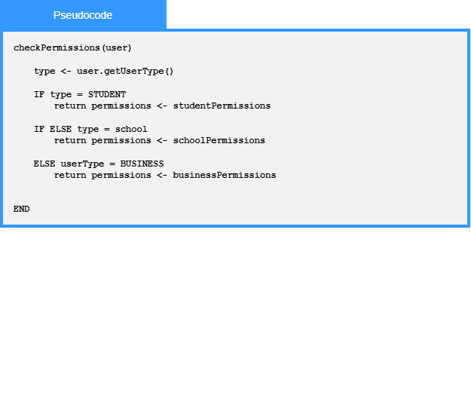

Local Data:
user: User

