1.6.2 updateImage() Algorithm

Purpose:
Updates an existing image by locating the current image file, validating and processing the new image file, replacing the stored image details, saving the updated image file, and returning a success or error result.
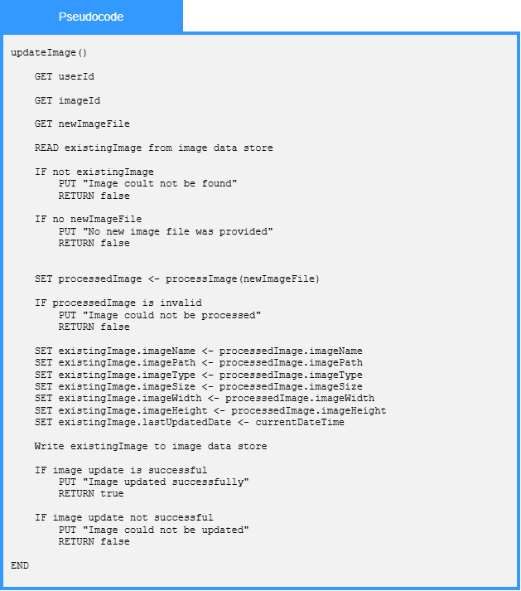

Local Data:

existingImage : Image

processedImage : Image

updateResult : UpdateResult

errorMessage : String

