1.6.4-ALG updateSettings() Algorithm
Purpose:
Update a user’s settings by getting the current settings record, validating the requested changes, applying the validated updates, saving the updated settings, and returning a success or error result.
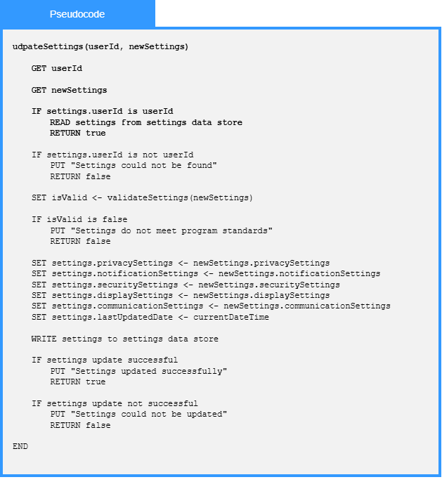

Local Data:
userId : Int
newSettings : Settings
settings : Settings
isValid : Boolean
currentDateTime : DateTime
updateResult : Boolean
errorMessage : String

