2.3 Resume Builder Desktop

Desktop View Design Information
Field | Description / Purpose
View Name & Number | 2.3 Resume Builder Desktop
Purpose / Design Concern | Provides a space that allows students to view and edit their resume that is to be used.
Description | Displays student’s resume and gives tools to make and save changes to the resume.
Requirements | SRS 3.5 Resume (3.5.1–3.5.5.2)
Elements | Logo
 | Search Bar
 | Profile/Menu
 | Dashboard
 | Profile
 | Jobs
 | Resume
 | Notifications
 | News Feed
 | Resume Editor Tools
 | Resume Viewer
Inputs | Resume Edits
Outputs | Resume reflecting saved changes and recent changes made
Navigation / References | Profile/Menu, Dashboard, Profile, Jobs, Resume, Notifications, News Feed
Viewpoint | UI Wireframe / Mockup (Desktop)

Desktop View
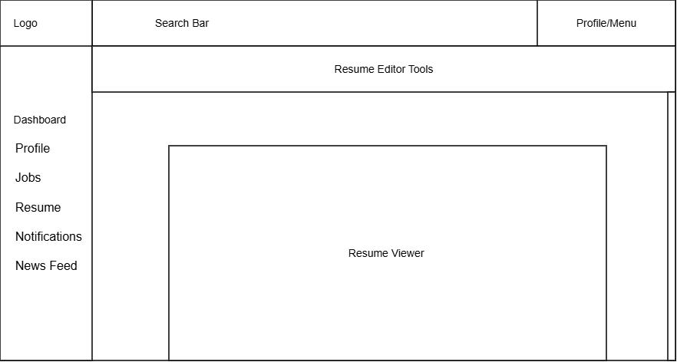

Mobile View
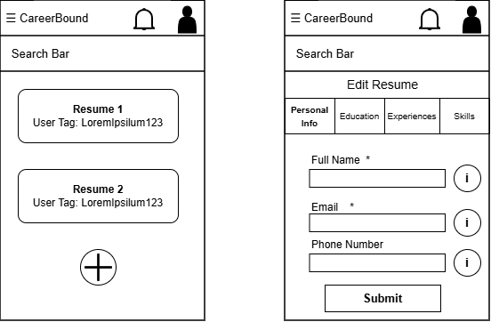

Mobile View Design Information

Field | Description / Purpose
View Name & Number | 2.3 – Resume Builder Screens
Purpose / Design Concern | Allows students to create and edit resumes to submit to companies.
Description | Show currently available resumes with user tags with the option to either create a new resume or edit an existing one
Requirements | SRS 3.5 Resume, 3.5.4 User Input, 3.5.5 Input Submission
Elements | Search bar
 | Resume List
 | Add New Resume Button
 | Edit Resume Section Tabs
 | Helpful info buttons
 | Submit Resume Button
 | Asterisks denoting Required Data Entry
Inputs | Search terms, resume data entries, wildcard search
Outputs | Matching resume data terms, resume list search results, new resume data entries
Navigation / References | Resume List, Edit Resume Screen
Viewpoint | UI Wireframe / Mockup (Mobile)

