1.9.3-ALG searchJobs() Algorithm
Purpose:
This algorithm manages the job search pipeline by validating criteria, checking for cached results, querying the database index, and filtering and ranking the final job listings for the user.
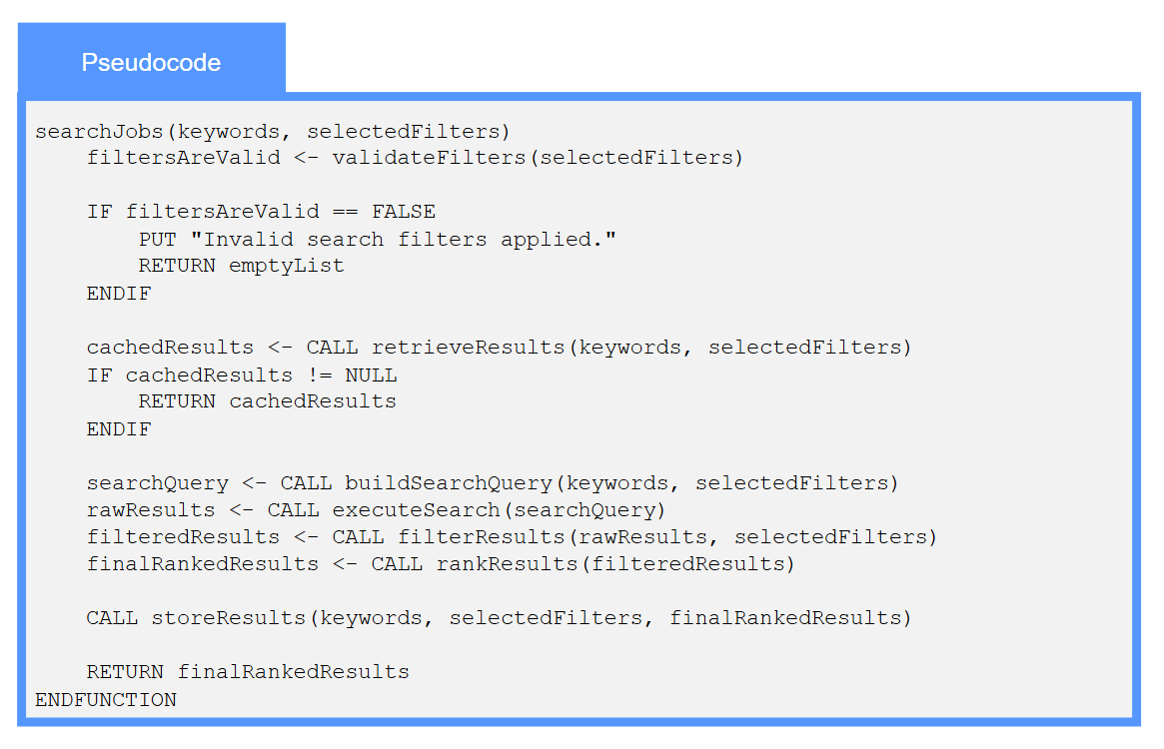

1.9.5-ALG validateFilters() Algorithm
Purpose:
This algorithm ensures data integrity by verifying that user-selected search filters—such as realistic GPA ranges, positive pay scales, and logical date ranges—contain valid data before processing.
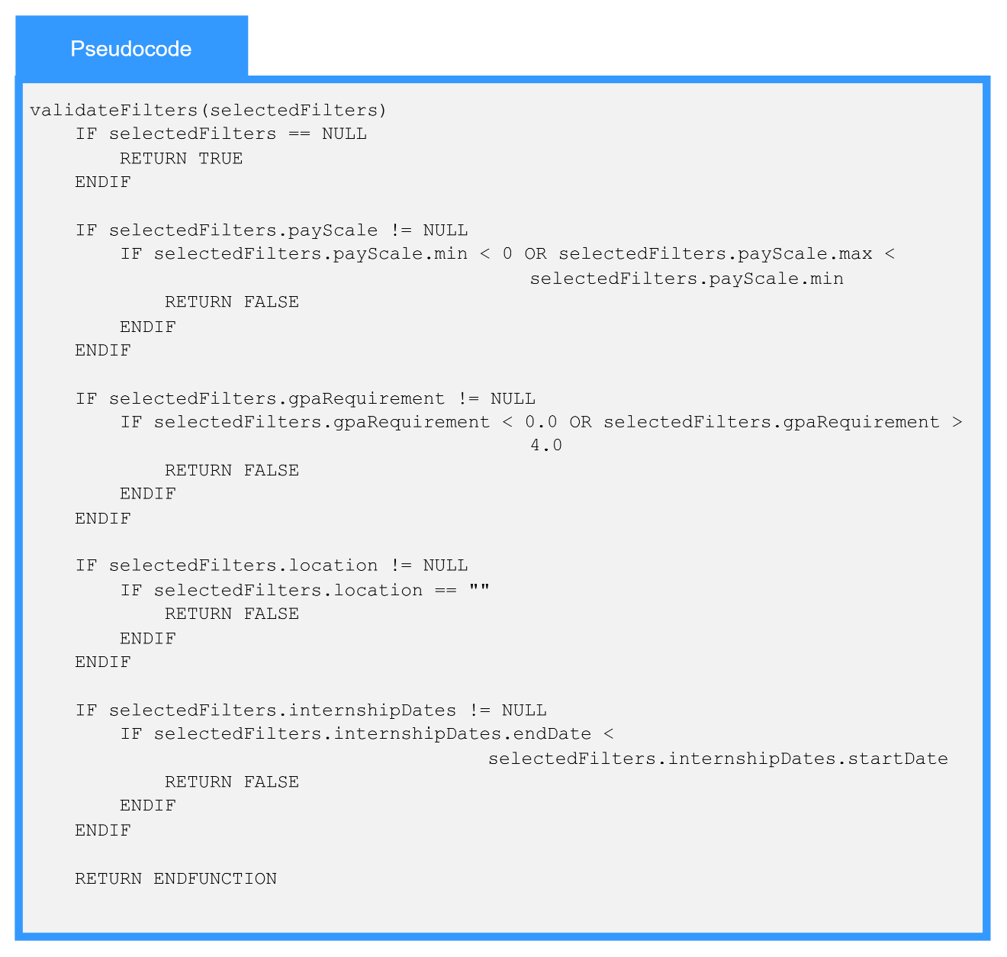

1.9.7-ALG buildSearchQuery() Algorithm
Purpose:
buildSearchQuery builds a search query from the user’s search terms and filters so the search service can find matching job results.
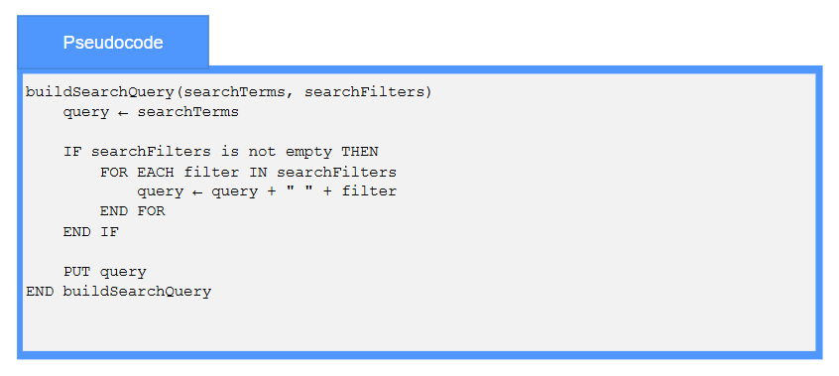

1.9.8-ALG retrieveResults() Algorithm
Purpose:
retrieveResults retrieves the matching search results from the search source or cache and returns them for display.
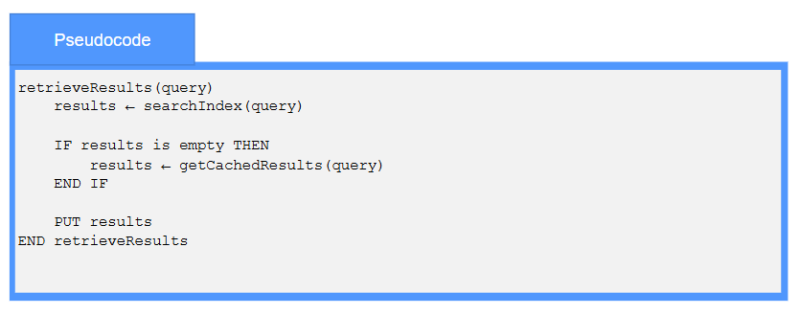

1.9.1-ALG advancedSearch() Algorithm
Purpose:
The algorithm validates the advanced search data and if data are valid then it performs the search according to the search data either for company search or for job search or for candidate search.
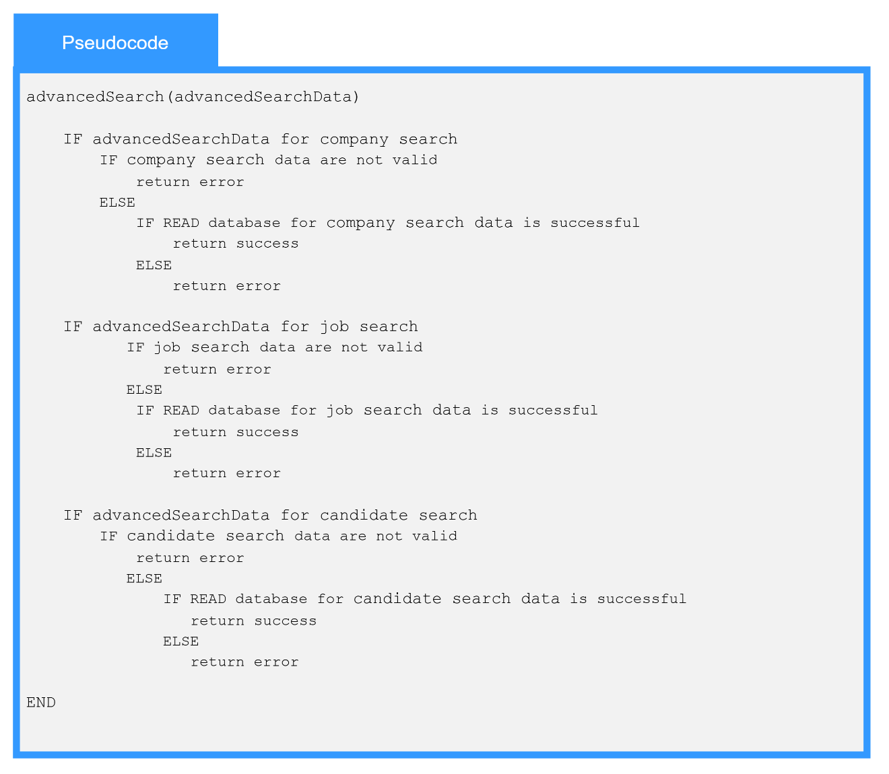

1.9.7-ALG processWildcardSearch() Algorithm
Purpose:
The algorithm validates the wildcard search data and if data are valid then it performs the wildcard search according to the search data either for company search or for job search or for candidate search.
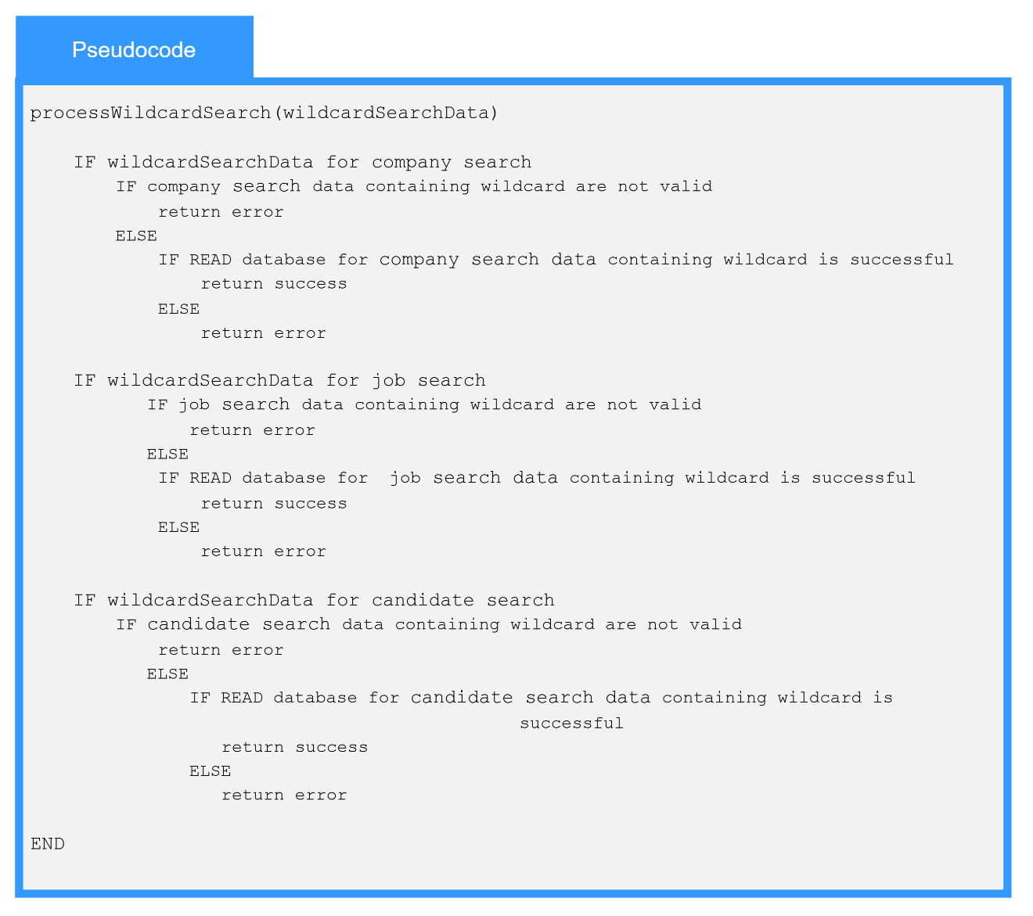

1.9.12-ALG rankResults() Algorithm
Purpose:
The algorithm validates the retrieved search results data and calculates a dynamic relevance score for each item based on defined system criteria—such as skill match percentages, GPA requirements, geographic location, and user follow status. It then sorts the evaluated data in descending order to ensure the most relevant companies, jobs, or student candidates are prioritized and returned to the user within the required performance threshold.
