1.6.1-ALG updateProfileInformation() Algorithm
Purpose:
Processes submitted profile updates by reading and parsing each profile information entry, saving the updated data to the profile data store, and returning a failure result if an update is unsuccessful.
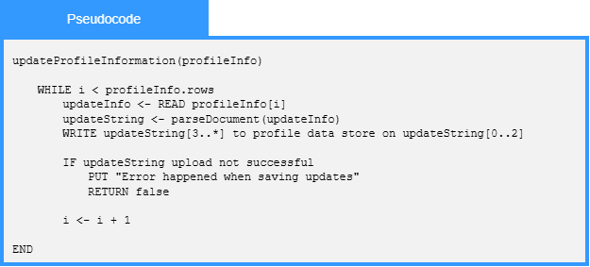

Local Data:
profileInfo : ProfileInformation
updateInfo : ProfileInformationEntry
updateString : String
profileDataStore : DataStore
saveSuccessful : Boolean

