1.5.3-ALG loginUser() Algorithm
Purpose:
This makes a login request using the input from the user. If it’s successful, it starts a userSession. If it’s failed less than 5 times, then the try count goes up. If it has failed more than 5 times, lockout happens as a security measure.
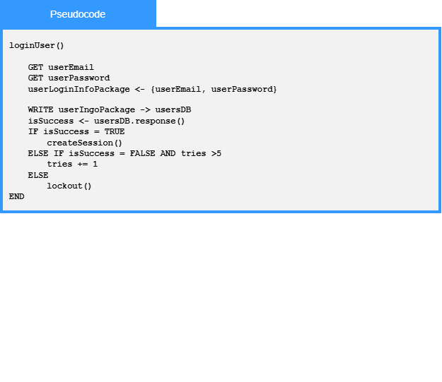
Local Data:
userEmail: string
userPassword: string
userLoginInfoPackage: List<string>

