- COMPONENT DESIGN

1.2 & 1.3 Web and Mobile Client Algorithms

1.2.1 & 1.3.1-ALG updateView() Algorithm
Purpose:
Determines which view should be shown and updates navigation state.
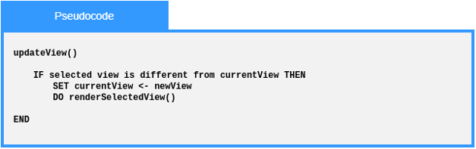
Local Data:
newView : View
currentView : View

1.2.1 & 1.3.1-ALG selectNavigationTarget() Algorithm
Purpose:
Determines the correct target view from a selected menu/button action.
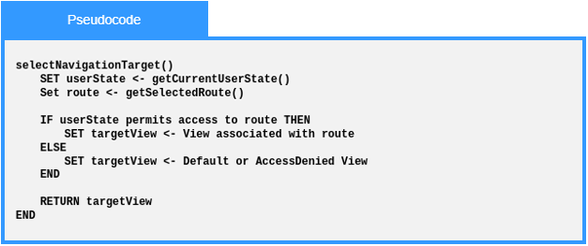
Local Data:
userState : State
route : Route

1.2.2 & 1.3.2-ALG onInit() Algorithm
Purpose:
Performs initial view setup when a page/view loads.
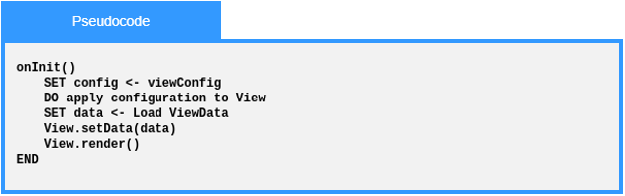
Local Data:
config : Config
data : ViewData

1.2.3 & 1.3.3-ALG submitForm() Algorithm
Purpose:
Coordinates the full form submission workflow.
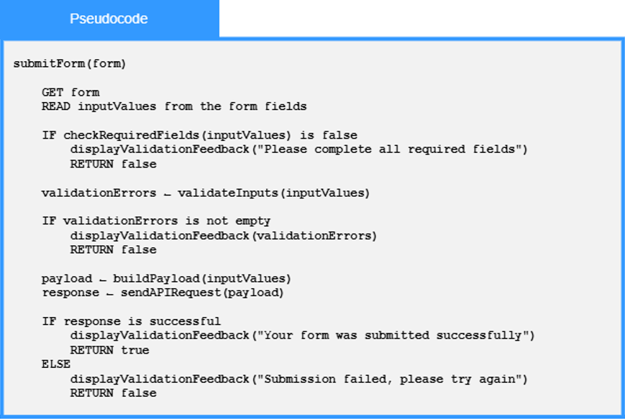
Local Data:
form : HTML DOM Object
inputValues : list of Strings

1.2.3 & 1.3.3-ALG validateInputs() Algorithm
Purpose:
Performs validation across submitted inputs.
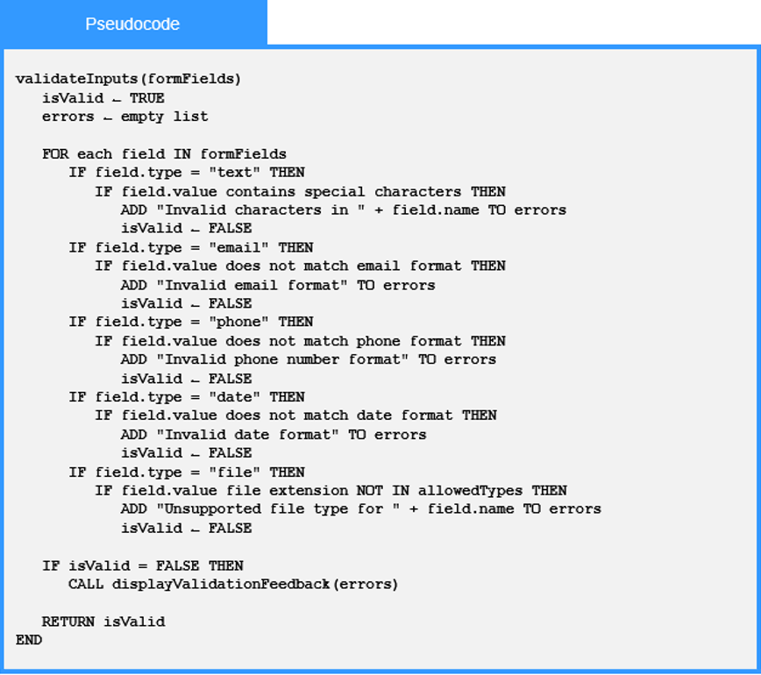
Local Data:
isValid : Boolean
field : HTML DOM Object

1.2.3 & 1.3.3-ALG checkRequiredFields() Algorithm
Purpose:
Checks whether mandatory fields are completed.
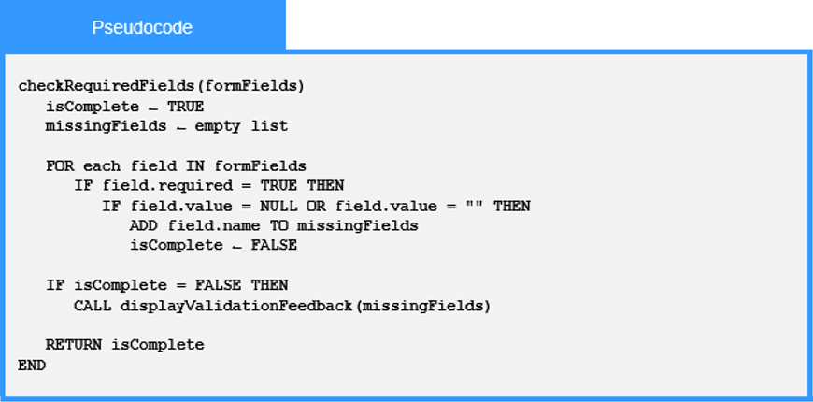
Local Data:
field : HTML DOM Object
isComplete : Boolean

1.2.3 & 1.3.3-ALG buildPayload() Algorithm
Purpose:
Converts form data into a request payload.
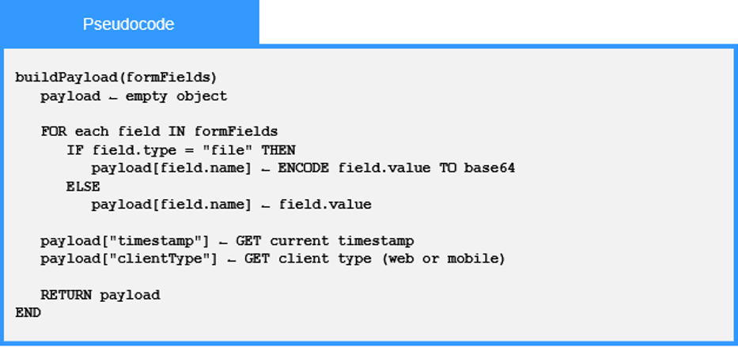

Local Data:
field : HTML DOM Object

1.2.3 & 1.3.3-ALG displayValidationFeedback() Algorithm
Purpose:
Displays errors or confirmation messages to the user.
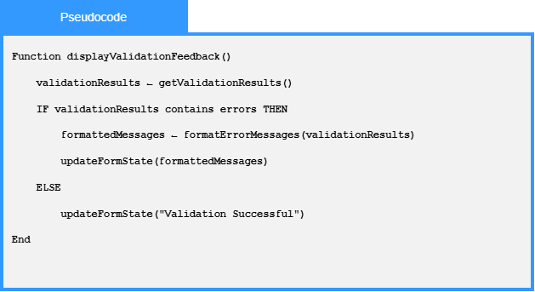
Local Data:
formattedMessages : List of Strings

1.2.4 & 1.3.4-ALG updateClientState() Algorithm
Purpose:
Updates stored client state after layout/accessibility changes.
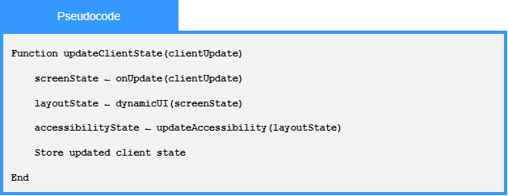
Local Data:
userId : Int
newSettings : Settings
settings : Settings
isValid : Boolean
currentDateTime : DateTime
updateResult : Boolean
errorMessage : String

1.2.4 & 1.3.4-ALG DynamicUI () Algorithm
Purpose:
Determines whether web or mobile layout rules should apply.
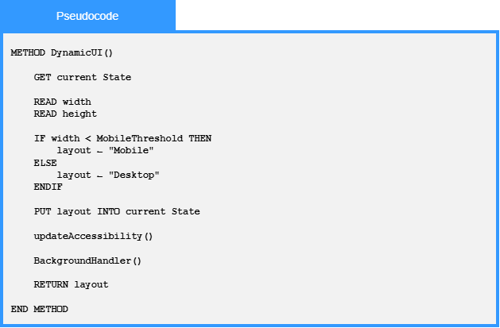
Local Data:
currentState : State
width : int
height : int
1.2.4 & 1.3.4-ALG updateAccessibility() Algorithm
Purpose:
Applies accessibility preferences to the client UI.
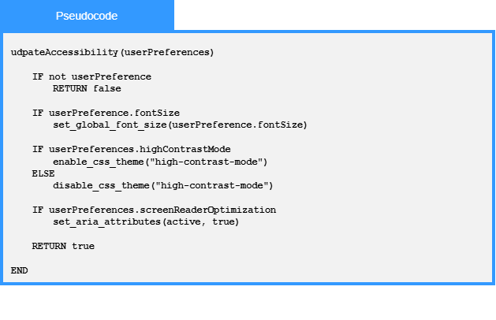
Local Data:
userPreferences : Config

1.2.4 & 1.3.4-ALG sendAPIRequest() Algorithm
Purpose:
Coordinates request creation, sending, response parsing, and error handling.
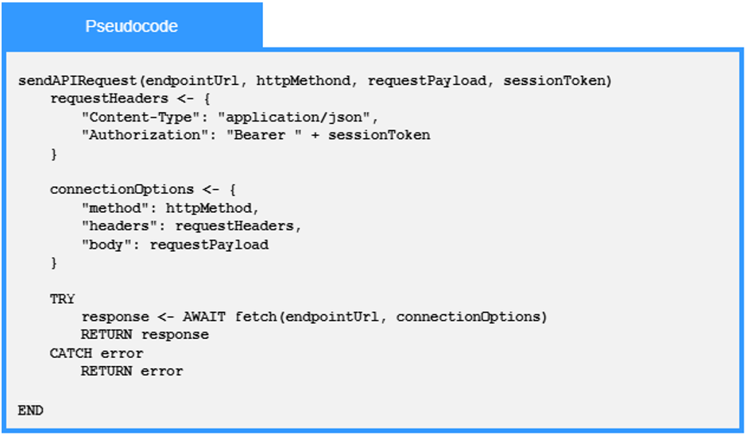
Local Data:
requestHeaders : Dictionary
connectionOptions : Dictionary

1.2.4 & 1.3.4-ALG ResponseParser() Algorithm
Purpose:
Interprets API responses and extracts usable data..
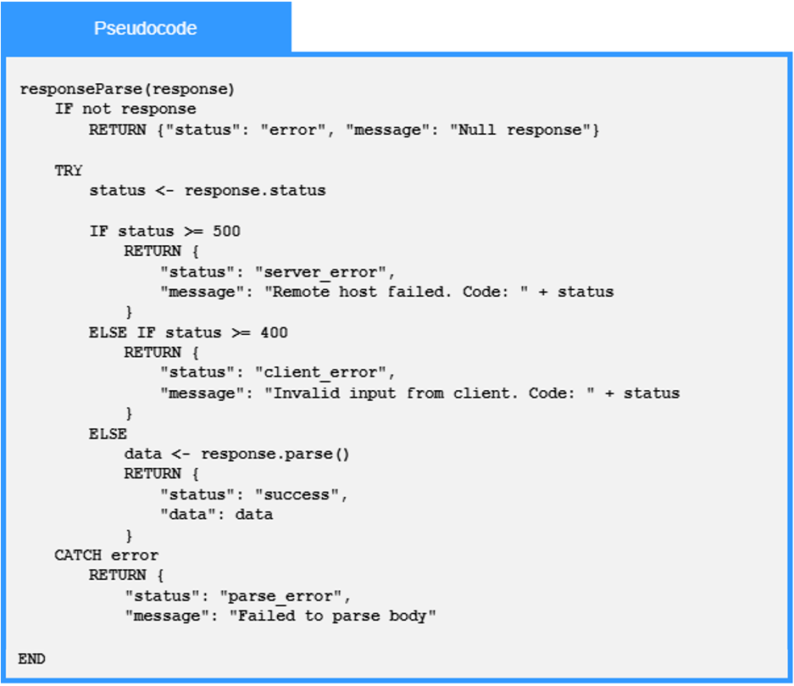
Local Data:
status : int

1.4 API Gateway / Orchestrator Algorithms

1.4.1-ALG authenticateIfNeeded() Algorithm
Purpose:
Authenticate user requests if necessary and update RequestContext with the result.
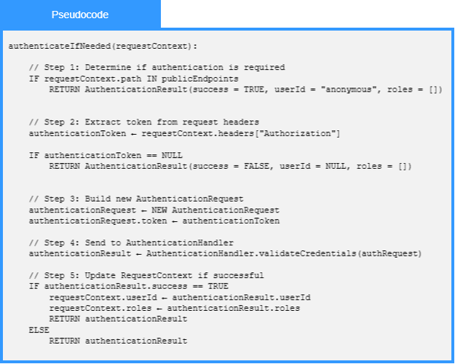
Local Data:
authenticationRequest : AuthenticationRequest
authenticationResult : AuthenticationRequest

1.4.2-ALG applyRoutingRules() Algorithm
Purpose:
Apply routing rules and definitions to a user request before it is routed to its intended destination.
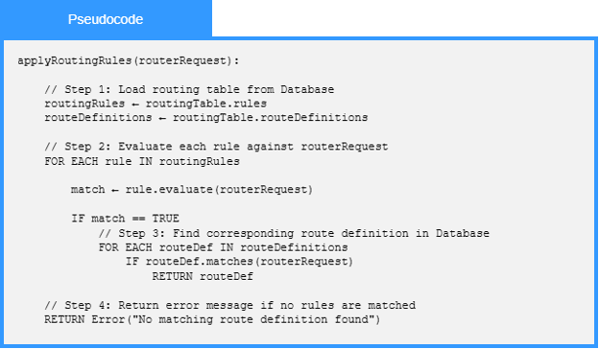
Local Data:
routingRules : List<RoutingRule>
routingDefinitions : List<RoutingDefinition>

1.4.3-ALG validateCredentials() Algorithm
Purpose:
Authenticate submitted user credentials against entries stored in the authentication database.
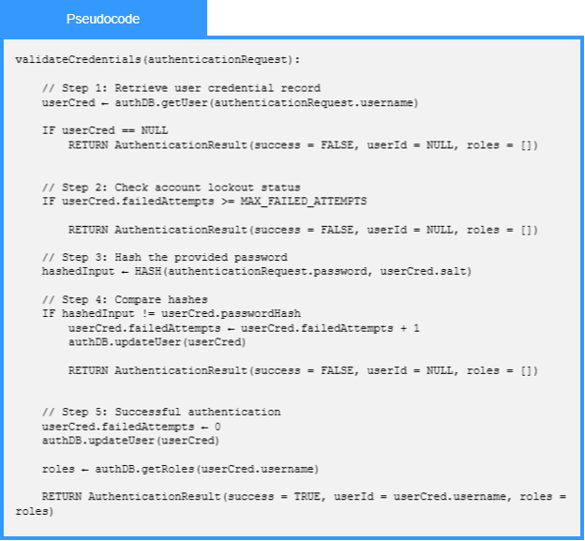
Local Data:
userCred : AuthenticationRequest
hashedInput : Hash<AuthenticationRequest>

1.4.4-ALG validate() Algorithm
Purpose:
Validates an incoming request by cleaning the request body, retrieving route rules, verifying the user, checking the request requirements, and returning either a valid request result or a validation error.
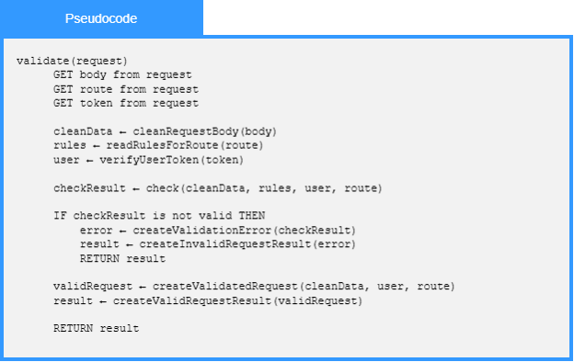
Local Data:
cleanData: Sanitized Request Data
rules: Validation Rules
user: User
checkResult: Check Result
error: Validation Error
validRequest: Valid Request
result: Validation Result

1.4.4-ALG check() Algorithm
Purpose:
Checks request data against user authentication, route permissions, required fields, and validation rules to determine whether the request is valid.
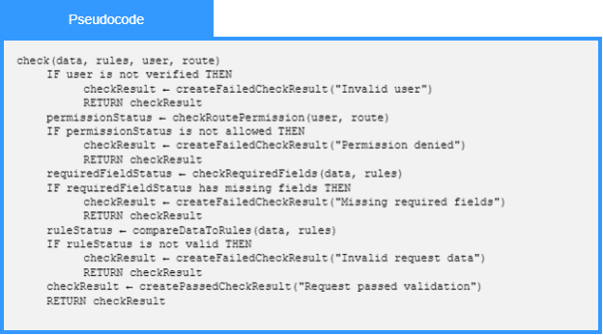
Local Data:
permissionStatus: Permission Status
requiredFieldStatus: Required Field Status
ruleStatus: Rule Status
checkResult: Check Result

1.4.4-ALG run() Algorithm
Purpose:
Runs the service request by finding the correct service route, returning an error if the route is missing, and building a response from the service result.
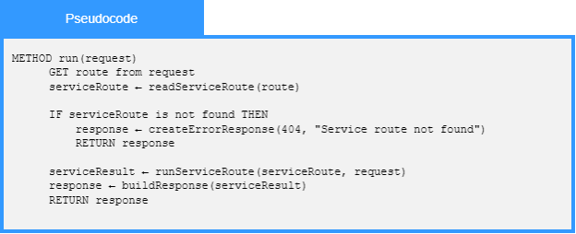
Local Data:
serviceRoute: Route Definition
serviceResult: Service Result
response: Response

1.5 Authentication Service Algorithms

1.5.1-ALG registerUser() Algorithm
Purpose:
The algorithm that takes the user input, puts it in a package, and sends it off to the corresponding database. Note: this algorithm DOES NOT verify the data.
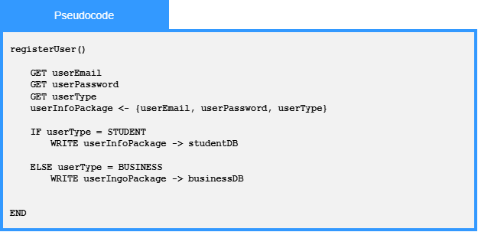
Local Data:
userEmail : string
userPassword : string
userType : enumeration
studentDB : external database
connectionbusinessDB : external database connection

1.5.1-ALG validateEmail() Algorithm
Purpose:
To ensure that the email is in the correct format and doesn’t extend past 254 characters according to the RFC 5321 section 4.5.3.1.3 standards. NOTE: This does not confirm that the email actually exists.
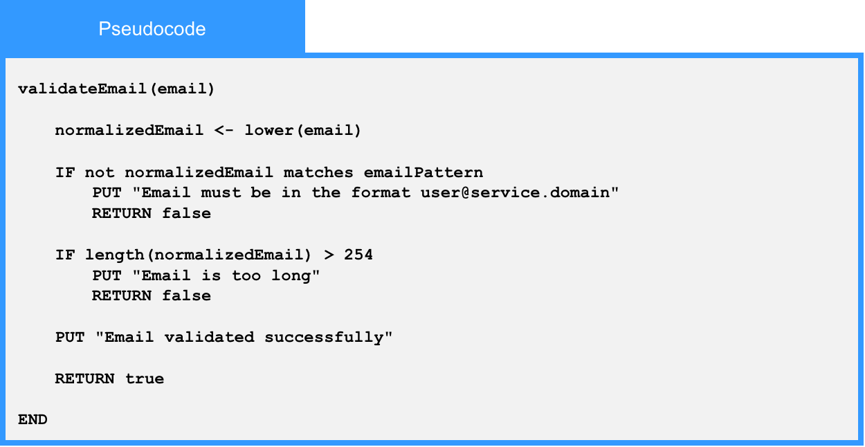
Local Data:
normalizedEmail : String
emailPattern : Regular Expression

1.5.1-ALG validatePassword() Algorithm
Purpose:
To ensure that the password is compliant with NIST SP 800-63B section A password standards.
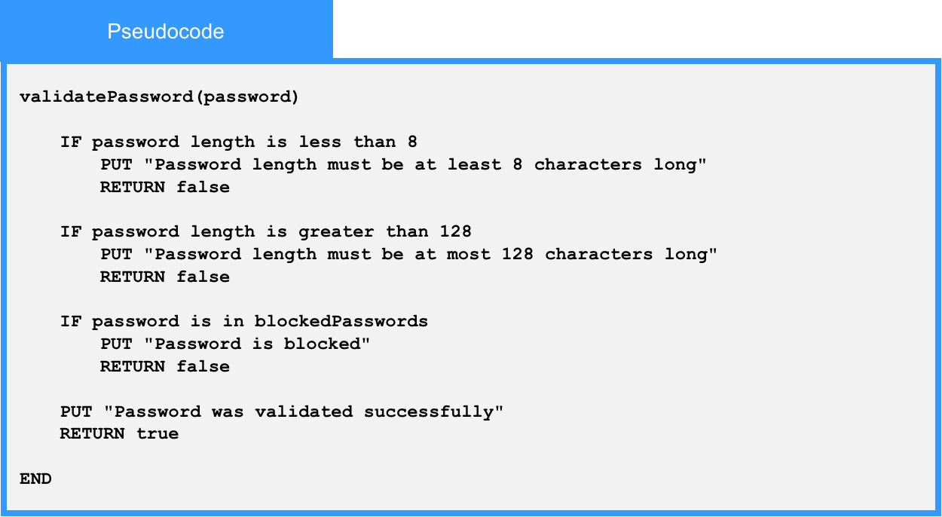
Local Data:
blockedPasswords : List of Strings

1.5.1-ALG hashPassword() Algorithm
Purpose:
Acts as a wrapper for a password hashing function from a certified cryptography library, and returns the hashed password.
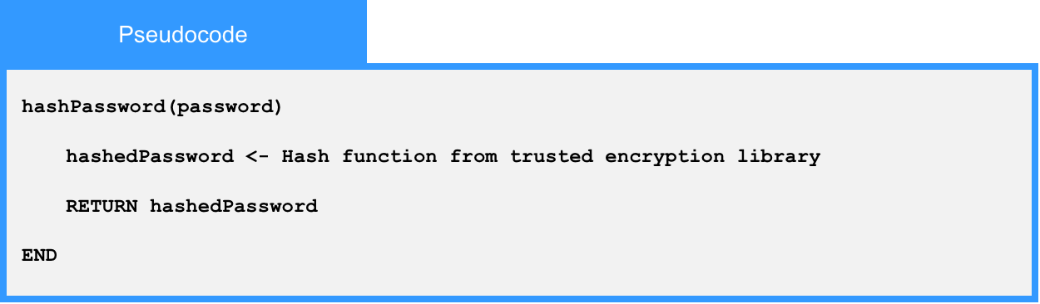
Local Data:
hashedPassword : String

1.5.2-ALG checkPermissions() Algorithm
Purpose:
This is for any service looking for what kinds of permissions are available to a specific type of user, based off of the user object.
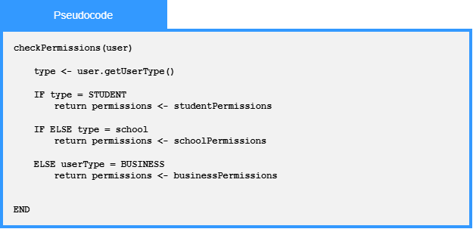
Local Data:
user : User

1.5.3-ALG LoginUser() Algorithm
Purpose:
To verify a user’s credentials and create a login session if the credentials are valid.
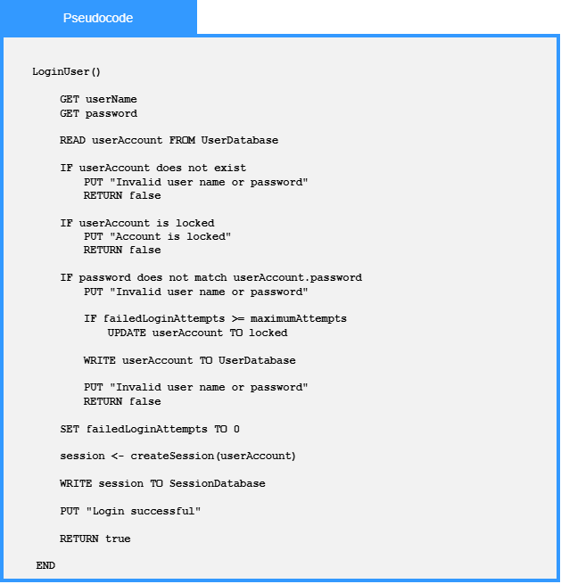
Local Data:
username : String
password : String
userAccount : UserAccount
failedLoginAttempts : Number
maximumAttempts : Number
session : Session

1.5.3-ALG LogoutUser() Algorithm
Purpose:
To end the user’s active session and remove access to authenticated features.
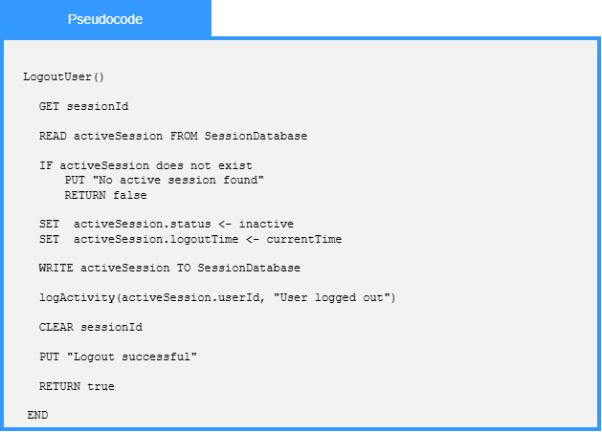
Local Data:
sessionId : String
activeSession : Session
logoutTime : DateTime
logoutSuccessful : Boolean

1.5.3-ALG CreateSession() Algorithm
Purpose:
To create an active login session for a valid user.
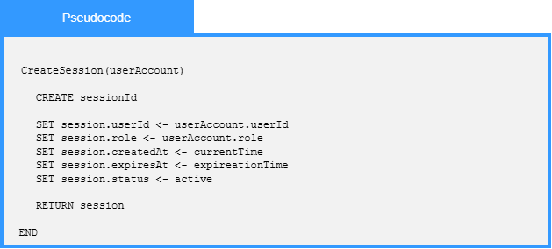
Local Data:
sessionId : String
userId : Number
role : String
createdAt : DateTime
expiresAt : DateTime
status : String

1.6 Profile Management Service Algorithms

1.6.1-ALG addProfileInformation() Algorithm
Purpose:
Adds a user’s profile information by validating the submitted profile details, building a new profile information record, saving it to the profile data store, and returning a success or error result.
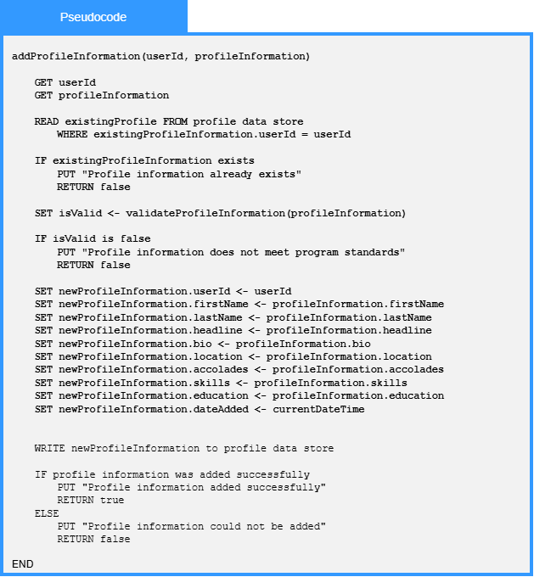
Local Data:
userId : Number
updatedProfileInformation : ProfileInformation
existingProfile : Profile
isValid: Boolean
curentDateTime : DateTime
updateResult : Boolean
errorMessage : String

1.6.1-ALG updateProfileInformation() Algorithm
Purpose:
Processes submitted profile updates by reading and parsing each profile information entry, saving the updated data to the profile data store, and returning a failure result if an update is unsuccessful.
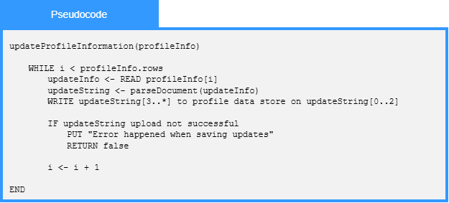
Local Data:
profileInfo : ProfileInformation
updateInfo : ProfileInformationEntry
updateString : String
profileDataStore : DataStore
saveSuccessful : Boolean

1.6.1-ALG addCompanyLocation() Algorithm
Purpose:
Adds a company location to the profile data store by validating the submitted address information, saving each location field, and returning a success or error result.
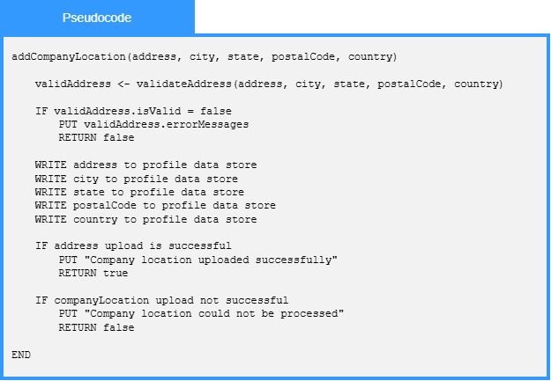
Local Data:
address : String
city : String
state : String
postalCode : String
Country : String
validAddress : ValidationResult

1.6.2-ALG updateImage() Algorithm
Purpose:
Updates an existing image by locating the current image file, validating and processing the new image file, replacing the stored image details, saving the updated image file, and returning a success or error result.
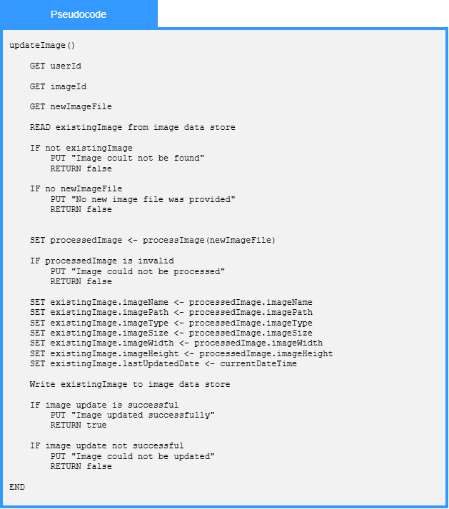
Local Data:
existingImage : Image
processedImage : Image
updateResult : UpdateResult
errorMessage : String

1.6.2-ALG processImage() Algorithm
Purpose:
Processes an uploaded image by checking if it is valid, resizing and cropping it to the required dimensions, compressing it to reduce file size, and returning the processed image for storage.
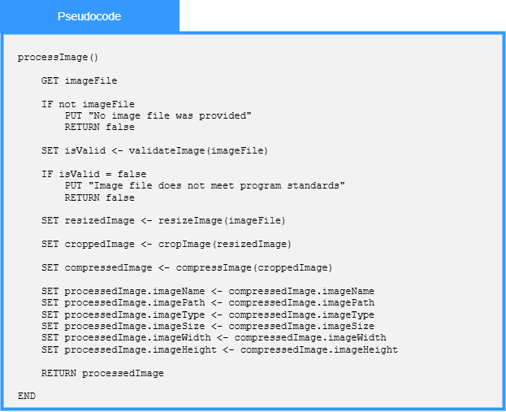
Local Data:
imageFile : File
isValid : Boolean
resizedImage : Image
croppedImage : Image
compressedImage : Image
processedImage : Image

1.6.4-ALG updateSettings() Algorithm
Purpose:
Update a user’s settings by getting the current settings record, validating the requested changes, applying the validated updates, saving the updated settings, and returning a success or error result.
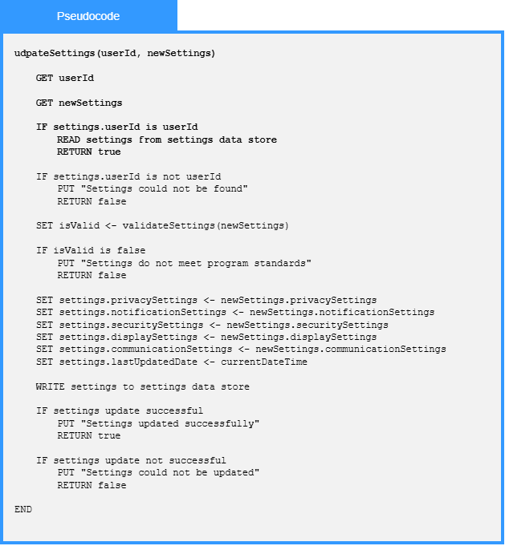
Local Data:
userId : Int
newSettings : Settings
settings : Settings
isValid : Boolean
currentDateTime : DateTime
updateResult : Boolean
errorMessage : String

1.6.5-ALG LogActivity() Algorithm
Purpose:
To create a record of what happened, who did it, and when it happened.
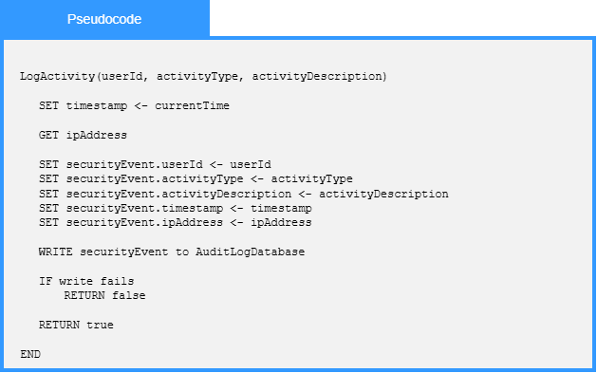
Local Data:
userId : Number
activityType : String
activityDescription : String
timestamp : DateTime
ipAddress : String
securityEvent : SecurityEvent
auditLog : AuditLog
logSuccessful : Boolean

1.7 Resume Service Algorithms

1.7.1-ALG createResume() Algorithm
Purpose:
Creates a resume from the student's completed resume form after verifying that all mandatory fields are present.
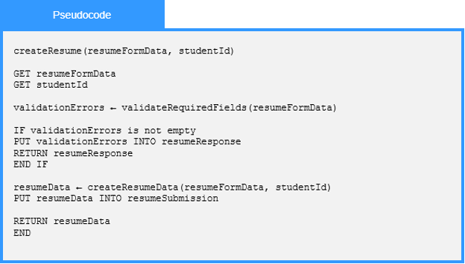

1.7.1-ALG uploadResume() Algorithm
Purpose:
Submits a validated student resume to Resume Storage and returns the result of the upload request.
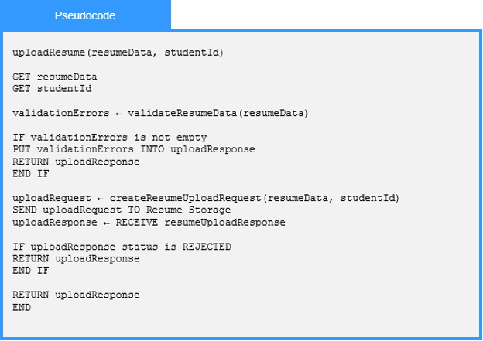

1.7.1-ALG validateResumeFile() Algorithm
Purpose:
Validates an uploaded resume file by checking that a file was provided, that its file type is allowed, and that its size does not exceed the permitted limit.
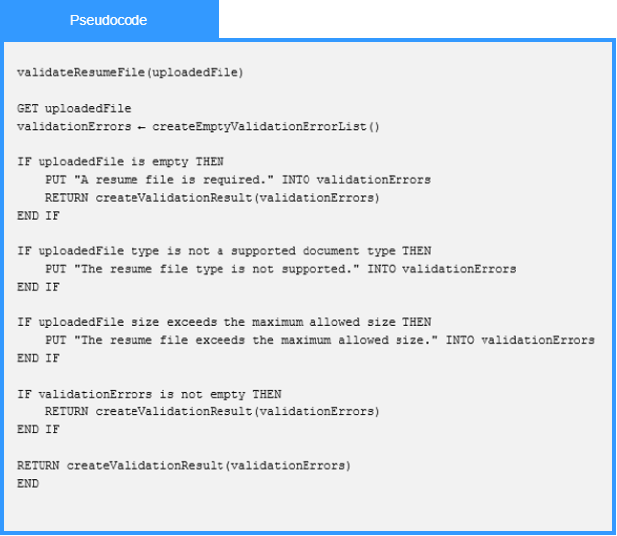

1.7.3-ALG saveResume() Algorithm
Purpose:
Save the information from a resume form as a record in the resume database after successful validation.
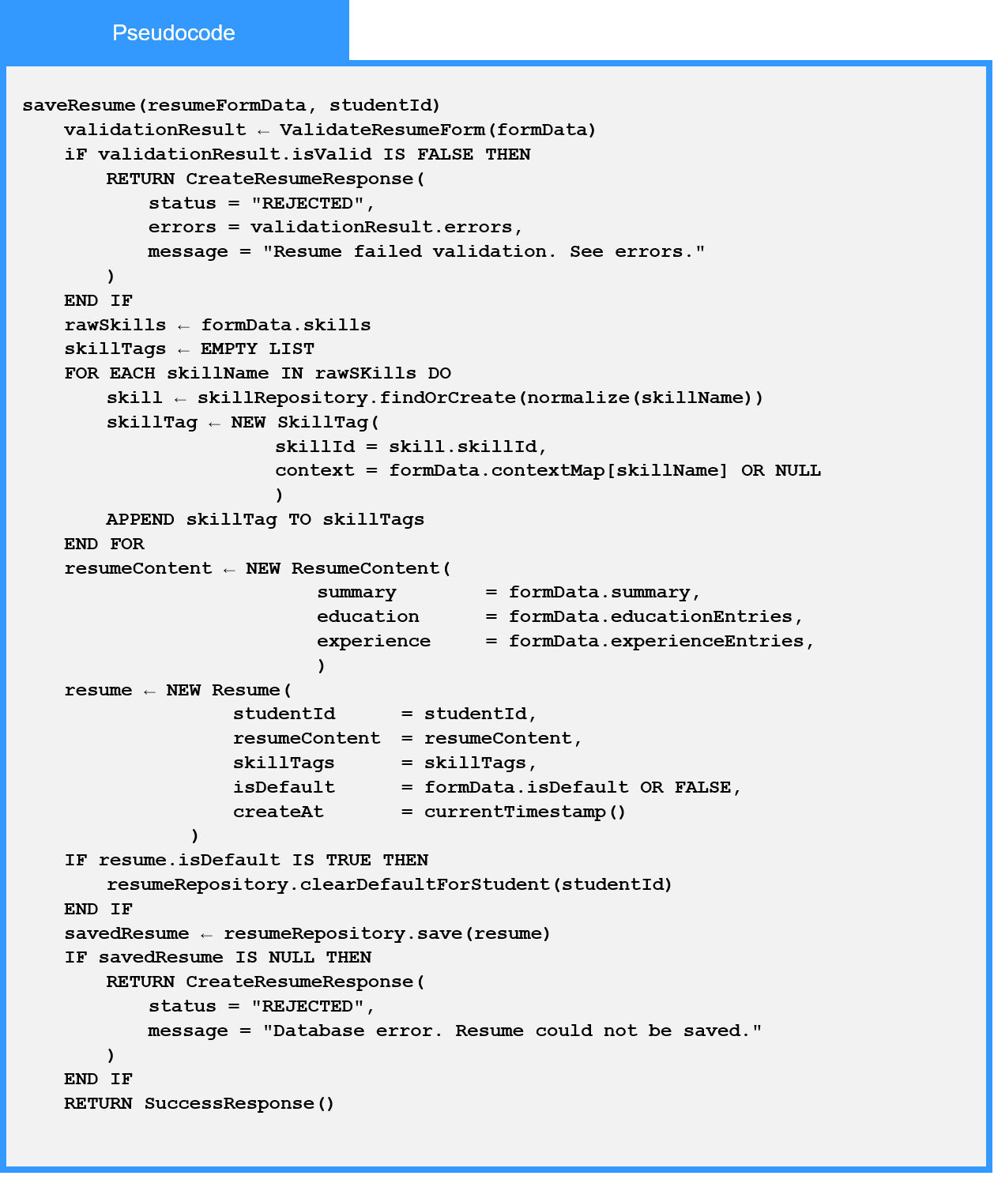

1.7.3-ALG saveSkill() Algorithm
Purpose:
Tag a skill to a student’s resume after verifying that it is in the database and create the skill if it does not exist yet.
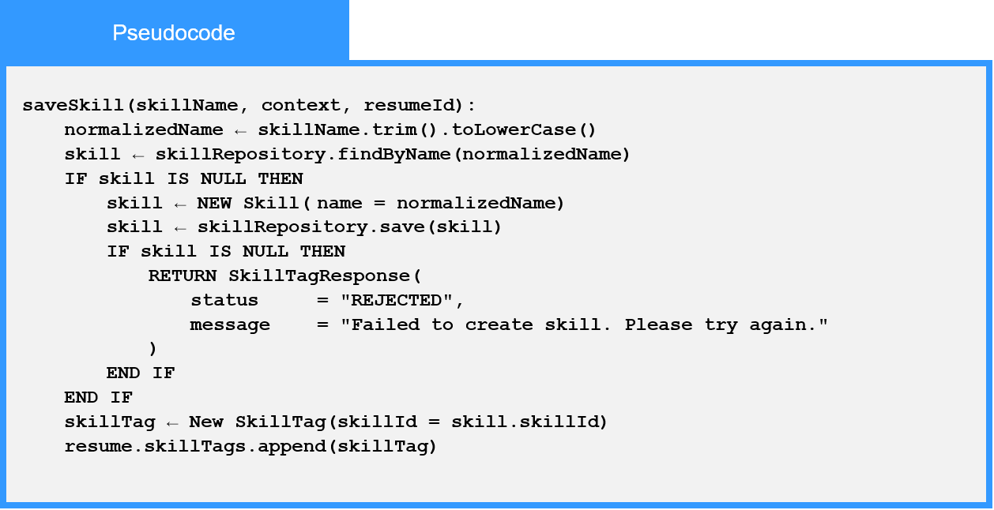

1.7.5-ALG checkResume() Algorithm
Purpose:
Validate a resume submission before storing to the Resume data store.
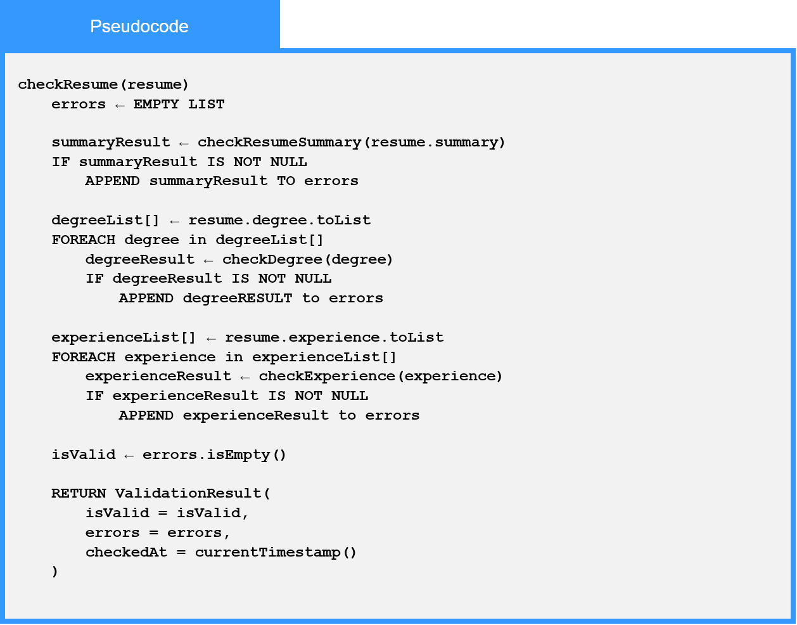
Local Data:
errors : List
summaryResult : Object
degreeResult : Object
experienceResult : Object
ValidationResult : Object

1.7.5-ALG validateResumeInput() Algorithm
Purpose:
Validates student-entered resume form data by checking required fields and verifying that contact, experience, education, date, and GPA information meet the required rules.
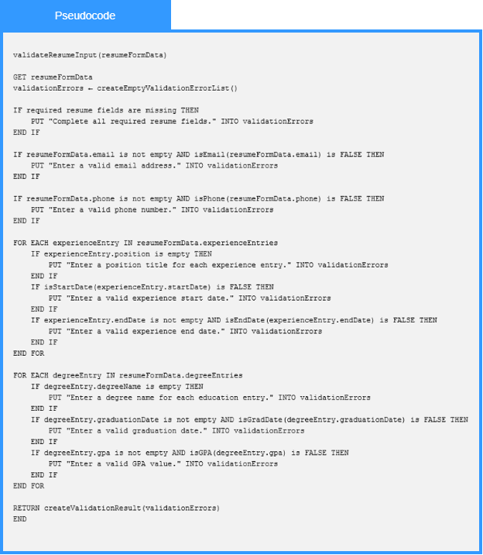

1.8 Job Posting Service Algorithms

1.8.1-ALG isAuthorized() Algorithm
Purpose:
isAuthorized checks if a user has the overall permission/role required to perform job posting actions like creating or editing.
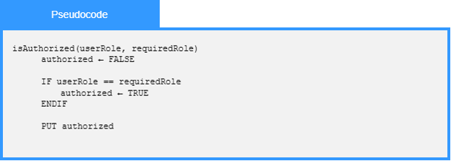

1.8.1-ALG verifyOwner() Algorithm
Purpose:
verifyOwner checks if the current user ID matches the owner ID of the specific job listing being modified.
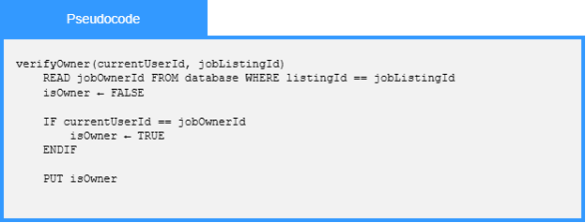

1.8.2-ALG createPost() Algorithm
Purpose:
The algorithm validates the data, checks if such a record already exists and if data are valid and such a record does not exist then it writes the data to the database as a new post record.
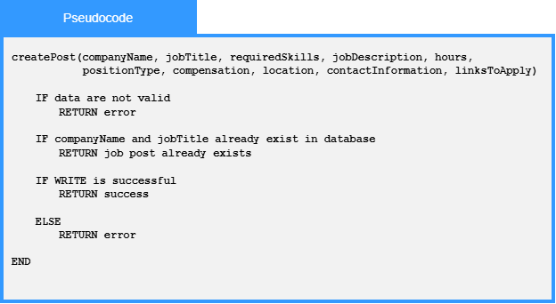

1.8.2-ALG modifyPost() Algorithm
Purpose:
The algorithm validates the data and if data are valid then it updates the record that has the same id.
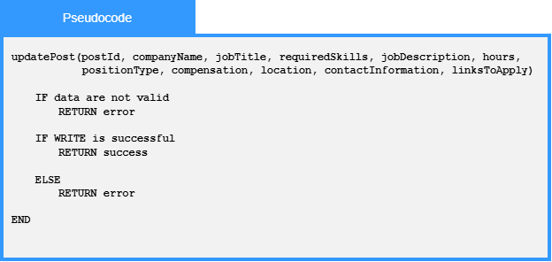

1.8.3-ALG validate() Algorithm
Purpose:
Validates the entry.
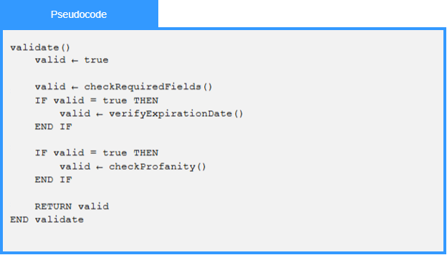

1.8.3-ALG checkProfanity() Algorithm
Purpose:
Checks for profanity in the entry.
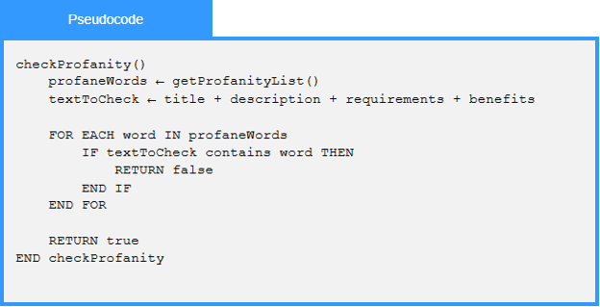

1.9 Search Service Algorithms

1.9.1-ALG submitSearch() Algorithm
Purpose:
Submits the search terms.
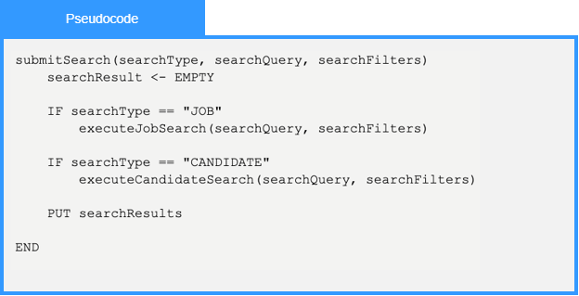

1.9.1-ALG advancedSearch() Algorithm
Purpose:
The algorithm validates the advanced search data and if data are valid then it performs the search according to the search data either for company search or for job search or for candidate search.
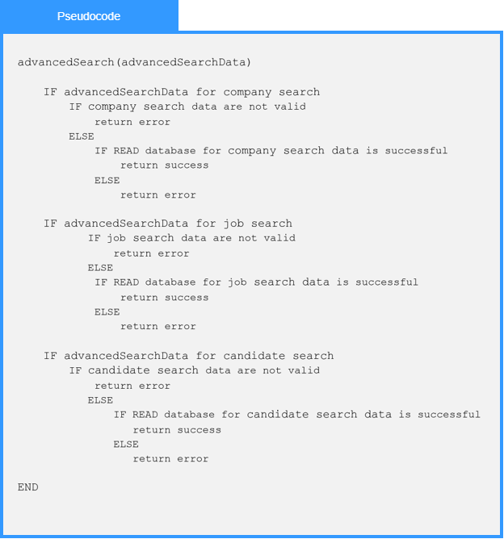

1.9.2-ALG filterCandidates() Algorithm
Purpose:
Filters candidates based on certain criteria.
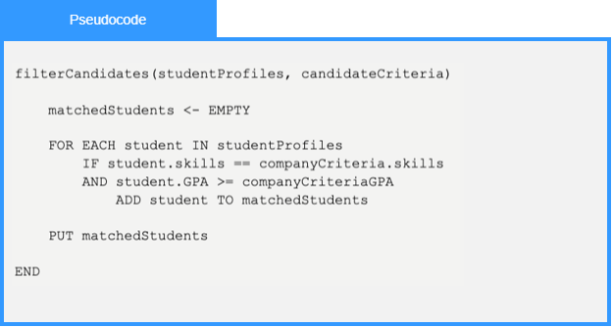

1.9.3-ALG searchJobs() Algorithm
Purpose:
This algorithm manages the job search pipeline by validating criteria, checking for cached results, querying the database index, and filtering and ranking the final job listings for the user.
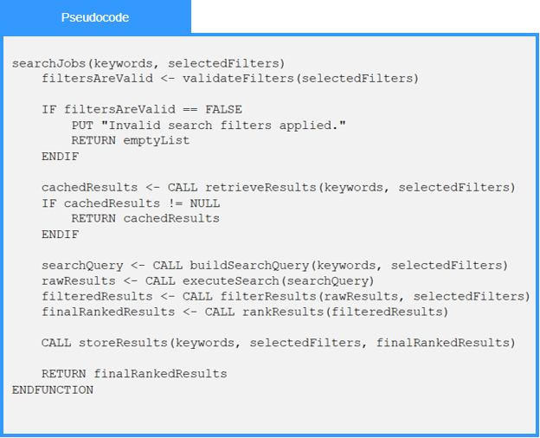

1.9.5-ALG validateFilters() Algorithm
Purpose:
This algorithm ensures data integrity by verifying that user-selected search filters—such as realistic GPA ranges, positive pay scales, and logical date ranges—contain valid data before processing.
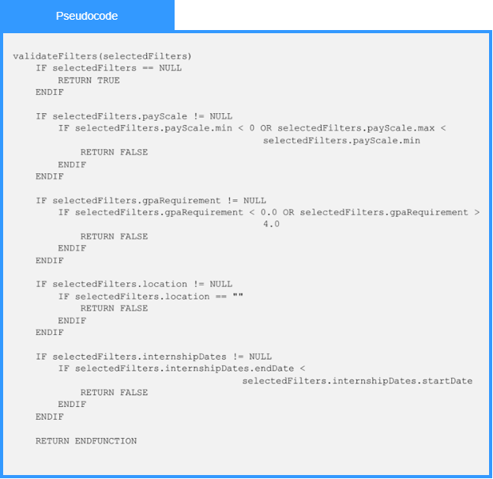

1.9.7-ALG buildSearchQuery() Algorithm
Purpose:
buildSearchQuery builds a search query from the user’s search terms and filters so the search service can find matching job results.
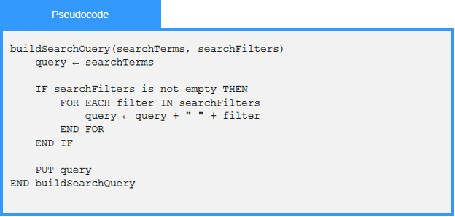

1.9.7-ALG processWildcardSearch() Algorithm
Purpose:
The algorithm validates the wildcard search data and if data are valid then it performs the wildcard search according to the search data either for company search or for job search or for candidate search.
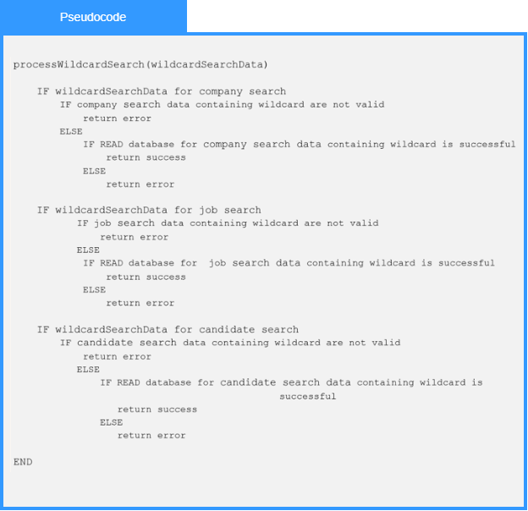

1.9.8-ALG retrieveResults() Algorithm
Purpose:
retrieveResults retrieves the matching search results from the search source or cache and returns them for display.
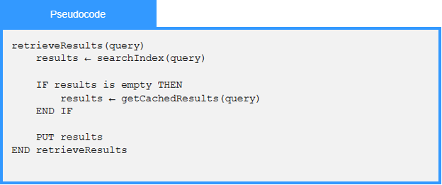

1.9.12-ALG rankResults() Algorithm
Purpose:
The algorithm validates search results, calculates a relevance score based on criteria such as skills, GPA, location, and user follow status, and returns the highest-ranked results.
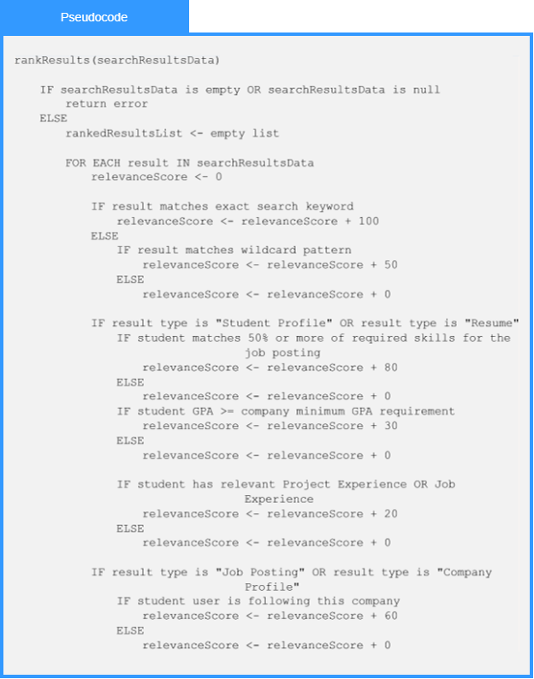
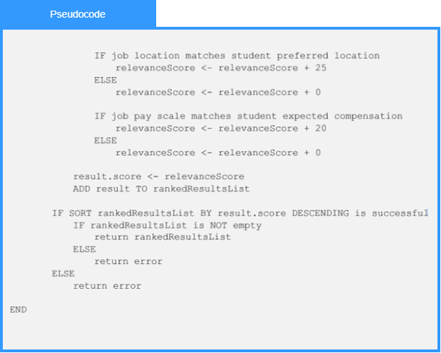

1.10 Communication Services Algorithms

1.10.3-ALG buildNotification() Algorithm
Purpose:
Creates notification content using information contained in the notification job and formats the notification delivery.
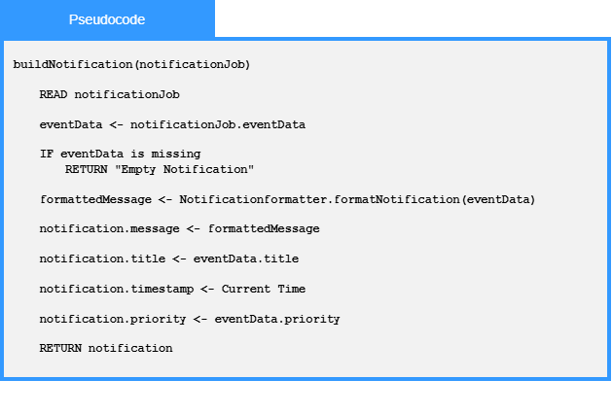

1.10.3-ALG orchestrateNotification() Algorithm
Purpose:
Coordinate the notification workflow by creating the notification, determining recipients, delivering notifications, archiving results, and updating news feed.
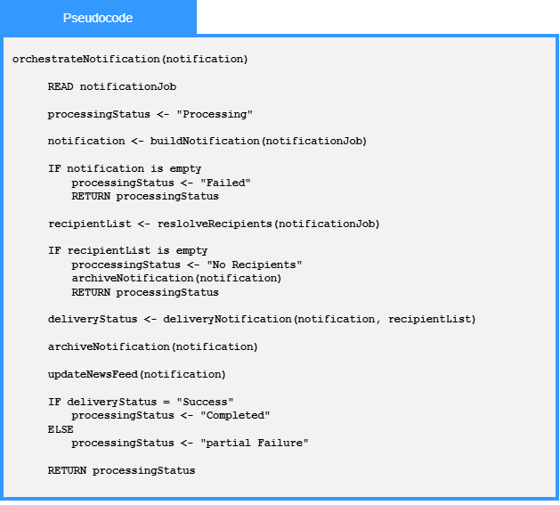

1.10.3-ALG resolveRecipients() Algorithm
Purpose:
Determines which users should receive a notification by applying recipient rules and removing users who should not receive notifications
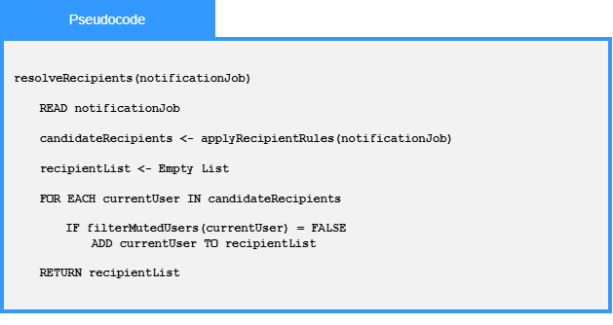

1.10.4-ALG formatNotification() Algorithm
Purpose:
Formats a notification job into notification content and prepares the message content needed for delivery.
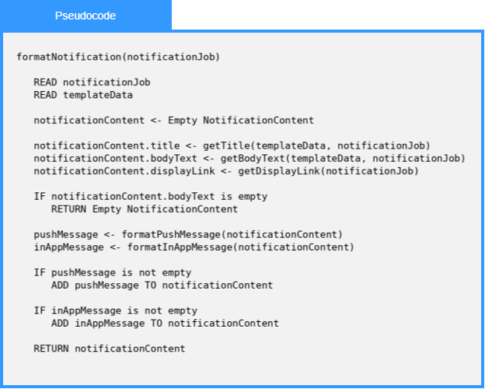
Local Data:
templateData : NotificationTemplate
notificationContent : NotificationContent
pushMessage : NotificationContent
inAppMessage : NotificationContent

1.10.5-ALG saveNotification() Algorithm
Purpose:
Stores notification content for the resolved recipients and creates notification records for later use.
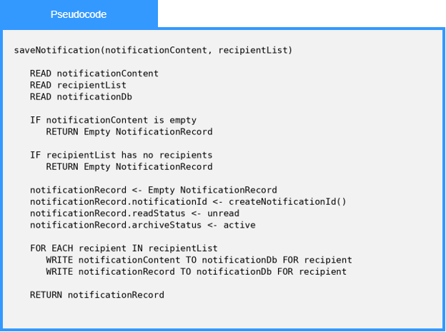
Local Data:
notificationDb : NotificationDb
notificationRecord : NotificationRecord
recipient : Recipient

1.10.6-ALG resolveRecipients() Algorithm
Purpose:
Determines which users should receive a notification by applying recipient rules and removing muted users.
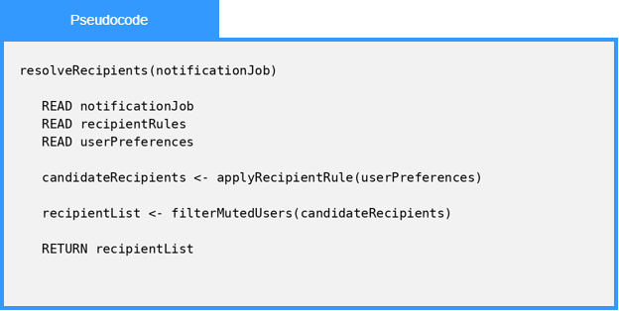
Local Data:
userPreferences : UserPreferences
recipientRules : RecipientRules
candidateRecipients : RecipientList
recipientList : RecipientList

1.10.7-ALG deliverPushNotification() Algorithm
Purpose:
Sends a routed notification to the recipient's device through the push service client. It looks up the device token, attempts delivery with a bounded number of retries, records the outcome in the delivery log, and returns a DeliveryResult describing whether the push succeeded.
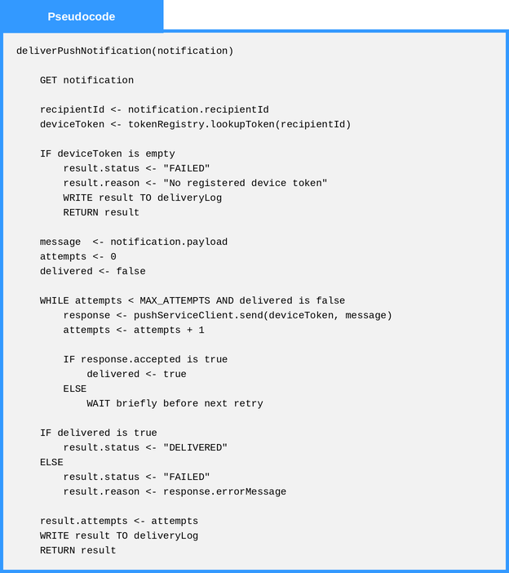
Local Data:
deviceToken : Text
message : NotificationPayload
attempts : Number
delivered : Boolean
result : DeliveryResult

1.10.7-ALG routeToService() Algorithm
Purpose:
Selects the correct delivery channel and service target for an incoming routing request and packages the request into a RoutedNotification. If no channel is requested, it chooses push when notifications are available and falls back to in-app delivery otherwise.
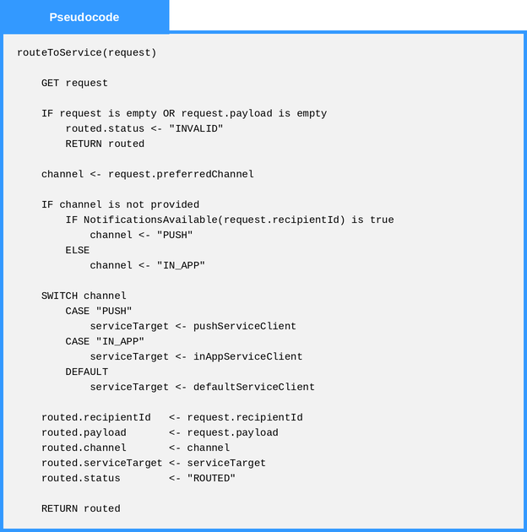
Local Data:
channel : Text
serviceTarget : ServiceClient
routed : RoutedNotification

1.10.8-ALG retrieveFeedItems() Algorithm
Purpose:
Reads a user's feed items from the feed repository, filters them by the category and unread criteria carried on the request, sorts the results newest-first, applies the requested item limit, and returns the assembled FeedItemList.
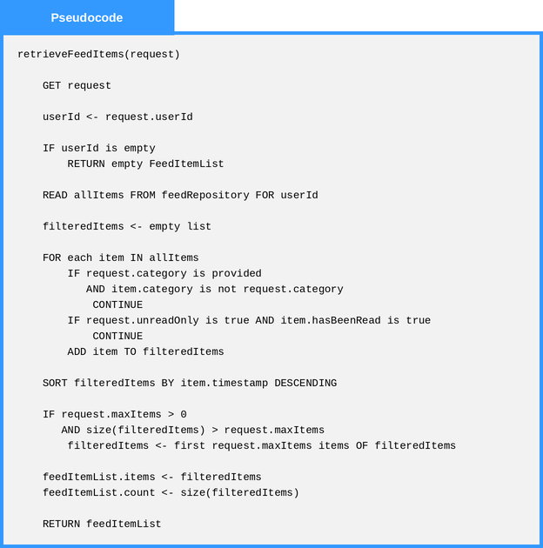
Local Data:
allItems : List of FeedItem
filteredItems : List of FeedItem
feedItemList : FeedItemList

1.11 Recommendation Service Algorithms

1.11.2-ALG applyCandidateFilters() Algorithm
Purpose:
Filters searchable student profiles by comparing each candidate against the employer’s selected search criteria and returning only candidates who satisfy the required filters.
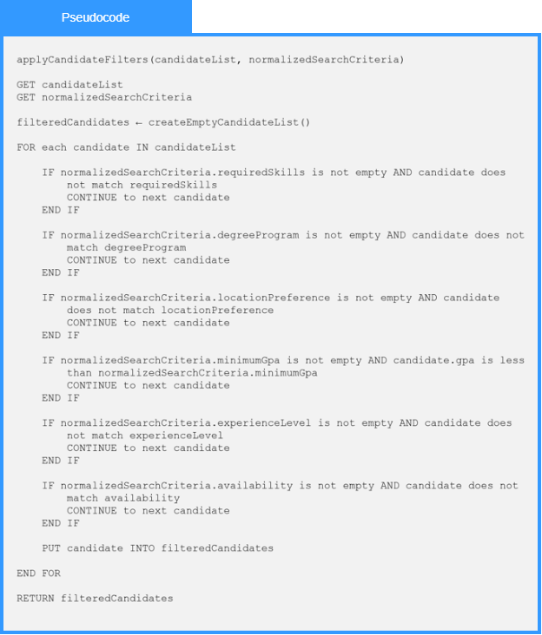
Local Data:
filteredCandidates : List of StudentProfile
candidate : StudentProfile

1.11.2-ALG recommendCandidates() Algorithm
Purpose:
Recommends qualified student candidates to an employer by validating the candidate search request, applying employer-selected filters, scoring eligible candidates, ranking the results, and returning a ranked recommendation list.
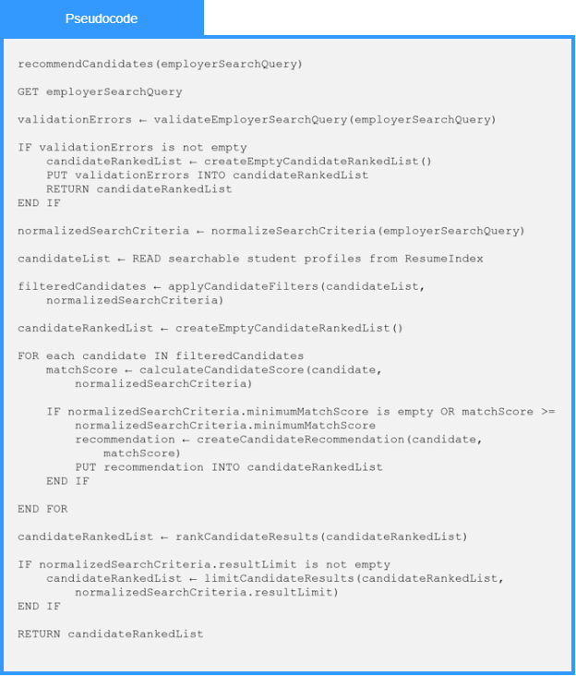
Local Data:
validationErrors : List of String
normalizedSearchCriteria : EmployerSearchQuery
candidateList : List of StudentProfile
filteredCandidates : List of StudentProfile
candidateRankedList : CandidateRankedList
matchScore : Number
recommendation : CandidateRecommendation

1.11.2-ALG calculateCandidateScore() Algorithm
Purpose:
Calculates a candidate ranking score for an employer search or recommendation request by evaluating required filters, skills, experience, profile and resume information, and weighted criteria; returns a bounded score, a score breakdown, and the candidate eligibility status.
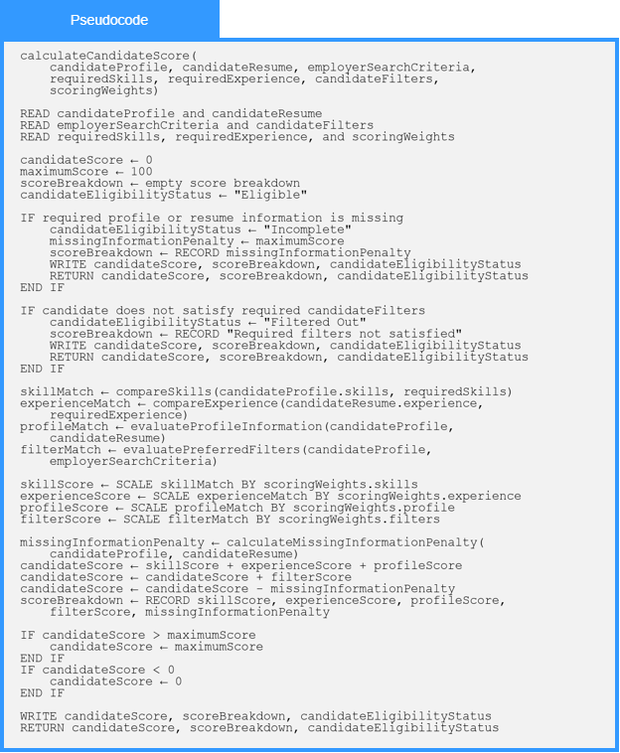
Local Data:
candidateScore : Number
maximumScore : Number
skillMatch : Number
experienceMatch : Number
profileMatch : Number
filterMatch : Number
skillScore : Number
experienceScore : Number
profileScore : Number
filterScore : Number
missingInformationPenalty : Number
scoreBreakdown : ScoreBreakdown
candidateEligibilityStatus : EligibilityStatus

1.11.2-ALG rankMatches() Algorithm
Purpose:
Accepts a list of Recommendation objects and returns them sorted in descending order by matchScore, so the highest-scoring candidates appear first. The algorithm uses an insertion sort, which is efficient for small to medium lists and preserves the relative order of equal scores (stable sort). If the input list is empty, it is returned immediately.
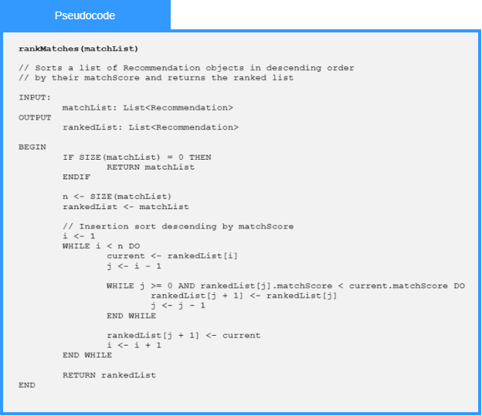
Local Data:
n: Integer
rankedList: List<Recommendation>
i: Integer
j: Integer
current: Recommendation

1.11.3-ALG compareExperience() Algorithm
Purpose:
Compares a student’s years of work experience against the experience requirement of a job posting and returns a weighted score out of 30. If the student meets or exceeds the requirement, they receive full marks. If not, a proportional score is calculated using the ratio of student years to require years. A small bonus is awarded for exceeding the requirement by two or more years, clamped to a maximum of 30 points.
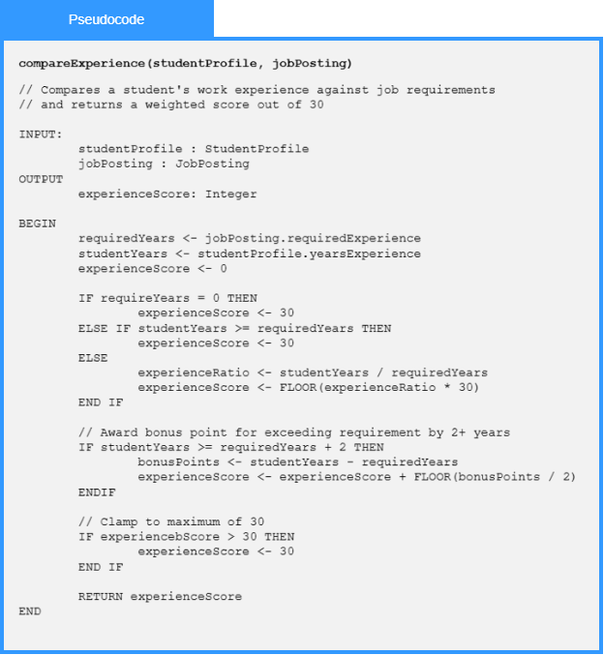
Local Data:
requiredYears: Integer
studentYears: Integer
experienceRation: Float
bonusPoints: Integer
experienceScore: Integer

1.11.3-ALG calculateMatchScore() Algorithm
Purpose:
Computes 0-100 composite score across four weighted sub-scores: skill match (40pts, delegated to compareSkills(), experience (30pts), education (20 pts), and location/remote (10 pts). Score is clamped at 100 before returning.
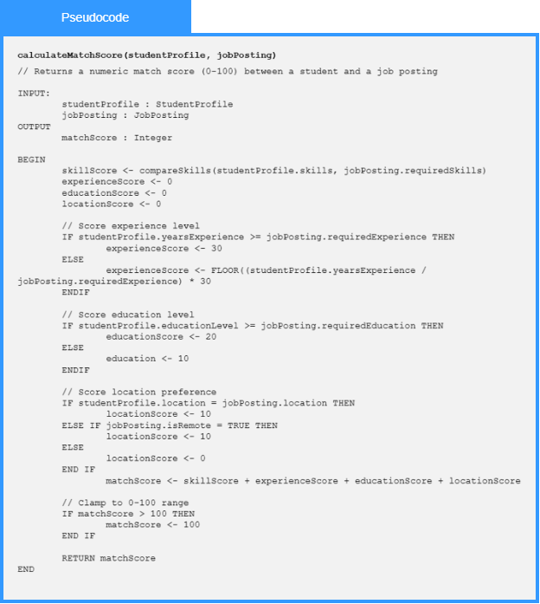
Local Data:
skillScore: Integer
experienceScore: Integer
educationScore: Integer
locationScore: Integer
matchScore: Integer

1.11.3-ALG compareSkills() Algorithm
Purpose:
Iterates every required skill against the student’s skill list using a case-insensitive name match, then scales the match ratio to 40 points. Called as a sub-routine by Algorithm 1.
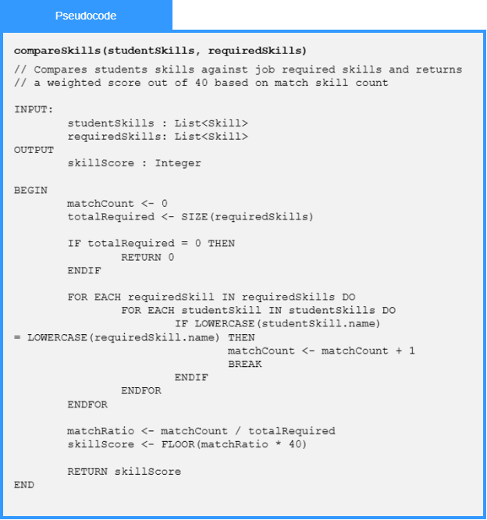
Local Data:
matchCount: Integer
totalRequired: Integer
matchRatio: Float
skillScore: Integer
requiredSkill: Skill
studentSkill: Skill

1.11.5-ALG generateRecommendations() Algorithm
Purpose:
Coordinates the final candidate recommendation process by validating an employer request, retrieving candidate and resume records, applying filters, scoring eligible candidates, ranking matches, limiting results, and returning the recommendation list and summary.
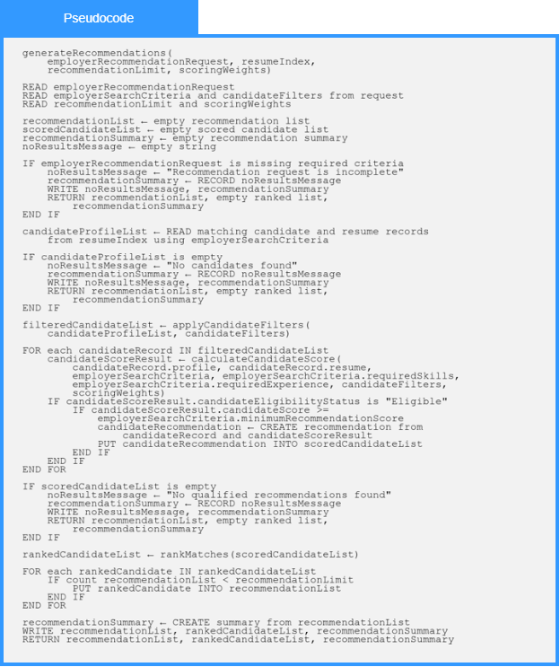
Local Data:
recommendationList : List of CandidateRecommendation
scoredCandidateList : List of CandidateRecommendation
rankedCandidateList : List of CandidateRecommendation
recommendationSummary : RecommendationSummary
noResultsMessage : String
candidateProfileList : List of CandidateRecord
filteredCandidateList : List of CandidateRecord
candidateRecord : CandidateRecord
candidateScoreResult : CandidateScoreResult
candidateRecommendation : CandidateRecommendation

1.12 External Services Algorithms

1.12.1-ALG getAddress()
Purpose:
Retrieves the complete address entered by the user and prepares it for validation.
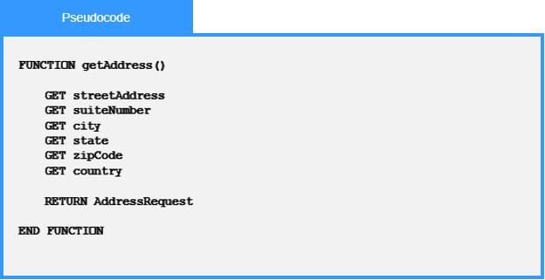

1.12.1-ALG validateAddress()
Purpose:
Verifies that all required address information is present before attempting USPS validation.
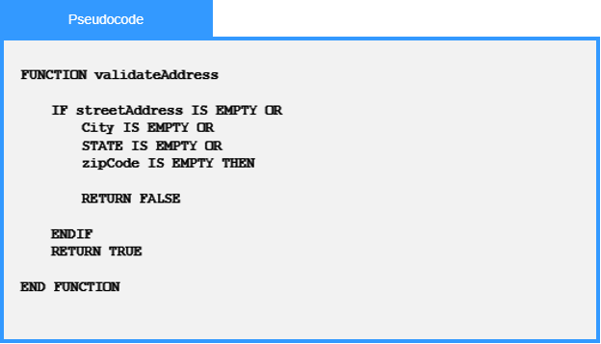

1.12.1-ALG standardizeAddress()
Purpose:
Formats the validated address according to USPS standards and returns the standardized address.
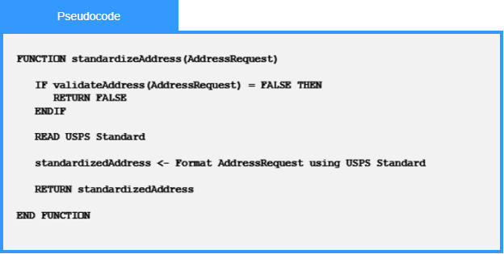

1.12.1-ALG getValidatedAddress() Algorithm
Purpose:
Retrieves a USPS-validated address by validating the city and ZIP code and returning a standardized address when the input is valid.
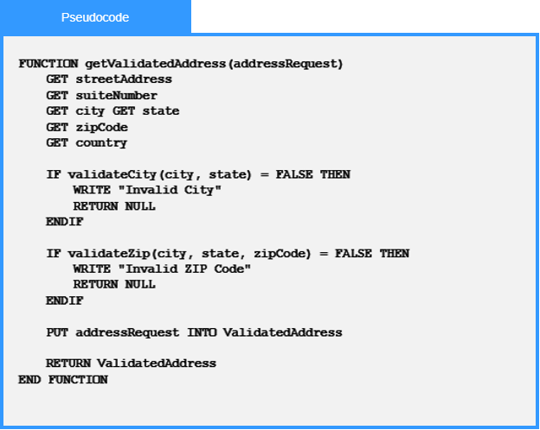

1.12.1-ALG validateCity() Algorithm
Purpose:
Verifies that the provided city exists and is valid for the specified state according to USPS address standards.
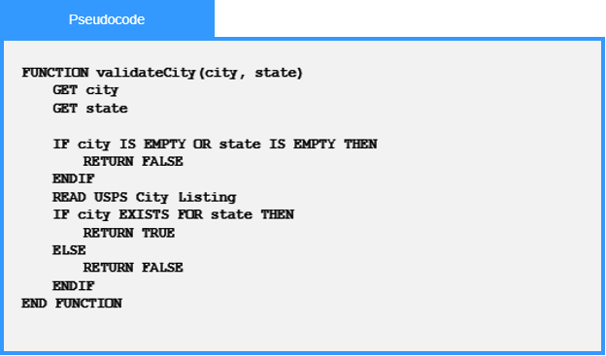

1.12.3-ALG pushNotificationGateway() Algorithm
Purpose:
This algorithm manages the delivery of push notifications to a user's registered devices. It validates that device tokens are available, sends the notification message to each device, tracks successful and failed deliveries, and returns a summary of the notification request, including delivery status and any errors encountered.
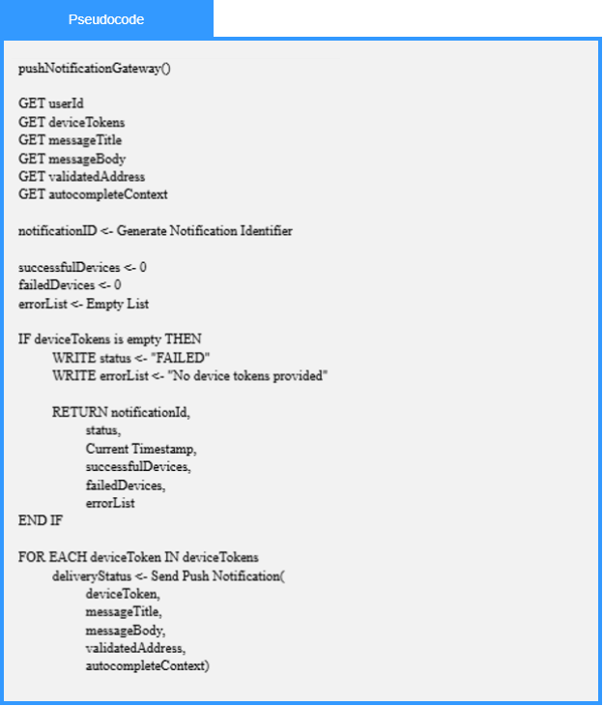
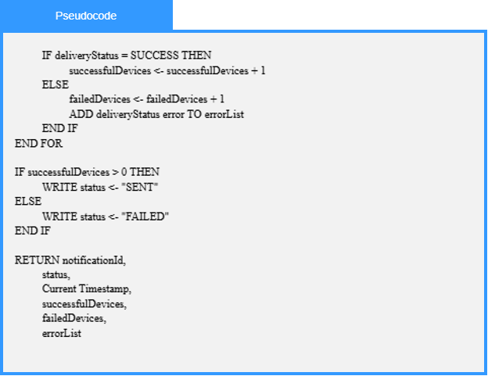
Local Data:
notificationId : Notification Identifier
successfulDevices : Number
failedDevices : Number
deliveryStatus : Status
errorList : List of Error Messages

1.13 Analytics Service Algorithms

1.13.1-ALG getResumeSubmissions() Algorithm
Purpose:
Fetches all resume form submissions for a job posting and accepts parameters to sort and filter candidates.
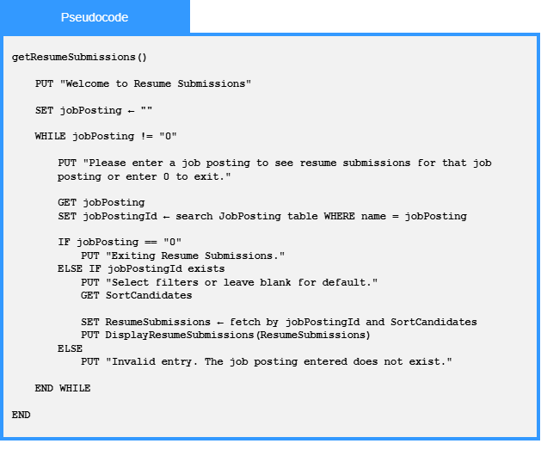

1.13.1-ALG manageJobPosting() Algorithm
Purpose:
Used so a company representative can add, edit, or delete a job posting.
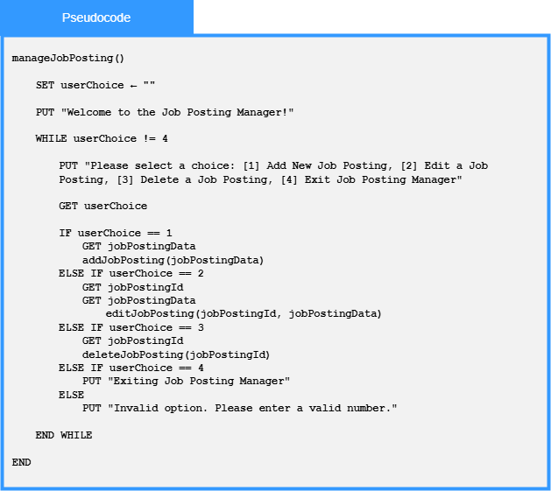

1.13.2-ALG displayFilteredCandidates() Algorithm
Purpose:
Displays filtered candidate profiles and their resumes within 3 seconds of search request submission.
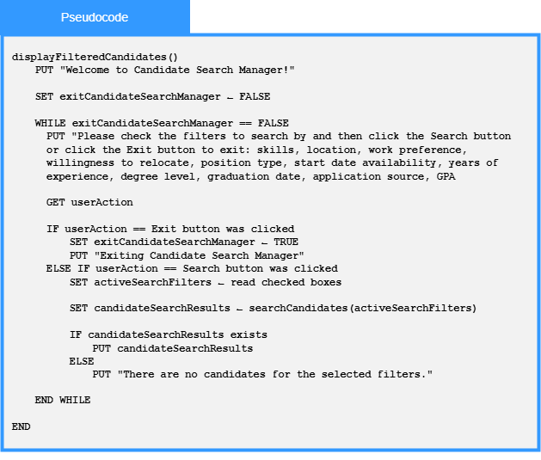

1.13.2-ALG parseWildcardSearches() Algorithm
Purpose:
This algorithm parses the searchQuery to make the parsedQuery.
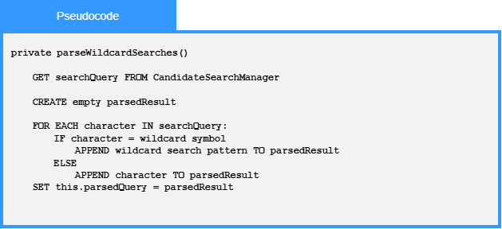
Local Data:
parsedResult : String

1.13.2-ALG autoFillSearchBar() Algorithm
Purpose:
This algorithm takes the input that the user has typed up and displays a complete suggestion.
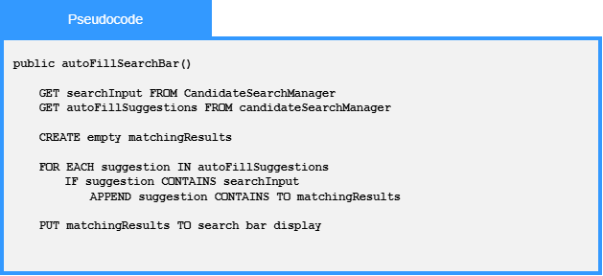
Local Data:
matchingResults : List<string>

1.13.3-ALG matchResume() Algorithm
Purpose:
This algorithm evaluates whether a student's resume meets a set of required job skills. It retrieves the specified resume, compares the skills listed in the resume against the required skills, calculates the number of matches, and returns a result indicating whether the resume satisfies all required criteria.
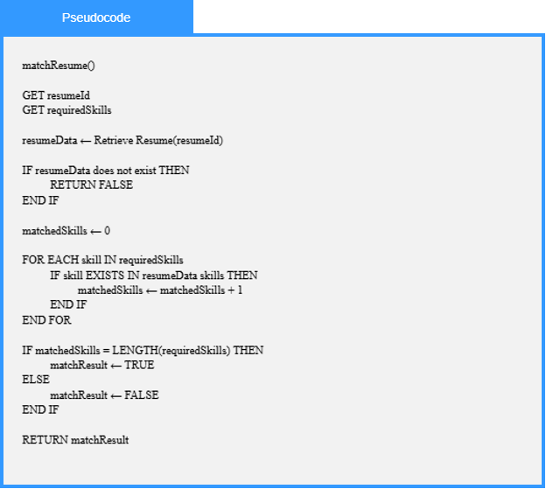
Local Data:
resumeData : Resume
requiredSkills : List of Skills
matchedSkills : Number
matchResult : Boolean

1.13.4-ALG notificationAndNewsFeedbackAnalytics() Algorithm
Purpose:
This algorithm processes user interaction events related to notifications and news content for analytics purposes. It validates incoming event data, records the interaction in the analytics repository, determines whether processing was successful, and returns the status of the operation along with any validation or processing errors.
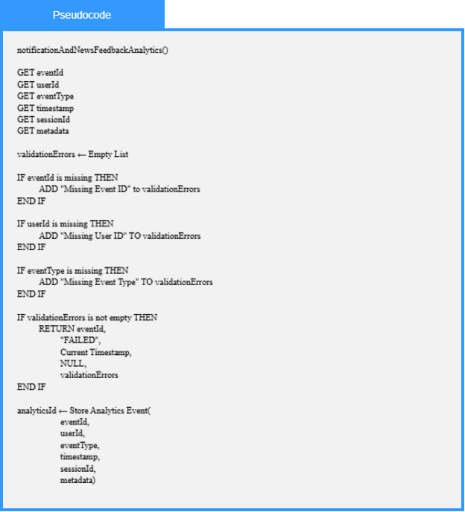
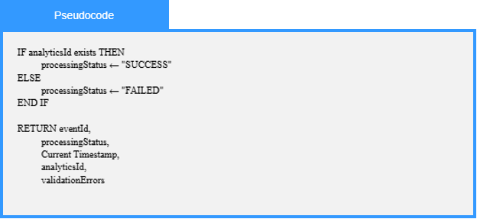
Local Data:
analyticsId : Analytics Identifier
processingStatus : Status
validationErrors : List of Error Messages

1.13.5-ALG PerformanceMonitor() Algorithm
Purpose:
This algorithm reads activity data, analyzes it, and creates a report or an alert for it.
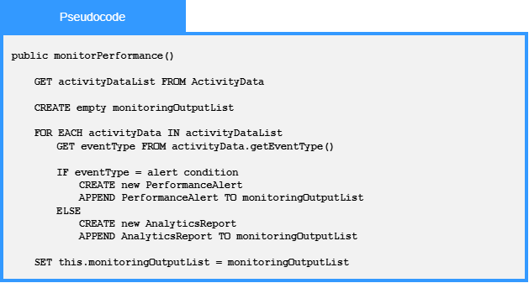
Local Data:
monitoringOutputList : List<MonitoringOutput>
activityData : ActivityData
eventType : String

