1.2.2 & 1.3.2-ALG renderSelectedView() Algorithm
Purpose:
Coordinates rendering after navigation or state change.
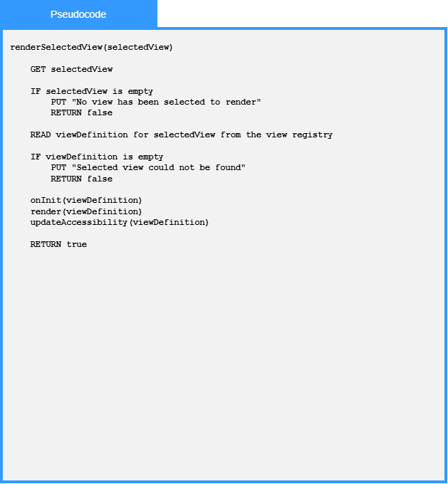
Local Data:
selectedView : View

1.2.2 & 1.3.2-ALG render() Algorithm
Purpose:
Displays view content and coordinates rendered UI components.
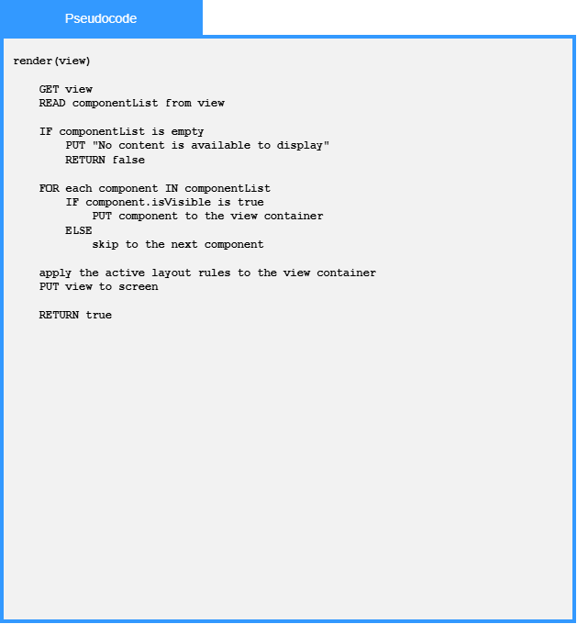
Local Data:
view : View
componentList : List of Component Objects

