Ethan, thanks for your work! Here are some suggestions below. You are welcome to use them or discard them, whatever you think is best.

For the criteria, I got it from this file below: 01_Standards/Milestone_3_Components/M3_Entity_Identification_Table_Standards_&_QA_Checklist.docx
Here is my thinking below.

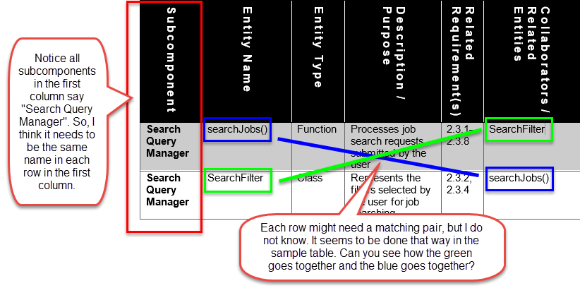

- Criteria: Table represents ONLY ONE subcomponent. Each Entity Identification Table shall represent only ONE subcomponent and contain all entities directly related to that subcomponent.
  - Suggestion: From my understanding, each table needs to be separate rather than combined.
- Criteria: Group Heading Format: Entity Identification Tables — <Component Name>
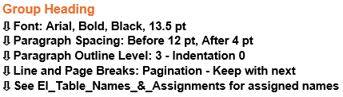

- Criteria: Table Heading Format: EI Table <Figure #>.<Inner Component #> — <Inner Component Name>
- Suggestion: I think functions are camelCase and have parentheses after the name. So, instead of PushNotificationGateway, it would be pushNotificationGateway().
- Suggestion: You may need other rows than just one row per table, but I am not sure.

From the criteria I listed, this is more of what I am thinking (see below).

Entity Identification Table — External Services Orchestrator
EI Table — 1.12.3 Push Notification Gateway
Subcomponent | Entity Name | Entity Type | Description / Purpose | Related Requirement(s) | Collaborators / Related Entities
External Services Orchestrator | pushNotificationGateway() | Function | Manages and securely delivers app notifications by standardizing data, routing messages to each user’s device, and temporarily storing notifications for offline users. | 1.12.1–1.12.3 | USPSAddressValidationAdapter, AutocompleteAPIAdapter
External Services Orchestrator | USPSAddressValidationAdapter |  | Maybe matching rows needed, maybe not? |  | pushNotificationGateway()
External Services Orchestrator | AutocompleteAPIAdapter |  | Maybe matching rows needed, maybe not? |  | pushNotificationGateway()

Entity Identification Table — Analytics Services Orchestrator
1.13.4 Notification and News Feedback Analytics
Subcomponent | Entity Name | Entity Type | Description / Purpose | Related Requirement(s) | Collaborators / Related Entities
Analytics Services Orchestrator | notificationAndNewsFeedbackAnalytics() | Function | Monitors, collects, and analyzes user interactions and reactions to app notifications and news feeds. | 1.13.1–1.13.4 | JobPostingAnalytics, SearchAndCandidateAnalytics, ProfileAndResumeEngagement
Analytics Services Orchestrator | JobPostingAnalytics |  | Maybe matching rows needed, maybe not? |  | notificationAndNewsFeedbackAnalytics()
Analytics Services Orchestrator | SearchAndCandidateAnalytics |  | Maybe matching rows needed, maybe not? |  | notificationAndNewsFeedbackAnalytics()
Analytics Services Orchestrator | ProfileAndResumeEngagement |  | Maybe matching rows needed, maybe not? |  | notificationAndNewsFeedbackAnalytics()

