1.5.1-ALG registerUser() Algorithm
Purpose:
The algorithm that takes the user input, puts it in a package, and sends it off to the corresponding database. Note: this algorithm DOES NOT verify the data.
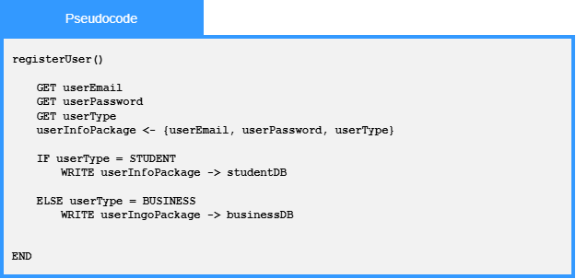

Local Data:
userEmail : string
userPassword : string
userType : enumeration
studentDB : external database
connectionbusinessDB : external database connection

1.5.1-ALG validateEmail() Algorithm
Purpose:
To ensure that the email is in the correct format and doesn’t extend past 254 characters according to the RFC 5321 section 4.5.3.1.3 standards. NOTE: This does not confirm that the email actually exists.
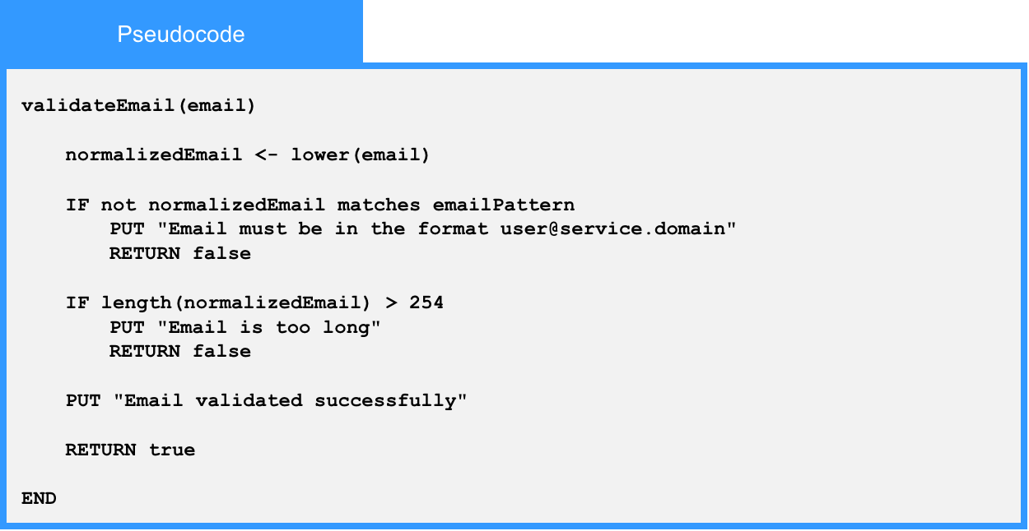
Local Data:
normalizedEmail : String
emailPattern : Regular Expression

1.5.1-ALG validatePassword() Algorithm
Purpose:
To ensure that the password is compliant with NIST SP 800-63B section A password standards.
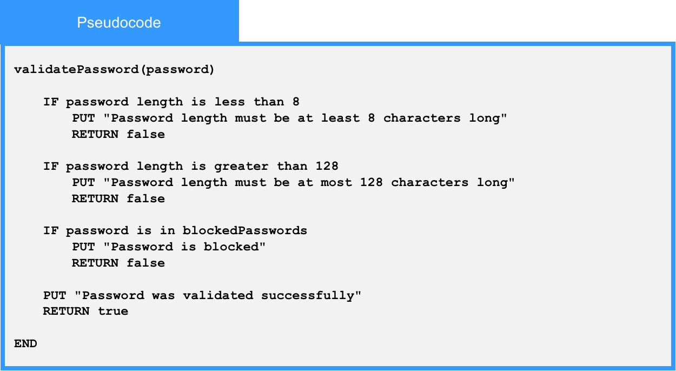
Local Data:
blockedPasswords : List of Strings

1.5.1-ALG hashPassword() Algorithm
Purpose:
Acts as a wrapper for a password hashing function from a certified cryptography library, and returns the hashed password.
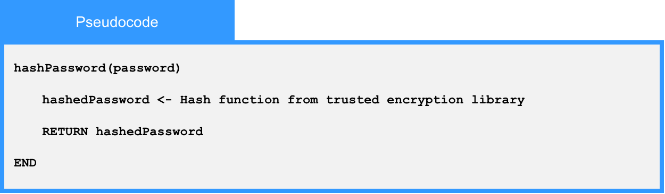
Local Data:
hashedPassword : String

1.5.2-ALG checkPermissions() Algorithm
Purpose:
This is for any service looking for what kinds of permissions are available to a specific type of user, based off of the user object.
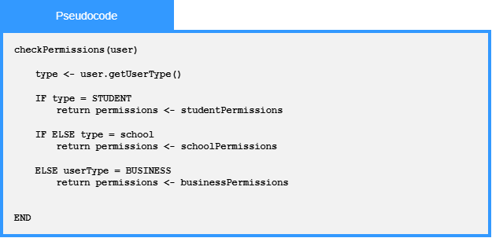

Local Data:
user : User

1.6.1-ALG addProfileInformation() Algorithm

Purpose:
Adds a user’s profile information by validating the submitted profile details, building a new profile information record, saving it to the profile data store, and returning a success or error result.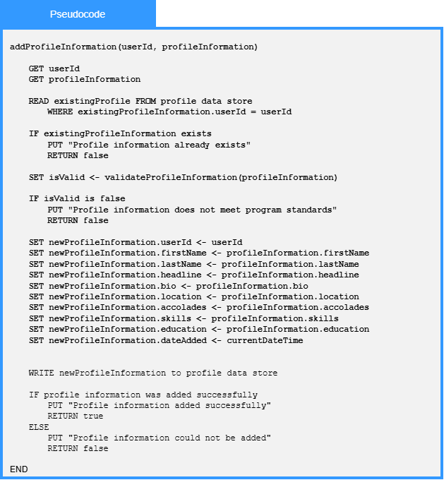

Local Data:
userId : Int
updatedProfileInformation : ProfileInformation
existingProfile : Profile
isValid: Boolean
curentDateTime : DateTime
updateResult : Boolean
errorMessage : String

1.6.1-ALG updateProfileInformation() Algorithm
Purpose:
Processes submitted profile updates by reading and parsing each profile information entry, saving the updated data to the profile data store, and returning a failure result if an update is unsuccessful.
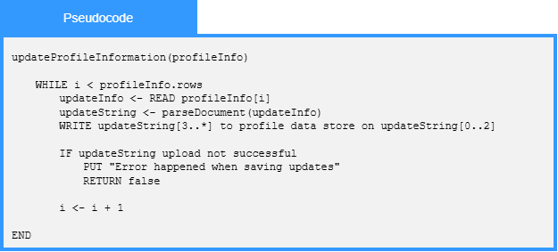

Local Data:
profileInfo : ProfileInformation
updateInfo : ProfileInformationEntry
updateString : String
profileDataStore : DataStore
saveSuccessful : Boolean

1.6.1-ALG addCompanyLocation() Algorithm

Purpose:
Adds a company location to the profile data store by validating the submitted address information, saving each location field, and returning a success or error result.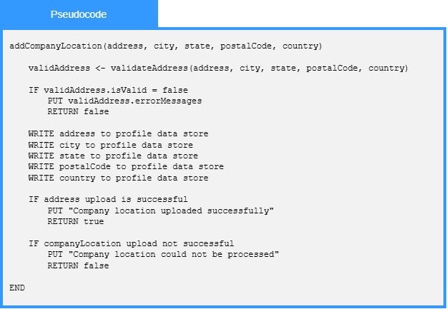

Local Data:
address : String
city : String
state : String
postalCode : String
Country : String
validAddress : ValidationResult

1.6.2-ALG updateImage() Algorithm

Purpose:
Updates an existing image by locating the current image file, validating and processing the new image file, replacing the stored image details, saving the updated image file, and returning a success or error result.
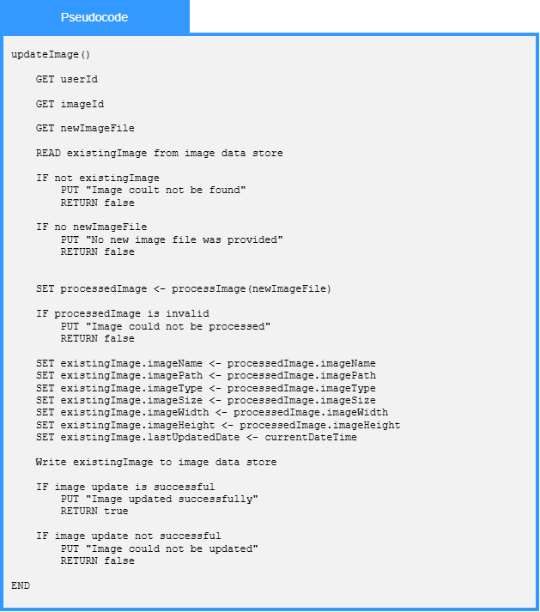

Local Data:

existingImage : Image

processedImage : Image

updateResult : UpdateResult

errorMessage : String

1.6.2-ALG processImage() Algorithm
Purpose:
Processes an uploaded image by checking if it is valid, resizing and cropping it to the required dimensions, compressing it to reduce file size, and returning the processed image for storage.
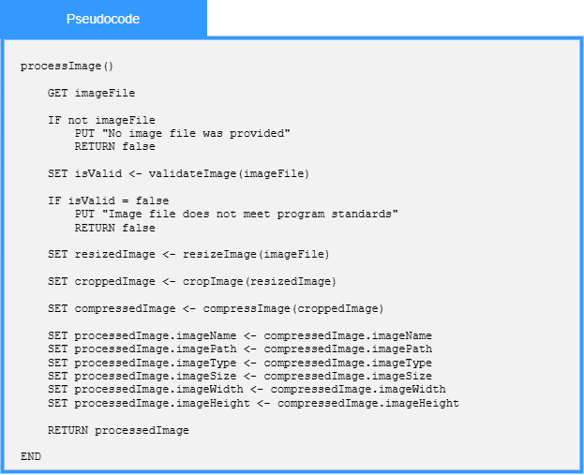
Local Data:
imageFile : File
isValid : Boolean
resizedImage : Image
croppedImage : Image
compressedImage : Image
processedImage : Image

1.6.4-ALG updateSettings() Algorithm
Purpose:
Update a user’s settings by getting the current settings record, validating the requested changes, applying the validated updates, saving the updated settings, and returning a success or error result.
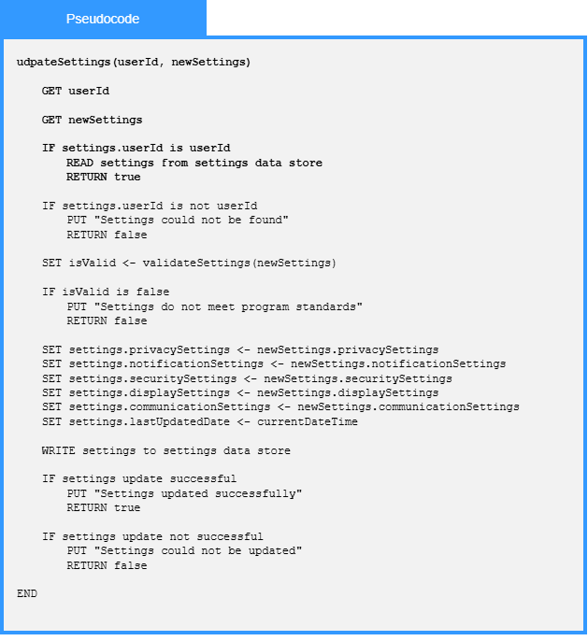

Local Data:
userId : Int
newSettings : Settings
settings : Settings
isValid : Boolean
currentDateTime : DateTime
updateResult : Boolean
errorMessage : String

*Note: We still have 4 algorithms in process they are 1.5.2-ALG loginUser(), 1.5.2-ALG logoutUser(), 1.5.2-ALG createSession(), and 1.6.5-ALG logActivity(). I am expecting that they will be completed by tomorrow (7/2/2026).

