SkillTag Class Diagram

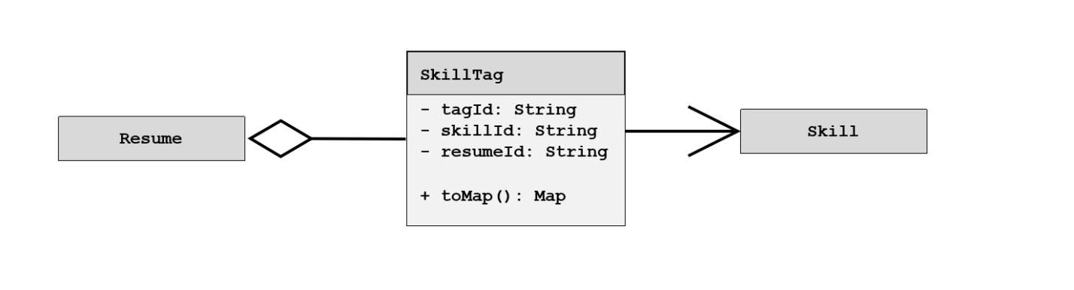

ResumeSubmission Class Diagram

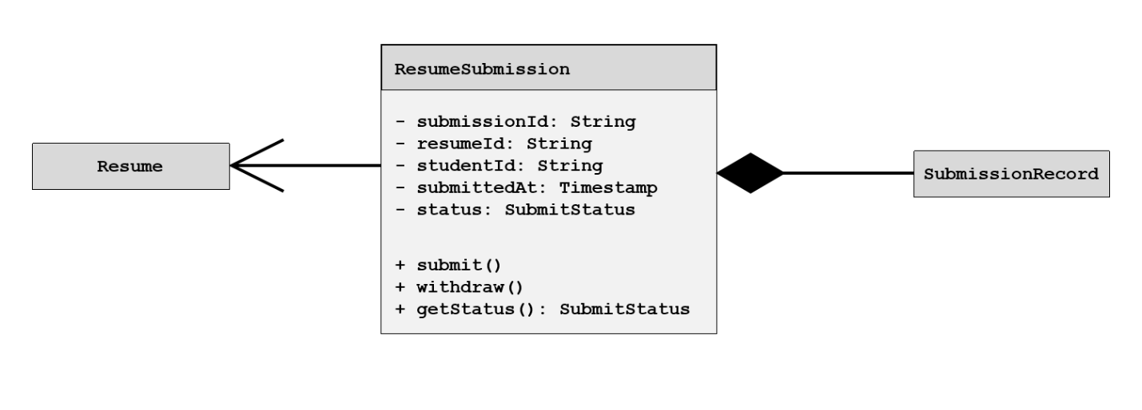

ValidationResult Class Diagram

