Milestone 5 Pseudocode Algorithm Design Standards
Naming Standards
1.11.2-ALG rankMatches() Algorithm
Purpose:
Accepts a list of Recommendation objects and returns them sorted in descending order by matchScore, so the highest-scoring candidates appear first. The algorithm uses an insertion sort, which is efficient for small to medium lists and preserves the relative order of equal scores (stable sort). If the input list is empty, it is returned immediately.

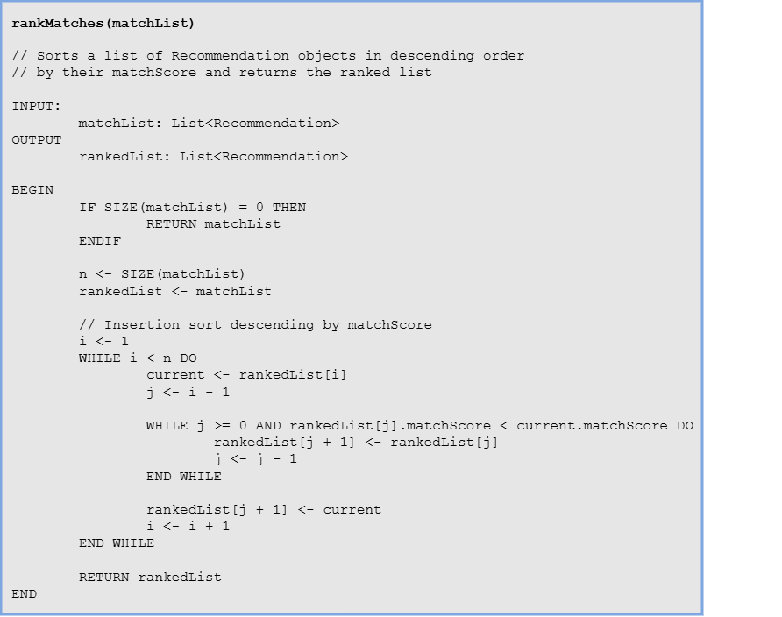

Local Data:
n: Integer
rankedList: List<Recommendation>
i: Integer
j: Integer
current: Recommendation

1.11.3-ALG compareExperience() Algorithm
Purpose:
Compares a student’s years of work experience against the experience requirement of a job posting and returns a weighted score out of 30. If the student meets or exceeds the requirement, they receive full marks. If not, a proportional score is calculated using the ratio of student years to required years. A small bonus is awarded for exceeding the requirement by two or more years, clamped to a maximum of 30 points.

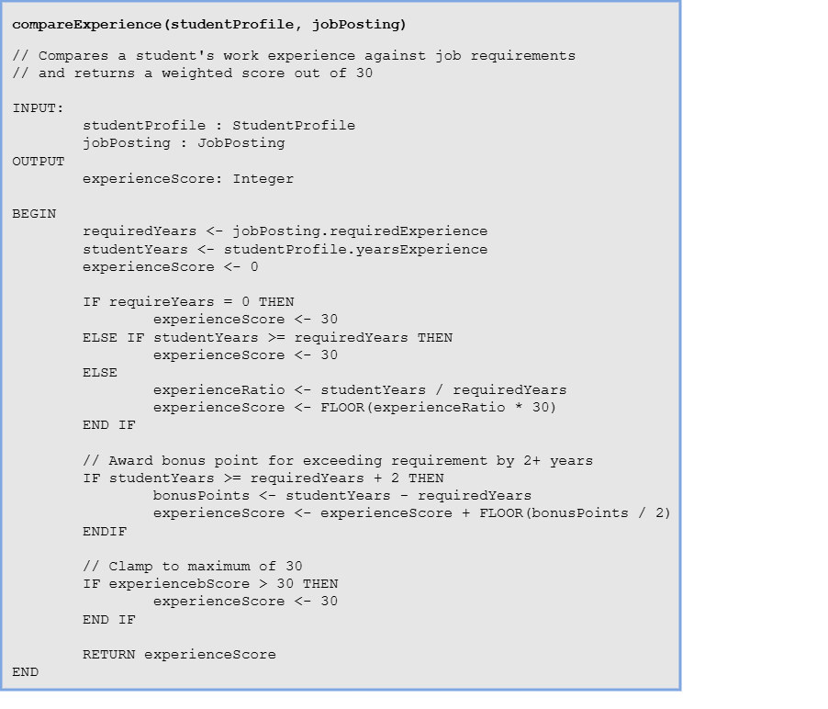

Local Data:
requiredYears: Integer
studentYears: Integer
experienceRation: Float
bonusPoints: Integer
experienceScore: Integer

1.11.3-ALG calculateMatchScore() Algorithm
Purpose:
Computes 0-100 composite score across four weighted sub-scores: skill match (40pts, delegated to compareSkills(), experience (30pts), education (20 pts), and location/remote (10 pts). Score is clamped at 100 before returning. 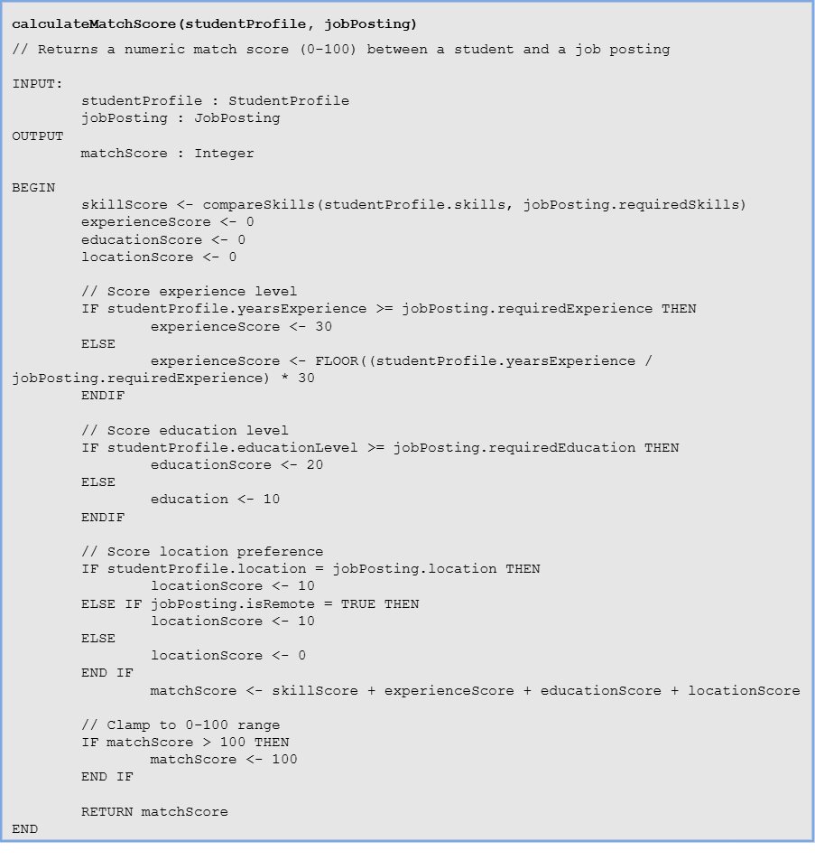
Local Data:
skillScore: Integer
experienceScore: Integer
educationScore: Integer
locationScore: Integer
matchScore: Integer

1.11.3-ALG compareSkills() Algorithm
Purpose:
Iterates every required skill against the student’s skill list using a case-insensitive name match, then scales the match ratio to 40 points. Called as a sub-routine by Algorithm 1.

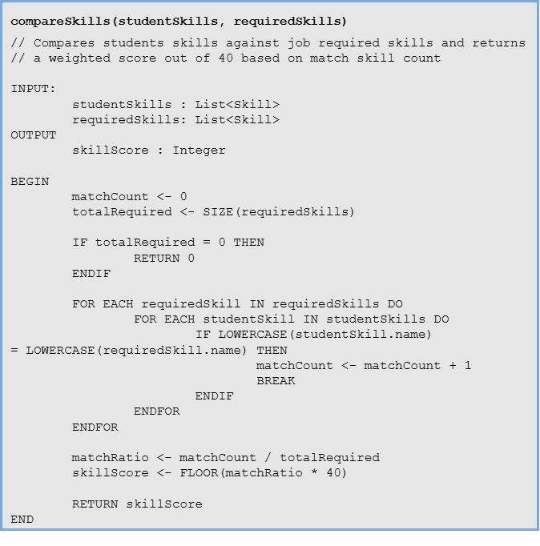
Local Data:
matchCount: Integer
totalRequired: Integer
matchRatio: Float
skillScore: Integer
requiredSkill: Skill
studentSkill: Skill

