- DATA DESIGN

  - Data Description
The information domain of Career Bound consists of students, companies, resumes, job postings, applications, notifications, search activities, and analytics events. These concepts are transformed into software data structures represented by classes, database records, API messages, and stored files. Each major business entity is assigned a corresponding data structure to support storage, processing, and communication throughout the system.
User account information is managed by the Authentication Service and stored in the primary database. Student and company profile information is managed by the Profile Management Service and stored in the primary database. Resume metadata is stored in the primary database while uploaded resume files are stored in File / Blob Storage. Job postings, applications, notifications, search activity data, and analytics events are similarly managed by their corresponding services and persisted within the system's data stores.
Persistent business data is maintained within the primary database, while binary assets and uploaded documents are maintained within File / Blob Storage. Data exchanged between client applications and backend services is transmitted through REST API messages over the system's communication interfaces.
Data Storage Items:
- Primary Database
- User Accounts
- Student Profiles
- Company Profiles
- Job Postings
- Applications
- Notifications
- Search Activity Data
- Analytics Data

- File / Blob Storage
- Resume Documents
- Profile Images
- Attachments
Career Bound stores data related to user authentication, student profiles, company profiles, resumes, job postings, search activities, notifications, and analytics events.
Persistent data is stored in the system database. Temporary data is exchanged through REST API messages between the client applications and backend services.
  - Data Dictionary
The detailed identification of system entities, functions, data stores, classes, modules, and related data structures is documented within the Entity Identification Tables (EITs) provided throughout Section 3.2 Decomposition Description. The EITs serve as the primary source for entity definitions and provide the foundation for the Class Designs, Database Design, File Format Specifications, and Network Protocol/API Message Specifications described in Sections 4.3 through 4.6.
For convenience, the major business and system data entities within Career Bound are summarized below. The following summary-level data dictionary connects these entities to the component decomposition presented in Section 3.2. Each entity listed below is managed, processed, stored, or exchanged by one or more components identified in Figures 1.2 through 1.15. The Related Component / Figure column provides traceability between the data entities and the architectural components responsible for their creation, management, storage, or use. Infrastructure, routing, presentation, and protocol-related entities are documented within the corresponding EITs and supporting design artifacts but may not be individually represented in this summary table.
Entity | Type | Description | Related Component / Figure
Analytics Event | System Entity | Recorded user activity and system metrics | - Analytics Service — Figure 1.13  - Database — Figure 1.14
Application | Business Entity | Student application submitted for a job posting | - Job Posting Service — Figure 1.8  - Database — Figure 1.14
Company Profile | Business Entity | Company account and profile information | - Profile Management Service — Figure 1.6  - Database — Figure 1.14
Job Posting | Business Entity | Published employment opportunity | - Job Posting Service — Figure 1.8  - Search Service — Figure 1.9; Database — Figure 1.14
Notification | Business Entity | System-generated user notification | - Communication Services — Figure 1.10  - Database — Figure 1.14
Recommendation | System Entity | Job or candidate recommendations generated by the system | - Recommendation Service — Figure 1.11
Resume | Business Entity | Student resume data and associated uploaded files | - Resume Service — Figure 1.7  - File / Blob Storage — Figure 1.15
Student Profile | Business Entity | Student account and profile information | - Profile Management Service — Figure 1.6  - Database — Figure 1.14
User Account | Business Entity | Authenticated user account information | - Authentication Service — Figure 1.5  - Database — Figure 1.14

  - Class Design

1.2.1 & 1.3.1–CD Menu Class Diagram
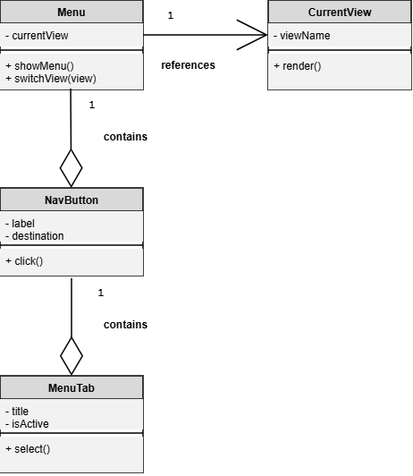

1.2.2 & 1.3.2–CD Navigation Management Class Diagram
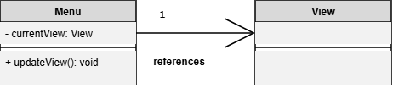

1.2.3 & 1.3.3–CD View Class Diagram
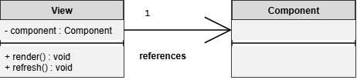

1.2.4 & 1.3.4–CD Localization Class Diagram
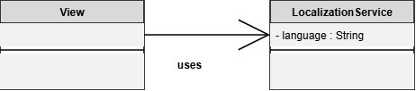

1.2.4 & 1.3.4–CD State Class Diagram
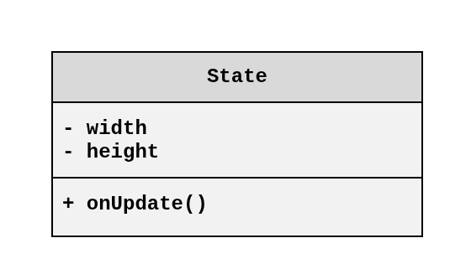

1.2.4 & 1.3.4–CD Dynamic UI Class Diagram
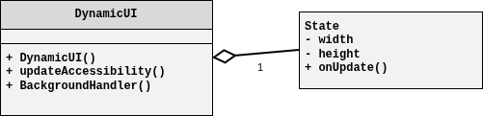

1.2.5 & 1.3.5–CD NetworkConfig Class Diagram
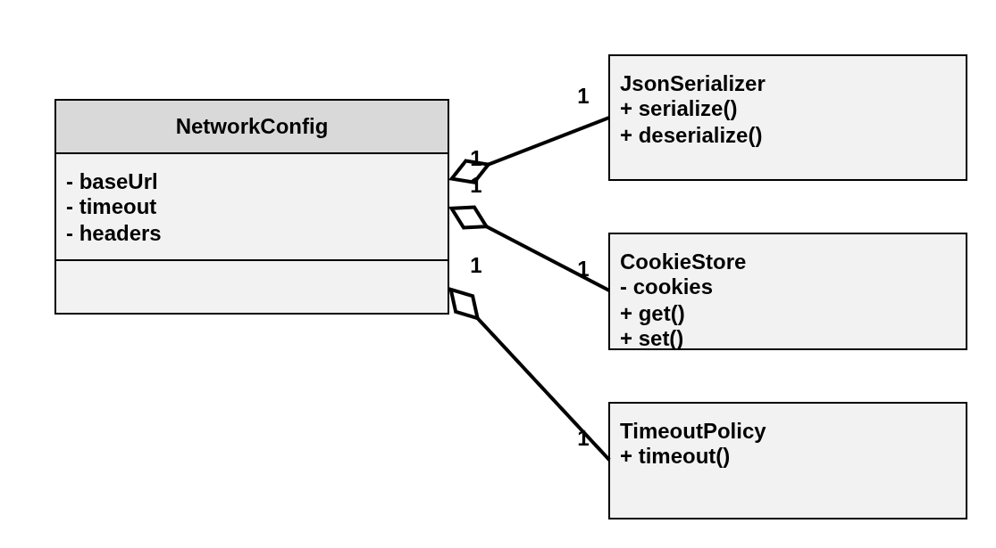

1.2.5.1 – 1.2.5.9-CD JobPosting Class Diagram
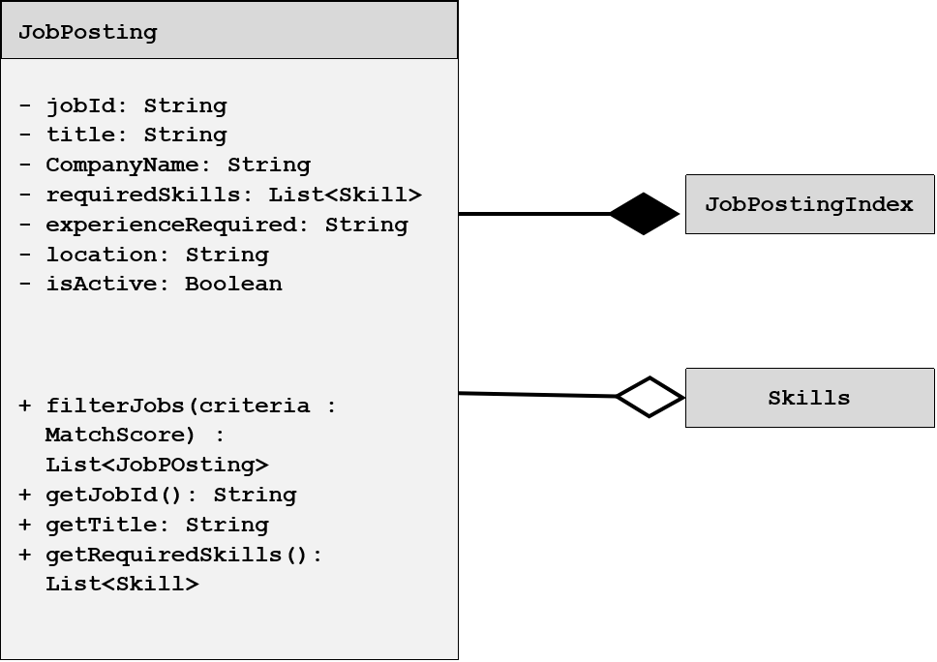

1.2.3.7, 1.3.3.3-CD Recommendation Class Diagram
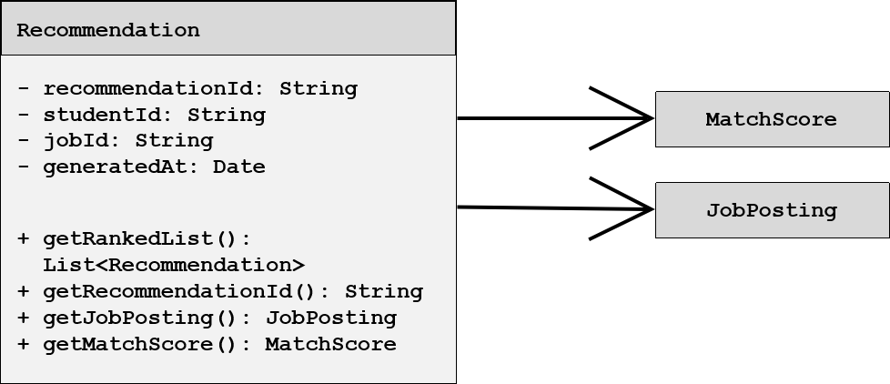

1.3.1.1 – 1.3.4-CD StudentProfile Class Diagram
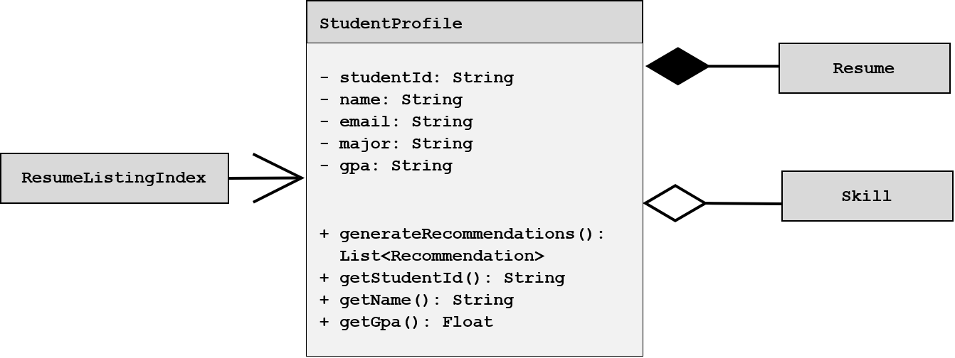

1.4.1 – CD API Gateway Class Diagram View

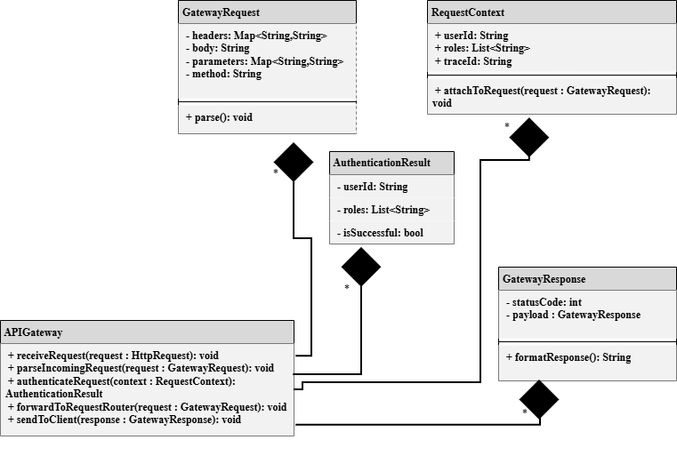

1.4.2 - CD Authentication Handler Class Diagram View

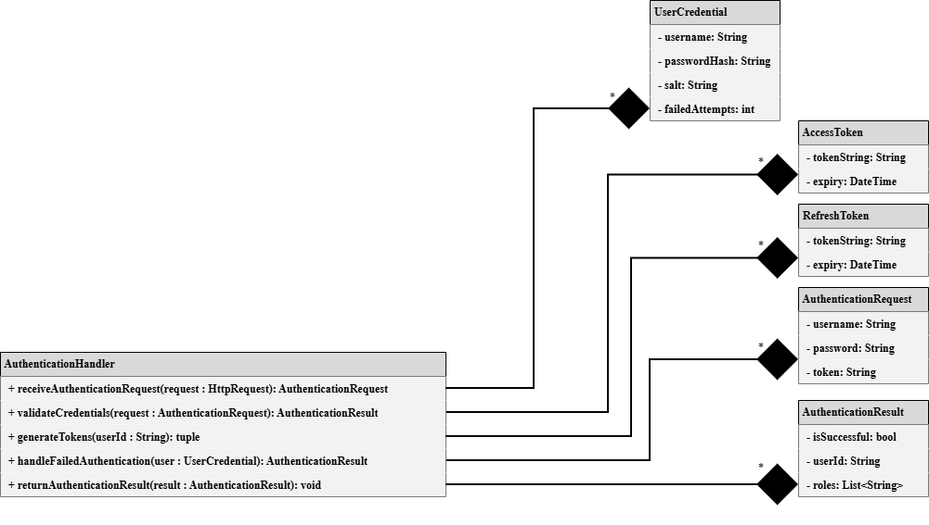

1.4.3-CD Request Router Class Diagram View

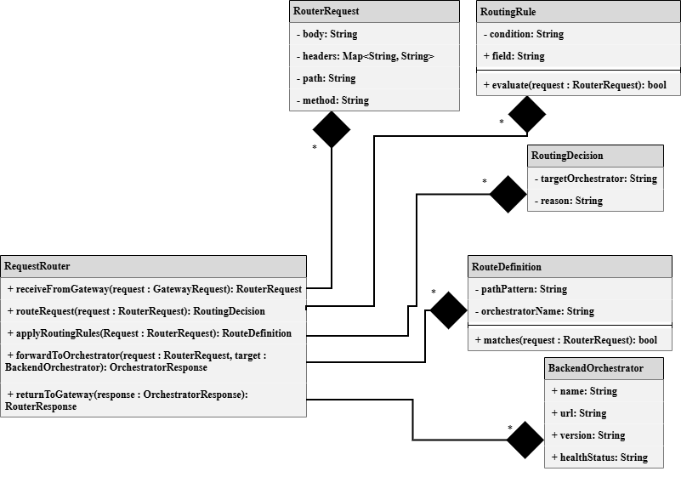

1.4.11–CD ExternalServicesOrchestrator Class Diagram
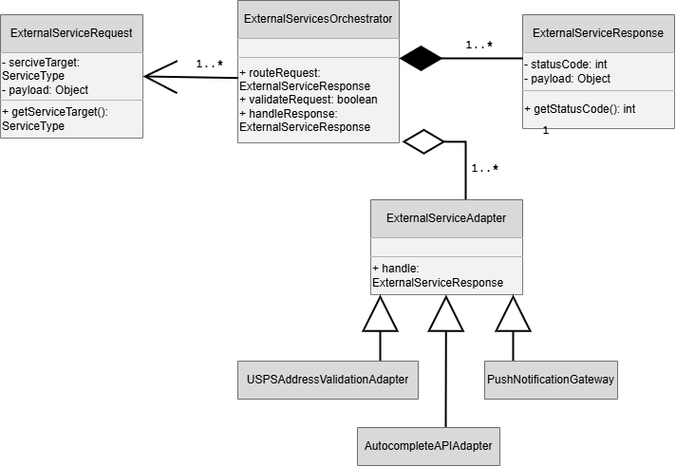

1.5.1–CD Registration Manager Class Diagram

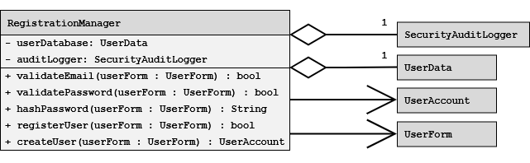1.5.2–CD Authorization/Role Manager Class Diagram

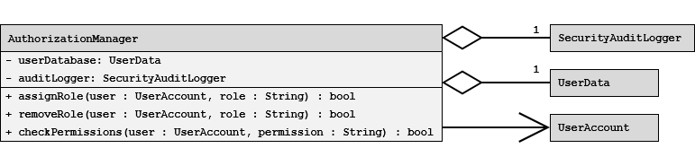1.5.3-CD Login & Session Manager Class Diagram
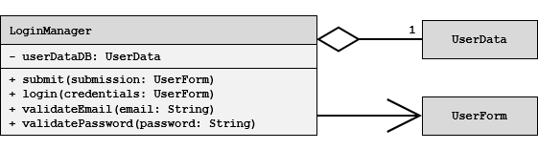

1.7.1-CD Resume Class Diagram

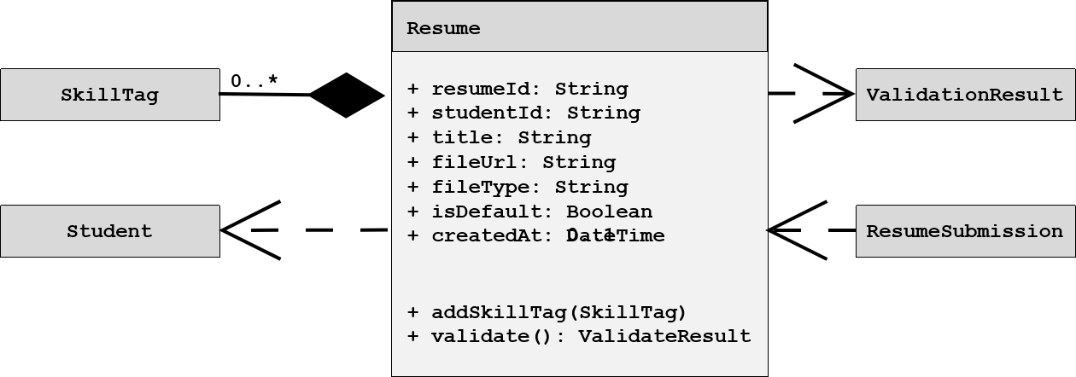1.7.3-CD Skill Class Diagram
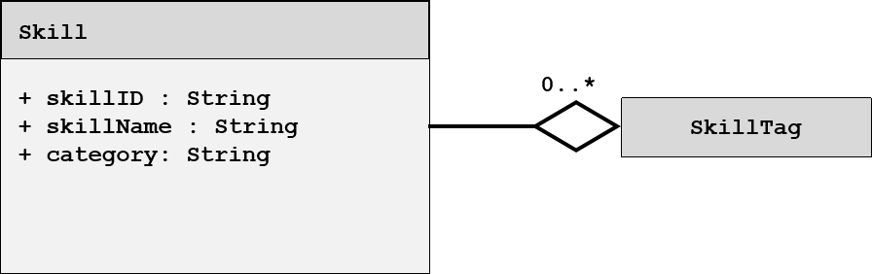

1.7.3-CD SkillTag Class Diagram
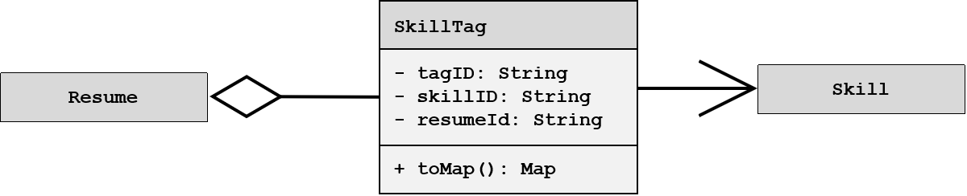

1.7.3-CD ResumeSubmission Class Diagram
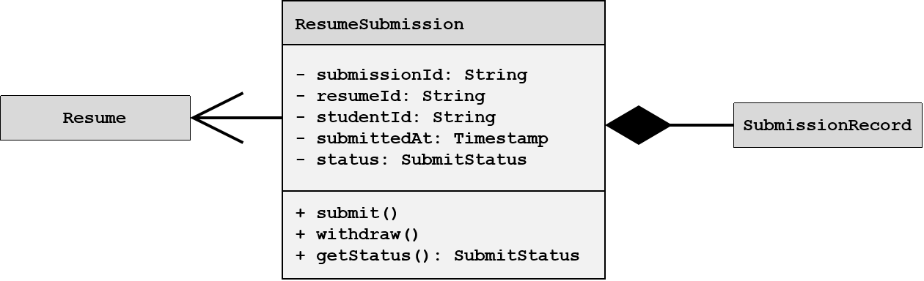

1.7.5-CD ValidationResult Class Diagram
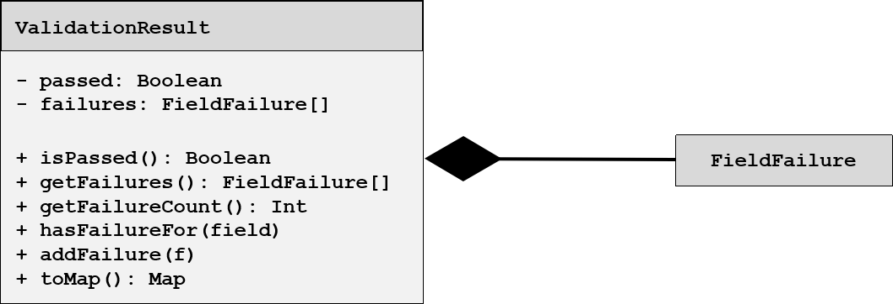

1.9.1-CD SearchController Class Diagram
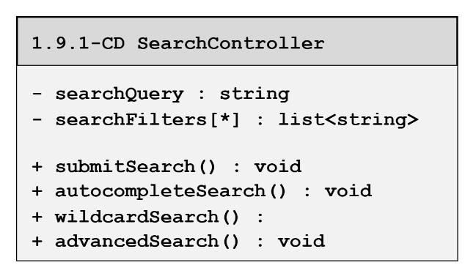

1.9.2-CD CandaditeSearch Class Diagram
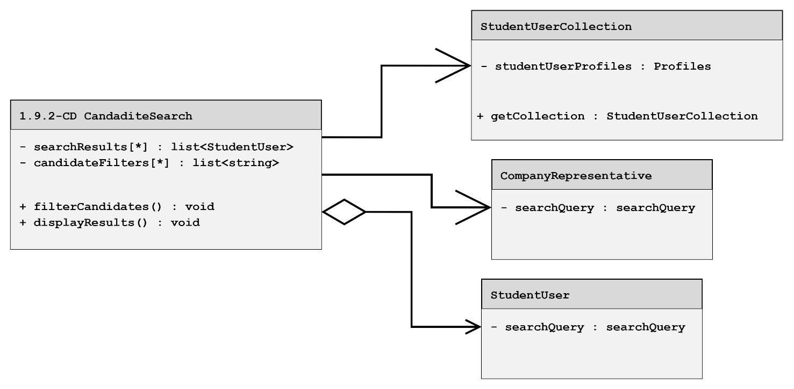

1.9.3-CD SearchController Class Diagram
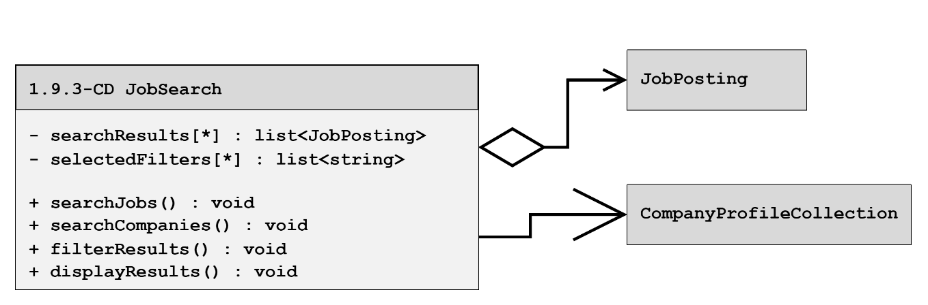

1.9.4-6-CD SearchController Class Diagram
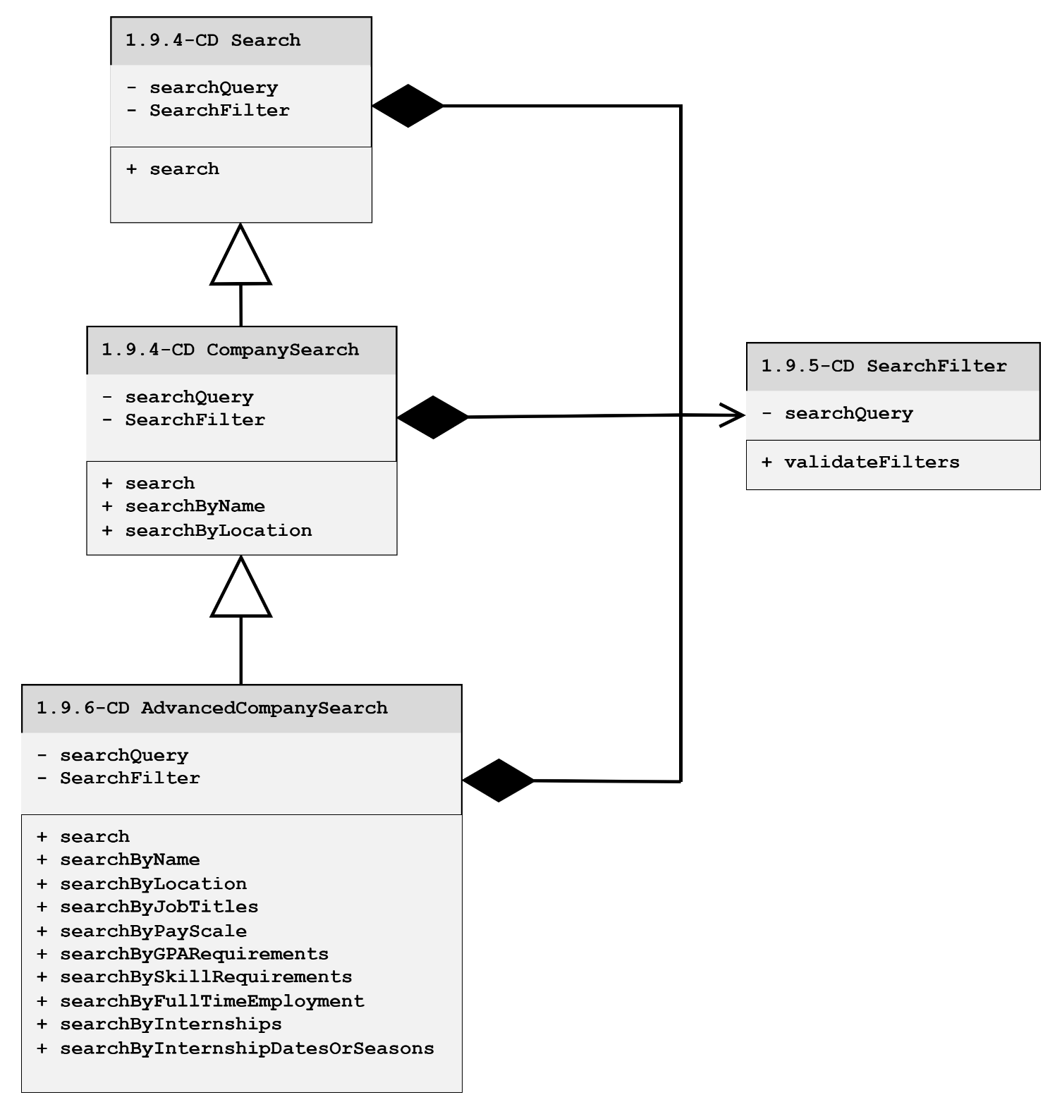

1.9.6 – CD AdvancedCompanySearch Class Diagram
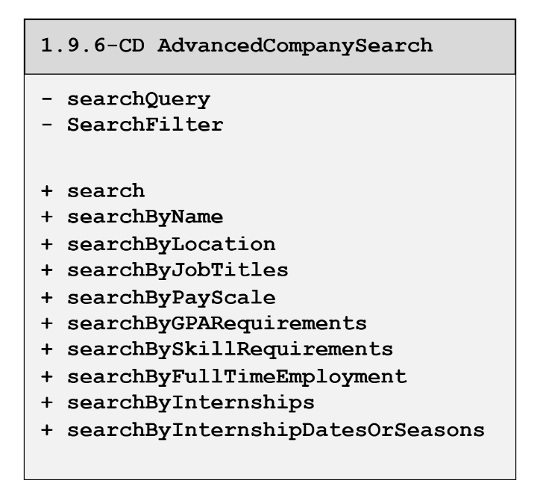

1.9.7-8-CD SearchController Class Diagram
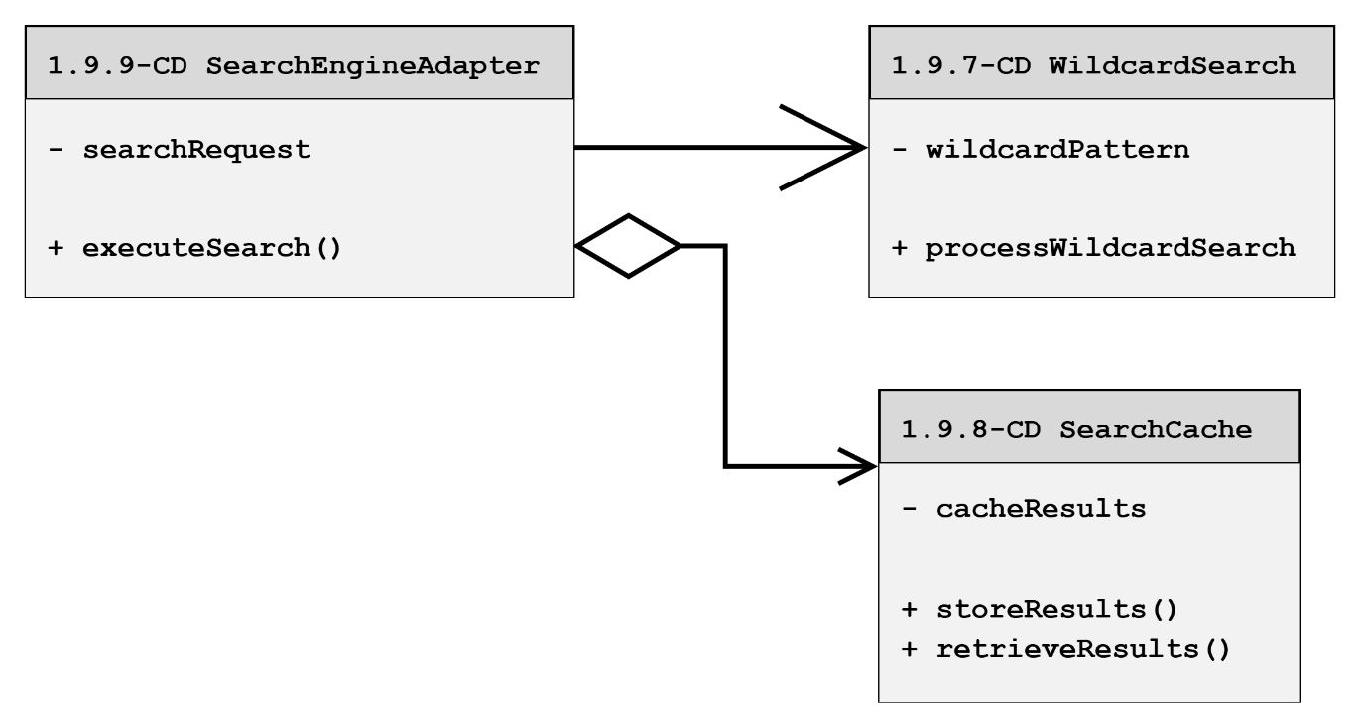

1.9.9-CD SearchController Class Diagram
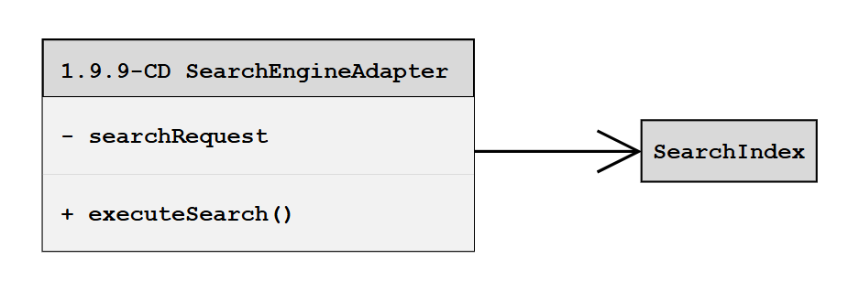

1.9.10-CD SearchController Class Diagram
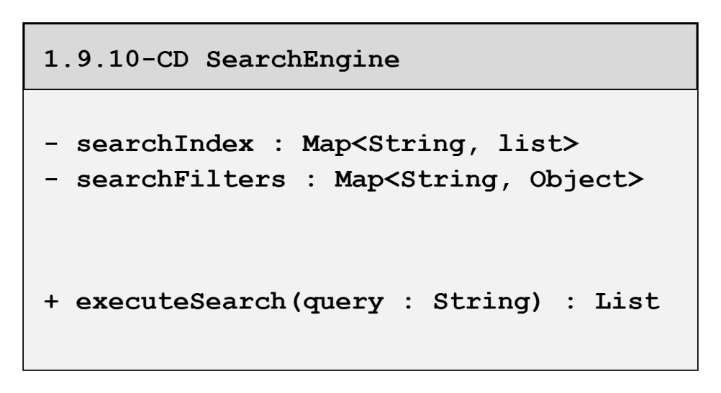

1.9.11-CD SearchController Class Diagram
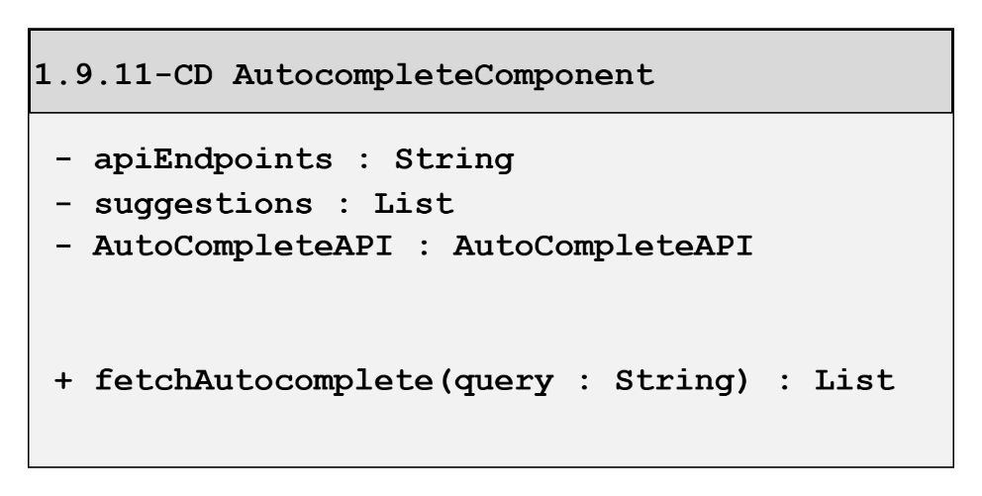

1.9.12-CD SearchController Class Diagram
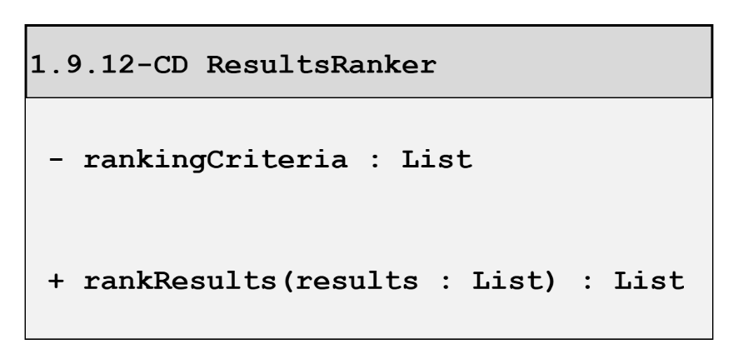

1.10.1 Event Listener Class Diagram
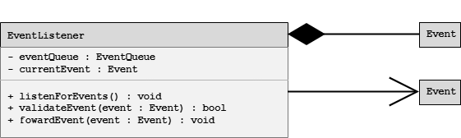

1.10.2 Notification Controller Class Diagram
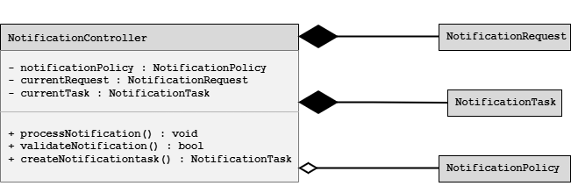

1.10.3 Notification Orchestrator Class Diagram
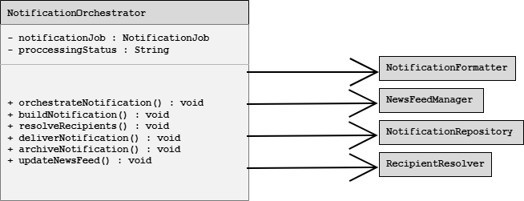

1.10.4-CD Notification Formatter Class Diagram
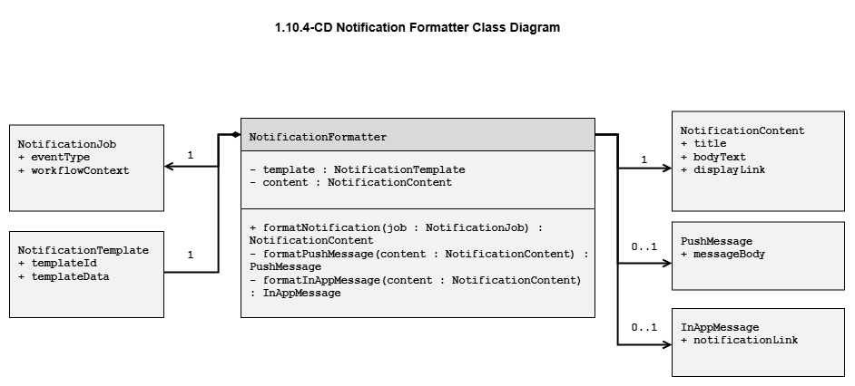

1.10.5-CD Notification Repository Class Diagram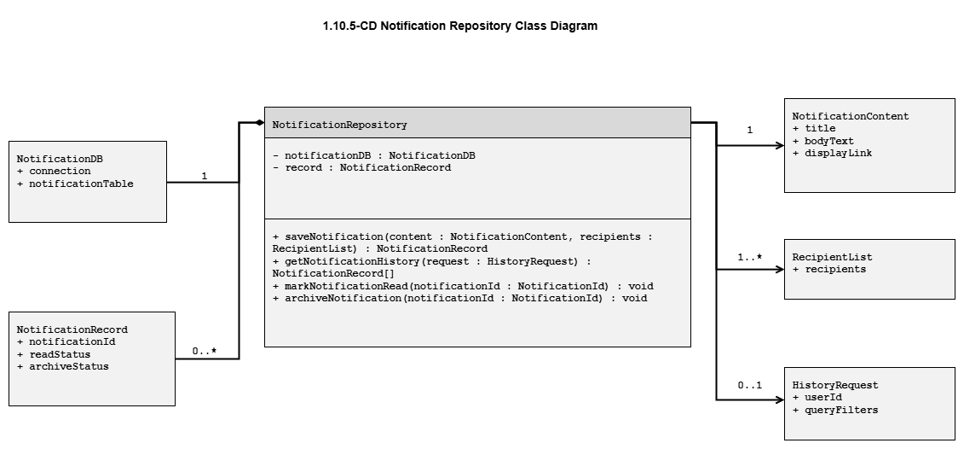

1.10.6-CD Recipient Resolver Class Diagram
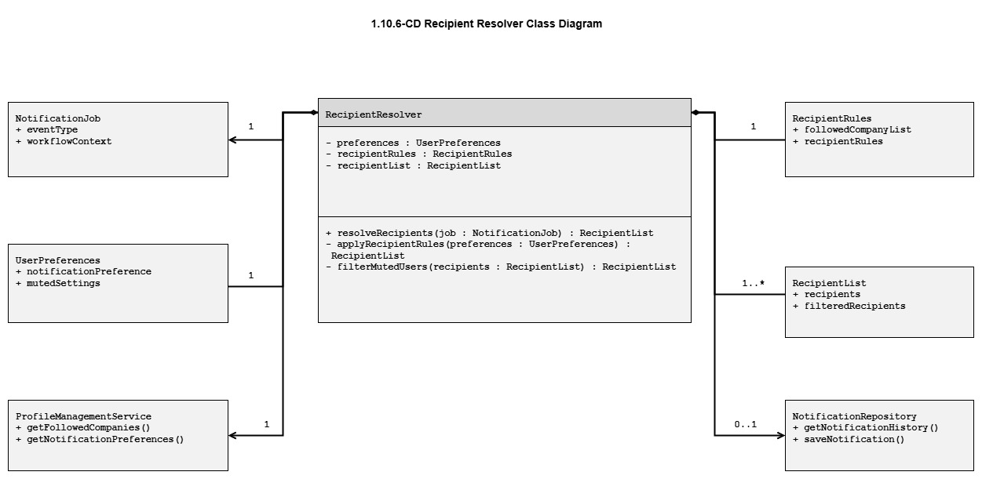

1.11.2-CD CandidateRecommender Class Diagram
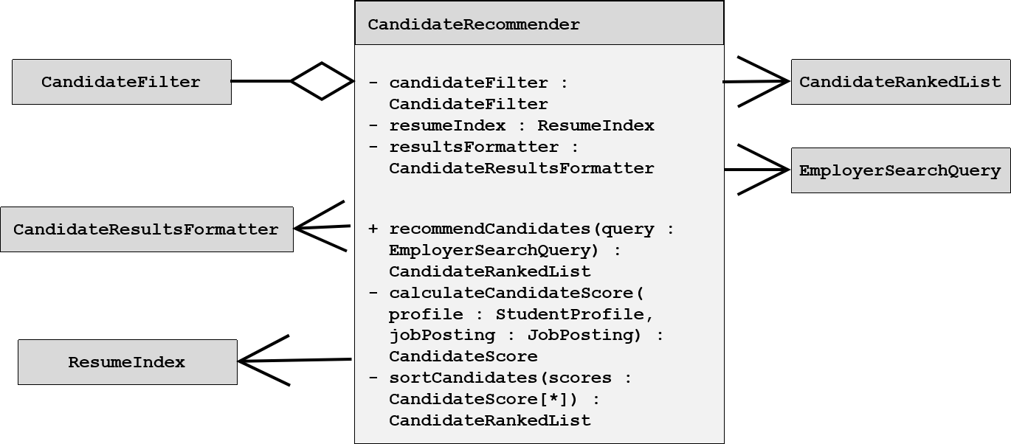

1.11.2-CD CandidateFilter Class Diagram
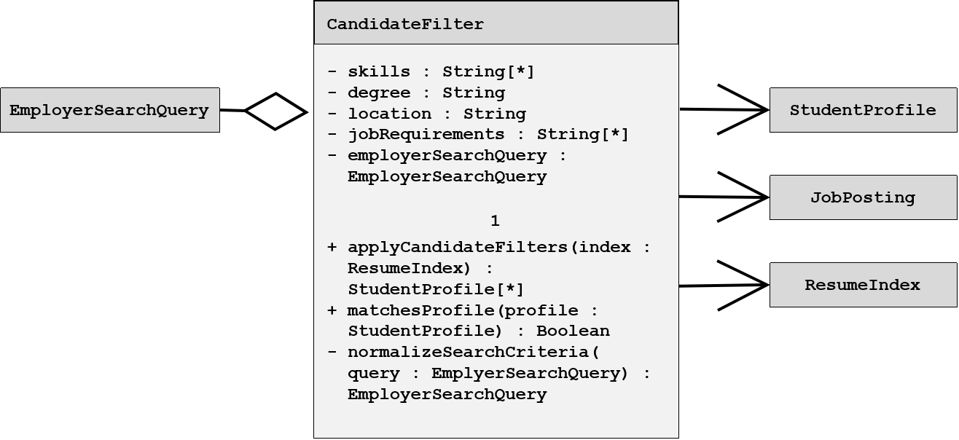

1.12.1 — USPS Address Validation Adapter Class Diagram
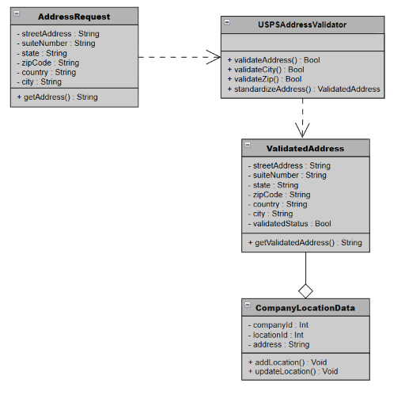

1.12.1 — Profile and Resume Engagement
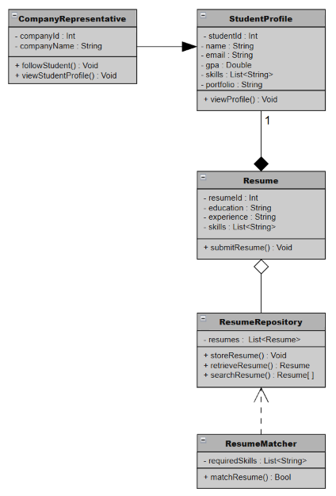

1.12.3 — Push Notification Gateway
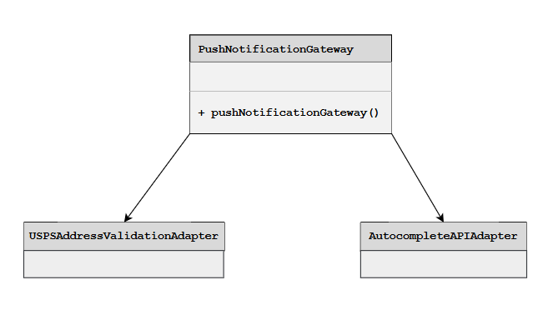

1.13.1 — CD JobPostingManager Class Diagram
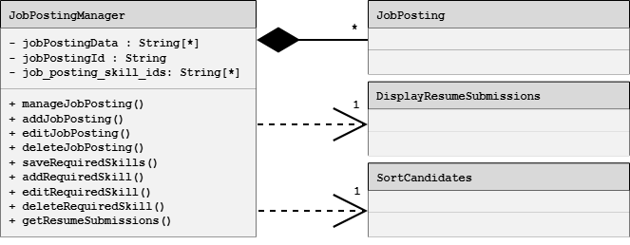

1.13.2 — CD CandidateSearchManager Class Diagram
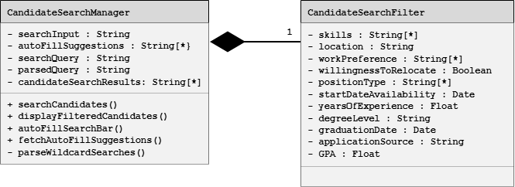

1.13.4 — Notification and News Feedback Analytics
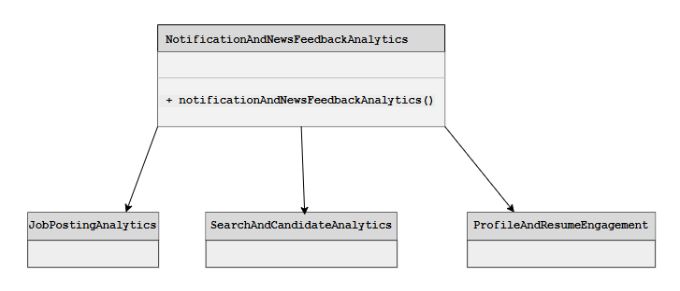

1.13.5-CD Performance Monitor Class Diagram
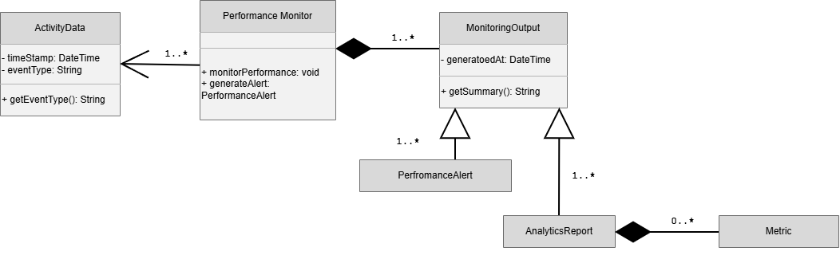

  - Database Design
This is where the database tables go.

  - File Format Specifications
This section describes any files the system stores or exchanges.

  - Network Protocol / API Message Specifications
Career Bound uses a RESTful API architecture over HTTPS.

All client-to-server and service-to-service communication is performed using HTTP request and response messages. API payloads are encoded using JSON.

Supported HTTP methods include:
- GET
- POST
- PUT
- DELETE

Authentication tokens are transmitted using HTTPS-secured headers. API responses are encoded using JSON message formats defined in the API Message Specifications that follow.

