ST_M3_Team3_News_Feed_Manager_1.10.8_v01

Component 1.10.8 — News Feed Manager
CareerBound — Team 3 | Author: Sergey Tsybenko (ST)

Overview
The News Feed Manager (1.10.8) manages the in-app news feed displayed to users. It receives feed events from the Notification Orchestrator (1.10.3), creates persisted feed entries, serves paginated feed item lists to the User App, and processes read/dismiss status updates from the user.

Data Flow Diagram — DFD Figure 1.10.8
Source file: ST_M3_Team3_News_Feed_Manager_1.10.8_DFD_v01.drawio

External Entities:
• Notification Orchestrator — sends feedEvent to the component
• User App — sends feedRequest and statusUpdate; receives feedItemList

Processes:
1.0 newsFeedManager() — main entry; routes incoming data to sub-processes
1.1 createFeedEntry() — persists newFeedEntry to D1
1.2 retrieveFeedItems() — reads feedItems from D1; returns feedItemList to User App
1.3 updateFeedStatus() — reads currentStatus from D1; writes updatedStatus to D1

Data Stores:
D1 Feed Item Repository — persisted feed entries per user
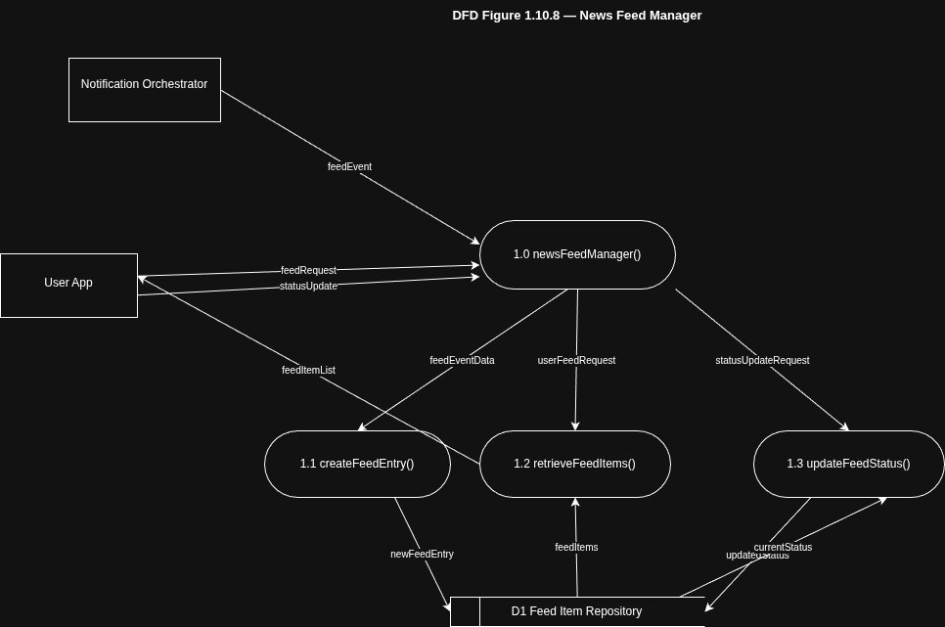

Structure Chart — SC Figure 1.10.8
Source file: ST_M3_Team3_News_Feed_Manager_1.10.8_StructureChart_v01.drawio

Module Hierarchy:
newsFeedManager()
├── createFeedEntry() [data couple: feedEventData]
├── retrieveFeedItems() [data couple: feedItems]
└── updateFeedStatus() [data couple: statusUpdate]
