ST_M3_Team3_Push_Delivery_Component_1.10.7_v01

Component 1.10.7 — Push Delivery Component
CareerBound — Team 3 | Author: Sergey Tsybenko (ST)

Overview
The Push Delivery Component (1.10.7) is responsible for routing and delivering formatted push notifications to user devices. It receives a notification payload from the Notification Orchestrator (1.10.3), resolves the appropriate push service (FCM for Android, APNs for iOS, or Web Push for browsers), transmits the notification, and records the delivery status.

Data Flow Diagram — DFD Figure 1.10.7
Source file: ST_M3_Team3_Push_Delivery_Component_1.10.7_DFD_v01.drawio

External Entities:
• Notification Orchestrator — sends notificationPayload to the component
• Push Service API (FCM / APNs / WebPush) — receives pushRequest; returns deliveryConfirmation

Processes:
1.0 pushDeliveryComponent() — main entry; dispatches to sub-processes
1.1 routeToService() — reads device token from D1; determines target push service
1.2 deliverPushNotification() — sends routedNotification to external push service
1.3 recordDeliveryStatus() — writes deliveryStatus to D2

Data Stores:
D1 Push Token Registry — stores device tokens per user
D2 Delivery Log — stores delivery status history
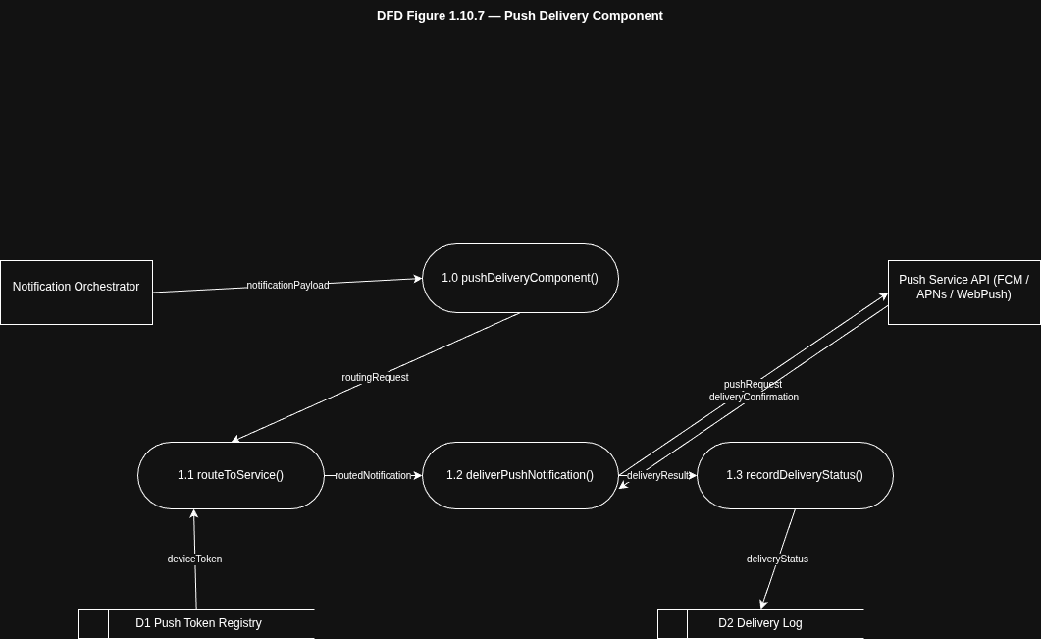

Structure Chart — SC Figure 1.10.7
Source file: ST_M3_Team3_Push_Delivery_Component_1.10.7_StructureChart_v01.drawio

Module Hierarchy:
pushDeliveryComponent()
├── routeToService() [data couple: deviceToken]
├── deliverPushNotification() [data couple: routedNotification]
└── recordDeliveryStatus() [data couple: deliveryStatus]
