1.4.1-ALG authenticateIfNeeded() Algorithm
Purpose:
Authenticate user requests if necessary and update RequestContext with the result.

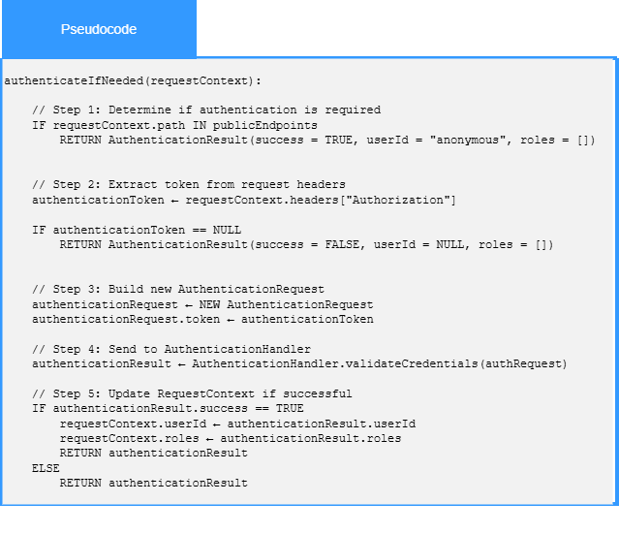
Local Data:
authenticationRequest : AuthenticationRequest
authenticationResult : AuthenticationRequest

1.4.2-ALG applyRoutingRules() Algorithm
Purpose:
Apply routing rules and definitions to a user request before it is routed to its intended destination.

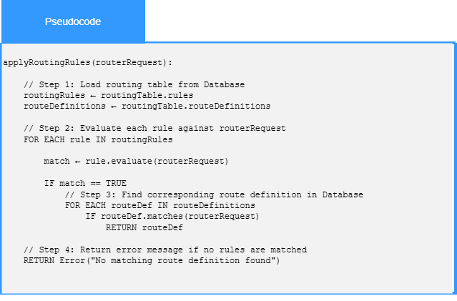
Local Data:
routingRules : List<RoutingRule>
routingDefinitions : List<RoutingDefinition>

1.4.3-ALG validateCredentials() Algorithm
Purpose:
Authenticate submitted user credentials against entries stored in the authentication database.

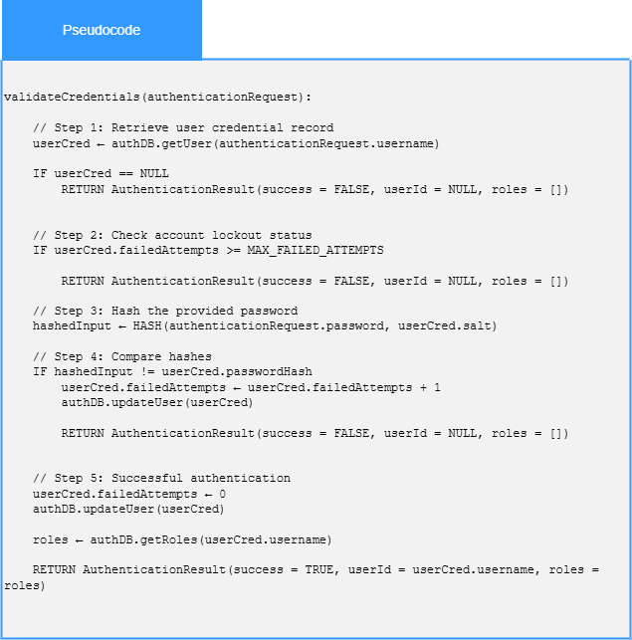
Local Data:
userCred : AuthenticationRequest
hashedInput : Hash<AuthenticationRequest>

