2.1 Student Dashboard
Desktop View
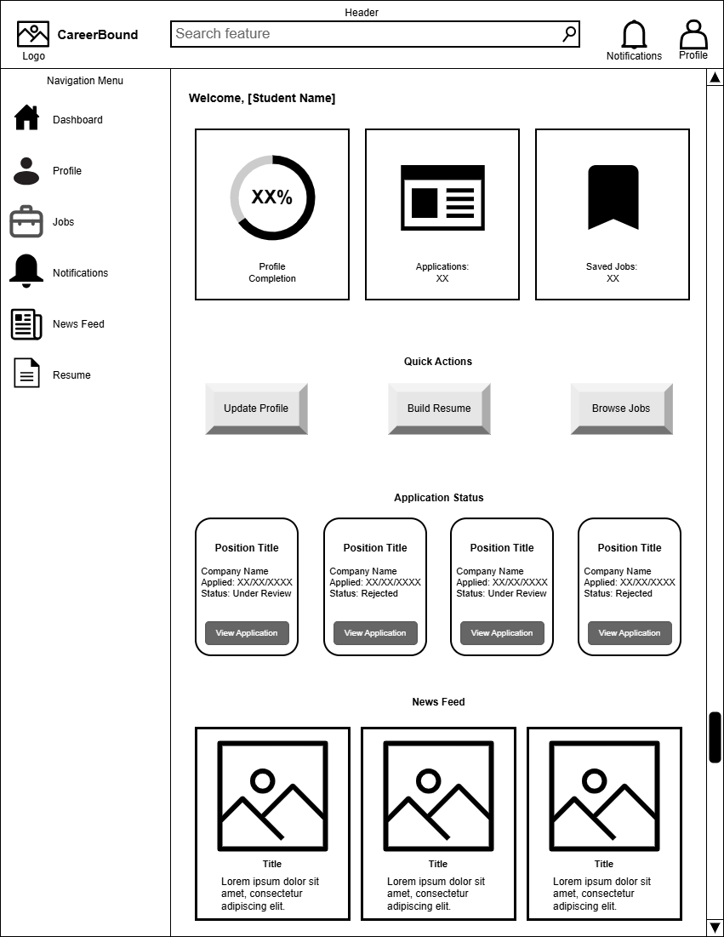
Mobile View
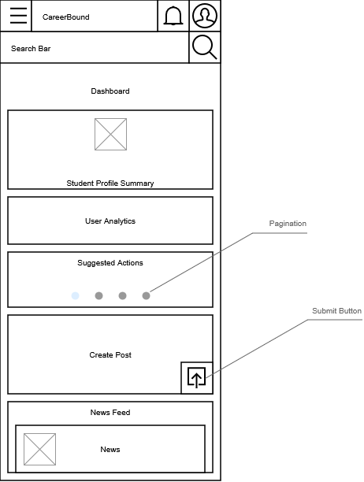

Design Information
Field | Description / Purpose
View Name & Number | 2.1 – Student Dashboard
Purpose / Design Concern | Provides students with a centralized dashboard for managing career development activities, tracking applications, accessing important tools, and viewing personalized updates within the CareerBound system.
Description | Displays a summarized student profile; profile progress (desktop) provides analytics such as profile views, profile completion, matching jobs, post impressions, application summaries; application tracking cards (desktop); recommends actions (mobile) to take such as improve profile, create resume, apply for a job; provides a shortcut to post creation; and displays social media-style news feed containing career-related updates and announcements.
Requirements | 3.1 Student User Profile, 3.2 Notifications, 3.3 Search Features, 3.4 News Feed, 3.5 Resume
Elements | Student Profile Summary Card (mobile)
 | Student User Analytics Card (mobile)
 | Suggested Actions Card (mobile)
 | Quick Create Post Card (mobile)
 | News feed List
 | News feed Cards
 | Submit Button
 | Navigation menu (Sidebar for desktop, toggle for mobile)
 | Header
 | Search Feature
 | Applications Summary Card (desktop)
 | Saved Jobs Summary Card (desktop)
 | Applications Status Cards (desktop)
 | Notifications toggle button
 | Profile Page hyperlink button
 | Pagination
Inputs | Student Post, Click, Scroll, Search queries, navigation selections, notification interactions, profile selections, quick action button selections, application card selections, news feed interactions
Outputs | Profile completion percentage, application status information, saved job totals, recommended actions, job application details, career updates, company announcements, News feed content, New Student Post, Navigation redirects, Navigate to next action card
Navigation / References | Authentication, Student Profile, Resume Builder, Job Search, Job Details, Notifications, News Feed, Saved Jobs, Job Applications
Viewpoint | UI Wireframe / Mockup (Desktop & Mobile)

