QA Defect Report — Team 5 / Milestone 2
Reviewer: QA | Date: 2026-05-21
4.2 News Feed Only
- Desktop header missing Logo in header row: Logo placeholder must appear in the top-left of the header row (alongside Search Bar and Profile/Menu), not in the left sidebar.
- Desktop left sidebar missing standard navigation: Left sidebar must list: Dashboard, Profile, Jobs, Resume, Notifications, News Feed. The Feed Filter items (Trending, Latest, Following, Career News, Events) may appear in the main content area but cannot replace the standard sidebar.
- Desktop wireframe contains color fills: Sidebar link text and Location label appear in color. Wireframe must be black and white only — convert all text and fills to black/white/grey.
- Mobile header non-conforming: Standard mobile header is: ☰ CareerBound. The submitted mobile header is missing the CareerBound app name, as well as the bell icon, and the profile icon in the header row(black and white not colored).
- "Scroll effect here": This might pass, Im not sure what editor will think about it, if you have time just re arrange the icons below eachother like it would be in mobile screen sizes.
- Mobile Side Bar: There should not be a side nav bar on mobile view, the search bar should be below the hamburger menu something like this:
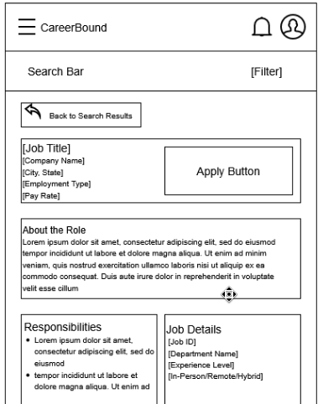
2.2 Student Profile Only
- Wireframes: The content is there, but does not quite match the style refrenced above with mobile. On desktop include the notification and profile icon along with the CareerBound text which is the logo for now.

