3.2 Candidate Search Screen

Desktop View
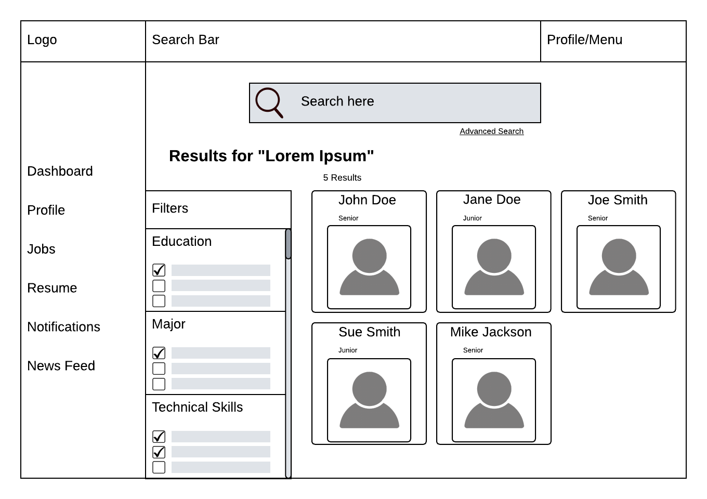

Mobile View
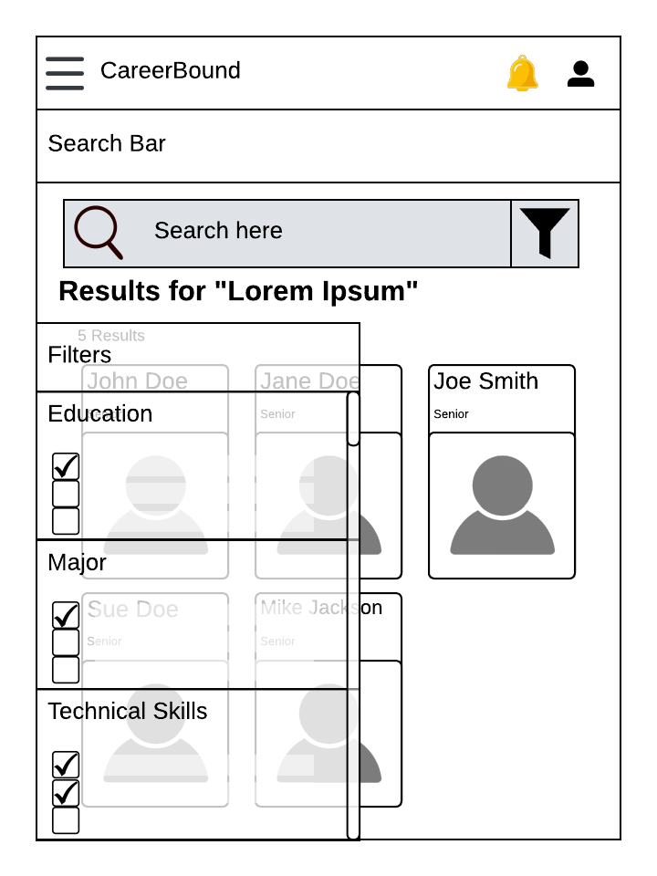

Design Information

Field | Description / Purpose
View Name & Number | 3.2 Candidate Search
Purpose / Design Concern | Allows company recruiters a way to find potential job seekers.
Description | A specialized search engine for the user to find candidates based on desired filters. Designed for both desktop users and mobile users.
Requirements | 2.3.1, 2.3.2, 2.3.4, 2.3.8
Elements | Search Bar
 | Site Navigation
 | Search Results Grid
 | Filter Categories
 | Filter Checkboxes
 | Search Result Cards
 | Advanced Search Toggle
 | Candidate Name
 | Candidate Profile Picture
 | Candidate Year
 | Filter Scroll Bar
Inputs | User will click on the search bar and enter a search item; user can choose a filter to toggle; the user can choose a candidate to open a new page.
Outputs | Candidate profile cards display candidate information; candidate profiles can be filtered.
Navigation / References
Viewpoint | UI Wireframe / Mockup (Desktop & Mobile)

