3.3 Job Posting Creation Screen

Desktop View
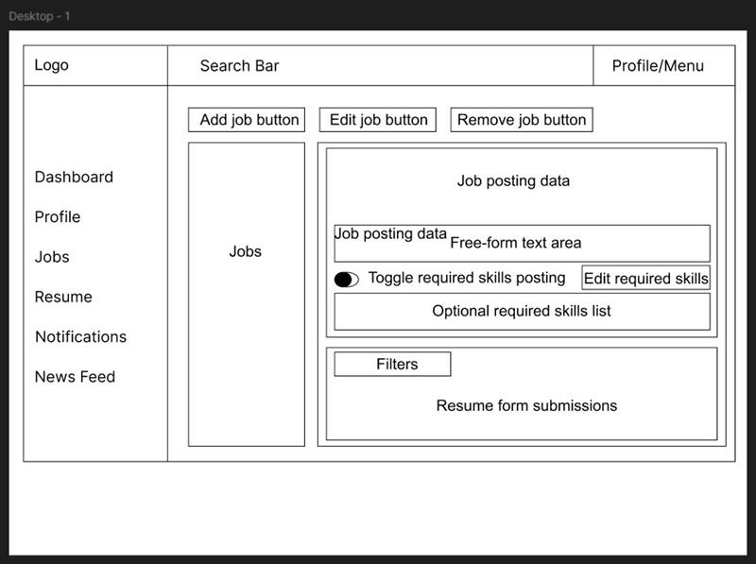

Mobile View
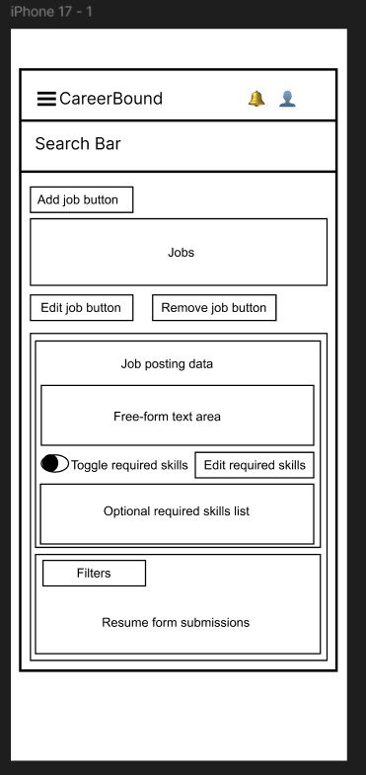

Design Information

Field | Description / Purpose
View Name & Number | 3.3 Job Posting
Purpose / Design Concern | Allows company users to create, edit, and remove job postings, manage required skills, and review resume submissions in a centralized Jobs view.
Description | Displays a company-facing Jobs screen with job posting controls, a job posting data panel, a free-form text area, a required skills toggle, an editable required-skills list, a filters section, and a resume form submissions area in both desktop and mobile wireframe layouts.
Requirements | SRS 2.5 Job Postings (2.5.1--2.5.7)
Elements | Header with logo, search bar, and profile/menu
 | Navigation menu with Dashboard, Profile, Jobs, Resume, Notifications, and News Feed
 | Add Job Button
 | Edit Job Button
 | Remove Job Button
 | Jobs Panel
 | Job Posting data section
 | Free-form text area
 | Required skills toggle
 | Edit Required Skills button
 | Optional required skills list
 | Filters section
 | Resume form submission panel
Inputs | Company user selects Add Job, Edit Job, or Remove Job; enters or edits job posting text; toggles required skills on or off; edits the required skills list; applies filters; reviews submitted resumes.
Outputs | Displayed job posting information, updated required skills settings, filtered submission results, and visible resume form submissions for review.
Navigation / References | Related views include Company Dashboard (3.1), Candidate Search (3.2)
Viewpoint | UI Wireframe / Mockup (Desktop & Mobile)

