Jason Morrissette

Student ID:

000534201

User Interface Design - D279

A.1 Planning for Future Functionality & Micro interactions

**Audience needs:**

The users of the Pet Paradigm website will need a website that will load quickly, is responsive for on-the-go use, and has tailored content for future and current pet owners. We also ensure that content is accessible with the use of a screen reader.

**Stakeholder needs:**

The Pet Paradigm Website's owners and stakeholders provide a clear, easy-to-use interface for potential users, including content related to the care of different types of pets. As well as providing several methods to get in touch with Pet Paradigm regarding adoption and pet care needs. We can implement best practices for SEO optimization by delivering High Quality content. And a Mobile First, Responsive design.

Proposed Micro Interactions: Here is a list of proposed microtransactions to improve site usability.

* Stylized Navigation. This will allow the audience to visually see what they are clicking on; this will be done with hover effects using CSS.
* Add social Media Icons to allow audience to follow Pet Paradigm social media accounts.
* Call to actions throughout the site to encourage the audience to get in touch with Pet Paradigm.
* Add Contact Us form that allows users to get in touch about Adoption Opportunities or Ask general questions about pet care.
* Added Text descriptions for images for accessibility.

A.2 Content for new page:

Chosen Persona: Fish Owners – “are interested in fresh and saltwater testing and maintenance based on the type of fish they house in their aquarium. These owners often view the site using handheld devices.”

Fish owners will come to the website looking for information regarding the different environments, and care instructions for their fish. The page will be tailored to display content about salt water and freshwater fish maintenance and care. The content will contain detailed information about safe chemical levels, how often to test water levels, and providing a call to action to talk to one of the company experts.

The page will be found in the main navigation menu by clicking on pets, the user will then be presented with a drop-down option that will allow them to navigate to the fish page. Or they will be able to navigate to the fish page by scrolling through the home page of the site by clicking on a stylized image link that links to the fish page.

A.3 Explanation of content removal or redevelopment:

**Audience needs:**

* Entire website will be redesigned to for with a responsive mobile first design, this will allow the user to use the website on a variety of devices including desktop, tablet and mobile.
* Navigation bar redesign: the navigation bar will have a clean look, that will have a hover feature to display a different color if the user hovers over a link in the nav bar. If the navigation element has child elements there will be a drop-down menu that appears.
* Company mission are displayed on the home page rather quickly to give the users a sense of values and the services offered

**Stakeholder needs:**

* Home page will be redesigned to feature the company mission statement This helps with SEO, increasing visibility and brand Recognition. There are also several call to actions to allow the user quick access to care information regarding the type of pet they own or are looking to own.
* Logo is displayed in Both Navigation and Footer elements.
* Search bar included in navigation bar.
* Removal of FAQ and replaced with an About Us Page. FAQ content is now displayed in the pet specific pages. The Companies values, mission statement, and other important information will be found in the about us page.

A.4 Visual Site Map

A.5 Meeting Stakeholder and Audience Needs

**Stakeholder Needs:**

* Both Audience and stakeholder require easy Navigation, content layout and quality, additional tools for users to contact the company via a contact us form.
* Stakeholders want to deliver quality, relevant information regarding pet healthcare and make this information easily accessible for the user.
* Stakeholders want better brand awareness and recognition via SEO. To meet this, need several keywords, a sitemap, proper page titles, H1 tags, Meta Descriptions and Alt tags will be used. An About us page providing detailed information about the company and their mission and values will also be included.
* Brand and Slogan will be in the header along nested within an H1 and H2 tag to help search crawlers index information.
* Search feature implemented to allow for the quick search of content on the page, or for future expansion while working with pet adoptions being able to provide users with a quick way to search for pets.

**Audience Needs:**

* Redesigning the entire website to make it more suer friendly, along with a new stylized navigation, making it easier for users to understand where they are on the website.
* Included accessibility features, such as live text to allow for screen readers to be able to read the screen. Alt tags on all images for screen reader use.
* Social Media icons added to allow users to follow company on social media for quick updates.
* Designed the site to be “mobile first” allowing the user to use the website on multiple screen resolutions for on the go use.
* Consultation area of website will contain information about the pet they are seeking care tips for.
* Contact us form will allow the Audience to submit an inquiry about a pet and get connected with a Pet Expert for a more humanized interaction.

A.6 Explain the primary and secondary navigational elements required to support information architecture.

Primary Navigation:

**Audience Needs:**

- The navigation bar is stylized to present a user-friendly site navigation option. Users can expect to navigate all relevant content in 1 or 2 clicks.

- Footer Section will display information how to get in touch via phone and address, will also feature a “contact us” button/link.

- Navigation elements will be highlighted while being hovered over to signify that the user is interacting with it.

**Stakeholder Needs:**

- The Navigation Bar Will Have Clear Labels, Home, Pets, About Us, Contact Us, and Search bar features.

- Logo Is displayed both on Navigation and in the footer and will return the user to the home page when clicked.

- Guarantees user expectations with a clear design with minimal distractions. This prevents the user from being overwhelmed and allows the user to navigate the site effectively.

Secondary Navigation.

**Audience Needs:**

* Users will gain success with specific details for pets by clicking the appropriate link on the navigation bar via Pets - > dropdown. Users can also navigate to the appropriate pet page via the home page.
* Users can access the contact form by clicking the “Contact Us” link in the navigation menu. click find Call to Action throughout the website to click a button to take them to the Contact Us form.

**Stakeholder Needs:**

- Breadcrumbs: Page Links will be underlined to allow the user to identify what page they’re on.

- Drop Down Menus adds increased user navigation of the website.

- Navigation elements provide an easy user navigation experience on the website with the use of a consistent and functional navigation bar.

- Logo Placement in the Navigation and Footer section will increase brand awareness.

B. Wire Frame

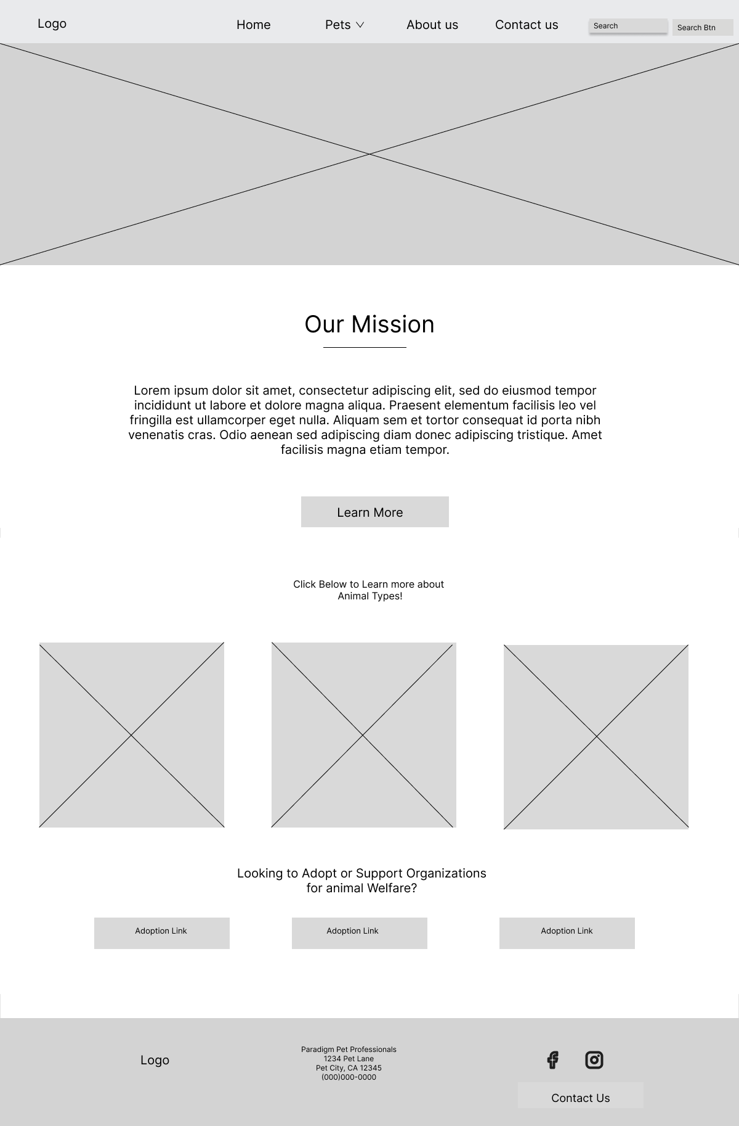

## C. Interactive Prototype

Link: https://jmorrissette1.github.io/WGU-D279-Taks-1/