Ex11sec4part6

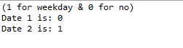

Ex11sec4part10

