Ex12sec1part3

In this example there is no effect on the program so it runs as intended. This is due to output overloads having no specified need to be const cause they don’t change like inputs do.

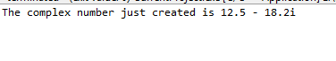

Ex12sec1part4

In this example, it will not compile, when using input overloads, they cannot use const declarations because if something changes to the input value then it’s considered illegal so the compiler flags it as an error.

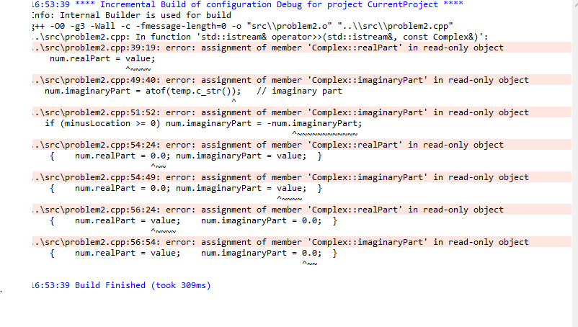

Ex12sec1part8

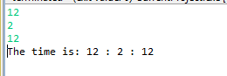

This example just shows the program entering hours mins and secs into the data members of the time class which use overloads for the I/O. The data stored in the object of class time is then printed.

Ex12sec2part3

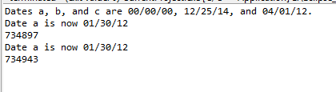

This example creates 3 dates for which 2 are initialized with values. Then the first 2 objects are assigned

new values using a long int constructor and are displayed using Gregorian form. After each is printed then their Julian counterpart is printed to shown.

Ex12sec2part5

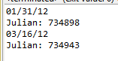

For this example, 2 dates were created using Gregorian format and converted to Julian format

Ex12sec3part2

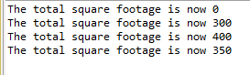

For the example problem above this program goes through these steps:

1. Shows current default values before values are changed in the classes data members
2. Constructs a room with values then displays the total area
3. Constructs a 2nd room with values then displays the total area
4. Changes the dimensions of the second room and redisplays the recalculated values

Ex12sec3part3

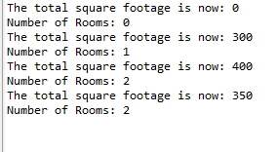

This shows a modified version of 12.3.2. In the program, another static variable is added to increment when the constructor is called. If it’s called twice 2 rooms exist.

Ex12sec4part1:

a.) Inheritance => The process of receiving data/or behavior about another entity through its an

b.) Base class => The starting point for which a child class is derived from

c.) Derived class => A child class inherits aspects of the base class/ parent class.

d.) Simple inheritance => One class feeds into another class to create a child class.

e.) Multiple inheritance => Two or more classes are used to derive a child class/ subclass.

f.) Class hierarchy => A family tree for classes that represents the ancestor of each class, for example a Zombie’s descents are stalker, bomber, speedy Gonzales, witch, tank and your average zombie.

Ex12sec4part5:

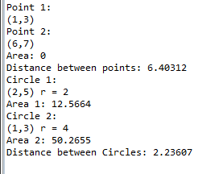

Created 2 objects for point class and circle class. Area for 2 points was 0 due to objects in the one-dimensional plane having no area but circles do have an area so that was calculated and outputted. Distance for both points and circles used their coordinates to find their distance from each other.

Ex12sec5part4and5:

4.) polymorphism = a call to a member function will cause a different function to be executed depending on the type of object that invokes the function

Ex: If I have a parent class shape and child classes circle and square, if I invoke circle to be my current shape via a pointer, the area function of circle will be called instead of squares.

5.)Virtual Functions and Pointers

Ex12Project1:

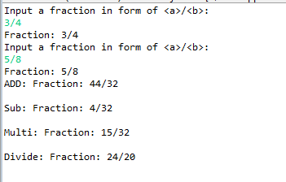

Testing ins and outs of fraction +-\*/ using input/output overloads

Ex12Project3:

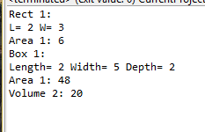

Created 2 objects, 1 rectangle and displayed its area and 1 box displaying its surface area and volume.