Ex13sec1part4:

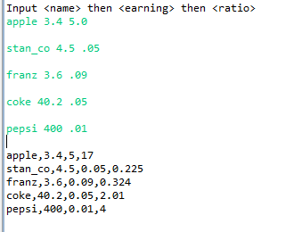

In this picture, 5 stocks were inputted by the user and each was printed with 1 extra element, the share price which is the earning \* ratio.

Ex13sec2part4:

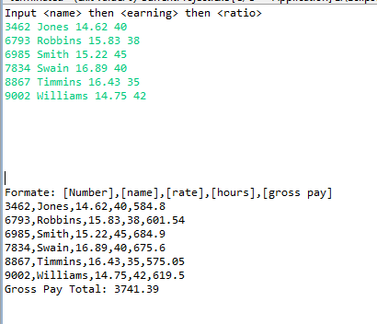

In this picture, 6 employees where inputted by the user and when the program printed each employee out it included how much they made total (hours\*rate) and then total of all employees gross was printed.

Ex13sec3part4

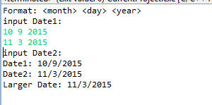

In this picture, 2 dates were entered by the user and each date was sent into a function (larger()) and they were both compared to see who’s larger. In this example date 2 was bigger. Ignore the “input date 2” error, this was due to a copy paste into console error, If you require clarification I will provide it.

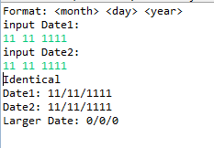

In this example, they are identical, so the program reflects that.