Ex13sec5part3

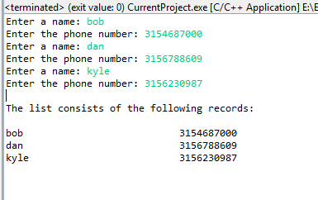

In this picture, 3 persons are entered in with data on the digits of their phone #.

Once the input process is complete, the record of persons is printed in the console window.