Section 1:

Nothing to show

Section 2:

Hand Written

Section 3:

Handwritten calculations on another page

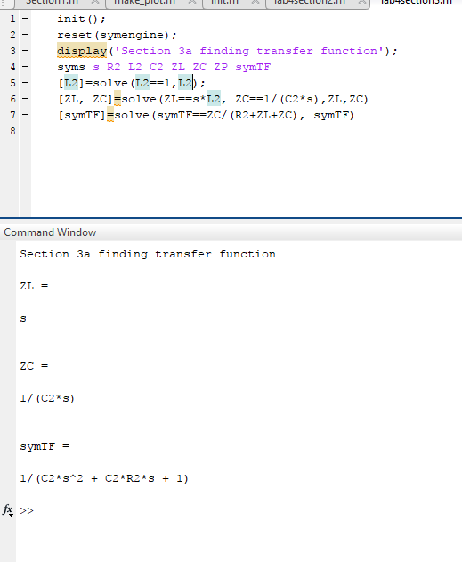

Section 4:

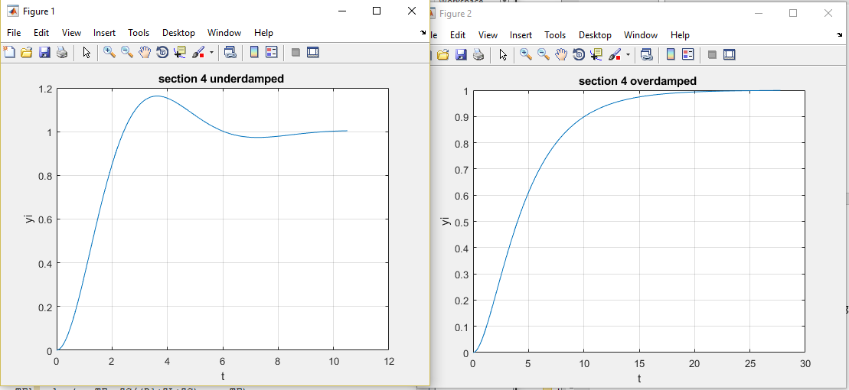Handwritten calculations on another page