Section1:

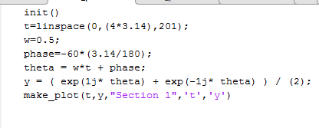

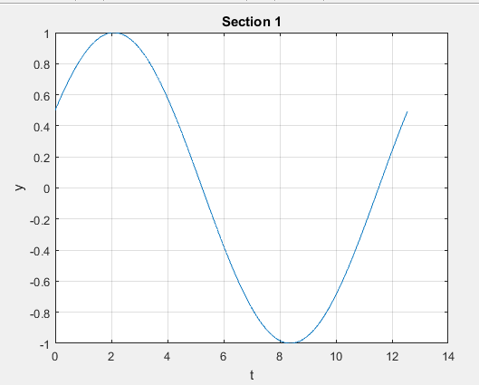

Section2:

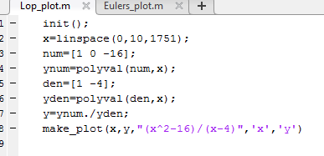

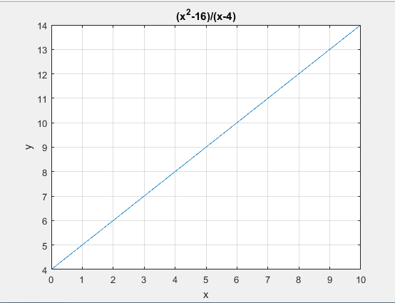

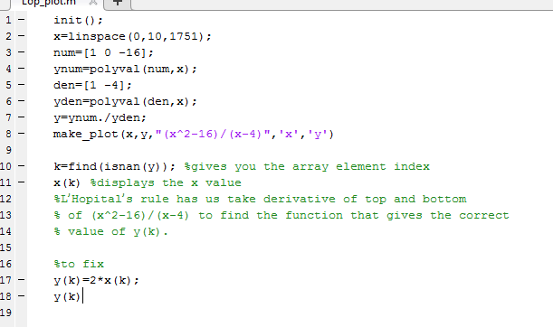

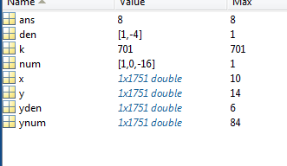

Section 3:

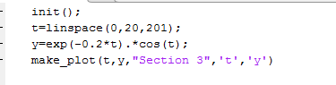

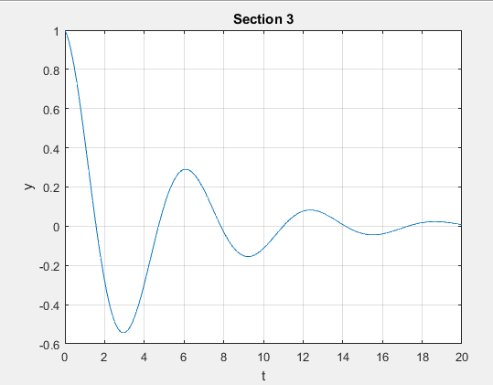

Section 4:

* 1. x(t)=4e-2tcos(5t+60)

* 1. x(t)=3cos(2t+12)

* 1. x(t)=e-tcos(t)



$\vec{X}= \left|X\right|e^{jθ}$ $s= σ+{ jω}$

$\vec{X}= \left|1\right|e^{-j}=1∠0$ $s= -1+j$

Joseph Rondinelli EET-321

Signals and Transforms LAB 1

Section: Friday 10:10 to 12:10