On the origin of citations

Jason Matthew Torres

September 15, 2015

# Load the data

## Read delim

counts_raw <- read.delim("data/counts-raw.txt.gz")  
counts_norm<- read.delim("data/counts-norm.txt.gz")

# Data exploration

What's the distribution of authors in all articles of our data set?

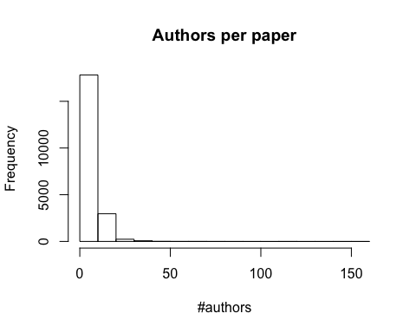

What's the distribution of **Facebook** shares per article of our data set?

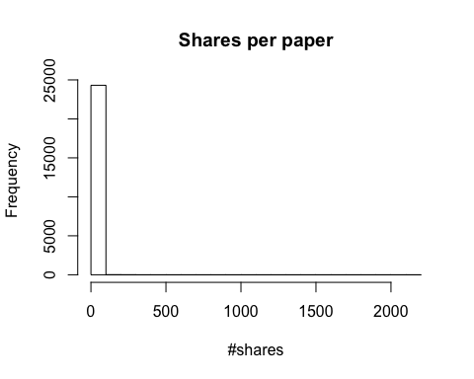

The average number of Facebook shares per paper in the data set is 0.6524187