**Assignment #2**

CS4379: Parallel and Concurrent Programming

CS5379: Parallel Processing

Spring 2020

***Due Date: 2/18, 12:30 p.m., please submit a soft copy via Blackboard (preferred) or a hard copy in class. Late submissions are accepted till 2/25, 12:30 p.m., with 10% penalty each day. No submissions accepted after 2/25, 12:30 p.m.***

***Please name your submission file starting as “LastName_FirstName_HW2”.***

**Q1.** What is the condition that two statements can execute in parallel?

Their order of execution must not matter.

**Q2.** Please give an example of output dependence and give a corresponding solution to remove the dependence.

Example:

A=1;

B=A;

Solution:

A=1;

B=1;

**Q3.** Consider the search tree shown in the following figure, in which the dark node represents the solution.

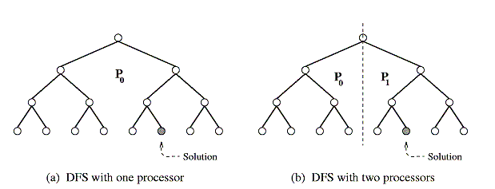

* + 1. If a sequential search of the tree is performed using the standard depth-first search (DFS) algorithm, how much time does it take to find the solution if traversing each arc of the tree takes one unit of time? Note: DFS begins by expanding the initial node and generating its successors. In each subsequent step, DFS expands one of the most recently generated nodes. If this node has no successors (or cannot lead to any solutions), then DFS backtracks and expands a different node.

26 units of time.

* + 1. Assume that the tree is partitioned between two processing elements that are assigned to do the search job, as shown in figure b. If both processing elements perform a DFS on their respective halves of the tree, how much time does it take for the solution to be found? What is the speedup? Is it a linear speedup, or a super-linear speedup, or a sub-linear speedup?

11 units of time, the speedup is linear

**Q4. (a)** Please derive the fixed-time scaled speedup formula (Gustafson’s Law). Assume a sequential ratio α of a problem cannot be parallelized, and the number of processing elements (processors) is *p*. **(b)** Please give two scenarios why we want to have scaled computing.

**Q5.** Please list three reasons why scaled computing is desired.

**Q6.** (a) Please study the following paper (can be found from the Blackboard) and write a 500 – 1,000 words of the summary of the paper. The summary should include: **1) problem statement**: what problem is studied in the paper; **2) solution**: what is the solution proposed in the paper; and **3) contribution**: what is the impact of the solution.

* M. Hill and M. Marty, “Amdahl’s Law in the Multicore Era”, IEEE Computer 2008

(b) Discussions. What new performance model (speedup/scalability) can you think of, or what new problems/ideas/hypothesis can you think of in terms of modeling and evaluating parallel computers (such as the paper you have just studied), or does the paper you have studied have any issues/shortcomings/limitations and how can you address them? Please provide a 300 – 600 words of discussions.

If this is the first time for you to read a scientific paper, please consider reading the below two papers regarding “how to read a paper” first.

1. “How to Read a Paper”, By S. Keshav, University of Waterloo. <http://ccr.sigcomm.org/online/files/p83-keshavA.pdf>
2. “How to Read a Research Paper”, By M. Mitzenmacher, Harvard University. <http://www.eecs.harvard.edu/~michaelm/postscripts/ReadPaper.pdf>

THE END.