February 25, 2015

Rhea Lauzon // Jeff Bayntun // Michael Chimick // Julian Brandrick

4O

Data Communications (Comp 4985)

Android GPS – Testing Document

Contents

Test Cases 2

Figures 3

Figure 1 – No Server 3

Figure 2- no Clients/Data 4

Figure 3 – Multiple Clients Website 5

Figure 4 – Server Receiving from Multiple Clients 6

## Test Cases

|  |  |  |  |  |
| --- | --- | --- | --- | --- |
| Test Number | Test | Tool/Application | Expected Outcome | Pass/Fail |
| 1 | Website running with no server | Application | Website displays the data previously collected | Pass |
| 2 | Website running with no clients | Application | Website displays the empty table/map | Pass |
| 3 | Website running with multiple clients | Application | Website refreshes and displays the new data as received | Pass |
| 4 | Server receiving data from multiple clients | Application | Server adds the data appropriately to XML | Pass |
| 5 | Client sending data over Wi-Fi | Application | Data is received by the server | Pass |
| 6 | Client sending data over 3G | Application | Data is received by the server | Pass |
| 7 | Client sending to no server | Application | No data is received and app does not crash | Pass |
| 8 | Address reverse lookup accurate | Application | Rough address is correct or very close | Pass |

## Figures

### Figure 1 – No Server

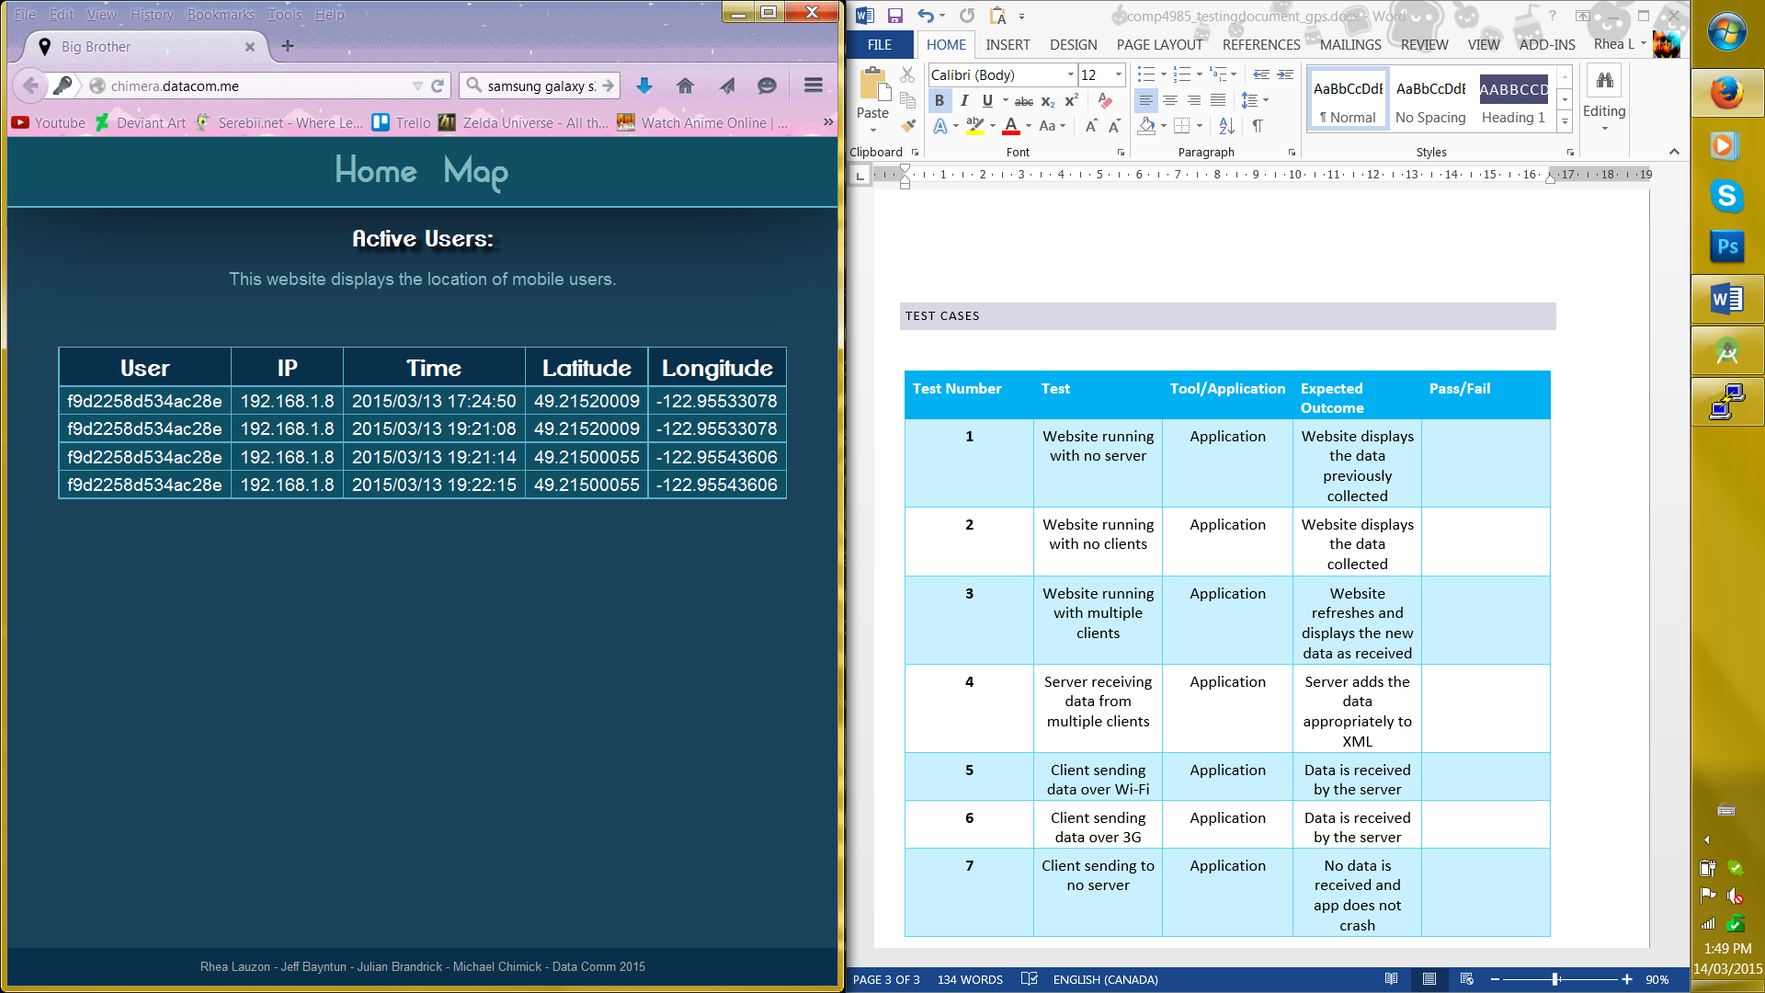

### Figure 2- no Clients/Data

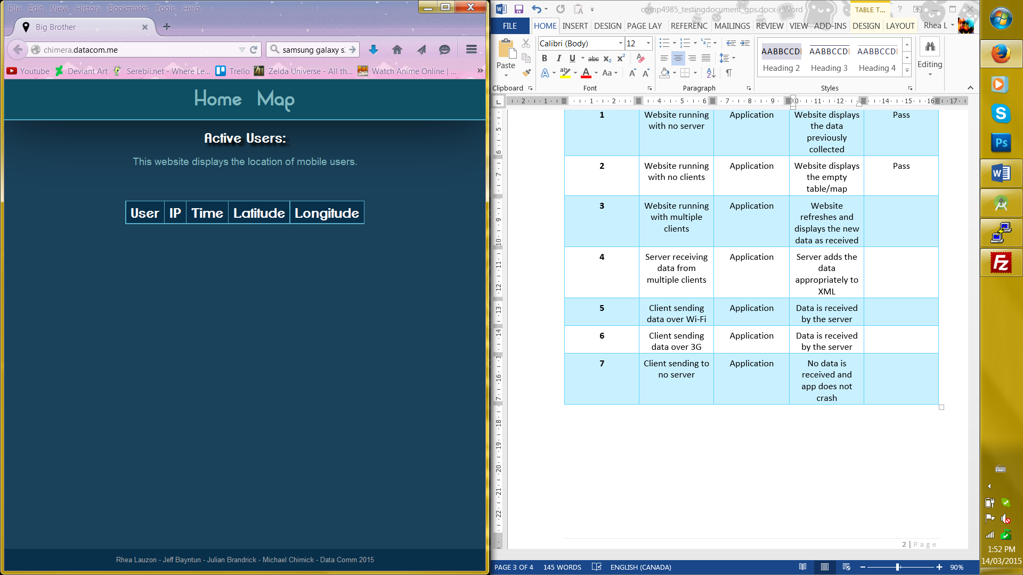

### Figure 3 – Multiple Clients Website

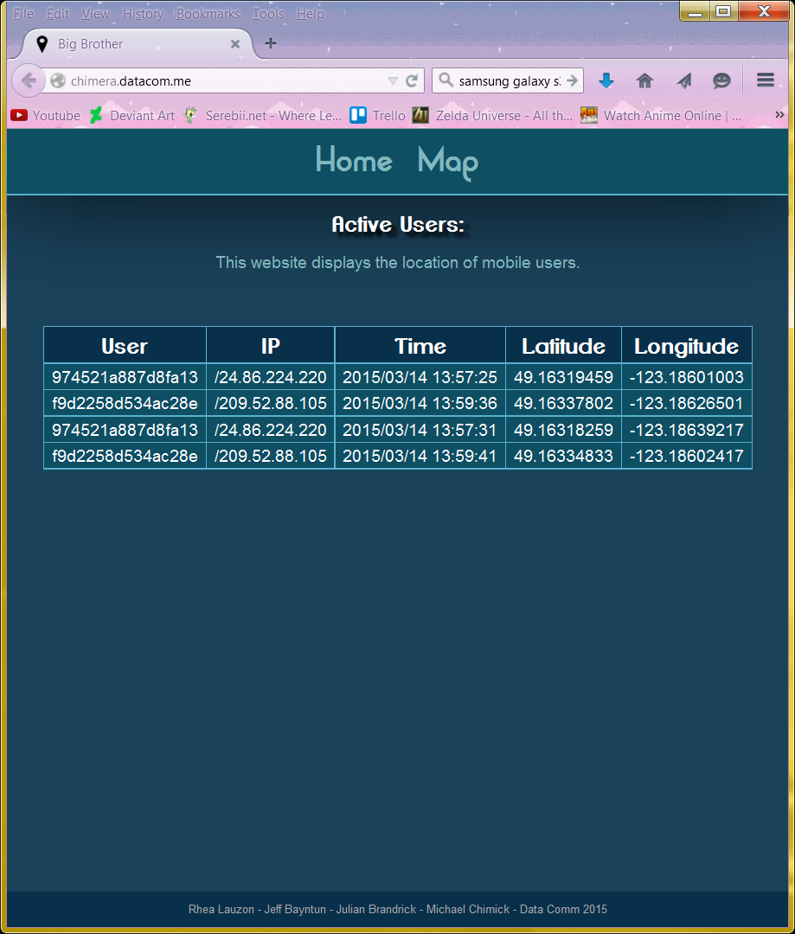

### Figure 4 – Server Receiving from Multiple Clients

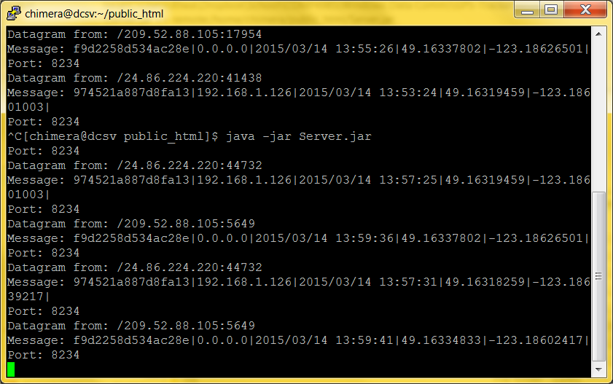

### Figure 5 – Server Receiving From Client over Wifi

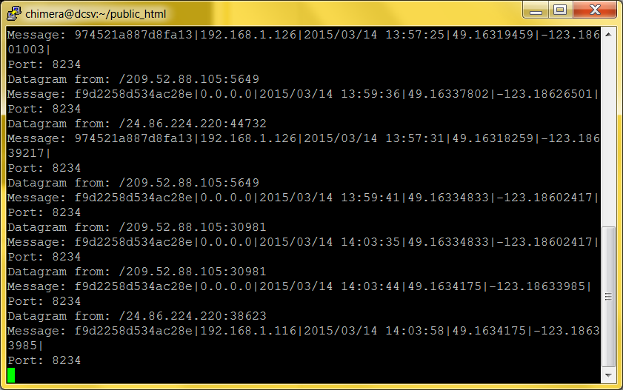

### Figure 6 – Server Receiving From Client Over 3G



### Figure 7 – Client Sending To No Server

App does not crash but you are unable to detect the connection considering it is UDP.

### Figure 8 – ADdress Lookup

