March 14, 2015

Rhea Lauzon // Jeff Bayntun // Michael Chimick // Julian Brandrick

4O

Data Communications (Comp 4985)

Android GPS – USER GUIDE

Contents

Overview 2

The Android Application (Client) 2

The Website 3

Home Page 4

Map Page 5

The Server 6

Conclusion 7

# Overview

This is the user guide for the Android GPS project, nicknamed “Big Brother”. The project is composed of multiple elements that work together and so this guide details how to use them.

This project contains 3 independent aspects:

* The website
* The Server
* The Android Application (Client)

In order for this project to work, the three must be used together to be functional.

# The Android Application (Client)

The GPS client is an Android Application that uses location services mixed with UDP sockets in order to send data to a Java server. The data includes various information about the client such as location, mac address, time of transfer, etc.

In order to use the client application, the APK must be installed on the android device you wish to use. Once it is installed, it is able to launch and you will be greeted with the following screen:

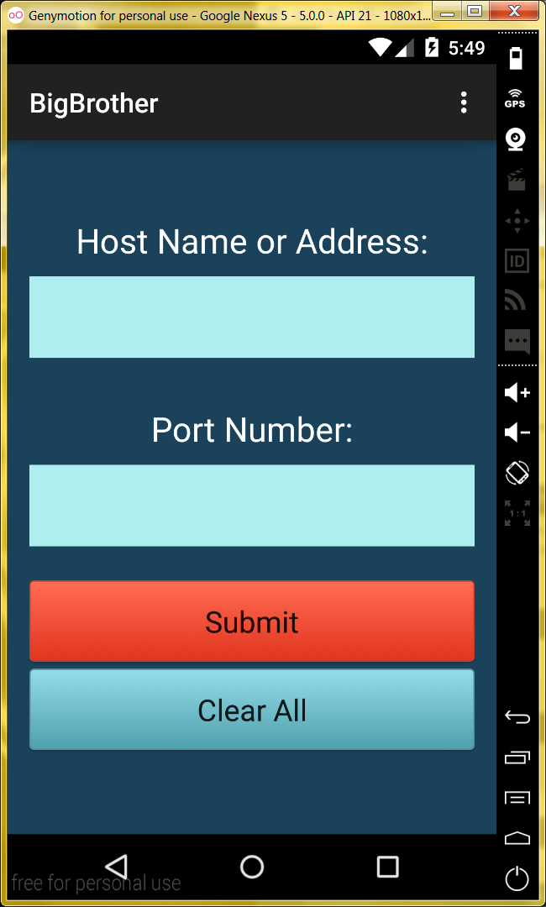

On this main screen you are prompted for information to communicate with the server. Once the information is filled in the ***“Submit”*** will become blue and usable. Upon clicking submit you will be taken to the *Tracking Central* which looks as follows:

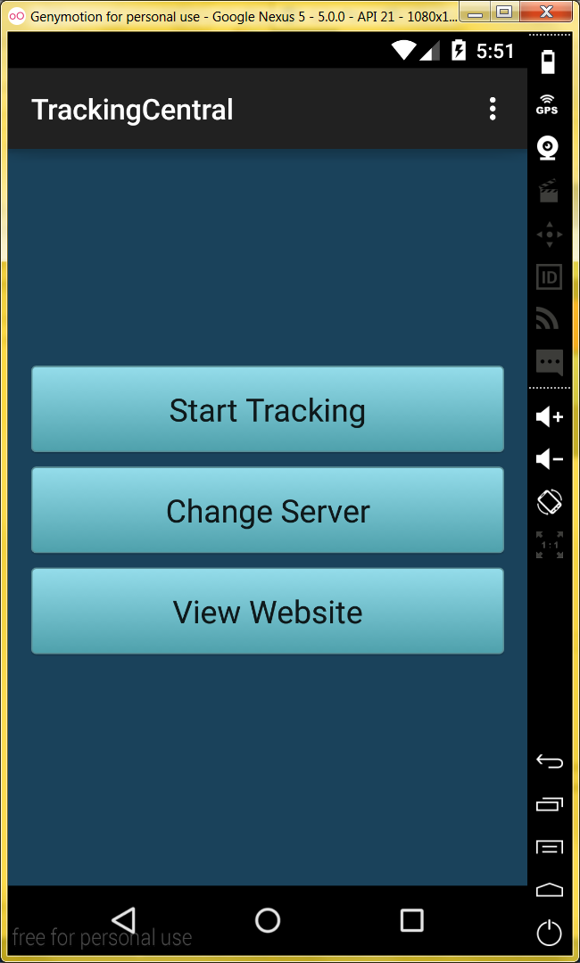

Here you can start the tracking which sends packets off to the Server when the location has changed. Once you begin the tracking, you can stop it using the same button.

If you wish to change the server you are connected to, the “Change Server” button will bring you back to the home screen.

Viewing the website brings you to chimera.datacom.me; the location our website is hosted on.

# The Website

In order to the display the information, the project includes a two page website which loads data from an XML file and displays them in two way. In order to display the data, the data must be placed in an xml file called “data.xml” and must be placed next to the index file. The website should be placed in the directory that your apache web server points to.

The website has two pages; the ***Home*** and ***Map****.* Each page shows the data in two different forms.

## Home Page

On the home screen, the data is presented in a simple table such as the following:

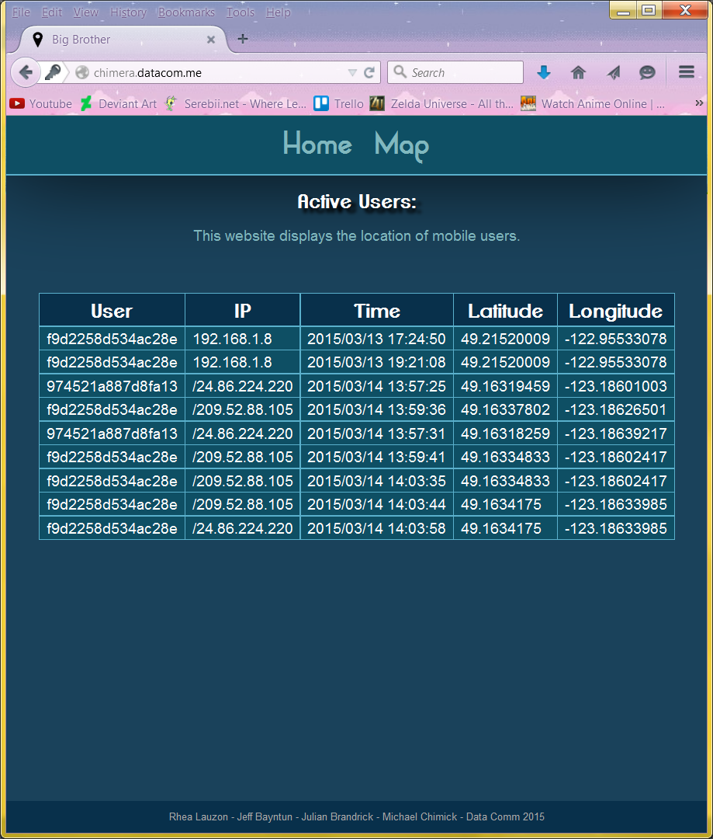

This table is updated by backend javascript every 5 seconds. It polls the data file for changes and remakes the table accordingly.

## Map Page

On the map screen, data is displayed on a styled google map with markers placed at each location. The pins are updated by backend javascript every 5 seconds like the home page.

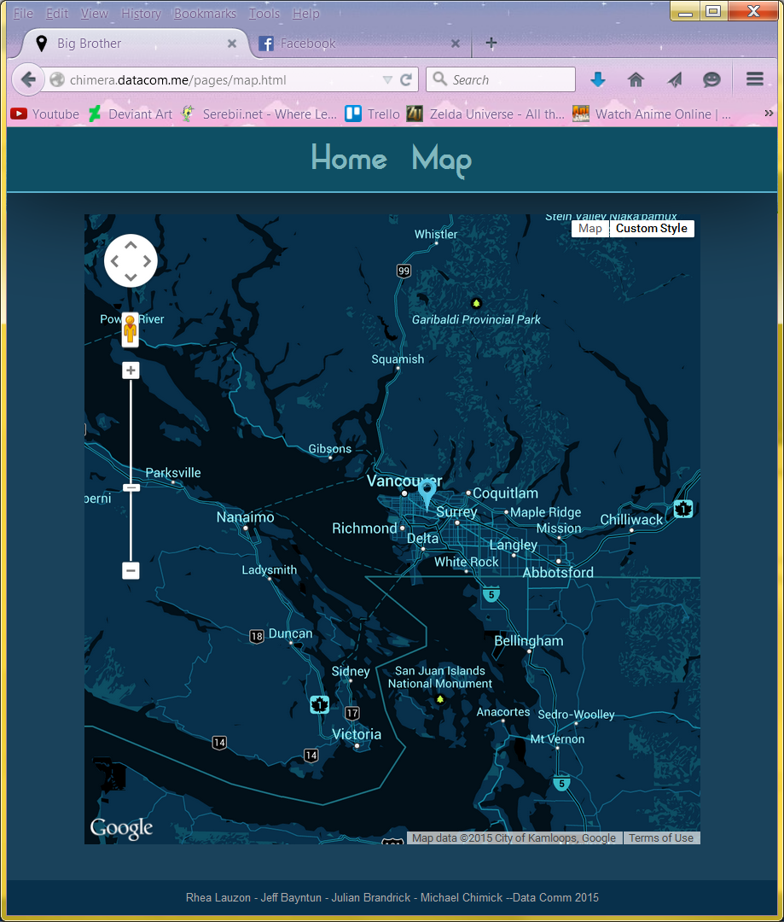

Upon clicking on a marker, the google map will be zoomed and centered on it. When a marker is hovered over, the information is displayed about that specific location.

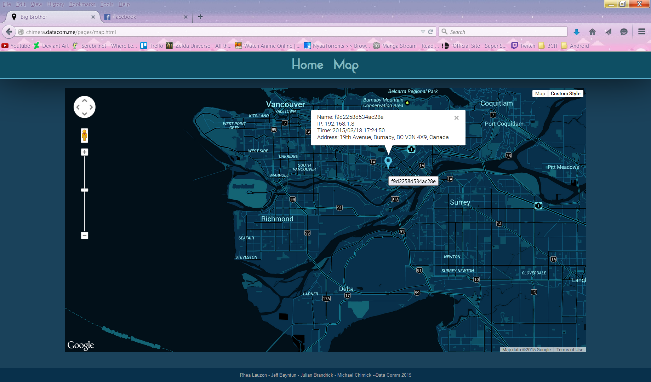

# The Server

The Server of the GPS project is a Java application. It accepts data from multiple connecting clients in a specified string pattern and formats them and saves it into an XML file so the website can load and parse the XML for displaying purposes.

To use the server, the Java must be compiled and run in the root directory or where the index.html is placed.

Once it is compiled it is run as following:

java Server [optional-port]

The server will begin waiting for UDP data until is closed vial CTRL+C. If you are running the server remotely make sure your port is being port forwarded otherwise clients will not be able to connect. If no port is specified the application runs on port 8234.

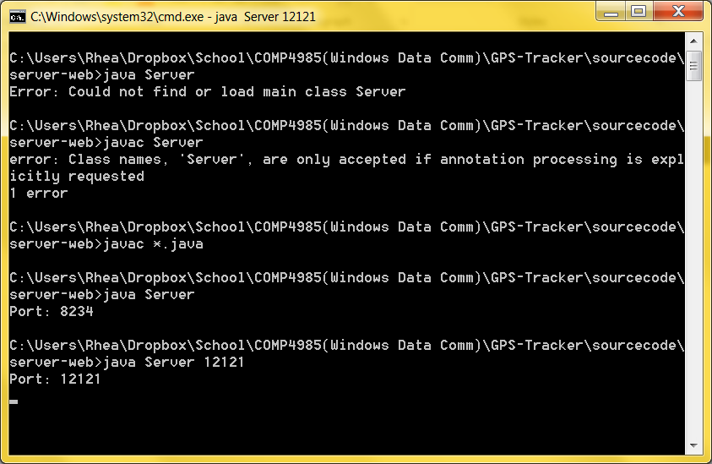

There is also a jar file that can be run if you do not have java installed. It is run as follows:

Java –jar Server.jar

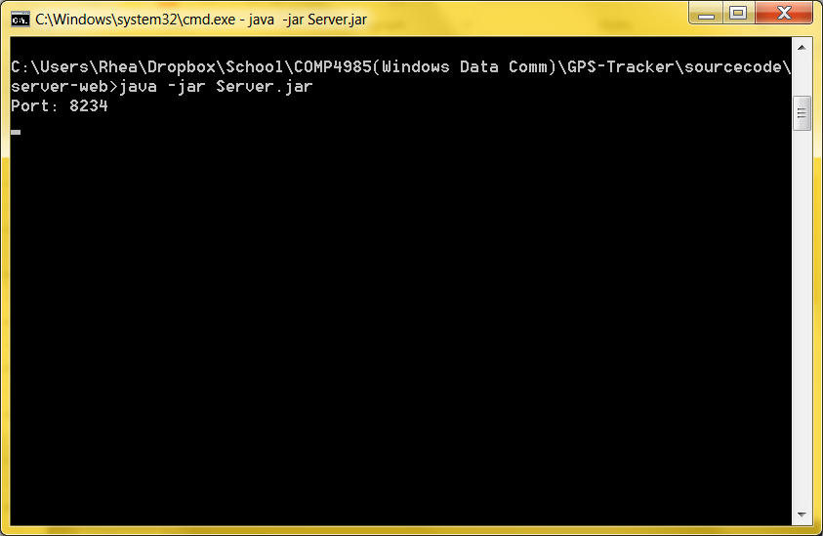

# Conclusion

With the 3 pieces running and properly set up as mentioned above, the project should work together in harmony. The website will show the data that the server is collecting via the connected android application clients!