Requirement Analysis
Data Flow Diagram
Date | 19 July 2026
Team ID | FinWise AI Team
Project Name | FinWise AI: Intelligent Loan Eligibility, Credit Analysis & Financial Advisory Platform
Maximum Marks | 2 Marks

Data Flow Diagram Template:
A Data Flow Diagram (DFD) shows how data moves through a system — between external entities, processes, and data stores — without describing control logic or timing. It helps the team validate that every input, computation, and output in the solution has a clear, traceable data path.
Reference: https://www.lucidchart.com/pages/data-flow-diagram
Level 0 – Context Diagram
The context diagram shows FinWise AI as a single process exchanging data with the User, the Claude AI service, and Google Sheets.
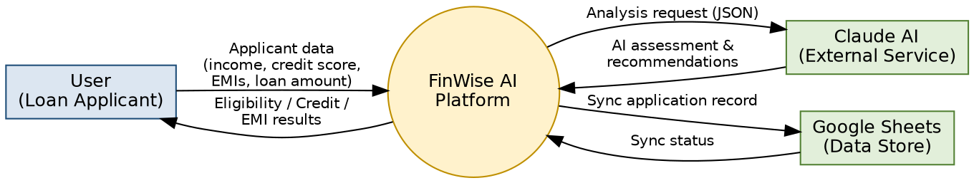
Level 1 – Detailed Data Flow
Level 1 decomposes the system into three processes: (1.0) Validate & Compute handles DTI/risk/EMI logic and caches the result; (2.0) Claude AI Reasoning generates the narrative assessment; (3.0) Sync to Google Sheets persists cached records for transparency.
