Requirement Analysis
Solution Architecture
Date | 19 July 2026
Team ID | FinWise AI Team
Project Name | FinWise AI: Intelligent Loan Eligibility, Credit Analysis & Financial Advisory Platform
Maximum Marks | 2 Marks

Solution Architecture Template:
The Solution Architecture shows how the major components of the system are organized into layers and how they interact — giving the engineering team a blueprint to build against and reviewers a clear picture of the technical design.
Reference: https://www.lucidchart.com/pages/software-architecture-diagram
FinWise AI follows a three-layer architecture:
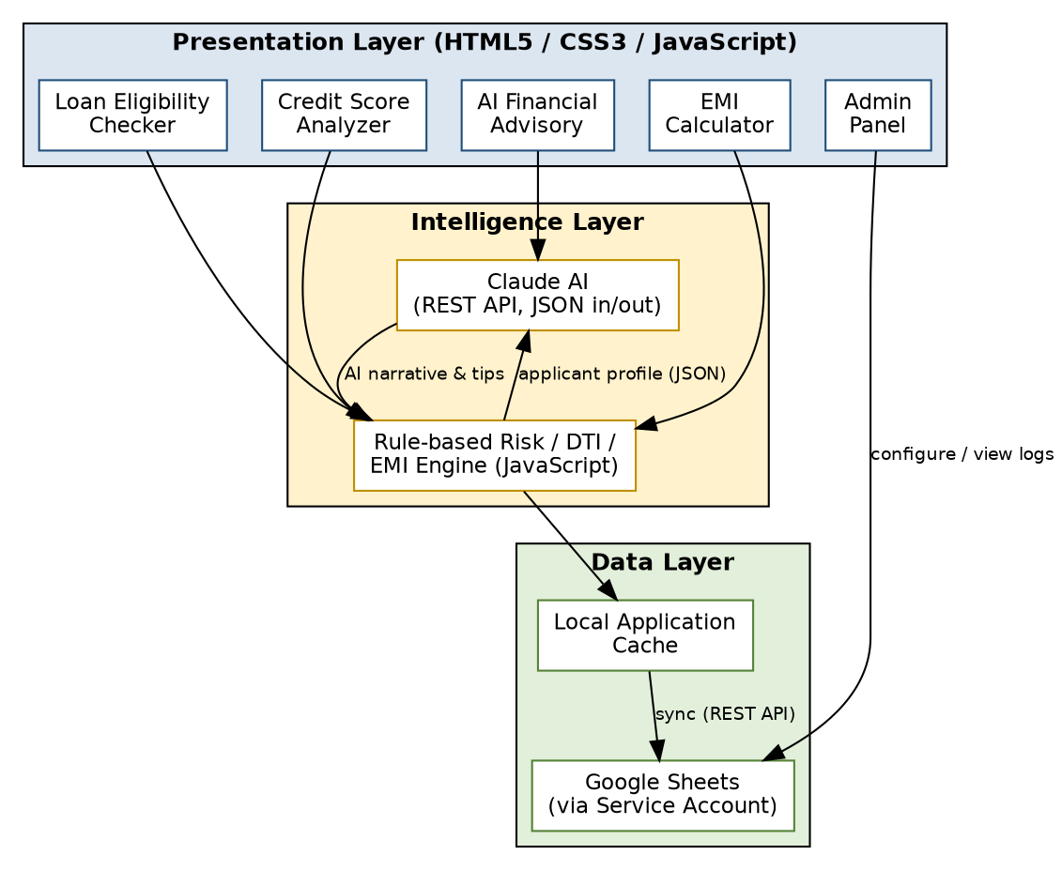
Layer | Responsibility
Presentation Layer | HTML5/CSS3/JavaScript single-page interface with dedicated modules for Loan Eligibility Checker, Credit Score Analyzer, EMI Calculator, AI Financial Advisory, and Admin Panel.
Intelligence Layer | A rule-based Risk/DTI/EMI engine performs the core financial computations; Claude AI receives applicant parameters via REST calls and returns JSON-structured risk assessments, credit tips, and advisory responses.
Data Layer | A local application cache captures every submission; on sync, records are written to a Google Sheet via a service-account-authenticated REST call, keeping a durable, auditable history.

