**Water Management System Using IoT**

*---------------------------------------------------------------------------------***-------------------------------------------------------------------------------*

Water is a vital resource for life, and its management is a key issue nowadays. Information and com- munications technology systems for water control are currently facing interoperability problems due to the lack of support of standardization in monitory and control equipment. This problem affects var- ious processes in water management, such as water consumption, distribution, system identification and equipment maintenance. OPC UA (Object Linking and Embedding for Process Control Unified Architecture) is a platform independent service-oriented architecture for the control of processes in the logistic and manufacturing sectors. Based on this standard we propose a smart water management model combining Internet of Things technologies with business processes coordination and decision support systems. We provide an architecture for sub-system interaction and a detailed description of the physical scenario in which we will test our implementation, allowing specific vendor equipment to be manageable and interoperable in the specific context of water management processes.

**1. INTRODUCTION**

Water is one of the most important basic needs for all living beings, but unfortunately, a huge amount of water is being wasted because of uncontrolled use and exploitation of water resource. Kerala averages rainfall of [3,000 mm a year. The](http://www.prokerala.com/kerala/climate.htm) general impression was that among all the states in India, Kerala had ample drinking water, but it's not the case. There are 1,164 problem villages without the adequate supply of drinking water. Even though Kerala has 44 rivers spanning its lush green landscape. Together, they contribute an annual discharge of 72, 00 million cubic meters of water which is unused to the Arabian Sea. One of the main reasons for the shortage is poor management of water.

Overflowing water tanks in residence, schools, colleges, Municipal overhead tanks, Hospitals etc. can contribute to the massive amount of water wastage. If we can control this we can save large amounts of water.

Conventional water tanks can neither monitor nor control the water level in the tank. As of now, the water level has to be manually checked and refilled according to the requirements.

So in this paper, we solve all the above mention problems with automatic water level detection and refilling of water storage system with the help of Internet of Things (IoT). Water management is defined as the activity of planning, developing, distributing and managing the op- timum use of water resources. This impacts on several key matters [1] of human lives, such as food production, water consumption, sewage treatment, irrigation, purification, energy generation and utiliza- tion, etc.

The lack of water ICT (Information and communications technology) standards prevents an effective interoperability, and increases the cost and the maintenance of new products. Nowadays there are many small and local producers of specific solutions in a weak and fragmented market. The almost no adop- tion of complex and interoperable systems jeopardizes the control and monitoring of water distribution networks, preventing also their evolution and necessary improvements, as an adoption of IoT (Internet of Things) paradigm.

In addition, current ICT systems for water management are proprietary and packed as independent products, support all management levels from the product development to the communication with man- agement systems. System maintenance and sustainability depends on the company providing it. This

entails the SMEs (Small and medium-sized enterprises) that develop water management ICT systems and tools may not enter the water market even with powerful solutions without considering a complete system that jeopardize their strengths.

**2. BASIC CONCEPTS**

Presented here is a Water Management System using IoT. Water level indication, automatic water pump on/off, etc are carried out by this project.

Laser sensor used in this project is VL53LOX for precise level indication. The issue of water scarcity is becoming more prevalent. The IoT enabled water management solutions like this use sensor to collect data and share data to the cloud.

**2.1 Transmitter section**

The transmitter section consists of an Arduino, HC12 transmitter, laser sensor, and NodeMcu. In the automatic water level detection and refilling of water storage system, the sensor used is Laser sensor which is a replacement of ultrasonic sensor because of its accuracy and small size. The Laser sensor is used to detect the water level. The Laser sensor is placed above the tank which continuously monitors the water level in real time. This information will be updated in the cloud and user can analyze the amount of water. These sensor values are sending to water pump via the HC12 transmitter to turn on/off the pump.

The sensor values are also forwarded to NodeMCU which is used for the IoT purpose. NodeMCU connects the system to a cloud storage. Here we use Adafruit cloud platform. The platform is designed in such a way that it will show the instantaneous value of current status of water. The

water level measured by sensors is sent continuously to NodeMcu and forwarded to Adafruit cloud, it gives a graphical representation of water level from which we can analyze our water usage.

**2.2 Receiver section**

The receiver section consists of Arduino Uno, relay, HC12 receiver and a motor. According to the value received from the sensors about water level to HC 12 receiver, the motor will automatically turn on/off to pump the water to the tank.

Sl.No Conditions of water level Motor status

Our project is mainly classified into different phases. They are:

1. Water level detection using laser sensor.

2. The laser sensor value transmission through HC12

Transceiver.

3. Based on laser sensor value motor is controlled using relay module.

4. Upload sensor value to cloud platform called Adafruit via ESP8266.

**3.1 Microcontroller- Arduino**

1 When the water level is below a minimum level

2 When the water level is above the maximum level

3 When the water level is in between maximum and minimum level

ON OFF

It can be controlled by a user using

Adafruit cloud platform

The Arduino Uno is used as the microcontroller in this system. It has 14 digital input/output pins, from which we are using 2 pins for connecting sensors- Laser sensor, HC12Transceiver, a USB connection, a power jack and a reset button is also present. We are using NodeMcu which contains a Wi-Fi module ESP8266 for giving the system an Internet-based approach.

**3.2 Laser sensor**

In the automatic water level detection and refilling of water storage system, the sensor used is Laser sensor

Depending on the water levels, as described above, the status of the motor will be automatically controlled. If the water level is in between maximum and minimum level set, then the user can control the status of the motor from the Adafruit cloud platform. Buttons ON and OFF have been provided for the same.

**3. PROPOSED SYSTEM**

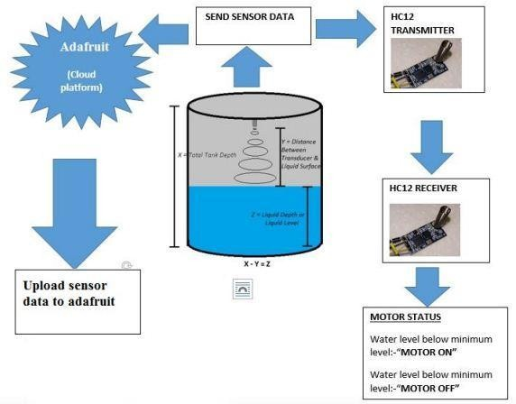

**Fig -2**: Block diagram.

which is a replacement of ultrasonic sensor because of its

accuracy and small in size. The sensor is placed on top of the tank facing downwards. The Laser sensor is used to detect the water level.

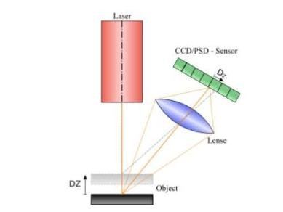

**Fig -2**: Laser sensor working.

**Features:**

The Laser sensor offers several features that help to achieve these goals. The special features include:

● Fully integrated miniature module

● 940nm Laser VCSEL

● VCSEL driver

● Ranging sensor with advanced embedded microcontroller

● 4.4 x 2.4 x 1.0mm.

● Fast, accurate distance ranging

● Measures absolute range up to 2m.

● High infrared light levels is ambient for operation

● Advanced embedded optical cross

● Talk compensation to simplify cover glass selection.

**3.3 HC 12 Transceiver**

The HC-12 is a half-duplex wireless serial port communication module with 100 channels with working frequency range of this transceiver is 433.4-473 MHz and multiple channels can be set with the stepping of 400 KHz with transmitting range of up to 1KM.

The MCU inside the module doesn't need to be programmed separately by user. The transparent transmission mode is only responsible for receiving and sending data in the serial port. So, it is easy to use.

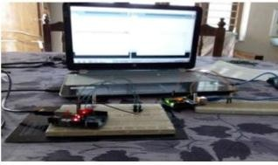

**Fig -3**: Long range communication via HC12 Transceiver.

**3.4 Relay**

220v alternating current (AC) powers the AC devices. Arduino cannot control such high voltage and amperes. For that purpose a relay is used. Arduino controls this relay to control AC devices according to the program. So we are using a relay as a switch to control high power devices (here water pump). Here we use the relay for controlling motor. According to the water level, the receiver section gets a command to turn ON/OFF the water pump. As water pump works on AC, this AC has to be controlled to automatically turn ON/OFF according to our system requirements. So, we use a relay in order to achieve this need.

**4. IoT IMPLEMENTATION**

.

Microcontroller (Arduino Uno) communicates with NodeMCU via SPI communication. We configured NodeMCU as master and microcontroller as a slave. The sensor values received to the slave will send it to the master. NodeMCU has an ESP8266 Wi-Fi module which helps in connecting to a local router. This router then connects to internet and uploads these sensor values to the Adafruit cloud platform. We can access this cloud platform from anywhere in this world simply by logging into our Adafruit account.

**5. RESULT**

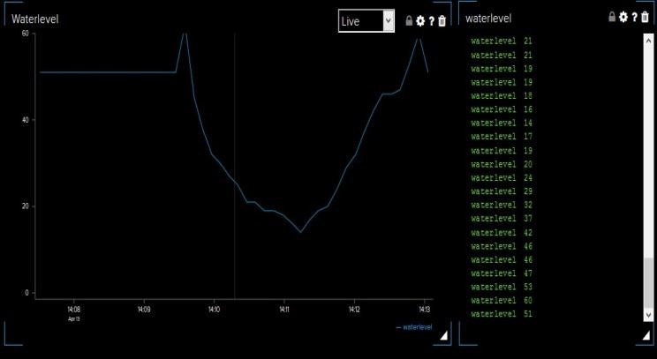

**Fig-5**: Graph obtained from Adafruit cloud platform

We implemented our proposed system in one of the residential water tanks, where the motor pump is 500 meters away. The water level is analyzed and maintained automatically with the help of our project. The graph obtained in the Adafruit cloud platform is shown above.

**COMPONENTS REQUIRED**

1. Arduino Board

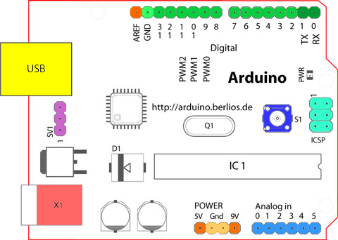

* Analog Reference pin (orange)
* Digital Ground (light green)
* Digital Pins 2-13 (green)
* Digital Pins 0-1/Serial In/Out - TX/RX (dark green) - *These pins cannot be used for digital i/o (*digitalRead*and*digitalWrite*) if you are also using serial communication (e.g.*Serial.begin*)*.
* Reset Button - S1 (dark blue)
* In-circuit Serial Programmer (blue-green)
* Analog In Pins 0-5 (light blue)
* Power and Ground Pins (power: orange, grounds: light orange)
* External Power Supply In (9-12VDC) - X1 (pink)
* Toggles External Power and USB Power (place jumper on two pins closest to desired supply) - SV1 (purple)
* USB (used for uploading sketches to the board and for serial communication between the board and the computer; can be used to power the board) (yellow)

1. **ULTRASONIC SENSOR**

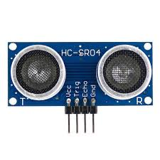

An ultrasonic sensor is an instrument that measures the distance to an object using ultrasonic sound waves.

An ultrasonic sensor uses a transducer to send and receive ultrasonic pulses that relay back information about an object’s proximity.

High-frequency sound waves reflect from boundaries to produce distinct echo patterns.

## How Ultrasonic Sensors Work?

Ultrasonic sensors work by sending out a sound wave at a frequency above the range of human hearing.  The transducer of the sensor acts as a microphone to receive and send the ultrasonic sound. Our [ultrasonic sensors](https://www.maxbotix.com/SelectionGuide/Selection-Guide.htm), like many others, use a single transducer to send a pulse and to receive the echo.  The sensor determines the distance to a target by measuring time lapses between the sending and receiving of the ultrasonic pulse.

1. **BREAD BOARD**

Breadboards are one of the most fundamental pieces when learning how to build circuits. In this tutorial, you will learn a little bit about what breadboards are, why they are called breadboards, and how to use one. Once you are done you should have a basic understanding of how breadboards work and be able to build a basic circuit on a breadboard.

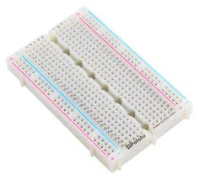

A breadboard is a solderless device for temporary prototype with electronics and test circuit designs. Most electronic components in electronic circuits can be interconnected by inserting their leads or terminals into the holes and then making connections through wires where appropriate. The breadboard has strips of metal underneath the board and connect the holes on the top of the board. The metal strips are laid out as shown below. Note that the top and bottom rows of holes are connected horizontally and split in the middle while the remaining holes are connected vertically.

1. RESISTORR

A **resistor** is a [passive](https://en.wikipedia.org/wiki/Passivity_(engineering)) [two-terminal](https://en.wikipedia.org/wiki/Terminal_(electronics)) [electrical component](https://en.wikipedia.org/wiki/Electronic_component) that implements [electrical resistance](https://en.wikipedia.org/wiki/Electrical_resistance) as a circuit element. In electronic circuits, resistors are used to reduce current flow, adjust signal levels, to divide voltages, [bias](https://en.wikipedia.org/wiki/Biasing) active elements, and terminate [transmission lines](https://en.wikipedia.org/wiki/Transmission_line), among other uses. High-power resistors that can dissipate many [watts](https://en.wikipedia.org/wiki/Watt) of electrical power as heat, may be used as part of motor controls, in power distribution systems, or as test loads for [generators](https://en.wikipedia.org/wiki/Electric_generator). Fixed resistors have resistances that only change slightly with temperature, time or operating voltage. Variable resistors can be used to adjust circuit elements (such as a volume control or a lamp dimmer), or as sensing devices for heat, light, humidity, force, or chemical activity.

Resistors are common elements of [electrical networks](https://en.wikipedia.org/wiki/Electrical_network) and [electronic circuits](https://en.wikipedia.org/wiki/Electronic_circuit) and are ubiquitous in [electronic equipment](https://en.wikipedia.org/wiki/Electronics). Practical resistors as discrete components can be composed of various compounds and forms. Resistors are also implemented within [integrated circuits](https://en.wikipedia.org/wiki/Integrated_circuits).

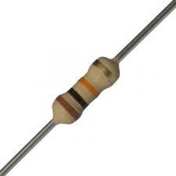

1. **LED**

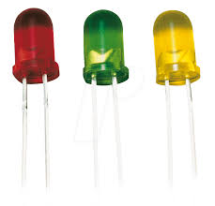

A **light-emitting diode** (**LED**) is a [semiconductor](https://en.wikipedia.org/wiki/Semiconductor) [light source](https://en.wikipedia.org/wiki/Light_source) that emits light when [current](https://en.wikipedia.org/wiki/Electric_current) flows through it. [Electrons](https://en.wikipedia.org/wiki/Electron) in the semiconductor recombine with [electron holes](https://en.wikipedia.org/wiki/Electron_hole), releasing energy in the form of [photons](https://en.wikipedia.org/wiki/Photon). The color of the light (corresponding to the energy of the photons) is determined by the energy required for electrons to cross the [band gap](https://en.wikipedia.org/wiki/Band_gap) of the semiconductor.[[5]](https://en.wikipedia.org/wiki/Light-emitting_diode#cite_note-5) White light is obtained by using multiple semiconductors or a layer of light-emitting phosphor on the semiconductor device.[[6]](https://en.wikipedia.org/wiki/Light-emitting_diode#cite_note-6)

Appearing as practical electronic components in 1962, the earliest LEDs emitted low-intensity infrared light.[[7]](https://en.wikipedia.org/wiki/Light-emitting_diode#cite_note-FirstPracticalLED-7) Infrared LEDs are used in [remote-control](https://en.wikipedia.org/wiki/Remote-control) circuits, such as those used with a wide variety of consumer electronics. The first visible-light LEDs were of low intensity and limited to red. Modern LEDs are available across the [visible](https://en.wikipedia.org/wiki/Visible_spectrum), [ultraviolet](https://en.wikipedia.org/wiki/Ultraviolet), and [infrared](https://en.wikipedia.org/wiki/Infrared) wavelengths, with high light output.

Early LEDs were often used as indicator lamps, replacing small incandescent bulbs, and in [seven-segment displays](https://en.wikipedia.org/wiki/Seven-segment_display). Recent developments have produced high-output white light LEDs suitable for room and outdoor area lighting. LEDs have led to new displays and sensors, while their high switching rates are useful in advanced communications technology

6)JUMPER WIRES

Jumper wires are simply wires that have connector pins at each end, allowing them to be used to connect two points to each other without soldering. Jumper wires are typically used with [breadboards](https://blog.sparkfuneducation.com/what-is-a-breadboard) and other prototyping tools in order to make it easy to change a circuit as needed. Fairly simple. In fact, it doesn’t get much more basic than jumper wires.

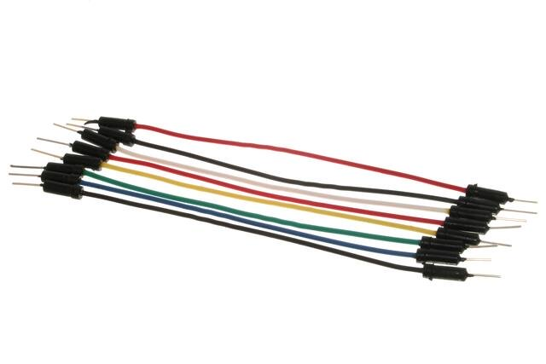

Photo Credit: [oomlout](https://commons.wikimedia.org/wiki/File:A_few_Jumper_Wires.jpg)

Though jumper wires come in a variety of colors, the colors don’t actually mean anything. This means that a red jumper wire is technically the same as a black one. But the colors can be used to your advantage in order to differentiate between types of connections, such as ground or power.

1. **H-BRIDGE**

An **H bridge** is an [electronic circuit](https://en.wikipedia.org/wiki/Electronic_circuit) that switches the polarity of a voltage applied to a load. These circuits are often used in [robotics](https://en.wikipedia.org/wiki/Robotics) and other applications to allow DC motors to run forwards or backwards.[[1]](https://en.wikipedia.org/wiki/H_bridge#cite_note-williams_stamp-1)

Most DC-to-AC converters ([power inverters](https://en.wikipedia.org/wiki/Power_inverter)), most [AC/AC converters](https://en.wikipedia.org/wiki/AC/AC_converter), the DC-to-DC [push–pull converter](https://en.wikipedia.org/wiki/Push%E2%80%93pull_converter), most [motor controllers](https://en.wikipedia.org/wiki/Motor_controller), and many other kinds of [power electronics](https://en.wikipedia.org/wiki/Power_electronics) use H bridges. In particular, a [bipolar stepper motor](https://en.wikipedia.org/wiki/Stepper_motor#Bipolar_motor) is almost invariably driven by a motor controller containing two H bridges.

The term *H bridge* is derived from the typical graphical representation of such a circuit. An H bridge is built with four switches (solid-state or mechanical). When the switches S1 and S4 (according to the first figure) are closed (and S2 and S3 are open) a positive voltage will be applied across the motor. By opening S1 and S4 switches and closing S2 and S3 switches, this voltage is reversed, allowing reverse operation of the motor.

Using the nomenclature above, the switches S1 and S2 should never be closed at the same time, as this would cause a short circuit on the input voltage source. The same applies to the switches S3 and S4. This condition is known as shoot-through.

Water management scenario description

Scenarios for water management consider natural environments, cities and rural regions. Systems de- ployed in these scenarios are controlled by applications that access to subsystems. It is necessary to consider various conditions, ranging from the number of subsystems to be deployed to the business mod- els that must be considered for subsystem control, exploitation services and information exchange. This Section describes the deployment scenario we have defined for validating the MEGA model, that is de- veloped in Aula Dei, an experimental station in Zaragoza, Spain. We also enumerate the list of functions that we are going to test in this station.

The Aula Dei experimental station is focused in the water management cycle, specifically in irri- gation. A complete irrigation system is modeled, from the water intake to the distribution to the latest elements (i.e. hydrants). One irrigation system works by gravity and the other one works by artificial pressure, to cover all the situations that can be presented in a real setting. From the point of view of the automation and control elements, the execution of various procedures is allowed in the same hydraulic element. Specifically, the installation is divided into:

1. Upper network with two water tanks at different levels and a lifting station with two pumps in parallel and level control function.

2. Pressure network with automatic pumping station, three pumps in parallel. Two of them with variable speed drive. The network is composed by 20 hydrants, grouped into 4 lines that return water to the tank, closing the cycle.

3. Control center with the necessary computer equipment for proper control and installation, as well as for conducting some tests over the management applications.

4. Channel with regulation elements for downstream water, regulation gate for upstream water, mixed regulation gate and flow controlled regulation gate.

• Water regulation flow tests, checking the optimal functioning of various control algorithms, both in pumping stations operating in conjunction with tanks and in regulation control points for hydrants.

• Tests on management applications, checking the correct operation and interoperability with the installed systems. Multiple computers are installed in order to perform parallel tests to check equipment coordination and detect interferences.

We enumerate a list of functions that we are going to test in the described scenario:

• Loading and configuration of the elements of the physical model. Mapping of hydraulic entities and association to subsystem controllers. Monitoring and listing of the elements of the physical model registered in the Coordination layer.

• Collection and consolidation of data from subsystems. Subsystem coordination and data integra- tion, i.e. integration of hydrants’ aggregated data for branch surveillance.

• Execution of control recipes in virtual entities, assigning to associated subsystem the correspond- ing actions. Creation of normalized history registries for virtual entities.

• Reception, interpretation, allocation and delivery of elements from the process model. Monitoring and listing of these elements.

• Storage, publication, and distribution of the hydraulic topology to applications that require it.

Storage and publication of sensor data (weather conditions, humidity, temperature) collected by legacy subsystems, adapted to the MEGA model.

**6. CONCLUSIONS**

Water management impacts on several key matters of human lives and several scenarios, such as cities, natural areas, agriculture, etc. Some works focus in the lack of ICT services and tools for water manage- ment, which would enable information reuse (goal of the PSI Directive [20]), easier fulfillment of policy regulations and resource monitoring.

In this paper we presented the MEGA initiative for defining a reference architecture for water man- agement based on integrating IoT capabilities to achieve a scalable and feasible industrial system. We define the management exploitation layer, coordination layer, subsystems layer and administration layer and the interfaces that enable layer interaction. We also consider the physical model, which defines the physical elements executing water management processes in a hierarchical way, and also, the process model, which organizes the execution of particular processes in water management subsystems.

Processes are defined based on automation principles and using the widely used standard OPC UA. We illustrate how such architecture can be used for controlling real water management systems, but still we need to clearly define operation procedures for dealing with many real problems such as physical network definition or identifiers mapping.

Finally, we describe the deployment scenario we have defined for validation the MEGA model, developed in Aula Dei, an experimental station on Zaragoza, enumerating the list of functions that we are going to test in this station.

We can conclude that the adoption of IoT and OPC UA facilitates water management companies the access to a wider global market and incorporates new benefits to decisions support systems, monitoring, water governance and also water-energy nexus. Future work will describe the performed test and will focus on the contribution to solve coordination problems when executing multiple recipes over the same physical resources, considering priority and conditional executions and also process optimization

Our intention of this research work was to establish a flexible, economical, easily configurable and most importantly, a portable system which can solve our water wastage problem. It is a robust system and small in size.

Our proposed system for water level monitoring comes under the field of Internet of Things (IoT). Our main objective was to design a smart system for approximating the water level in the tank and prevent overflow or analyse the water usage. This analysing feature can also help us in finding whether there is any leakage in the tank or not.

Nowadays liquid level monitoring is vital in many industries too like oil, automotive etc. Using our smart system we can analyse the usage and also detect the leakage in the tanks of these industries.

**ACKNOWLEDGEMENT**

We wish to express our deep sense of gratitude to our beloved Chairman Sri. K.G Madhu and all trust members of Ammini College of Engineering for providing all the necessary facilities to conduct our project work. We express our sincere thanks to the principal Dr. Shasi Dharan for his support. We express our gratitude to Head of the Department Ms. Susan Varghese, Department of Electronics and Communication Engineering, for the support and guidance she has extended to carry out the project work successfully. We extend our sincere thanks to the project coordinator and our guide Ms.Sithara Krishnan, Assistant professor and staff members of the Department of Electronics and Communication Engineering for their valuable suggestions and help throughout our project work.

**REFERENCES**

1. Water Quality Monitoring for rural areas-A sensor cloud based economical project by Nikhil Kedia

2. Sensor-Network based Intelligent water quality monitoring and control by Li Zhenan, Wang Kai, Liu Bo

3. GSM based water tank level monitoring and pump control system by B.Dhivya, Priya, S.P Maniprabha, Dr.V.Chandrasekharan, G.Kandasamy

4. Real time water quality monitoring system by Mithila

Barabde, Shruthi Danve

5. Water tank control by Divya Kaur.

6. Real time wireless monitoring and control of water systems using Zigbee 802.15.4 by Saima Maqbool, Nidhi Chandra.

7. Industrial sewage water quality monitoring system by Akila U, Elackiaselvi R, Maheshwari R, Shanmugavalli K, Mrs. T.Prathibha.