# Installation Kit

**FYP Title:**

Elevating Timogah's User Experience with User Interface Improvements and Gamified Engagement for Enhanced Customer Retention and Loyalty

**Name:** Tang Jhen Nee

**Majoring:** Software Engineering

## XAMPP

1. First, the user downloads the XAMPP from the XAMPP official website, “https://www.apachefriends.org/download.html”.

1. Then the user run the XAMPP installer.

1. After finish installing, launch XAMPP Control Panel, go to “htdocs” in XAMPP file by clicking “Explorer”.

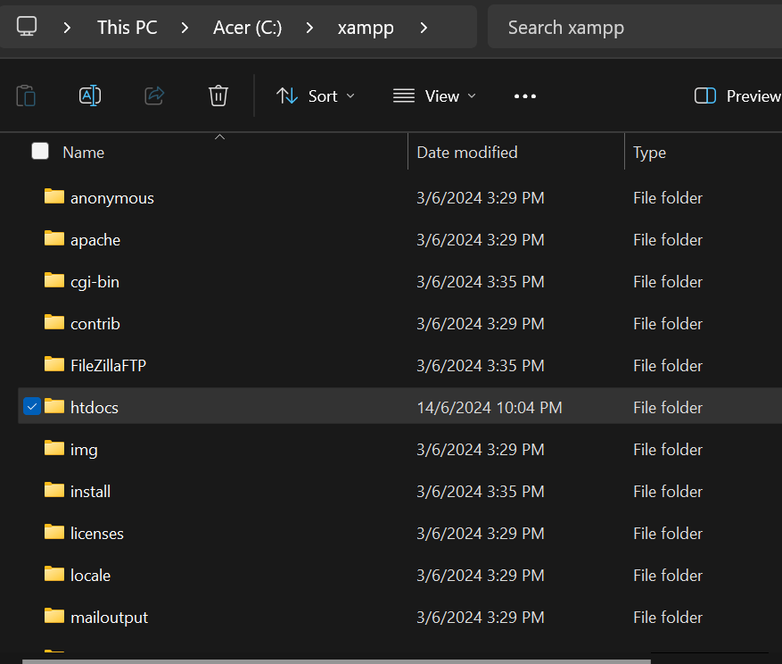

1. Find “htdocs” in XAMPP “Explorer”.
2. Paste the “timogah_fyp” FYP source code into “htdocs” file and make sure the source code is unzipped.

## Visual Studio Code

1. First the user goes to official website, “https://code.visualstudio.com/Download” to download the Visual Studio Code.

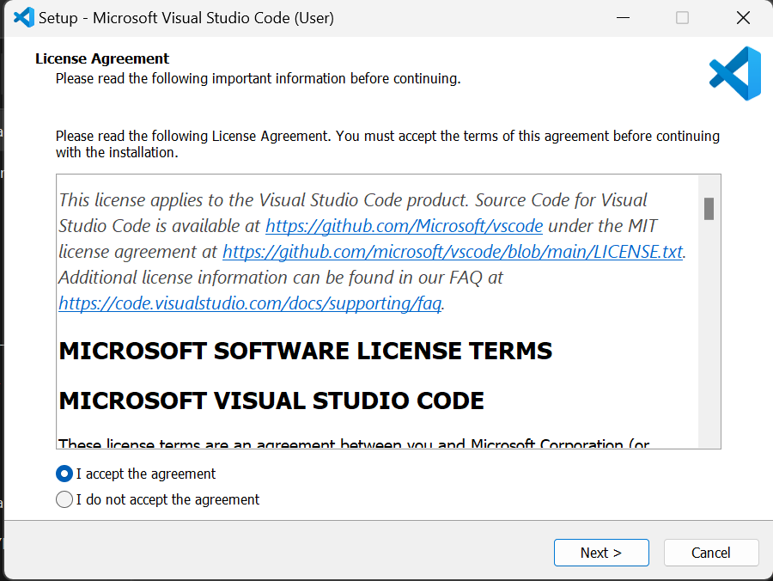

1. Run the setup of the Visual Studio Code to install.
2. After installation, the user is ready to use Visual Studio Code.

## Source Tree

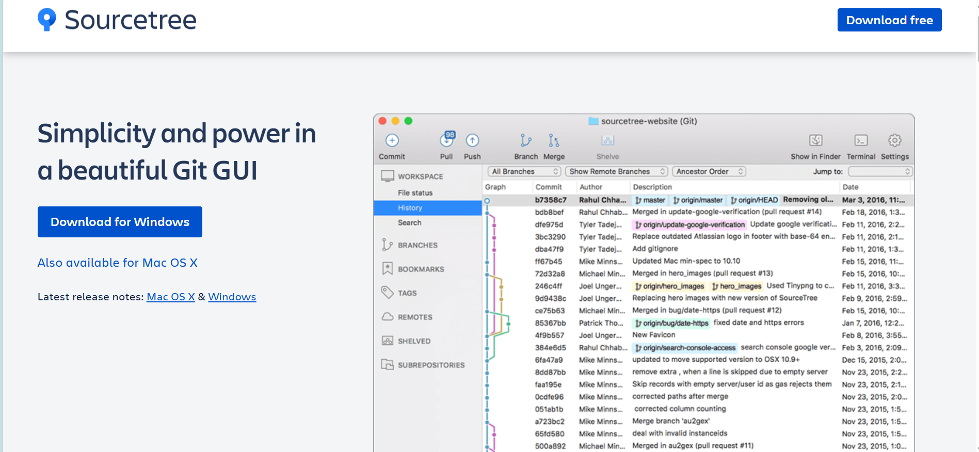

1. First, the user downloads Source Tree from official website.
2. From the ZIP file you download, click the application file (EXE for Windows or DMG for Mac) to download.
3. After you install, you'll have to agree to the Atlassian Customer Agreement and hit Continue.
4. You need an Atlassian account to use Sourcetree. When you get to this screen, cick either use an existing account or Go to My Atlassian and follow the prompts to create a new account. Once you've got an account, you'll be able to log in with Use an existing account.