2020-AT-01-ita.odt Alberi digitali
6yo–8yo:  – | 8yo–10yo:  – | 10yo–12yo:  – | 12yo–14yo:  – | 14yo–16yo:  – | 16yo–19yo:  hard
Answer Type: Multiple-Choice with Images
Categories (click to choose):  ☑ algorithms and programming  ☑ data structures and representations |  |  | ☐ computer processes and hardware  ☐ communication and networking  ☐ interactions, systems and society

Body
Un albero digitale cresce dal seguente pezzo di albero singolo:
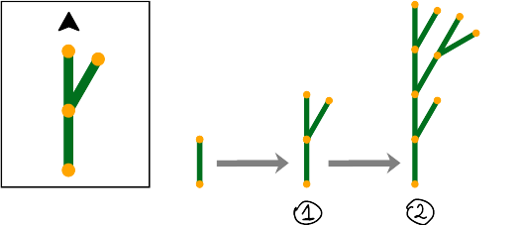
Cresce gradualmente secondo una regola di crescita predeterminata.
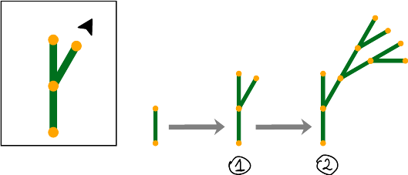
La regola della crescita specifica come un pezzo di albero può essere sostituito da una struttura di nuovi pezzi di albero. In ogni passo, ogni pezzo di albero viene sostituito in questo modo. La punta di una freccia indica dove e in quale direzione vengono messi insieme i pezzi dell'albero. A destra ci sono due esempi di una regola di crescita e le corrispondenti prime due fasi di crescita.

Il seguente albero digitale è cresciuto in 3 fasi di crescita: 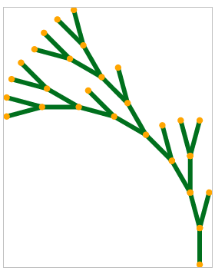

Question / Challenge
Secondo quale regola di crescita è cresciuto l'albero digitale?

Answer Options / Interactivity Description
A) | B) | C) | D)
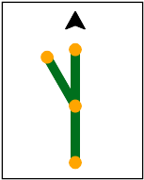 | 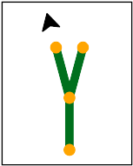 | 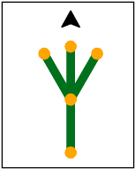 | 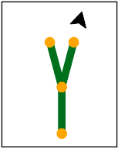

Answer Explanation
La risposta corretta è B)
Regola di crescita | 4 fasi di crescita | Descrizione
 | 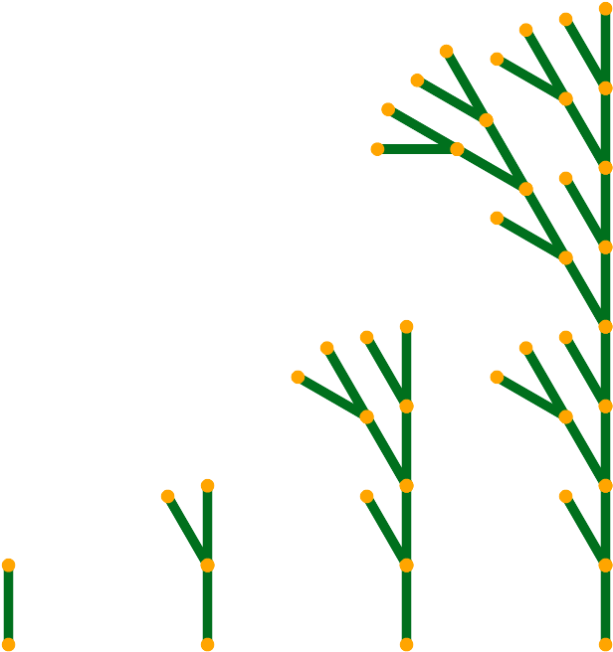 | Il resto dell'albero è sempre aggiunto al ramo che punta verso l'alto, in linea retta. Forma così un tronco dritto con rami che puntano solo a sinistra.
 | 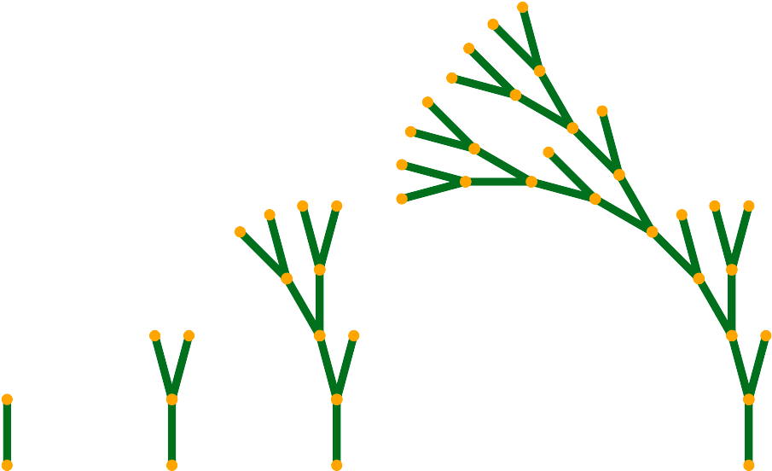 | Il resto dell'albero viene sempre aggiunto al ramo superiore sinistro. L'albero quindi si inclina a sinistra.
 | 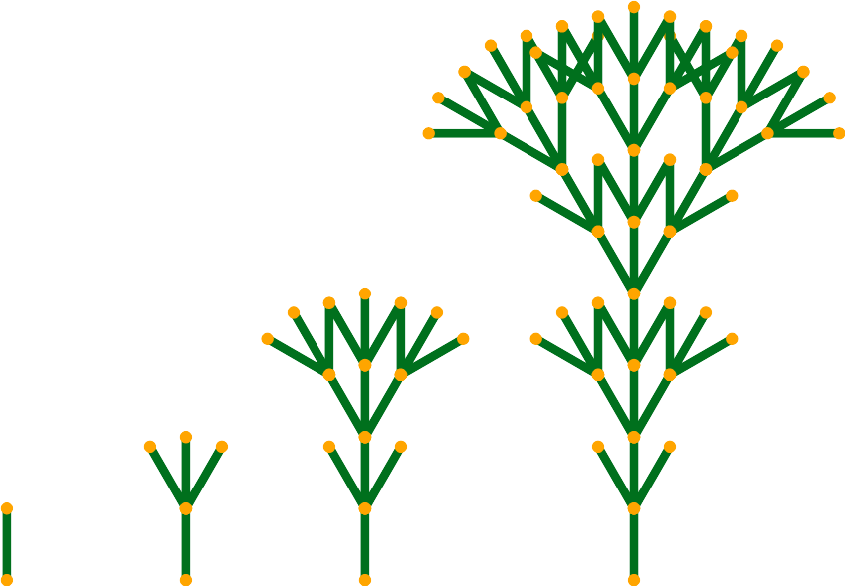 | Il resto dell'albero è sempre aggiunto al centro, in linea retta. I due rami a sinistra e a destra formano una struttura uniforme e simmetrica.
 | 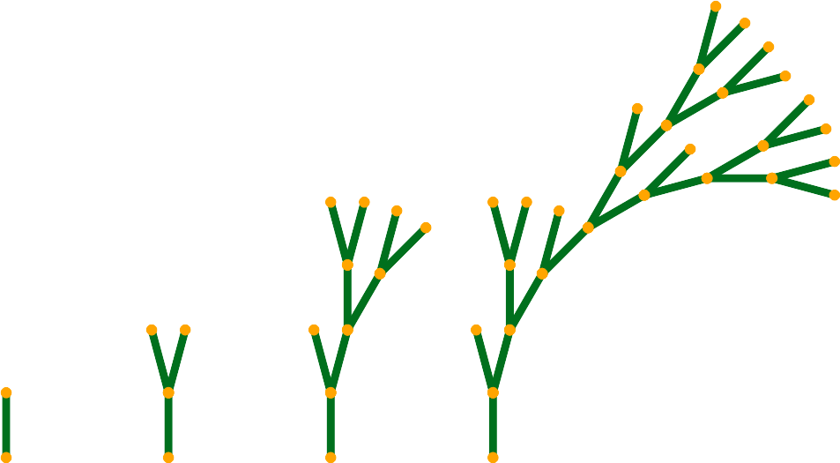 | Il resto dell'albero viene sempre aggiunto al ramo superiore destro. L'albero quindi si inclina a destra.

It’s Informatics
Nel compito si può vedere come l'applicazione ripetuta di una regola di crescita molto semplice possa creare figure complicate. Tali figure, che consistono di parti simili all'intera figura, sono chiamate frattali. I frattali sono molto spesso utilizzati dai computer, ad esempio per creare paesaggi o effetti speciali per i film..
In biologia, i cosiddetti sistemi di Lindenmayer (dal nome del biologo Aristid Lindenmayer) vengono utilizzati per simulare la crescita delle piante. Anche i frattali vengono creati in questo processo. Nel compito abbiamo visto quattro esempi molto semplici di un sistema di Lindenmayer..
Gli alberi nel compito sono creati applicando una regola ad ogni pezzo di albero, e poi applicandola di nuovo ai pezzi di albero risultanti e così via. Tali processi sono chiamati ricorsivi. Il concetto degli algoritmi ricorsivi è importante nell'informatica. Con questo tipo di algoritmo è possibile descrivere molte cose complicate in modo molto semplice.

Keywords and Websites
Frattale, sistema di Lindenmayer, algoritmo ricorsivo, iterazione
https://it.wikipedia.org/wiki/Frattale
http://paulbourke.net/fractals/lsys/
https://it.wikipedia.org/wiki/Sistema_di_Lindenmayer
https://it.wikipedia.org/wiki/Algoritmo_ricorsivo
https://it.wikipedia.org/wiki/Iterazione

Wording and Phrases
(digitaler) Baum: eine grafische, potenziell verzweigende Struktur, die aus den zwischen Verzweigungspunkten befindlichen Strecken besteht.
(Baum)Stück: Die oben genannten Strecken werden als Stücke des Baumes bezeichnet.
Regel: gibt an wie jedes Stück eines Baums durch eine Sruktur neuer Stücke ersetzt wird.

Comments
By: Margot Phillipps (svn: phillipps) on 2020-04-27
Rating as is: 5/6 Potential: 6/6
It's informatics section: Can be improved
my comment: the it’s informatics section gives a detailed but very short overview of L-systems. It is meat to give students the terms to be able to research themselves.
HTML, ODT and PDF all not available in the review system so read from svn.(Problem is because its 01 but odt is 03?)
my comment: was fixed
[AGE]Appropriate
2. [IDEA]The idea is attractive and original (well to Bebras as far as I know!) I really like this task. My one comment is that it may *not* actually determine algorithmic thinking. Sample size of 1 comment follows. My daughter (art and the arts) beats the CS types in our family hands down at the game of Set. She just "sees" the patterns while we work them out. This may happen with this problem but it is a minor consideration.
my comment: I think the task is not easy to solve for most students
3. [TEXT] The explanation of the text is minimal, but I think that is in keeping with the age group and difficulty level assigned. However, I think adding something to say the length of the branch is an important factor would reduce confusion, as the example has branches which look to be all the same length.
my comment: could be added. I think it is not necessary to solve the task.
Similarly, the direction of the arrow either has to be more exaggerated in the graphics or there should be something in the text to alert the reader to subtle differences in arrow direction. At first glance rules 1 and 4 are the same.
my comment: I have emphasized it in the text and visually.
4. [EXPL]The explanation is clear (although students might want to slowly draw it for themselves to be convinced!)

5. [ITâ€™S INF] This is well connected to the task, but isn't age appropriate in my view. Adding more detail to connect the likely knowledge of students to the terms would enhance this section (eg: "context-free, deterministic (not stochastic)" are beyond 14 year olds).
my comment: it’s informatics could be extended. Intention now is keep it short and give students the necessary terms to research on their own.
6. [GRAPH] The difference between rules 1 and 4 are not easily discernible. The arrow directions need to be exaggerated.
my comment: I have emphasized it in the text and visually.
7. [AUTH] Compliant
8. [NAME] This is 2020_AT_01 but the odt file in the svn is numbered 03
========================================
By: Pieter Waker (svn: waker) on 2020-04-27
Rating as is: 4/6 Potential: 5/6
It's informatics section: Can be improved
Than you for making the task visible.
This is a refreshingly new addition to the Bebras tasks.
One area where improvement is perhaps necessary is to distinguish more clearly between case 1 and case 4. It is clear once one has noticed that the arrows differ slightly, but it is difficult to see.
my comment: I have emphasized it in the text and visually.
========================================
By: Zsuzsa PluhÃ¡r (svn: pluhar) on 2020-05-01
Rating as is: 4/6 Potential: 6/6
It's informatics section: Great as it is now
review of Ãgnes E.N.
1. [AGE] Is the age/difficulty level specified? Is it appropriate for the task and question?
With modification it would be right and appropriate, who hasn't worked with LOGO recursions.
This version is too difficult and it doesn't understandable who hasn't seen such type of recursion.
My comment: actually L-systems are iterative not recursive. Student DOES NOT have to understand recursion.
2. [IDEA] Is the idea original and attractive? Does it require some computational thinking skill to be understood and solved?
The idea is the recursion of pictures.
CT skills: recursion.
My comment: actually L-systems are iterative not recursive. Student DOES NOT have to understand recursion.
3. [TEXT] Is the text of the task clear and understandable by students of the appropriate level, without CS pre-knowledge? Are words and expressions used consistently in the text and question?
In the explanation there is just 0., 1., and the 2. level of recursion. In the tasks there are the 4. level.
My comment: its iteration not recusion. I think showing more steps doesn’t make it more difficult. It might even make the ansert clearer. Students can always focus on a sub tree of the solution if they desire.
Some parts of the 2. image is not visible in the document.
My comment: works now. Seems to have been a libre officwe glitch. Svgs are correct.
I think the explanation of the sample would helps the understanding of the task.
My comment: explanation was added
4. [EXPL] Is the â€œexplanationâ€ section available and complete? Is it understandable by students of the appropriate level? Is there a clear reason why the correct answer is correct? Is there a clear reason why the wrong answers are wrong?
It would be right if the sample would written in the same style.
My comment: I have added a text for the example.
5. [ITâ€™S INF] Is the â€œItâ€™s informaticsâ€ section available? Is it understandable by students of the appropriate level? Is it well connected to the task?
OK
6. [GRAPH] Are the figures clear and appealing? Are they suitable for the age group (not too many beavers for older students!). Are they CC-licensed and may be re-used and modified? Are they available in SVG format (i.e., as vector graphics)?
The arrows must be drawn with different colors than the image. I don't understand the red cross.
My comment: I did that. But task also should be color safe. Color used should show as different grey scale and color is not mentioned in text.
7. [AUTH] Are the name(s) and mail address(es) of the author(s) available?
Names do, emails don't.
My comment: fixed
8. [NAME] Do the names of the task folder and file(s) comply with the prescribed format?
Yes
Alisher Ikramov (ikramov.alisher@list.ru), Vipul Shah (v.shah@tcs.com), Valentina Dagiene (valentina.dagiene@mif.vu.lt), 2020-05-20, Expanded It’s Informatics section, Answer revised, image added, other minor edits.
We really liked the task, however we could not complete it. It needs work with pictures (they are not clear to understand the process). We felt that we might have to look at the code too.
=====================================
Pre-D-A-CH-HU comments:
Christian Datzko: maybe not as Drag & Drop but as regular multiple choice (who does a tree created by this rule look like)?
Zsuzsa Pulhar: Es ist eine schwere Aufgabe – vielleicht wenn wir nur ein Regel geben und nach den Ergebniss fragen? Oder umgekehrt?
===============================
Wilfried Baumann, Wolfgang Pohl, Susanne Datzko am Workshop in Pitztal: Graphiken gemeinsam verbessert (einfügen der Endpunkte) und vereinfacht (nur Pfeile als Regeln, gleiche Wachstumswinkel), Ähnlichere (mit gleichen Winkeln) aber besser unterscheidbare Regeln/Bäume erstellt, Text angepasst (Wolfgang)
================================
Susanne Datzko, susanne.datzko@inf.ethz.c, 2020-08-24:
- Aufgabentext und Graphiken im Taskbody etwas anders strukturiert um Platz zu sparen. Absätze zusammengefasst.
- Antworterklärung alles in einer Tabelle zusammengefasst.
- Metadaten aufgeräumt
Fabian Frei, fabian.frei@inf.ethz.ch, 2020-08-28:
- Aufgabentext überarbeitet, um ein paar potentielle Missverständnisse auszuschliessen. (Insbesondere Plural vs. Singular.)
- In Lösung «Abzweig» durch andere Formulierungen ersetzt, da dieses Wort in der Schweiz meines Wissens völlig unüblich ist.
- «Das ist Informatik» übersetzt und etwas angepasst.

Graphics and Other Files
2020-AT-01-ita.odt This file.
2020-AT-01_answer[A-D].svg, 2020-AT-01_explanation[A-D][-compatible].svg, 2020-AT-01_taskbody_example[1-2]-compatible.svg, 2020-AT-01_taskbody[1-6].svg: Graphics by Wilfried Baumann, modified by Susanne Datzko and Wolfgang Pohl

Authors
Wilfried Baumann, baumann@ocg.at, Austria
Gerald Futschek, gerald.futschek@tuwien.ac.at, Austria

Contributors
Alisher Ikramov, (ikramov.alisher@list.ru), Uzbekisthan
Vipul Shah, (v.shah@tcs.com), India
Valentina Dagienė, valentina.dagiene@mif.vu.lt, Lithuania
Wolfgang Pohl, pohl@bwinf.de, Germany
Susanne Datzko, susanne.datzko@inf.ethz.ch, Switzerland
Fabian Frei, fabian.frei@inf.ethz.ch, Switzerland

Graphics
Wilfried Baumann, baumann@ocg.at, Austria
Gerald Futschek, gerald.futschek@tuwien.ac.at, Austria
Alisher Ikramov, (ikramov.alisher@list.ru), Uzbekisthan
Vipul Shah, (v.shah@tcs.com), India
Valentina Dagienė, valentina.dagiene@mif.vu.lt, Lithuania
Wolfgang Pohl, pohl@bwinf.de, Germany
Susanne Datzko, susanne.datzko@inf.ethz.ch, Switzerland

License

Copyright © 2020 Bebras – International Challenge on Informatics and Computational Thinking. This work is licensed under a Creative Commons Attribution-ShareAlike 4.0 International License. https://creativecommons.org/licenses/by-sa/4.0/.

