2020-IN-26-ita Scale e serpenti
6yo–8yo:  – | 8yo–10yo:  – | 10yo–12yo:  – | 12yo–14yo:  easy | 14yo–16yo:  – | 16yo–19yo:  –
Answer Type: Multiple-Choice
Categories (click to choose):  ☑ algorithms and programming  ☑ data structures and representations |  |  | ☐ computer processes and hardware  ☐ communication and networking  ☐ interactions, systems and society

Body
Nel gioco delle scale e serpenti tutti i giocatori partono dalla casella 1, e il primo giocatore che raggiunge la casella 49 vince. In ogni turno si tira il dado e si sposta la statuina nel campo corrispondente (tra 1 e 6).
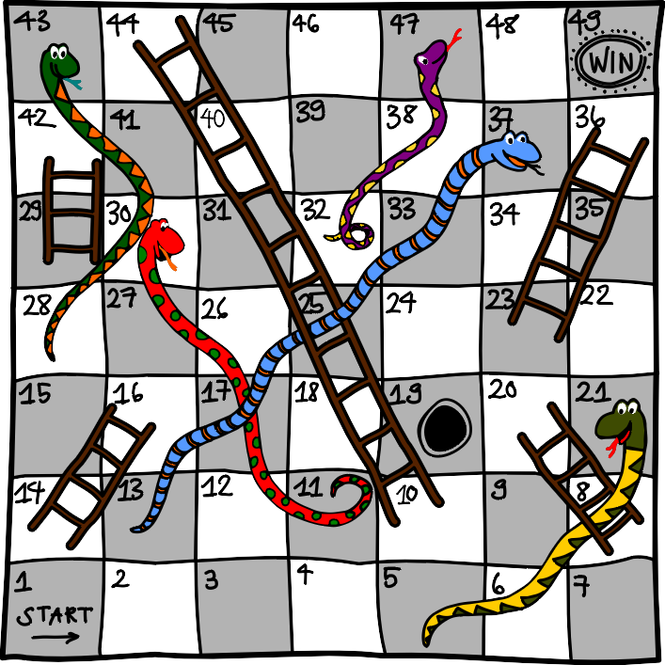
Se si finisce in un campo con la testa di un serpente, si scivola verso il campo con la sua coda. Ma se si finisce ai piedi di una scala, si può salire fino in cima.
Esempio: stai sulla casella 26 e tiri un 3. Puoi passare a 29 e quindi avanzare immediatamente alla casella 42. Nel turno successivo tiri un 5, atterri sulla testa del serpente del campo 47 e devi tornare al campo 32.

Question / Challenge
La tua statuina è sul campo 19, di quanti turni hai bisogno minimo per raggiungere il campo 49?

Answer Options / Interactivity Description
- 2 turni
- 3 turni
- 4 turni
- 5 turni

Answer Explanation
La risposta corretta è B) 3 turni.
Se sei avido e tieni conto solo dei tiri che ti porteranno verso la meta, hai bisogno di almeno 4 turni: Con un 4 arrivi dal 19 al 23 e con la scala al 36, da lì non ci sono più scale e hai bisogno di altri 3 tiri, per esempio 6 - 6 - 1 per raggiungere la meta.
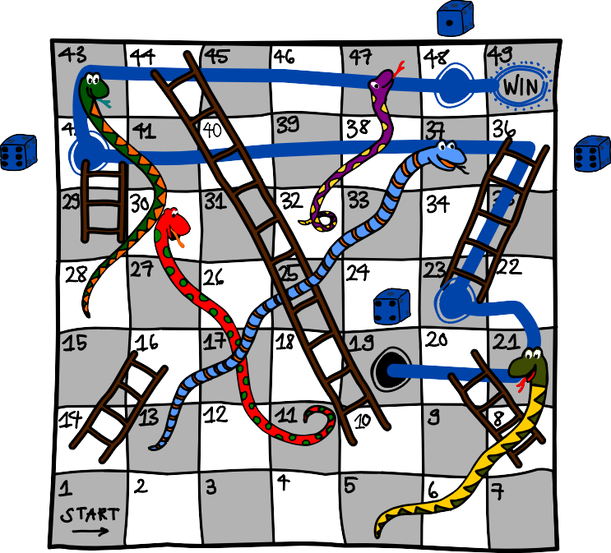
Ma se si accetta una mossa che all`inizio sembra un peggioramento, ci si arriva in 3 turni, con i lanci 2 - 5 - 5. Dal 19 al 21 e attraverso il serpente fino alla casella 5, poi al 10 e fino al 44 e poi fino alla meta.
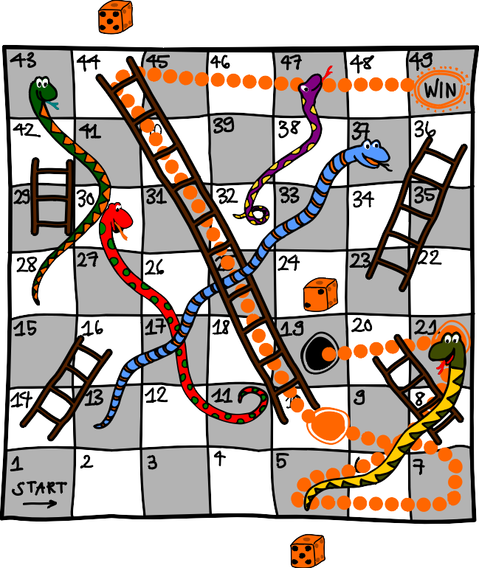
In 2 turni l'obiettivo non si può raggiungere. Ad un tiro dalla meta si trovano i campi 48, 46, 45, 44 e nessuno di questi campi può essere raggiunto dal 19 in un solo turno.

It’s Informatics
Molti compiti possono essere risolti trovando il cammino più breve tra due punti. Qui, "breve" spesso non ha il significato intuitivo. Qui, per esempio, abbiamo cercato il percorso con il minor numero di tiri e non il percorso che attraversa meno campi. Questo è conosciuto anche dai sistemi di navigazione, che ci propongono il percorso più breve o quello che ci richiede meno tempo. Nelle aziende di logistica, gli stessi dispositivi calcolano il percorso con il pedaggio più basso.
Nell' informatica, le stesse procedure (algoritmi) possono spesso essere utilizzate per compiti molto diversi se sono modellati in modo corrispondente.

Keywords and Websites
Cammini minimi, scale e serpenti
https://it.wikipedia.org/wiki/Algoritmo_di_Dijkstra
https://it.wikipedia.org/wiki/Scale_e_serpenti

Wording and Phrases
Turno: consiste nel lanciare il dado, far avanzare la statuina del numero corrispondente di caselle, e se si avanza in una casella "speciale": "salire la scala" o "scivolare giù dal serpente".
Scivolare verso il basso: Se si avanza in un campo "speciale" con la testa di un serpente si deve saltare indietro al campo dove si trova la coda del serpente.
Salire la scala: Se si arriva ad un campo "speciale" con il piede di una scala, si puo avanzare fino al campo dove si trova la cima della scala.
Lancio del dado: si può lanciare un numero casuale da 1 a 6. In questo caso, tuttavia, si può ipotizzare il caso migliore.

Comments
By: baumann wilfried (svn: baumann) on 2020-04-26 Non-assigned review Rating as is: 1/6 // Potential: 4/6 // It's informatics section: Can be improved // interesting! // but: i think this task teaches you about human psychology not about computational thinking.
1) a common pitfall for this task is to only search forward and overlook the optimal route that, in the first step, takes you further away from the goal. "humans tend to prefer greedy algorithms." I think that's the take away from this task. while it would be interesting to learn if people with talent for computational thinking are less likely to, it is wrong to assume that without basis. i doubt it. maybe there is even a negative correlation? i think this is an open question.
2) students that are very familiar with this game will have an unfair advantage.
3) snakes and ladders is purely based on chance. players have no scope of action (freedom of maneuvre). (unlike ludo = parcheesi) unfortunately young children are not aware of that. really this game embodies the opposite than what we are trying to advocate. I wouldn't mention it in contex with bebras without making that clear to participants. social, motoric and very basic arithmetic skills are involved of course. sorry if this sounds to harsh. i know some people might feel i overreact I would really be interested in seeing an improved version, that fixes some of what was mentioned.
========================================
By: Tom Naughton (svn: naughton) on 2020-04-30 Assigned review: Rating as is: 6/6 // Potential: 6/6 // It's informatics section: Great as it is now This is an excellent task, and very well presented. Pupils must construct a program in their heads and follow the steps carefully in order to determine how many instructions are necessary to solve the problem. Each instruction can have quite complicated side-effects (e.g. going up a ladder). The "It's Informatics" section then goes further to teach the shortest path algorithm in a novel way using a twist of this well-known game. The proof that the game cannot be won with two throws is succinct, and will be educational in itself for one way to prove an algorithm is optimal.
The target ages are appropriate, but I think it could also be a task for the oldest age group.
Possibly, the initial explanation for how to play the game could be improved slightly -- it might not be completely unambiguous for someone who has never played the game before.
Possibly there should only be four answers to choose from.
The hand-drawn board from the author is really excellent. Because it is a line drawing, it is a pity it was not created as a vector image initially rather than as a raster image.
=======================
By: Melinda Phelps (svn: phelps) melinda.phelps@csiro.au, Australia, 20-05-20, working group 1, Bebras Workshop: Its Informatics adjustment to add Breadth First Search.
By: Hannah Piper (svn: piper), hannah.piper@csiro.au, Australia, 2020-05-19, working group 1, Bebras Workshop: Changed the number of rolls in explanation from 5 to 4 (to get from cell 19 to cell 23). I have changed ‘die’ to ‘dice’ (now acceptable for singular or plural usage) to avoid confusion with an international audience. Also did an edit of text and fixed some discrepancies between numerical and non-numerical use of numbers and replaced all instances of ‘throw’ with ‘roll’ of the dice for consistency. New graphics to demonstrate the answers and explanation section.
=========================
pre-D-A-CH-HU-comments
Christian Datzko: I have the impression that this might be a copyrighted game … really make sure that this is not the case, otherwise we could get into big trouble. In the AE show a graph with the minimum number of steps from each “special cell” to the next (that is: snake head & ladder bottom), from that prove the optimality of the problem. Aka: using CS modeling to improve the understanding of the solution. // once the AE is improved, the II can really talk about shortest path.
Susanne Datzko: II: Kann man einen Graphen für das Leiterspiel zeichnen?
Karsten S: copyright issues will not apply if the image is not a copy
Zsuzsa Pulhar: Dieses Spiel ist nicht über taktische Strategien, sondern über Zufallen.
Wolfgang Pohl: Snakes and ladders is very old, so no copyright. The rules must by clarified: ladders/snakes only are effective if reached with the last step in a move.
DACHHU: Indische Quelle im It’s Iformatics erwähnen.
==============================
Jens Gallenbacher, biber@gallenbacher.de, 2020-07-15:
- Ein durchgängiges Beispiel erschien mit sinnvoller.
- Bei der Aufgabe war wichtig “ohne Gegner” einzufügen, weil man sonst auf die Idee kommen könnte, dass man den Gegner noch beachten müsste, der ja schneller fertig werden könnte.
- Bei der Erklärung Greedy etwas mehr herausgeholt.
- Bei der 2-Wurf-Erklärung fand ich sinnvoller, von hinten zu argumentieren, weil dies ja die Idee hinter einigen Algorithmen ist.
- Bei “Its Informatics” vereinfacht und Fachbegriffe weggelassen – es ist auch so gut verständlich.
Susanne Datzko, susanne.datzko@inf.ethz.ch, 2020-08-21:
- Graphiken neu gezeichnet, da die alten PNGs waren – Erläuterungsgraphik mit je nur einem möglichen Weg mit Angabe der Würfelaugenzahlen.
- Runden/Wurf/Zug vereinheitlicht
- Versucht ein Wording zu schreiben
- Deutscher Link gesetzt, Leiterspiel als Keyword eingefügt
- Metadaten aufgeräumt und Comments eingefügt.
Fabian Frei, fabian.frei@inf.ethz.ch, 2020-08-26: Die verschiedenen «Du»/«du» auf Grossschreibung vereinheitlicht.

Graphics and Other Files
2020-IN-26-ita.odt This file.
2020-IN-26_taskbody[-compatible].svg, 2020-IN-26_explanation[1-2][-compatible].svg: by Susanne Datzko, source graphic for style and snakes drawn on iPad by Preethi Sudharsha
alternative-graphics by Susannah Quidilla

Authors
Prathyush Ponnekanti, prathyushakarun@gmail.com, India
Preethi Sudharsha, postbox@sudharsha.com, India
Melinda Phelps, melinda.phelps@csiro.au, Australia

Contributors
Hannah Piper, hannah.piper@csiro.au, Australia
Susannah Quidilla, susannah.quidilla@csiro.au, Australia
Jens Gallenbacher, biber@gallenbacher.de, Germany
Susanne Datzko, susanne.datzko@inf.ethz.ch, Switzerland

Graphics
Susanne Datzko, susanne.datzko@inf.ethz.ch, Switzerland

License

Copyright © 2020 Bebras – International Challenge on Informatics and Computational Thinking. This work is licensed under a Creative Commons Attribution-ShareAlike 4.0 International License. https://creativecommons.org/licenses/by-sa/4.0/.

