2020-JP-04-ita Comparazioni pesanti
6yo–8yo:  – | 8yo–10yo:  – | 10yo–12yo:  hard | 12yo–14yo:  medium | 14yo–16yo:  – | 16yo–19yo:  –
Answer Type: Multiple-Choice with Images
Categories (click to choose):  ☑ algorithms and programming  ☑ data structures and representations |  |  | ☐ computer processes and hardware  ☐ communication and networking  ☐ interactions, systems and society

Body
Cinque scatole sono contrassegnate da cinque diversi simboli: , , ,  e .
Con l'aiuto di una bilancia si comparano due scatole alla volta. La seguente comparazione mostra, ad esempio, che è più pesante di :

In totale sono state effettuate cinque comparazioni:


Question / Challenge
Qual è la scatola più pesante?

Answer Options / Interactivity Description
A) | B) | C) | D) | E)

Answer Explanation
La scatola C) con il pentagono è la più pesante.
La figura seguente contiene quattro delle cinque comparazioni effettuate e tutte e cinque le scatole.
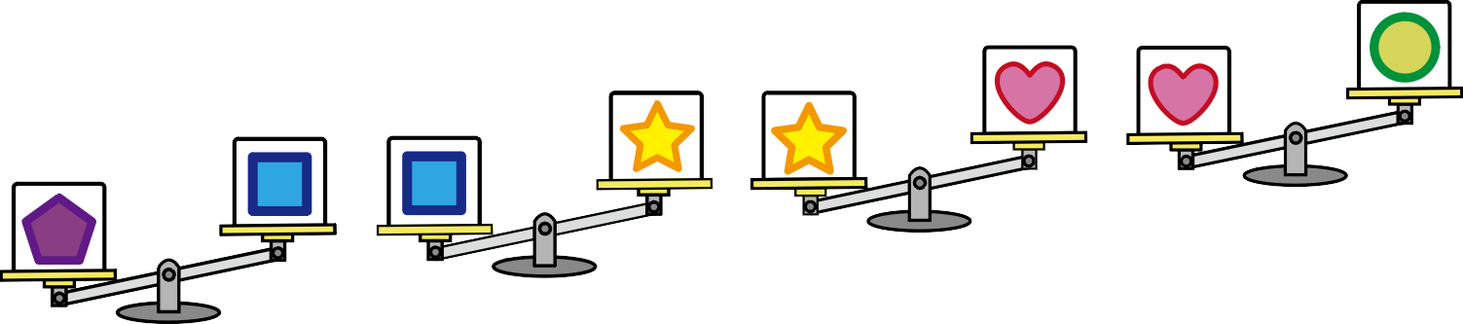

Così si vede subito: la scatola con il pentagono è più pesante di quella con il quadrato . La scatola con il quadrato è più pesante della scatola con la stella . La scatola con la stella è più pesante di quella con il cuore . E la scatola con il cuore è più pesante della scatola con il cerchio .
Da questo si può ora concludere che la scatola con il pentagono è più pesante di tutte le altre. Ciò è dovuto ad una speciale proprietà di comparazione dei pesi:
Se A è più pesante di B e B è più pesante di C, allora anche A è più pesante di C. Questa proprietà molto importante si chiama relazione transitiva.
A proposito, c'è un modo intelligente per abbreviare questo compito. Poiché si sta cercando la scatola più pesante, è sufficiente cercare la scatola che non è più leggera di qualsiasi altra scatola, e questa è solo la scatola con il pentagono. .

It’s Informatics
Fondamentalmente, questo compito riguarda l'ordinamento di qualsiasi oggetto. In informatica, per l'ordinamento vengono spesso utilizzati dei grafi speciali, che consistono in nodi (gli oggetti da ordinare) e archi (comparazione di due oggetti). Gli oggetti in questo compito sono le scatole e le comparazioni sono le pesate. Se si disegnano gli archi come frecce che puntano all'oggetto più pesante, il grafo per questo compito si presenta così:
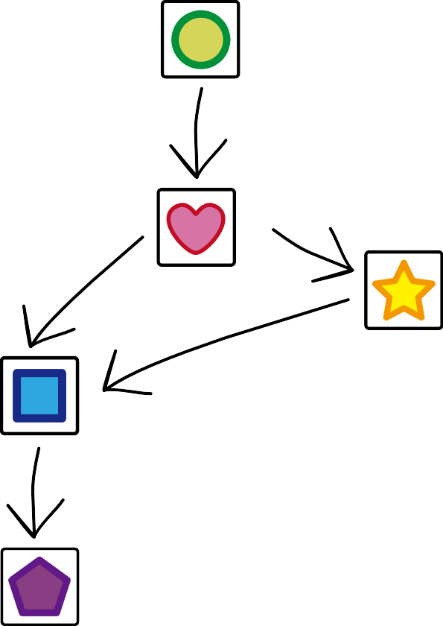
Gli oggetti devono ora essere ordinati in fila, in modo che le frecce partano sempre dagli oggetti più a sinistra verso gli oggetti più a destra. Una tale disposizione è chiamata ordinamento topologico. Un ordinamento topologico si ottiene molto semplicemente rimuovendo ripetutamente un nodo dal grafo verso il quale non c'è alcuna freccia puntata e ponendo i nodi rimossi in quest'ordine.
Ma attenzione: non tutti i grafi hanno un ordinamento topologico. Per esempio, non c'è un ordinamento topologico se ci sono tre frecce che puntano in un cerchio.

Keywords and Websites
Relazione transitiva, grafo, ordinamento topologicos
https://it.wikipedia.org/wiki/Relazione_transitiva
https://it.wikipedia.org/wiki/Grafo
https://it.wikipedia.org/wiki/Ordinamento_topologico

Wording and Phrases
Schwerer sein – I chose to use «heavier» as an adverb and not as an adjective because then it's simpler to make a uniform formulation for the comparison of two boxes as well as finding the box which his the most heaviest.
Vergleich – to compare the weight of two boxes by using the scale
Ein Knoten auf den kein Pfeil zeigt – instead of formulating it as a «Knoten ohne Vorgänger» I chose this simpler formulation because otherwise the concept of a «Vorgänger» would have to be introduced first.
Objekt: Knoten/Kiste
Vergleich: Kante/Wägung
Topologische Sortierung: Eine lineare Anordnung, die die durch den Graphen vorgegebenen Eigenschaften erfüllt.

Comments
This quiz was originally created by the student in Hakuyo High School, Japan
By: Pieter Waker (svn: waker) on 2020-04-19 Non-assigned review Rating as is: 4/6 Potential: 6/6
It's informatics section: Great as it is now
Lovely task.
This task should be used for more than one level!
Some improvements to the text suggestions:
There are five blocks, each of which has different weight.
By using a balance scale, you obtained five results as depicted below.
Question / Challenge
Which is the heaviest block??
By: moon (svn: moon) on 2020-04-30 Non-assigned review Rating as is: 3/6 Potential: 4/6
It's informatics section: Can be improved
1. [AGE] Younger students seem suitable to solve.
2. [IDEA] It seems to be a problem that shows basic computing operations well.
3. [TEXT] It is described in easy sentences at an appropriate level.
4. [EXPL] In addition to the description now, it would be good to explain the order of the weights of the five marks.
8. [NAME] There are no keywords and websites, wording and phrases, comments. This is an essential part of understanding the problem.
9. [OTHER]It is suggested to make the conditions of the problem more complicated. For example, it is possible to present a situation in which any two weights among the five marks cannot be determined, and apply them as 'don't care' conditions to solve the problem.
Wolfgang Pohl, pohl@bwinf.de, Date (2020-05-19), Amended the task as follows:
- Example for comparison given, because kids might not know about balance scales.
- Renamed “marks” to “boxes”; the images are 2D only, but could well be boxes, and boxes have a weight. Note that the task needs a new title now, see above.
- The explanation presents a “smart” way of thinking about the solution.
- The II text tries to address the students as well and is a little bit more elaborate.
Pre-D-A-CH-HU:
- CD: This would be the opportunity to display the weight relations in a graph … do it for the AE!!! Making structures visible is a classic CT topic and we must not miss it here! And don’t talk about “sorting” too much in the II but rather about transforming relations into a graph and applying a classical graph algorithm here (in this case: find a root in a directed graph).
- SD: noch ein 6. Vergleich mit der 5-eckigen Box unten? Schwierigkeit 8-10 medium
- ZP: “expl.” erweitern,
- WP: Very nice easy task.
D-A-CH-HU:
- s. Kommentare im Bewertungsdokument
Christian Datzko, christian@bebras.services, 2020-07-12:
- The example comparison is the same as one of the five comparisons made in total. The example comparison is repeated as one of the five comparisons. I chose not to mention this, because without realizing it it's also fine and if a student accidently takes the example also into account it doesn't make a difference, because it's one of the other comparisions.
- I chose to explicitely name the term transitive although it's probably beyond the language that the students at target age have heard of (and maybe even some teachers). However, this is a crucial piece of information which comes naturally for the student that solves it but that isn't a given for each and every situation or comparison.
- I chose to give two graphs for this problem: the graph in the Answer Explanation relates the comparisons (as nodes) with each other while the graph in the It's Informatics compares the objects (as nodes) with each other. This is done on purpose: the graph with the comparisons as nodes is likely more close to the student's point of view while the graph with the objects as nodes is closer to how a computer scientist would model this situation. Such an example is a good chance to suggest alternate views on models to sutdents.
- For the «It's Informatics» I chose not to introduce the difference between an undirected and a directed graph, because the difference is not vital to this task and any relationship between nodes is obviously a directed relationship so it comes natural that this (type of a) graph is directed.
- Although a topological sort is quite an advanced theoretical concept taking into account the target age, I chose to name it anyway: first of all it's always better to name a certain concept explicitely rather than just saying «computer scientists can solve this problem» or «a computer can somehow model this» and secondly is this concept not as difficult as it seems; I am convinved that even the solution algorithm described is simple enough for students to understand given some time and maybe a hands-on situation (laying out the graph on a desk with objects and arrows and letting the student remove any objects without a predecessor).
Christian Datzko, christian@bebras.services, 2020-07-15:
- The Austrian Working Group thought that the graph of the relations (as presented in the task itself but sorted according to the weight relations) wouldn't as as much extra value as anticipated so I deleted it together with the explanatory texts.
Fabian Frei, fabian.frei@inf.ethz.ch, 2020-08-24:
- Bild mit den vier Wägungen in Diagonale erstellt und eingefügt, plus zwei Sätze dazu.
- Besprechung Transitivität umgestellt und angepasst. Insbesondere sollte man nicht sagen, dass diese (konkreten) Vergleiche transitiv sind, die Relation ist es oder nicht.
- Inkonsistenz behoben: Pentagon → Kiste mit dem Pentagon
- Text überarbeitet, Unsauberkeiten korrigiert. (Insbesondere ist der Graph keine topologische Sortierung, er gibt nur die Bedingungen an.)
- Im Grunde ein schlechtes Beispiel für eine topologische Sortierung, da die Kisten durch das Gewicht total geordnet sind. (Und das ergibt sich genau wie die Transitivität , die auch selbst erkannt werden muss.)
- URLs repariert/ergänzt.

Graphics and Other Files
2020-JP-04-ita.odt This file.
2020-JP-04-taskbody[1-5][-compatible].svg, 2020-JP-04-answer[1-5][-compatible].svg: self-made by Maiko Shimabuku, improved by Susanne Datzko
2020-JP-04-explanation[-compatible].svg, 2020-JP-04-answer0-compatible: Cobbled together from the above by Fabian Frei
2020-JP-04-explanation[-compatible].svg, 2020-JP-04-itsinformatics[-compatible].svg: self-made by Christian Datzko, improved by Susanne Datzko

Authors
Maiko Shimabuku, shimabuku.m@gmail.com, Japan.
Hiroyuki Nagataki, nagataki@osakac.ac.jp, Japan.

Contributors
Wolfgang Pohl, pohl@bwinf.de, Germany.
Christian Datzko, christian@bebras.services, Hungary.
Susanne Datzko, susanne@datzko.ch, Switzerland.
Gerald Futschek, gerald.futschek@tuwien.ac.at, Austria.
Fabian Frei, fabian.frei@inf.ethz.ch, Switzerland

Graphics
Maiko Shimabuku, shimabuku.m@gmail.com, Japan.
Christian Datzko, christian@bebras.services, Switzerland.
Susanne Datzko, susanne@datzko.ch, Switzerland.
Fabian Frei, fabian.frei@inf.ethz.ch, Switzerland

License

Copyright © 2020 Bebras – International Challenge on Informatics and Computational Thinking. This work is licensed under a Creative Commons Attribution-ShareAlike 4.0 International License. https://creativecommons.org/licenses/by-sa/4.0/.

