2020-LT-05-ita.odt Il castoro testardo
6yo–8yo:  – | 8yo–10yo:  – | 10yo–12yo:  – | 12yo–14yo:  hard | 14yo–16yo:  medium | 16yo–19yo:  –
Answer Type: Multiple-Choice
Categories (click to choose):  ☑ algorithms and programming  ☐ data structures and representations |  |  | ☐ computer processes and hardware  ☐ communication and networking  ☐ interactions, systems and society

Body
Il castoro Fred incontra i canguri su un percorso di ceppi di albero. Il percorso è piuttosto stretto, così che lui e i canguri non possano passare allo stesso tempo. Ma c'è uno specifico ceppo di albero dal quale i canguri possono saltare su una pietra e da lì tornare a questo ceppo, come mostrato nella foto. Solo un animale alla volta può stare su ogni ceppo di albero e sulla pietra.
Fred vuole andare avanti. È abbastanza testardo e disposto a tornare indietro di un ceppo solo 10 volte al massimo. In avanti, invece, può andare tutte le volte che vuole.
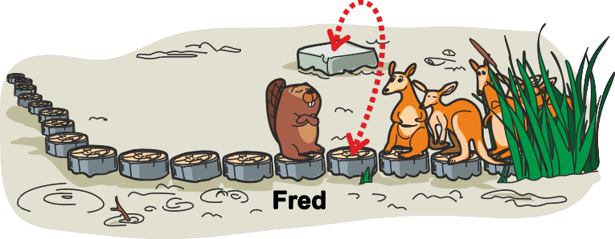

Question / Challenge
Qual è il numero massimo di canguri che Fred può far passare?

Answer Options / Interactivity Description
- Più di 10 canguri.
- Esattamente 10 canguri.
- Esattamente 6 canguri.
- Esattamente 4 canguri.
- Meno di 4 canguri.
- È impossibile dirlo con certezza.

Answer Explanation
Fred può far passare un massimo di 6 canguri.
Un canguro passa Fred come segue:
Il canguro salta sulla pietra. | 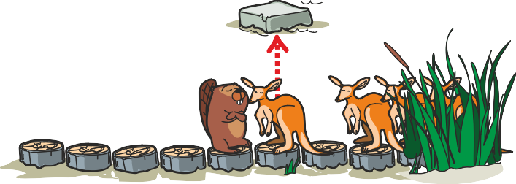
Fred cammina due ceppi d'albero in avanti. | 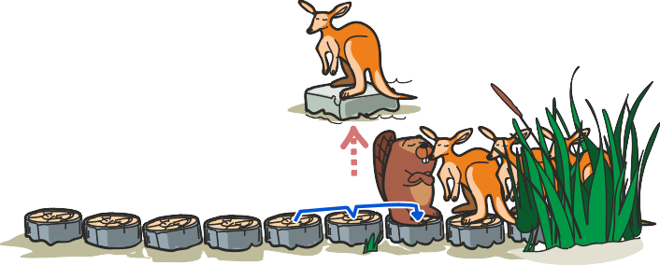
Il canguro salta indietro e continua il suo cammino. | 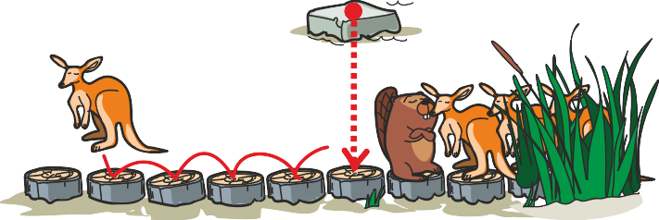
Se Fred ora torna indietro di due ceppi, è tornato alla posizione di partenza e può ripetere la procedura per far passare un altro canguro. | 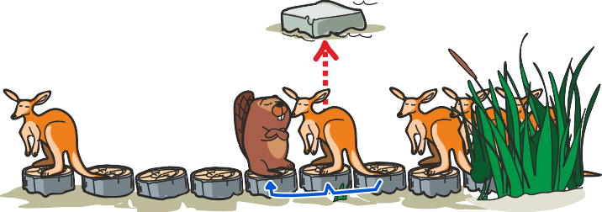
Poiché torna indietro di un massimo di 10 ceppi, può farlo cinque volte e insieme al primo canguro può far passare un massimo di 6 canguri.

It’s Informatics
Nell' informatica i compiti vengono risolti, tra l'altro, con l'ausilio di algoritmi: seguendo semplici istruzioni e comandi che vengono eseguiti passo dopo passo - proprio come "Fred cammina un ceppo di albero in avanti" o "un canguro salta su una pietra".
In una iterazione (o "loop" in inglese), le sequenze di istruzioni possono essere ripetute. In questo modo, i compiti uniformi possono essere eseguiti in modo affidabile più volte. Di solito è vantaggioso creare la stessa situazione ad ogni passaggio d` iterazione - la cosiddetta invariante. Nel nostro caso Fred deve tornare alla sua posizione di partenza più e più volte, in modo che la stessa procedura funzioni di nuovo per il canguro successivo.

Keywords and Websites
Algoritmo, iterazione, invariante
https://it.wikipedia.org/wiki/Algoritmo
https://it.wikipedia.org/wiki/Programmazione_strutturata
https://www.khanacademy.org/computing/computer-science/algorithms/intro-to-algorithms/v/what-are-algorithms
https://www.bbc.co.uk/bitesize/topics/z3tbwmn/articles/z3whpv4

Wording and Phrases
Baumstumpfpfad / Pfad: a path which the beavers and kangaroos want to pass without getting wet or dirty; as such it’s considered to be a temporary place for at most one animal to be; after the first introduction of it as a «Baumstumpfpfad» it's only called «Pfad»
Stein: a different place for a kangaroo to stand without getting wet or dirty; the stone can only be reached by kangaroos by jumping and not by beavers; the stone can only be reached from one specific log
vorwärts / zurück gehen: take one step into the desired direction / take one step into the direction the beavers or kangaroos do not prefer to go
Schritt: the word «Schritt» is avoided specifically to avoid having to define that a step is going to the next log.

Comments
By: ioannou2 (svn: ioannou2)
on 2020-04-23
Assigned review
Rating as is: 4/6
Potential: 6/6
It's informatics section: Can be improved
Very nice task with very nice image as well.
The explanation of the task in the main part should be improved.
The informatics section can be improved.
By: Tom Naughton (svn: naughton)
on 2020-05-01
Assigned review
Rating as is: 4/6
Potential: 6/6
It's informatics section: Can be improved
Excellent task.
The story is incomplete: "However he needs..."
The age group is fine, but possibly should also be relevant for the oldest age group.
For the youngest age group, I suggest that there is only one beaver in the story. The existence of the other beavers is irrelevant to the specific question asked, and could confuse pupils unnecessarily.
Amazing graphics.
It's informatics could be improved to talk about lists or queues, or something that better captures the nature of the simulation in this particular task, but I can't think of anything obvious myself.
Valentina Dagiene: I tried to improve the ormulation.
Yasemin Gulbahar, ysmnglbhr@gmail.com and Christian Datzko, christian@bebras.services, 2020-05-19:
- We decided to keep the other four beavers, because they’re so cute. We made sure that the text is clear that the backwards steps of the four non-leading beavers will not be counted.
- We decided to make more answer alternatives: >10 (instead of >6), 10 (because of the misconception that a single going-back-step would be sufficient to let one kangaroo pass) and <4.
- We decided to write “(to) stay on the path” instead of “(to) stay on the log path” in the first paragraph to enable kangaroos to also be willing to stand on stones.
- We changed the “Answer Explanation”: we put the “loop” first and then let another kangaroo pass to show the algorithmic background of the task.
- We rewrote the “It’s Informatics” section to be more connected to the task.
Susanne Datzko, susanne@datzko.ch and Anna Morpurgo, anna.morpurgo@unimi.it, 2020-05-21:
We named the leading beaver Fred, so that it is simpler to adress him in the text. We also did add the word “specific” to the third sentence to make it even clearer that only from this log it would be possible to jump back an forth.
We did add Fred into the taskbody graphic and because in the explanation there is only Fred left, we decided it isn’t necessary to put his name also.
Jens Gallenbacher, biber@gallenbacher.de, 2020-07-15:
- Deutsche Übersetzung
- Ich sehe keinen Vorteil darin, die restliche Biberfamilie einzubeziehen, nur um sie dann zu ignorieren -> nur Fred den Kangurus begegnen lassen
- Am Anfang musste klar gemacht warden, was ein Schritt ist
- Die Rechnung ist meiner Meinung nach in der Erklärung nicht zielführend und irrelevant
- Alle weiteren Erklärungen m. E. zu weit für diese Aufgabe und ist anhand des Beispiels nicht erschließbar
Christian Datzko, christian@bebras.services, 2020-07-15:
- reduced the story further to it's core, unified the wording, asked Susanne to further improve the graphics
- Susanne further improved the graphics.
Fabian Frei, fabian.frei@inf.ethz.ch, 2020-08-21:
- «ein Känguru» → «die Kängurus», um klar zu machen, dass jedes so ausweichen kann.
- In der Übersetzung den einen Baumstumpf, von dem die Kängurus ausweichen können, als «einen bestimmten Baumstamm» herausgehoben (wie «specific» im Englischen).
- Verweis auf das Bild.
- «10 Baumstümpfe» → «10 Mal einen Baumstumpf», um klar zu machen, dass man es beliebig aufteilen darf.
- Rechtschreibung

Graphics and Other Files
2020-LT-05-ita.odt This file.
2020-LT-05_taskbody[-compatible].svg, 2020-LT-05_explanation[1-4][-compatible].svg: created from scratch by Vaidotas Kinčius, little corrections and improved compatibility Susanne Datzko.

Authors
Valentina Dagienė, valentina.dagiene@mif.vu.lt, Lithuania
Vaidotas Kinčius, vaidotas.kincius@bebras.lt, Lithuania

Contributors
Yasemin Gulbahar, ysmnglbhr@gmail.com, Turkey
Christian Datzko, christian@bebras.services, Hungary
Anna Morpurgo, anna.morpurgo@unimi.it, Italy
Marios Omar Choudary, marios.choudary@gmail.com, Pakistan
Susanne Datzko, susanne@datzko.ch, Switzerland
Jens Gallenbacher, biber@gallenbacher.de, Deutschland
Fabian Frei, fabian.frei@inf.ethz.ch, Switzerland

Graphics
Vaidotas Kinčius, vaidotas.kincius@bebras.lt, Lithuania
Susanne Datzko, susanne@datzko.ch, Switzerland

License

Copyright © 2020 Bebras – International Contest on Informatics and Computer Fluency. This work is licensed under a Creative Commons Attribution-ShareAlike 4.0 International License. https://creativecommons.org/licenses/by-sa/4.0/.

