2020-PT-06-ita Prossima fermata, stazione!
6yo–8yo:  – | 8yo–10yo:  hard | 10yo–12yo:  easy | 12yo–14yo:  easy | 14yo–16yo:  – | 16yo–19yo:  –
Answer Type: Interactive (Drag & Drop)
Categories (click to choose):  ☑ algorithms and programming  ☐ data structures and representations |  |  | ☐ computer processes and hardware  ☐ communication and networking  ☐ interactions, systems and society

Question / Challenge
Trascina i binari sui punti verdi in modo che il treno  possa raggiungere la stazione .

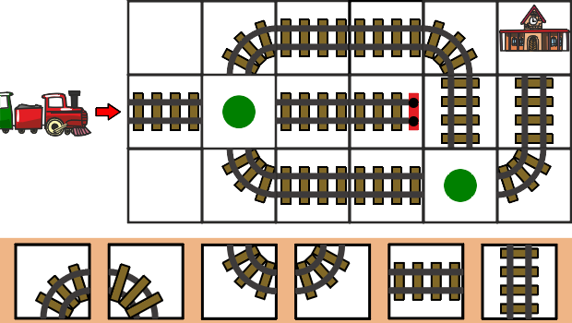
Answer Options / Interactivity Description
Die Schienenstücke auf dem beigen Hintergrund (draggable1-6) können in die mit grünen Punkten markierten Felder (container1-2) gezogen werden.
Es gibt 2 richtige Lösungen:
- container1 (grüner Punkt) → draggable4 (Kurve nach oben) und container2 → draggable3 (Kurve nach rechts.
- Container1 (grüner Punkt) → draggable2 (Kurve nach unten und container2 → horizontale Gerade

Answer Explanation
Per questo problema ci sono le seguenti 2 soluzioni:
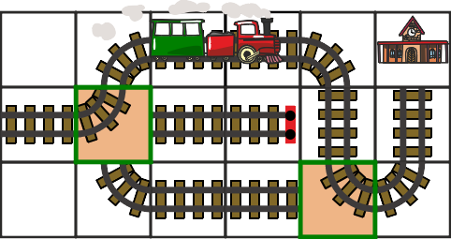
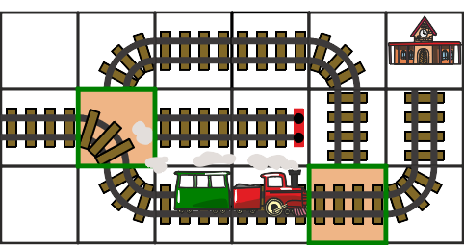
Con altre combinazioni il treno deraglia o si scontra con il paraurti.

It’s Informatics
Proprio come un treno viaggia ostinatamente sui binari, un computer esegue ostinatamente le istruzioni di un programma. Non è in grado di riconoscere quando il programma contiene un errore e può bloccarsi, così come un treno può deragliare se i binari sono costruiti in modo errato. Quindi, quando si scrive un programma, bisogna stare molto più attenti che, per esempio, spiegare la strada per la stazione a una persona.
Il compito di cui sopra consiste nell'inserire i comandi mancanti nei punti giusti di un programma in modo da raggiungere l'obiettivo.

Keywords and Websites
Programma, istruzione
- https://it.wikipedia.org/wiki/Algoritmo

Wording and Phrases
Schienen: Fahrweg für Schienenfahrzeuge. Gleis wird nicht verwendet.
Entgleisen: Der Zug fährt ausserhalb des Fahrwegs.

Comments
Pedro Ribeiro, pribeiro@dcc.fc.up.pt (2020-04-05)
I’m not really sure of the difficulty, and easy for the 6y-8y would also seem suitable (although there needs to be visual interpretation and there are two possible paths that might “confuse”)
Reviewers’ comments:
By: Karolína Mayerová (svn: mayerova) on 2020-04-24 Assigned review: Rating as is: 5/6 // Potential: 5/6 // It's informatics section: Can be improved // It could be more difficult to see informatics in a given task, but it is a nice task for spatial imagination. It has nice graphics and well-chosen distractors.
========================================
By: baumann wilfried (svn: baumann) on 2020-05-03 Non-assigned review: Rating as is: 4/6 // Potential: 5/6 // It's informatics section: Can be improved nice task for the very young. // that's informatics can be improved. // a few ideas:
computational thinking is about analyzing systems, sometimes incomplete ones or with incomplete information about them. it is also about predicting outcomes after well defined changes are made to the system. to do that, you have to carry out in your mind what you think happens when the system runs.
It is a very common task for computer scientists and programmers to analyze systems, sometimes incomplete ones, for example because they are still in the process of being built or sometimes with imcomplete information about them. It is also very common to make predictions about such a system and anticipate (foresee) how well-defined changes to that system would effect outcomes. For small systems you can try to work out everything in your mind. for larger systems you have to carefully carry out all of the systems actions step by step and you might have to keep a record of all important events and details.
========================================
IBW 2020
Gabriel Parriaux, gabriel.parriaux@hepl.ch and Michael Weigend, mw@creative-informatics.de (2020-05-18):
We extended the II section and the answer explanation. We also removed the trees from the images to make them simpler (they are really nice even without decoration). The bitmap images (train and station) were replaced by vector graphics (Vaidotas Kincius).
II section: We developed two different text sections for two different target groups. The text for kids is written in simple language and tries to build a bridge from the railroad track in the task to computer programming. So we did not use the term algorithm.
The second text is for teachers and tries to explain the connection to computational thinking.
Answer explanation: We added images for the wrong answers.
===========================
Pre-D-A-CH-HU comments
Christian Datzko: CT/CS? CD: Don’t do any different texts for teachers or students.
Susanne Datzko: Informatik-Bezug ist schwach
====================
2020-07-16, Peter Rossmanith, rossmani@cs.rwth-aachen.de, Germany: German translation
So wäre eine schöne Interaktivität: Man kann die Schienenstücke auf die markierten Felder ziehen. Sobald beide Felder gefüllt sind, fährt der Zug mit rauchendem Schornstein die Gleise entlang und pfeift, wenn er den Bahnhof erreicht. Entgleist der Zug, wird dies entsprechend dramatisch animiert. (Jens meint, dass das Pfeifen weggelassen werden muss, da es zu Unruhe zwischen den Teilnehmern führt.)
2020-08-21, Susanne Datzko, susanne.datzko@inf.ethz.ch, Switzerland:
- Die oben beschriebene Interaktivität ist leider nicht umsetzbar. Es wird eine einfache Drag and Drop-Lösung erstellt. Dafür habe ich die Antwortgraphiken mit einem fahrenden Zug versehen.
- Graphiken kompatibel gemacht und aus einer Lokomotive einen Zug angedeutet. Antwortgraphiken erstellt.
- Metadaten aufgeräumt
- Kleine Umformulierung der Frage, und die Nummerierung der Punkte entfernt, da bei dieser Interaktivität nicht mehr notwendig.
- Deutscher Titel hinzugefügt
Fabian Frei, fabian.frei@inf.ethz.ch, Switzerland: Kleine Ergänzung und minimale Überarbeitung in «Das ist Informatik».

Graphics and Other Files
2020-PT-06-ita.odt This file.
Original Graphics by Pedro Ribeiro
2020-PT-06_taskbody-interactive[-compatible].svg, 2020-PT-06_explanation[1+2]-compatible.svg, 2020-PT-06_taskbody[2-3][-compatible].svg: by Vaidotas Kinčius, vaidotas.kincius@bebras.lt, Lithuania modifications and compatible graphics by Susanne Datzko

Authors
Pedro Ribeiro, pribeiro@dcc.fc.up.pt, Portugal.

Contributors
Gabriel Parriaux, gabriel.parriaux@hepl.ch, Switzerland
Michael Weigend, mw@creative-informatics.de, Germany
Vaidotas Kinčius, vaidotas.kincius@bebras.lt, Lithuania
Peter Rossmanith, rossmani@cs.rwth-aachen.de, Germany
Susanne Datzko, susanne.datzko@inf.ethz.ch, Switzerland

Graphics
Vaidotas Kinčius, vaidotas.kincius@bebras.lt, Lithuania
Susanne Datzko, susanne.datzko@inf.ethz.ch, Switzerland

License

Copyright © 2020 Bebras – International Challenge on Informatics and Computational Thinking. This work is licensed under a Creative Commons Attribution-ShareAlike 4.0 International License. https://creativecommons.org/licenses/by-sa/4.0/.

