2020-SK-04-ita Dall'alveare ai fiori
6yo–8yo:  – | 8yo–10yo:  – | 10yo–12yo:  hard | 12yo–14yo:  easy | 14yo–16yo:  – | 16yo–19yo:  –
Answer Type: Interactive (Click-On-Object)
Categories (click to choose):  ☑ algorithms and programming  ☐ data structures and representations |  |  | ☐ computer processes and hardware  ☐ communication and networking  ☐ interactions, systems and society

Body
Un'ape  vola in su, in giù, a sinistra o a destra. Per volare la distanza di un quadrato ci impiega 10 minuti. Vola dall'alveare  per un massimo di 30 minuti prima di tornare indietro.

Question / Challenge
Quali fiori si possono raggiungere dall'alveare in massimo 30 minuti? Clicca su di loro.
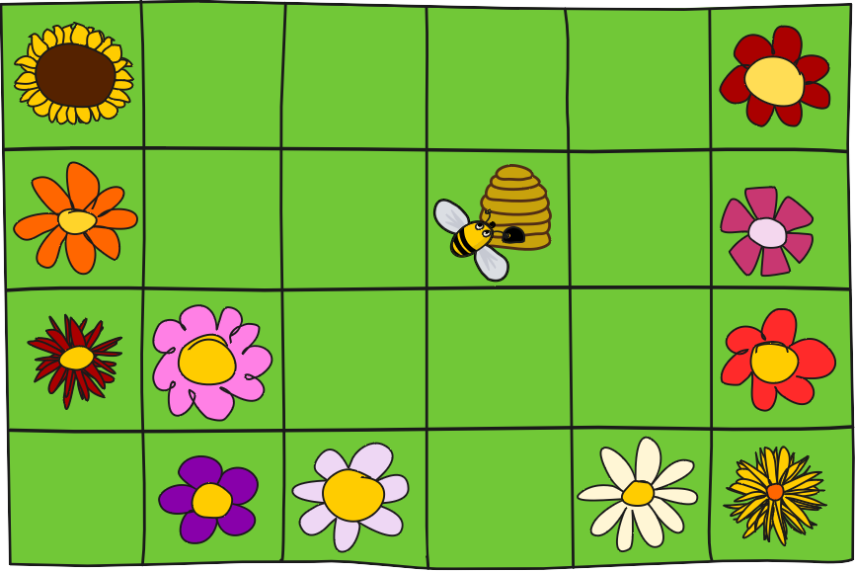

Answer Options / Interactivity Description
Die Blumen sind durch Klicken an- und abwählbar. Auf den angewählten sitzt eine Biene.

Answer Explanation
I fiori con sopra un'ape sono raggiungibili dall'alveare in massimo 30 minuti:
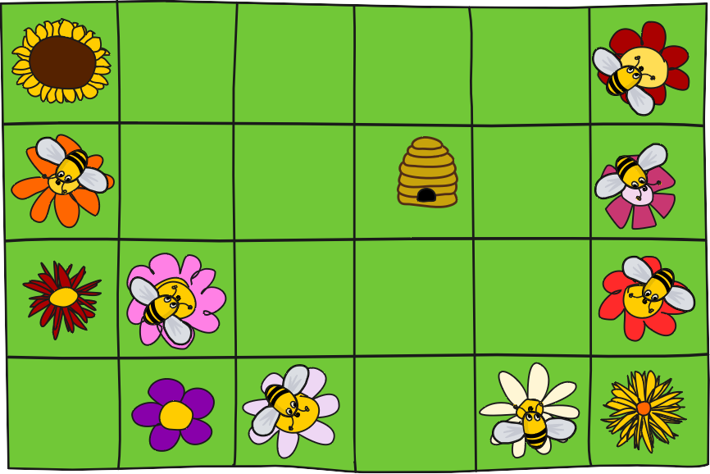
L'immagine sottostante mostra per ogni campo quanti minuti necessita un'ape per raggiungerlo dall'alveare. Così in mezz'ora tutti i campi con un 10, 20 o 30 sono raggiungibili.
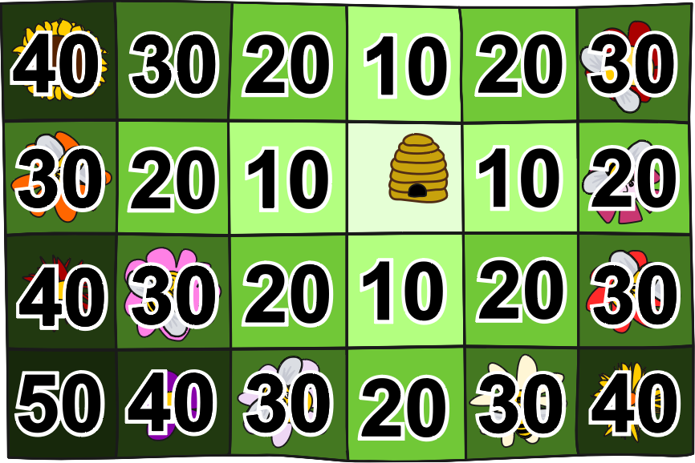
Riempire i numeri funziona in questo modo: Nelle caselle accanto all'alveare scriviamo 10 perché l'ape ha bisogno di 10 minuti per volare dall'alveare a lì. Poi scriviamo 20 in tutti i campi vuoti accanto a un campo con 10, perché l'ape ha bisogno di 10 minuti per volare da un campo all'altro. Continueremo a farlo. Così ne scriviamo 30 in tutti i campi vuoti accanto a un campo con 20. Poi ne scriviamo 40 in tutti gli spazi vuoti accanto a uno spazio con 30. Infine, scriviamo 50 in tutti i campi vuoti accanto a un campo con 40.

It’s Informatics
Quando si risolve il compito, si calcola per ogni campo il tempo in cui un'ape può raggiungerlo dall'alveare. Per prima cosa vengono determinati i campi raggiungibili in 10 minuti. Questi vengono poi utilizzati per determinare i campi che si trovano a 20 minuti di distanza. Utilizzando i campi distanti 20 minuti, si trovano poi i campi distanti 30 minuti e così via.
Quindi utilizziamo i risultati già calcolati e memorizzati (i numeri dei campi riempiti) per calcolare ulteriori risultati (i numeri dei campi vicini, ancora vuoti). Questo principio molto generale si chiama programmazione dinamica. Di solito è importante l'ordine in cui vengono calcolati i risultati. Anche questo è da considerare con il volo delle api.
Nel compito un'ape vola in 10 minuti solo su, giù, a sinistra o a destra. Questo è un po' insolito, perché in realtà un'ape probabilmente volerebbe anche in diagonale sui campi. Con questa ipotesi più realistica, i campi raggiungibili in mezz'ora sarebbero limitati da un cerchio invece che da un diamante come nel compito.
La consueta misura della distanza che porta ad un cerchio è chiamata distanza euclidea. La misura della distanza così come nel compito in cui si è autorizzati a muoversi solo orizzontalmente o verticalmente attraverso i quadrati è chiamata distanza di Manhattan (il nome deriva dalle reti stradali a griglia delle città moderne come Manhattan).

Keywords and Websites
Programmazione dinamica, distanza euclidea, distanza di Manhattan (o geometria del taxi)
https://it.wikipedia.org/wiki/Programmazione_dinamica
https://it.wikipedia.org/wiki/Ricerca_in_ampiezza
https://it.wikipedia.org/wiki/Distanza_euclidea
https://it.wikipedia.org/wiki/Geometria_del_taxi

Wording and Phrases
Blume – auch statt «Feld mit Blume». «Blume» statt «Blüte», da es das einfachere und zudem botanisch treffendere Wort ist.
Bienenstock – Das Wort ist vielleicht unbekannt, doch der Kontext macht die Bedeutung klar.
Feld – Eines der Quadrate, egal ob mit oder ohne Blume
eine Biene – Singular, weil der erste Satz so simpler ist. In der Frage wird nicht spezifiziert, ob eine Biene oder mehrere Bienen fliegen und ob sie das nur einmal oder mehrmals täglich tun, für die Erreichbarkeit ist dies irrelevant. Die interaktive Umsetzung deutet mehrere Bienen an und markiert alle Blumen, die die Bienen des Bienenstocks bestäuben können.
10 Minuten – So gewählt, weil ein Bienenflug in Realität rund 30 Minuten dauert.
Halbe Stunde – Statt 30 Minuten, da wohl der Zielgruppe angemessene Schwierigkeit.

Comments
Monika Tomcsányiová, monika.tomcsanyiova@fmph.uniba.sk, (2020-04-05): The was motivated by the task 2019-PK-04. This task is a much simpler version (not including optimization) intended for younger age groups.
- Tiberiu Iorgulescu, tiberiu.irg@gmail.com, Pakistan, motivation (author of the task 2019-PK-04) and the original picture of the hive and bees
2020-04-05, Peter Tomcsányi, tomcsanyi@fmph.uniba.sk, Slovakia: modification of pictures, explanation it's informatics
Peter Tomcsányi, tomcsanyi@slovanet.sk, (2020-04-07): The task can be easily turned into and Interactive (click on object) type by requiring the contestant to click all the flowers that the bee can reach.
=================================
By: Pieter Waker (svn: waker) on 2020-04-19 Non-assigned review Rating as is: 4/6 // Potential: 5/6 // It's informatics section: Great as it is now // There is an inherent problem with this type of question: what counts as a square? Here the hive-square clearly does not count as a square while the flower-squares count as squares. // In this particular case the fact that it is a multiple choice question, the available answers make it clear what is intended. // the text can be corrected very simply: // The bee can fly from one square to the next in a horizontal or vertical direction only.
When a bee flies out of the hive in the morning, it can fly a distance up to a maximum of 3 squares beyond the hive-square (or beyond the square on which the hive is).
>> We used this wording, thanks for suggestion
========================================
By: Wolfgang Pohl (svn: pohl) on 2020-04-24 Assigned review: Rating as is: 4/6 // Potential: 5/6 // It's informatics section: Great as it is now // Rating: 4 as of now; 5 potential // Overall assessment: Nice task, with some details to look at. The only issue is a slight lack of originality. I would prefer an interactive version, as mentioned by the authors.
1. [AGE] Is the age/difficulty level specified? Is it appropriate for the task and question? Yes. Yes. May even be considered easy for 8-10yo.
2. [IDEA] Is the idea original and attractive? Does it require some computational thinking skill to be understood and solved? Grid distance is not too original, but definitely within the scope of Bebras and CT.
3. [TEXT] Is the text of the task clear and understandable by students of the appropriate level, without CS pre-knowledge? Are words and expressions used consistently in the text and question?
The wording section is clear. "up to a maximum of" is redundant; "a distance of up to 3 squares" is enough.
>> It seems to me a valid suggestion, but Pieter Waker (who is considered a native English speaker, I think) in his suggestion kept the "maximum", so I am keeping it, too.
I wonder whether (very smart) kids may think the bee also has to be able to return to the hive with her 3 square reach. Then she could actually reach none of the flowers. Btw, this idea could lead to an interesting and a little bit more difficult version of the task.
I also wonder whether smart kids would give the answer 1, as "a bee" can fly to only 1 flower (at a time), if you take things very precisely.
Proposal:
- first sentence: "The bees …"
- second sentence: "When any of the bees …, it can fly a distance of up to 3 squares to reach a flower."
"How many flowers can be reached by the bees?"
>> Thanks for suggestions, I used them. In an interactive version, the question would be "Which flowers can be reached by the bee/bees?" This is OK with one bee as well.
4. [EXPL] Is the “explanation” section available and complete? Is it understandable by students of the appropriate level? Is there a clear reason why the correct answer is correct? Is there a clear reason why the wrong answers are wrong? Good!
5. [IT’S INF] Is the “It’s informatics” section available? Is it understandable by students of the appropriate level? Is it well connected to the task? Good!
6. [GRAPH] Are the figures clear and appealing? Are they suitable for the age group (not too many beavers for older students!). Are they CC-licensed and may be re-used and modified? Are they available in SVG format (i.e., as vector graphics)?All OK.
7. [AUTH] Are the name(s) and mail address(es) of the author(s) available? Yes.
8. [NAME] Do the names of the task folder and file(s) comply with the prescribed format? Yes.
=================================
Peter Tomcsányi, tomcsanyi@slovanet.sk, (2020-05-14), Comments after reviews: I consider copying complete reviews to this place being a disaster for readability of this file. Therefore we commented the .txt file (indicated our comments by >>) and added just some short comments below:
We changed the wording of the Body and Question based on Comments from Pieter Waker and Wolfgang Pohl.
================================
Ungyeol Jung, purnagi@gmail.com, Kwangsik Moon, newnnewer@gmail.com, 2020-05-19, We lowered the age group by one step. In Answer explanation, corrected typo error. Added keywords(Manhattan distance, Taxicab geometry). We suggest Answer type be changed to interactive so that students can click on the flowers.
Vipul Shah, v.shah@tcs.com, 2020-05-19, Change the title to “Where can it fly?”.
Madhavan Mukund, madhavan@cmi.ac.in, 2020-05-20, Minor rewording of task statement to make English more “natural”.
===========================
Pre-D-A-CH-HU comments:
Christian Datzko: make a flood-fill with the minimum distance for each square, that’ll make the AE even easier to be understood.
Susanne Datzko: Interaktive Version besser
Zsuzsa Pulhar: Inform. ist neu und interessant
Wolfgang Pohl: Text needs clarification. Make interactive, see the explanation.
==============================================
Christian Datzko, christian@bebras.services, 2020-07-16: reworked the task to achieve the target age language requirements; discarded «dynamic programming» and opted for wavefront algorithm & gradient descent instead because that's how it's called in robotics
Fabian Frei, fabian.frei@inf.ethz.ch, 2020-07-17: Reworked the task to make it shorter and clearer. Discarded «wave-front algorithm & gradient descent» and opted for dynamic programming because it is an important general principle and well exemplified by the task.
Fabian Frei, fabian.frei@inf.ethz.ch, 2020-07-20: Several small rephrasings. Added wave-front expansion algorithm although I have not found yet a suitable reference beside the English Wikipedia entry. I do not think that the method of gradient descent is well exemplified in this task; it would require a lot of additional explanation and the task does not ask for a concrete shortest path. To keep it simple, one could omit the mention of the wavefront expansion algorithm as well.
Fabian Frei, fabian.frei@inf.ethz.ch, 2020-07-20: Removed the part about the wavefront expansion algorithm and added a description of the algorithm as a breadth-first search instead.
Susanne Datzko, susanne.datzko@inf.ethz.ch, 2020-08-24:
- neue Graphiken gezeichnet, da die Urheberrechte im ursprünglichen Task (2020-PK-04) nicht ganz klar waren
- in der Erläuterungsgraphik gleich die 10, 20, 30, 40 und 50 Minuten eingetragen
- Kommentare hinzugefügt für die Dokumentation der Änderungen
- Metadaten aufgeräumt
Fabian Frei, fabian.frei@inf.ethz.ch, 2020-08-24:
- Anpassung des Texts an die neue Graphik.
- Tippfehler.
- Titel geändert.
- Kleine Anpassungen für flüssigeren Text.
Juraj Hromkovič, juraj.hromkovic@inf.ethz.ch, 25-08-24:
- Alternative Aufgabenformulierung, die ohne Zeitaspekt auskommt:
Eine Biene schafft es bei einem Ausflug vom Bienenstock über höchstens drei Felder zu fliegen, sie zu besichtigen und die Blumen dort zu bestäuben. Danach muss sie zurückkehren. Sie kann von einem Feld aus nur nach oben, links, rechts oder unten fliegen. (Bild von Feld mit vier Pfeilen.)
Fabian Frei, fabian.frei@inf.ethz.ch, 2020-08-24:
- 30 Minuten statt halber Stunde
- Abschnitt über tiefenbeschränkte Breitensuche gelöscht, da schon lang genug und kein Platz für genaue Erläuterung.

Graphics and Other Files
2020-SK-04-ita.odt This file.
Origianl-Graphics by Peter Tomcsany and Tiberiu Iorgulescu.
2020-SK-04_taskbody-interactive[-compatible].svg, 2020-SK-04_explanation[1-2][-compatible].svg, 2020-SK-04_taskbody[2-3]-compatible.svg: remade by Susanne Datzko

Authors and Contributors (incl. Graphics)
Monika Tomcsányiová, tomcsanyiova@fmph.uniba.sk, Slovakia
Tiberiu Iorgulescu, tiberiu.irg@gmail.com, Pakistan
Peter Tomcsányi, tomcsanyi@fmph.uniba.sk, Slovakia
Ungyeol Jung, purnagi@gmail.com, Korea
Kwangsik Moon, newnnewer@gmail.com, Korea
Peter Rossmanith, rossmani@cs.rwth-aachen.de, Germany
Fabian Frei, fabian.frei@inf.ethz.ch, Switzerland
Christian Datzko, christian@bebras.services, Hungary
Susanne Datzko, susanne.datzko@inf.ethz.ch, Switzerland

License

Copyright © 2020 Bebras – International Challenge on Informatics and Computational Thinking. This work is licensed under a Creative Commons Attribution-ShareAlike 4.0 International License. https://creativecommons.org/licenses/by-sa/4.0/.

