2020-UZ-02-ita L'arcipelago dei castori
6yo–8yo:  – | 8yo–10yo:  – | 10yo–12yo:  – | 12yo–14yo:  hard | 14yo–16yo:  medium | 16yo–19yo:  medium
Answer Type: Interactive (Click-On-Object)
Categories (click to choose):  ☑ algorithms and programming  ☑ data structures and representations |  |  | ☐ computer processes and hardware  ☐ communication and networking  ☐ interactions, systems and society

Body
L'arcipelago dei castori è composto da dieci isole collegate da ponti. Qui sotto c'è una mappa. Il numero su ogni ponte indica il peso totale massimo ammissibile in tonnellate per un camion che vuole attraversare quel ponte.
Il castoro Knuth vuole costruire una spiaggia sull'isola di Borkum. Vuole quindi trasportare quanta più sabbia possibile dall'isola di Ameland all'isola di Borkum in un solo viaggio. Non gli interessa la lunghezza del viaggio, ma non vuole passare su nessun ponte più di una volta.

Question / Challenge
Che strada deve prendere con il suo camion per arrivare a Borkum?
[Clicca su tutti i ponti sul percorso scelto dal camion. Con un altro clic è possibile rimuovere di nuovo il ponte dal proprio percorso].
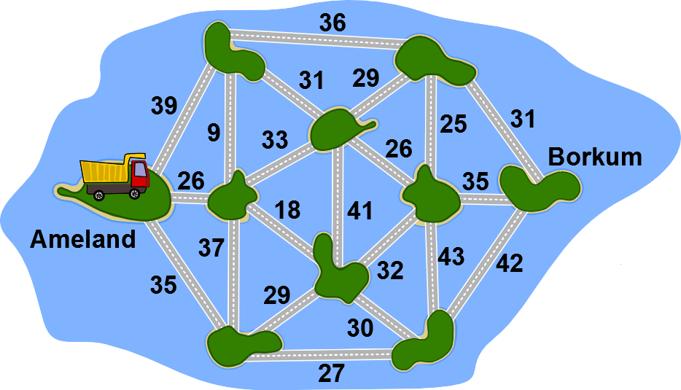

Answer Options / Interactivity Description
Interactivity comments: when clicking on a vertex, it is selected, which is presented as in the answer explanation (black street).
Es müssen ZWEI korrekte Antworten berücksichtigt werden: Die unten abgebildete Beispielantwort und die, bei der die Brücke mit 35 (adjazent zu B) statt der Brücken 42 und 43 markiert sind.

Answer Explanation
Per il viaggio, il peso totale massimo di un camion è di 32 tonnellate. Si prende il seguente percorso, ad esempio:
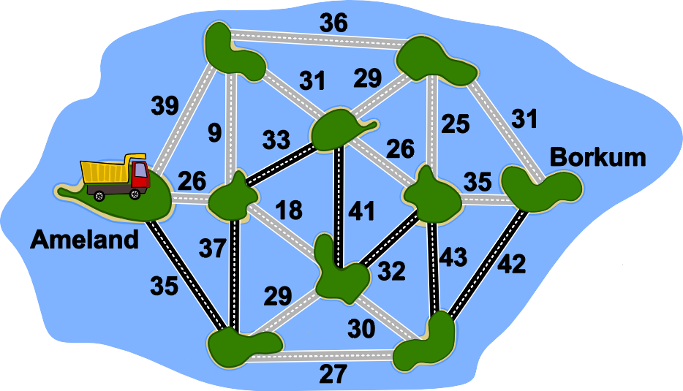
Per determinare questo, possiamo, ad esempio, per prima cosa togliere tutti i ponti dalla mappa e ordinarli in base alla loro capacità di carico. Iniziamo con quelli con la maggiore capacità di carico e li aggiungiamo alla mappa. Poi aggiungiamo quelli con la seconda maggior capacità di carico e così via. Nel seguente diagramma i ponti inseriti con le portate 43, 42, 41, 39, 39, 37, 36, 35 sono contrassegnati in nero.
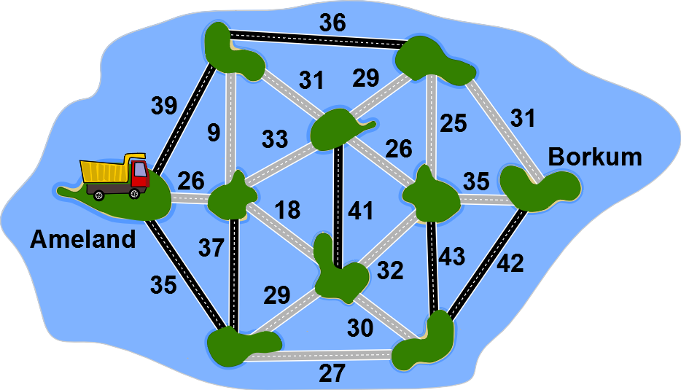
Tuttavia, se inserendo un ponte dovessimo creare un cosiddetto ciclo, cioè un percorso circolare, non lo metteremmo in quanto le isole di questo ciclo sarebbero già accessibili da ponti di maggiore capacità. Nel seguente diagramma, il ponte con una capacità di carico di 35 verrebbe inserito, ma non farebbe altro che abbreviare un percorso già esistente.
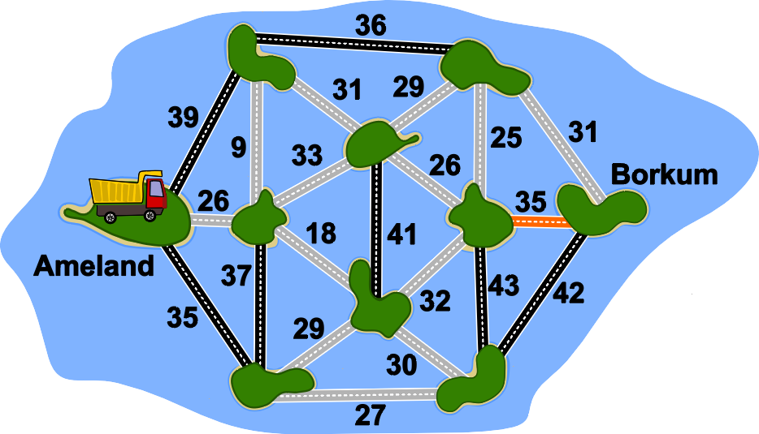
Lo faremo fino a quando tutte le isole saranno collegate. Ora c'è solo una strada possibile tra ogni paio d `isole e il ponte con la capacità più piccola dà il massimo peso che stiamo cercando.
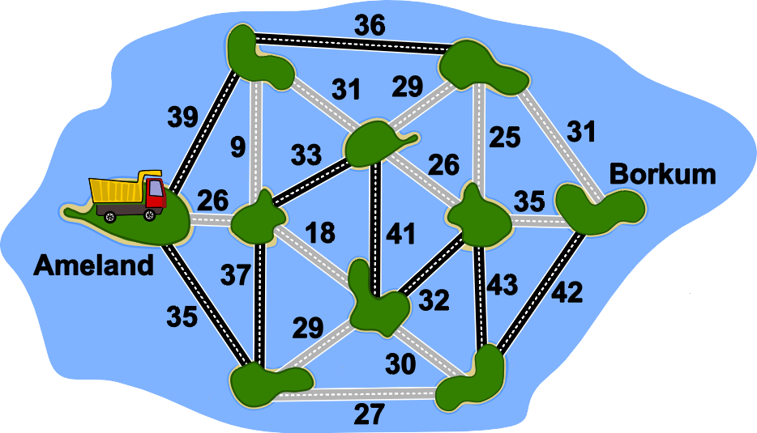

It’s Informatics
Una vera e propria applicazione per la soluzione di questo compito è l'identificazione del "collo di bottiglia" (in inglese "bottleneck") nelle reti di computer, cioè la maggiore velocità di trasmissione possibile tra due computer della rete. Il compito qui riguarda il peso totale massimo di un camion in viaggio tra due isole come un collo di bottiglia. Questo è determinato dalla capacità di carico del ponte più debole. Nelle reti di computer questo sarebbe il collegamento con la larghezza di banda più bassa.
Per una soluzione, la rete può essere prima modellata, cioè semplificata, come qui presentato. Nel nostro caso, l'algoritmo di Kruskal crea un albero ricoprente massimo in cui il collo di bottiglia è direttamente visibile.

Keywords and Websites
Grafo, albero ricoprente, algoritmo di Kruskal
https://it.wikipedia.org/wiki/Albero_ricoprente
https://it.wikipedia.org/wiki/Algoritmo_di_Kruskal

Wording and Phrases
Maximales Gesamtgewicht: maximale Belastbarkeit der Brücke. Ist der Lastwagen schwerer, darf er die Brücke nicht überqueren.

Comments
y: Pieter Waker (svn: waker) on 2020-04-22 Non-assigned review: Rating as is: 4/6 Potential: 5/6 // It's informatics section: Can be improved This task can be used for more than one age-group. // IMHO it is a very good task. // Some comment: The solution, as described, contains a number of subtraction errors: 43 - 10 = 33 and 42 - 10 = 32 // There is a different way of calculating the answer:
1. Work out the route that can carry the most - as described.
2. Find the weakest bridge on that route: 32
3. 32 -10 = 22 (only one subtraction needed!)
4.1000 \ 22 = 45.45 therefore 46 trips needed
========================================
By: Lucia Budinska (svn: budinska) on 2020-04-25 Assigned review: Rating as is: 3/6 // Potential: 4/6// It's informatics section: Can be improved // Task is not suitable for age group 10-12 and I don't see it as medium task for them. The graph is too abstract and there are so many information there which 10 years old pupil cannot comprehend in 3 minutes. The languauge used in task and in answer explanation is not suitable for this age group. At least in Slovakia 12 years old pupils don't know anything about ceiling of number, or Prim algoritm or any other algorithm used in text.
This could be good task for high school students. Idea behind the task is nice, students need to make some mental steps in order to solve the task, but all of them (which way is the best, cargo can be at most 30 tons, truck weights 10 tons, divide 1000 into cargos, the result is not a neutral number, I need to round it up...) are too much for middle school.
I can see it in 12-14 group, (maybe in 10-12), but with some changes. Interactivity could be helpful - like find the way from A to B that truck can use to deliver the biggest cargo. (But I would make the graph easier if using it in 10-12.) They don't need additional information like 1000 tons, or 10 tons for car and 30 for cargo and so on.
The Explanation of answer should be rewritten - to match the language of target audience. It's informatics has the same issues as the explanation - it's good for adults, not for kids in (lower)secondary.
========================================
By: Mathias Hiron (svn: hiron) on 2020-04-28 Assigned review: Rating as is: 3/6 // Potential: 4/6 // It's informatics section: Can be improved // This task is a classical widest path task with two extra arithmetic steps.
I'm really not a fan of the two extra steps. It makes the task statement longer, and will penalize students who have difficulty reading statements, who are absent minded and forget to take into account the weight of the truck, or students who have a hard time making a division or getting it wrong. These are not good reasons to penalize students for a computational thinking challenge.
Other than that, the widest path problem is a good problem to use once at Bebras, we use it once in a while in different forms.
===================================
2020-05, Timur Sitdikov, str719@mail.ru, Uzbekistan: Age changed from “10-12, medium” to “12-14, hard” and “14-16, medium”.
Decided to leave two extra steps as is, otherwise the task would be quite standard.
Added intermediate step to calculations in the explanation: ceiling(1000 / 22) = ceiling(45.45) = 46.
About subtraction errors: there is no mistake, as there are two steps done:
1) Set weight of an edge to 40, if it’s larger than 40.
2) Subtract 10.
Thus we have 43 → 40 → 30 and 42 → 40 → 30.
========================================
Andrey Brodnik, andrej.brodnik@upr.si, 2020-05-20:
The task was left more or less the same with the following changes:
- simplified and shortened the text (Beaverburg left out)
- amount of sand to be moved decreased to 250t, because this is 220t +22t + 8t = 10 x 22t + 22t + 2t and needs no ceiling function to explain the final result; moreover, this makes task suitable for younger categories
Possible simplifications:
- do not consider the gross vehicle mass as a sum of vehicle itself and the cargo; this will make task less realistic, but simpler
- decrease the maximum cargo to 20t, which in the given graph completely changes the algorithm as one can eliminate arcs with limitation below 30t and just ask one self whether A and B are in the same graph component.
- decrease the capacity of the bridge from t to B to 31t which will force us to go to q first.
At workshop, Mathias Hiron, mathias.hiron@gmail.com, France:
- removed the step that required to add the weight of the truck to the weight of the sand (thoo mathematical, not computational thinking)
- removed the step that required several trips. Too mathematical again.
- changed the task to an interactive version where you actually select the path
- wrote a new answer explanation that is based on kruskal and is easier to explain
- updated It’s informatics section accordingly
- added alternative multiple choice version
==================================================
pre-D-A-CH-HU comments:
Christian Datzko: not really inspiring.
Susanne Datzko: zu viel Rechnen.
Karsten S.: explanation is too complicated
Wolfgang Pohl: OK if interactive.
==================================================
2020-07-16, Jens Gallenbacher, biber@gallenbacher.de, Germany:
- Bei der Frage eingefügt, dass die Länge egal ist.
- Algorithmus sinnvoll gemacht, so dass konsequent auf Zyklen verzichtet wird.
2020-08-22, Susanne Datzko, susanne.datzko@inf.ethz.ch, Switzerland:
- Metadaten aufgeräumt, Comments eingefügt, Autoren nachgeführt
- Anordnung der Texte im Taskbody angepasst (interaktives Bild nach unten geschoben. Keine Zusatzinfos in der Frage, sondern nach oben geschoben.)
- LKWs in Lastwagen umgewandelt, da in der Schweiz eher Lastwagen als Bezeichnung gebräuchlich ist.
- Wording ergänzt.
- Graphiken kompatibel gemacht und rot markierte Brücke in Orange geändert, da für Farbenblinde der Kontrast zwischen Schwarz und Rot zu schwach war.
- Deutsche Links in Keyword und Websites
Fabian Frei, fabian.frei@inf.ethz.ch, 2020-08-26:
- Sehr kleine textliche Überarbeitungen
- Das “(an A)” habe ich nicht verstanden und entfernt.

Graphics and Other Files
2020-UZ-02-ita.odt This file.
2020-UZ-02_taskbody-interactive[-compatible].svg, 2020-UZ-02_explanation[1-4][-compatible].svg: by Susanne Datzko, original by the Task Autor

Authors
Maksim Bolonkin, maksimbolonkin@gmail.com, Uzbekistan.
Timur Sitdikov, str719@mail.ru, Uzbekistan.

Contributors
Mathias Hiron, mathias.hiron@gmail.com, France
Andrey Brodnik, andrej.brodnik@upr.si, Slovenia
Jens Gallenbacher, biber@gallenbacher.de, Germany
Susanne Datzko, susanne.datzko@inf.ethz.ch, Switzerland

Graphics
Maksim Bolonkin, maksimbolonkin@gmail.com, Uzbekistan.
Timur Sitdikov, str719@mail.ru, Uzbekistan.
Mathias Hiron, mathias.hiron@gmail.com, France
Andrey Brodnik, andrej.brodnik@upr.si, Slovenia
Jens Gallenbacher, biber@gallenbacher.de, Germany
Susanne Datzko, susanne.datzko@inf.ethz.ch, Switzerland

License

Copyright © 2020 Bebras – International Challenge on Informatics and Computational Thinking. This work is licensed under a Creative Commons Attribution-ShareAlike 4.0 International License. https://creativecommons.org/licenses/by-sa/4.0/.

