2021-AT-01-deu.odt Tierbeobachtung
6yo–8yo:  – | 8yo–10yo:  – | 10yo–12yo:  hard | 12yo–14yo:  medium | 14yo–16yo:  easy | 16yo–19yo:  –
Answer Type: Interactive (Click-On-Object) (☐ keep order of multiple-choice/-select)
Categories (click to choose):  ☑ algorithms and programming  ☐ data structures and representations |  |  | ☐ computer processes and hardware  ☐ communication and networking  ☐ interactions, systems and society

Body
Die Förster wollen die Tiere auf den Wegen im Wald beobachten. Von jeder Lichtung aus können sie alle abgehenden Wege bis zur nächsten Lichtung beobachten. Es sollen möglichst wenig Förster alle Wege beobachten.

Question / Challenge
Klicke auf möglichst wenig Lichtungen, von denen die Förster alle Wege beobachten können!
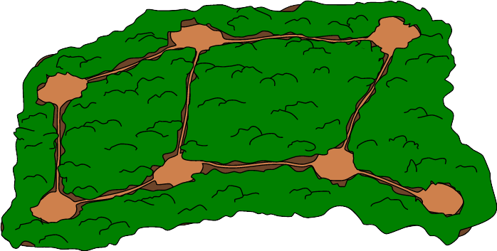

Answer Options / Interactivity Description
Interactive task: It is possible to click at an glade to put a ranger on it. Then all ways next to the glade are marked. If you click again on an glade with a ranger, the ranger and the marked ways are removed (except the ways that are observed by other rangers).

Answer Explanation
Das Bild zeigt die minimale Lösung, bei der Förster auf nur drei Lichtungen stehen und alle Wege beobachten können.
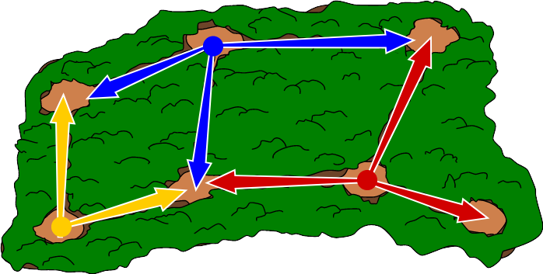Es gibt acht Wege, die beobachtet werden müssen. Wenn nur 2 Förster alle Wege beobachten könnten, müsste es eine Lichtung geben von der mindestens vier Wege fortführen. Aber eine solche Lichtung gibt es nicht in diesem Wald. Daher sind 2 Förster zu wenig.
Es sind also mindestens drei Förster zur Beobachtung aller Wege notwendig und daher ist die hier angegebene Lösung eine Lösung mit der kleinstmöglichen Anzahl an Förstern. Tatsächlich gibt es keine weitere Lösung mit genau 3 Förstern.
Von der Anzahl 8 zu überblickender Wege und dass es keine Lichtungen mit mehr als 3 wegführenden Wege gibt, können wir schließen: Jeder Förster muss mindestens 2 Wege überblicken, die die anderen Förster nicht überblicken.
Um nun den Weg in die Sackgasse rechts unten zu überblicken, muss der Förster, wie in der Abbildung am linken Ende der Sackgasse platziert werden. Um den waagrechten Weg oben rechts zu überblicken, kommt dann nur noch der Förster oben in der Mitte in Frage und zuletzt der Förster ganz links unten. Somit kommt man nur auf die angegebene Lösung und es kann keine weiteren geben.

It’s Informatics
Beziehungen zwischen Dingen (z.B. Wege zwischen Lichtungen) können als sogenannter Graph dargestellt werden.
Ein Graph besteht aus Knoten (hier: die Lichtungen), dargestellt als Kreise, und Kanten (hier: die Wege), dargestellt als Linien zwischen den Knoten. Der Graph dieser Aufgabe schaut so aus:
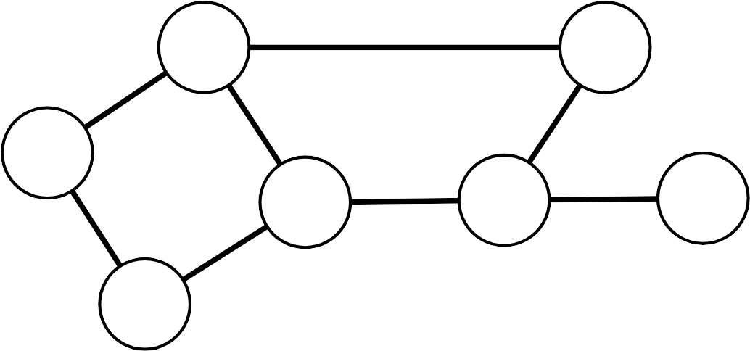
Bei dieser Biberaufgabe soll man eine kleinste Anzahl an Knoten des Graphen finden, von denen insgesamt alle Kanten des Graphen weggehen.
So eine Teilmenge der Knoten nennen Informatiker eine Knotenüberdeckung (minimal vertex cover).
Solche Knotenüberdeckungsprobleme finden wir im Alltag zum Beispiel beim Suchen der besten Stellen für Straßenlampen oder für das geschickte Platzieren von Überwachungskameras.

Keywords and Websites
Graph, Knotenüberdeckung,
https://de.wikipedia.org/wiki/Knoten%C3%BCberdeckung

Wording and Phrases
Lichtung: baumlose Stelle im Wald
Weg: eine einfach begehbare Verbindung zwischen zwei Lichtungen,

Comments
Florentina Voboril, florentina.voboril@gmx.at, 2021-03-27: Created the task
Florentina Voboril, florentina.voboril@gmx.at, 2021-05-06: Reviews and changes
- I doubt the appropriateness for the given age groups, though, let alone the concept of "adjacent". Also, quite a level of abstraction is involved, as in this non-interactive setting positioning of rangers has to imagined (unless you redraw the setting on paper, but that would take too much time during the competition). I suggest to start with 10-12.
→ I removed the word “adjacent”. I changed the task to interactive.
- Why do the rangers "stand" on a "seat"? "Sit" would be OK as well.
→ I changed this.
- Why do you observe paths in order to observe animals. Wouldn't they prefer to stay beneath the trees?
→ I thought that it might be hard to see animals behind trees. So the rangers have to wait until they move to the ways, where they can be seen.
- The second "observe" has a meaning somewhat different from the first. Perhaps you should use sth like "oversee".
→ I changed this
- Why can rangers see to the next high seat only? The ranger on the very left seat could well be able to see as far as the third seat from the left in the upper row. You could avoid this issue by changing the map slightly.
→ I changed this.
- "adjacent" is a strong notion, but as such not comprehensible to the intended age group. Also note, that in the explanation, high seats are adjacent to paths, while in the task, paths are adjacent to high seats. In graph theory, which you are referring to, two nodes (here: high seats) are adjacent, if connected by a vertex. So you are using "adjacent" in a somewhat unusual way.
→ I changes the word “adjacent” to “next to it”.
- You are using "paths" for the edges in this graph. In graph theory, paths usually are sequences of edges, leading along a sequence of nodes.
→ I changed the word “paths” to “ways”.
- I suggest not to ask for the number of rangers but for the number of high seats to be occupied. Because this is what you have to think about: Which high seat should be occupied by a ranger. Thus, there would be one degree less of implicitness.
→ I changed the question.
- The “It’s informatics” text is quite minimal. The reader does not learn why this task is related to the notion of "minimum vertex cover"? What is a vertex, what is a (minimum) cover? Some explanation is needed.
→ I added more background information.
- The graphics are OK. In the explanation image, the beavers are a little bit hard to detect, maybe. The line colors could be a little bit more different.
→ I made the beavers a bit larger and changed the colors.

author, e-mail, date (YYYY-MM-DD): Comment.
COMMENTS BY: Margarita Flores-Sicich margaritafloressicich@gmail.com and Sarah Atkins sarah.atkins@me.com (5/19/2021):
- Regarding age group: I agree with comments above regarding age group for this task. I believe it is for older students. Sarah Atkins comment: I changed the age groups.
- Regarding wording of BODY: I recommend clearer wording in order to better understand task. I am suggesting the following wording: The forest rangers would like to observe the types of animals that are on the walking trails. To do this, the forest rangers watch the walking trails every day, at the same time, from tall observation towers. Only one ranger can occupy an observation tower - as there is only room for one person in tower. Sarah Atkins comment: I simplified and condensed the text further: The forest rangers need to observe the types of animals that wander onto the paths. They watch the paths from tall observation towers. There is only room for one ranger in each observation tower.
- Regarding the QUESTION/CHALLENGE: I also recommend clearer wording in order to better understand the question that is being asked of the student. I am suggesting the following wording: How many observation towers need to have a forest ranger in order to see all the walking trails? Sarah Atkins comment: I changed walking trails to paths:
- Regarding Graphics: I recommend using observation tower image, rather than current image. Perhaps something like this image: 
- Regarding Graphics: I recommend using a different tree image that looks more distinctive as a forest tree, such as this image: 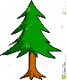
- Sarah Atkins comment: New graphics were developed and inserted.
=====================
Zsuzsa Pluhár, DACHU-preparing, 2021-06-23: Following the DACHU meeting’s comments:
- change pictures (top view from the forest) – Susanne Datzko
- instead of towers the rangers stand on the ground – they can not see over the trees
- as answer need to give the number of glades with rangers and not the number of rangers
- explanation is extended

Graphics and Other Files
2021-AT-01-deu.odt This file.
forest.svg, Florentina Voboril, self-made (not used in final version)
forest_solution.svg, Florentina Voboril, self-made (not used in final version)
graph.svg, Florentina Voboril, self-made
2021-AT-01-eng-Forest-Observation.svg, Vu Luan, self-made
2021-AT-01-eng-Forest-Observation-Answer.svg, Vu Luan, self-made

filename, author, source/self-made, license

Authors, Contributors, and Editors (incl. Graphics)
Author: Florentina Voboril, florentina.voboril@gmx.at, Austria
Editor: Margarita Flores-Sicich, margaritafloressicich@gmail.com, USA
Editor: Sarah Atkins, sarah.atkins@me.com, AU
Graphics: Vu Luan, vuvanluanftuk50@gmail.com, VN
Translation and II v1, in DACHU: Zsuzsa Pluhár, pluharzs@ik.elte.hu
DACHU graphics, translation and II: Susanne Datzko
German version: Gerald Futschek, gerald.futschek@tuwien.ac.at, Austria
author / contributor / editor, e-mail, country.

License
Copyright © 2021 Bebras – International Challenge on Informatics and Computational Thinking. This work is licensed under a Creative Commons Attribution-ShareAlike 4.0 International License. https://creativecommons.org/licenses/by-sa/4.0/.

