2021-IE-02-deu.odt Sack mit Münzen
6yo–8yo:  hard | 8yo–10yo:  medium | 10yo–12yo:  easy | 12yo–14yo:  – | 14yo–16yo:  – | 16yo–19yo:  –
Answer Type: Multiple-Choice with Images (☐ keep order of multiple-choice/-select)
Categories (click to choose):  ☐ algorithms and programming  ☑ data structures and representations |  |  | ☐ computer processes and hardware  ☐ communication and networking  ☐ interactions, systems and society

Body
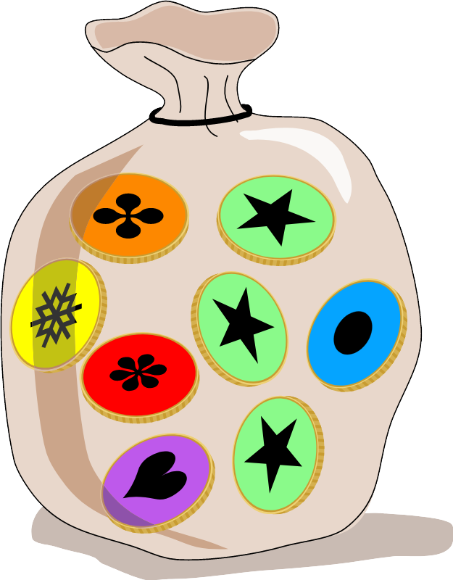
In Emils Land gibt es 4 verschiedene Arten von Münzen. Du siehst hier die beiden Seiten dieser Münzen und auch Emils Sack mit seinen Münzen.
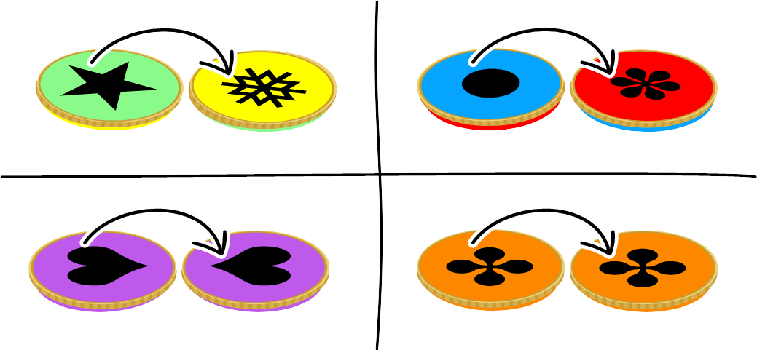
Sein Sack mit Münzen wurde nun geschüttelt.

Question / Challenge
Welcher ist Emils Sack?

Answer Options / Interactivity Description
A) | B) | C) | D)
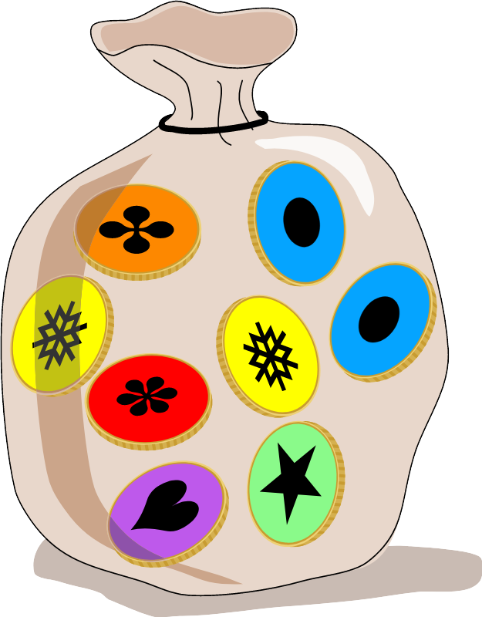 | 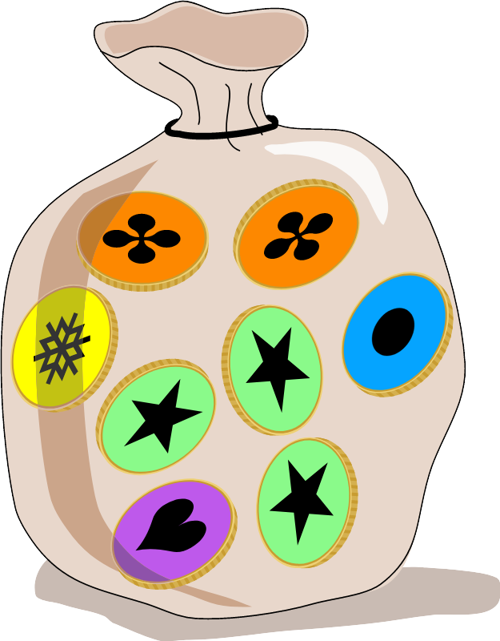 | 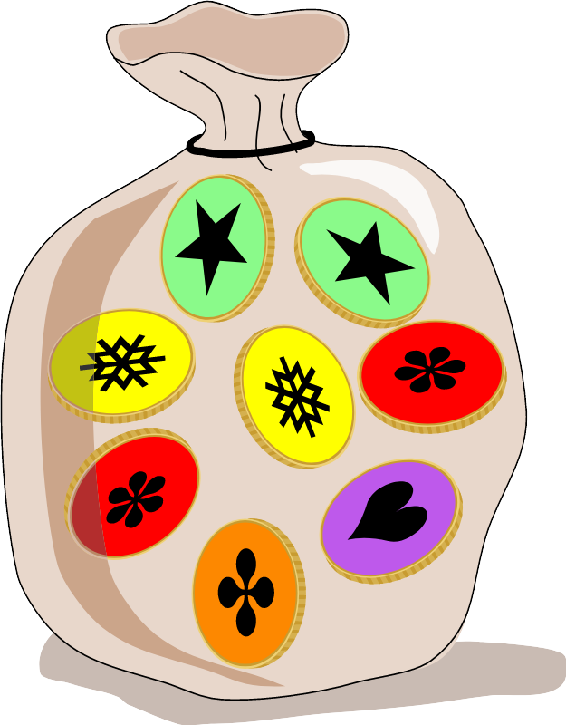 | 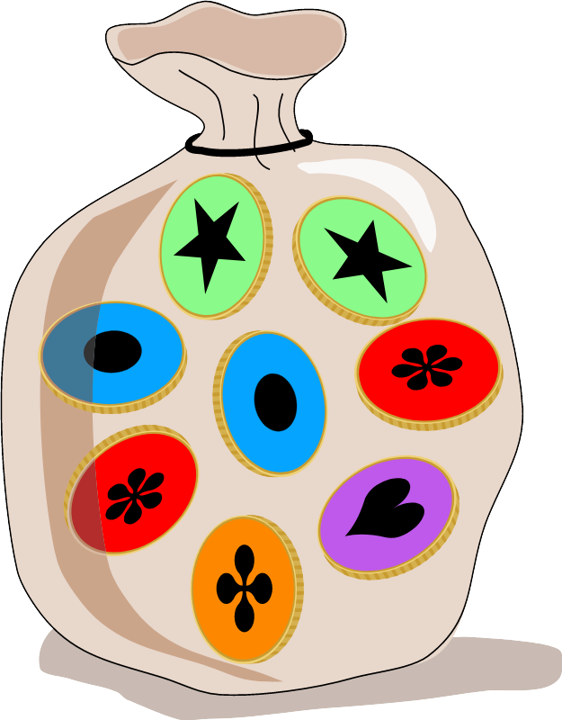

Answer Explanation
Die richtige Antwort ist C.
Emils Sack hat 4 Stück von , 2 Stück von  eine Münze von  und eine von der Art .

Emils Sack | 4 | 2 | 1 | 1
Sack A | 3 | 3 | 1 | 1
Sack B | 4 | 1 | 2 | 1
Sack C | 4 | 2 | 1 | 1
Sack D | 2 | 4 | 1 | 1
Nur Sack C hat für jede Münzenart die gleiche Anzahl Münzen wie Emils Sack. Daher ist es die Lösung.

It’s Informatics
In dieser Aufgabe muss man die Münzarten erkennen, ohne dass man beide Seiten der Münzen sieht. Man hat nur eine unvollständige Information. Objekte der realen Welt werden in einem Computersystem mit seinen wesentlichen Merkmalen gespeichert. Oft genügt es nur einen Teil dieser Merkmale zu kennen um ein Objekt erkennen zu können. Eine Kamera in einem autonomen Fahrzeug sieht stets nur Teile der Realität und das Computersystem muss trotzdem in der Lage sein Fahrzeuge und Verkehrsteilnehmer zu erkennen und auf die jeweilige Verkehrssituation richtig zu reagieren. Die Künstliche Intelligenz in Computersystemen lernt ähnlich wie Menschen allmählich aus Fragmenten die Objekte immer besser richtig zu erkennen.

Keywords and Websites
Multimenge: https://de.wikipedia.org/wiki/Multimenge
Unstrukturierte Daten: https://de.wikipedia.org/wiki/Unstrukturierte_Daten

Wording and Phrases
Emil: Ein Name, der deutlich leichter auszusprechen ist als der gälische Originalname Saoirse
Sack von Münzen: ich verwende das Wort Sack, weil das am ehesten der Grafik entspricht. Beutel wäre auch eine mögliche Bezeichnung.
Arten von Münzen
die 2 (beiden) Seiten von Münzen

Comments
Tom Naughton, tomn@cs.nuim.ie, 2021-04-02: This task is an improved version of a “work needed” task 2018-IE-02: Balloon Bags.
========================================
Review by: Pieter Waker on 2021-04-20 Non-assigned review Rating as is: 4/6 Potential: 5/6
It's informatics section: Great as it is now
Combination of age group and difficulty level: The level is good
Trust the Irish to confuse the Cant with a name like Saoirse. Please give her a non-Gaelic name, or at least one we can pronounce.
Response by Tom Naughton on 2021-05-05: I don’t mind. It might be boring for children to have the same names repeated in tasks every year. I will leave it to the Task Workshop working group to make a ruling on this :-)
========================================
Review by: Pedro Marcelino (svn: marcelino) on 2021-04-22 Assigned review Rating as is: 3/6 Potential: 4/6
It's informatics section: Can be improved
Combination of age group and difficulty level: The level is good
[IDEA]- I had fun solving this task :)
[TEXT] - Short and sweet.
[EXPL] - To connect this exercise with unstructured information and abstraction sounds like a stretch to me. I solved it by just counting the possible cases and checking which option would fit. Nothing fancy. Thus, I suggest we use a different explanation (e.g., rules, conditionals).
[GRAPH] - I would change the "B" with the symbol used to distinguish the color of the coins (i.e., +, *). The symbols are great to help color-blinded people, but I think that, as it is now, it's hard to read the symbols.
[AUTH] - Name and email available.
[NAME] - The name comply with the prescribed format.
Response by Tom Naughton on 2021-05-05: Regarding the graphics, they have been improved as suggested.
Regarding the task being a weak example of unstructured information, I would reply that the simplicity of the example is dictated by the age group that the task is targetted at. A more sophisticated example could be used in a task for older participants. To the reviewer’s comment “I solved it by just counting the possible cases and checking which option would fit” I would respectfully reply that this is exactly the concept of putting some additional structure onto the data.
========================================
Review by: Sébastien Combéfis (svn: combefis) on 2021-04-26 Assigned review Rating as is: 3/6 Potential: 4/6
It's informatics section: Great as it is now
Combination of age group and difficulty level: The level is good
Fun task!
To make it easier to use the task on paper printed with only B/W, or to take into account colourblind people, you can maybe enclose the B in a shape for each colour (red face can become triangle face) in place of adding a small shape on top of each coin.
The explanation can maybe be better structured by first characterising Saoirse's bag to have the count of coins and then comparing it with the four solutions.
Response by Tom Naughton on 2021-05-05: Regarding the graphics, they have been improved as suggested. Regarding the explanation, it has been restructured as suggested.
========================================
Marielle Léonard (FR), marielleleonard59@gmail.com, 19/05/2021:WG5: add graphics witch show the two sides of the coins, and remove text in the body.
Gabrielė Stupurienė (LT), gabriele.stupuriene@mif.vu.lt, 19/05/2021:WG5: change explanation into a table, improve text.

Graphics and Other Files
2021-IE-02-deu.odt This file.
question.svg, Taina Lehtimäki, self-made using items below, license same as task
{green, yellow, red, blue, purple, orange}.svg, Taina Lehtimäki, self-made using items below, license same as task
answer_{a, b, c, d}.svg, Taina Lehtimäki, self-made using items below, license same as task
explanation_{a, b, c, d}.svg, Taina Lehtimäki, self-made using items below, license same as task
Sources of component items used in above SVG files:
- Bag: https://freesvg.org/money-bag-image, Licence: Public Domain, by OpenClipart
- Coins: modified from https://freesvg.org/vector-clip-art-of-coin, Licence: Public Domain, by j4p4n (SVG id 8764).
double_orange.svg, double_purple.svg, green_yellow.svg, red_blue.svg created from original coins : Marielle Léonard, marielleleonard@gmail.com, France

Authors, Contributors, and Editors (incl. Graphics)
Author, Tom Naughton, tomn@cs.nuim.ie, Ireland
Author, Taina Lehtimäki, taina@cs.nuim.ie, Ireland
Editor, German version, Gerald Futschek, gerald.futschek@tuwien.ac.at, Austria

License

Copyright © 09/13/2021 Bebras – International Challenge on Informatics and Computational Thinking. This work is licensed under a Creative Commons Attribution-ShareAlike 4.0 International License. https://creativecommons.org/licenses/by-sa/4.0/.

